RV POSEIDON cruise 518/1
25 September – 11 October 2017 (Bremerhaven – Bremerhaven)

1st Weekly Report
Poseidon cruise 518 takes place in the framework of the Horizon 2020 project STEMM-CCS of the EU. The project’s main goal is to develop and test strategies and technologies for the monitoring of subseafloor CO₂ storage operations. In this context a small research-scale CO₂ gas release experiment is planned for 2019. The current cruise aims at collecting necessary oceanographic and biogeochemical baseline data for this release experiment. Leg 1 plans to deploy a device for high-precision measurements of O₂, CO₂ and pH in the bottom water, a stereo-camera system and a multibeam echosounder to determine gas bubble emissions at the seafloor. GEOMAR’s remotely operated vehicle, ROV PHOCA, is used to place and operate these instruments on the seabed. In addition, ROV push cores and gravity cores will be collected for sediment biogeochemical analyses and video-CTD casts study the water column. The work is complemented by hydroacoustic surveys aiming at detecting gas bubble leakages at abandoned wells in the North Sea.
The scientific party boarded RV Poseidon on Monday, 25th, to unload their equipment and install it in the ship’s laboratories. Cruise preparations were concluded the next day with a harbour trial of ROV PHOCA and we set sail through the river Weser mouth early Wednesday morning. Having a calm sea we went straight to our first stations for hydroacoustic investigations of possible gas seepage at abandoned wells in the German Bight. At the 54-year old blowout crater Figge Maar, located about 20 nm north of the island Juist, we saw indications for vigorous gas seepage in the hydroacoustic data, so-called flares. This blowout structure is about 17 m deep, relative to the surrounding seafloor, and about 500 m across. After mapping the seafloor feature, we continued north to the “Entenschnabel”, the outer part of Germany’s EEZ in the North Sea, and then entered into the UK sector. On our way to the main working area in the vicinity of the Goldeneye platform, where we arrived Saturday morning, we successfully surveyed more abandoned wells for gas emissions. After three video-CTD casts and three gravity cores, the wave conditions had improved sufficiently in the afternoon of September, 30th, to allow diving with ROV PHOCA and deploy MPI’s O₂/CO₂ eddy covariance tool. This short dive was followed by more hydroacoustic surveys around Goldeneye and at abandoned wells further to the east.
On Sunday, our research work had to be discontinued because of the predicted bad weather conditions with strong winds up to 20 m/s and increasing wave heights. We have now taken shelter in the Moray Firth in Scotland until the multiple storm fronts have passed. Crew and scientific party are all well, and based on the weather forecast we hope to continue our field work on Friday or Saturday to be able to have, at least, a few more stations before returning to Bremerhaven.

On behalf of all participants I am sending the best wishes.
Matthias Haeckel, chief scientist

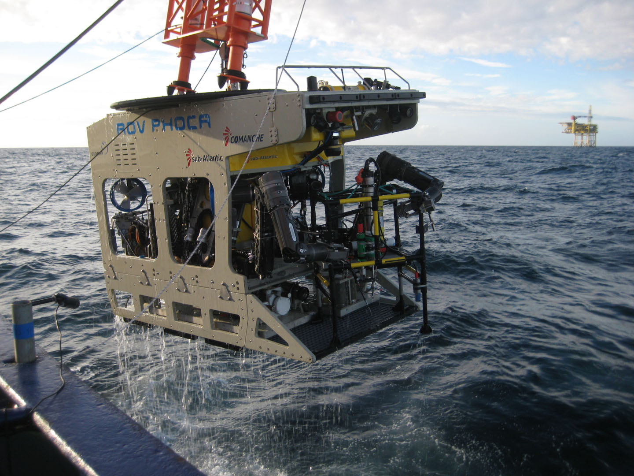
Picture (Dirk Koopmans): ROV PHOCA is retrieved after a dive in the vicinity of the Goldeneye Platform.

