Supplementary File A1: Photographs of sample DR65-1
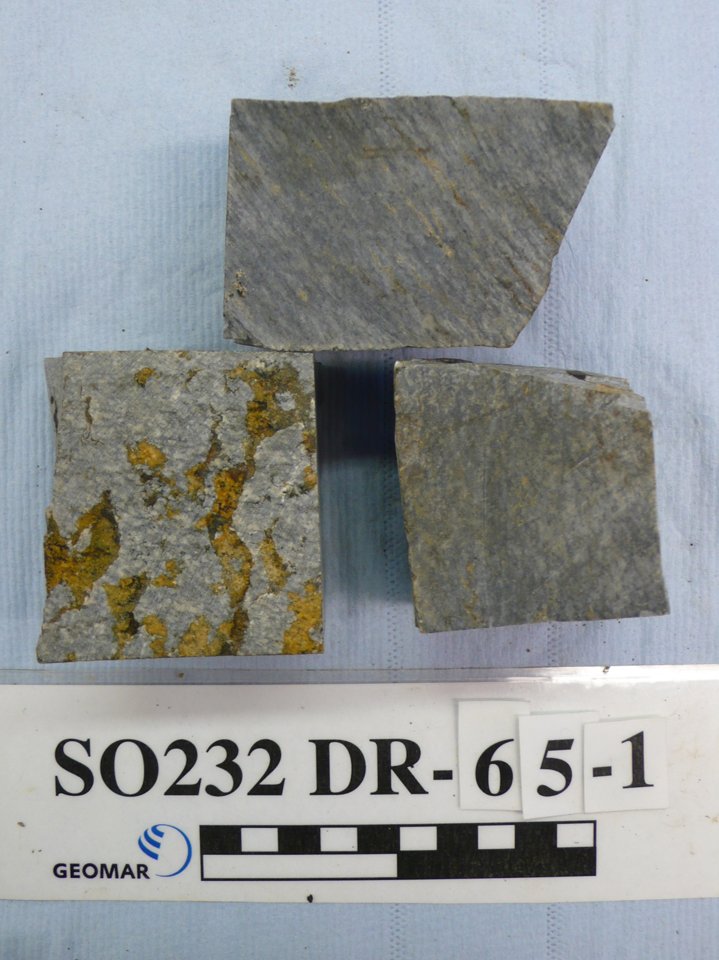
10 cm

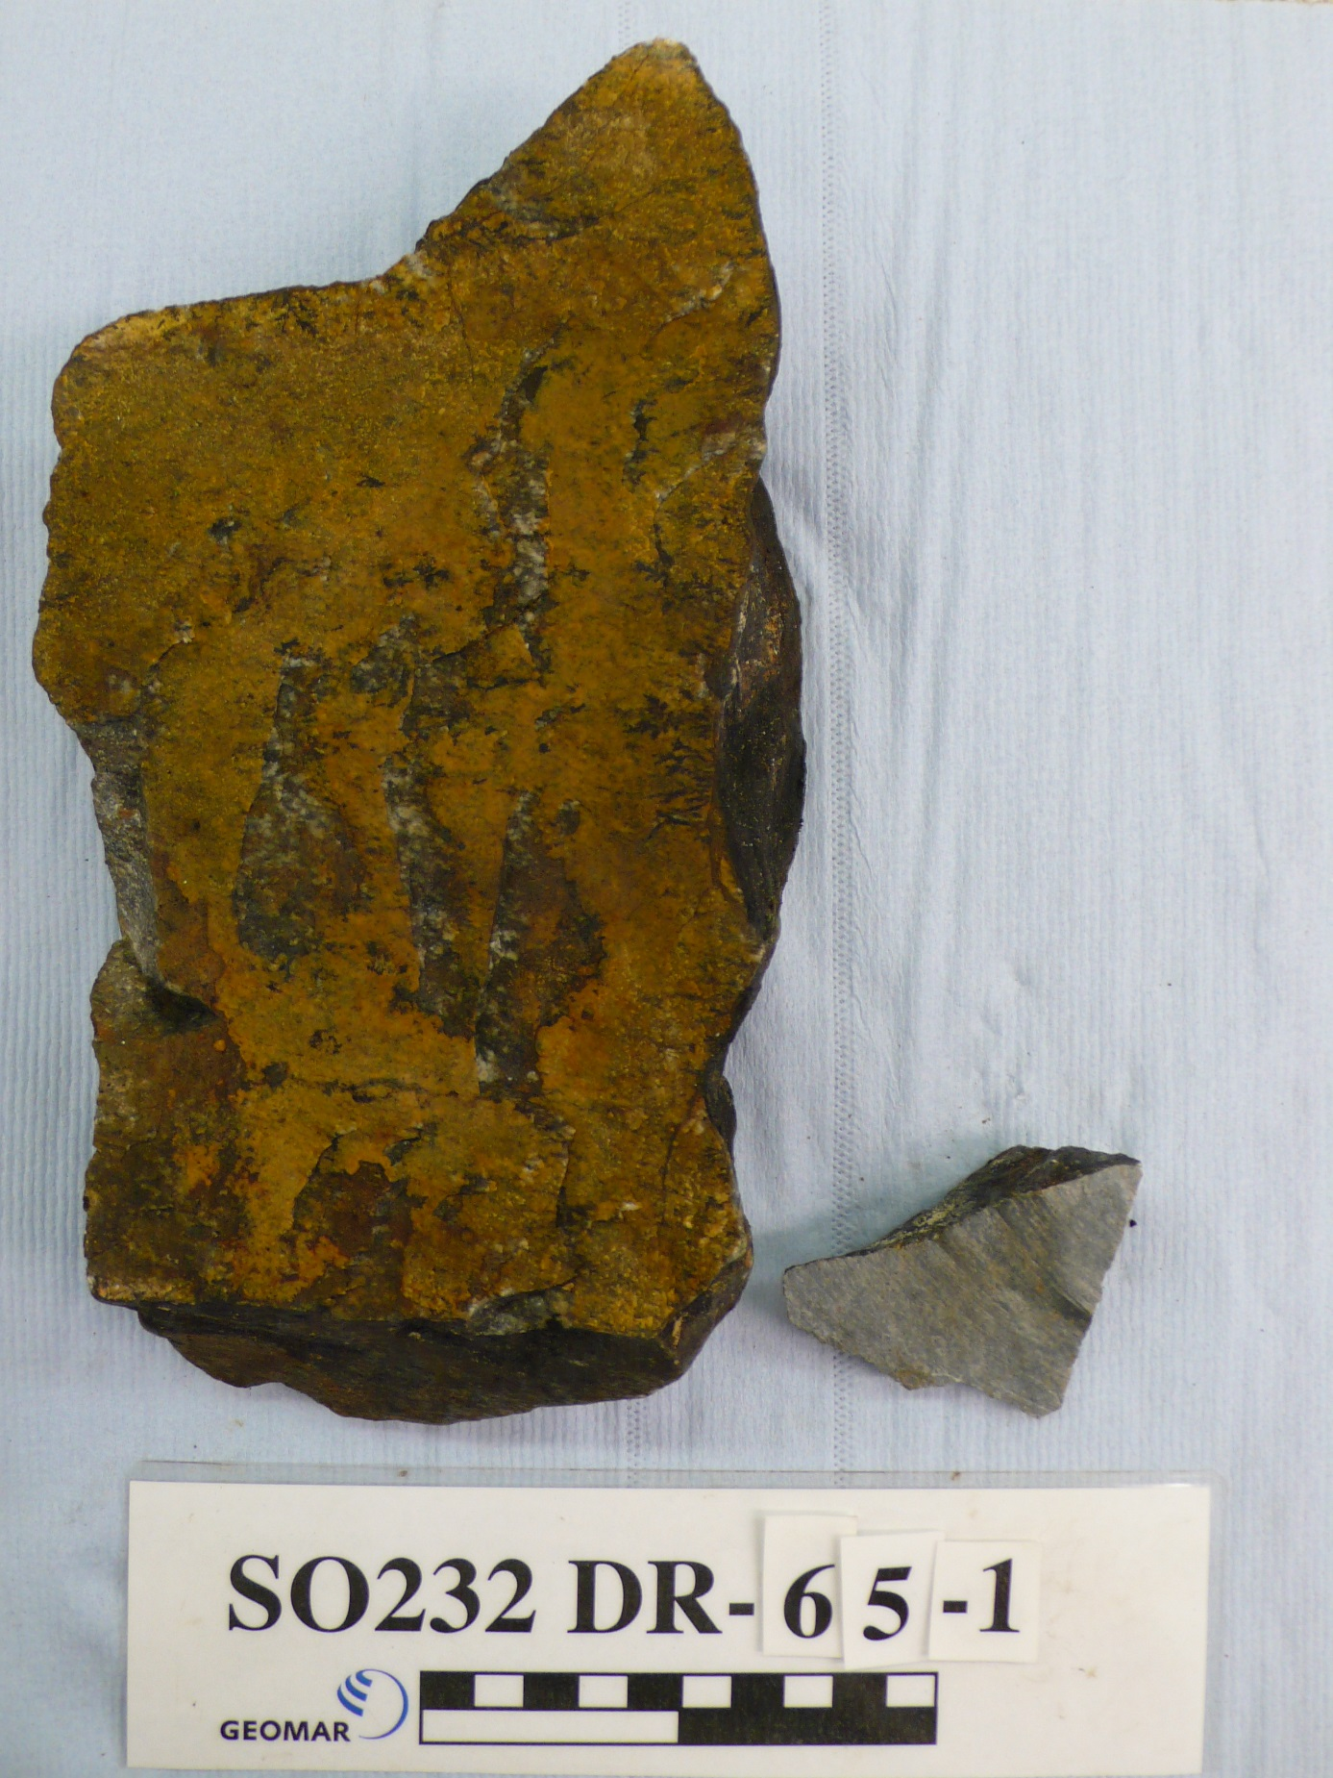
10 cm

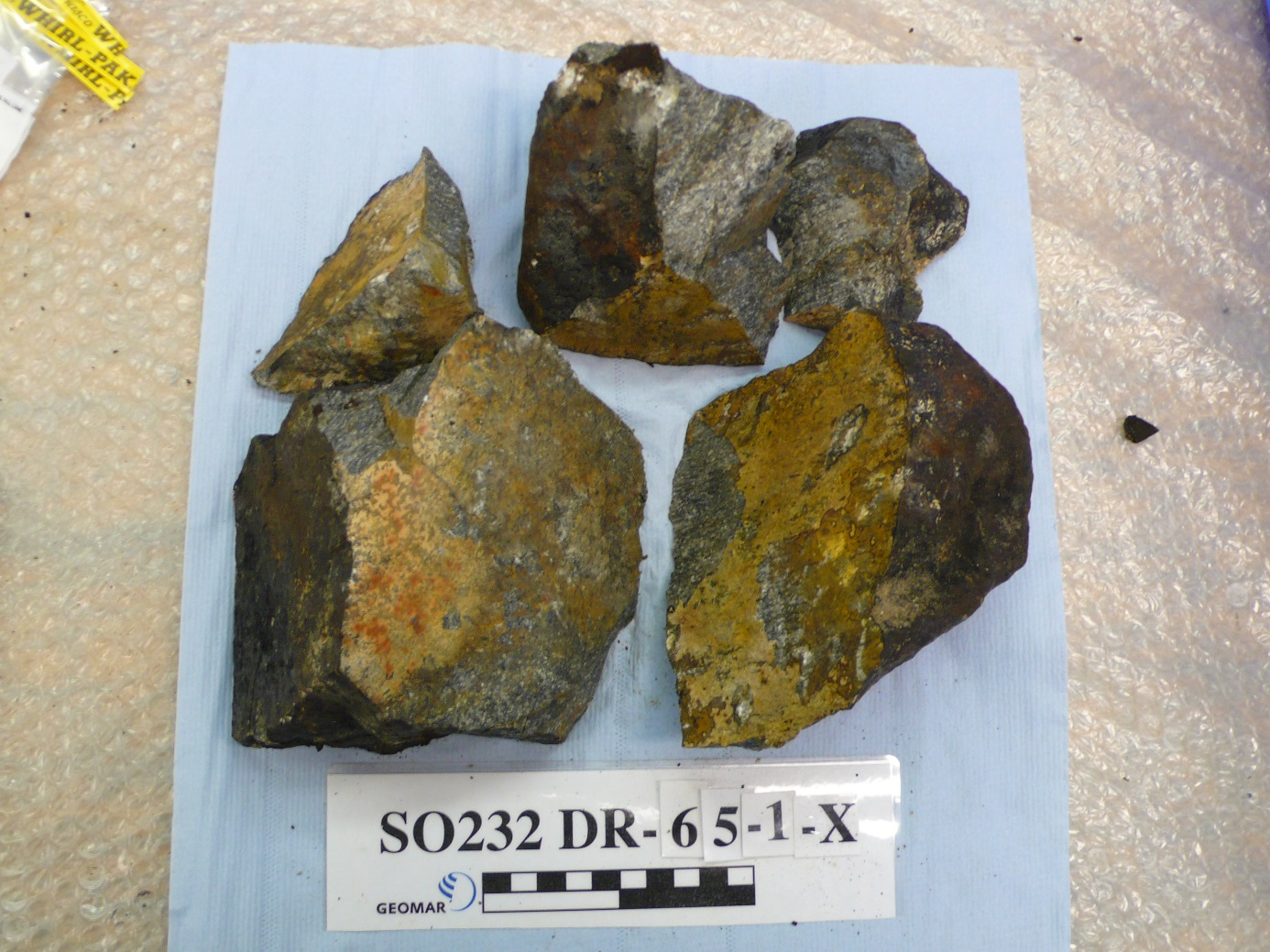
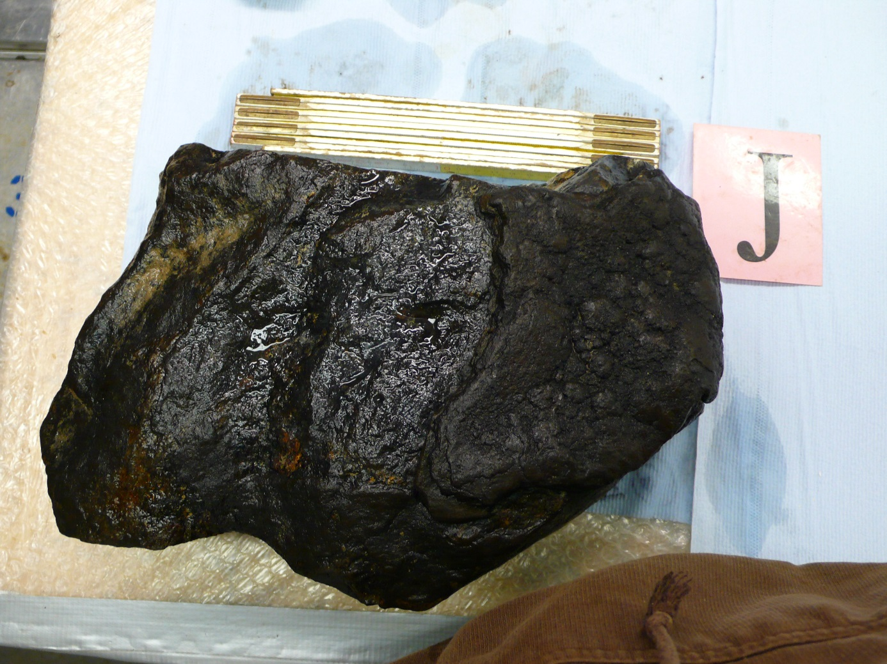
20 cm

Supplementary File A2: Detailed analytical methods

The samples were crushed, sieved and repeatedly washed in deionized water in an ultrasonic bath until a clear solution was obtained in order to remove seawater and dust. Then ~5 g of the 0.5-2 mm rock chips were handpicked under a binocular microscope in order to obtain the macroscopically freshest material by avoiding secondary minerals along cracks and as vesicle fillings. For major and trace element analyses, fine homogeneous powders were made using an agate ball mill, whereas handpicked chips were used for radiogenic isotope analyses.

Major elements

Major elements were analyzed at the Hamburg University, Germany, using a MagixPro PW 2540 XRF. Several reference materials were analyzed along with the SO232 samples and in most cases deviations from accepted values were <5% (<10% for MnO) (Govindaraju, 1994, Jochum et al., 2016; supplementary Table B2). The major element composition of DR14-1G was determined on four to five polished glass chips using a JEOL JXA-8200 Electron Microprobe at GEOMAR. The instrument was operated with an accelerating voltage of 15 kV and a spot size of 5 μm and a beam current of 6 nA. Counting times for K, Ti, S and Cl was 30 s, for Mn and Fe 40 s, and for all other elements 20 s. Na was analyzed first to minimize loss due to migration. The instrument was calibrated and the analytical quality was monitored using natural reference glasses VG-A99 (USNM 113498), VG-2 (USNM 111240/52), ALV981 (R23-5) and CFA-47 measured at the beginning and at the end of the analytical run. Internal reproducibility was good (see supplementary Table B3).

Trace elements

Trace element concentrations for 34 elements were determined on 100 mg powder dissolved by acid-pressure digestion following the analytical procedure described in Garbe-Schönberg (1993). Measurements were done using an Agilent 7500cs at the Institute of Geosciences, Kiel University, Germany. Instrumental reproducibility and sample replication are generally better than 2% for most elements (supplementary Table B4) except for the transition metals, which vary between 3-5%. Analyses of reference material BHVO-2, prepared along with the samples, agree within 3% of the values issued by Jochum et al. (2016) (http://georem.mpch-mainz.gwdg.de). For standard BIR-1 most elements agree within 5% of the recommended values. Larger deviations are observed for Cs and U reflecting extreme depletion of these elements in BIR-1 approaching detection limits (supplementary Table B5). The suspected continental crust sample SO232-DR-65-1 was prepared in a PARR bomb, in order to ensure dissolution of accessory minerals such as zircon. The relative difference between XRF and ICPMS data for Zr are better than 1%.
Trace-element concentrations in glass sample SO232-DR14-1G were analyzed by laser ablation – inductively coupled plasma - mass-spectrometry (LA-ICP-MS) using an Agilent 7500s quadrupole mass-spectrometer coupled with 193nm Excimer laser ablation system GeoLasTM Pro (Coherent®) at the Institute of Geosciences, Kiel University, Germany. Analyses were performed with 60 µm spots, 10 Hz pulse frequency, and 10 J/cm² laser fluence. The analyses were performed in a large two-volume “Zürich” ablation cell. Carrier gas was He (1 l/min) with addition of H₂ (0.014 l/min), which were mixed with Ar (0.85 l/min) before introduction into the spectrometer. Oxide production rate, estimated as ThO+/Th+, was <0.5%. Analyses were performed in time-resolved mode and included 20 s background measurement followed by 60 s sample ablation and signal measurement. Dwell time was 20 ms for all elements. All spectra were inspected with GLITTER software to define intervals for integration and exclude possible contamination from surface and/or crystal phases occasionally trapped during analysis. Concentrations were quantified from the measured ion yields normalized to ⁴³Ca. Ca concentrations came from microprobe data, and MPI-DING KL2-G glass was used as a primary standard for all elements. Reference glasses ATHO-G, GOR132-G, BCR-2G were analyzed as unknowns. Consistency between microprobe and LA-ICP-MS data was checked by comparison of Si and Ti concentrations which agreed within 5 %. The trace element concentrations for SO232-DR14-1G were obtained by averaging data from 6 points in different glass chips (supplementary Table B6).

Radiogenic isotopes

Detailed descriptions of the chemical procedures and mass spectrometry techniques at GEOMAR Helmholtz Centre for Ocean Research Kiel can be found in Hoernle et al. (2011). Briefly, Sr-Nd-Pb (DS) isotope ratios were analyzed on a ThermoFisher Scientific Triton+ and Hf on a NU Plasma HR MC-ICPMS. In order to remove possible surface alteration/contamination fresh rock chips (100-150 mg of 0.5-2 mm size) were mildly acid leached in 2N HCl at 70°C for 1 hour and then triple-rinsed in ultra-pure water prior to acid-digestion in concentrated ultra-pure HF-HNO3. Additionally, the effects of seawater alteration on the Rb-Sr system were investigated by leaching the powders in hot (150°C) 6N HCl for several hours followed by triple rinsing in ultra-pure water and centrifugation in ultra-pure water before digestion. Hf chemistry followed the procedures of Blichert-Toft et al. (1997) and Geldmacher et al. (2006) using 200-500 mg of fresh rocks. Samples were diluted to 80-100 ppb Hf to obtain a total Hf beam of 12-14 V that was analyzed by static multi-collection. Sr, Nd and Hf isotope ratios were mass-bias corrected to ⁸⁶Sr/⁸⁸Sr = 0.1194, ¹⁴⁶Nd/¹⁴⁴Nd = 0.7219 and ¹⁷⁹Hf/¹⁷⁷Hf = 0.7325 (assuming exponential mass fractionation). All errors for Sr, Nd, Hf and Pb isotope ratio measurements are given as twofold standard error of the mean (2SE) representing the twofold standard deviation from the mean of n integrations divided by the square root of n-1. The external 2σ uncertainties, defined as twofold standard deviations (2SD) from the mean of multiple analysis of the standards, are ± 0.000007 for NBS987 (n= 20) and ± 0.000007 for La Jolla (n= 24). We measured NBS987 and La Jolla reference materials every 4th to 5th sample to obtain a normalization value for each sample turret relative to our preferred values of ⁸⁷Sr/⁸⁶Sr = 0.710250 for NBS987 and ¹⁴³Nd/¹⁴⁴Nd = 0.511850 for La Jolla. Double-spike corrected NBS981 values and corresponding 2SD’s are ²⁰⁶Pb/²⁰⁴Pb = 16.9413 ± 34, ²⁰⁷Pb/²⁰⁴Pb = 15.4984 ± 32, ²⁰⁸Pb/²⁰⁴Pb = 36.7215 ± 87, ²⁰⁷Pb/²⁰⁶Pb = 0.914828 ± 89, ²⁰⁸Pb/²⁰⁶Pb = 2.16757 ± 9 (n= 10). Standard bracketing normalized ¹⁷⁶Hf/¹⁷⁷Hf yielded = 0.282170 ± 6 (n= 45) for our in-house Hf SPEX which corresponds to ¹⁷⁶Hf/¹⁷⁷Hf = 0.282163 for JMC-475. Total Pb blanks were below 25 pg, Sr blanks typically below 100 pg, and Nd-Hf blanks typically below 50 pg, and thus all were considered negligible.

References:
Blichert-Toft J., Chauvel C. and Albarède F. (1997) Separation of Hf and Lu for high-precision isotope analysis of rock samples by magnetic sector-multiple collector ICP-MS, Contrib. Mineral. Petrol. 127, 248-260
Bouvier A., Vervoort J.D. and Patchett P.J. (2008) The Lu-Hf and Sm-Nd isotopic composition of CHUR: Constraints from unequilibrated chondrites and implicationsfor the bulk composition of terrestrial planets, Earth Planetary Sci. Lett. 273, 48-57, doi:10.1016/j.epsl.2008.06.010
Garbe-Schönberg C.-D. (1993) Simultaneous determination of thirty-seven trace elements in twenty-eight international rocks standards by ICP-MS, Geostandard Newslett. 17, 81-97, doi: 10.1111/j.1751-908X.1993.tb00122.x
Geldmacher J.R., Hoernle K., Klügel A., van den Bogaard P., Wombacher F. and berning B. (2006) Origin and geochemical evolution of the Madeira-Tore Rise (eastern North Atlantic), J Geophys Res 111, doi: 10.1029/2005JB003931
Govindaraju K. (1994) Compilation of working values and sample description for 383 geostandards, Geostandard Geoanalyt. Res 18, 1-158, doi: 10.1046/j.1365-2494.1998.53202081.x-i1
Hoernle K., Hauff F., Kokfelt T.F., Haase K., Garbe-Schönberg C.-D. and Werner R. (2011) On- and off-axis chemical heterogeneities along the South Atlantic Mid-Ocean Ridge (5-11°S): Shallow or deep recycling of ocean crust and/or intraplate volcanism? Earth Planetary Sci. Lett. 306, 86-97, doi: 10.1016/j.epsl.2011.03.032
Hoernle K., Rohde J., Hauff F., Garbe-Schönberg C.-D., Homrighausen S., Werner R. and Morgan J.P. (2015) How and when plume zonation appeared during the 132 Myr evolution of the Tristan Hotspot, Nat. Comm. 6, doi: 10.1038/ncomms8799
Hofmann A.W. (1988) Chemical differentiation of the Earth: the relationship between mantle, continental crust, and oceanic crust, Earth Planetary Sci. Lett. 90, 297-314, doi: 10.1016/0012-821X(88)90132-X
Homrighausen S., Hoernle K., Hauff F., Wartho J.-A., van den Bogaard P. and Garbe-Schönberg D. (2019) New age and geochemical data from the Walvis Ridge: The temporal and spatial diversity of South Atlantic intraplate volcanism and its possible origin, Geochim. Cosmochim. Acta 245, 16-34, doi: 10.1016/j.gca.2018.09.002
Jochum K.P., Weis U., Schwager B., Stolll B., Wilson S.A., Haug G.H., Andreae M.O. and Enzweiler J. (2016) Reference values following ISO guidelines for frequently requested rock reference materials, Geostandard Geoanal. Res. 40, 333-350, doi: 10.1111/j.1751-908X.2015.00392.x
Mirnejad H. and Bell K. (2006) Origin and source evolution of the Leucite Hills lamproites: Evidence from Sr-Nd-Pb-O isotopic compositions, J. Petrol. 47, 2463-2489, doi: 10.1093/petrology/egl051
Murphy D.T. Collerson K.D. and Kamber B.S. (2002) Lamproites from Gaussberg, Antarctica: Possible transition zone melts of Archean subducted sediments, J. Petrol. 43, 981-1001
Rohde J., Hoernle K., Hauff F., Werner R., O’Connor J., Class C., Garbe-Schönberg C.-D. and Jokat W. (2013) 70 Ma chemical zonation of the Tristan-Gough hotspot track, Geology 41, 335-338, doi: 10.1130/G33790.1
Stracke A., Bizimis M. and Salters V.J.M. (2003) Recycling oceanic crust: Quantitative constraints, Geochem. Geophys. Geosystems 4, doi: 10.1029/2001GC000223
Willbold M. and Stracke A. (2006) Trace element composition of mantle end-members: Implications for recycling of oceanic and upper and lower continental crust, Geochem. Geophys. Geosyst. 7, doi: 10.1029/2005GC001005
Workman R. K. and Hart S. R. (2005) Major and trace element composition of the depleted MORB mantle (DMM), Earth Planet. Sci. Lett. 231, 42–53, doi: 10.1016/j.epsl.2004.12.005

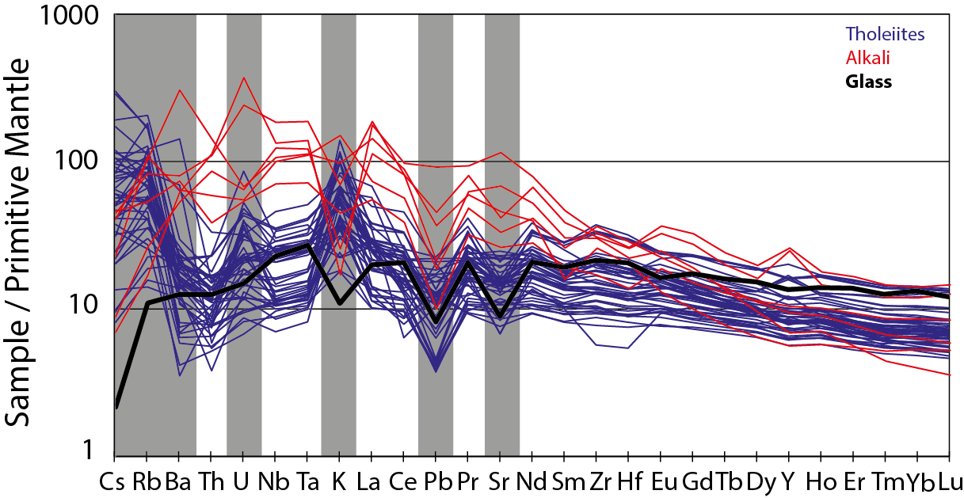

Supplementary Figure A3. Multielement diagram normalized to Primitive Mantle values of Hofmann (1988). The full spectrum is shown in order to highlight possible fluid-mobile element (gray bars) peaks, indicating possible alteration. Fresh glass sample DR14-1, analyzed with Laser Ablation ICPMS, serve as reference. Most of the samples are enriched in Cs, Rb, U and K.

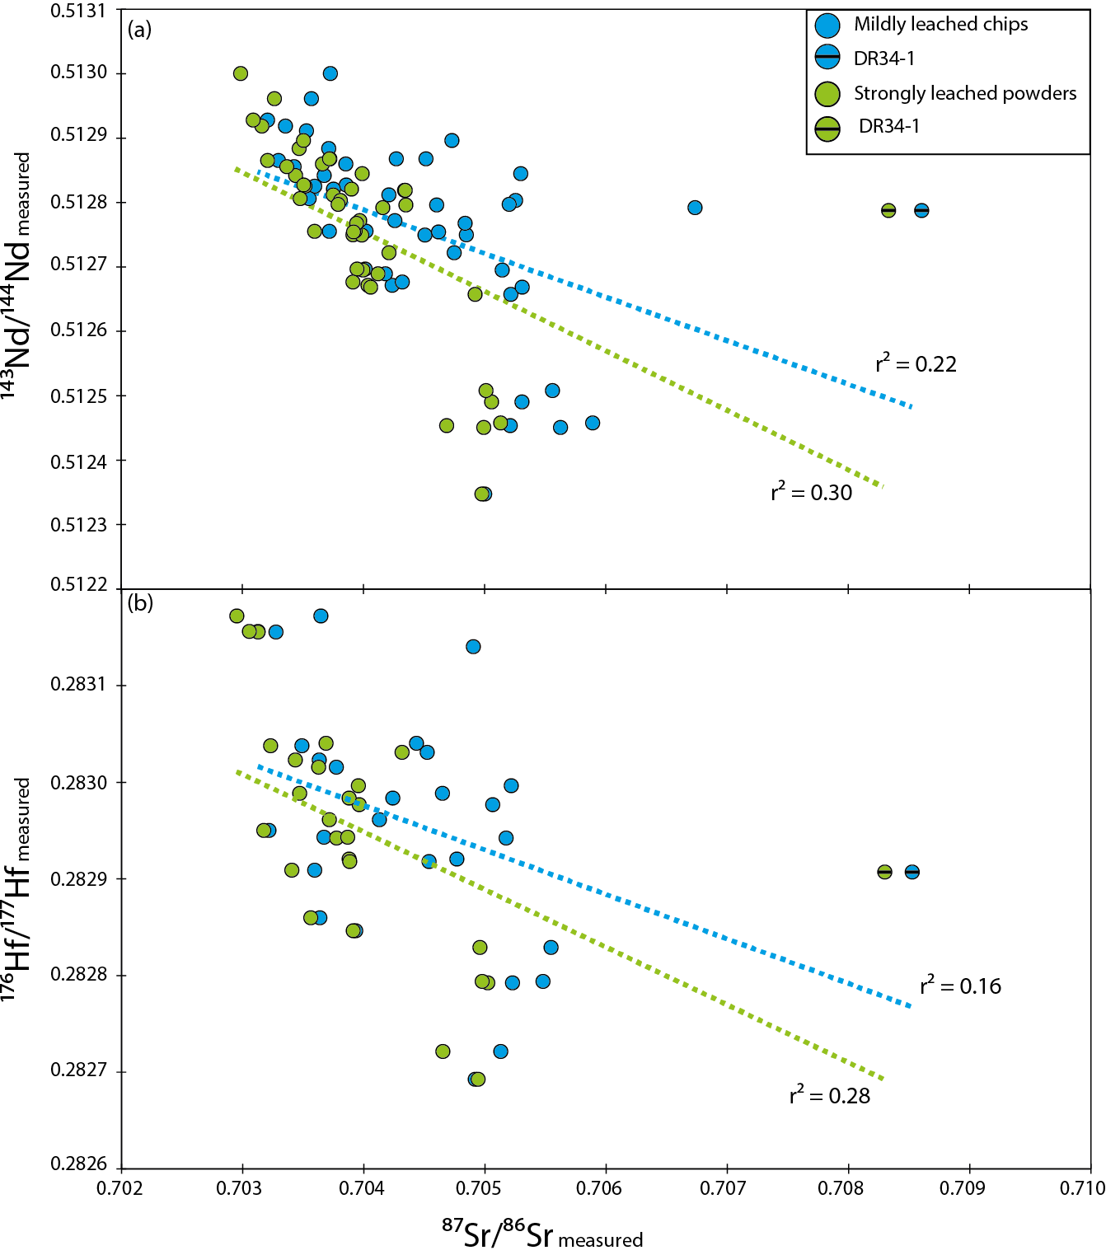
Supplementary Figure 4. Plots of measured ⁸⁷Sr/⁸⁶Sr vs. (a) measured ¹⁴³Nd/¹⁴⁴Nd (b) measured ¹⁷⁶Hf/¹⁷⁷Hf for the mildly leached rock chips (blue) and strongly leached powders (green). The coefficient correlation r² is fairly low for both leaching experiments.

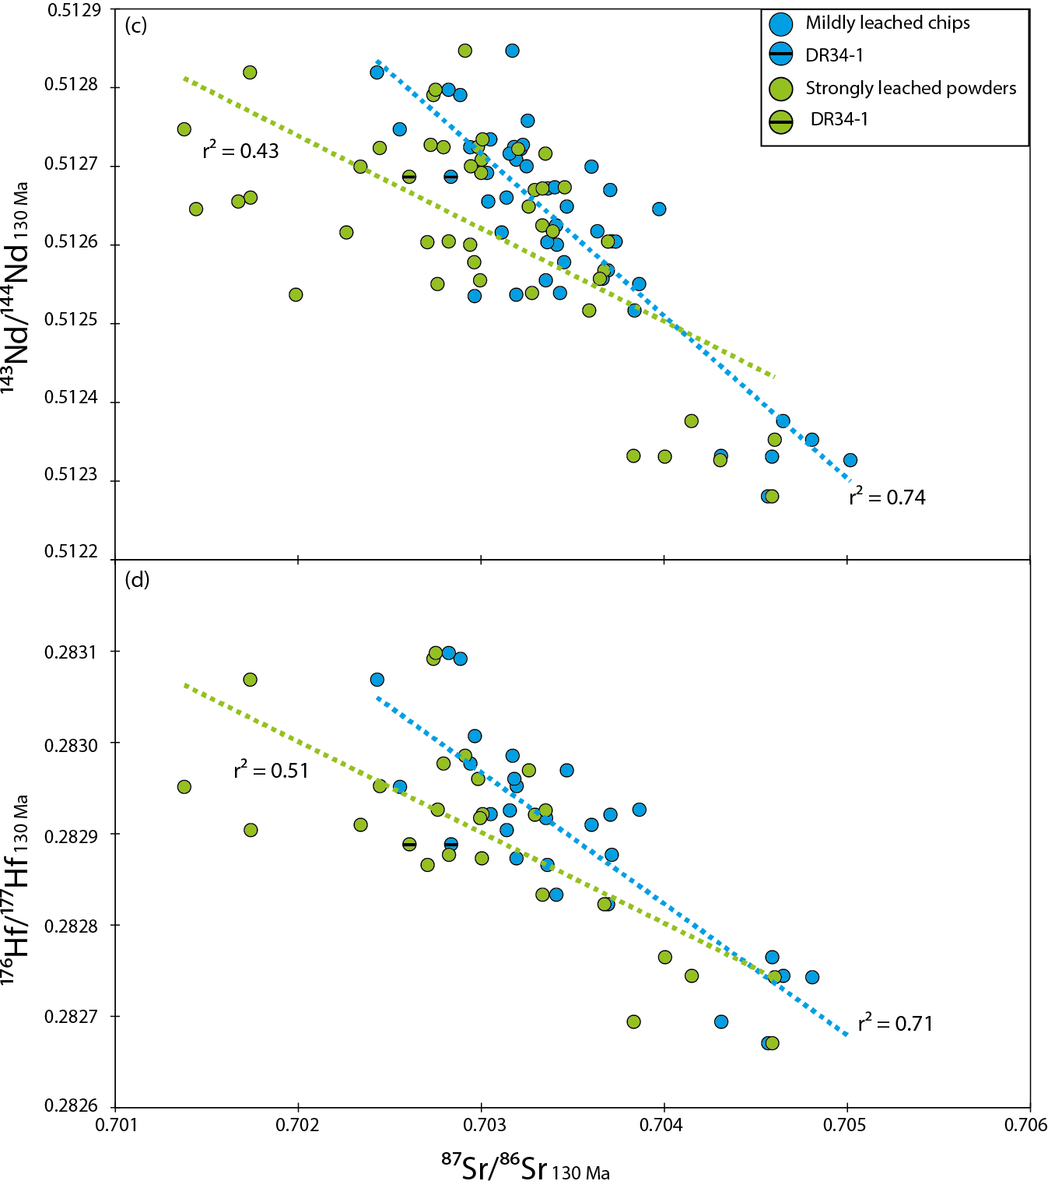
Supplementary Figure 4 (continued). Plots of initial ⁸⁷Sr/⁸⁶Sr vs. (c) initial ¹⁴³Nd/¹⁴⁴Nd (d) initial ¹⁷⁶Hf/¹⁷⁷Hf. The coefficient correlation r² is remains low for the strongly leached powders, partly because of 6 over-corrected samples with initial ⁸⁷Sr/⁸⁶Sr < 0.702.

