
Global Biogeochemical Cycles
Supporting Information for
Sargassum sp. act as a Large Regional Source of Marine Dissolved Organic Carbon and Polyphenols
Leanne C. Powers^{1*†}, Norbert Hertkorn^{2†}, Natasha McDonald^{3,4}, Philippe Schmitt-Kopplin^{2,5}, Rossana Del Vecchio⁶, Neil V. Blough⁷, and Michael Gonsior^{1*}
¹ University of Maryland Center for Environmental Science, Chesapeake Biological Laboratory, Solomons, MD, 20688 USA
² Helmholtz Zentrum Muenchen - German Research Center for Environmental Health, Research Unit Analytical BioGeoChemistry, D-85764 Neuherberg, Germany
³ Bermuda Institute of Ocean Sciences, 17 Biological Station, St. George’s GE 01, Bermuda
⁴ GEOMAR Helmholtz Centre for Ocean Research, Wischhofstr. 1-3, 24148 Kiel, Germany
⁵ Technische Universität München, Chair of Analytical Food Chemistry, D-85354 Freising-12 Weihenstephan, Germany
⁶ University of Maryland, Earth System Science Interdisciplinary Center, College Park, MD, 20742 USA
⁷ University of Maryland, Department of Chemistry and Biochemistry, College Park, MD, 20742 USA

Contents of this file

Text S1 to S2
Figures S1 to S13
Tables S1 to S6

Introduction
Supporting information includes additional details on the characterization of Sargassum SPE-DOM via FT-ICR MS (Text S1) and NMR spectroscopy (Text S2).

Text S1. Additional Details on Sargassum SPE-DOM composition analyzed by FT-ICR MS
A number of methods exist to extract compounds from dried brown algae (Isaza Martínez & Torres Castañeda, 2013; Wijesinghe & Jeon, 2012). More specifically, a suite of isolation and purification techniques exist to analyze phlorotannins, typically by chromatographic methods like high pressure liquid chromatography-mass spectrometry (LC-MS) (Isaza Martínez & Torres Castañeda, 2013). Mass spectrometry has also been used for the structural analysis of other common compounds isolated from brown algae. For example, a diverse class of sulfated polysaccharides (fucoidans) and a number of terpenoids have been extracted from various brown algae and characterized (Blunt et al., 2006; Li et al., 2008). Previous work has found that dried Sargassum fluitans contained 45% alginate (Fourest & Volesky, 1996), a major component of their cell walls. The carbohydrate fraction was 6 to 12% of the DOC exuded from kelp during growth stages and increased to 34 to 64% during the rest of the year whereas the phenolic fraction was 10 to 20% of the released DOC during growth stages and 6 to 10% during the rest of the year (Abdullah & Fredriksen, 2004). However, data on specific classes of compounds actively released by living Sargassum have not been investigated to date.

In both positive and negative ionization modes, a small number of formula were unique to exudation experiments performed in either indoor or outdoor tanks (negative mode van Krevelen diagrams shown in Figure S3B), but the majority of assigned formula were common between all incubations (Figure S3B). Intensity weighted (wt) average molecular characteristics were not different within ± 1 standard deviation between indoor and outdoor incubations. In positive ESI ionization mode, CHNO formulas were most abundant (51% of assigned peaks), followed by CHO formulas (46%), with minor contributions of CHOS, CHNOS, and CHOBr formulas (~1% each). The greater contribution of nitrogen containing formulas is likely due to their preferential ionization in ESI positive mode (Kujawinski et al., 2004). Nonetheless, positive mode formula assignments were similar to those determined previously for marine DOM (Hertkorn et al., 2013). Both CHO and CHNO formulas extended into regions of less oxygenation in van Krevelen space (average O/C_{wt} around 0.3 to 0.4) when compared to ESI negative mode formula assignments (Figure 2B). A number of metabolites, such as monoterpenes or loliolide derivatives, terpenoids, and fucoxanthin (a major brown algae carotenoid), have been extracted and identified in brown algae (Haugan & Liaaen-Jensen, 1994; Kimura & Maki, 2002; Reddy et al., 2008; Sugawara et al., 2006). These metabolites generally have a low oxygen content and high saturation, with known compounds having O/C and H/C ratios around 0.2 and 1.5, respectively. ESI positive mode CHNO formula had high diversity in the KMD/z* plot (not shown), which has been observed previously in algal bloom DOM analyzed in ESI negative mode (Zhang et al., 2014). The authors noted that these nominal insertions or deletions of CH₂ can occur easily in peptides with amino acid variations.

Text S2. Additional Details on Sargassum SPE-DOM composition analyzed by NMR

Phlorotannins are main exudates of brown algae and carry a characteristic 1,3,5-trioxo-aromatic substitution produced by rearrangement of triketide rings, formed by the acetate-malonate pathway. Derivatives of the basic unit phloroglucinol (C₆H₆O₃) comprise ~700 often bioactive natural products (Singh et al., 2010) of which ~150 are phlorotannins of different size and oxygenation resulting from nominal condensation of phloroglucinol units (Isaza Martínez & Torres Castañeda, 2013). Remarkably, the three-fold 1,3,5-symmetry of oxygen substitution is retained in virtually all of them. Smaller size phlorotannins are classified according to their coupling modes, namely C_{ar}-C_{ar} (biaryl, fucols, resulting from oxidative coupling of two C● radicals) or C_{ar}-O-C_{ar} (arylether, phlorethols; resulting from oxidative coupling of one O● and one C● radical (Isaza Martínez & Torres Castañeda, 2013; Vershinin et al., 2017). Larger size phlorotannins divide into linear (two linkages) and branched (three linkages) and show multiple and mixed interphloroglucinol linkages, leading to further classification into other established groups of fuhlols, eckols and fucophlorethols (Isaza Martínez & Torres Castañeda, 2013). Key substructures include furans resulting from condensation of C-C-bound hydroxylated aromatics and 1,4-dioxines resulting from condensation of hydroxylated aryl ethers.
The combined electron-donating resonance effects of two ortho- and one para oxygen substituents in 1,3,5-trioxo-phlorotannins produce NMR chemical shifts δ_{H/C} (Van Altena & Steinberg, 1992; Steevensz et al., 2012; Stiger-Pouvreau et al., 2014; Yotsu-Yamashita et al., 2013) that are normally attributed to either olefinic protons (=CH; δ_{H} ~ 5.8-6.1 ppm) or anomeric positions in carbohydrates (O₂CH; δ_{C} ~ 90-100 ppm) but not to benzene derivatives. Further functionalization (oxygenation and carboxylation) of 1,3,5-trioxoaromatics produces comparatively weaker inductive substituent effects leading to limited downfield displacements of δ_{H/C} for remaining positions (Perdue et al., 2007). Considerable hydrogen deficiency occurs in all larger-size phlorotannins because at least four aromatic positions have to be occupied by non-hydrogen substituents; further oxidation will replace hydrogen by hydroxyl groups (Kuhnert et al., 2010) leading to aromatic rings with five or even six oxygen substituents. Hence, extensive polymerization and oxidation reduce the count of non-exchangeable protons and make detection of evolved phlorotannins by ¹H NMR spectroscopy eventually impractical.

We have obtained the Sargassum exudates under realistic outdoor conditions comprising exposure to sunlight and oxygen. They contained a highly diverse mixture of biomolecules produced by Sargassum itself, epiphytes and other microorganisms that have colonized the Sargassum plants. Hence, 1D (Figure S5, S6) and 2D NMR spectra (Figure S7, S8, S9, S10) showed the expected fundamental metabolite classes lipids (abundant), peptides (clearly discernible but not prominent; Figure S7) and carbohydrates (abundant and molecularly diverse; Figure S7, S8) in the aliphatic section (Figure S7). In addition, Sargassum extracts showed a fairly well developed NOM signature comprised of CRAM (carboxyl-rich alicyclic compounds) (Hertkorn et al., 2006), oxygenation products of carotenoids (Arakawa et al., 2017) and other OC₂CH-units (Figure S8). Overall, the presence of classical aromatic molecules (NOM-type and natural products) and phlorotannins (Figure S9) resulted in an unusually high abundance of aromatic molecules in Sargassum extract when compared with that of common aquatic and marine organic matter including surface Sargasso Sea SPE-DOM (Table S2).

Individual Sargassum extracts showed considerable variance of composition (Table S2, S3) for all functionalities, reflecting a complex temporal evolution of a multi-organism mini ecosystem under experimental conditions. However, differences in NMR spectra of individual samples 394-396 rather referred to changes in relative NMR resonance amplitude than positioning of main NMR resonances, indicating abundance variations of common molecules rather than fundamental changes in chemical structures present. Two conspicuous alterations deserve mentioning. At first, phlorotannins were very abundant in sample “395”, suggesting a capacity of Sargassum to even double the exudation of phlorotannins compared with that found in the consolidated (pooled) sample (Table S2, S3; Figure S6). Second, a certain group of aliphatic esters (-CO-(O=C)-CH₂-C_{alkyl}, probably microbially-derived lipid-like compounds with >15 very closely spaced NMR resonances and convoluted cross peaks at δ_{H/C}: ~3.67 / ~62.5; ~3.64 / 71.6 (HMBC cross peak to δ_{C} ~174.6 ppm; Figure S10; ~3.56 / ~73.9 ppm) had been produced in the order 394 >> 396 >> 395. Remarkably, high abundance of phlorotannins went along with low proportions of these esters and vice versa. These opposing trends might result from inhibition of metabolic activity within the foodweb living with Sargassum by biocidal effects of exudated phlorotannins.
In summary however, the concordance of ¹H NMR resonances indicated variance in relative abundance of certain molecules rather than presence of divergent molecules in individual Sargassum exudates; hence, pooling of the three individual samples 394-396 was warranted to obtain high-quality 2D (Figure S7-S10, S12) and ¹³C NMR spectra (Figure S11). These were indispensable for characterization for Sargassum-derived phlorotannins which were particularly rich in quaternary carbon atoms.
The increased spectral dispersion of ¹H, ¹³C HSQC NMR spectra (Figure S9) was used to constrain the relative proportions of phlorotannin-related methine carbon units in the “phlorotannin-section” of one-dimensional ¹H and ¹³C NMR spectra. This approach could resolve the relative proportions of anomeric O₂CH groups and =C_{sp2}H groups from δ_{C}: 90-107 ppm, and the relative proportions of conjugated and alkylated olefins and aromatic =C_{sp2}H units from δ_{H}: 5.8-6.5 ppm and provided more accurate assessment of the phlorotannin contents in Sargassum extracts (Tables S3 and S4; Figure S9, S12).
¹H NMR spectra indicated that open ocean Sargasso Sea water showed larger contents of pure (42% vs. 29% CCCH units) and functionalized (27% vs. 21% OCCH units) aliphatic groups but contained much less oxygenated (26% vs. 42% OCH units) and unsaturated (5% vs. 9% =CH units) protons than consolidated Sargassum extract. ¹³C NMR spectra demonstrated far more methylene carbon (54% vs. 29%) at the expense of some methyl groups (26% vs. 31%), and considerably less methine carbon (20% vs. 39%) of consolidated Sargassum extract compared with open Sargasso Sea surface ocean SPE-DOM (Hertkorn et al., 2013). This implies lower extent of aliphatic branching, in line with the low proportions of C₃CH-units observed in Sargassum extracts (25% vs. 46%) when compared with those present in open Sargasso Sea surface ocean SPE-DOM. These characteristics indicate that Sargassum extract still features a sizable and recognizable biochemical component and is therefore chemically less evolved than the more fully evolved biogeochemical open ocean Sargasso Sea water SPE-DOM.

Figure S1. Irradiance (W cm⁻² s⁻¹ nm⁻¹) measured using an Optronic Laboratory 756 spectroradiometer for the two light sources used for Sargassum exudation experiments. The blue line is an irradiance spectrum from a Radion LED lamps (Eco Tech Marine) measured at the height Sargassum sat in the tank and the black line is a typical irradiance spectrum of natural sunlight reaching the earth’s surface at solar noon and 32°N in late summer.

Figure S2. Phenolic content (expressed as µM phloroglucinol equivalents) determined using the Folin-Ciocalteu reagent versus dissolved organic carbon (DOC) concentration (µM) determined in solid phase extracted (SPE)-DOM samples collected from all tank incubations (white circles are indoor tanks, yellow circles are uncovered outdoor tanks and the blue circle is an outdoor tank with a Plexiglas cover). Green circles are data from dried Sargassum leaching experiments and the red circle is data from a tank that reached 49 °C, and are therefore excluded from both regressions (Phenolic content vs. DOC - solid black line and 95% confidence intervals – dashed lines).

Figure S3. (A) Negative electrospray FT-ICR mass spectra of Sargassum DOM from m/z = 200 to 800 for typical indoor (black, left) and outdoor (orange, right) experiments. Inset figure in (A, right) is for nominal mass m/z 389, corresponding to matching molecular formula assignments based on (Herzsprung et al., 2016). (B) van Krevelen diagrams for CHO formula assigned to samples analyzed in negative ionization mode, highlighting assignments unique to indoor tanks (averaged, n = 6), those unique to outdoor tanks (averaged, n = 4), and those common between indoor and outdoor experiments.

Figure S4. (A-C) van Krevelen diagrams for formula assignments made to average positive electrospray FT-ICR mass spectrum of Sargassum DOM: (A) CHO formulas (blue), (B) CHNO formulas (orange), and (C) CHOS and CHOBr formulas. (D) CHO formula assignments unique to positive ionization mode (grey squares), those unique to negative ionization mode (light blue circles), and those found between both electrospray ionization modes (black circles).

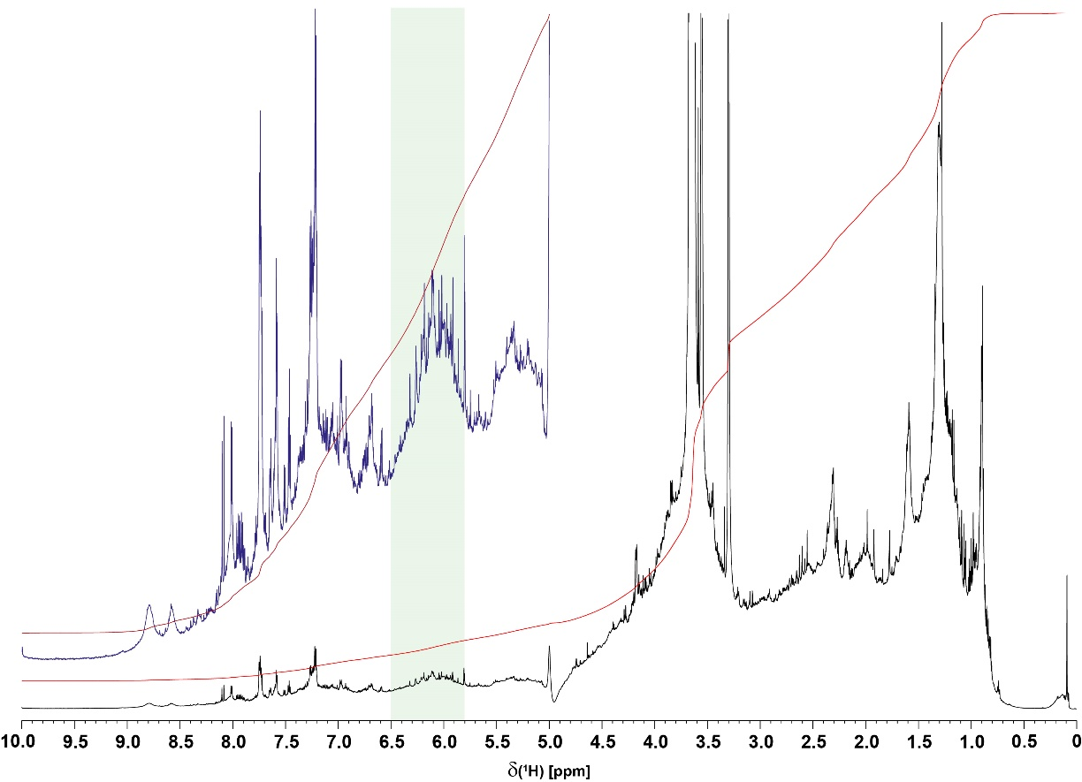

Figure S5. ¹H NMR spectra (800 MHz, CD₃OD) of consolidated Sargassum extract, with putative section of phlorotannins indicated (green shade; cf. text).
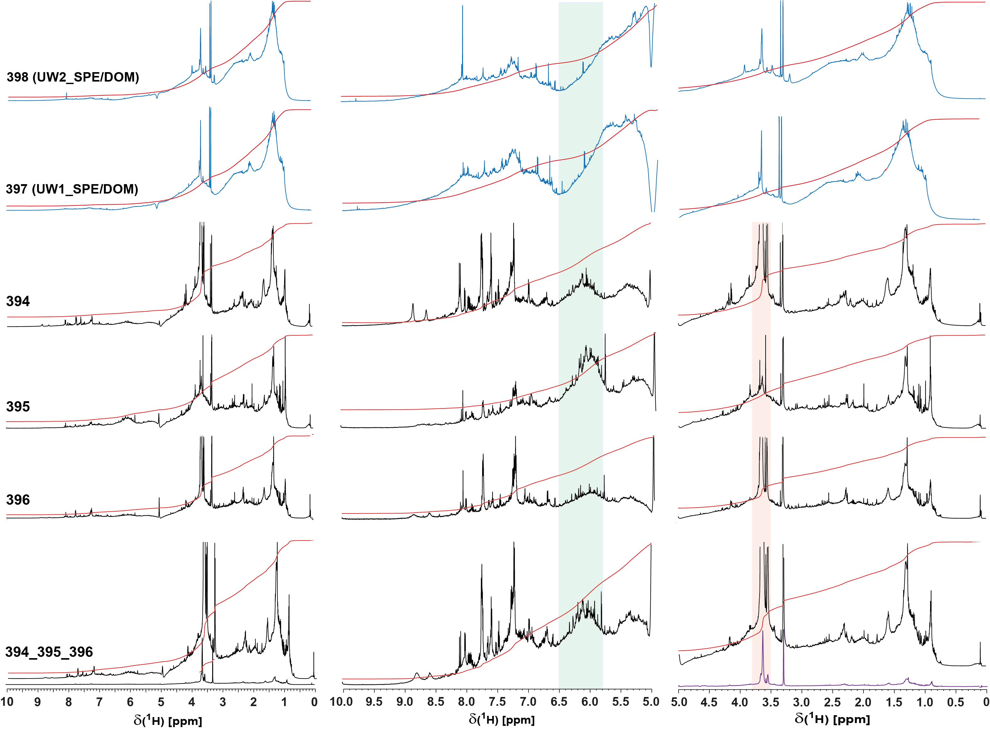
Figure S6. ¹H NMR spectra (800 MHz, CD₃OD) of (center rows) three individual Sargassum extracts (394 – outdoor incubation after 28 h, 395 – outdoor incubation after 27 h, 396 – outdoor incubation after 30 h, details in Table 1) and (bottom row) consolidated Sargassum extract; upper two rows show surface ocean water SPE-DOM (blue) obtained in the vicinity of the Sargassum sampling areas. Green shaded section indicates phlorotannins (in Sargassum extracts) whereas the orange shaded section represents aliphatic esters -CO-(O=C)-CH₂-C_{alkyl}, probably microbial lipid-like compounds present in Sargassum extract (cf. Figure S8, S10). These are particularly abundant in sample 394. The abundances of these metabolites and that of phlorotannins appear inversely related, suggesting inhibition of biological activity (e.g. by microbial metabolism) in colonized Sargassum by exudated phlorotannins (cf. text). Surface open ocean SPE-DOM shows the commonly observed broad NMR envelopes characteristic of an evolved, highly branched organic matter in which phlorotannins do not produce overly recognizable NMR signatures on top of the olefins common to open ocean SPE-DOM (Hertkorn et al., 2013). Here, the content of olefins in surface water SPE-DOM considerably exceeds that of aromatic compounds (Hertkorn et al., 2013). While oxygenated aromatic molecules are present, the proportion of carboxylated aromatic rings is significantly higher than that found in Sargassum extract. Overall, open ocean SPE-DOM and Sargassum extract show fundamentally distinctive chemical structures.

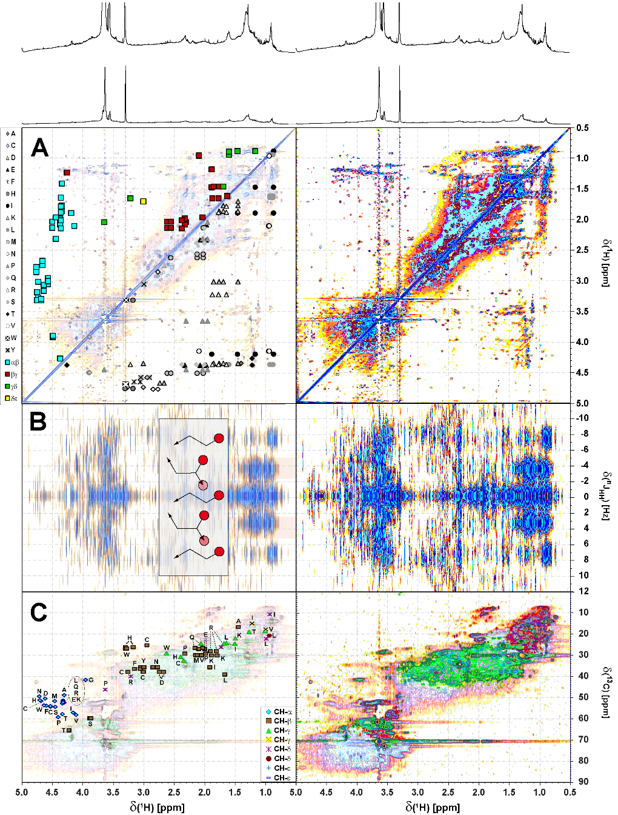
Figure S7. (A) ¹H, ¹H TOCSY (B) ¹H, ¹H JRES and (C) ¹H, ¹³C DEPT-HSQC NMR spectra of consolidated Sargassum extract; aliphatic section. Left panels A and C indicate cross peaks resulting from proteinaceous amino acids (see attendant single letter code of amino acids) in proteins following alanine (A) annotated according to position and carbon multiplicity (Hertkorn et al., 2002); left panel B indicated ethyl (linear, δ_{H} < 0.95 ppm) and branched δ_{H} ~ 0.8-1.3 ppm. (panel A): upper left half: amino acid-derived COSY cross peaks according to positioning in peptides (blue squares); (panel A): lower right half: amino acid-derived TOCSY cross peaks according to individual amino acids (individual gray symbols). (Panel C): ¹H, ¹³C DEPT HSQC NMR spectrum; color code: weak shaded: CH₁₂₃; green: CH₂, red: CH₃.
Figure S8. Multiplicity-edited ¹H, ¹³C DEPT-HSQC NMR spectrum of consolidated Sargassum extract, with projection ¹H- and multiplicity-edited ¹³C NMR spectra (percentage relates to fractions of methyl, methylene and methine carbon to total protonated carbon, CH₁₂₃). Assignment of major substructures; general colours: CH₃: red; CH₂ green, and CH: shaded ¹H, ¹³C HSQC NMR spectrum; section a: C-CH₃ cross peaks (with major motifs provided); section b: C-CH₃ cross peaks within aliphatic chains; section c: C=C-CH₃ and -SCH₃ cross peaks, carotenoid derivatives; section d: acetyl H₃C-C(=O)-O-C- (δ_{C} < 22 ppm), and acetamide H₃C-C(=O)-NH-C- (δ_{C} > 22 ppm); section e: C₂CH₂ cross peaks; δ_{H} > 2.15 ppm: HOOC-CH₂-; δ_{H} < 2.15 ppm: HOOC-CH_{n}-CH₂-, this includes carboxyl-rich alicyclic compounds CRAM (Hertkorn et al., 200) as well as other remotely functionalized branched aliphatics; dotted ellipsoid: H₃C-N- methylamines (δ_{H/C} ~ 2.7/37 ppm); section f: HOOC-(CH₂)_{n}(C₂)CH units δ_{H} > 2.15 ppm: HOOC-CH-; δ_{H} < 2.15 ppm: HOOC-CH_{n}-CH-; this includes carboxyl-rich alicyclic compounds CRAM (Hertkorn et al., 2006) as well as other remotely functionalized branched aliphatics; section g: -C-CH₂-N amine cross peaks; section h: glycine in peptides; section i: methoxy (OCH₃) cross peaks from aromatic (δ_{H} > 3.65 ppm) and aliphatic esters (δ_{H} < 3.65 ppm); section j: aliphatic methyl ethers H₃CO-C_{alkyl}; section k: oxomethylene (OCH₂) cross peaks, likely from carbohydrates; section l: -(C=O)OCH₂, probably indicating microbial fatty acid derivatives; section m: -NH-C(=O)-CαH_{n}-C (n: 1, 2) in peptides; section n: OC₂CH cross peaks, dotted line, d_{H} > 4 ppm, oxidation products from carotenoids (Arakawa et al., 2017) (cf. main text). Box insert denotes section of OCH₃ cross peaks: e₁: aliphatic methyl esters, e₂: aromatic methyl esters, e₃: aliphatic methyl ethers; the relative abundance follows: e₁ > e₂ ≈ e₃. Proportions of methine (CH), ethylene (CH₂) and methyl (CH3) carbon are provided with recognition of the transfer amplitude of protonated carbon in ¹³C DEPT-45 NMR spectra (CH: 0.707; CH₂: 1.0; CH₃): 1.06 carbon. This correction was erroneously not performed in Hertkorn et al., 2013 (small print letter with asterisk denote relative abundances as computed without correction).

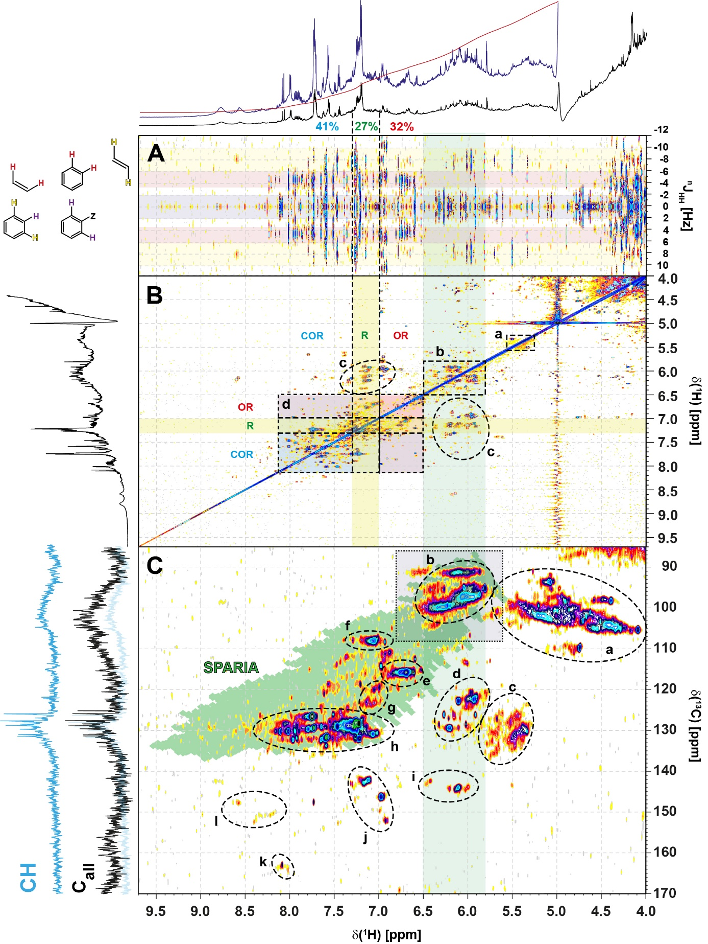
Figure S9. (Panel A) ¹H, ¹C JRES NMR, (panel B) ¹H, ¹H TOCSY NMR and (panel C) ¹H, ¹³C HSQC NMR spectrum of consolidated Sargassum extract: section of unsaturated C-H bonds (=CH) and anomeric positions in carbohydrates (O₂CH). Green shaded area corresponds to entire range of chemical shift which is accessible to single aromatic rings (SPARIA: substitution patterns in aromatic rings by increment analysis (Perdue et al., 2007)). JRES NMR spectra indicate presence of 1,2-di-, 1,3-di und 1,2,3-trihydrogen substituted aromatic rings, together with trans double bonds arising from natural products; cis-double bonds are rather rare. TOCSY NMR spectra display rare isolated olefins (section a), whereas the section of phlorotannins (δ_{H} ~ 5.8-6.5 ppm, green shade) also hosts natural products with conjugated olefins (section c); section d represents connectivities between electron-donating (OR), neutral (R) and electron-withdrawing (COR) substituents in aromatic rings; the latter are most abundant, suggesting presence of many carboxylated aromatic rings. It is conceivable that phlorotannin radicals may also be subject to further oxidation into carboxylic acid derivatives in contact to air (Schmitt-Kopplin et al., 1998). However, HMBC cross peaks arising from phlorotannins were virtually absent in general (data not shown; cf. Figure S10), probably caused by short transverse NMR relaxation times in large-size phlorotannins, and their huge structural diversity. (panel C) ¹H, ¹³C HSQC NMR spectrum with key substructures denoted as follows (cf. 8, 24): section a: anomeric O₂CH in carbohydrates (sp³-hybridized); section b: 1,3,5-trioxosubstituted aromatics (phlorotannins; for further differentiation, see dotted box, Figure S12); section c: certain five membered N-, O- and S-heterocycles, C-substituted olefins; section d: C-conjugated olefins, attached to aliphatics, certain five membered N-, O- and S-heterocycles; section e: classical NOM hydroxyl-aromatic systems and natural products, guaiacyl units (G5/6), para-coumarate (C3/5); section f: phenolic natural products, guaiacyl units (G2); section g: alkylated and oxygenated NOM aromatics; section h: classical NOM aromatics with high proportion of carboxylated units from δ_{H} > 7.3 ppm; from δ_{H} > 8 ppm: multiply carboxylated aromatics, six-membered nitrogen heterocycles; sterically uncongested polycyclic aromatic hydrocarbons; section i: olefins with proximate multiple carbon substitution; five-membered heterocycles with conjugated C_{sp2}-units; section j: polarized double bonds, also conjugated; section k: certain six-membered nitrogen heterocycles, very likely with more than one nitrogen; section l: certain six-membered nitrogen heterocycles.
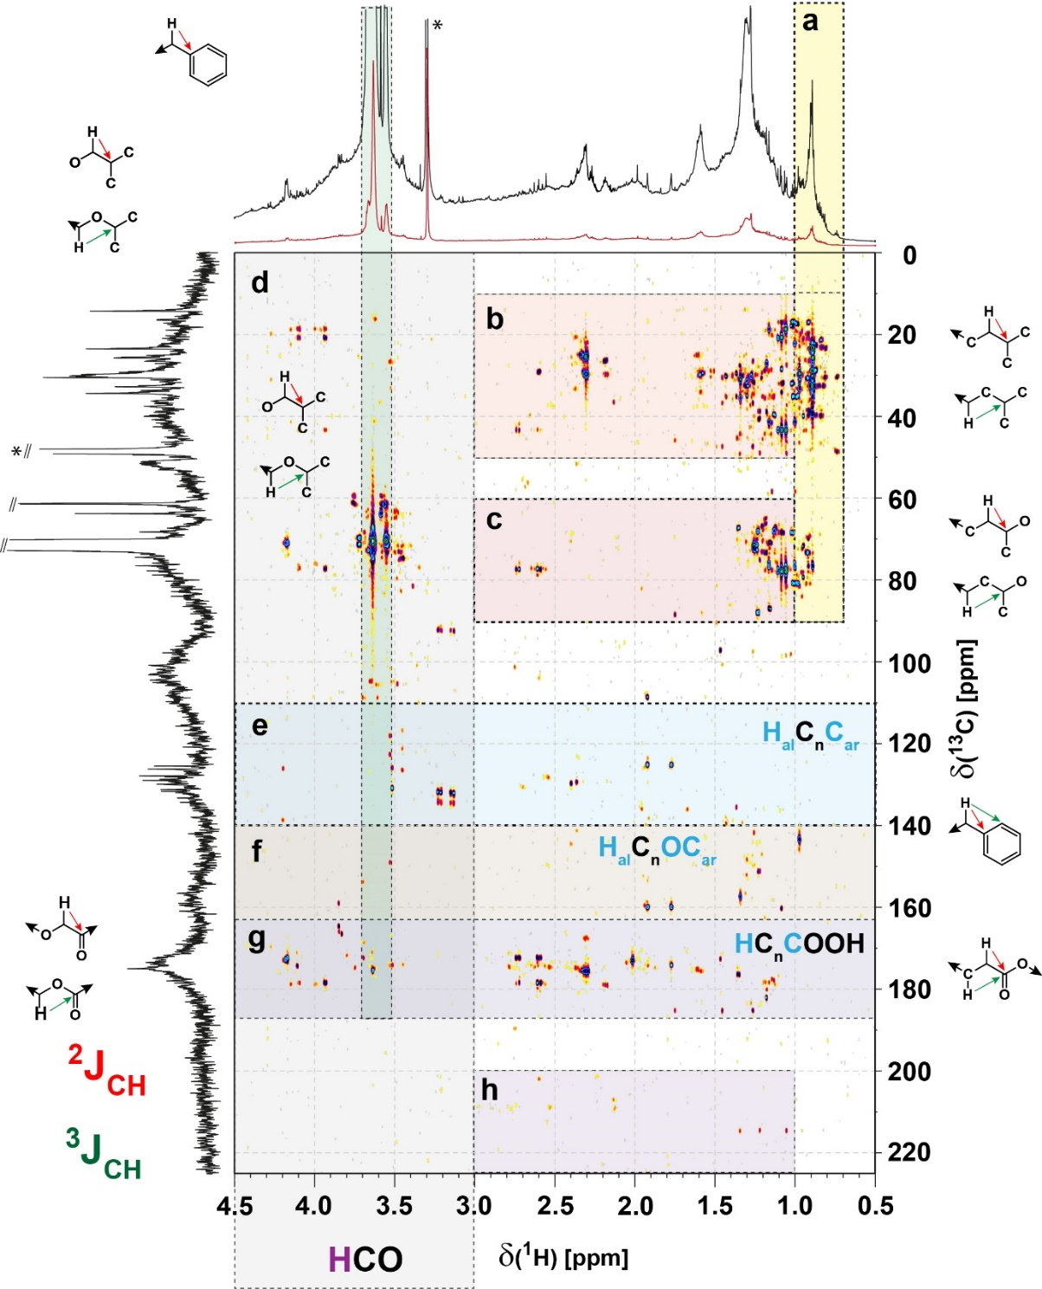

Figure S10. ¹H, ¹³C HMBC spectrum of consolidated Sargassum extract with substructure regimes indicated: panel a: HMBC cross peaks ^{2,3}J_{CH} connecting methyl with various groups: H₃C-(C)CC (δ_{C}< 60 ppm), H₃C-(C)CO (δ_{C}~ 60…100 ppm), and H₃C-(C)CO₂ (δ_{C}~ 165-187 ppm); panel b: intra aliphatic HMBC cross peaks HC(C)C within aliphatics (^{2,3}J_{CH}); panel c: intra aliphatic HMBC cross peaks HC(C)CO (^{2,3}J_{CH}); panel d: general HMBC cross peaks within oxygenated aliphatic units (HC(C)HCO (^{2,3}J_{CH}); panel e: HMBC cross peak connecting aliphatic protons with sp²-hybridized carbon (olefin or aromatics) HC_{al}(C)C_{sp2} (^{2,3}J_{CH}); panel f: HMBC cross peak connecting aliphatic protons with oxygenated aromatic natural products HC_{al}C_{sp2}(O)- (³J_{CH}); panel g: HMBC cross peak connecting aliphatic protons with carbonyl carbon HC_{al}(C)C(=O)X (^{2,3}J_{CH}); panel h: aliphatic ketones HC(C)C=O (^{2,3}J_{CH}). The green insert between δ_{H} ~3.5-3.7 ppm denotes presence of esters of likely microbial origin: a series of >20 resolved ¹H, ¹³C HSQC (section m in Fig. S8) and ¹H, ¹³C HMBC cross peaks indicates presence of several closely related compounds in Sargassum SPE-DOM.

Figure S11. Panel A: Multiplicity-edited and single-pulse ¹³C NMR spectra of consolidated Sargassum extract, with proportions of methine, methylene and methyl referred to all protonated carbon Σ(CH₁₂₃) = 100%. Exponential line broadening used here was lb = 12.5 Hz. Compared with Atlantic surface ocean SPE-DOM (Hertkorn et al., 2013), the Sargassum extract contained far more methylene carbon (50% vs. 25%) at the expense of methyl groups (23% vs. 26%), and considerably less methine carbon (27% vs. 49%). Percent values provided in italics denote proportions of C_{q}, methine, methylene and methyl referred to all carbon Σ(C_{all}) = 100 %. All relative abundances of CH₁₂₃ are corrected for transfer amplitudes of ¹³C DEPT-45 NMR spectra (cf. experimental section). This implies lower extent of aliphatic branching, in line with the low proportions of C₃CH-units observed in Sargassum extracts (25% vs. 46%) when compared with those present in open Atlantic surface ocean SPE-DOM. The relative proportions of multiplicity-edited carbon were as follows: (HC_{ar}-C / O-HC-O, phlorotannins / HC-O / HC-C): 16 / 11 / 48 / 25; (H₂C-O / H₂C-C): 46 / 54; (H₃C-O / H₃C-C): 8 / 92, and confirm large proportions of phlorotannins and a very large proportion of oxygenated methylene groups (46% vs. 15% as observed in open Atlantic surface ocean SPE-DOM).

Panel B: Overlay of single-pulse (black), QUATD (C_{q}; brown), DEPT-45 (CH₁₂₃; purple) and DEPT-90 (CH; blue) ¹³C NMR spectra of consolidated Sargassum extract. Exponential line broadening used here was 35 Hz. A large variance of substitution motifs was found in Sargassum phlorotannins; in particular, multiply oxygenated phlorotannins (i.e. with 4-6 oxygen atoms per aromatic ring) produced ¹³C NMR resonances of C_{ar}-O-units, ranging from δ_{C} ~165 ppm down to ~130 ppm, a range not observed for classical phenolic units which resonate at δ_{C} ~158 ± 8 ppm. C_{ar}-C-units occupied a range from δ_{C} ~ 90-140 ppm. Hence, appreciable ¹³C NMR integral was observed in the region from δ_{C} ~ 90-165 ppm; nevertheless the large spread of δ_{C}, caused limited S/N ratio, even at lengthy acquisitions. The yellow shaded area provides an expansion from δ_{C} ~85 - 130 ppm in which the majority of carboxylated and alkylated 1,3,5-trioxoaromatic which are not placed within condensed, polyoxygenated systems, resonate.
Quaternary carbon allowed improved description of phlorotannin structural diversity. When we defined the entire ¹³C_{q} NMR integral from δ_{C} ~ 90-165 ppm as 100%, the section of C_{ar}-O units (δ_{C} ~ 140-160 ppm) which was part of a freely rotating 1,3,5-trioxo-aromatic ring had 23% abundance; the section of oxidized aromatic compounds with ≥ 4 oxygen atoms per aromatic ring (δ_{C} ~ 120-140 ppm) in elaborate, fused chemical environments was 18%, while the bulk of oxygenated 1,3,5-phlorotannins ranged near 60% quaternary carbon. With a range of δ_{C} ~ 90-120 ppm, C_{q} occupied a much wider section of δ(¹³C) than respective methine carbon atoms which resonated from δ_{C} ~ 90-102 ppm (Figure 3, Figure S12). The relative proportions of quaternary and methine carbon from δ_{C} ~ 90-120 ppm, i.e. the section in which the common and C-substituted phlorotannins resonated were >8:1. This implies a very substantial oxygenation of aromatic rings with nevertheless have retained their intrinsic 1,3,5-trioxo substitution pattern. Carboxylated and alkylated phlorotannins probably result from carboxylation of reactive radical intermediates (Schmitt-Kopplin et al., 1998).
A very few solution-state QUATD ¹³C NMR spectra are published; Lam et al. (2007) have investigated a freshwater DOM in which the overall proportion of C_{q} was quite sizable (~67%; Figure 2 in Lam et al. (2007)); however in contrast to Sargassum extract, freshwater DOM showed almost no quaternary carbon from δ_{C} ~ 90-102 ppm, and also nearly negligible ketones at δ_{C} > 195 ppm.

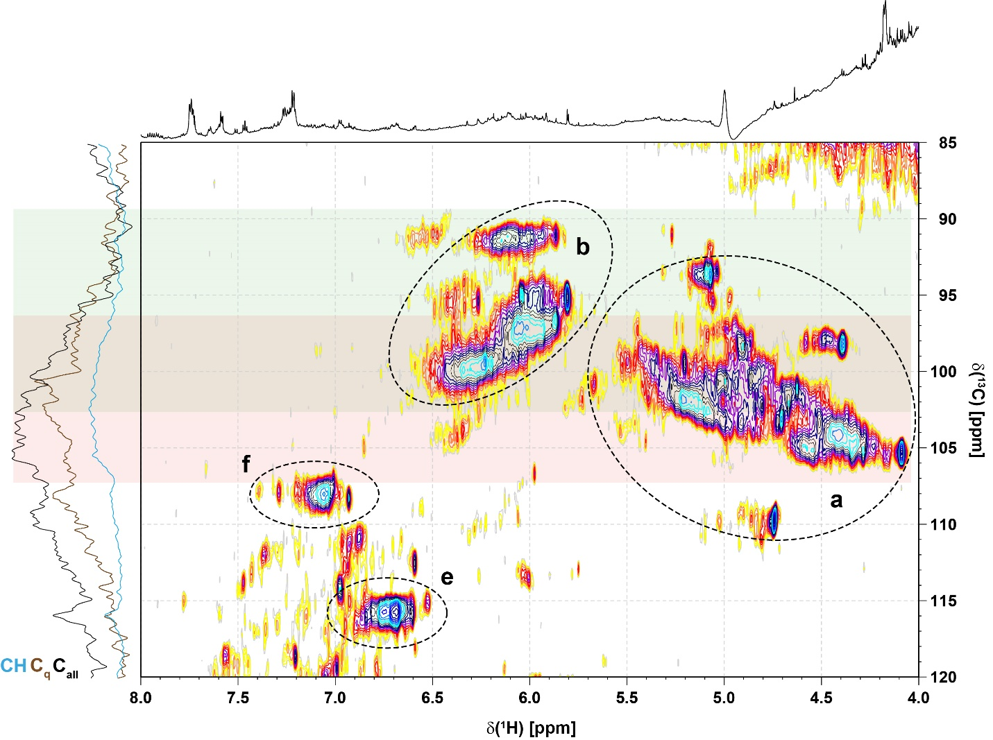

Figure S12. Section of ¹H, ¹³C HSQC NMR spectrum of consolidated Sargassum extract (cf. Figure 3) showing the overlap of methine carbon atoms derived from phlorotannin- (green shaded) and anomeric positions (red shaded) at δ_{C} ~ 96-102 ppm. Sections a, b, e, and f are explained in Figure S9. In contrast to phlorotannins which are quite rich in quaternary carbon atoms, common carbohydrates do not show quaternary carbon atoms. Hence, quaternary carbon atoms in the section δ_{C} ~ 96-102 ppm arise solely from phlorotannins; owing to all-positive increments of aliphatic substitution in aromatic rings, the relevant chemical shift range of C_{q} in phlorotannins extends to δ_{C} ~ 96-120 ppm. A comparison of the relative ¹³C NMR section integrals originating from quaternary carbon and methine carbon results in a ratio of ~10 : 1. This distributes into >7:1 for the bulk of oxygenated and carboxylated, terminal 1,3,5-phlorotannins (60% of relevant C_{q}), >5:1 for oxidized aromatic compounds within more condensed phlorotannins with a minimum of 4 oxygen atoms per aromatic ring (18% of relevant C_{q}), and a set of C_{q} only C_{ar}-O units (23%).
The data of Figure S11 and S12 indicate an average count of hydrogen per aromatic ring in Sargassum phlorotannins near 0.5, implying a very high degree of condensation and oxygenation.
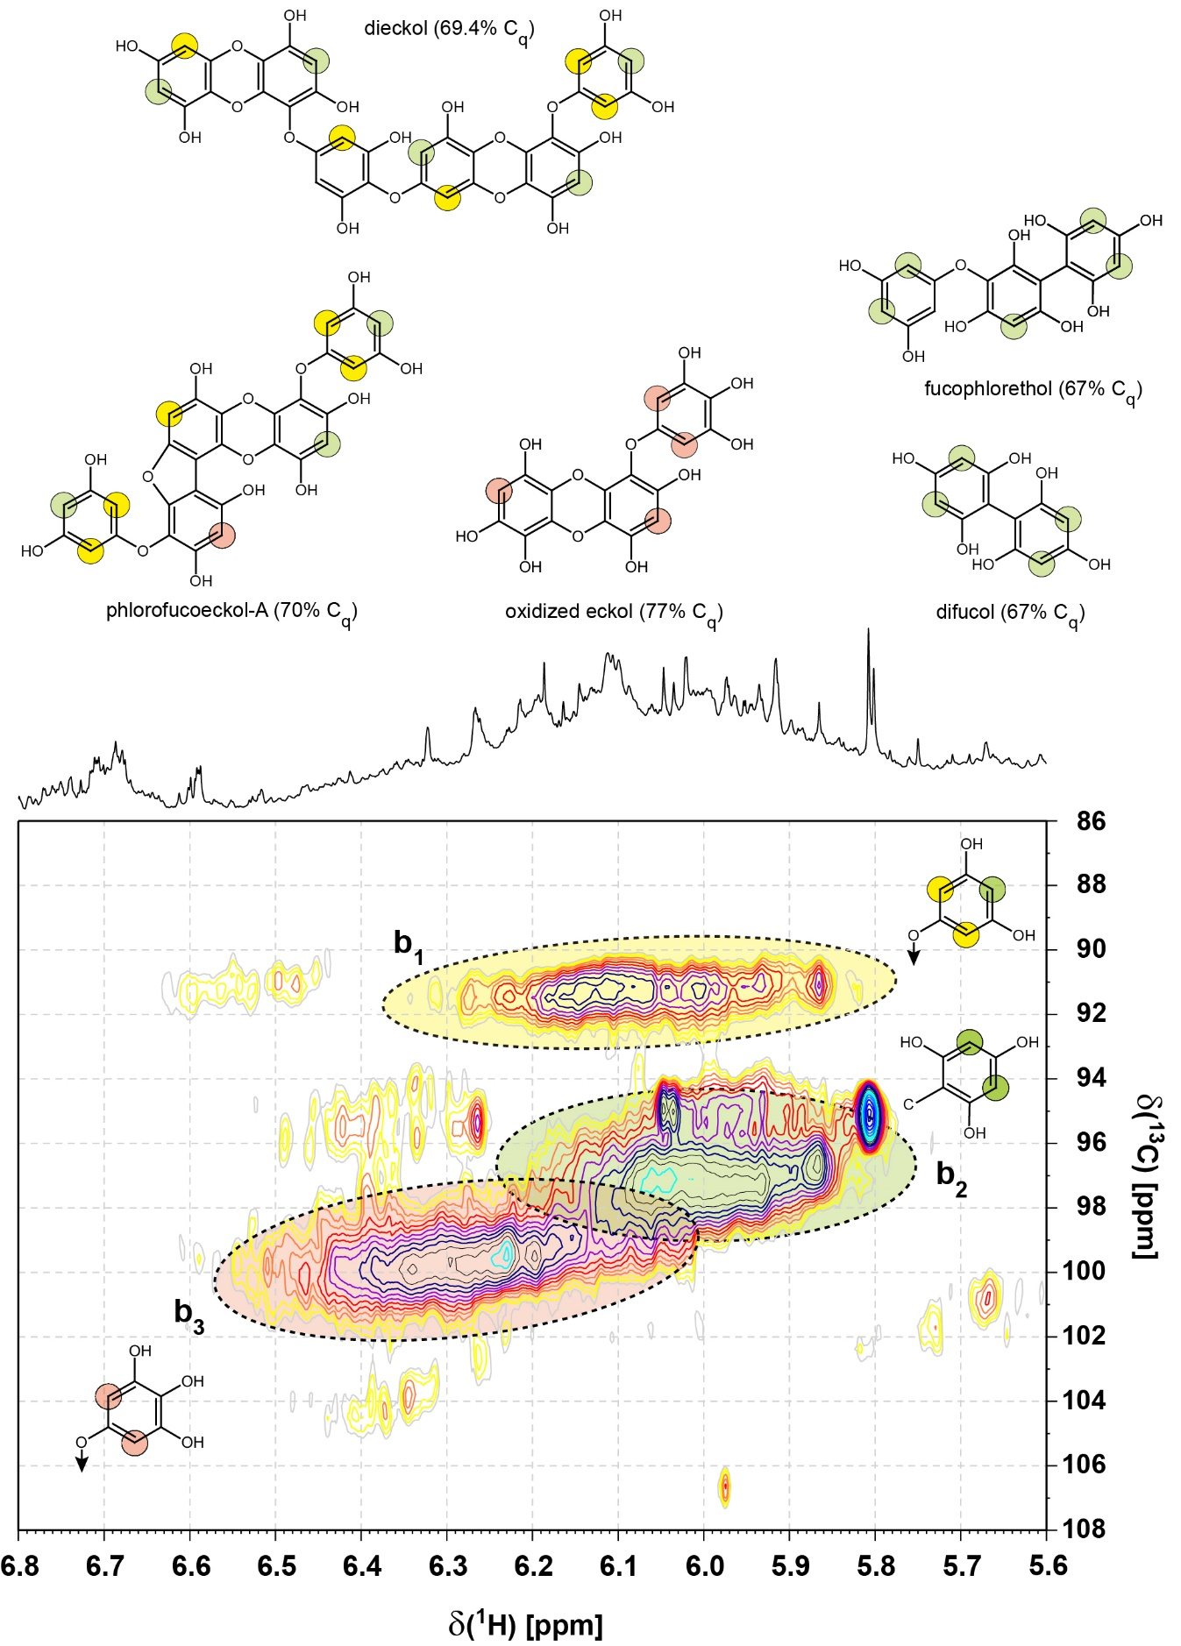

Figure S13. ¹H, ¹³C HSQC NMR spectrum of consolidated Sargassum extract: section of 1,3,5-trioxoaromatic compounds (i.e. phlorotannins) with key substructures, associated δ_{H/C} values and percentage of quaternary carbon atoms provided. The model structures indicate ranges of δ_{H/C} according to three major classes of substitution indicated by color (δ_{H/C} ~ 5.9-6.3 / 93±1.5 ppm, δ_{H/C} ~ 5.8-6.2 / 98±2 ppm and δ_{H/C} ~ 6.0-6.4 / 101±2 ppm). These included an array of 3,5-dihydroxybenenes attached via oxygen at C1 and substituted 1,4-dioxins (section b₁ (also resonating in section b₂) 15%), carbon-bound 2,4,6-trihydroxybenzenes (section b₂, 45%), and oxidized phlorotannins, with ≥4 oxygen atoms (section b₃, 40%). Notably, oxidized phlorotannins while not becoming more hydrogen-deficient than ordinary ones with respect to molecular composition (as detected by FTICR mass spectrometry) exhibit smaller proportions of non-exchangeable protons which are observed in ¹H NMR detected spectra acquired with solvent suppression or standard 2D NMR spectra. Hence, oxidized phlorotannins produce lesser and smaller HSQC cross peaks at equal molar concentration than ordinary ones. Terminal aromatic rings of phlorotannins often show local C2 symmetry which frequently causes two protons to resonate at identical frequencies (e.g. at 3,5- or 2,6-positions), providing NMR resonances with double amplitude. The structural regularity of common phlorotannins with distinct trioxo aromatic rings separated by aryl-aryl or arylether bonds allows for extrapolation of δ_{H/C} values. So far, HSQC cross peaks of any NOM investigated at our institute (> 300) with analogous δ_{H/C} have only been observed in Suwannee River water in which these probably represented catechins and other terrestrial derived tannins (Figure 7 in Perdue et al. (2007)).
Table S1. Intensity-weighted (wt) average (± 1 standard deviation) molecular characteristics for Sargassum SPE-DOM for all non-stress incubations (described in Section 2.2). These characteristics were determined for assigned molecular compositions containing only carbon, hydrogen, and oxygen (CHO) analyzed in either negative (neg.) or positive (pos.) ionization modes. Analogous processing was repeated for CHO + sulfur (CHOS) assignments, CHO + nitrogen (CHNO) assignments, CHNOS assignments, and CHO + bromine (CHOBr) assignments. CHO formulas were additionally grouped by those that were common between both negative and positive ion modes, those that were unique to neg. mode and those that were unique to pos. mode.
 | MW_{wt} (Da) | O/C_{wt} | H/C_{wt} | DBE_{wt} | AI_{wt} | AI_{mod_wt} | X_{C_wt} (m = 1) | X_{C_wt} (m = 0.5)
CHO neg.  (n = 1016) | 383.1 ± 78.0 | 0.61 ± 0.11 | 0.83 ± 0.30 | 11.0 ± 3.4 | 0.18 ± 0.20 | 0.50 ± 0.18 | 2.27 ± 1.59 | 2.57 ± 0.47
CHO pos.  (n = 1218) | 405.9 ± 60.1 | 0.40 ± 0.19 | 1.31 ± 0.43 | 8.0 ± 4.2 | 0.13 ± 0.14 | 0.28 ± 0.20 | 2.44 ± 1.19 | 2.54 ± 0.77
CHOS neg. (n = 101) | 333.8 ± 34.2 | 0.43 ± 0.19 | 1.67 ± 0.25 | 3.5 ± 1.9
CHOS pos. (n = 31) | 401.9 ± 35.5 | 0.47 ± 0.20 | 1.64 ± 0.25 | 4.1 ± 1.7
CHNO neg. (n = 85) | 358.0 ± 54.9 | 0.42 ± 0.14 | 1.33 ± 0.28 | 7.3 ± 2.0
CHNO pos. (n = 1332) | 392.3 ± 50.5 | 0.31 ± 0.12 | 1.51 ± 0.27 | 6.7 ± 2.7
CHOBr neg. only (n = 68) | 356.6 ± 43.2 | 0.68 ± 0.08 | 0.62 ± 0.14 | 8.7 ± 1.5
CHOBr pos. only (n = 16) | 392.2 ± 28.5 | 0.62 ± 0.05 | 0.72 ± 0.07 | 9.4 ± 1.2
CHNOS pos. only (n = 25) | 360.1 ± 26.2 | 0.20 ± 0.12 | 1.41 ± 0.35 | 7.6 ± 3.7
Common CHO  (n = 373) | 418.0 ± 47.0 | 0.56 ± 0.12 | 0.91 ± 0.30 | 11.4 ± 3.0 | 0.15 ± 0.05 | 0.45 ± 0.17 | 1.32 ± 0.28 | 2.56 ± 0.21
CHO neg. only  (n = 640) | 353.4 ± 80.8 | 0.62 ± 0.12 | 0.82 ± 0.32 | 10.2 ± 3.5 | 0.18 ± 0.19 | 0.51 ± 0.20 | 2.27 ± 1.63 | 2.52 ± 0.53
CHO pos. only  (n = 843) | 437.5 ± 85.7 | 0.37 ± 0.18 | 1.67 ± 0.38 | 4.7 ± 4.2 | 0.09 ± 0.18 | 0.19 ± 0.23 | 2.57 ± 0.93 | 2.77 ± 1.02

Table S2. ¹H NMR section integral (800 MHz, CD₃OD) of Sargassum extracts for key substructures of Bermuda solar irradiation experiments; sample numbers 394, 395, 396, and consolidated samples 394_395_396 (* large proportion of phlorotannins), together with two surface Atlantic ocean SPE-DOM (cf. Figure S6); ** large proportions of esters COOCH₂). All phlorotannins exhibit low H/C atomic ratios in general and a paucity of C_{ar}H groups in particular. Provided that already three ring positions are occupied by oxygen and at least another one by a linkage to neighbouring aromatic rings, an average count of 1.5 protons per aromatic ring in phlorotannins is probably an upper limit. Hence, estimates on the abundance of phlorotannins in real-world complex DOM based in ¹H NMR spectra alone are rather ill-constrained and will almost always underestimate its actual proportions.
sample |  | Bermuda outdoor, full sun 28h  4 L [%] | Bermuda outdoor, full sun 27h  850 mL [%] | Bermuda outdoor, full sun 30h  830 mL [%] | [%] | Sargasso Sea surface SPE-DOM [%] | Sargasso Sea surface SPE-DOM [%]
δ(¹H) [ppm] | key substructures | 394 | 395 | 396 | consoli-dated | 397 | 398
10.0 - 7.0 ppm | =C_{ar}H | 3.1 | 3.4 | 3.7 | 2.9 | 1.7 | 1.9
7.0 - 5.0 ppm | =CH, O₂CH, phlorotannins | 4.8 | 11.4* | 5.7 | 6.3 | 3.7 | 3.7
5.0 - 3.1 ppm | OCH | 47.1** | 32.3 | 37.6** | 41.8 | 25.5 | 25.0
3.1 - 1.9 ppm | XCCH | 17.7 | 24.7 | 22.2 | 20.5 | 26.7 | 27.3
1.9 - 0.5 ppm | CCCH | 27.3 | 28.2 | 30.8 | 28.6 | 42.4 | 42.1

Table S3. Proportions [%] of C_{ar}-H units in phlorotannins and otherwise oxygenated aromatics (C_{ar}-OZ; Z: H, C) as computed from ¹H NMR spectra (100% = total integral), with recognition of cross peak distribution in ¹H, ¹³C HSQC NMR spectra.
sample |  | Bermuda outdoor, full sun 28h  4 L [%] | Bermuda outdoor, full sun 28h  850 mL [%] | Bermuda outdoor, full sun 28h  830 mL [%]
δ(¹H) [ppm] | key substructures | 394 | 395 | 396 | cons
7.2 - 7.0 ppm | 35% oxygenated C_{ar}-OZ  (Z: H, C); 65% C_{ar}-H aromatics | 0.21 | 0.25 | 0.29 | 0.27
7.0 – 6.5 ppm | 90% oxygenated C_{ar}-OZ  (Z: H, C);  10% polarized double bonds | 0.67 | 1.66 | 1.08 | 0.74
6.5 – 5.8 ppm | 85% phlorotannins  (1,3,5-trioxo C_{ar}H)  15% conjugated double bonds | 1.42 | 4.42 | 2.14 | 4.26
7.2 – 5.8 ppm | total C_{ar}-OZ (any kind) | 2.30 | 6.10 | 3.50 | 5.27

Table S4. Proportions of C_{ar}-H units in phlorotannins and otherwise oxygenated aromatics (C_{ar}-OZ; Z: C, H) as computed from single-pulse, edited ¹³C NMR (CH units; Figure S11) and ¹H, ¹³C HSQC NMR spectra (Figure S9). A large variance of substitution motifs was found in Sargassum phlorotannins; in particular, multiply oxygenated phlorotannins (i.e. with 4-6 oxygen atoms per aromatic ring) produced ¹³C NMR resonances of C_{ar}-O-units, ranging from δ_{C} ~165 ppm down to ~130 ppm, a range not observed for classical phenolic units which resonate at δ_{C} ~158 ± 8 ppm. C_{ar}-C-units occupied a range from δ_{C} ~ 100-140 ppm. Hence, appreciable ¹³C NMR integral was observed in the region from δ_{C} ~ 100-165 ppm; nevertheless the large spread of δ_{C}, caused limited S/N ratio, even at lengthy acquisitions of NMR spectra. (a) At a minimum of 60% quaternary carbon atoms per aromatic ring in evolved and oxygenated phlorotannins, a minimum of 18% of phlorotannins were present in consolidated Sargassum extract. As observed in sample “395” (cf. Figure S6), Sargassum may exudate considerably higher proportions of phlorotannins under certain circumstances.

δ(¹³C) [ppm] | key substructures  (¹³C NMR) | consolidated (¹³C NMR) | consolidated (¹³C DEPT/QUATD (CH) / C_{q} NMR) | key substructures (DEPT CH)
160 - 140 ppm | 95% oxygenated C_{ar}-OZ  ipso positions(Z: H, C) | 4 | - / 14.5 | 95% oxygenated C_{ar}-OZ  ipso positions(Z: H, C)
140 - 120 ppm | 90% common organic matter molecules and complex, extended phlorotannins |  | - / 16.2 | 90% common organic matter molecules
120 - 107 ppm | 95% oxygenated C_{ar}-OZ  ortho and para positions (Z: H, C); 5% double bonds; five-membered heterocycles | 13 | 3.6 / 9.5 | 95% oxygenated C_{ar}-OZ  ortho and para positions (Z: H, C)
107 - 103 ppm | 65% phlorotannins (1,3,5-trioxo C_{ar}H); ortho and para positions (Z: H, C); 35% anomerics (O₂CH) |  | 0.1 / 4.3 | 3% phlorotannins (1,3,5-trioxo C_{ar}H)  ortho and para positions (Z: H, C)
103 - 90 ppm | 80% phlorotannins (1,3,5-trioxo C_{ar}H); 20% anomerics (O₂CH) |  | 4.7/ 9.9 | 60% phlorotannins (1,3,5-trioxo C_{ar}H)
160 - 90 ppm | total C_{ar}-OZ (any kind) | 18ª | 8.4 / 44.4 | total C_{ar}-OZ (any kind)

Table S5. (Top): ¹³C NMR section integrals (percent of total carbon) and key substructures of consolidated Sargassum SPE-DOM. Bottom: Substructures used for basic NMR-derived reverse mixing model with nominal H/C and O/C ratios given (Hertkorn et al., 2013). Sargassum extract showed lower H/C ratio (1.23 vs. 1.38) and higher O/C ratio (0.78 vs. 0.73) than surface open Atlantic Ocean SPE-DOM (Hertkorn et al., 2013).

δ(¹³C) ppm | 220-187 | 187-167 | 167-145 | 145-108 | 108-90 | 90-47 | 47-0 | H/C ratio | O/C ratio
key substructures | C=O | COX | C_{ar}-O | C_{ar}-C,H | O₂CH | OCH | CCH
all carbon | 3.3 | 9.5 | 3.7 | 10.6 | 9.3 | 33.4 | 30.2 | 1.23 | 0.78
C_{q} only | 10.9 | 24.8 | 14.7 | 17.0 | 15.8 | 6.7 | 10.1
H/C ratio | 0 | 1 | 0 | 1 | 1 | 1 | 2 | - | -
O/C ratio | 1 | 2 | 1 | 0 | 2 | 1 | 0 | - | -

Table S6. Acquisition parameters of NMR spectra, shown according to Supplementary figures. PK: probeheads used for acquisition of NMR spectra, 8QCI: cryogenic inverse geometry 5 mm z-gradient ¹H/¹³C/¹⁵N/³¹P QCI probe (B₀ = 18.8 T);; 5D: cryogenic classical geometry 5 mm z-gradient ¹³C, ¹H probe (B₀ = 11.7 T); NS: number of scans (for 2D NMR: F2); AQ: acquisition time [ms]; D1: relaxation delay [ms]; NE: number of F1 increments in 2D NMR spectra; WDW1, WDW2: apodization functions in F1/ F2 (EM/GM: line broadening factor [Hz]; QS: shifted square sine bell; SI: sine bell); PR1, PR2: coefficients used for windowing functions WDW1, WDW2, EM is given in [Hz], SI/QS derived functions indicate shift by π/n. (*) asterisk: coadded ¹³C NMR spectra.

spectrum | SI  Figure | PK | NS | AQ [ms] | D1 [ms] | NE | WDW1 | WDW2 | PR1 | PR2
¹H NMR | 5, 6 | 8QCI | 224-1280 | 5000 | 5000 | - | EM | - | 1 | -
¹³C DEPT-45, -135 NMR | 8, 11 | 5D | 82944* | 1000 | 2000 | - | EM | - | 12.5 | -
¹³C DEPT-90 NMR | 8, 11 | 5D | 165888* | 1000 | 2000 | - | EM | - | 12.5 | -
¹³C QUATD NMR | 4A, 11 | 5D | 55838 | 1000 | 19000 | - | EM | - | 12.5
¹³C NMR | 11 | 5D | 83456* | 1000 | 19000 |  | EM | - | 12.5
¹H, ¹H JRES | 7, 9 | 8QCI | 320 | 1000 | 500 | 64 | QS | QS | 0 | 0
¹H, ¹H TOCSY | 7, 9 | 8QCI | 32 | 1000 | 2500 | 2048 | EM | QS | 2.5 | 4
¹H,¹³C DEPT HSQC | 6, 7, 8 | 8QCI | 256 | 250 | 1250 | 400 | EM | QS | 7.5 | 2.5
¹H, ¹³C HSQC | 4, 9, 12, 13 | 8QCI | 1024 | 250 | 1250 | 275 | EM | QS | 7.5 | 2.5
¹H, ¹³C HMBC | 10 | 8QCI | 1600 | 1000 | 500 | 281 | EM | QS | 2.5 | 2.5

References

Abdullah, M. I., & Fredriksen, S. (2004). Production, respiration and exudation of dissolved organic matter by the kelp Laminaria hyperborea along the west coast of Norway. Journal of the Marine Biological Association of the UK, 84(5), 887–894. https://doi.org/10.1017/S002531540401015Xh
Van Altena, I. A., & Steinberg, P. D. (1992). Are differences in the responses between North American and Australasian marine herbivores to phlorotannins due to differences in phlorotannin structure? Biochemical Systematics and Ecology, 20(6), 493–499. https://doi.org/10.1016/0305-1978(92)90003-V
Arakawa, N., Aluwihare, L. I., Simpson, A. J., Soong, R., Stephens, B. M., & Lane-Coplen, D. (2017). Carotenoids are the likely precursor of a significant fraction of marine dissolved organic matter. Science Advances, 3(9), 1–12. https://doi.org/10.1126/sciadv.1602976
Blunt, J. W., Copp, B. R., Munro, M. H. G., Northcote, P. T., & Prinsep, M. R. (2006). Marine natural products. Natural Product Reports, 23(1), 26–78. https://doi.org/10.1039/b502792f
Fourest, E., & Volesky, B. (1996). Contribution of sulfonate groups and alginate to heavy metal biosorption by the dry biomass of Sargassum fluitans. Environmental Science and Technology, 30(1), 277–282. https://doi.org/10.1021/es950315s
Haugan, J. A., & Liaaen-Jensen, S. (1994). Algal carotenoids 54. Carotenoids of brown algae (Phaeophyceae). Biochemical Systematics and Ecology, 22(1), 31–41. https://doi.org/10.1016/0305-1978(94)90112-0
Hertkorn, N., Harir, M., Koch, B. P., Michalke, B., & Schmitt-Kopplin, P. (2013). High-field NMR spectroscopy and FTICR mass spectrometry: Powerful discovery tools for the molecular level characterization of marine dissolved organic matter. Biogeosciences, 10(3), 1583–1624. https://doi.org/10.5194/bg-10-1583-2013
Hertkorn, N, Permin, a, Perminova, I., Kovalevskii, D., Yudov, M., Petrosyan, V., & Kettrup, a. (2002). Comparative analysis of partial structures of a peat humic and fulvic acid using one- and two-dimensional nuclear magnetic resonance spectroscopy. Journal of Environmental Quality, 31(2), 375–87. https://doi.org/10.2134/jeq2002.3750
Hertkorn, Norbert, Benner, R., Frommberger, M., Schmitt-Kopplin, P., Witt, M., Kaiser, K., et al. (2006). Characterization of a major refractory component of marine dissolved organic matter. Geochimica et Cosmochimica Acta, 70(12), 2990–3010. https://doi.org/10.1016/j.gca.2006.03.021
Hertkorn, Norbert, Harir, M., Cawley, K. M., Schmitt-Kopplin, P., & Jaffé, R. (2016). Molecular characterization of dissolved organic matter from subtropical wetlands: A comparative study through the analysis of optical properties, NMR and FTICR/MS. Biogeosciences, 13(8), 2257–2277. https://doi.org/10.5194/bg-13-2257-2016
Herzsprung, P., Hertkorn, N., Von Tümpling, W., Harir, M., Friese, K., & Schmitt-Kopplin, P. (2016). Molecular formula assignment for dissolved organic matter (DOM) using high-field FT-ICR-MS: Chemical perspective and validation of sulphur-rich organic components (CHOS) in pit lake samples. Analytical and Bioanalytical Chemistry, 408(10), 2461–2469. https://doi.org/10.1007/s00216-016-9341-2
Isaza Martínez, J. H., & Torres Castañeda, H. G. (2013). Preparation and chromatographic analysis of phlorotannins. Journal of Chromatographic Science, 51(8), 825–838. https://doi.org/10.1093/chromsci/bmt045
Kimura, J., & Maki, N. (2002). New loliolide derivatives from the brown alga Undaria pinnatifida. Journal of Natural Products, 65(1), 57–58. https://doi.org/10.1021/np0103057
Kuhnert, N., Clifford, M. N., & Müller, A. (2010). Oxidative cascade reactions yielding polyhydroxy-theaflavins and theacitrins in the formation of black tea thearubigins: Evidence by tandem LC-MS. Food & Function, 1(2), 180. https://doi.org/10.1039/c0fo00066c
Kujawinski, E. B., Del Vecchio, R., Blough, N. V., Klein, G. C., & Marshall, A. G. (2004). Probing molecular-level transformations of dissolved organic matter: Insights on photochemical degradation and protozoan modification of DOM from electrospray ionization Fourier transform ion cyclotron resonance mass spectrometry. Marine Chemistry, 92(1-4 SPEC. ISS.), 23–37. https://doi.org/10.1016/j.marchem.2004.06.038
Lam, B., Baer, A., Alaee, M., Lefebvre, B., Moser, A., Williams, A., & Simpson, A. J. (2007). Major Structural Components in Freshwater Dissolved Organic Matter. Environmental Science & Technology, 41(24), 8240–8247. https://doi.org/10.1021/es0713072
Li, B., Lu, F., Wei, X., & Zhao, R. (2008). Fucoidan: Structure and bioactivity. Molecules, 13(8), 1671–1695. https://doi.org/10.3390/molecules13081671
Perdue, E. M., Hertkorn, N., & Kettrup, A. (2007). Substitution patterns in aromatic rings by increment analysis. Model development and application to natural organic matter. Analytical Chemistry, 79(3), 1010–1021. https://doi.org/10.1021/ac061611y
Reddy, P., Urban, S., & Natural, T. (2008). Linear and Cyclic C 18 Terpenoids from the Southern Australian Marine Brown Alga. Journal of Natural Products, 71, 1441–1446.
Schmitt-Kopplin, P., Hertkorn, N., Schulten, H. R., & Kettrup, A. (1998). Structural changes in a dissolved soil humic acid during photochemical degradation processes under O₂ and N₂ atmosphere. Environmental Science and Technology, 32(17), 2531–2541. https://doi.org/10.1021/es970636z
Singh, I. P., Sidana, J., Bharate, S. B., & Foley, W. J. (2010). Phloroglucinol compounds of natural origin: Synthetic aspects. Natural Product Reports, 27(3), 393–416. https://doi.org/10.1039/b914364p
Steevensz, A. J., MacKinnon, S. L., Hankinson, R., Craft, C., Connan, S., Stengel, D. B., & Melanson, J. E. (2012). Profiling phlorotannins in brown macroalgae by liquid chromatography-high resolution mass spectrometry. Phytochemical Analysis, 23(5), 547–553. https://doi.org/10.1002/pca.2354
Stiger-Pouvreau, V., Jégou, C., Cérantola, S., Guérard, F., & Lann, K. Le. (2014). Phlorotannins in sargassaceae species from brittany (France): Interesting molecules for ecophysiological and valorisation purposes. Advances in Botanical Research (Vol. 71). Elsevier. https://doi.org/10.1016/B978-0-12-408062-1.00013-5
Sugawara, T., Matsubara, K., Akagi, R., Mori, M., & Hirata, T. (2006). Antiangiogenic activity of brown algae fucoxanthin and its deacetylated product, fucoxanthinol. Journal of Agricultural and Food Chemistry, 54(26), 9805–9810. https://doi.org/10.1021/jf062204q
Vershinin, V., Dyadyuk, A., & Pappo, D. (2017). Iron-catalyzed selective oxidative arylation of phenols and biphenols. Tetrahedron, 73(26), 3660–3668. https://doi.org/10.1016/j.tet.2017.03.094
Wijesinghe, W. A. J. P., & Jeon, Y. J. (2012). Enzyme-assistant extraction (EAE) of bioactive components: A useful approach for recovery of industrially important metabolites from seaweeds: A review. Fitoterapia, 83(1), 6–12. https://doi.org/10.1016/j.fitote.2011.10.016
Yotsu-Yamashita, M., Kondo, S., Segawa, S., Lin, Y. C., Toyohara, H., Ito, H., et al. (2013). Isolation and structural determination of two novel phlorotannins from the brown alga Ecklonia kurome Okamura, and their radical scavenging activities. Marine Drugs, 11(1), 165–183. https://doi.org/10.3390/md11010165
Zhang, F., Harir, M., Moritz, F., Zhang, J., Witting, M., Wu, Y., et al. (2014). Molecular and structural characterization of dissolved organic matter during and post cyanobacterial bloom in Taihu by combination of NMR spectroscopy and FTICR mass spectrometry. Water Research, 57, 280–294. https://doi.org/10.1016/j.watres.2014.02.051

