JGR: Solid Earth
Supporting Information for
Crustal structure of the Niuafo’ou Microplate and Fonualei Rift and Spreading Center in the northeastern Lau Basin, Southwestern Pacific
F. Schmid^{1*}, H. Kopp^{1,2}, M. Schnabel³, A. Dannowski¹, I. Heyde³, M. Riedel¹, Mark D. Hannington^{1,4}, M. Engels³, A. Beniest⁵, I. Klaucke¹, N. Augustin¹, P. A. Brandl¹, C. Devey¹

Affiliations
¹GEOMAR, Helmholtz Centre for Ocean Research Kiel, Germany
²Department of Geosciences, Kiel University, Germany
³BGR, Federal Institute for Geosciences and Natural Resources, Hannover, Germany
⁴Department of Earth Sciences, University of Ottawa, Ontario, Canada
⁵Vrije Universiteit Amsterdam, The Netherlands

Corresponding author: Florian Schmid (fschmid@geomar.de)

Contents of this file

Texts S1 and S2
Figures S1 to S4

Text S1. Representation of the correlation length (model-smoothing) file used in the tomographic inversion.

The horizontal and vertical correlation length for the velocity nodes are stored in the file (vcorr.dat), which stores the following information.

First line: nx nz - number of nodes in x an z direction

Second line: x₁ x₂ - node’s x-coordinates

Third line: b₁ b₂ - corresponding bathymetry (negative for subaerial)

Fourth line: z₁ z₂ - node’s z-coordinates

Firth to (4+nx)^{th} line: Lhi1 Lhi2 - horizontal correlation length at node (i,j)

5+nx to (4+2nx)^{th} line: Lvi1 Lv2 - vertical correlation length at node (i,j)

Content of the correlation length file (vcorr.dat):
2 2
0.0 295.0
0.0 0.0
0.0 18.0
2 7
2 7
1.0 2
1.0 2

Text S2. Gravity data processing.

The processing of gravity data included the following steps.
- Application of a 76 seconds time shift due to the overcritical damping of the sensor.
- Conversion of raw the voltage output values to mGal by applying a conversion factor of 4.505 mGal/mV. This step is accomplished by the DACQS software during acquisition.
- Connection of the harbor gravity value to the world gravity net IGSN 71,
- Correction for the Eötvös effect using the navigation data,
- Subtraction of the normal gravity (GRS80),
- Correction for the instrumental drift (performed after completion of the cruise).

The resulting data represent the so-called free-air gravity anomaly (FAA) which is in case of marine gravity simply the Eötvös-corrected, observed absolute gravity minus the normal gravity. Gravity values were recorded with a data rate of 1 Hz. This data rate was kept during data processing. The KSS32-M raw data show short-wavelength oscillations in the order of 1-2 mGal especially while cruising with higher ship velocities. A median filter of 300 s window length was applied to the data to correct for these short-wavelength oscillations. Infrequent outliers were removed manually in advance of the filtering. Data recorded during sharp turns and rapid speed changes of the vessel show disturbed values and were removed manually. Tracks shorter than about 10 km were omitted.

To quantitatively check the accuracy of the data, data from repeated transits along the same profile lines were compared (see Figure S4 below). During the SO-267 cruise, gravity data along three profiles were measured twice. Figure S2 shows the data acquired during two passes along profiles BGR18-2R3. The plot demonstrates that the accuracy of the free-air gravity anomalies is better than 1 mGal.

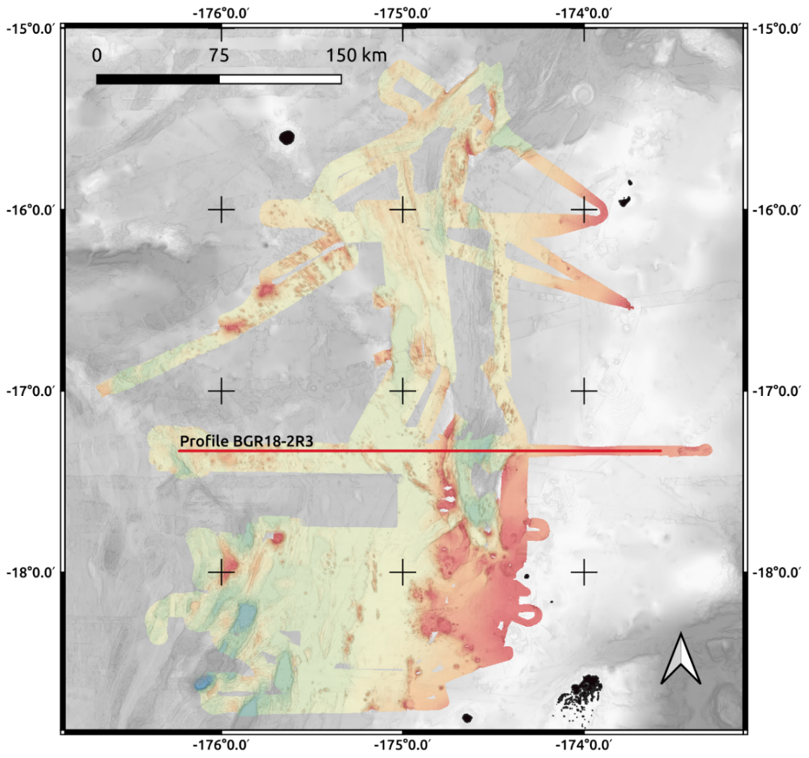

Figure S1. Bathymetry map of the northeastern Lau Basin. With color shaded areas representing multibeam echosound data from SO267 expedition (Hannington et al., 2019), gray areas resemble data from the Global Multi Resolution Topography synthesis (Ryan et al., 2009).

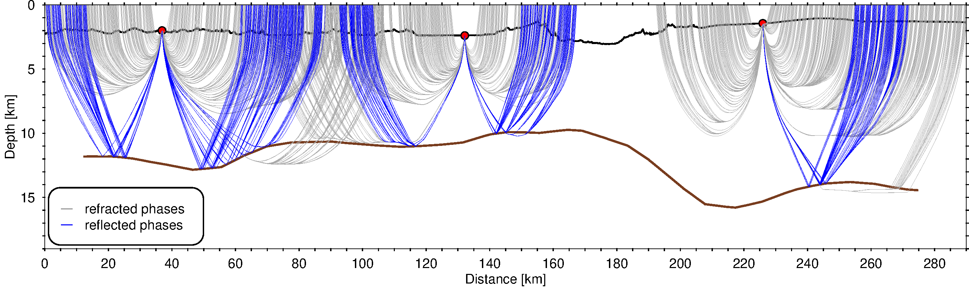

Figure S2. Plot of ray paths for three instruments (OBS-307, OBS-323, OBs-338). The brown solid line represents the Moho interface.

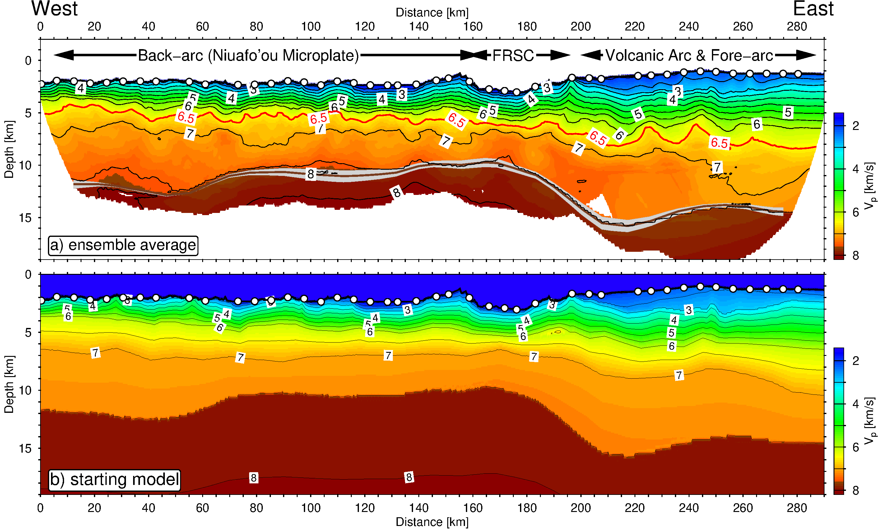

Figure S3. a) Plot of ray ensemble average P-wave tomography model. B) Starting velocity model, generated by interative forward modelling with the RAYINVR software of Zelt and Smith (1992).

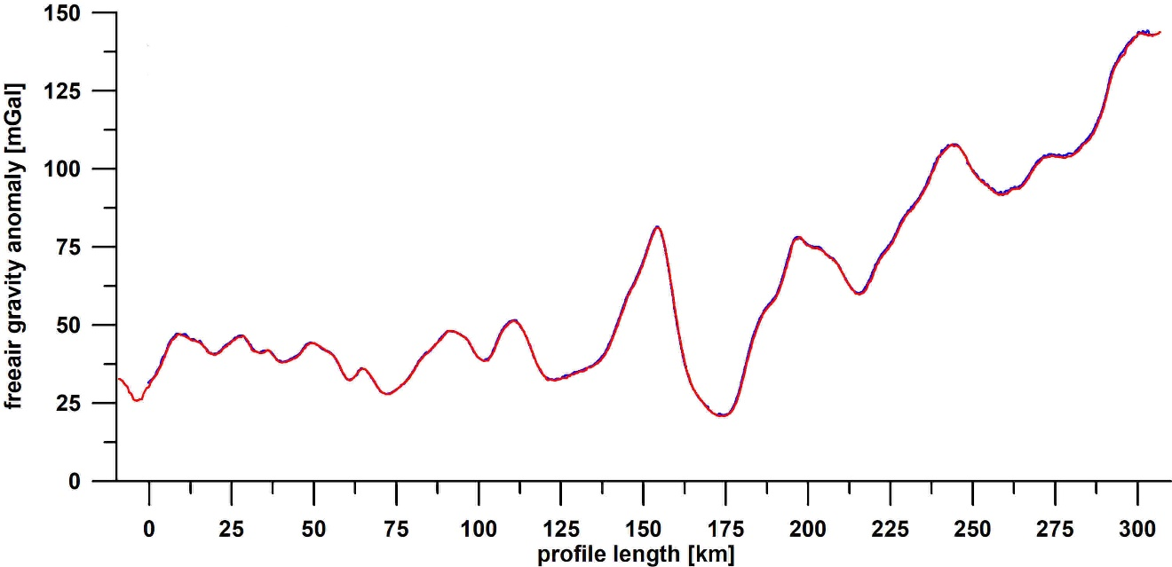Figure S4. Comparison of free-air gravity anomalies acquired during a first (red) and a second (blue) transit along profile BGR18-2R3. Note, the mismatch between both datasets is smaller than 1.0 mGal.
References

Hannington, M. D., H. Kopp, and M. Schnabel (2019), RV SONNE Cruise Report SO267: ARCHIMEDES I: Arc Rifting, Metallogeny and Microplate Evolution – an Integrated Geodynamic, Magmatic and Hydrothermal Study of the Fonualei Rift System, NE Lau Basin, Suva (Fiji) – Suva (Fiji), 11.12.2018 – 26.01.2019Rep., Kiel.
Ryan, W. B. F., et al. (2009), Global multi-resolution topography synthesis, Geochemistry, Geophysics, Geosystems, 10(3), doi: 10.1029/2008GC002332.
Zelt, C. A., and R. B. Smith (1992), Seismic traveltime inversion for 2-D crustal velocity structure, Geophys. J. Int., 108, 16-34, doi: 10.1111/j.1365-246X.1992.tb00836.x.

