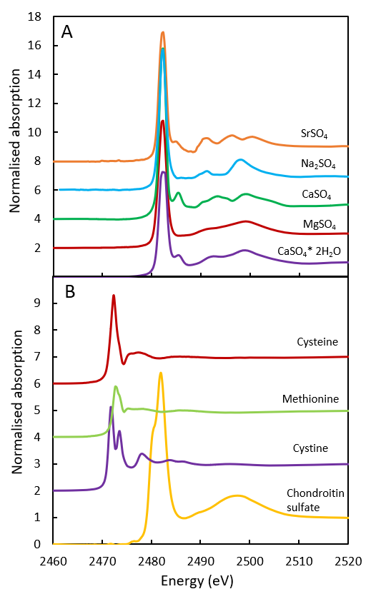
Supplementary material. S XANES reference spectra (modified after Fichtner et al., 2018) measured from total electron yield. A: Inorganic sulphate reference spectra with S K-edge at 2482 eV. B: Organic sulphur reference spectra with S K-edge at around 2472 eV for S²⁻ and 2482 eV for S⁶⁺.

