GEOMAR
Helmholtz-Zentrum für Date: 12.06.2014
Ozeanforschung Kiel

Cruise Report

Compiled by: Dipl. Biol. Burkhard von Dewitz

R.V. ALKOR Cruise No.: AL 437

Dates of Cruise: 12.05. – 27.05.2014

Areas of Research: Physical, chemical, biological and fishery oceanography

Port Calls: Karlskrona, Sweden, 18.05. – 20.05.2014; Rönne, Danmark, 24.05. – 25.05.2014

Institute: GEOMAR, FB3 (Marine Ecology, Evolutionary Ecology of Marine Fishes)

Chief Scientist: Dipl. Biol. Burkhard von Dewitz

Number of Scientists: 11

Projects: BONUS BIO-C3, BIOACID-II, VECTORS, POPDYN, FISHERIES INDUCED EVOLUTION

Cruise Report

This cruise report consists of 14 pages including the cover page:

1. Scientific crew…………………………………………………………………. 2
2. Research program…………………………………………………………........ 3
3. Narrative of cruise with technical details……………………………………… 5
Table1. Overview of gear deployment…………………………………………… 7
4. Detailed cruise timeline………………………………………………………... 8
5. Scientific report and first results……………………………………………….. 9
6. Scientific equipment …………………………..…………………………..….. 12
7. Acknowledgements……………………………………………………………. 12
8. Appendix E1: Station list…………………………………………………….... 12

1. Scientific crew

Name | Function | Institute | Leg
Burkhard von Dewitz | Chief scientist | GEOMAR Kiel | Entire cruise
Svend Mees | Scientist | GEOMAR Kiel | Entire cruise
Andrea Franke | Scientist | GEOMAR Kiel | Entire cruise
Isabel Keller | Scientist | GEOMAR Kiel | Entire cruise
Hendrik Jan Ties Hoving | Scientist | GEOMAR Kiel | Till Karlskrona
Cornelia Rüther | Scientist | GEOMAR Kiel | From Karlskrona
Julia Hoffmann | Scientist | Department of Economics, CAU Kiel | Entire cruise
Sophia Wagner | Master student | GEOMAR Kiel | Entire cruise
Florian Webers | Bachelor student | GEOMAR Kiel | Entire cruise
Anna Lena Kolze | Master student | GEOMAR Kiel | Entire cruise
Clarissa Mohm | Bachelor student | GEOMAR Kiel | Entire cruise
Total | 11

Chief scientist:

Dipl. Biol. Burkhard von Dewitz, GEOMAR Helmholtz Centre for Ocean Research
Düsternbrooker Weg 20, 24105 Kiel
Phone: 0431 600 4539
Fax: 0431 600 4553
E-Mail: bdewitz@geomar.de
2. Research program

This multidisciplinary cruise extended a long-term data series on (eco-)system composition and functioning of the Baltic Sea, with a focus on the deeper basins, collected since 1986 by the GEOMAR Helmholtz Centre for Ocean Research and its predecessors IFM-GEOMAR Kiel and IFM Kiel. The key characteristic of this series is the integration of oceanographic and biological information to enhance understanding of environmental and (fish) population fluctuations, and evolutionary processes in this system, in the context of climate change and anthropogenic stressors. The resulting datasets and samples are essential for a number of ongoing projects, including the large-scale international project BONUS BIO-C3 coordinated by GEOMAR. The spatial focus lies on the Bornholm Basin (the most important spawning area of Baltic cod), but also includes the Western Baltic Sea, Arkona and Gotland Basin and Gdansk Deep (Figure 1), thus covering ICES subdivisions 22, 24, 25, 26 and 28 (Figure 2).

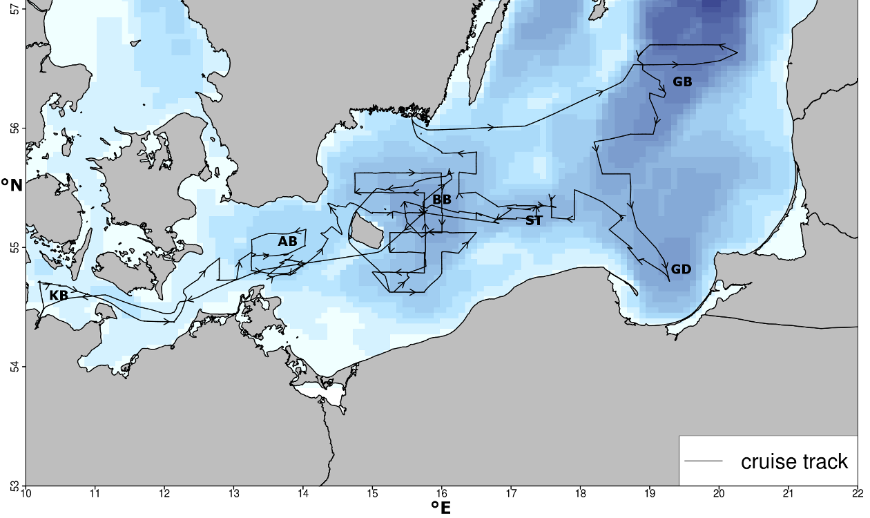
Figure 1 Cruise track of AL 437. KB = Kiel Bight, AB= Arkona Basin, BB = Bornholm Basin, ST = Stolpe Trench, GD = Gdansk Deep, GB = Gotland Basin

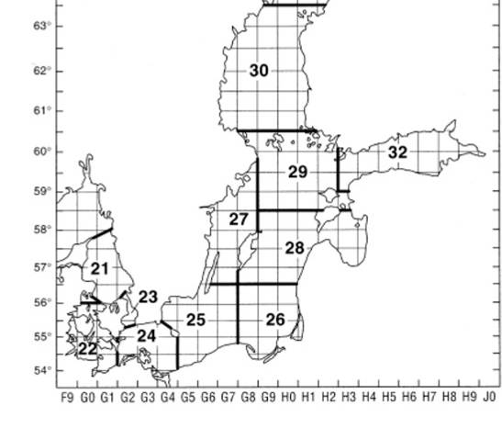

Figure 2 ICES subdivisions in the Baltic Sea area. Source: ICES
Specific investigations included a detailed hydrographic survey (oxygen, salinity, temperature, light intensity) (Figure 3), plankton surveys (zoo- and ichthyplankton, with the goal to determine the composition, abundance, vertical and horizontal distribution, and nutritional status of species, and to address questions regarding plankton phenology) (Figure 4a), and pelagic fishery hauls (Figure 4b). The latter served to determine size distributions, maturity status, and length – weight relationships of the three dominant fish species in the pelagic system of the Baltic, cod (Gadus morhua), herring (Clupea harengus) and sprat (Sprattus sprattus), as well as the benthic flatfish flounder (Plathichthys flesus). Secondly, various different samples were obtained for more detailed analyses, including gonad samples of cod, stomachs of cod, herring and sprat for dietary analyses, otoliths of cod for aging, and tissue samples of cod, flounder, whiting, plaice and others for genetic analyses. In addition, along the cruise track, hydroacoustic (echosounder) data were collected continuously for later analysis of fish abundance and distribution.
While these analyses and samples mainly stood in the context of the continuation of the long-term data series, cod and plankton samples were also taken for new research lines, e.g., by DTU Aqua in Silkeborg, Denmark, and the IOW in Warnemünde, Germany, in the context of the project BIO-C3. In addition, cruise AL 437 included a new work line on board. As started in April on AL 435 measurements of sexual immune dimorphisms in cod and herring were performed. These used Fluorescence Activated Cell Sorting (FACS) to determine the immunocompetence of the individuals (see 5. special projects). Additionally the cruise was utilized to perform test deployments of a new illuminated high resolution towed camera system. At the moment under development by Henk-Jan Hoving (GEOMAR) it will be utilized for the Future Ocean research project ‚In situ observations of Cape Verdean pelagic fauna in a changing ocean’.

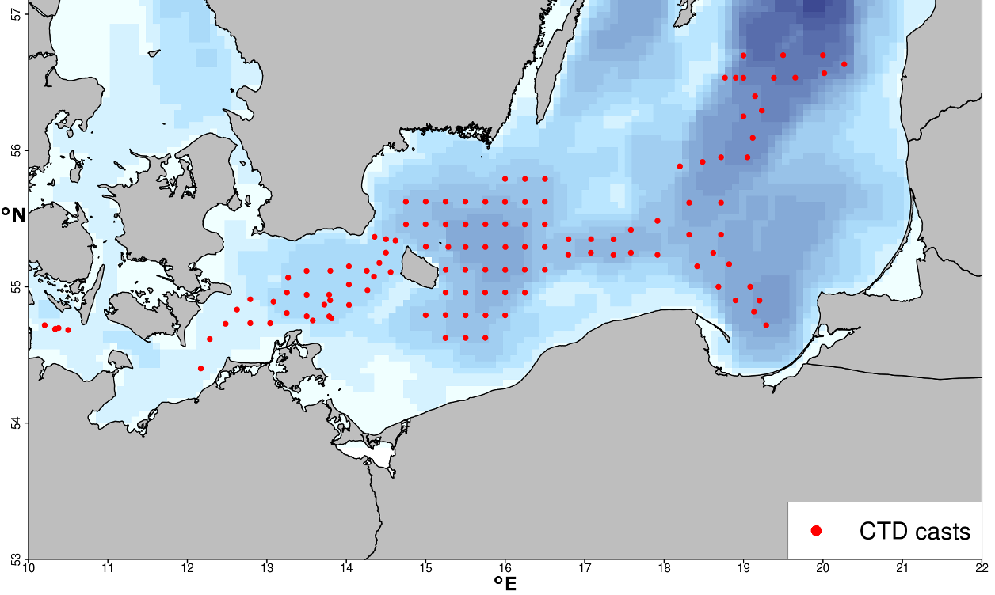
Figure 3 Stations where vertical CTD profiles were obtained on AL437.

3. Narrative of cruise with technical details

Cruise AL 437 successfully accomplished the ambitious work program that had been planned, benefiting from good weather conditions and an ideal working environment and high motivation of permanent crew and scientists on board. Equipment functioned smoothly.
On May 12 2014 7:30 (all times board time) remaining scientific gear was loaded on RV ALKOR and first preparations of gear and laboratories started. On completion of restocking fuel reserves and as all preparations showed sufficient progress to ensure operational capability on arrival at the first station, RV ALKOR departed from GEOMAR pier at 10:00 heading to the first research area in the Kiel Bight.
Over the duration of the cruise, hydroacoustic data obtained with four different echosounder frequencies (38, 70, 120 and 200 kHz) were continuously recorded. In addition, work for the sexual immune dimorphism project (see 4.i) took place in parallel to the standard program throughout the duration of the cruise whenever suitable samples were available.
In the Kiel Bight (SD22) the first working area of the cruise 3 Stations were covered during the first day (May 12) with Bongo, CTD and towed Multinet MIDI casts. Additionally two fishery hauls with a pelagic trawl were performed in the Kiel Bight. All 3 Stations were placed in the deeper ditch in the central Bight running from Maasholm eastward to the Fehmarn Belt. This area is frequently used as fishing ground from surrounding ports and is therefore suitable for sampling of fishery related projects.
The next 3 Days between May 13 2014 2:00 and May 15 2014 4:25 station work continued in the Arkona Basin (SD 24). All Stations of the previously set Station grid in this Area were covered with CTD and Bongo net hauls (24 stations; Figure 3,4a). Additionally 8 fishery hauls were performed in the southwestern part of the Basin (Figure 4b). The fishery stations were chosen to obtain a suitable sample size of Cod individuals in this area and therefore were oriented on the current commercial fishery activities in the area and the previously recorded echosounder information. On one of the last stations heading to the Bornholm Basin the first test deployment of the mentioned towed pelagic camera system took place.
Following the completed station work in the Arkona Basin the main working Area in the Bornholm Basin (SD 25) and also half of the Stolpe Trench was covered in 51 Stations with CTD and Bongo net hauls (Figure 3,4a) from May 15 2014 5:58 until May 18 2014 11:28. During this Period 5 stations in the Central Part of the Basin were also used for pelagic fish trawls and two more test deployments of the towed pelagic camera system. In Addition the central deep station BB23 in Bornholm Basin was intensively sampled, including CTD casts, zoo- and phytoplankton sampling with Bongo, Apstein and WP-2 nets, oxygen measurements of water samples obtained with the rosette water sampler using the Winkler method, and micro-/nanoplankton samples taken from the same water samples.
The cruise then completed the first leg with a scheduled visit to Karlskrona, Sweden, to debark one scientist and embark the replacement on May 19 2014.

On the second leg of the cruise station work was resumed first in the Gotland Basin (SD 28) where CTD, IKS-80 net casts and 5 fishery hauls were performed on 20 Stations in the southern Basin (May 20 2014 19:25 – May 22 2014 2:34; Figure 3,4). Followed by similar station work in the Gdansk Deep (May 22 2014 3:58 – May 22 2014 20:49) where 11 stations were covered and 4 fishery hauls were performed in the western part of the Basin to avoid Russian territorial waters (Figure 3,4). Between May 22 2014 22:04 and May 23 2014 16:35 the Stolpe Trench was covered from east to west with identical sampling of CTD and IKS-80 casts on 9 stations and 5 fishery hauls (Figure 3,4).

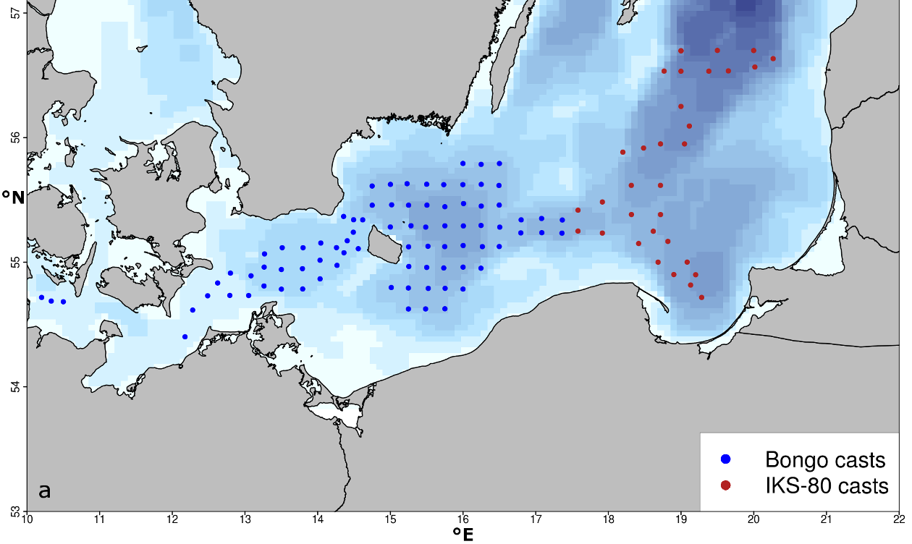

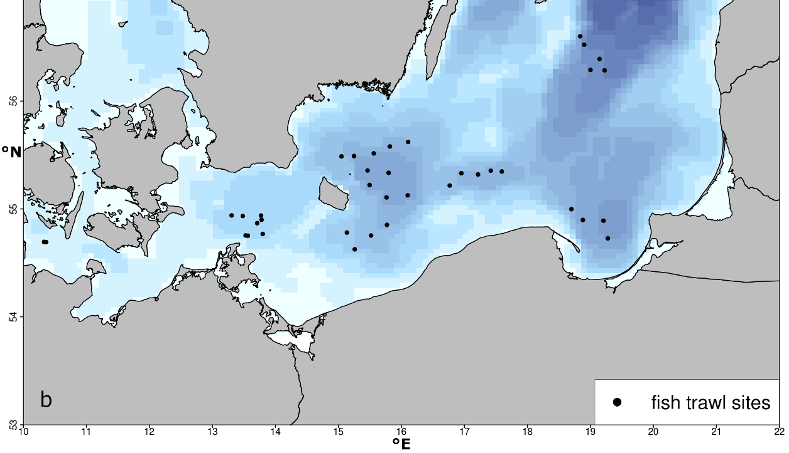
Figure 4 Stations covered during cruise AL 437. a.) Plankton sampling with Bongo (blue circles) and IKS-80 (red circles) net casts. b.) Fishery stations covered with pelagic trawls.

To add a second time point to the first intensive sampling of the central Bornholm Basin on May 15, same sampling efforts including CTD casts, zoo- and phytoplankton sampling with Apstein and WP-2 nets, oxygen measurements and micro-/nanoplankton samples were repeated from 20:00 to 22:30 on May 23 at the same station.
On May 24 and 25, 9 fishery hauls were performed in the northern and southern part of the Bornholm Basin to reach a satisfying horizontal coverage of the area. Between the fishery days RV ALKOR stayed overnight at Port Rönne on Bornholm.
Last sampling efforts from May 25 2014 18:01 to May 26 2014 12:19 were dedicated to the intensive vertically and temporally resolved sampling of plankton communities by four towed Multinet MAXI and four vertical Multinet MIDI hauls over a 24 hour period, covering the water depth in 5 m and 10 m depth layers, respectively, at the previous mentioned station BB23.
Following the completion of the research program on May 26 at 12:19, RV ALKOR steamed for Kiel harbor and reached port on May 27 at 07:45. After unloading, the cruise ended at 11:00. Compared to the initial program, the only changes lay in some reorganization of the cruise leg order to avoid bad weather.
Additional detail on the cruise timeline and track (Figure 1), the station list (Appendix E1) and an overview of gear deployments (Table 1) are provided below.

Table 1 Overview of gear deployment. Mesh sizes are given in brackets.
Gear | Deployments (n)
ADM-CTD | 124
Hydroacoustic transect  (continuous along cruise track) | 1
Watersampler + CTD | 2
Bongo, Babybongo (150μ, 335μ, 500μ) | 83
IKS-80 (500μ) | 32
WP-2 (100μ) | 8
Apstein (55μ) | 8
Multinet MAXI horizontal (335μ) | 10
Multinet MIDI horizontal (335μ) | 3
Multinet MIDI vertical (50μ) | 6
pelagic trawl (Jungfischtrawl) | 39

4. Detailed cruise timeline (all times board time):

Monday 12/05/2014 Loading equipment, Leaving GEOMAR Westshore pier, steaming to Kiel Bight. 1224 start of station work in Kiel Bight. CTD, Bongo, MIDI multinet towed, pelagic fishery.

Tuesday 13/05/2014 – Thursday 15/05/2014 Station work in the Arkona Basin. CTD, Bongo, pelagic fishery. Furthermore the first test deployment of the towed pelagic camera system was conducted.

Thursday 15/05/2014 Start of station work in the Bornholm Basin. CTD, Bongo, pelagic fishery. Upon arrival at station BB23 on Thursday 15/05/2014 10:30, first detailed plankton sampling with additional Apstein, WP-2, and rosette water sampler hauls. Upon completion, continuation of station work in Bornholm Basin until Sunday 18/05/2014. In this period 2 additional test deployments of the towed pelagic camera system were realized. After completion of last station at 11:28, steaming for Karlskrona, Sweden.

Monday 19/05/2014 Debarking of one scientist, embarking of one scientist

Tuesday 20/05/2014 11:00 departure from Karlskrona, heading to Gotland Basin.

Tuesday 20/05/2014 19:25 Start of station work CTD, IKS-80, pelagic fishery in the area Gotland Basin

Thursday 22/05/2014 0234 End of station work in Gotland Basin, heading to Gdansk Deep.

Thursday 22/05/2014 Station work IKS-80, CTD, pelagic fisheries in the area Gdansk Deep.

Thursday 22/05/2014 - Friday 23/05/2014 Station work IKS-80, CTD, pelagic fishery in area Stolpe Trench, after completion of last station at 16:35, steaming to station BB23.

Friday 23/05/2014 1945 Upon arrival on central deep station BB23, intensive sampling: CTD, water sampler, Apstein, WP-2. After end of sampling, steaming to northeastern Bornholm Basin.

Saturday 24/05/2014 Pelagic fishery hauls in the northern Bornholm Basin. After completion of 5 hauls steaming to Bornholm Rönne port, mooring at port over night.

Sunday 25/05/2014 Pelagic fishery hauls in the southwestern Bornholm Basin, after completion of last haul at 1537, steaming for central station BB23.

Sunday 25/05/2014 1801 Start of intensive 24h sampling with towed multinet MAXI, vertical multinet MIDI.

Monday 26/05/2014 Upon completion of station work at 12:19, steaming for Kiel harbor.

Tuesday 27/05/2014 0730 Arrival Kiel East shore pier, unloading; 1000 relocation to GEOMAR west shore berth. 1130 unloading completed; end of cruise.

5. Scientific report and first results

Ichthyo– and zooplankton sampling

Bongo- and Babybongo hauls covered Kiel Bight (3 hauls), Arkona Basin (29 hauls), and Bornholm Basin including the western part of the Stolpe Trench (51 hauls) (Figure 4a). Larvae of cod (Gadus morhua) (n = 1 in total), sprat (Sprattus sprattus) (n = ~566), flounder (Plathichthys flesus) (n = 395) and other species (n = 70) were picked from the 500 μm bongo-samples and conserved at -80 °C for subsequent RNA/DNA analysis. All Bongo samples were also checked for the presence of gelatinous zooplankton. The jellyfish species Aurelia aurita and Cyanea capillata were present regularly, whereas no adults and only a small number of larvae (n = 1 in total) of the invasive combjelly Mnemiopsis leidyi were found. Following these initial on board steps, all Bongo samples were conserved in formol, and will be used for the determination of species composition and abundance of (ichthyo-)plankton.
Stations in the eastern part of Stolpe trench and the Gdansk Deep and Southern Gotland Basin were covered with IKS-80 instead of Bongo hauls (Figure 4a) to ensure compatibility of data with a long-term IKS-80 sampling series maintained by the Latvian Fish Resources Agency (LATFRA; Andrei Makarcuks).
Repeated Multinet MAXI (335μ, towed, sampling of the water column in 5 m layers) and MIDI (50μ, vertical, sampling of the water column in 10 m layers) (HYDROBIOS, Kiel) casts were done over a 24 hour period on May 25-26 on the central deep Bornholm Basin station BB23 to reveal the vertical distribution of ichthy- and zooplankton. In addition, WP-2 (100 μm) and Apstein (55 μm) nets and the rosette water sampler were deployed to obtain additional samples, including nano/micro phytoplankton samples in the context of plankton phenology work within the BONUS BIO-C3 project (Dr. Jörg Dutz, IOW).

Fishery

Pelagic fishery was conducted in the Kiel Bight (2 hauls), Arkona Basin (8 hauls), Bornholm Basin (14 hauls), Stolpe Trench (5 hauls), Gotland Basin (5 hauls) and Gdansk Deep (4 hauls) (Figure 4b). In parallel to the fishery hauls, hydroacoustic measurements of fish distribution patterns were recorded continuously. Catches were dominated by sprat (Sprattus sprattus) followed by herring (Clupea hargenus), cod (Gadus morhua) (n = 1135), whiting (Merlangius merlangus) (n = 213) and flatfishes. The latter were comprised mainly of flounder (Platichthys flesus) (n = 43), but also, plaice (Pleuronectes platessa) (11) and in western parts common dab (Limanda limanda) (n = 89). Four coal fish (Pollachius virens), one goldsinny wrasse (Ctenolabrus rupestris), one shorthorn sculpin (Myoxocephalus scorpius), one great sandeel (Hyperoplus lancealatus), one european smelt (Osmerus eperlanus) and one three-spined stickleback (Gasterosteus aculeatus) completed the catches. Regarding cod, it was noticeable that higher catches were usually accomplished when the net was trawled on to the bottom, indicating a near benthic distribution and oxygen levels sufficiently high for cod in the bottom layers.
For each haul and the entire catch, catch weight and length frequencies of all species (illustrated in Figure 5 for cod) were taken. Stomach samples were taken from sprat (10 per 1 cm length class) and herring (10 per 2 cm length class). For cod, single fish data (length, weight, sex and maturity stage) and samples (otoliths, fin clips for genetic analysis, stomachs and gonads) were obtained for 687 individuals (see Figure 6 for illustration), whereas only length and weight were measured for the remaining individuals.

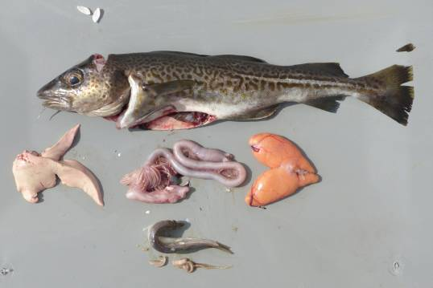
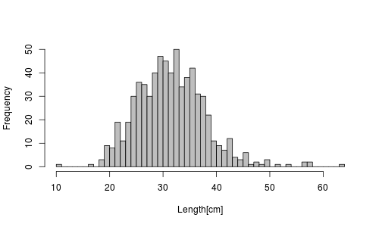

Figure 5 Relative length frequency distribution of individual sampled cod during AL 437 (n = 687).
Figure 6 Samples (otoliths, fin clips, stomach contents, gonads) and measures (total length, weight, gutted weight, liver and gonad weight) taken from 687 out of 1135 cod individual during the cruise (illustrated here for a 38 cm female, maturity stage IV, with full stomach, from Bornholm Basin). Photo: Nickel

Hydrography

CTD profiles from 124 stations were obtained with the ADM-CTD and the HYDROBIOS water sampler with attached CTD (Figure 3). Conditions varied depending on the basin and location of the Baltic sampled, and will be analyzed in depth in context of the long-term data series on hydrographic conditions. In general, Bornholm Basin stations were characterized by a permanent halocline in ca. 60 m depth, with sharply increasing salinity and decreasing oxygen levels below. However, oxygen near the bottom in most locations still exceeded 2.5 to 3 ml/l and frequently reached up to 4 ml/l, which pointed to a potential inflow over the winter/early spring 2013/2014. The relatively good oxygen situation also explained the distribution of cod adults near the bottom, indicated by increased catches with increasing proximity of the trawl to the bottom during AL 437.

Special projects

The two additional lines of work carried out in parallel to the above cruise program as “special projects” successfully completed the planned sampling, measurements and tests. Short summaries of these projects and the work realized on board are given below.

(i) Sexual immune dimorphism in cod and herring (Andrea Franke and Isabel Keller, GEOMAR Kiel)

Reproductive success of females depends on longevity, of males on the number of matings. An efficient immune system is important for successful clearance of parasites and pathogens and thus correlates with longevity. This is why females usually have a stronger immune response than males across the animal kingdom. Our recent data, however, suggest that the sole production of eggs and sperm may not be of such outstanding importance but that sexual immune dimorphism rather exclusively bases on the difference in life-history strategy and hence, on investment into the offspring and parental care. Whereas during the last year we mainly focused on animals with extreme parental care, during cruise AL 437 we investigated differences between males and females are also present in species without parental care that reproduce over the simple deposition of the reproductive elements into the water during a mass spawning event, and hence, exclusively rely on the production of reproductive elements without further investment into offspring.
We successfully measured male and female immunocompetence of 199 herring and cod individuals. Specifically, upon capture, the sex of each fish was determined, size was measured and reproductive stage estimated. Animals were grouped into juvenile, pre-spawning and spawning. Blood was collected from the caudal vein, and head kidney and spleen were dissected and collected in medium. The samples from blood, spleen and head kidney were then further processed for immunocompetence measurements using flow cytometry (Fluorescence Activated Cell Sorting, FACS). The number of cells from the innate and adaptive immune system was measured according to size and complexity of cells. The activity of the immune system was assessed using cell cycle measurements. Gills were stored in RNA later to measure immune gene expression in the laboratory.

(ii) Test deployments of a towed pelagic camera system (Henk-Jan Hoving, GEOMAR Kiel)

For the Future Ocean research project ‚In situ observations of Cape Verdean pelagic fauna in a changing ocean’ a towed pelagic camera system is being developed that can be deployed from ships of opportunity. This instrument is being developed to optically ‘sample’ organisms in the water column, in particular those that are poorly captured by nets (e.g. cnidarians and ctenophores).
The system consists of an aluminum frame, a high definition video camera, a CTD and oxygen sensor, a battery, LED light arrays and a telemetry system that transfers the collected environmental data via the CTD conducting cable to the deck unit on the ship. A low quality version of the locally stored HD video is also transferred via the CTD cable to the deck unit for preview. The research goal is to quantify observed organisms in the water column by manual annotation of the video obtained by the towed camera system, and to correlate organism diversity, abundance and distribution with the physical and chemical environment of the water column of the deep ocean.
The goal during AL 437 was to obtain routine with deployment and retrieval of the system, to perform stability tests, and to make tests with illumination and different cameras and camera settings. During the three instrument deployments (maximum deployment depth 42 m) on AL 437 these goals were met.

6. Scientific equipment: instruments and gear

Hydrography:
- ADM-CTD with additional O2 sensor
- Hydrobios Water Sampler with CTD and O2 sensor

Zooplankton:
- Baby Bongo-Net (150 μm)
- Bongo-Net (335 μm)
- Bongo Net (500 μm)
- WP2 (100 μm)
- Apstein net (55 μm)
- Deep STAR (towed camera device)

Ichthyoplankton:
- Bongo-Net (335 μm and 500 μm)
- Hydrobios Multinet MAXI (335 μm horizontal tows)
- Hydrobios Multinet MIDI (300 μm horizontal tows and 50 μm vertical hauls)
- IKS-80 (500 μm)

Fish:
- Jungfisch Trawl (pelagic trawls) (0.5 cm)

Hydroacoustic:
- 38, 70, 120 and 200 kHz-echosounder EK60

7. Acknowledgements

Thanks to Captain Lass and the entire crew of RV ALKOR for their outstanding support during the cruise, and to Rudi Lüthje and Svend Mees for their support in preparing the cruise!

8. Appendix E1: Station list of AL 435

Supplied with the report in electronic form as Excel table, “Appendix E1 – AL435_station_list.

