Appendix 1
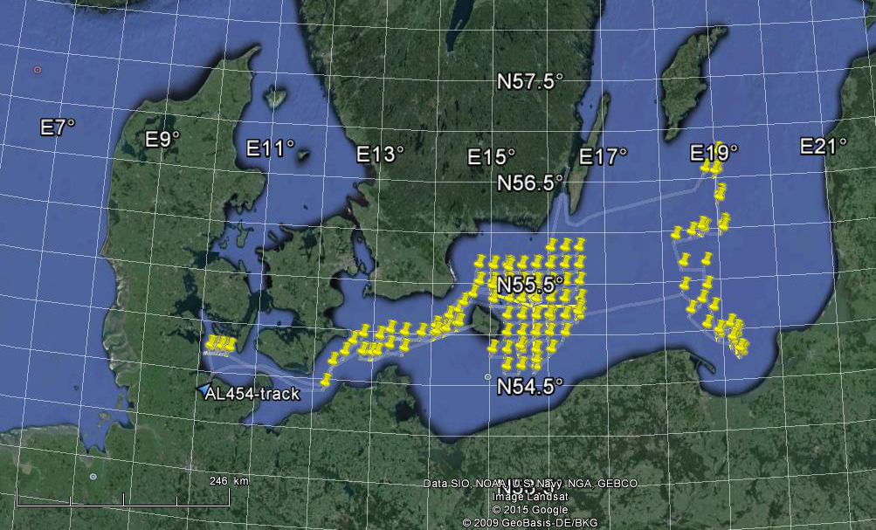
Cruise track and CTD stations of AL454, April 15-29 2015 (for detailed station info, see https://portal.geomar.de/metadata/leg/show/329864 ).

