Supplementary Material to:

Evolution of extreme stomach pH in bilateria inferred from gastric alkalization mechanisms in basal deuterostomes
Meike Stumpp, Marian Y. Hu, Yung-Che Tseng, Ying-Jeh Guh, Yi-Chih Chen, Jr-Kai Yu, Yi-Hsien Su and Pung-Pung Hwang

Table S1 Seawater physiochemical parameters during acidification experiments
pH treatment | pH | A_{T}  (mM) | pCO₂ (µatm) | C_{T}  (mM) | Temp °C | Sal
S. purpuratus
8.1 | 8.04 ± 0.01 | 2.02 ± 010 | 489 ± 16 | 1.89 ± 0.09 | 14 | 31
7.0 | 6.98 ± 0.02 | 2.06 ± 0.01 | 6456 ± 482 | 2.30 ± 0.10 | 14 | 31
P. flava
8.2 | 8.25 ± 0.002 | 2.21 ± 0.02 | 332 ± 4 | 1.91 ± 0.02 | 25 | 31
7.0 | 6.99 ± 0.015 | 2.20 ± 0.02 | 7683 ± 265 | 2.40 ± 0.01 | 25 | 31

Table S2 Artificial seawater solutions
ion | 5 mM Na⁺ | 0 HCO₃⁻ | 0 K⁺
Na⁺ | 5 | 474 | 430
K⁺ | 9.9 | 9.9 | 0
Mg²⁺ | 53.3 | 53.3 | 53.3
Ca²⁺ | 10.3 | 9.9 | 15.3
Cl⁻ | 488.6 | 519.3 | 478.6
SO₄²⁻ | 28 | 28 | 28.2
HCO₃⁻ | 2.35 | 0 | 2.35
NMDG⁺ | 443
Hepes |  | 5
pH | 8.2 | 8.2 | 8.2
Osmolality | 1004 ± 10 | 1009 ± 10 | 1007 ± 10
Artificial seawater (ASW) solutions (concentrations given in mmol Kg⁻¹)

Table S3 Sea urchin (Strongylocentrotus purpuratus) primer sequences used for qPCR
Gene name | Abbreviation | primer | Amplicon length | Accession number
Na⁺/K⁺-ATPase | NKA | [F] 5'-GTCTTCTTGGGTGTATCCTTCT-3' | 148 bp | XM_001202868.1
 |  | [R] 5'-TAGCAGTCAAGGTCAGACATAC-3'
Na⁺/H⁺-exchanger 3 | NHE3 | [F] 5'-TGCTCACCCTGTCTAGTATTC-3' | 173 bp | XM_001178217.1
 |  | [R] 5'-GCTGAGTGATGTAGTCCCTAA-3'
V-type H⁺-ATPase | VHA | [F] 5'-GAAAGATGGAAGCGGCTAAAG-3' | 119 bp | XM_001176838.1
 |  | [R] 5'-ATTGTCCAGGATAACCAGAGG-3'
Na⁺/HCO₃⁻ cotransporter | NBC | [F] 5'-GTAGAGTTCCATCCAGAGGTT-3' | 172 bp | NM_001079551.1
 |  | [R] 5'-TTGTGGGTAGGTCCAGATTAG-3'
transmembrane and coiled-coil domains 3 (Tmco3) | KHE | [F] 5'-GTTGGTGGAGCCCATTAGAGA-3' | 168 bp | SPU_020239
transmembrane and coiled-coil domains 3 (Tmco3) |  | [R] 5'-CTCAGGGTTGTGACGCTTAGA-3'
Cl⁻/HCO₃⁻ exchanger 2 | AE2 | [F] 5'-GTTCCTAACAGCAGAGAAGATG-3' | 176 bp | XM_788556.3
 |  | [R] 5'-GTGAGAGACATGCAAAGTAGAG-3'
Carbonic anhydrase | CA | [F] 5'-GCGGTGTTATCCATCTTTCAC-3' | 163 bp | XM_003726241.1
 |  | [R] 5'-GGGAAGCCACTCCTAATTACT-3'
Elongation factor 1A | EF1a | [F] 5'-GAGAGTTTGAGGCTGGTATCT-3' | 155 bp | NP_001116969
 |  | [R] 5'-GACCTCCCTGACGATTTCTTT-3'
Ubiquitin-1 | UBQ1 | [F] 5'-GAGAGGAATCCTGAGGTATCG-3' | 160 bp | XM_777914.3
 |  | [R] 5'-GTAGCGCATTATAACCACCTG-3'

Table S4 Acorn worm (Ptychodera flava) primer sequences used for qPCR
Gene name | Abbreviation | primer | Amplicon length
Na⁺/K⁺-ATPase | NKA | [F] 5'-CTCACAGTGGGCAGTGTTAAAG-3' | 148 bp
 |  | [R] 5'-GTGCACCCTTCATGACCAATAG-3'
Na⁺/H⁺-exchanger 3 | NHE3 | [F] 5'-ATCGTCTTGGAAGCCGGATATT-3' | 161 bp
 |  | [R] 5'-TCCATTTCTACGTCCACCCATC-3'
V-type H⁺-ATPase | VHA | [F] 5'-GTACACTGACTTGGCAACCATC-3' | 149 bp
 |  | [R] 5'-TCTGACCTTCTGTGATGTACCC-3'
Na⁺/HCO₃⁻ cotransporter | NBC | [F] 5'-GCCCTAGAGACGTTGGAAGTTA-3' | 148 bp
 |  | [R] 5'-AGTGATACGACGTTCCCTTCTG-3'
transmembrane and coiled-coil domains 3 (Tmco3) | KHE | [F] 5'-TAAGCTCCCAGTCACACAGTAA-3' | 170 bp
transmembrane and coiled-coil domains 3 (Tmco3) |  | [R] 5'-AATCACCACGACAAAGGTCAAG-3'
Cl⁻/HCO₃⁻ exchanger 2 | AE2 | [F] 5'-ACGAAGAATTCGATGGAGACTG-3' | 162 bp
 |  | [R] 5'-CACATTGCGTACATTGGTCTTG-3'
Carbonic anhydrase | CA | [F] 5'-GATGGTGGGAAGCTGATGAAAG-3' | 154 bp
 |  | [R] 5'-GTGTTCGTGAGTGTCATGGTAG-3'
Elongation factor 1A | EF1a | [F] 5'-GCTGATTGTGCTGTGTTGATTG-3' | 154 bp
 |  | [R] 5'-GCTCTGTGTTGTCCATCTTGTT-3'
Ubiquitin-1 | UBQ1 | [F] 5'-GCAGGAAATGATGAGAAGTCAGG-3' | 149 bp
 |  | [R] 5'-CTGAGAATGGGTTTGTACCAAGG-3'

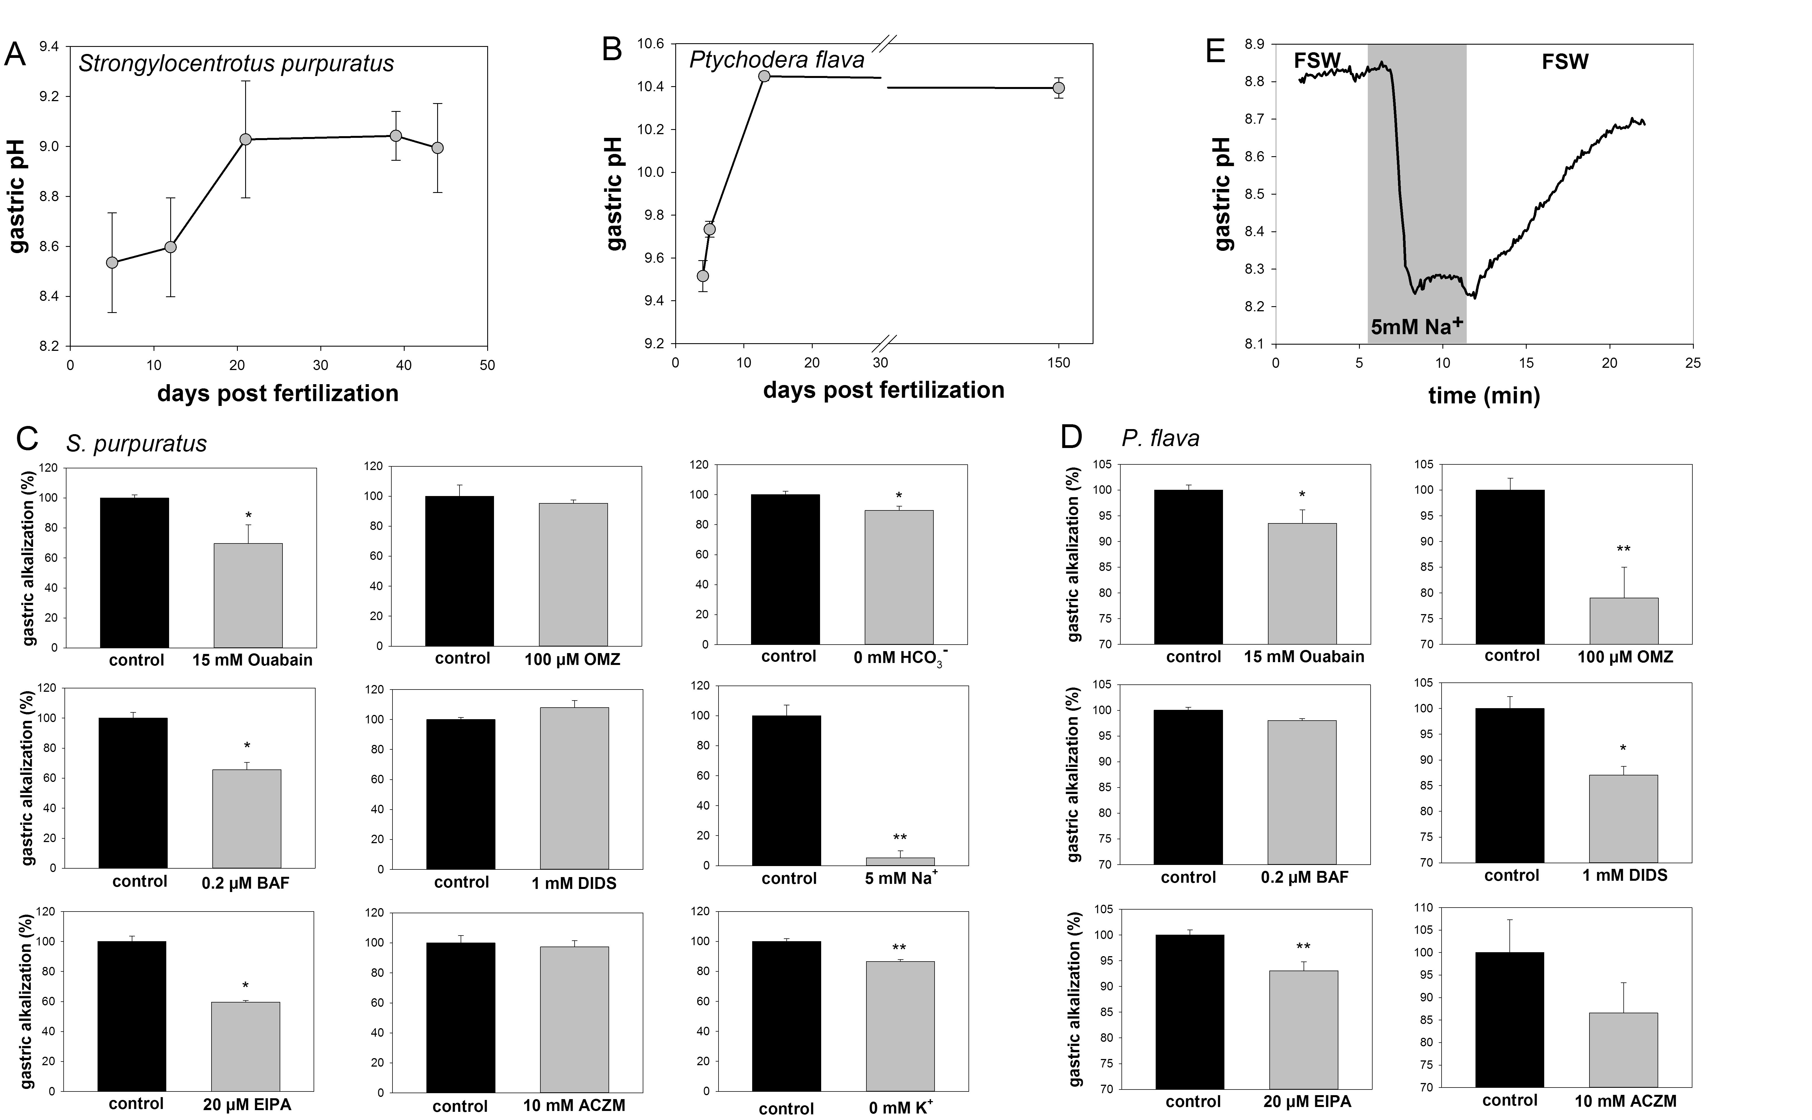Figure S1 Gastric pH along larval development of Strongylocentrotus purpuratus (A) and Ptychodera flava (B). Values are presented as mean ± SE (n = 4; with 4 -6 animals from each of the four culture bottles). Raw data of the inhibitor experiments showing the control and the inhibitor groups from which the relative change in gastric inhibition (Fig. 1 D) was calculated for S. purpuratus (C) and P. flava (D). Values are presented as mean ± SE and asterisks denote significant differences (* p<0.05, ** p<0.001; n= 5-7). Real time trace of gastric pH in S. purpuratus larvae during exposure to 5 mM Na⁺ ASW (E). In response to artificial seawater containing 5 mM Na⁺ gastric pH drops rapidly by 0.6 pH units to seawater pH levels of 8.2. During washout with natural seawater the gastric pH recovers slightly below control conditions.

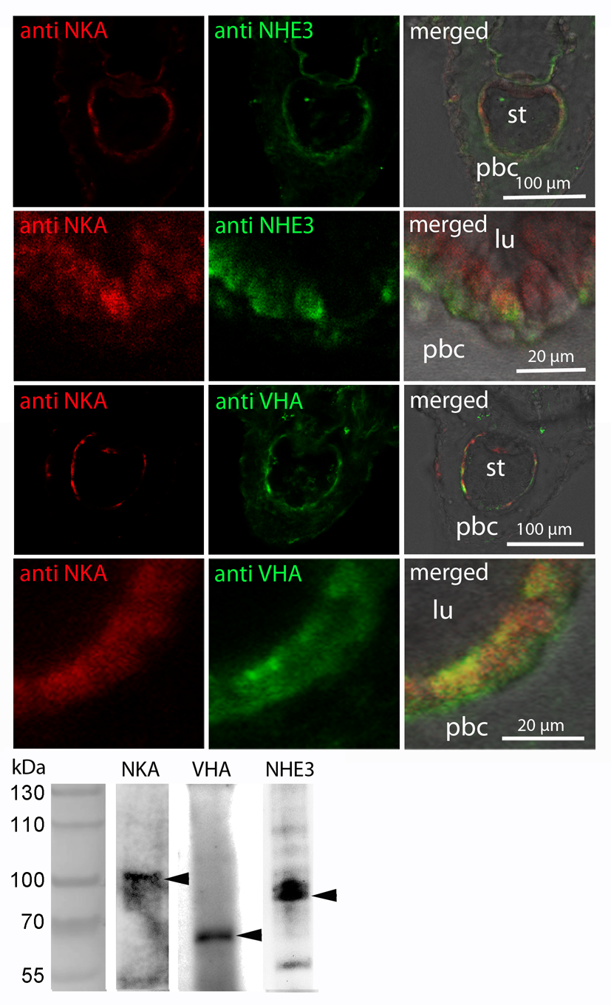
Figure S2 Immunohistochemical analyses of acid-base transporters in sea urchin pluteus larvae. Colocalization of putative acid-base transporters in sea urchin larvae using antibodies designed against Na⁺/K⁺-ATPase (NKA) (chicken), V-Type-H⁺-ATPase (squid) and Na⁺/H⁺-exchanger 3 (fish) (upper panel). Flourescence images are presented separately (left and middle lane) and in a merged version including a bright field image (right lane). Western blot analysis demonstrates specific immunoreactivity with proteins in the predicted size range (lower panel).

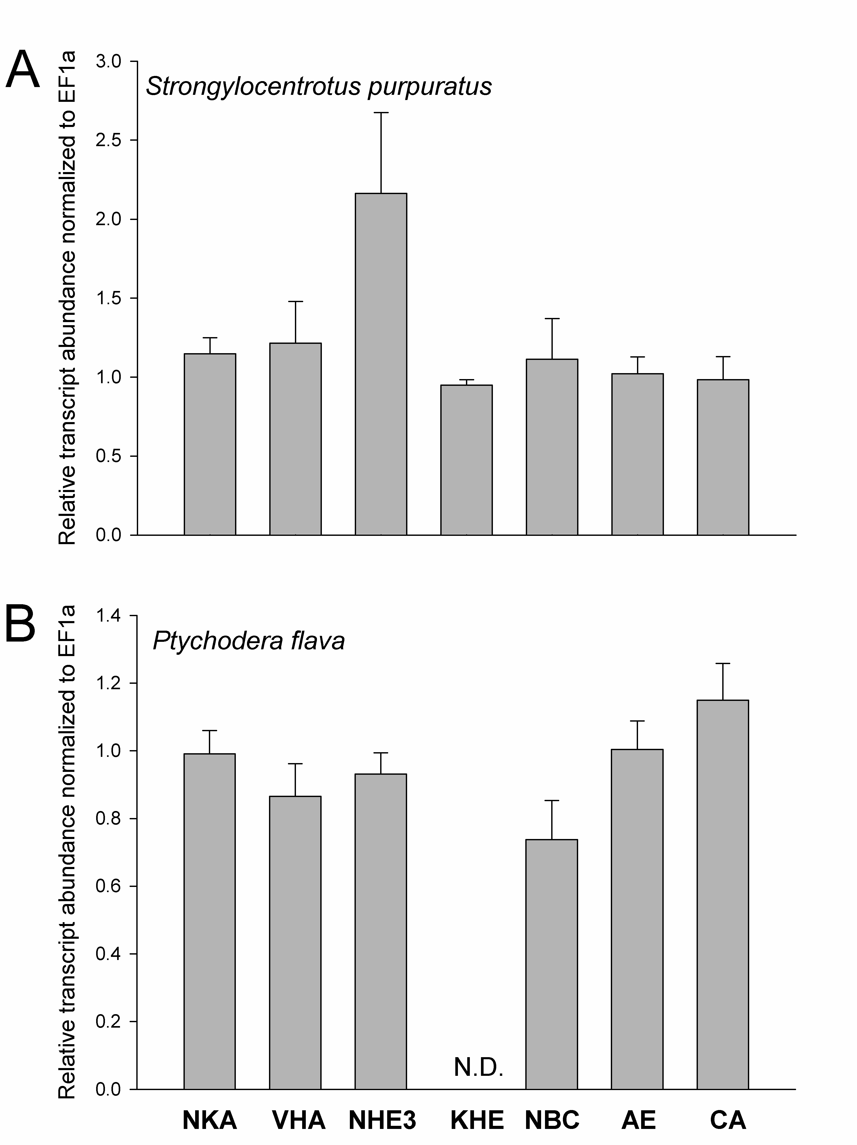
Figure S3 Relative transcript abundance of acid-base regulatory genes under control conditions. Thranscript abundance of Na⁺/K⁺-ATPase (NKA), V-Type-H⁺-ATPase (VHA), Na⁺/H⁺-exchanger 3 (NHE3), K⁺/H⁺ exchanger (KHE), Na⁺/HCO₃⁻ cotransporter (NBC), anion exchanger (AE) and carbonic anhydrase (CA) in sea urchin (S. purpuratus) pluteus larvae (A) and hemichordate (P. flava) tornaria larvae (B). Transcript concentrations of the putative KHE were not detectable in P. flava larvae. Transcripts were normalized to the housekeeping matrix of UBQ1 and EF1a and bars represent mean ± SE.
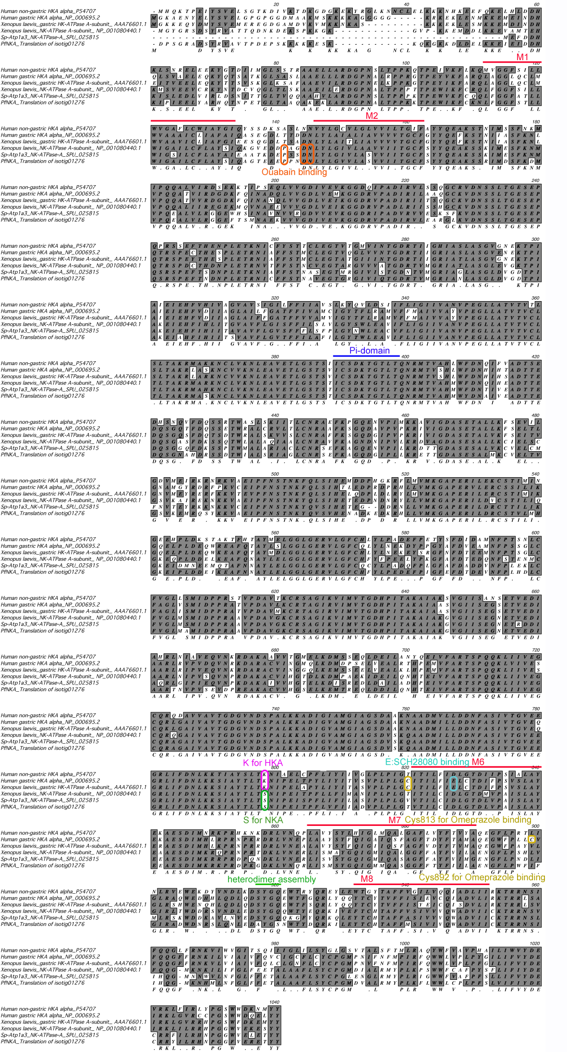
Figure S4 Alignment of deduced Na⁺/K⁺-ATPase (NKA), gastric-type H⁺/K⁺-ATPase (g-HKA) and non-gastric H⁺/K⁺-ATPase (n-g-HKA) aminoacid sequences. Ouabain binding between transmembrane domain 1 and 2 (M1, M2) is highly specific for NKAs including those from sea urchin and hemichordate. Omeprazole binding to Cys₈₁₃ and Cys₈₉₂ is highly conserved among g-HKA, and suggest no effect on NKAs or n-g HKAs. Additionally, the binding site for Sch28080, another specific inhibitor for g-HKA is indicated in this alignemnt in tranasmembrane domain M6. The affinity for H⁺ or Na⁺ in KHAs and NKAs is determined by K (lysine) or S (serine) at position 798. Other functional domains including phosphorylation site (Pi) and heterodimer assembly site are highlighted.

