Supplementary Material

Microzooplankton stoichiometric plasticity inferred from modelling mesocosm experiments in the Peruvian Upwelling region

Marki, A.* and Pahlow, M.

**\* Correspondence:** Marki, Alexandra: amarki@geomar.de

# Supplementary Data

Table S1 shows parameter estimates for dinoflagellates (representing *Gymnodinium sp*.) and thus supplements Table 1 in the main text.

Figure S1 shows all our model configurations and supplements Figure 2 of the main text.

Figures S2 and S3 show our results of the specialist NNPZ-s and NNPZ-s-zooQP configurations. Please consult the main text for further details.

# Model configurations

We set up several model configurations (Figure S1), which differ in model complexity in terms of the number of trophic levels and the trophic strategies of the microzooplankton grazers. We simulate two nutrients, dissolved inorganic nitrogen and phosphorus (DIN and DIP, respectively), phytoplankton, and one to three trophic levels, representing phytoplankton, P, and two microzooplankton grazers, Z1 and Z2, to experiment with ecosystem models of different complexity (Figure S1).

We simulate "bottom-up" control with the optimality based chain model (OCM) representing primary production , and "top-down" control with the optimal current feeding model (OCF) (Pahlow and Prowe, 2010). Although the OCF was originally developed for current feeders, it can also describe other foraging strategies or feeding modes (Pahlow and Prowe, 2010). For example, ciliates (and copepods) create a feeding current (Jørgensen, 1983;Stoecker, 1984), whereas dinoflagellates are cruise feeders, which increases the foraging efficiency by increasing prey encounter rate, but also the risk of becoming a prey by increasing encounters with higher predators (Visser et al., 2008;Pahlow and Prowe, 2010). Since the microzooplankton community in the mesocosms was identified as comprising ciliate and dinoflagellate species (Hauss et al., 2012), the foraging strategy in our model is defined by the dinoflagellate and/or ciliate parameter set (Table 1, Figure 2, Table S1 and Figure S1). Furthermore, we investigate the role of specialised (strict herbivores and/or carnivores) vs. omnivorous feeding behaviour and stoichiometric plasticity of the zooplankton as possible physiological response mechanisms to changes in food quality (in terms of C:N:P ratios).

# Model complexity

The simplest (NNP) configuration contains only the nutrient and phytoplankton compartments and has 6 state variables (DIN, DIP, phyto POC, phyto PON, phyto POP and Chl; see Figures 3 and 4). In the intermediate (NNPZ) configuration we introduce a second trophic level, the zooplankton guild as primary predators, by employing one additional state variable: zoo POC (Z) (Figure 2), representing the total microzooplankton biomass (BMtot) (Figure 2). Our most complex model configuration (NNPZZ) comprises three trophic levels. Here we include two microzooplankton compartments, the primary and secondary predators, with the corresponding state variables Z1, representing the dinoflagellate biomass, and Z2, representing the ciliate biomass (Figure S1). In all our model configurations we employ the same phytoplankton parameters as given in Tables 1 and S1. The microzooplankton compartment(s) in the NNPZ and NNPZZ model configurations are parameterised with the pre-calibrated parameter sets of Pahlow and Prowe (2010) employing either the parameters of the ciliate *Strobilidium spiralis* or the parameters of the dinoflagellate *Gymnodinium spec.* (indicated by the suffix "-D-" in the configuration name; Table S1 and Figure S1)*.*

Our three main specialist configurations (NNPZ-s, NNPZ-Ds and NNPZZ–s) represent the simplest food web structure, a linear food chain, where the organisms are treated as strict food specialists feeding on only one type of food. In the specialist configurations we assume that the only (Z) or first (Z1) predator is grazing on a strict phytoplankton diet. In the specialist NNPZZ-s configuration the second predator (Z2) is preying on the first predator (Z1) and thus is assumed to be a strict carnivore. The omnivore NNPZ-oD configuration is parameterized with the dinoflagellate parameters (supplementary Table S1 and Figure S1). Since both the specialist NNPZ-sD and the omnivore NNPZ-oD simulations produce very similar results and underestimate zooplankton growth (not shown), our model evaluation in the main text focuses mainly on the specialist NNPZ-s and omnivore NNPZ-o model configurations (Figures 2-8, Figures S1-S3).

The NNPZZ-v model configuration represents partial omnivory, where the primary predator (Z1) is solely grazing on phytoplankton, and the secondary predator (Z2) has a mixed diet consisting of his preferred food (Z1=dinoflagellates) and (less preferred) phytoplankton (Kiørboe et al., 1996) (Figure S1). The extended omnivory (NNPZZ-o) configuration is obtained by also allowing for intraguild predation within the primary and secondary predator compartments (Figure S1). In the NNPZZ-o simulation we lower 𝜙 for Z2-intraguild predation to one-fourth, because we assume that two other food sources (Z1 and phytoplankton) were available, and feeding on the own guild (Z2) would increase the risk of becoming a prey (Figure S1). Due to the observed size differences we assume that dinoflagellates (Z1) do not prey on ciliates (Z2). However, the addition of a third trophic level with different feeding strategies in our most complex configuration (NNPZZ, Figure S1) cannot explain the behaviour of the high and low DIN:DIP treatments at the same time; indeed, the NNPZZ configurations only show marginal differences compared to the NNPZ-o configurations with no significant improvement in model performance for both experiments (not shown).

## Specialist configurations (NNPZ-s/NNPZ-s-zooQP):

Figures S2 and S3 show modelling results of the PU1 and PU2 mesocosm experiments, respectively, obtained by implementing a simple specialist food chain, i.e. nutrients are taken up by phytoplankton, which is grazed by microzooplankton. We use a pre-calibrated parameter-set for ciliates according to Pahlow and Prowe (2010) (Table 1). These NNPZ-s (low microzooplankton P:C quota, Table1) and NNPZ-s-zooQP (high P:C quota, Table 1) configurations clearly show the rather strong top-down control by the microzooplankton compartment, which here is the top of the food-web. To control the microzooplankton compartment, we simulate omnivory in the form of intraguild predation, as described and shown in the main text of the manuscript in the NNPZ-o and NNPZ-o-zooQP configurations (Figures 5 to 8). This prevents excessive grazing of phytoplankton and controls the zooplankton compartment.

# Supplementary Figures and Tables

Table S1: Symbol definitions, units and parameter estimates of the optimality-based chain model for phytoplankton and the optimal current feeding model for zooplankton;

|  |  |  |  |
| --- | --- | --- | --- |
| Symbol | Units | Estimates | Definition |
| *phytoplankton parameters* | |  |  |
| 𝐴0 | m3 mmol−1 d−1 | 0.15 | nutrient affinity |
| α | mol m2 E−1 (g Chl)−1 | 0.9 | light absorption coefficient |
| $$Q_{0}^{N}$$ | molN molC−1 | 0.07 | N subsistence quota |
|  | molP molC−1 | 0.0019 | P subsistence quota |
| ζ Chl | molC (g Chl)−1 | 0.5 | cost of photosynthesis |
| ζ N | molN molC−1 | 0.6 | cost of DIN uptake |
|  | mol molC−1 | 5 | maximum rate parameter |
| *microzooplankton parameters for dinoflagellates, representing Gymnodinium sp.* | | | |
| 𝑐𝑎 | -- | 0.33 | cost of assimilation coefficient |
| 𝑐𝑓 | -- | 0.25 | cost of foraging coefficient |
| 𝐼𝑚𝑎𝑥 | d−1 | 2.9 | max. specific ingestion rate |
| 𝜙 | m3 mmolC−1 | 2.64 | prey capture coefficient |
| 𝑄N | molN molC−1 | 0.2 | N:C ratio (N quota) |
| 𝑄P | molP molC−1 | 0.013—0.026* | P:C ratio (P quota) |
| 𝑅𝑀 | d−1 | 0.05 | specific maintenance respiration |

* range of different constant microzooplankton P:C ratios, tested for identifying the most suitable microzooplankton phosphorus quota;

## Supplementary Figures

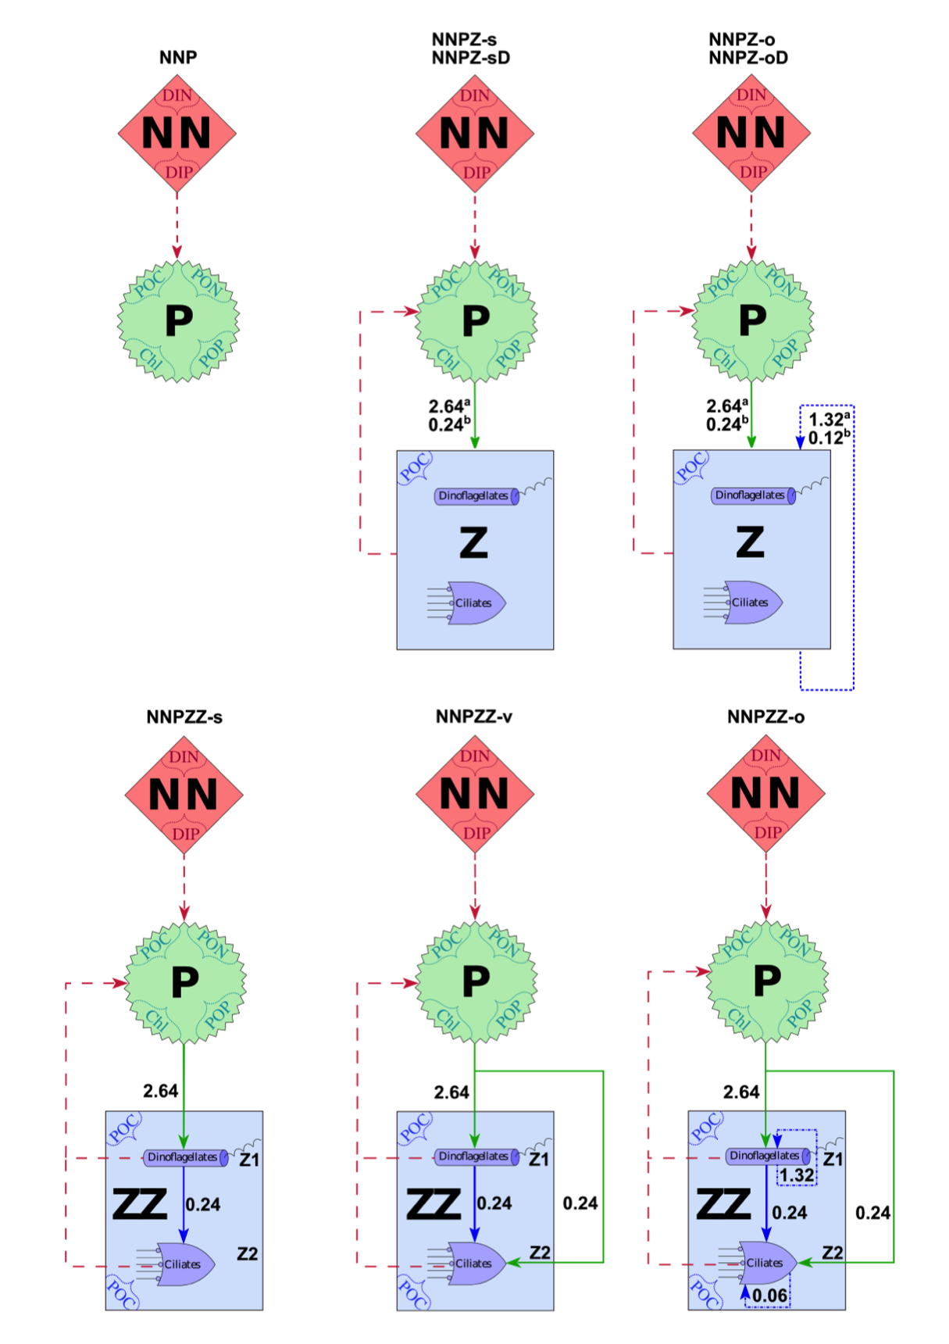

Figure S1: Model configurations with prey capture coefficients and the main compartments NN=Nutrients, P=Phytoplankton and Z=Zooplankton; the suffix -D indicates that the single Z compartment is represented by dinoflagellates, assumed to behave as specialists (“-sD”) or omnivores (“-oD”), respectively; the suffix “‑zooQP” represents a higher zooplankton phosphorus quota (*QP*= 0.0195 molP molC-1), compared to the other NNPZ configurations; the NNPZZ-s configuration simulates strict food specialists; the NNPZZ-v configuration simulates partial omnivory and the NNPZZ-o configuration simulates extended omnivory. Numbers are prey capture coefficients in m-3mmolC-1; solid lines represent prey capture coefficients of dinoflagellates or ciliates for phytoplankton and/or microzooplankton - set to 100 %, either representing the preferential food source or food of equal quality for the predator; blue dash-dotted lines represent intraguild prey capture coefficients - either set to 50 % assuming that the microzooplankton community is split into 50% intraguild prey and 50% intraguild predators or set to 25% assuming that two equal food sources are available and that the risk of becoming a prey is higher (Z2); in the omnivore NNPZZo configuration, intraguild predation occurs for Z1 and Z2 but Z1 does not prey on Z2. aDinoflagellates are represented by *Gymnodinium sp.* Parameters (Table S1); bCiliates are represented by *Strobilidium spiralis* parameters (see main text, Table 1).



Figure S2: Effect of different microzooplankton elemental phosphorus quotas on specialist model feeding behaviour of the PU1-NNPZ-s configuration (A:C) with lower microzooplankton P:C quota ( $Q_{Z}^{P}$ = 0.013 molP molC-1) and the NNPZ-s-zooQP configuration (D:E) with higher microzooplankton P:C quota ( $Q_{Z}^{P}$ = 0.0195 molP molC-1) (Table S1); Microzooplankton biomass is initialised with the total initial zooplankton biomass (BMtot) of ciliates and dinoflagellates (Figure S1). The microzooplankton compartment is initialised with the parameters of the ciliates (*Strobilidium spiralis)*. Left y-axis: (A,D) DIN, (B,E) phytoplankton POC and (C,F) phytoplankton PON:POP ratio; right y-axis: (A,D) DIP, (B,E) (micro)zooplankton POC and (C,F) phytoplankton Chl:C ratio; units of DIN, DIP, phytoplankton POC and (micro)zooplankton POC are mmol m-3; phytoplankton PON:POP ratio is given in mol mol-1, phytoplankton Chl:C ratio is given in g mol-1 and time is given in days (d); model discontinuities are due to dilutions; observations (marks) are daily averages, where vertical bars indicate the range between the lowest and the highest measurement of all mesocosms within one treatment.



Figure S3: Same as Figure S2, but showing data and ensemble model simulations for PU2 for the specialist NNPZ-s and NNPZ-s-zooQP configurations.

# References

Hauss, H., Franz, J.M.S., and Sommer, U. (2012). Changes in N:P stoichiometry influence taxonomic composition and nutritional quality of phytoplankton in the Peruvian upwelling. *Journal of Sea Research* 73**,** 74-85. doi: 10.1016/j.seares.2012.06.010.

Jørgensen, C.B. (1983). Fluid mechanical aspects of suspension feeding. *Marine Ecology Progress Series* 11**,** 89-103. doi: 10.3354/meps011089.

Kiørboe, T., Hansen, J.L.S., Alldredge, A.L., Jackson, G.A., Passow, U., Dam, H.G., Drapeau, D.T., Waite, A., and Garcia, C.M. (1996). Sedimentation of phytoplankton during a diatom bloom: Rates and mechanisms. *Journal of Marine Research* 54**,** 1123-1148. doi: 10.1357/0022240963213754.

Pahlow, M., and Prowe, A.E.F. (2010). Model of optimal current feeding in zooplankton. *Marine Ecology Progress Series* 403**,** 129-144. doi: 10.3354/meps08466.

Stoecker, D.K. (1984). Particle production by planktonic ciliates. *Limnol. Oceanogr.,* 29**,** 930--940.

Visser, A.W., Mariani, P., and Pigolotti, S. (2008). Swimming in turbulence: zooplankton fitness in terms of foraging efficiency and predation risk. *Journal of Plankton Research* 31**,** 121-133. doi: 10.1093/plankt/fbn109.