Supplementary information

Supplementary tables
Table S1. Summary of the UK-SSB research cruises.
Cruise codeª | Cruise sampling dates (dd/mm/yy)^{b} | Cruise Principle Investigator | C_{T}/A_{T} sample collectors | No. of C_{T}/A_{T} samples
DY008 | 21/03—04/04/14 | H. A. Ruhl | L. Darroch | 45
JC105 | 16/06—22/06/14 | J. E. Hopkins | J. Fox, R. Houlding, P. Nelson | 105
DY026A | 04/08—13/08/14 | R. Sanders | R. Sims | 60
DY026B | 17/08—22/08/14 | D. Sivyer | R. Sims | 16
DY018 | 10/11—01/12/14 | J. Sharples | L. Darroch, J. E. Hopkins | 301
DY021 | 03/03—24/03/15 | E. M. S. Woodward | N. Hicks | 47
DY029 | 02/04—28/04/15 | A. Poulton | A. Poulton, K. Mayers | 214
DY030 | 05/05—23/05/15 | G. Fones | R. Sims | 72
DY033 | 13/07—01/08/15 | C. M. Moore | R. Sims | 201
DY034 | 07/08—31/08/15 | H. A. Ruhl |  | 52
ªCruise codes beginning with DY were on the RRS Discovery, while JC stands for the RRS James Cook. ^{b}Cruise sampling dates indicate the time period for collection of samples used in this study, not necessarily the entire duration of the cruises.

Table S2. Coefficients fitted to Eq. (1) at CCS for each time interval (cf. Table 1 and Supp. Figs. S1–S4) for the variables DIC, DIN, DIP, and practical salinity. Units for v₀ and v₁ are the same as for the relevant variable (i.e. mmol m⁻³ for C_{T}, DIN and SRP, and dimensionless for practical salinity), while z₀ and z₁ are in m.
 | C_{T} |  |  |  | DIN
Interval code | v₀ | v₁ | z₀ | z₁ | v₀ | v₁ | z₀ | z₁
W14 | 2199.3 | 0 | 0 | 0 | 8.22 | 0 | 0 | 0
lSp14 | 2168.9 | 38.70 | 40.0 | 9.64 | 4.64 | 4.391 | 43.8 | 6.80
Su14 | 2173.2 | 42.87 | 36.2 | 8.36 | 4.68 | 4.542 | 39.9 | 6.48
A14 | 2190.3 | 27.88 | 54.4 | 9.99 | 6.48 | 3.808 | 53.3 | 9.24
W15 | 2207.1 | -1.08 | 80.0 | 12.38 | 7.34 | 0.056 | 28.0 | 0.69
IB1 | 2206.6 | 2.04 | 70.7 | 0.68 | 6.56 | 0.529 | 52.9 | 15.83
IB2 | 2203.6 | 7.86 | 35.8 | 13.93 | 5.37 | 1.465 | 34.3 | 17.85
IB3 | 2192.8 | 15.97 | 26.8 | 19.54 | 3.21 | 3.549 | 19.7 | 26.09
IB4 | 2197.8 | 12.38 | 36.5 | 15.30 | 4.37 | 2.385 | 35.8 | 18.15
IB5 | 2195.1 | 13.27 | 42.3 | 7.71 | 4.70 | 2.027 | 41.7 | 8.91
IB6 | 2195.5 | 11.54 | 30.2 | 13.78 | 4.06 | 2.897 | 32.4 | 8.04
IB7 | 2191.3 | 17.68 | 35.9 | 9.39 | 3.92 | 2.944 | 35.2 | 10.53
IB8 | 2186.6 | 21.58 | 37.7 | 3.21 | 4.03 | 3.247 | 37.2 | 4.89
eSp15 | 2186.4 | 21.92 | 35.1 | 4.04 | 4.17 | 3.634 | 35.6 | 5.34
Su15 | 2180.1 | 37.27 | 44.1 | 12.17 | 4.20 | 4.122 | 48.6 | 7.78
 | SRP |  |  |  | Practical salinity
Interval code | v₀ | v₁ | z₀ | z₁ | v₀ | v₁ | z₀ | z₁
W14 | 0.59 | 0 | 0 | 0 | 35.310 | 0 | 0 | 0
lSp14 | 0.37 | 0.303 | 42.1 | 10.80 | 35.324 | -0.0101 | 18.8 | 2.33
Su14 | 0.36 | 0.302 | 38.8 | 7.01 | 35.395 | 0.0429 | 21.8 | 17.17
A14 | 0.45 | 0.248 | 54.2 | 9.41 | 35.437 | 0.0444 | 58.1 | 2.45
W15 | 0.49 | 0.040 | 0.4 | 29.42 | 35.356 | 0.0096 | 15.0 | 3.33
IB1 | 0.50 | 0.025 | 51.6 | 12.65 | 35.343 | 0.0222 | 54.8 | 14.72
IB2 | 0.43 | 0.089 | 36.5 | 14.87 | 35.338 | -0.0251 | 23.7 | 52.69
IB3 | 0.27 | 0.250 | 17.4 | 30.97 | 35.326 | -0.0097 | 43.7 | 18.90
IB4 | 0.34 | 0.146 | 37.0 | 20.29 | 35.321 | -0.0106 | 31.8 | 6.99
IB5 | 0.38 | 0.143 | 42.1 | 8.16 | 35.326 | -0.0174 | 42.4 | 6.72
IB6 | 0.34 | 0.189 | 33.1 | 8.33 | 35.322 | -0.0168 | 34.9 | 8.36
IB7 | 0.33 | 0.184 | 36.5 | 11.04 | 35.312 | -0.0058 | 42.3 | 0.90
IB8 | 0.34 | 36.363 | 0.16 | 5.02 | 35.311 | 0.0041 | 35.3 | 2.01
eSp15 | 0.35 | 35.486 | 0.2 | 6.03 | 35.322 | 0.0218 | 35.9 | 7.20
Su15 | 0.34 | 48.082 | 0.27 | 9.08 | 35.398 | -0.0266 | 35.1 | 0.03

Supplementary figures
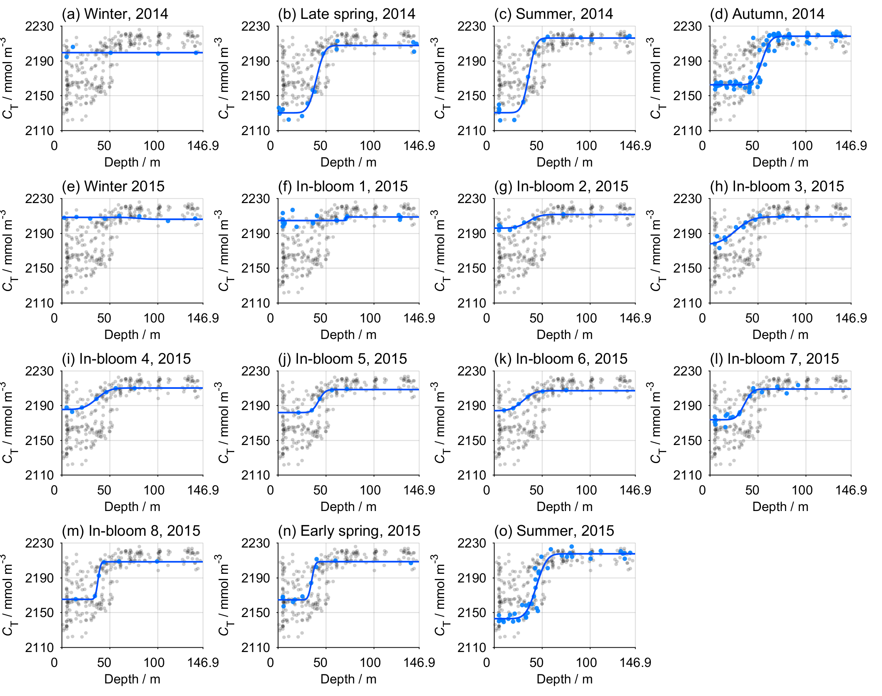

Figure S1. Dissolved inorganic carbon (C_{T}) profiles at each time point at CCS (Table 1). The grey circles show the entire CCS dataset, while the blue circles highlight the data at each time point. The blue line shows the final vertical profile used for inventory calculations (Supp. Table S2).

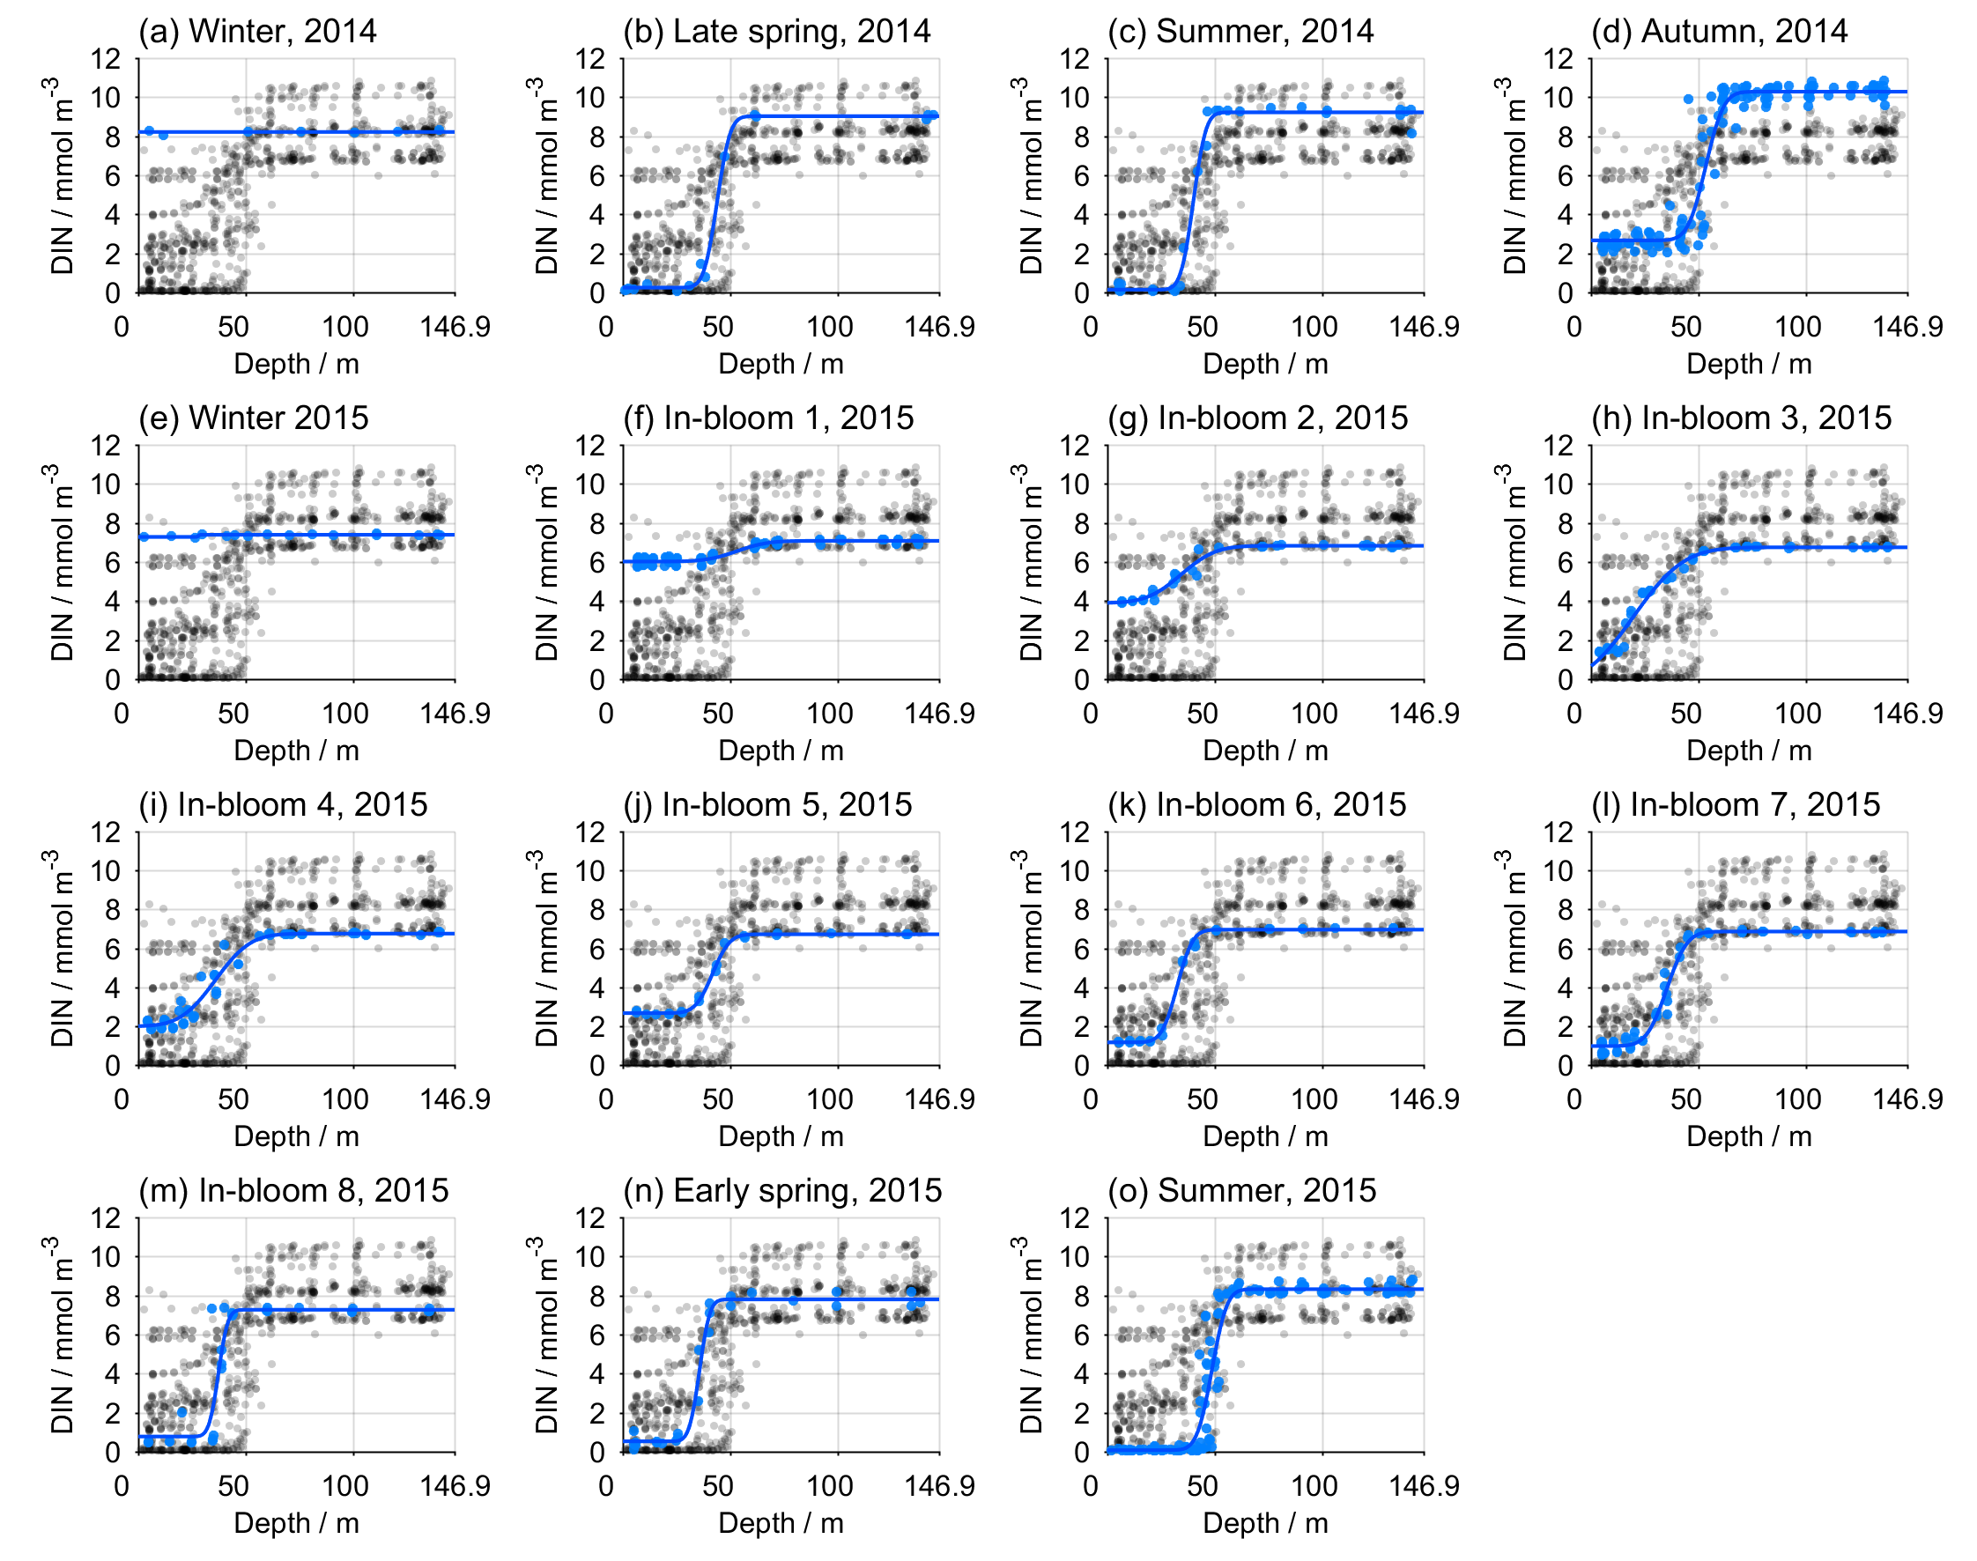

Figure S2. Dissolved inorganic nitrogen (DIN, nitrate + nitrite + ammonium) profiles at each time point at CCS (Table 1). The grey circles show the entire CCS dataset, while the blue circles show the data at each time point. The blue line shows the final vertical profile used for inventory calculations (Supp. Table S2).

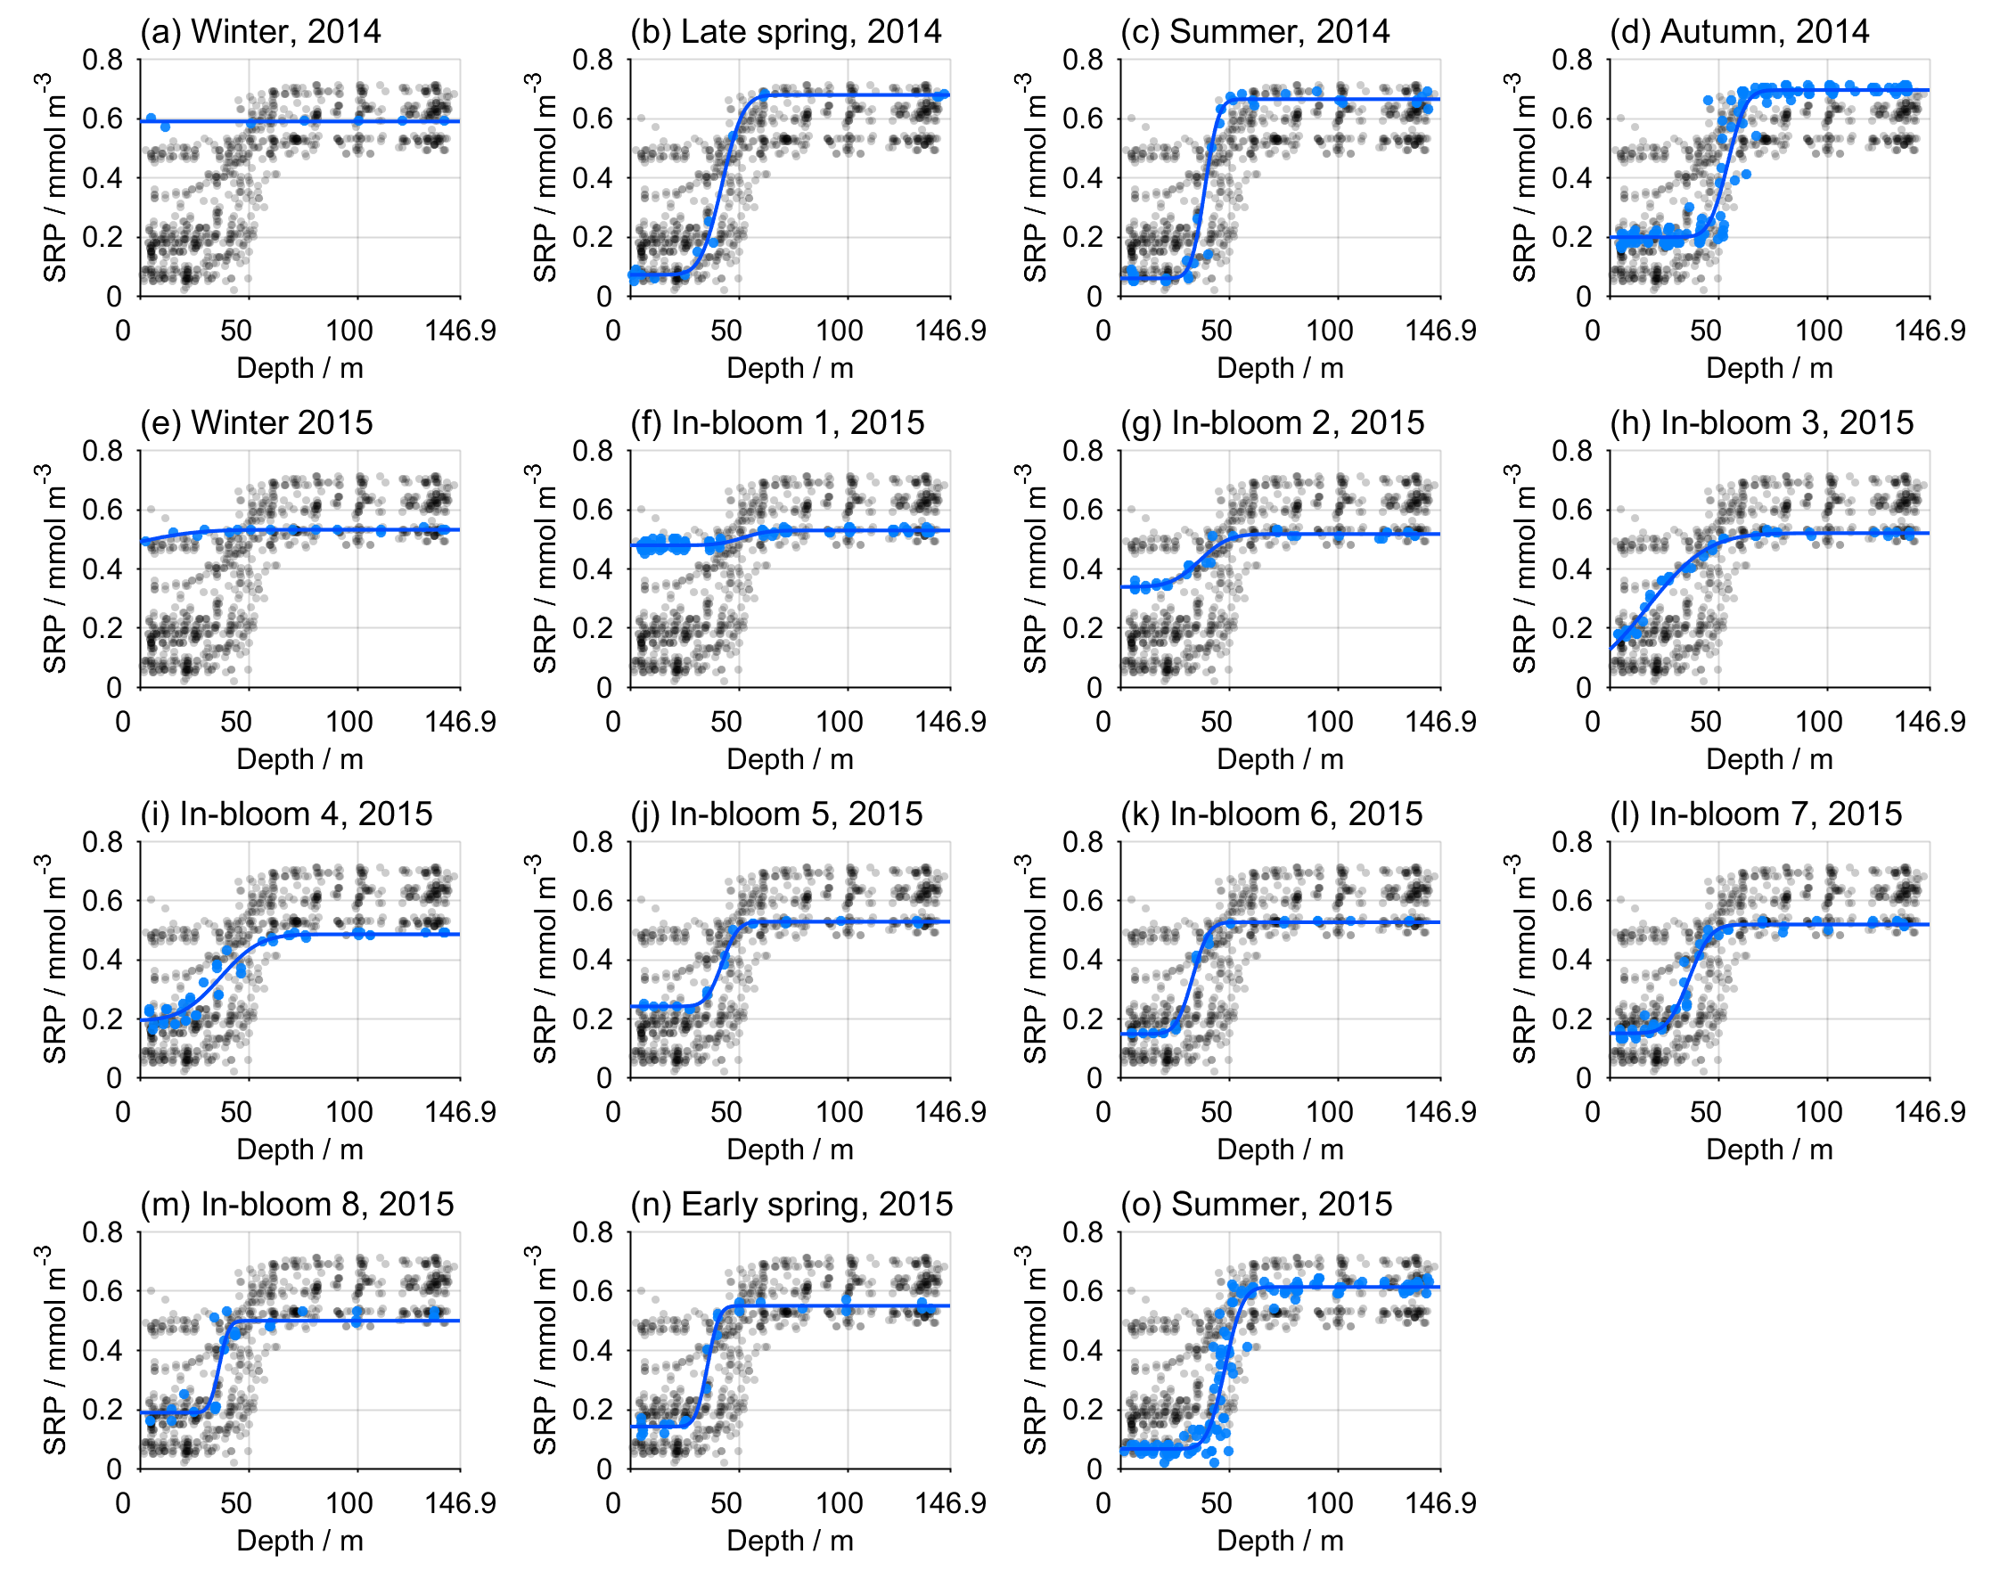

Figure S3. Soluble reactive phosphorus (SRP) profiles at each time point at CCS (Table 1). The grey circles show the entire CCS dataset, while the blue circles show the data at each time point. The blue line shows the final vertical profile used for inventory calculations (Supp. Table S2).

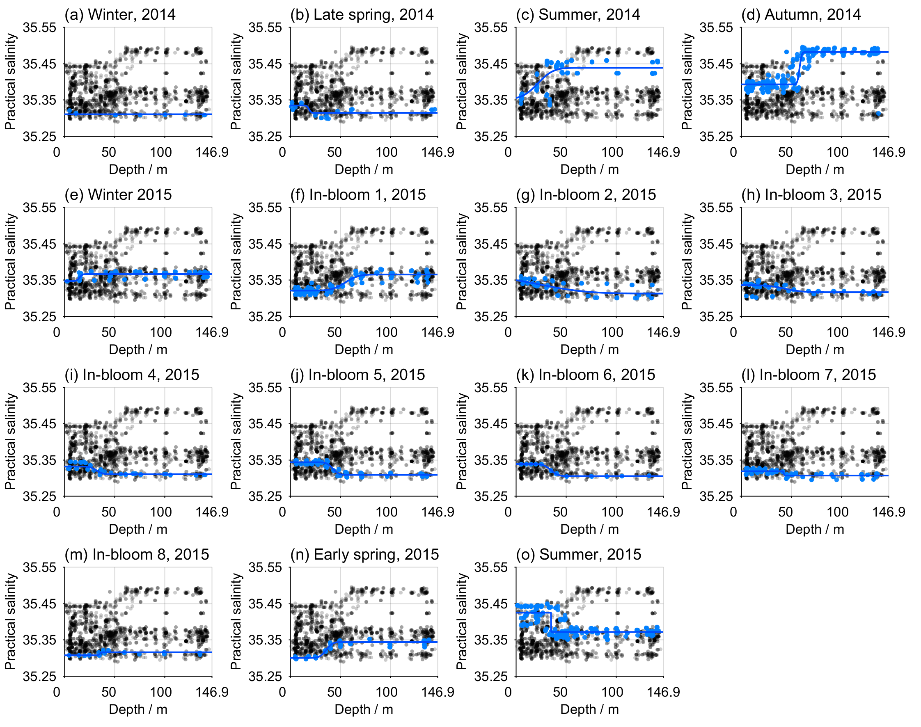

Figure S4. Practical salinity profiles at each time point at CCS (Table 1). The grey circles show the entire CCS dataset, while the blue circles show the data at each time point. The blue line shows the final vertical profile used for inventory calculations (Supp. Table S2).

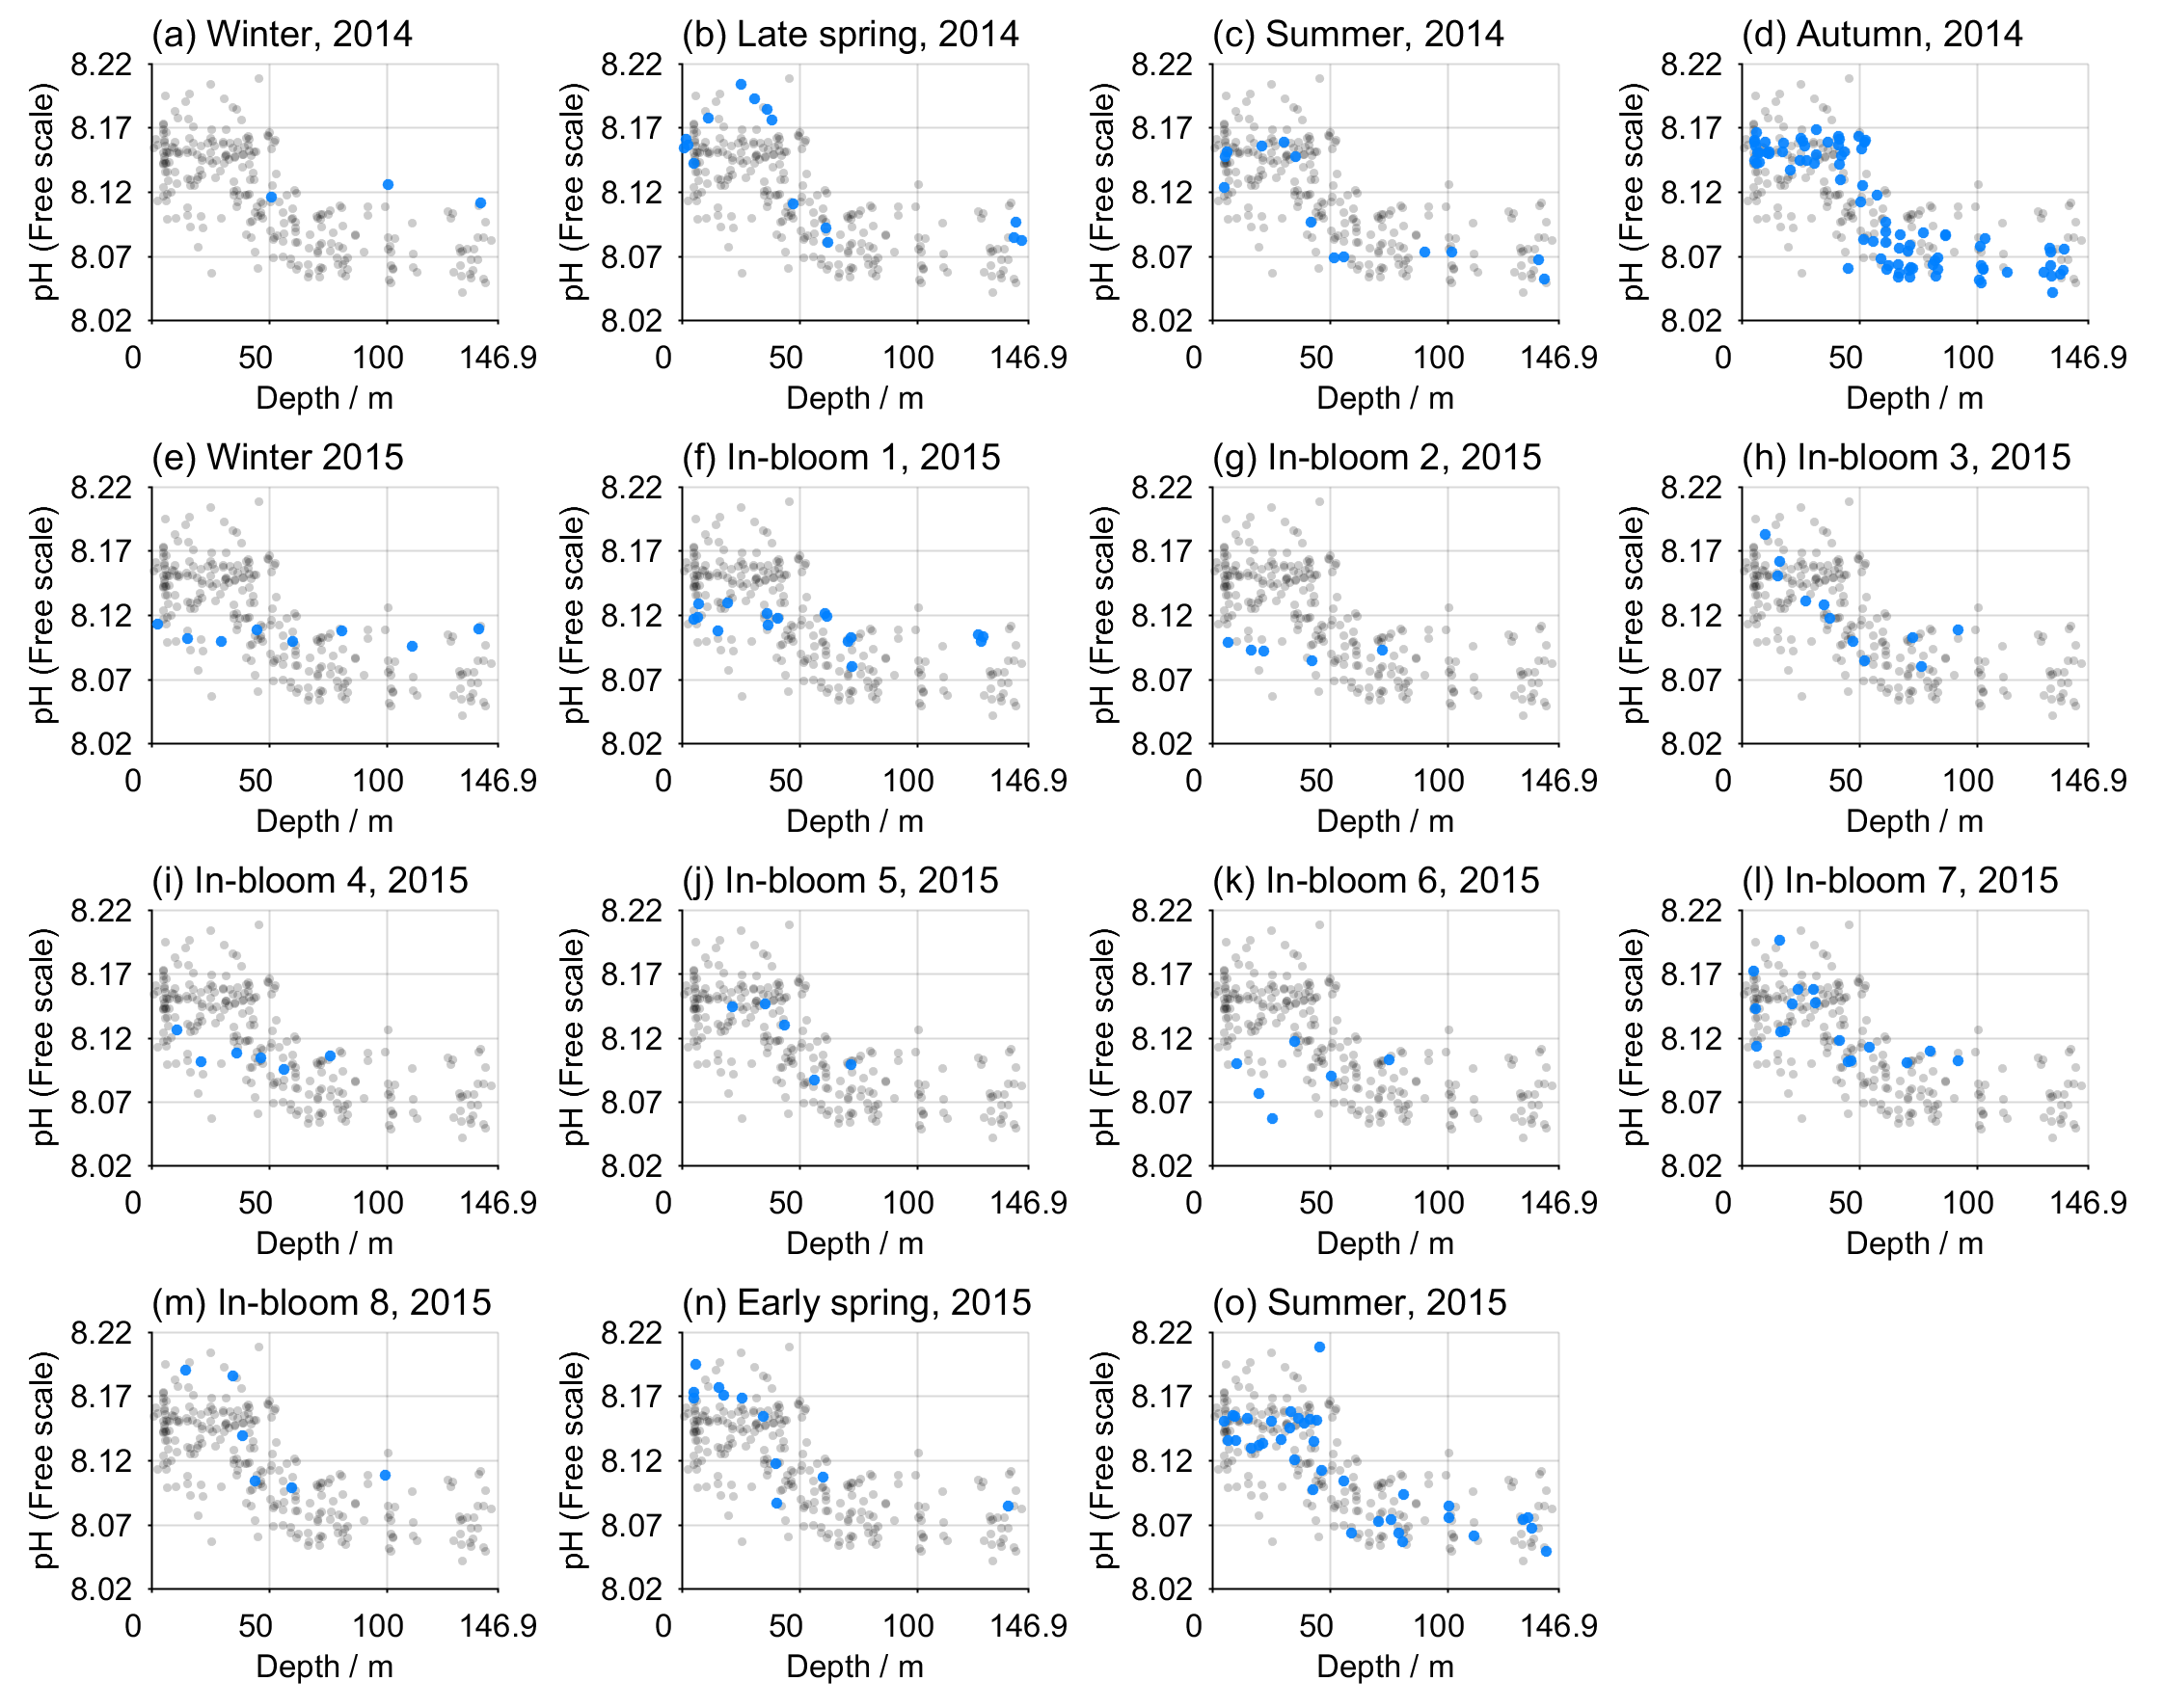

Figure S5. Seawater pH on the Free scale at each time point at CCS (Table 1), calculated from A_{T} and C_{T} measurements (van Heuven et al., 2011). The grey circles show the entire CCS dataset, while the blue circles show the data at each time point.

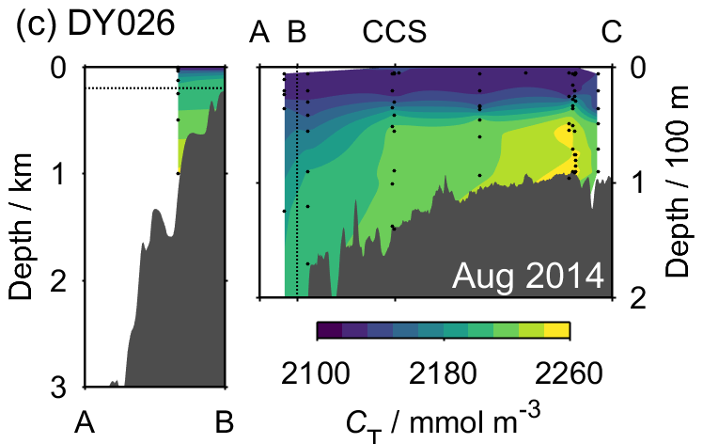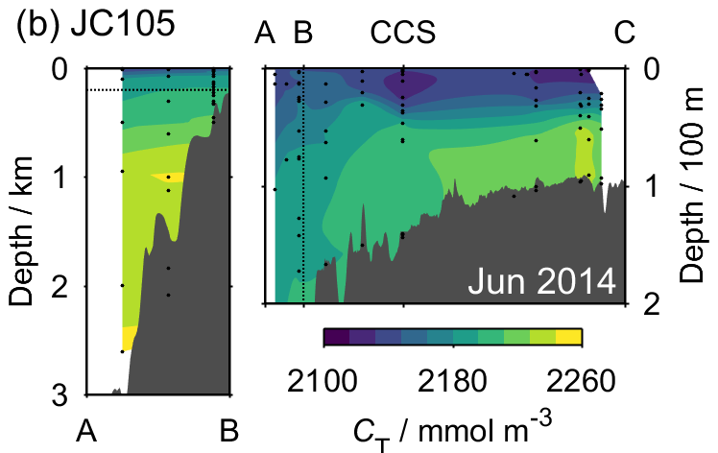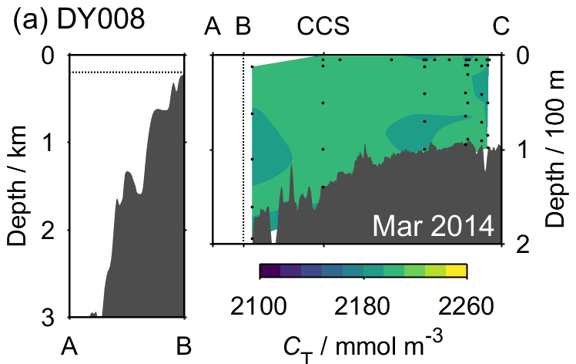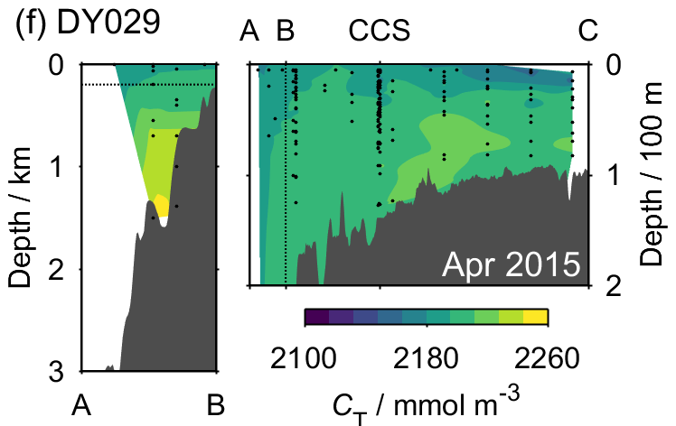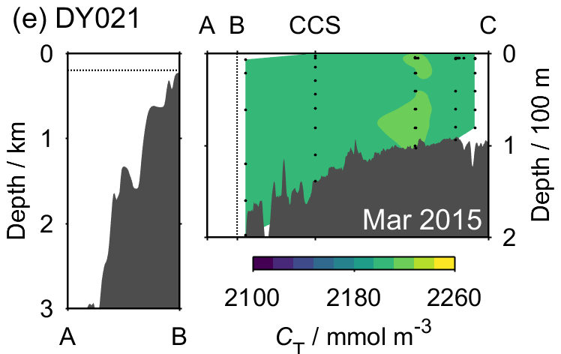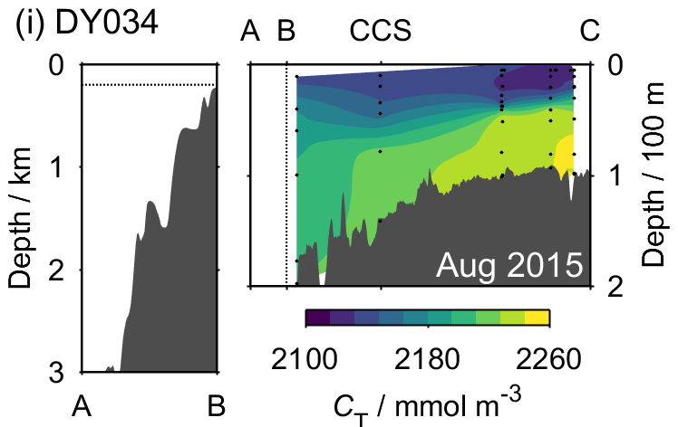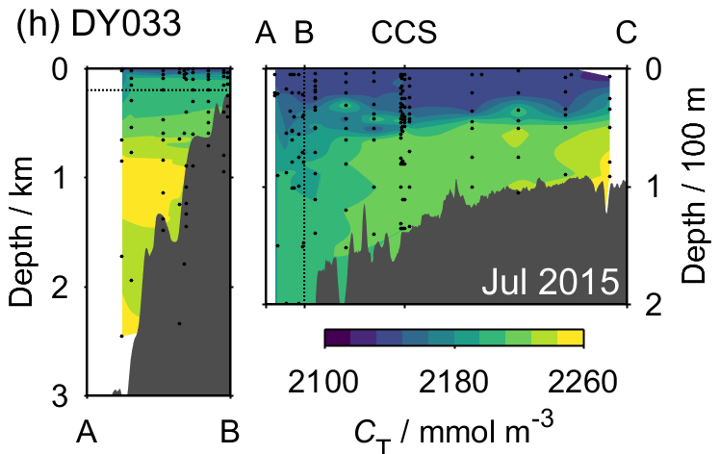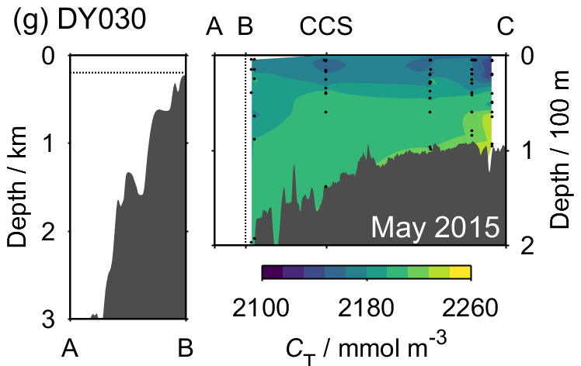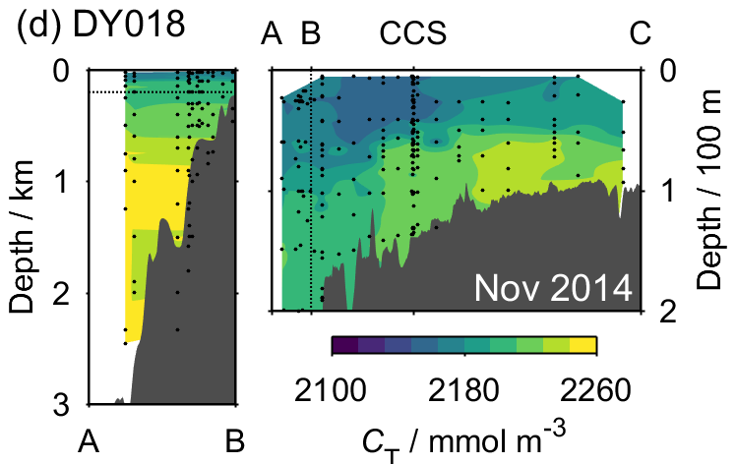

Figure S6. Transects of dissolved inorganic carbon (C_{T}) measured across the Celtic Sea for all of the SSB cruises. In each panel, the area above the horizontal dotted line in the left plot is the same as that to the left of the vertical dotted line in the right plot. Black points indicate the sample locations. The geographical locations of points A, B, CCS and C are shown by Fig. 1.

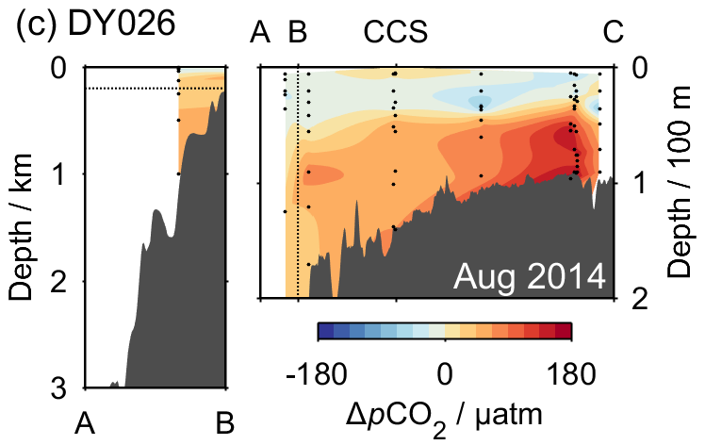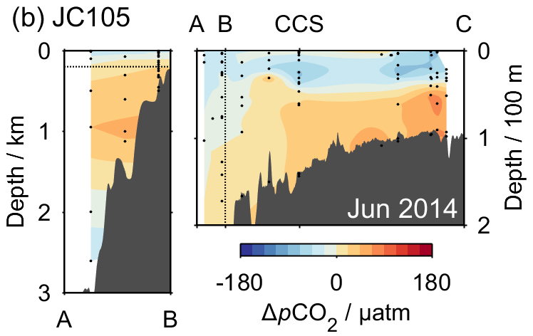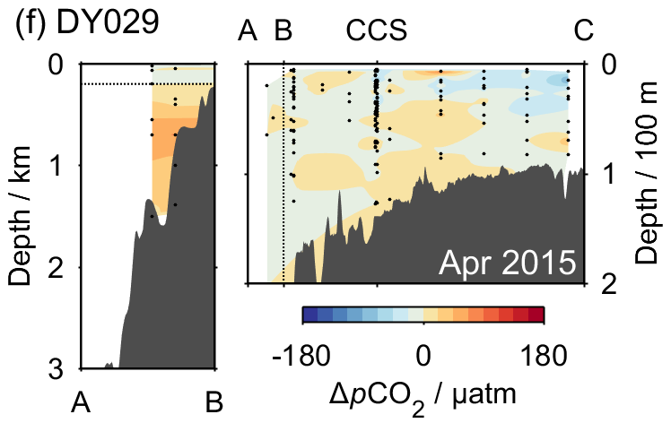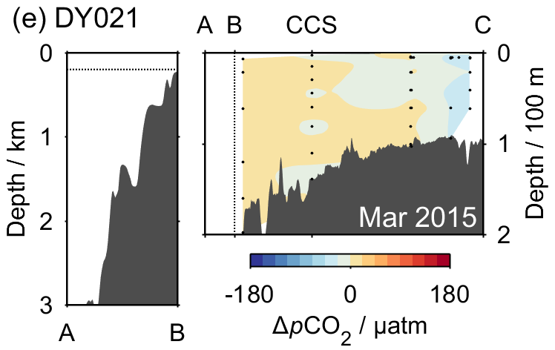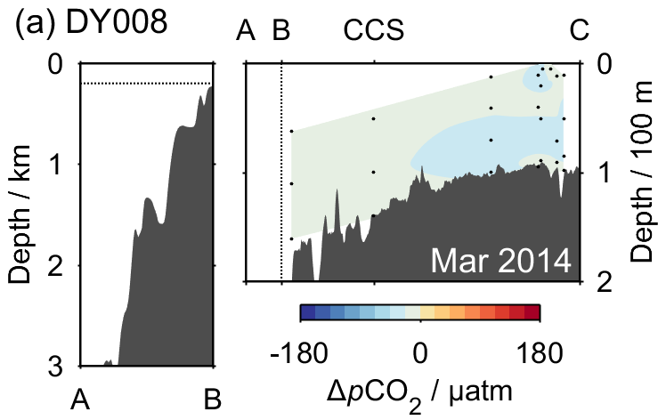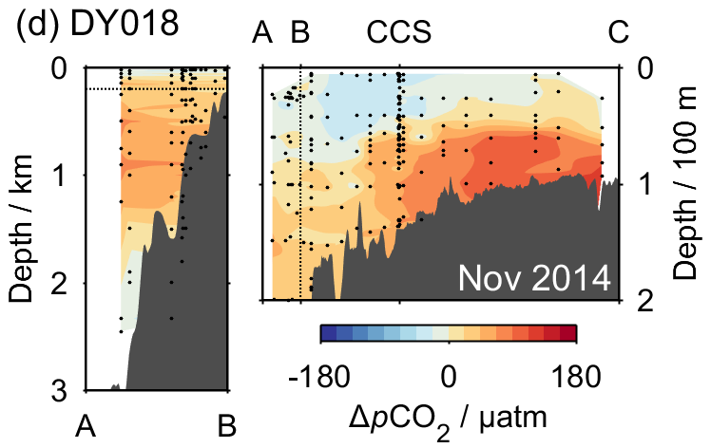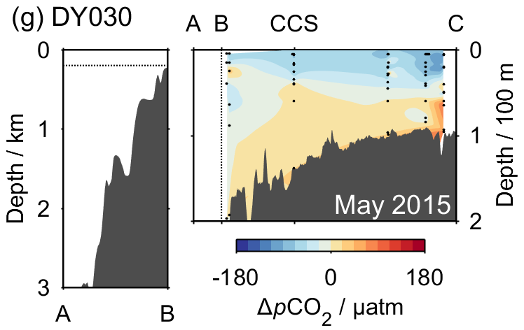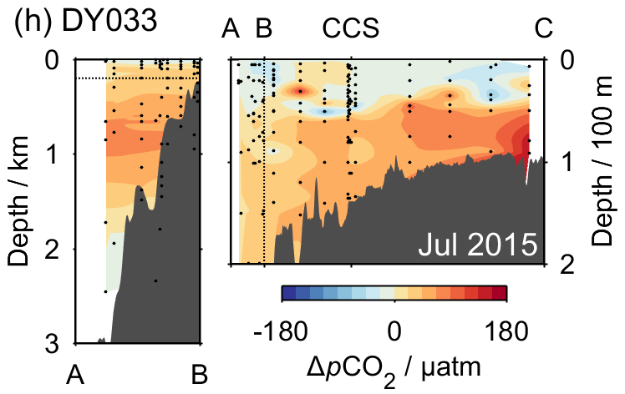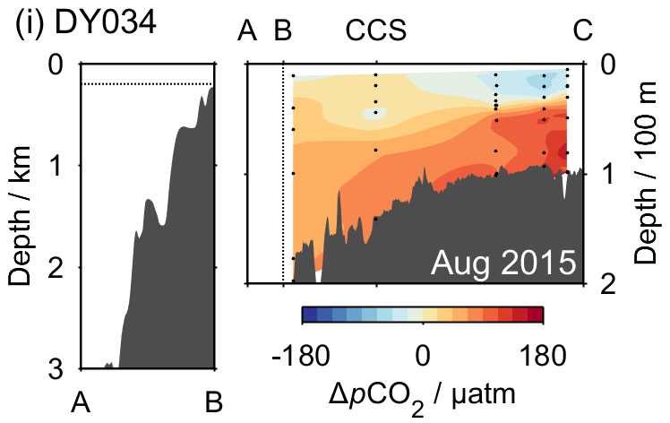

Figure S7. Transects of ΔpCO₂, calculated from C_{T} and A_{T} measurements, across the Celtic Sea for each SSB cruise. The layout is as described for Fig. 7.

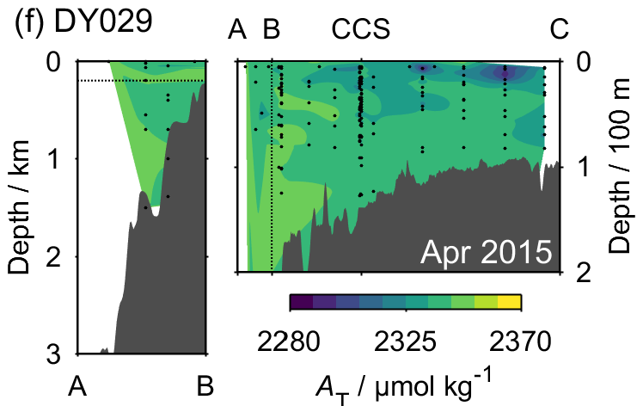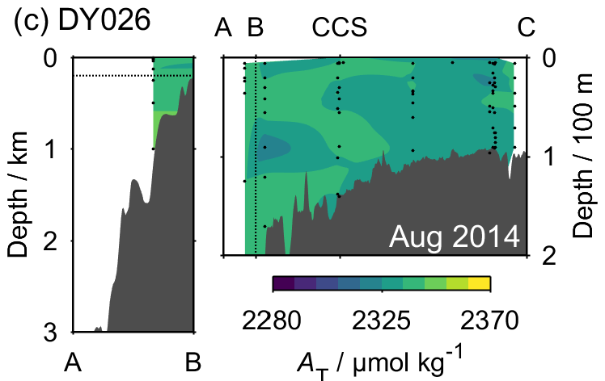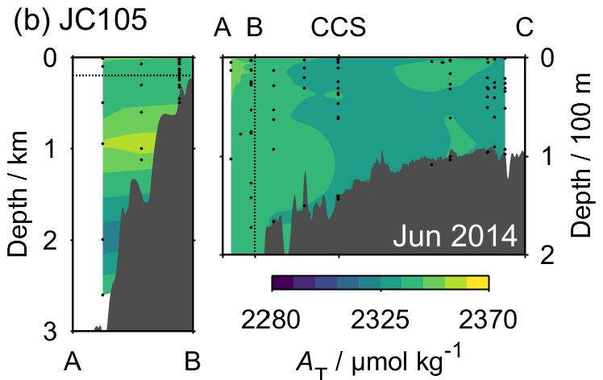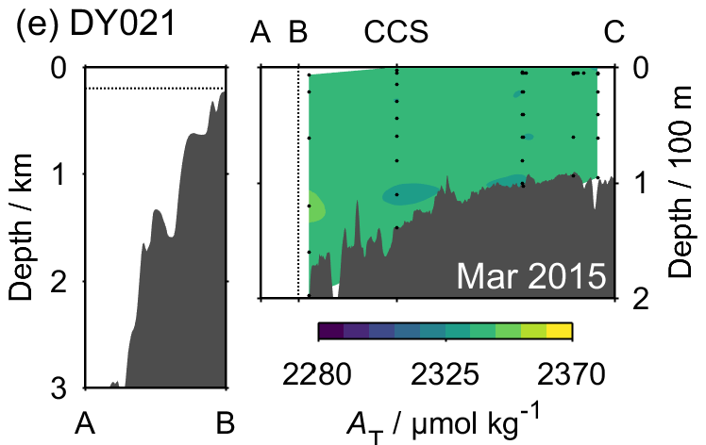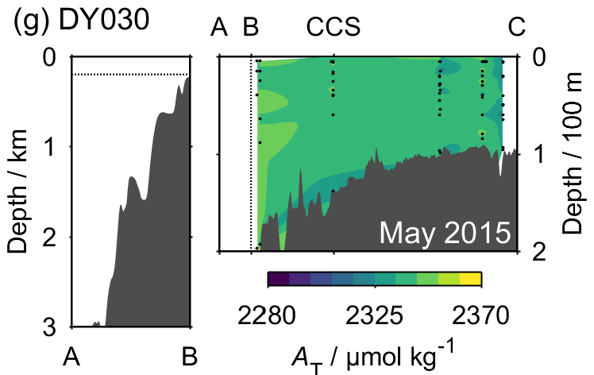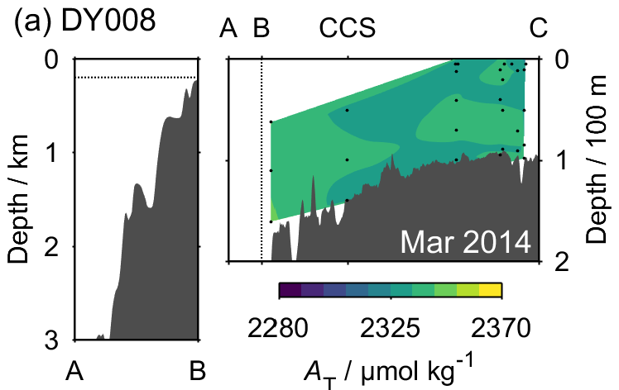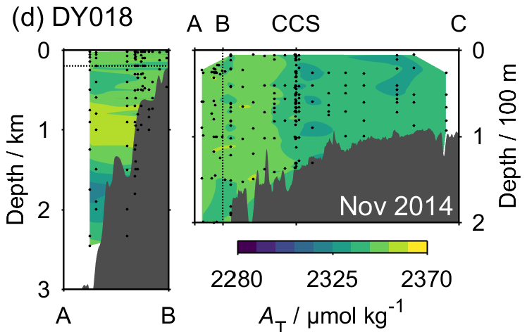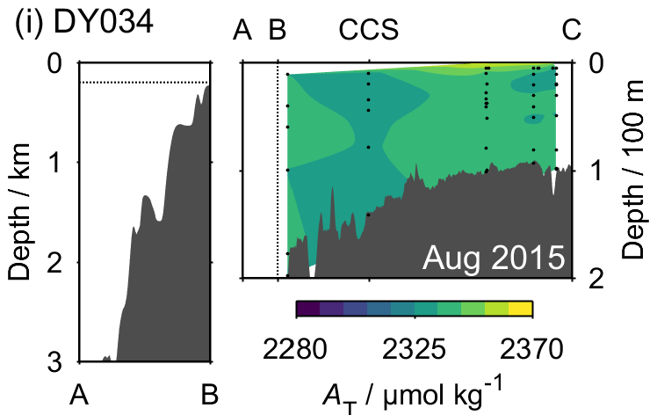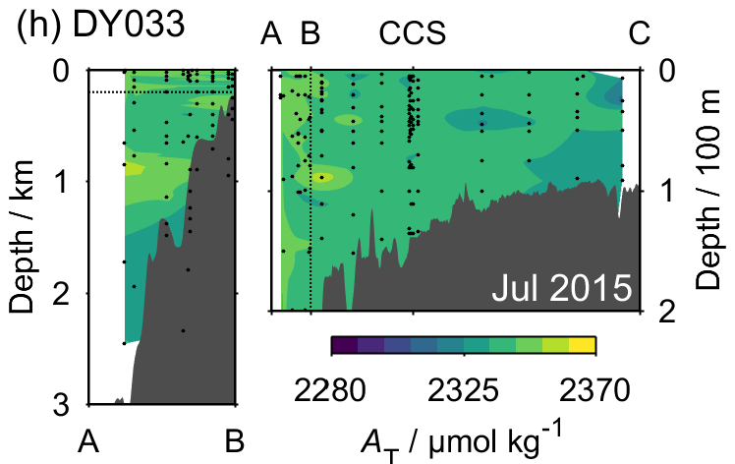

Figure S8. Transects of total alkalinity (A_{T}) across the Celtic Sea for all of the UK-SSB cruises. In each panel, the area above the horizontal dotted line in the left plot is the same as that to the left of the vertical dotted line in the right plot. Black circles indicate sample locations.

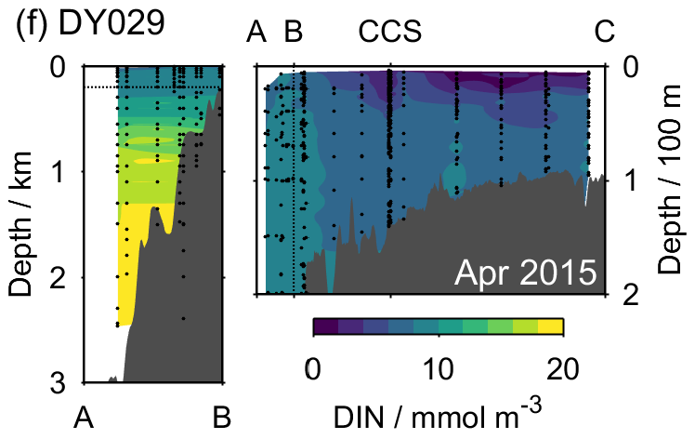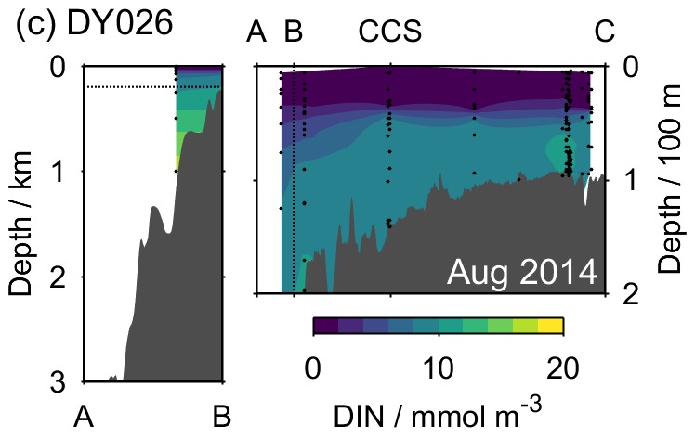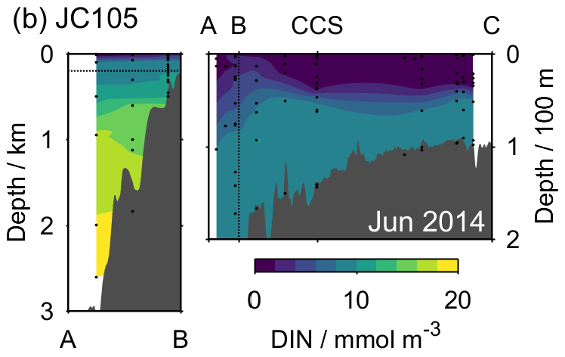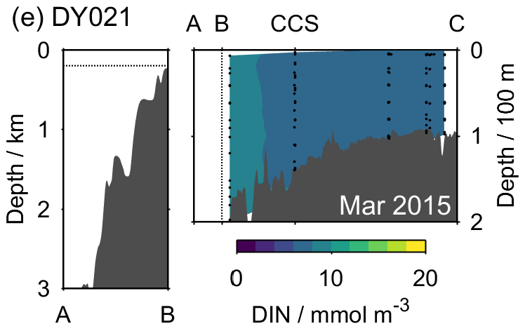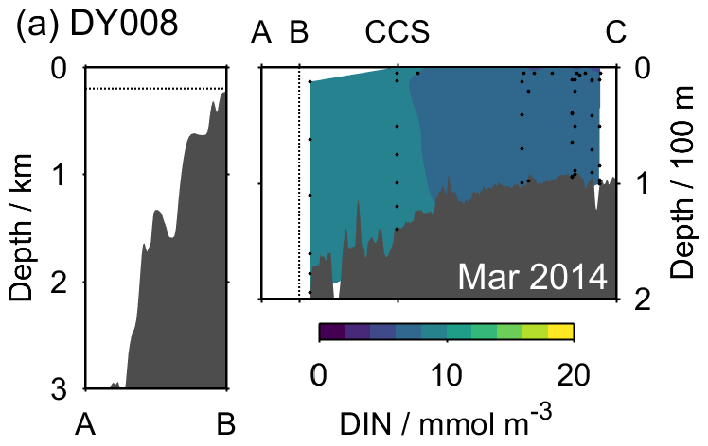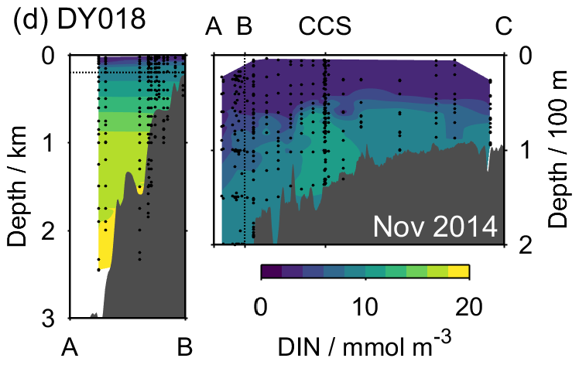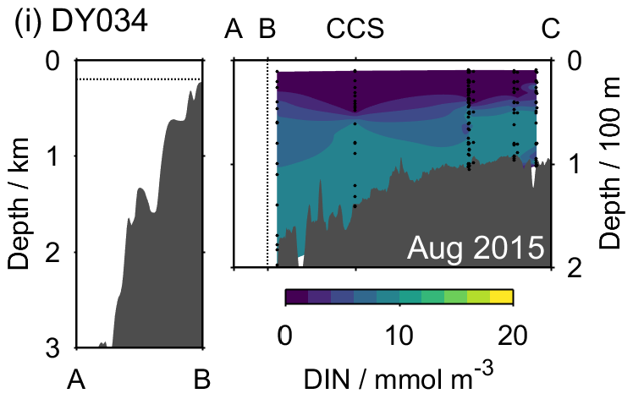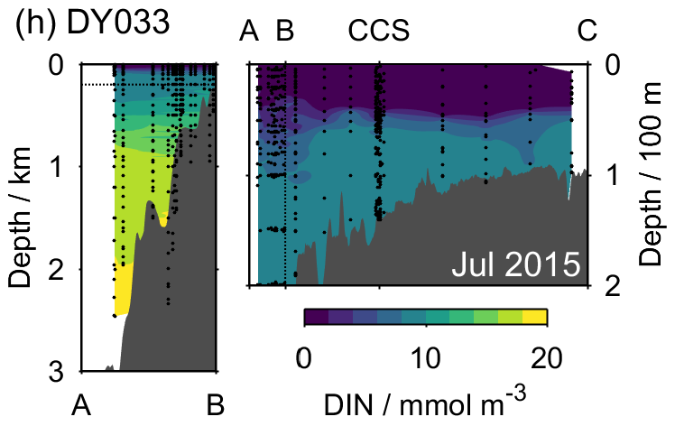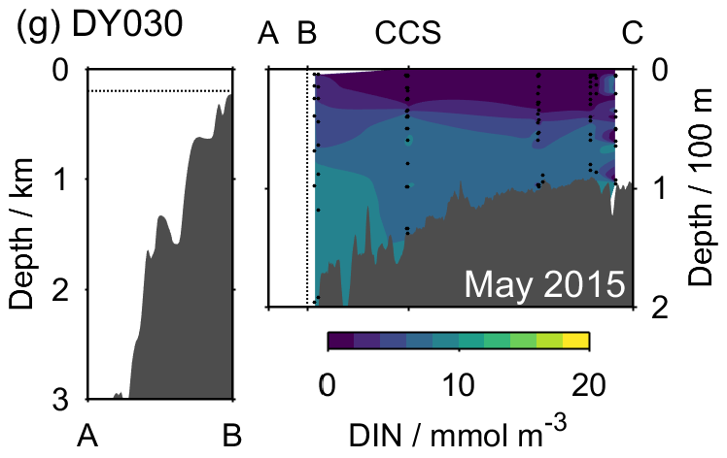

Figure S9. Transects of dissolved inorganic nitrogen (DIN, nitrate + nitrite + ammonium) across the Celtic Sea for all of the UK-SSB cruises. In each panel, the area above the horizontal dotted line in the left plot is the same as that to the left of the vertical dotted line in the right plot. Black circles indicate sample locations.

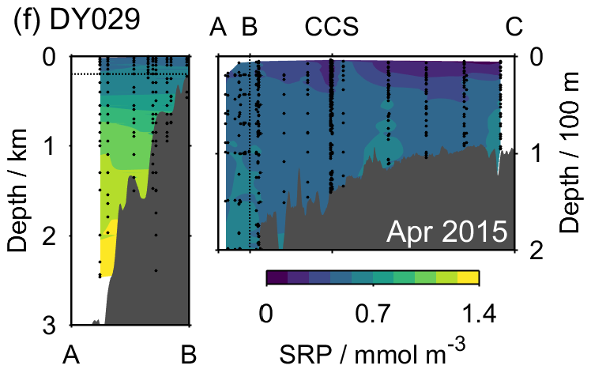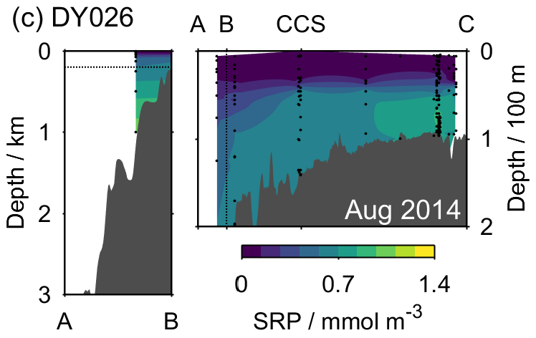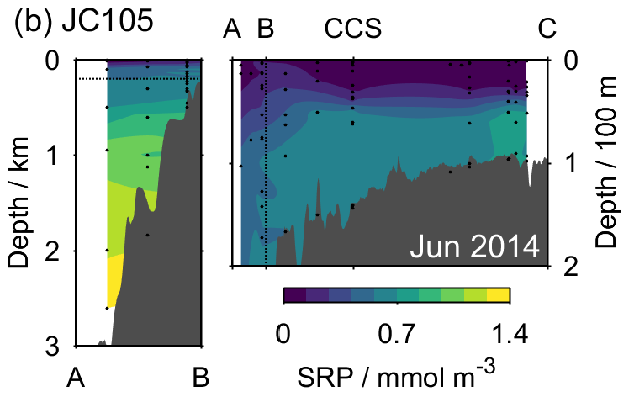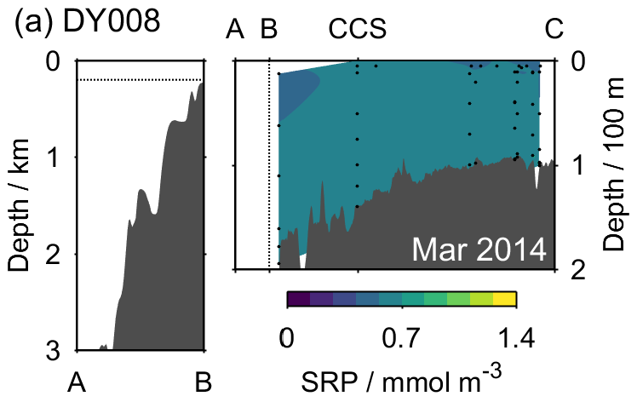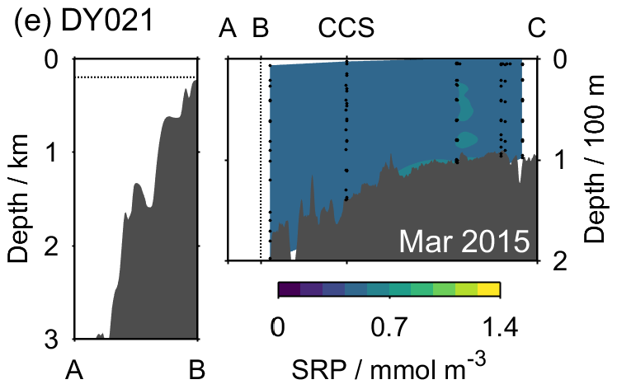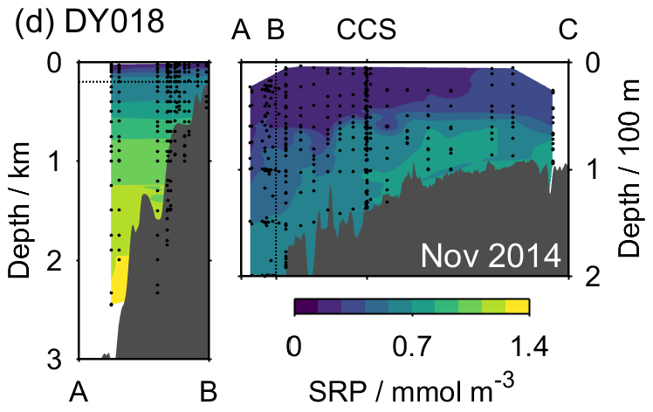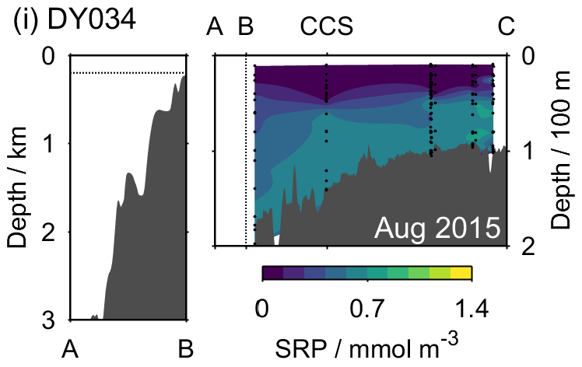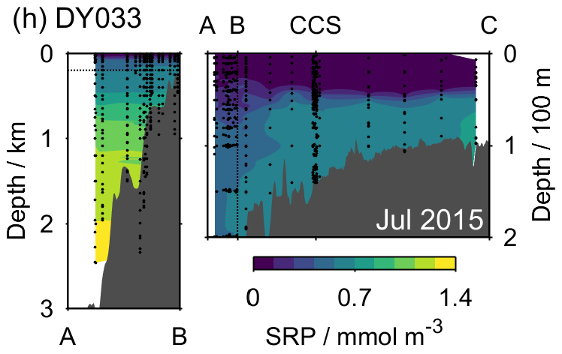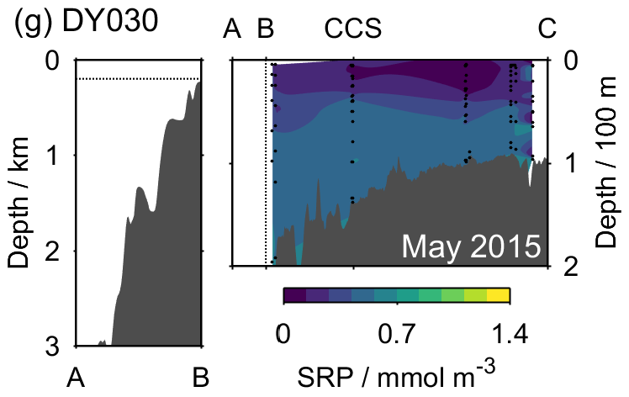

Figure S10. Transects of soluble reactive phosphorus (SRP) across the Celtic Sea for all of the UK-SSB cruises. In each panel, the area above the horizontal dotted line in the left plot is the same as that to the left of the vertical dotted line in the right plot. Black circles indicate sample locations.

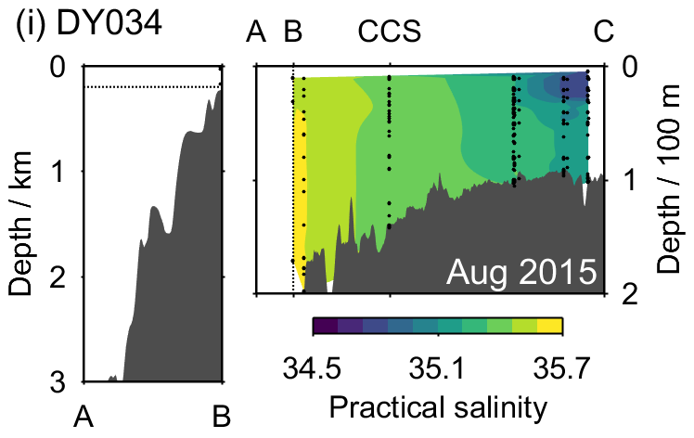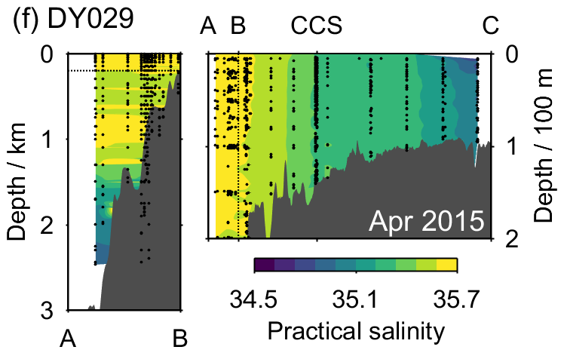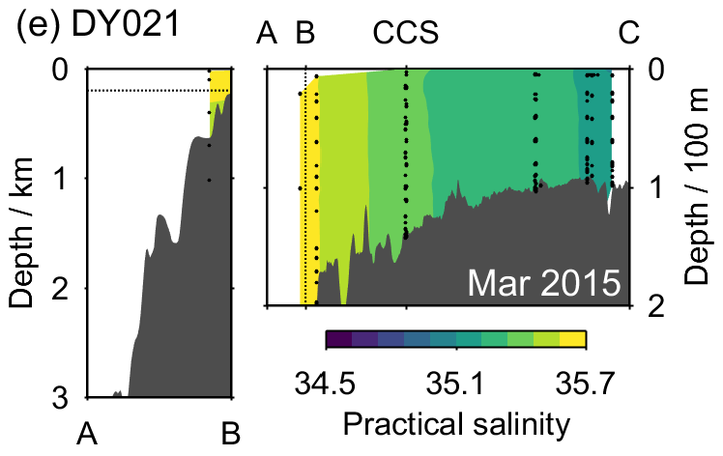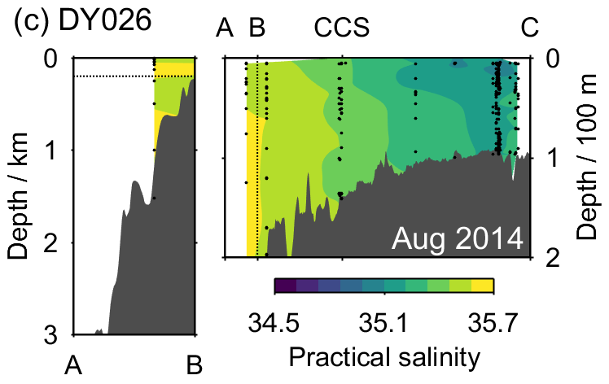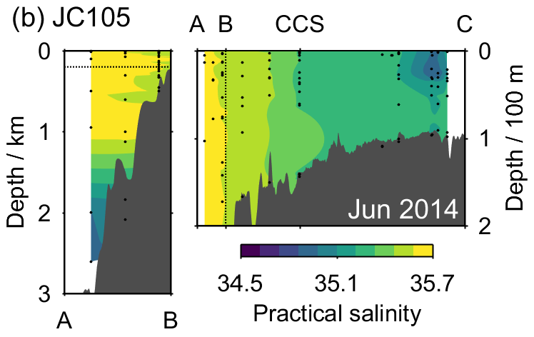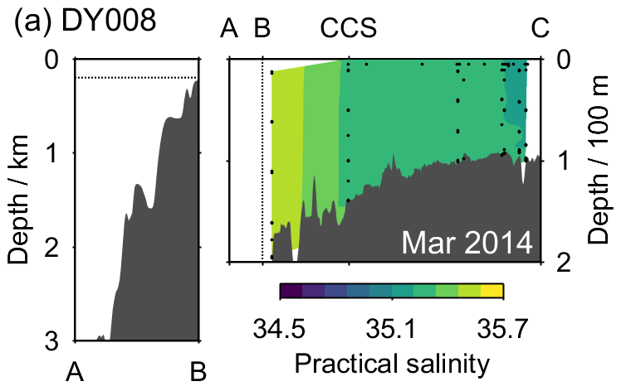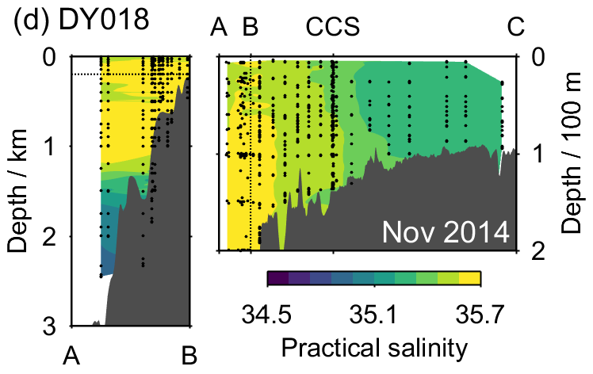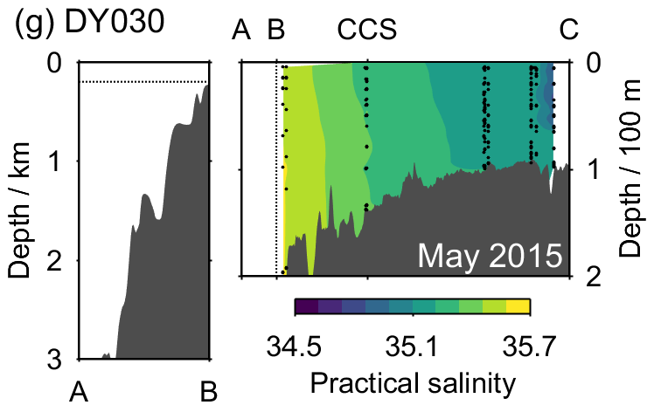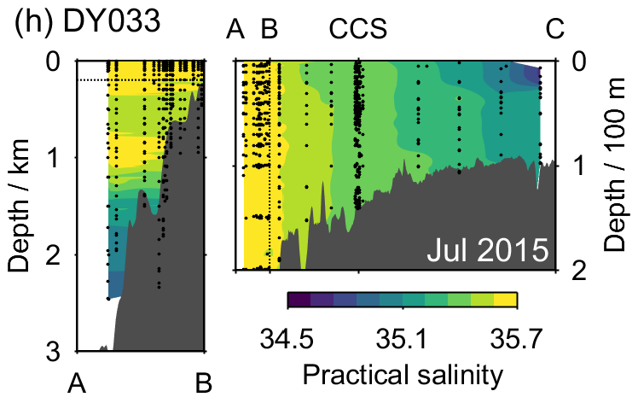

Figure S11. Transects of practical salinity across the Celtic Sea for all of the UK-SSB cruises. In each panel, the area above the horizontal dotted line in the left plot is the same as that to the left of the vertical dotted line in the right plot. Black circles indicate sample locations.

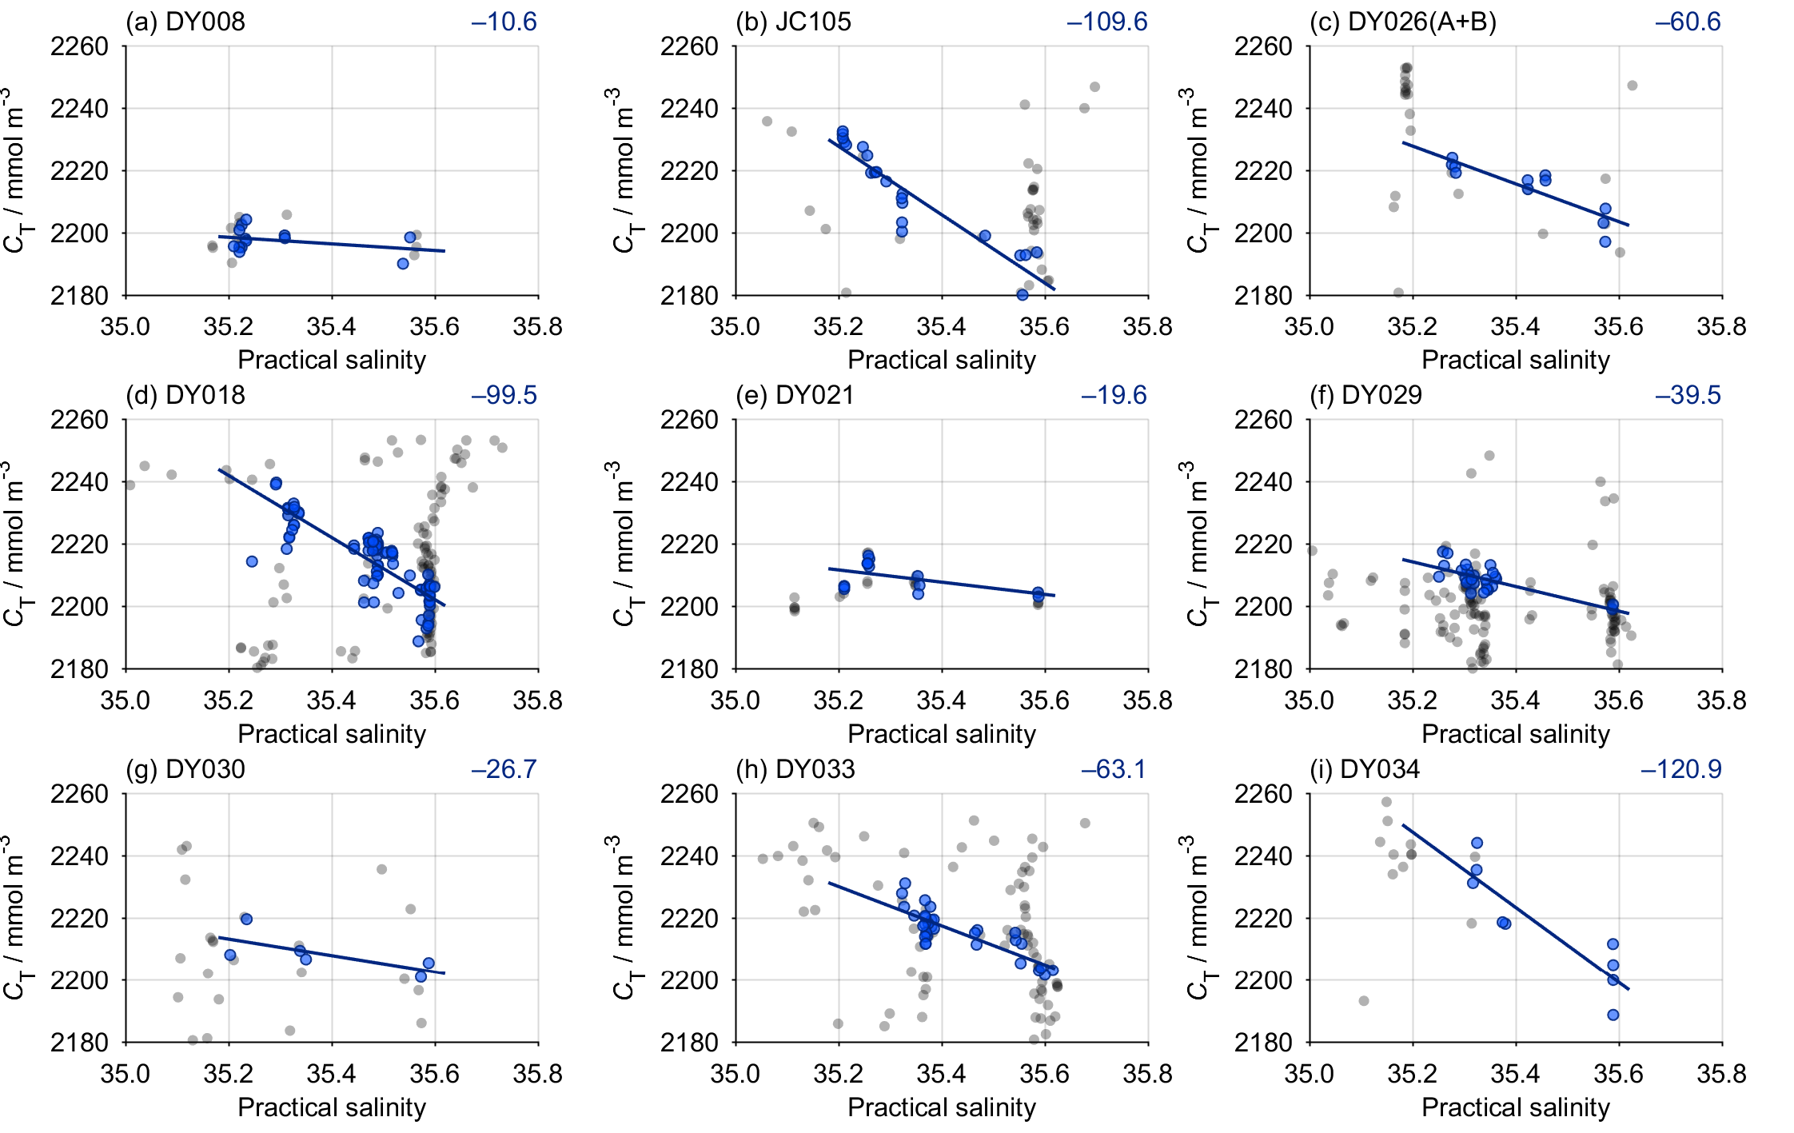

Figure S12. Relationship between dissolved inorganic carbon (C_{T}) and practical salinity for each UK-SSB cruise. The points used to generate each regression are shown in blue (Section 2.8), and the slope is indicated towards the top right of each panel (see also Fig. 7 and Table 3).

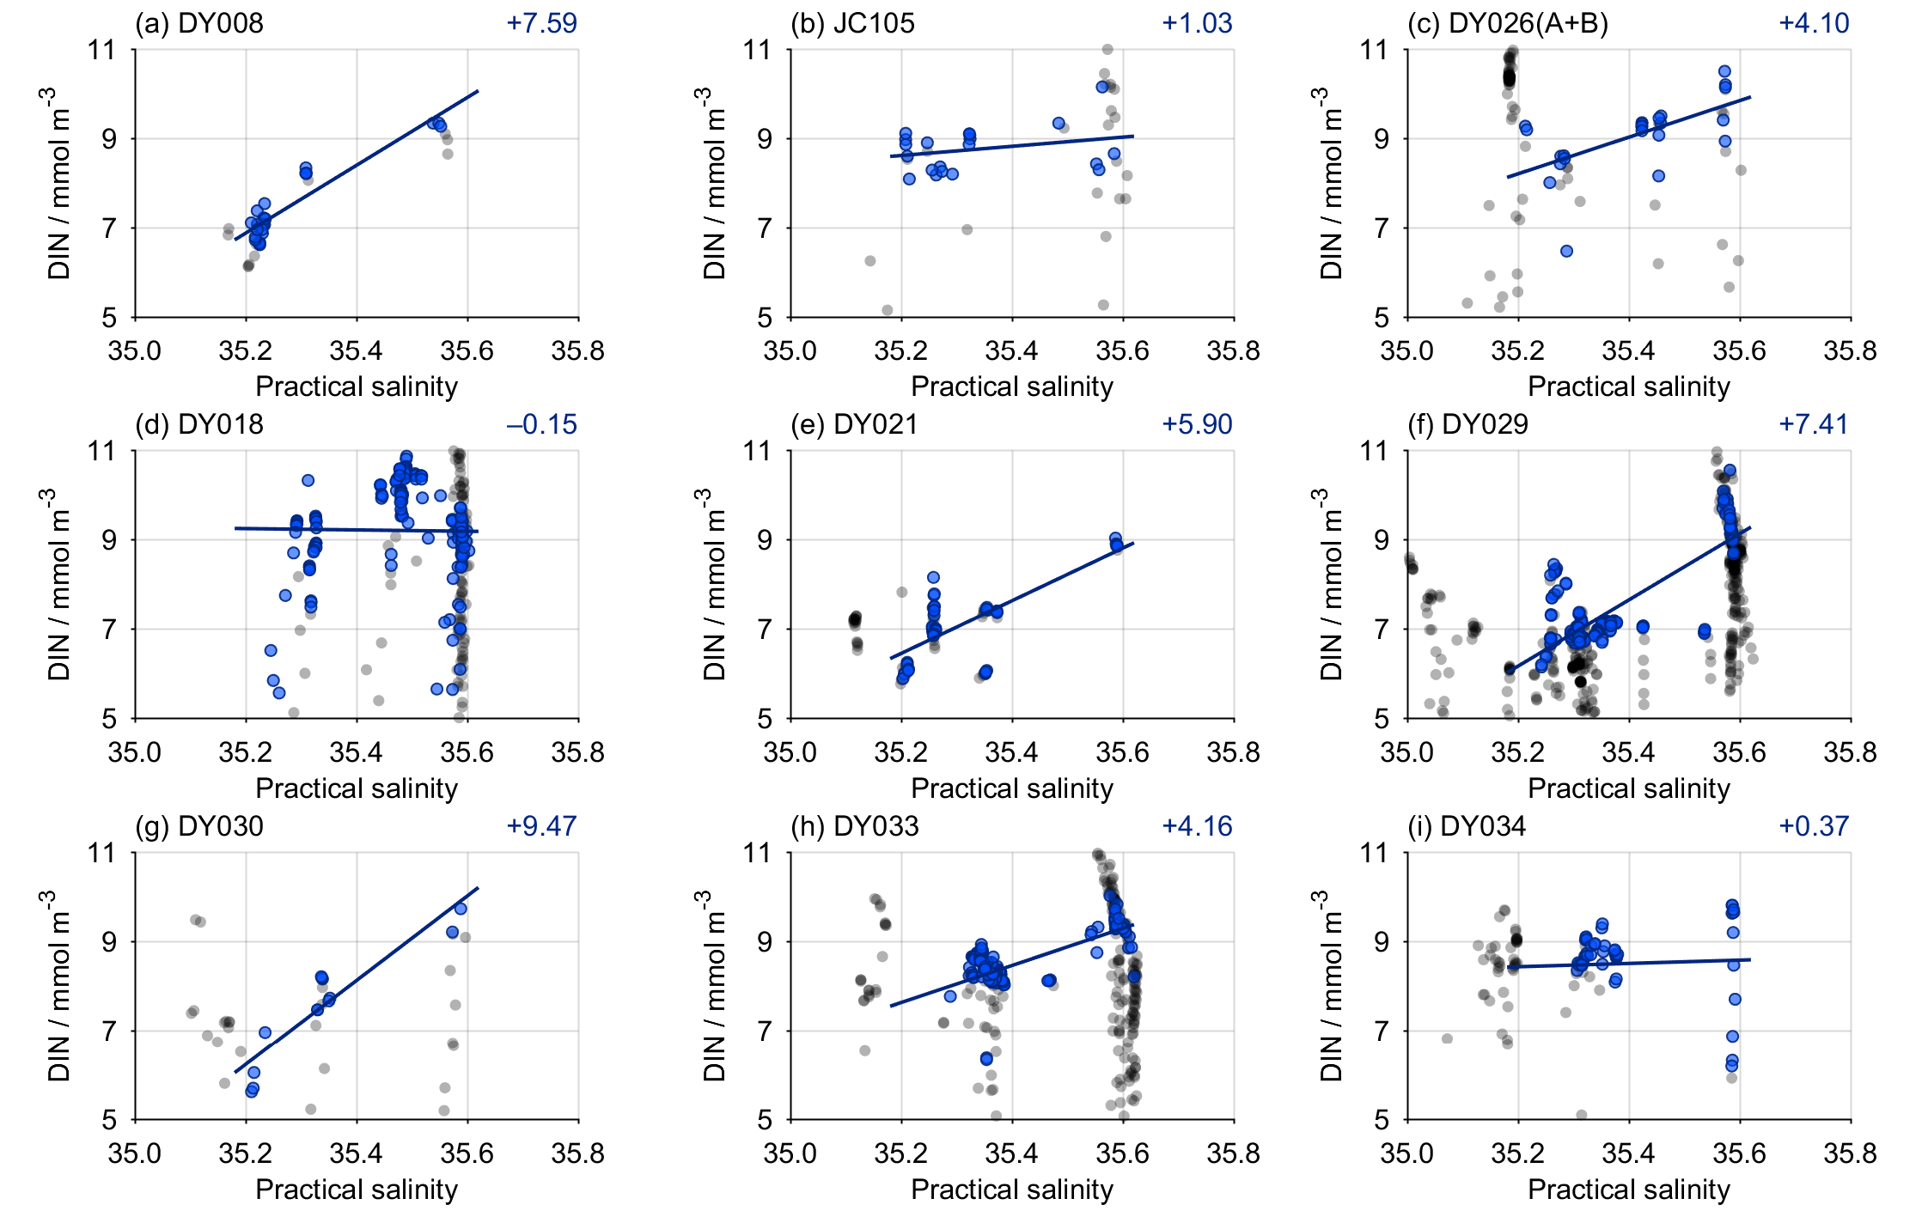

Figure S13. Relationship between dissolved inorganic nitrogen (DIN, nitrate + nitrite + ammonium) and practical salinity for each UK-SSB cruise. The points used to generate each regression are shown in blue (Section 2.8), and the slope is indicated towards the top right of each panel (see also Fig. 7 and Table 3).

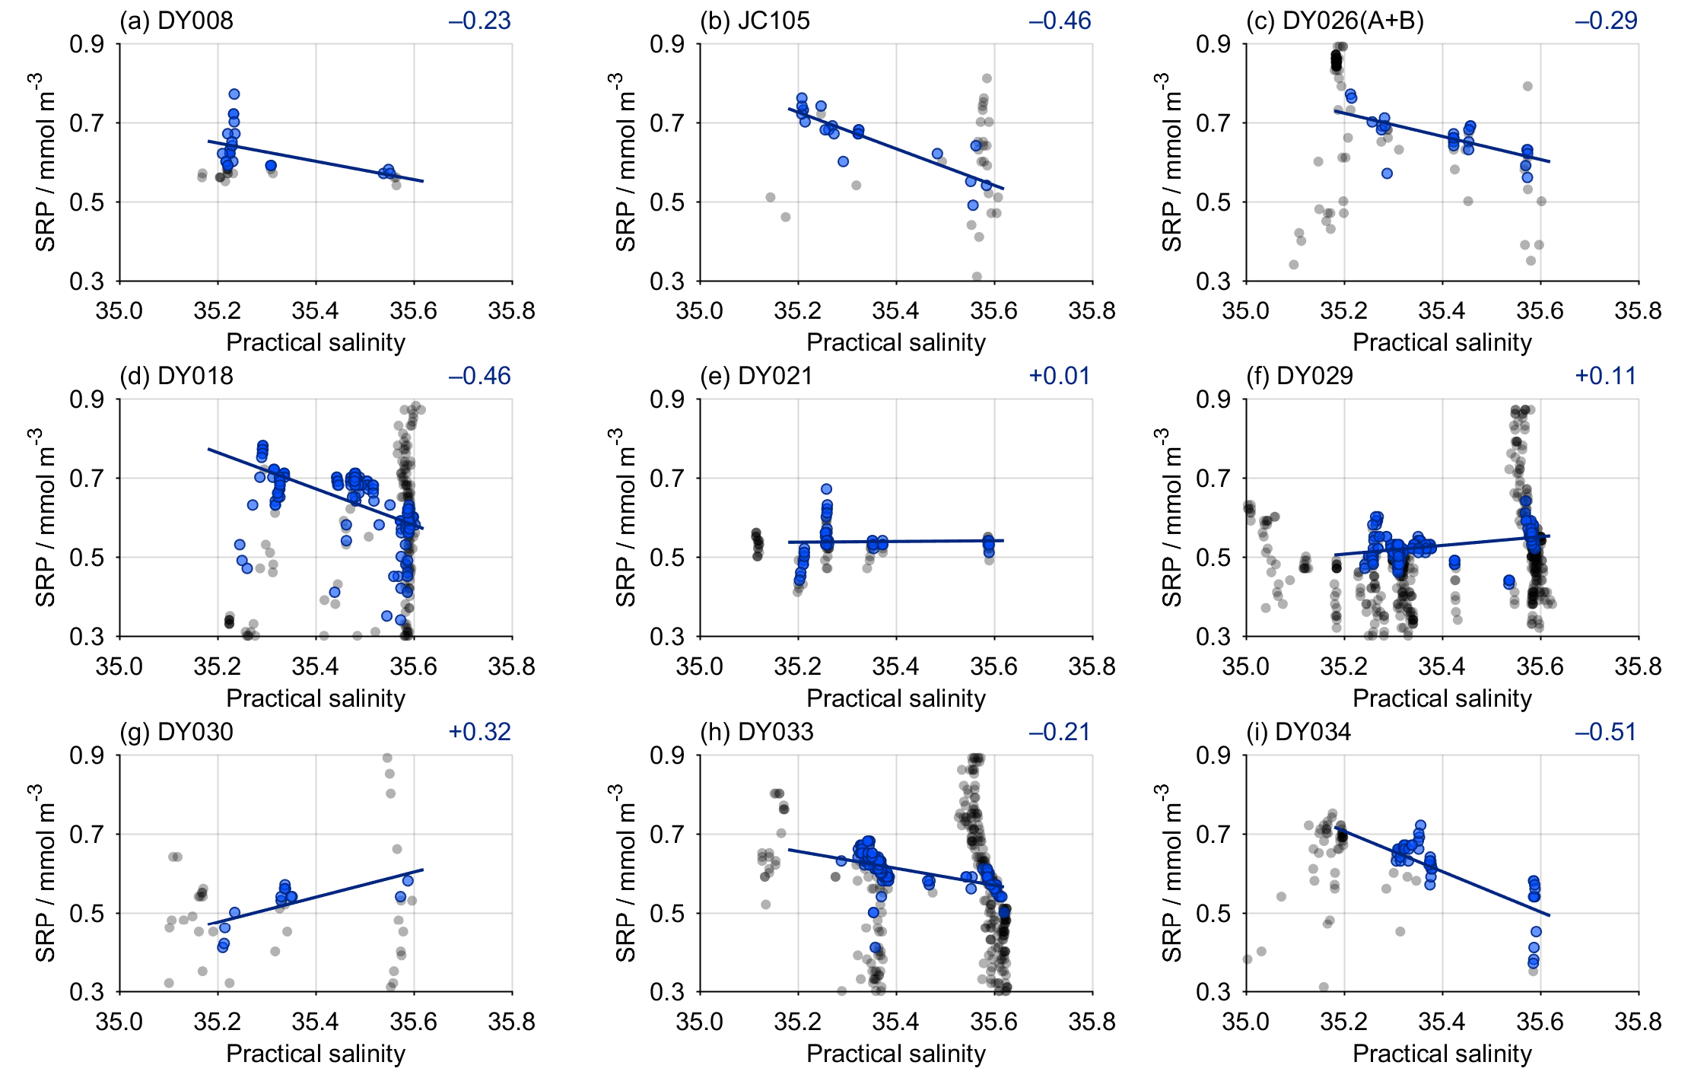

Figure S14. Relationship between soluble reactive phosphorus (SRP) and practical salinity for each UK-SSB cruise. The points used to generate each regression are shown in blue (Section 2.8), and the slope is indicated towards the top right of each panel (see also Fig. 7 and Table 3).

