Managing Fisheries with a Ruler
The reformed Common Fisheries Policy of the EU and similar legislation around the world all exploited fish stocks to be managed such that they are larger than the size required to produce maximum sustainable yields (MSY). However, the data required for full stock assessments are available for only a quarter of the exploited stocks. This has renewed interest in simpler methods to approximate stock size from typically available limited data, such as productivity derived from life history traits combined with time series of catch or length composition data combined with best available approximations of natural mortality and fecundity.
We have developed a length-based Bayesian biomass estimator (LBB) that takes the simplification a step further: most commercial species grow throughout their lives, reaching maximum size at maximum age. This implies that somatic growth and natural mortality of adults are aligned such that they can be expressed through a constant ratio. The mortality caused by fishing can be expressed as similar ratio, and the combined total mortality can then be estimated from the observed decline in numbers of survivors as a cohort of newborn fish grows in length.
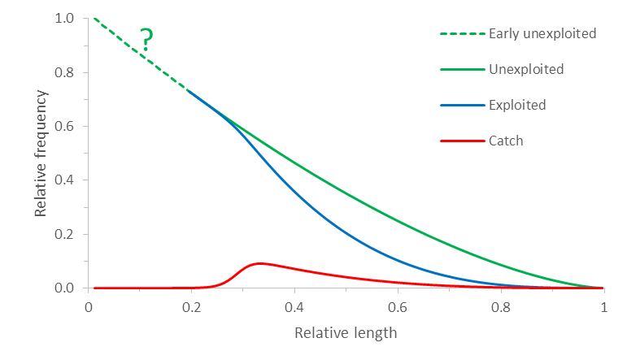
Figure 1. Decline in numbers of a cohort of fish as they grow from early juveniles to maximum length. The green curve indicates no fishing, the red curve is the catch, the blue curve is the exploited length structure, and the difference between the green and the blue curve is proportional to the difference between the exploited and unexploited size of the stock.
The concept is illustrated in Figure 1. The green curve shows the natural decline in numbers as fish grow from early juvenile to maximum length. From a certain size onward, the fish become vulnerable to fishing gear, until all individuals that encounter the gear (here assumed as a trawl) are retained by the gear, indicated by the red curve. The number of fish remaining in the water is then reduced as indicated by the blue curve, and the difference between the green and the blue curves is proportional to the depletion of the stock.
Of the three curves in Figure 1, only the red curve can be observed as length frequency in the commercial catch. LBB takes that information and estimates the corresponding gear selectivity and mortality rates with a Monte Carlo approach. This information can then be used in standard fisheries equations to give preliminary estimates of important fisheries reference points: (1) the current relative to the unexploited stock size; (2) a proxy for the stock size that can produce MSY; and (3) the gear selectivity that would maximize catch and biomass and minimize the impact on size structure for a given fishing pressure. This information can then be used either directly in the management of data-poor stocks, or to inform other stock assessment methods that use additional data.
For example, if stock size is below the one that can produce MSY, managers can temporarily reduce catches until increased stock size allows continuous higher catches. If length at first capture is below the one that would maximize catch and biomass, management can implement a gradual increase in minimum landing length. This is also relevant in the context of the Marine Strategy Framework Directive (MSFD) of the EU, which requires that exploited populations of marine species have a size and age structure indicative of a healthy stock, to ensure the presence of large and highly fecund spawners as a buffer against recruitment failures. Our study shows that optimizing the length at first capture, as was already the case in 12 of the examined stocks, resulted in a mean length of spawners similar to the one without fishing, thus presumably fulfilling this requirement of the MSFD.
The full description of LBB is available in the ICES Journal of Marine Science (doi:10.1093/icesjms/fsy078). The LBB source code, example data and a step-by-step user guide are available from https://oceanrep.geomar.de/43182/.

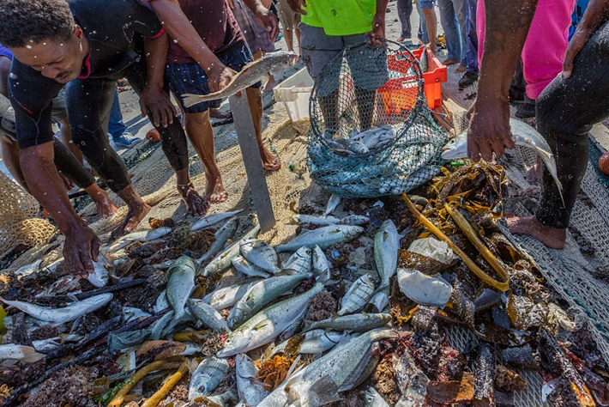
Figure 2. Fishers sorting and measuring the catch of a beach-seine in False Bay, South Africa. Undersized fish are collected in a hoop-net for immediate release. Of 170 permits for such operations in the 1970s, only 4 remain today. Methods such as LBB can help in estimating the stock status of the four main species and in determining minimum landing sizes that reduce the impact of fishing on these stocks (Photographer: Robert Tarr).

