Are Ponto-Caspian species able to cross salinity barriers? – A case study of the gammarid Pontogammarus maeoticus

SUPPLEMENTARY MATERIAL

Nora-Charlotte Pauli^{1,2,3}, Filipa Paiva^{1,4}, Elizabeta Briski^{1,*}

¹GEOMAR Helmholtz Centre for Ocean Research Kiel, Düsternbrooker Weg 20, 24105 Kiel, Germany
²Christian-Albrechts Universität Kiel, Am Botanischen Garten 5-9, 24118 Kiel, Germany
³ present adress: Institute for Chemistry and Biology of the Marine Environment, Carl-von-Ossietzky University, Carl-von-Ossietzky-Straße 9-11, 26111 Oldenburg, Germany
⁴MARE – Marine and Environmental Sciences Centre, Quinta do Lorde Marina, Sítio da Piedade, 9200-044, Caniçal, Madeira Island, Portugal

*Corresponding author: Elizabeta Briski, Phone: +49 431 6001589, Fax +49 431 600 4402, e-mail: ebriski@geomar.de
Table S1. Results of pairwise comparisons of selection treatments and experimental condition of adult survival applying Dunn’s test with Bonferroni adjustment.
Table S2. Pairwise comparisons of selection treatment and experimental condition combinations of juvenile survival using the ‘lsmeans’ function in R applying a Bonferroni adjustment. SE and df denote standard error and degrees of freedom, respectively.
Table S3. Pairwise comparisons of selection treatment and experimental condition combinations of juvenile cephalon length using the ‘lsmeans’ function in R applying a Bonferroni adjustment. SE and df denote standard error and degrees of freedom, respectively.
Figure S1. Offspring-midparent regression for the “selected 4 PSU” (left) and “selected 16 PSU” (right) selection treatments in “control” experimental condition. The linear regression functions, R², p-value, and slope are shown. The slope of the regression was used as the heritability estimate (h²).
Figure S2. Offspring-midparent regression for the “selected 4 PSU” (left) and “selected 16 PSU” (right) selection treatments in “low stress” experimental condition. The linear regression functions, R², p-value and slope are shown. The slope of the regression was used as the heritability estimate (h²).
Figure S3. Offspring-midparent regression for the “selected 4 PSU” selection treatment in “high stress” experimental condition. The linear regression functions, R², p-value, and slope are shown. The slope of the regression was used as the heritability estimate (h²).
Table S1. Results of pairwise comparisons of selection treatments and experimental condition of adult survival applying Dunn’s test with Bonferroni adjustment.
Contrast | z-value | p-value adj.
“Selected 16 PSU” treatment - “Ambient 10 PSU” treatment | 3.511 | < 0.001
“Selected 4 PSU” treatment – “Ambient 10 PSU” treatment | 4.433 | < 0.001
“Selected 4 PSU” treatment – “Selected 16 PSU” treatment | 0.845 | 0.598
“High stress” exp. condition – “Control” exp. condition | 3.096 | 0.003
“Low stress” exp. condition – “Control” exp. condition | 0.248 | 1
“Low stress” exp. condition – “High stress” exp. condition | - 2.590 | 0.014

Table S2. Pairwise comparisons of selection treatment and experimental condition combinations of juvenile survival using the ‘lsmeans’ function in R applying a Bonferroni adjustment. SE and df denote standard error and degrees of freedom, respectively.
Treatment | Contrast | Estimate | SE | df | z-ratio | p-value
Experimental condition | Selection treatment
“Control” | “Selected 4 PSU” - “Ambient 10 PSU” | 0.026 | 0.027 | NA | 0.978 | 0.985
“Control” | “Selected 4 PSU” – “Selected 16 PSU” | - 0.171 | 0.072 | NA | - 2.388 | 0.051
“Control” | “Ambient 10 PSU” – “Selected 16 PSU” | - 0.197 | 0.069 | NA | - 2.825 | 0.014
“High stress” | “Selected 4 PSU” – “Ambient 10 PSU” | - 0.01 | 0.037 | NA | - 0.265 | 1
“High stress” | “Selected 4 PSU” – “Selected 16 PSU” | - 0.169 | 0.297 | NA | - 0.57 | 1
“High stress” | “Ambient 10 PSU” – “Selected 16 PSU” | - 0.159 | 0.297 | NA | - 0.536 | 1
“Low stress” | “Selected 4 PSU”- “Ambient 10 PSU” | - 0.038 | 0.029 | NA | - 1.277 | 0.605
“Low stress” | “Selected 4 PSU” – “Selected 16 PSU” | - 0.031 | 0.032 | NA | - 0.962 | 1
“Low stress” | “Ambient 10 PSU” – “Selected 16 PSU” | 0.007 | 0.032 | NA | 0.222 | 1
Selection treatment | Experimental condition
“Selected 4 PSU” | “Control” – “High stress” | 0.025 | 0.033 | NA | 0.77 | 1
“Selected 4 PSU” | “Control” – “Low stress” | 0.065 | 0.03 | A | 2.122 | 0.102
“Selected 4 PSU” | “High stress” – “Low stress” | 0.039 | 0.032 | NA | 1.239 | 0.646
“Ambient 10 PSU” | “Control” – “High stress” | - 0.011 | 0.032 | NA | - 0.34 | 1
“Ambient 10 PSU” | “Control” – “Low stress” | 0.001 | 0.026 | NA | 0.029 | 1
“Ambient 10 PSU” | “High stress” – “Low stress” | 0.012 | 0.035 | NA | 0.33 | 1
“Selected 16 PSU” | “Control” – “High stress” | 0.027 | 0.303 | NA | 0.09 | 1
“Selected 16 PSU” | “Control” – “Low stress” | 0.205 | 0.072 | NA | 2.836 | 0.014
“Selected 16 PSU” | “High stress” – “Low stress” | 0.178 | 0.297 | NA | 0.599 | 1
Table S3. Pairwise comparisons of selection treatment and experimental condition combinations of juvenile cephalon length using the ‘lsmeans’ function in R applying a Bonferroni adjustment. SE and df denote standard error and degrees of freedom, respectively.
Treatment level | Contrast | Estimate | SE | df | z-ratio | p-value
Experimental condition | Selection treatment.
“Control” | “Selected 4 PSU” – “Ambient 10 PSU” | - 0.027 | 0.015 | NA | - 1.744 | 0.244
“Control” | “Selected 4 PSU” – “Selected 16 PSU” | 0.121 | 0.031 | NA | 3.903 | < 0.001
“Control” | “Ambient 10 PSU” – “Selected 16 PSU” | 0.148 | 0.03 | NA | 4.923 | < 0.001
“High stress” | “Selected 4 PSU” – “Ambient 10 PSU” | 0.119 | 0.021 | NA | 5.591 | < 0.001
“High stress” | “Selected 4 PSU” – “Selected 16 PSU” | nonEst | NA | NA | NA | NA
“High stress” | “Ambient 10 PSU” – “Selected 16 PSU” | nonEst | NA | NA | NA | NA
“Low stress” | “Selected 4 PSU” – “Ambient 10 PSU” | 0.042 | 0.019 | NA | 2.114 | 0.104
“Low stress” | “Selected 4 PSU” – “Selected 16 PSU” | 0.104 | 0.023 | NA | 4.53 | < 0.001
“Low stress” | “Ambient 10 PSU” – “Selected 16 PSU” | 0.062 | 0.022 | NA | 2.847 | 0.013
Selection treatment | Experimental condition
“Selected 4 PSU” | “Control” – “High stress” | - 0.045 | 0.019 | NA | - 2.41 | 0.048
“Selected 4 PSU” | “Control” – “Low stress” | - 0.002 | 0.019 | NA | - 0.112 | 1
“Selected 4 PSU” | “High stress” – “Low stress” | 0.043 | 0.021 | NA | 2.088 | 0.11
“Ambient 10 PSU” | “Control” – “High stress” | 0.101 | 0.018 | NA | 5.499 | < 0.001
“Ambient 10 PSU” | “Control” – “Low stress” | 0.067 | 0.016 | NA | 4.151 | < 0.001
“Ambient 10 PSU” | “High stress” – “Low stress” | - 0.035 | 0.021 | NA | - 1.686 | 0.275
“Selected 16 PSU” | “Control” – “High stress” | nonEst | NA | NA | NA | NA
“Selected 16 PSU” | “Control” – “Low stress” | - 0.019 | 0.033 | NA | - 0.591 | 0.555
“Selected 16 PSU” | “High stress” – “Low stress” | nonEst | NA | NA | NA | NA

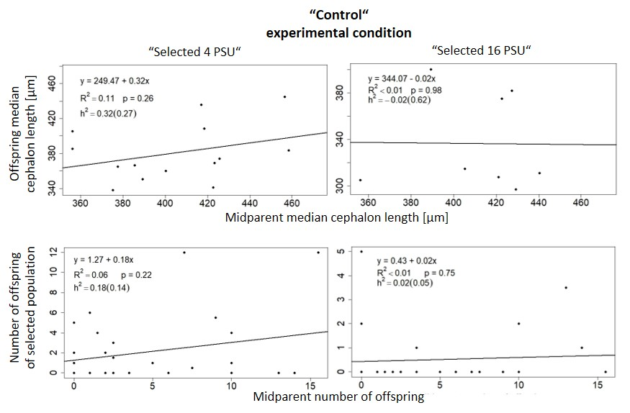
Figure S1. Offspring-midparent regression for the “selected 4 PSU” (left) and “selected 16 PSU” (right) selection treatments in “control” experimental condition. The linear regression functions, R², p-value, and slope are shown. The slope of the regression was used as the heritability estimate (h²).
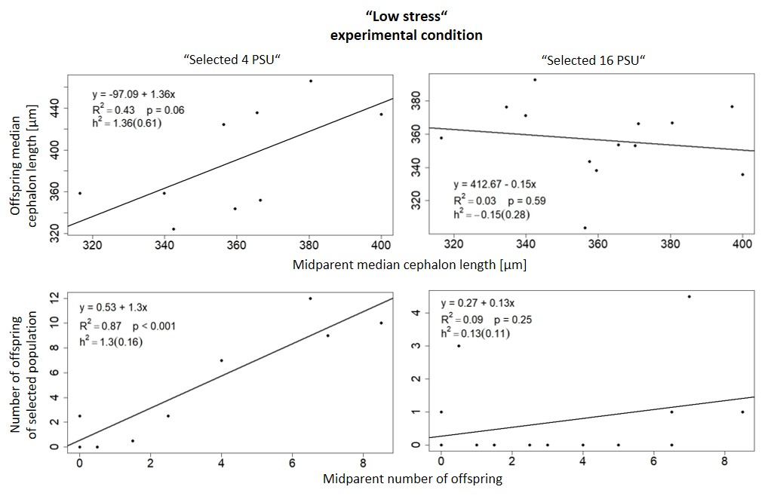
Figure S2. Offspring-midparent regression for the “selected 4 PSU” (left) and “selected 16 PSU” (right) selection treatments in “low stress” experimental condition. The linear regression functions, R², p-value and slope are shown. The slope of the regression was used as the heritability estimate (h²).
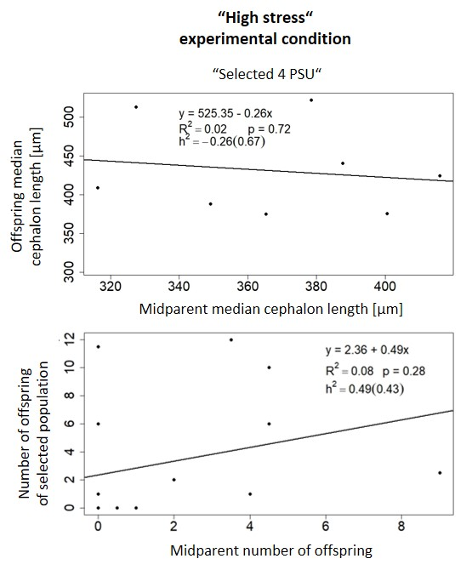
Figure S3. Offspring-midparent regression for the “selected 4 PSU” selection treatment in “high stress” experimental condition. The linear regression functions, R², p-value, and slope are shown. The slope of the regression was used as the heritability estimate (h²).

