Weekly report cruise POS532

4/2/2019-11/2/2019 (written on 10/2/2019)

The goal of our cruise is to establish the role of gelatinous zooplankton in the biological carbon pump, which is the process where organic carbon is transported via biological mechanisms from the water column to the seafloor. We will also study the impact of mesoscale eddies on pelagic communities and the third goal is to collect baseline data on the diversity and distribution of deep pelagic organisms, including the bathypelagic zone, which extends from 1000-4000 m. During our cruise we use a variety of equipment to collect deep-sea in situ observations, including the manned submersible JAGO, the ocean floor observation system OFOS, and the pelagic in situ observation system PELAGIOS. For biological sample collection, we use JAGO but also two kinds of Multinet, one fine meshed for the sampling of mesozooplankton and a larger one with coarser mesh for micronekton and macrozooplankton.

The region of our expedition are the Cape Verde islands. From our previous cruise POS520 we know that the leeway of the Cape Verde islands, with their high topography and steep slopes, provide excellent and calm conditions for deep-sea biological work, and deep waters can be reached very close to the islands.

Our cruise started in Mindelo. The advance team arrived on the 1st of February and together with the POSEIDON crew they unpacked the containers that were sent from Germany on the 2nd of February. All cruise equipment was loaded on to the POSEIDON, including the JAGO container and a large fibre optic winch, ‘the Werner Winch’. The remaining cruise participants were scheduled to fly on February 2nd but after arriving at Hamburg airport at 4 am, it was sad to see that the flight was canceled. The airline informed us that the first next possibility would be the next day, same time same place. Fortunately the second try worked, and on February 3rd we all arrived on the POSEIDON, where we immediately started to mobilize equipment, and organize the labs.

Due to the delay in flights, the captain decided not to depart at 0800 on 4/2/2019 as planned but at 1300, and this gave us more time to clear the decks for departure. On 4/2/2019 we arrived in the Bay of Tarrafal off the island of Santa Antao (photograph), where we performed a test dive with JAGO at our mesopelagic station (bottom depth 1000 m). Unfortunately a major issue with the submersible was discovered after the dive. Due to unknown causes, the pressure regulation system was flooded with seawater, and the whole system needed to be cleaned as soon as possible. Fortunately, JAGO was repaired quickly and we were able to continue diving in the morning of 7/2/2019.

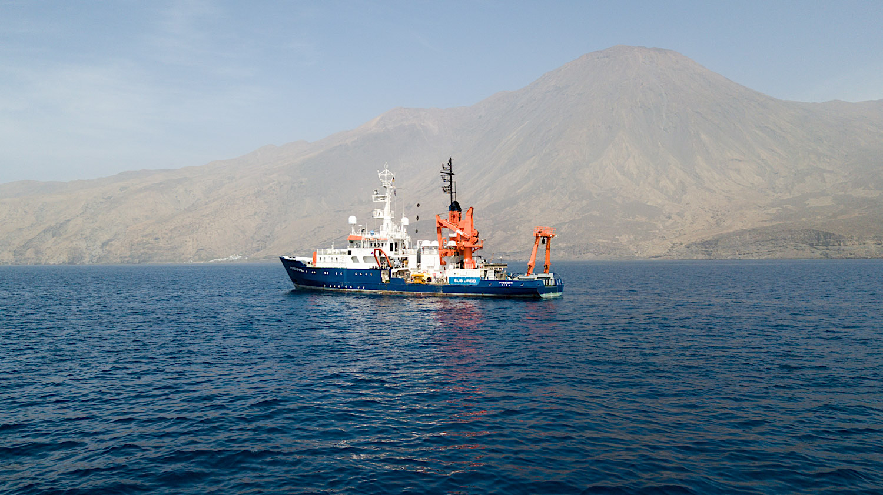

*Research vessel POSEIDON in our study region, the Bay of Tarrafal of the Cape Verdean island Santa Antao*

The JAGO days are alternated by so-called W2 winch days where we perform multinet sampling, CTD stations for hydrography and eDNA collection, as well as PELAGIOS tows for video transects. Unfortunately we have encountered problems with the PELAGIOS system, and were unable to collect pelagic video so far.

We use the inshore station mesopelagic station (1000 m bottom depth) for our work and also an offshore bathypelagic station (bottom depth 3000 m) where we use the same sampling but cannot deploy JAGO due to the high swell. Our colleague Karen Osborn from the Smithsonian Institute in Washington makes scientific photographs of the organisms that we collect in the multinets, and preserves them for genetic, morphological and histological analyses. This enables documentation of fragile animals when they are recently captured, and results in spectacular images.

We are now one week on our way and have done 7 JAGO dives so far. Using JAGO we were able to capture a variety of fragile gelatinous zooplankton. The collections included two specimens of an undescribed species of the pelagic worm *Poeobius,* an organism that was only very recently discovered in the Atlantic via in situ observations. The specimens were gently captured with JAGO and now allow a proper species description and scientific naming.

Another group of invertebrates that we documented in the water column are pyrosomes, pelagic tunicates that occur in high densities, and spend the day at 400-500 m but migrate in large numbers to the surface at night. Using the multinet we captured these animals. With JAGO we have observed them in the water column but also on the seafloor. On 9/2/2018 we performed an OFOS survey to quantify the pyrosomes on the seafloor. We are interested to calculate how much biomass and carbon is transported from the water column to the seafloor via the deposition of pyrosome carcasses. Today the JAGO team also collected pyrosomes from the seafloor, and we will use these specimens for carbon content measurements. While surveying the seafloor a variety of organisms were encountered including a crab that had decorated its carapace (photograph).

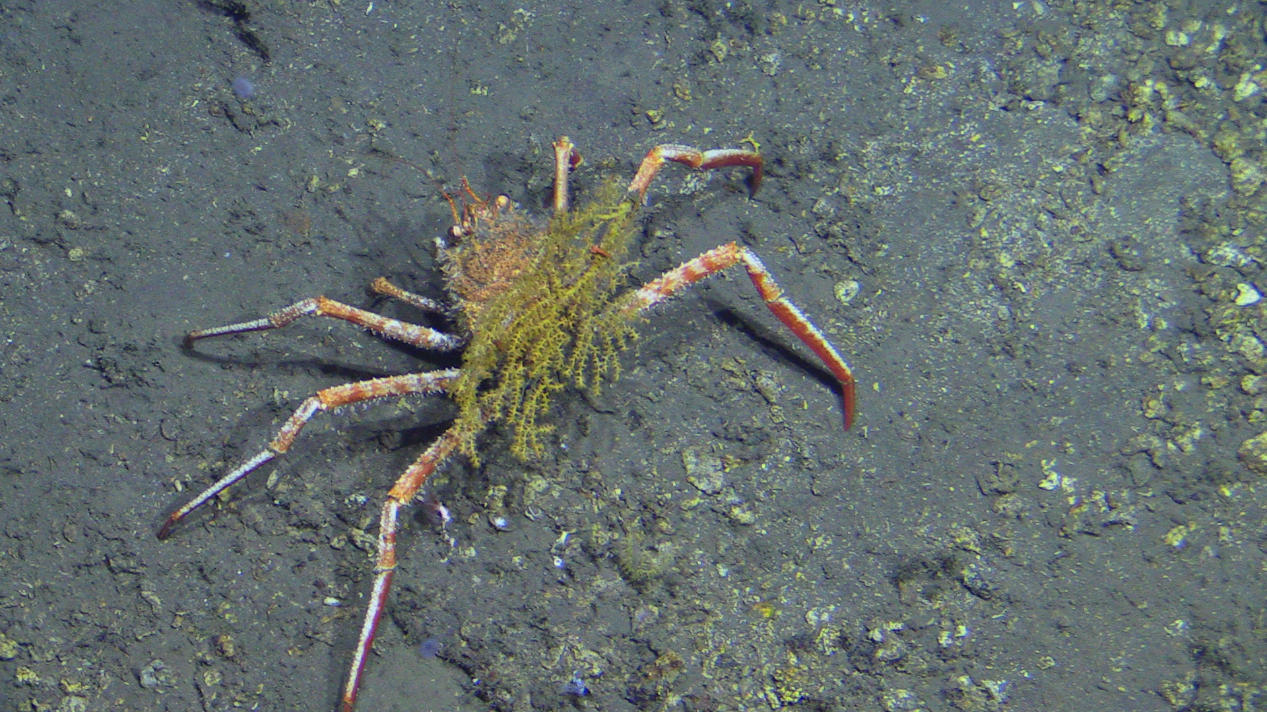

*A crab that has decorated its carapace as observed in the Cape Verdean deep sea off Santa Antao with submersible JAGO*

Rui Freitas, a collaborator from the Universada Cabo Verde is doing the last JAGO dive of today. We just heard that they observed a shark of 1.5 m at 300 m. Rui Freitas is an ichthyologist, a fish expert, and particularly interested to document the deep-sea fish fauna in Cape Verde waters. The OFOS survey has provided one of the first insights in the ecological zonation of the steep island slope of Santa Antao, and many fishes were observed which will be identified and counted by Rui Freitas and his students.

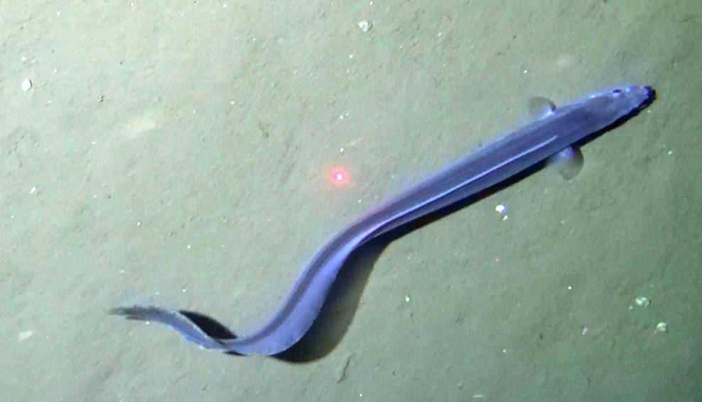

*An eel-like fish observed on the deep seafloor by the ocean floor observation system OFOS, which is used for bottom video transects*

In between the active station work we also perform acoustic surveys using an echosounder (EK80) on a pole that we hang over the side. The acoustic data we collect with the EK80 while steaming slowly between the stations are complemented by collecting current data with the ship’s ADCP. Thereby we can later evaluate layers whether high zooplankton biomass (acoustic backscatter) and fish distribution is correlated to patterns in the current structure or sites of intense mixing. The use of acoustic methods, with in situ camera observations and net catches is a strong combination to obtain insight in the biomass, distribution and behaviour of pelagic and deep-sea organisms.