Appendix A. Supplementary data
Long-term records of hard-bottom communities in the southwestern Baltic Sea reveal the decline of a foundation species
Markus Franz^{a,*}, Francisco Rafael Barbozaª, Hans-Harald Hinrichsenª, Andreas Lehmannª, Marco Scottiª, Claas Hiebenthalª, Markus Molis^{b}, Renate Schüttª, Martin Wahlª
ª GEOMAR Helmholtz Centre for Ocean Research Kiel
^{b} Alfred-Wegener Institute, Helmholtz Centre for Polar and Marine Research, Bremerhaven, Bremen, Germany
* Corresponding author: Research division of Marine Ecology, GEOMAR Helmholtz Centre for Ocean Research Kiel, Düsternbrooker Weg 20, 24105 Kiel, Germany, email address: mfranz@geomar.de

Table S1. Classification of genera recorded into functional groups.
Functional group | Genus
LFAS | Acrosiphonia
 | Cystoclonium
 | Dasya
 | Polysiphonia
LMAS | Chorda
 | Dumontia
 | Ulva
LMSS | Chalinula
 | Halichondria
MESC | Conopeum
 | Einhornia
 | Electra
MFAS | Aglaothamnion / Callithamnion
 | Ceramium
 | Chaetomorpha
 | Cladophora
 | Derbesia
 | Ectocarpus
 | Pylaiella
 | Rhodomela
 | Spermothamnion
 | Sphacelaria
 | Spongomorpha
MFSC | Laomedea
MMSS | Balanus
 | Mytilus
 | Spirorbis
SEAS | Hildenbrandia
 | Hydrolithon
SFAS | Scagelothamnion
SMSS | Corophium
 | Polydora

Table S2. Modelling results of Generalized Linear Mixed Model (GLMM) comparing Mytilus coverage in the years before (2005-2009) and after (2010-2015) the decline and between stations of Kiel (1 - 4) and Lübeck (5 - 7) bights. The GLMM was specified based on a gamma-distribution and log-link function. To adjust the within station variability, the station identity was included as random factor.
Model component | Estimate | Std. error | t-value | p-value
Intercept | 3.304 | 0.211 | 15.645 | < 0.001
After | -1.359 | 0.286 | -4.752 | < 0.001
Lübeck Bight | 0.703 | 0.323 | 2.179 | 0.029
After:Lübeck Bight | 1.311 | 0.437 | 3.002 | 0.003

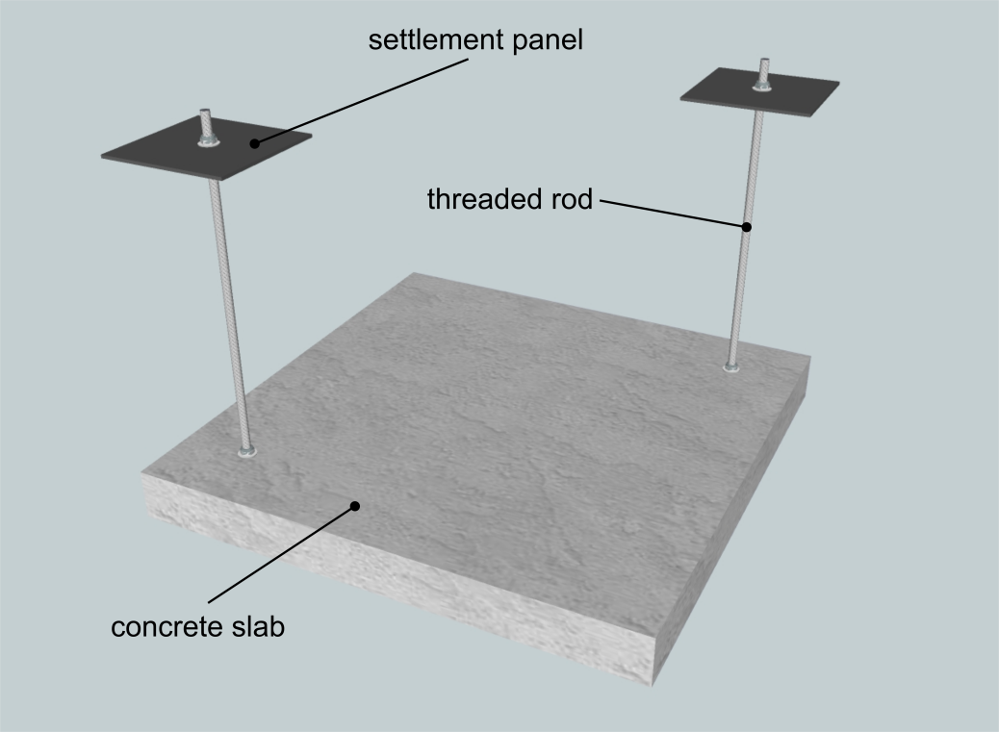
Figure S1. Outline of the deployed settlement panel system.

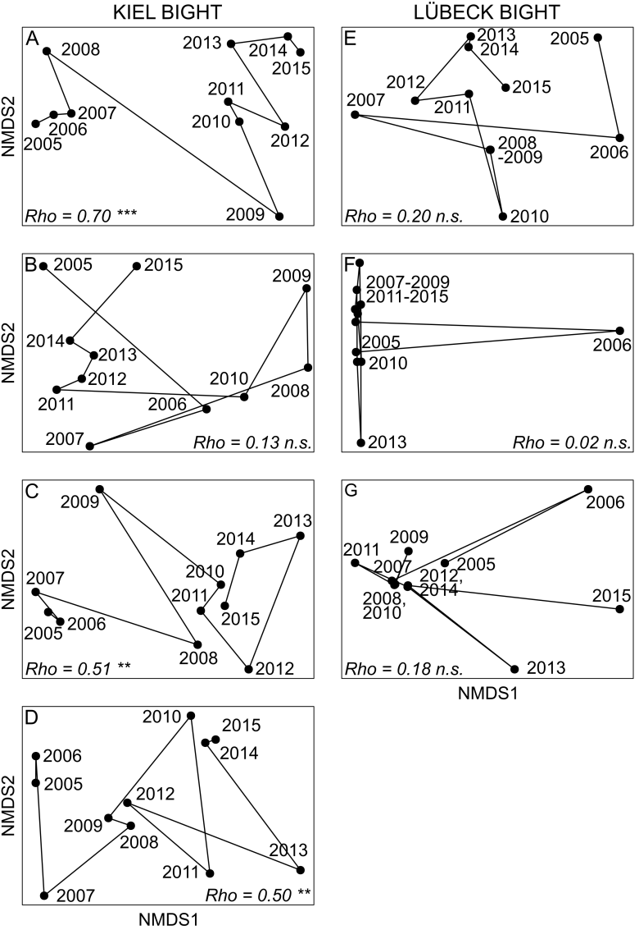
Figure S2. nMDS trajectories based on Bray-Curtis dissimilarities between consecutive years for the functional composition of the communities at the respective monitoring stations. For all plots stress was ≤ 0.08. Correlation coefficient (Rho) and significance levels (*** p < 0.001; ** p < 0.01; * p < 0.05; n.s. = not significant) of the RELATE analysis are given. Charts are ordered from station 1 (A) to 7 (G).
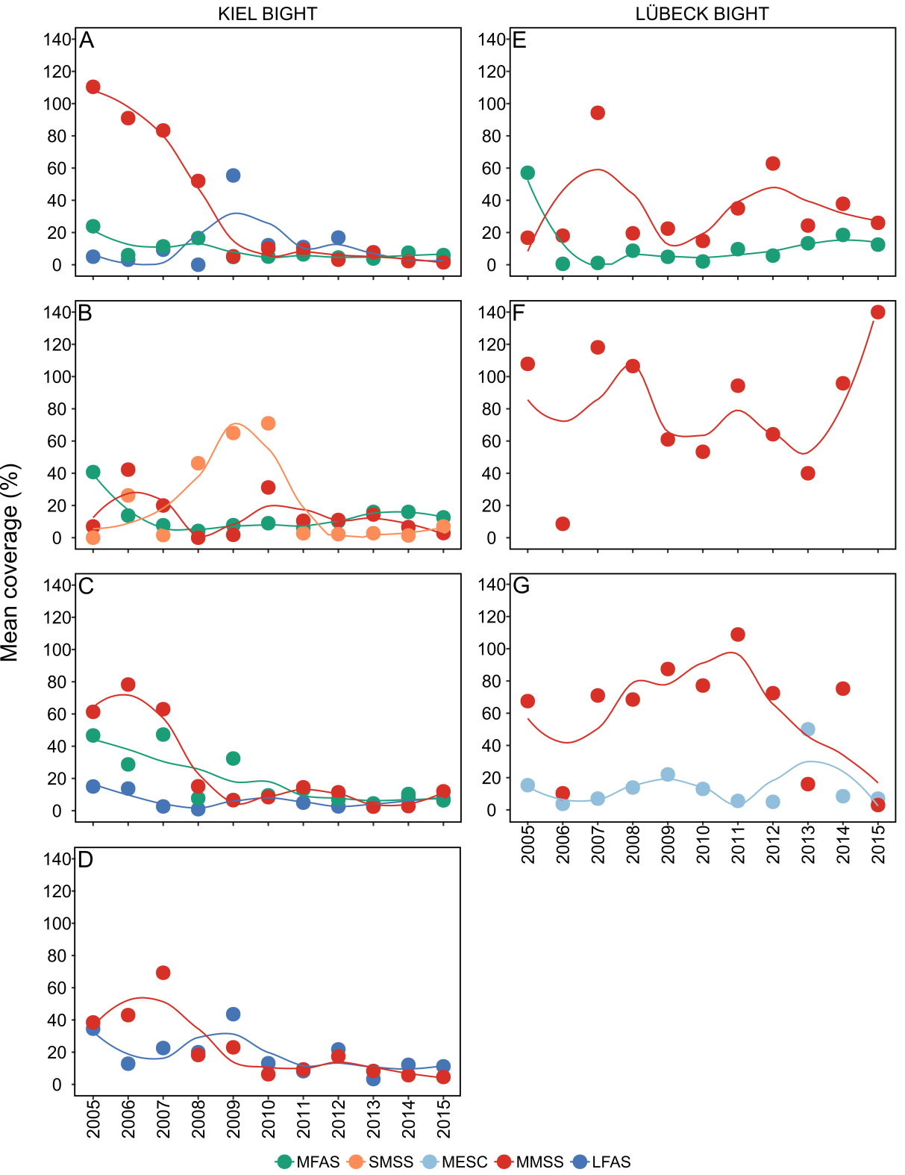
Figure S3. Mean coverage (%) of functional groups (see codes for functional groups in Table 1) that were identified with SIMPER analysis. These groups reach a cumulative contribution in similarity of 75% over the monitoring period 2005-2015. Curves from LOESS smooth functions (span = 0.6) are visualized to highlight temporal dynamics. The panels present results from station 1(A) to station 7 (G).

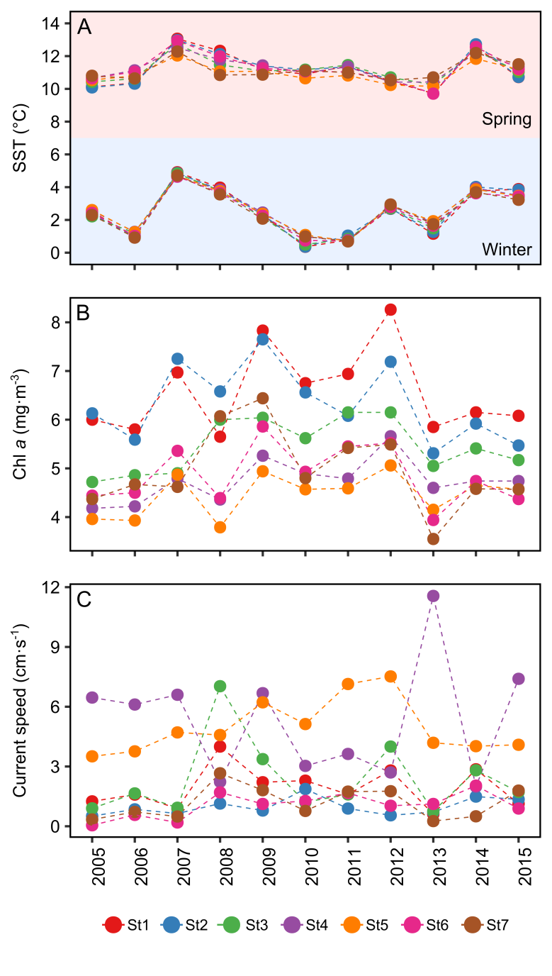
Figure S4. Temporal trends of environmental variables over the entire monitoring period (2005-2015). Mean values of sea surface temperature in spring and winter (SST; A), chlorophyll a concentration (Chl a; B) and current speed (C) in spring are presented. Note that only values recorded for spring were included in the Generalized Additive Mixed Model (GAMM).

