[Journal of Geophysical Research: Atmospheres]
Supporting Information for
Drivers and surface signal of inter-annual variability of boreal stratospheric final warmings
R. Thiéblemont¹, B. Ayarzagüena^{2,3}, K. Matthes^{4,5}, S. Bekki⁶, J. Abalichin⁷, and U. Langematz⁷
¹Laboratoire des Sciences du Climat et de l'Environnement (LSCE), CNRS, Saint-Aubin, France. ²Universidad Complutense de Madrid (UCM), Madrid, Spain. ³Instituto de Geociencias, CSIC-UCM, Madrid, Spain. ⁴GEOMAR-Helmholtz Centre for Ocean Research, Kiel, Germany. ⁵Christian-Albrechts-Universität zu Kiel (CAU), Kiel, Germany. ⁶Laboratoire Atmosphères, Milieux, Observations Spatiales (LATMOS), CNRS, Guyancourt, France. ⁷Freie Universität Berlin (FUB), Berlin, Germany.
Contents of this file

Figures S1 to S6
Introduction
Supporting material repeats CESM1(WACCM) composite analysis presented in the main manuscript but for ERA-Interim reanalyses and EMAC-O multi-decadal simulation (140 years).

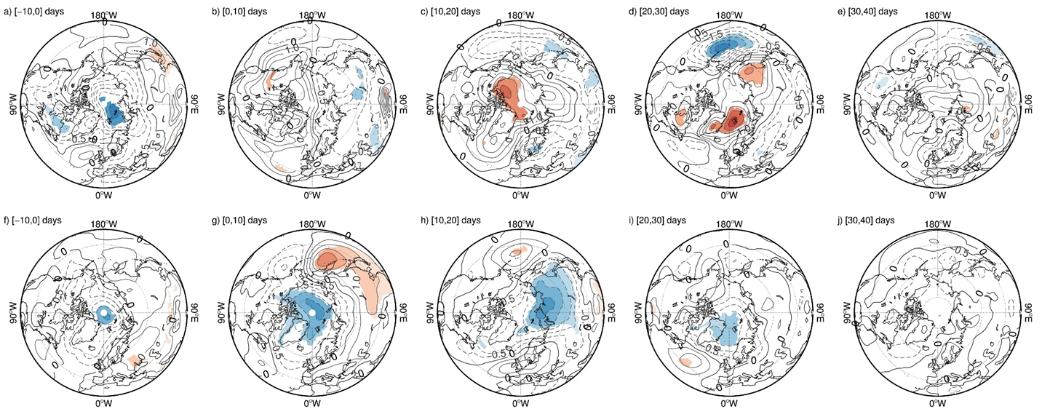
Figure S1. Same as Figure 3 but for EMAC-O.
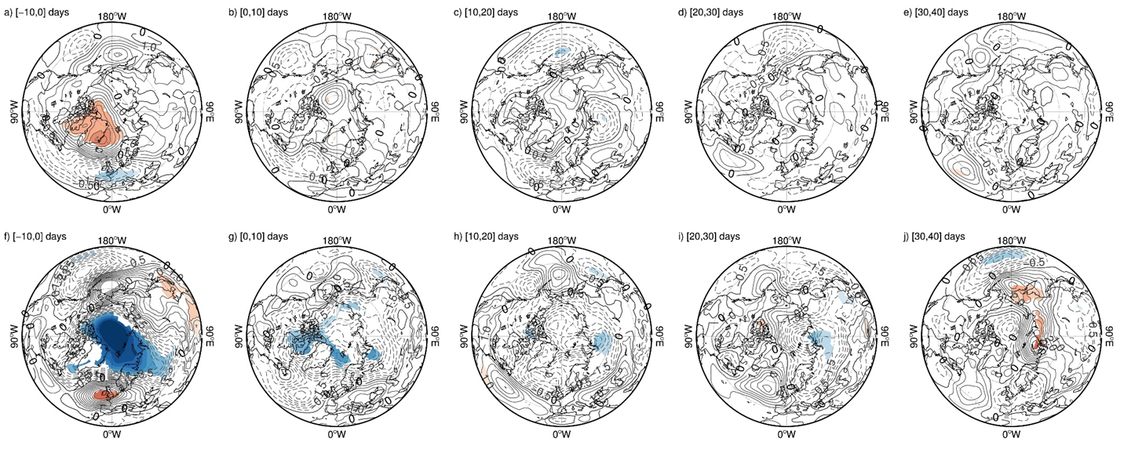
Figure S2. Same as Figure 3 but for ERA-Interim

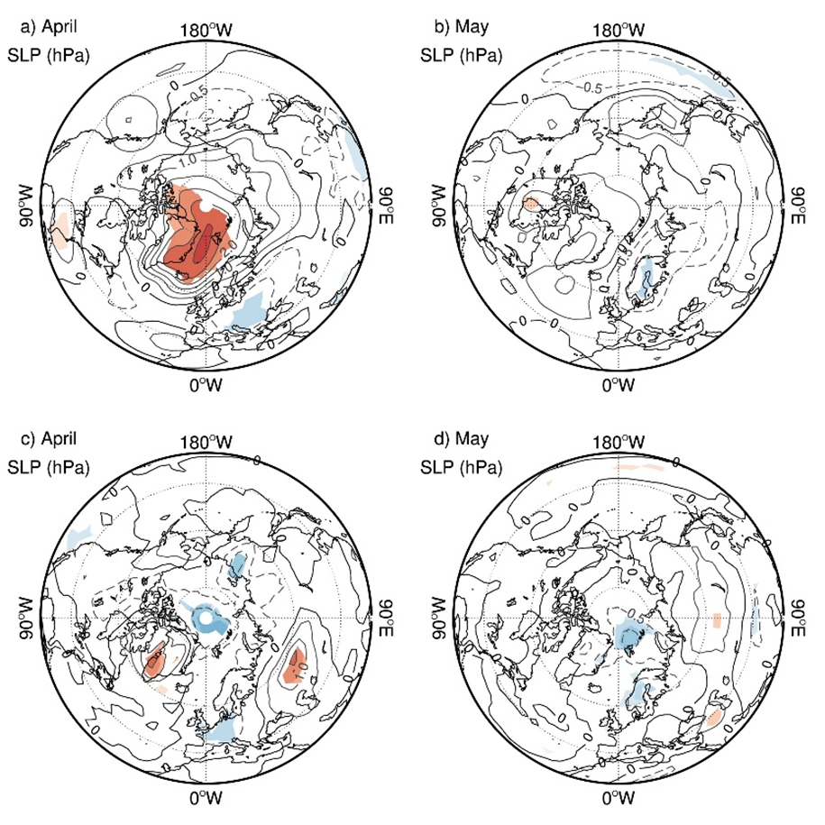
Figure S3. Same as Figure 5(a-d) but for EMAC-O.
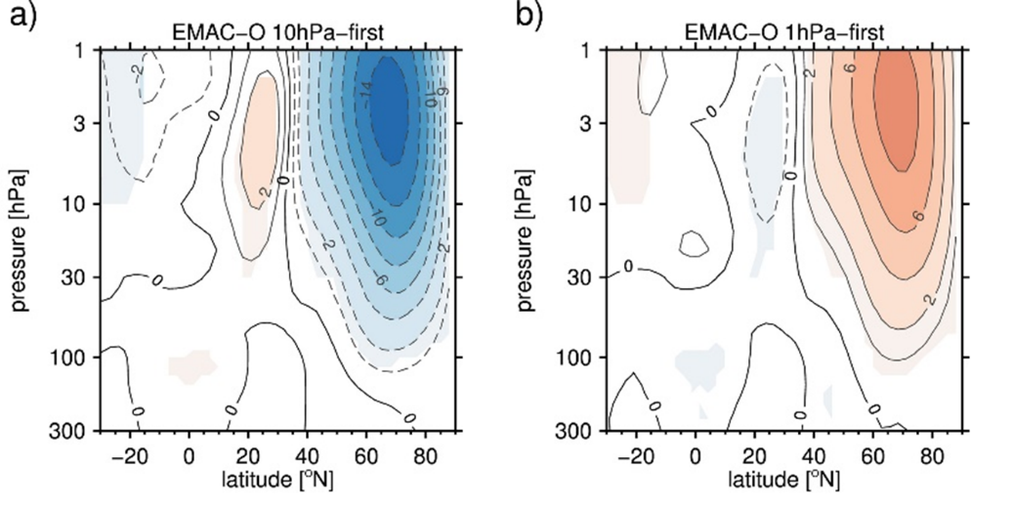
Figure S4. Same as Figure 6 but for EMAC-O.
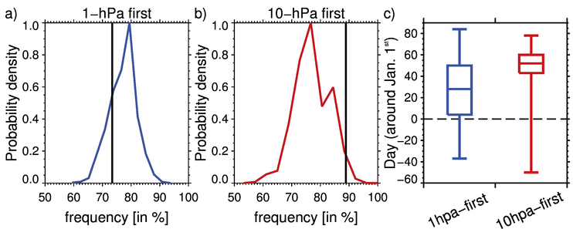
Figure S5. Same as Figure 7 but for EMAC-O.
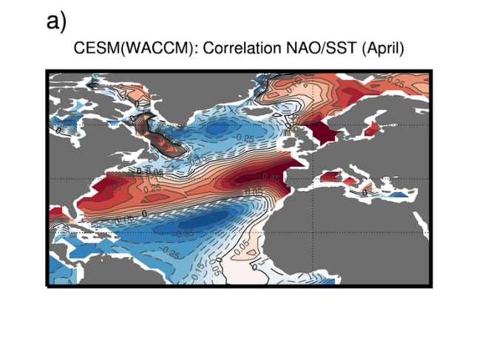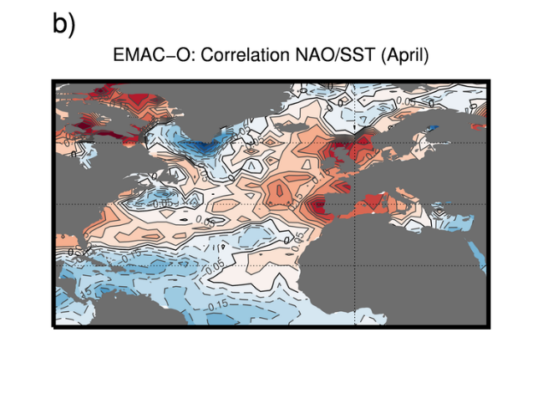
Figure S6. Correlation coefficient pattern between the NAO index in April and the North Atlantic SST field for (a) CESM(WACCM) and (b) EMAC-O.

