Automation of boron chromatographic purification for δ¹¹B analysis of coral aragonite

Elwyn de la Vega^{a*}, Gavin L. Fosterª, Miguel Angel Martínez-Botíª, Eleni Anagnostou^{a,b}, M. Paul Field^{c}, M. Hwan Kim^{c}, Paul Watson^{c}, Paul A. Wilsonª

ªSchool of Ocean and Earth Science, National Oceanography Centre Southampton, University of Southampton, Southampton SO14 3ZH, U.
^{b}GEOMAR Helmholtz Centre for Ocean Research Kiel, Wischhofstraße 1-3, 24148 Kiel, Germany.
^{c}Elemental Scientific, Inc., 7277 World Communications Drive, Omaha, NE 68122, USA

*Correspondence to: Elwyn de la Vega, School of Ocean and Earth Science, University of Southampton Waterfront Campus, National Oceanography Centre Southampton, European Way, Southampton SO14 3ZH, UK.
E-mail: elwyn.de-la-vega@soton.ac.uk

δ¹¹B JCp-1 (‰) | 2sd (‰) | Reference | Boron separation
24.4 | 0.1 | Dissard et al²⁶ | Anion exchange chromatography
24.2 | 0.24 | Liu et al⁶ | Micro sublimation
24.3 | 0.34 | McCulloch et al²⁵ | Cation and anion exchange chromatography
24.3 | 0.25 | Henehan et al²⁷ | Anion exchange chromatography
Table S1. Published δ¹¹B measurements of the carbonate reference material JCp-1 with boron separation methods used. All measurements were conducted on MC-ICPMS.

Reference material | Matrix type | Long term δ¹¹B (‰) |  | Sample load (μL/min)
 |  |  |  | 100 | 200 | 500
NIST 951 | No matrix | 0 | δ¹¹B (‰) | 0 | -0.08 | -0.2
JCp-1 | Carbonate | 24.25 |  | 24.45 | 24.5 | 24
Seawater | ionic | 39.61 |  | 39.52 | 39.47 | 38.65

Table S2. δ¹¹B values of standards and reference materials processed at different flow rate.

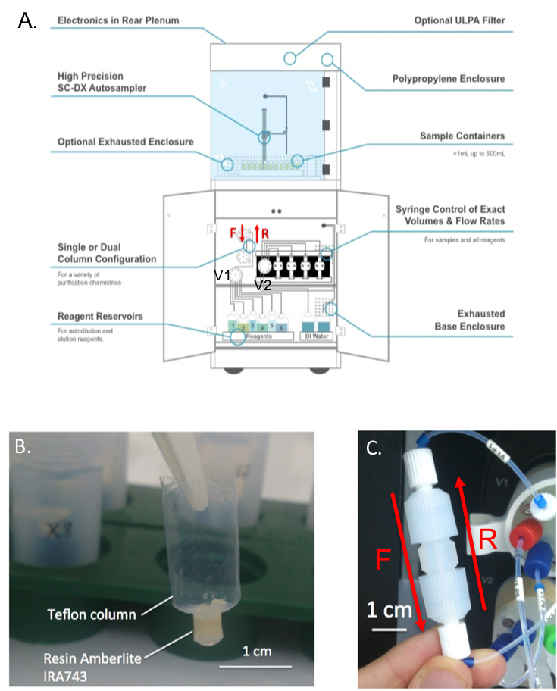

Figure S1. (A) Illustration of the prepFAST-MC device automated system (ULPA filter and polypropylene enclosure was not used at Southampton), the equipment uses reagents (Milli-Q and 0.5M HNO₃) that are taken up according to the protocol described in Table 2, and dispensed to various locations thanks to a rotary multivalve (valve V1). Reagents are taken up in a coil (not illustrated) before being dispensed to either the probe (bypassing the column), the column (in forward or reverse flow) or the waste. Syringes control the flow through the system via valve V2 that is connected to the coil and valve 1 in order to take up or dispense reagents with controlled volume and flow rate. A separate milli-Q bottle (DI water on the illustration) rinses the line through valve 2, coil, valve 1 and to waste between each action of reagents take up/dispensing. (B) Hand-made Teflon micro-column used with the standard method and (C) prepFAST column, both filled with Amberlite resin IRA743. Red arrows indicate direction of flow forward (F) or reverse (R).

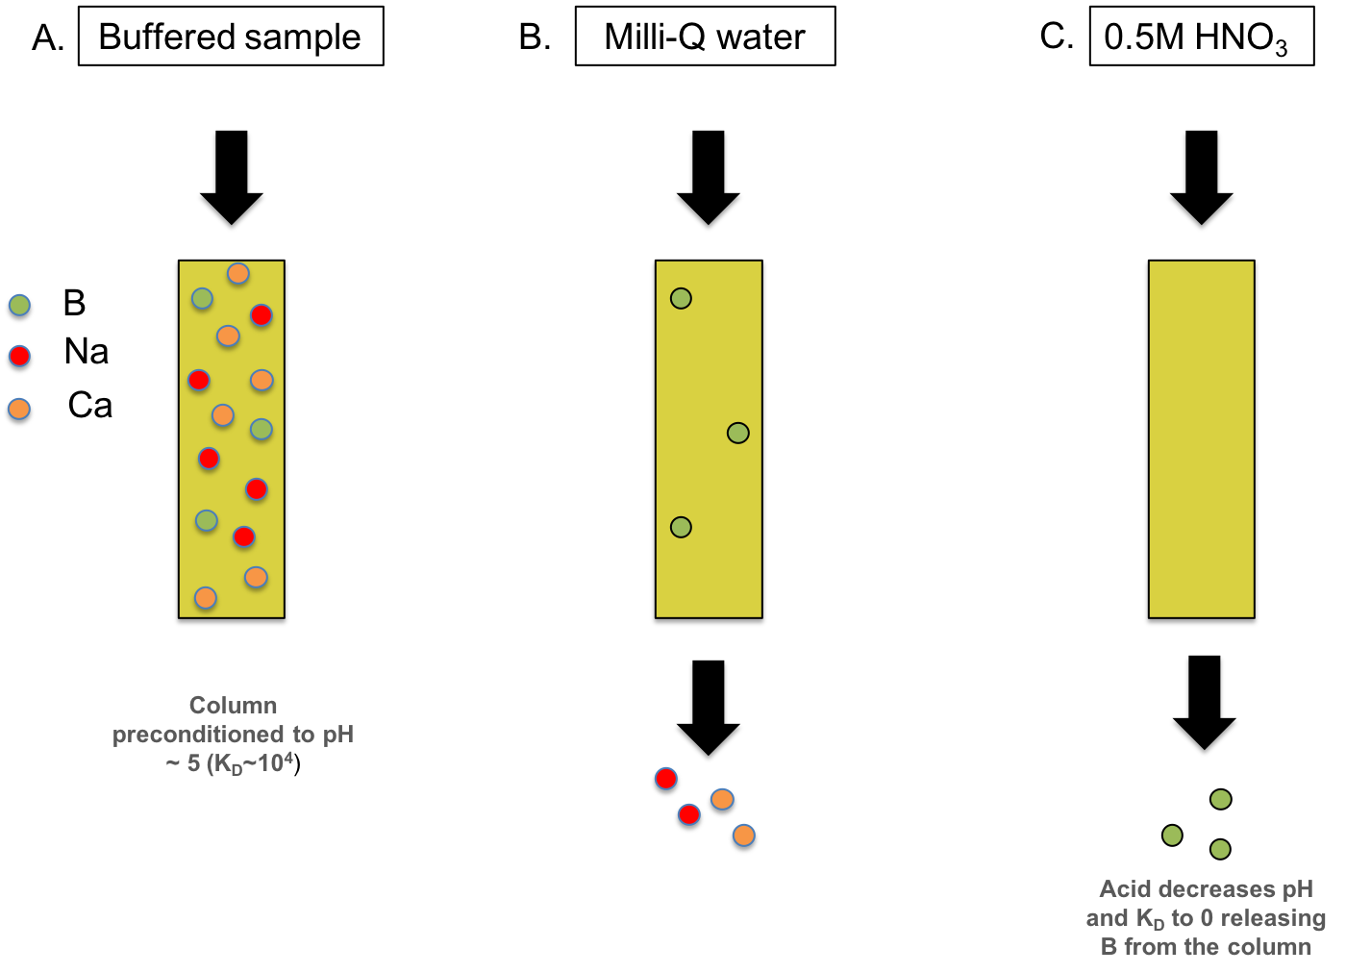
Fig S2. Illustration of ion exchange chromatography. Buffered sample is loaded onto a resin (A) preconditioned with milli-Q water (increasing the partition coefficient K_{D} between boron and resin to 10⁴). Matrix is removed with milli-Q water (B), and boron eluted with 0.5M nitric acid (C).

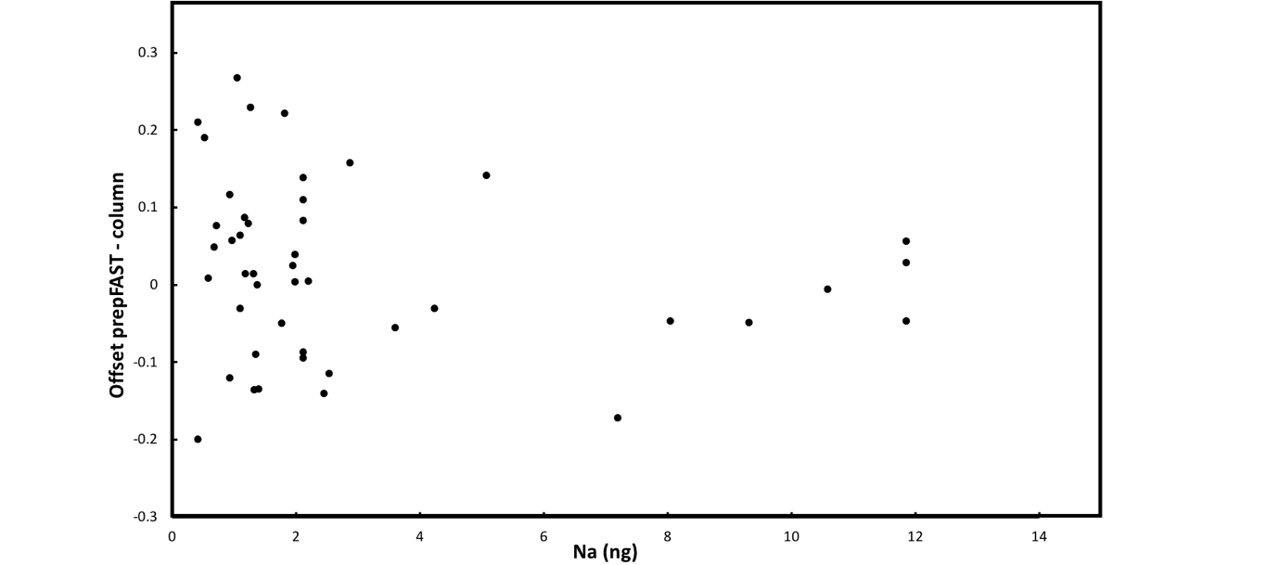

Fig S3. δ¹¹B offset between the prepFAST and manual standard method as a function of Na in purified samples. (r²=0.04. p=0.20) showing no correlation between the two.

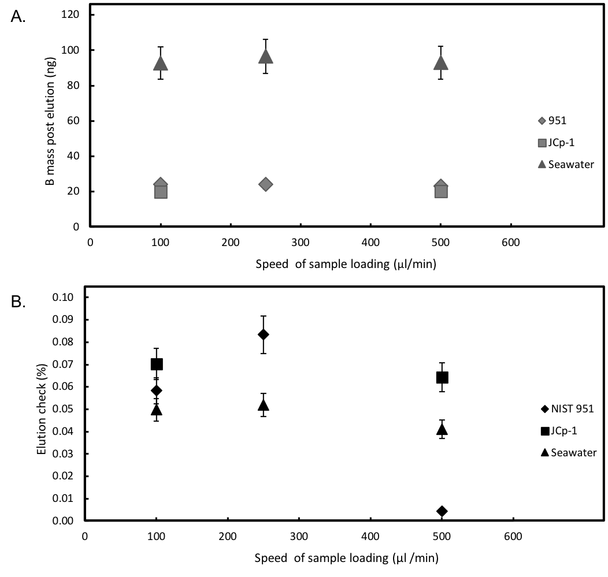
Fig S4. (A) Boron yield and (B) elution check as a function of speed of sample load.

