

*Geochemistry, Geophysics, Geosystems*

Supporting Information for

Focused Fluid Flow along the Nootka Fault Zone and Continental slope, Explorer-Juan de Fuca Plate Boundary

M. Riedel1, K.M.M. Rohr2, G.D. Spence3, D. Kelley4, J. Delaney4, L. Lapham5, J. Pohlman6, R.D. Hyndman2,3, E.C. Willoughby2

1GEOMAR Helmholtz Centre for Ocean Research Kiel, 2Geological Survey of Canada, 3University of Victoria, School of Earth and Ocean Sciences, 4University of Washington, Seattle, 5Centre for Environmental Science, University of Maryland, 6US Geological Survey, Woods Hole

**Contents of this file**

Table S1

Figure S1

Figure S2

Figure S3

Figure S4

Figure S5

Figure S6

Figure S7

**Introduction**

This supporting information provides geochemical pore-fluid data (sulfate, chloride) as well as methane concentrations, and methane stable carbon isotopes for two cores taken in the vicinity of the mud mound Maquinna (Table S1, Figure S1). Also included are data for sediment porosity.

Additional documentation is provided from bottom video observations made by remotely operated vehicles (ROVs). Vent biota (here we show images of the white galatheid crabs, squat lobsters) were observed at Maquinna mound during one ROV dive in 2002 (Figure S2). Images from bottom video observations taken during several ROV dives at the toe of the Nootka slope (Figure S3) are shown in Figure S4 providing evidence for the wide-spread fluid escape and associated chemosynthetic communities and carbonate formations.

This document also provides more detailed maps of the Nootka fault zone (Figure S5) in support of Figure 2.

Maps showing regional variations in historical seismicity is included in Figure S6. A map of selected earthquake focal mechanisms after Hutchinson et al. (2019) is shown in Figure S7.

Table S1. Geochemical data for cores C17 and C18. nd = not determined. No ethane was detected in core 18.

|  |  |  |  |  |  |  |  |
| --- | --- | --- | --- | --- | --- | --- | --- |
| **Core ID** | **Depth (cmbsf)** | **Porosity** | **SO42- (mM)** | **Cl- (mM)** | **CH4 (mM)** | **δ13C-CH4 (‰)** | **C1:C2** |
| C17 | 2.5 | 0.69 | 28.52 | 527.79 | 0.0003 |  | 7 |
|  | 12.5 | 0.71 | 26.99 | 541.46 | 0.0002 |  | 7 |
|  | 22.5 | 0.66 | 23.57 | 573.89 |  |  |  |
|  | 32.5 | 0.67 | 27.31 | 521.73 | 0.0005 |  |  |
|  | 42.5 | 0.69 | 12.98 | 558.62 | 0.0004 |  |  |
|  | 77.5 | 0.72 | 28.48 | 567.25 | 0.0002 |  |  |
|  | 102.5 | 0.67 | 27.42 | 526.58 | 0.0002 |  |  |
|  | 132.5 | 0.60 | 27.31 | 551.55 | 0.0005 |  |  |
|  | 192.5 | 0.75 | 26.56 | 546.87 | 0.0008 | -72.42 |  |
|  | 252.5 |  | 26.99 | 539.27 | 0.0031 | -84.79 | 26 |
|  | 312.5 | 0.57 | 4.29 | 547.88 | 0.2217 | -90.54 | 42 |
|  | 363.5 | 0.40 | 2.53 | 577.48 |  | -77.53 |  |
|  | 395.5 | 0.52 | 4.00 | 571.49 | 4.2225 | -75.83 | 450 |
|  | 442.5 | 0.43 | 2.82 | 573.05 | 4.1223 | -74.04 | 390 |
|  | 472.5 | 0.58 | 1.94 | 579.64 | 2.6004 | -74.84 | 431 |
|  | 492.5 |  | 2.19 | 583.72 |  |  |  |
|  | 502.5 | 0.29 | 1.96 | 537.88 | 2.6439 | -74.80 | 345 |
|  | 532.5 | 0.57 | 1.79 | 536.17 |  | -74.31 |  |
|  | 562.5 | 0.49 | 1.58 | 555.40 | 2.5010 | -74.56 | 358 |
|  | 592.5 | 0.47 | 1.50 | 547.38 | 3.1829 | -74.04 | 406 |
|  | 617.5 | 0.54 | 1.53 | 567.77 | 2.1609 | -73.97 | 358 |
| C18 | 5 | 0.74 | 28.37 | 552.54 | 0.0003 |  |  |
|  | 45 | 0.75 | 29.92 | 572.49 | 0.0003 |  |  |
|  | 85 | 0.76 | 30.01 | 587.76 | 0.0003 |  |  |
|  | 145 | 0.71 | 31.02 | 577.04 | 0.0003 |  |  |
|  | 353 | 0.61 | nd | nd | 0.0003 |  |  |
|  | 426 | 0.55 | 20.07 | 619.30 | 0.0004 |  |  |
|  | 500 | 0.35 | 15.96 | 0.00 | 0.0008 | -73.78 |  |
|  | 575 | 0.43 | 11.99 | 569.29 | nd |  |  |

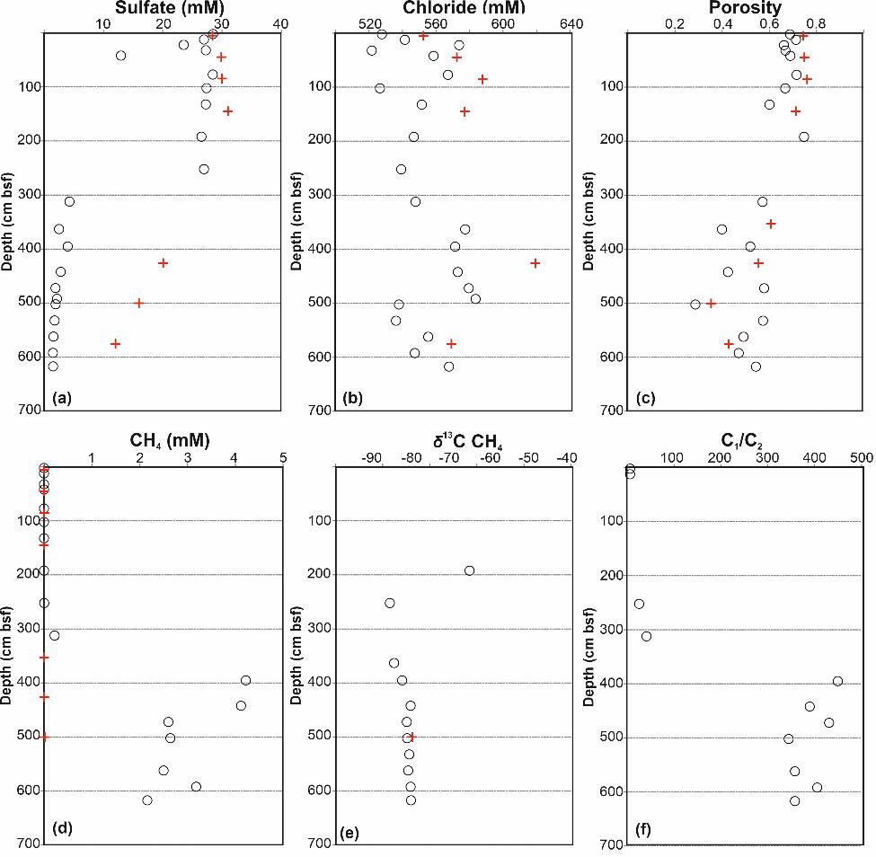

**Figure S1.** Pore water data at Maquinna from cores C17 (black ○) and C18P (red +) on the abyssal plain. (a) Sulfate concentrations, (b) Chloride concentrations, (c) porosity, (d) Pore water dissolved methane (CH4) concentrations, (e)  13C values of methane from head-space samples (no data < 2 mbsf as concentrations were too low), (f) methane (C1) to ethane (C2) ratios for core C17.

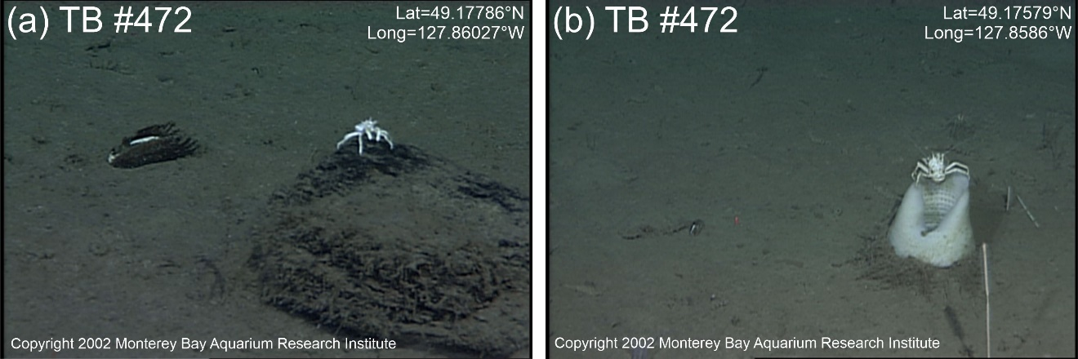

**Figure S2.** White galatheid crabs (squat lobsters) seen on Maquinna mound. (a) A crab sitting on small rock next to a dead *Solemya riedi* clam shell, (b) a crab sitting on glass-sponge. Nine sightings of these crabs, typical for hydrothermal systems, were made. These are the only sightings of this type of crab along the northern Cascadia margin around cold vents with chemosynthetic communities.

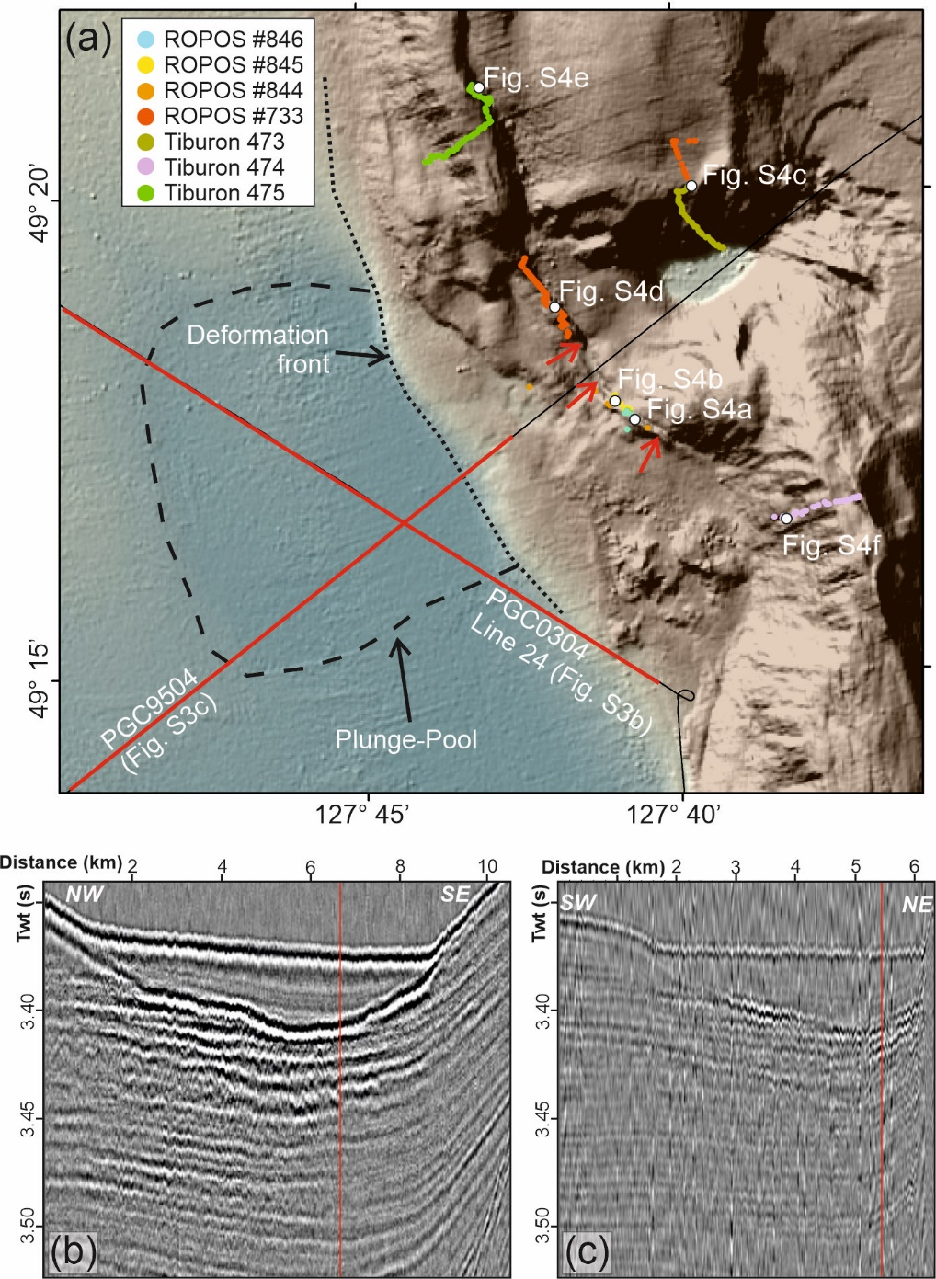

**Figure S3.** (a) Map showing dive tracks of ROV ROPOS and Tiburon at the toe of the Nootka slope. West of the toe of the slope a broad plunge-pool from sediment turbidity flows has developed, ~10 meter deeper than the surrounding topography. The plunge pool is associated with the canyon that eroded the steep cut into the frontal ridges of the short and steep accretionary prism formed. Red arrows indicate fault scarp, which was the target of several dives to collect bottom video observations. Locations of images taken of chemosynthetic communities are indicated as white dots with labels of Supplement Figure S4. Two seismic sections crossing the plunge-pool show sediment fill of up to 40 ms thickness two-way time (TWT) (~35 m): (b) Line PGC9504, and (c) Line 24, PGC0304. Red lines in (b) and (c) mark location of line crossing.

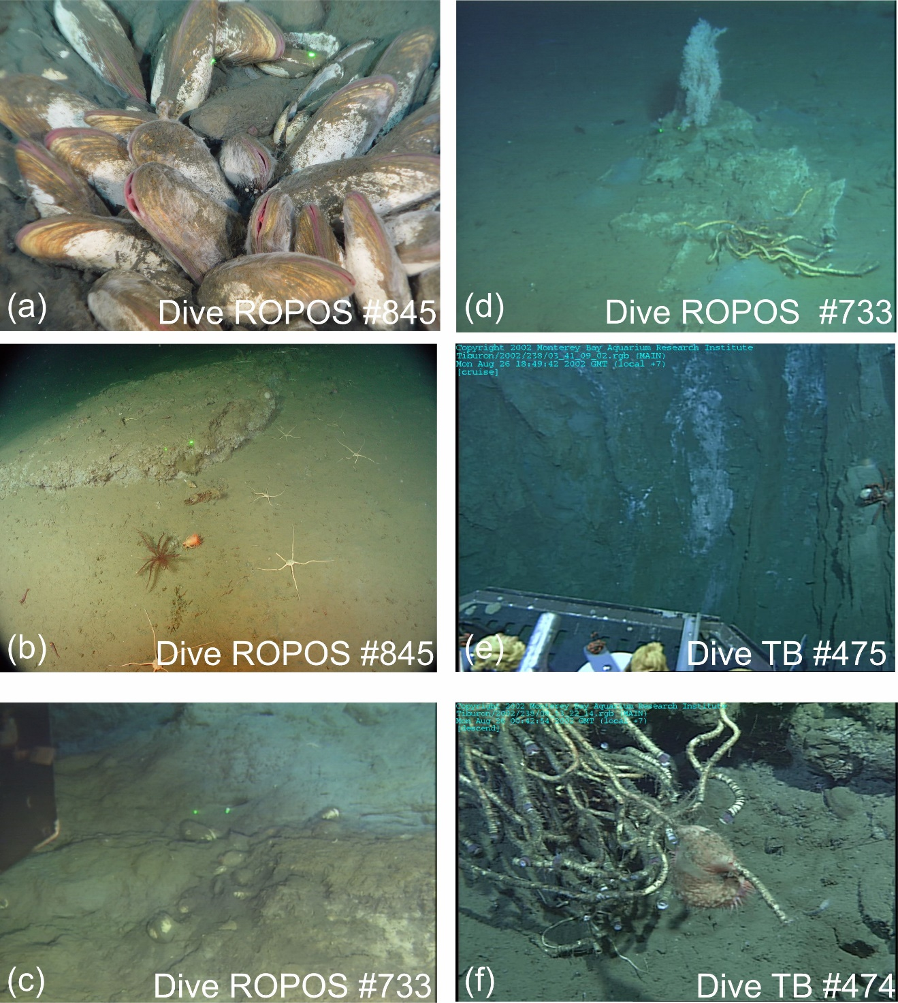

**Figure S4.** Images of cold vent communities seen along the tow of the Nootka slope: (a) Vesicomyid clams, (b) carbonate pavement, (c) Vesicomyid clams and bacterial mat, (d) Vestimentiferan tubeworm near carbonate rock, (e) bacterial mat (presumably *Beggiatoa*) along rock-outcrop, and (f) Vestimentiferan tubeworm at carbonate rock. Where visible, the distance between two green laser-beam dots is 10 cm. Locations for images are given in Supplement Figure S3.

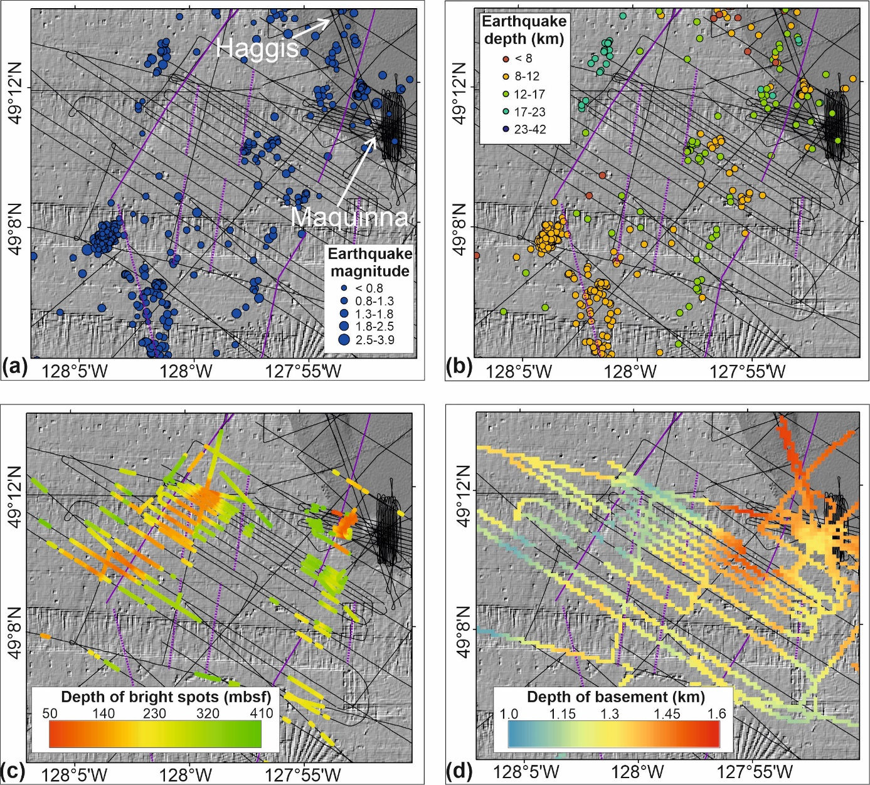

**Figure S5.** Detailed maps of the Nootka Fault zone traces (NNF: northern Nootka Fault, SNF: southern Nootka fault, (purple lines) as identified from bathymetry as well as single-channel seismic and 3.5 kHz data (line location shown as thin black lines). Shown are: (a) locations of seismicity with magnitude proportional to symbol size (Hutchinson et al., 2019). (b), earthquake hypocenter depth (Hutchinson et al., 2019), (c) depth of bright spots below seafloor, and (d) basement depth below seafloor. Locations of small sediment-hosted faults identified in seismic and acoustic data are shown as short white line segments in (c) and (d). Location of seafloor mounds Haggis and Maquinna are given in (a).

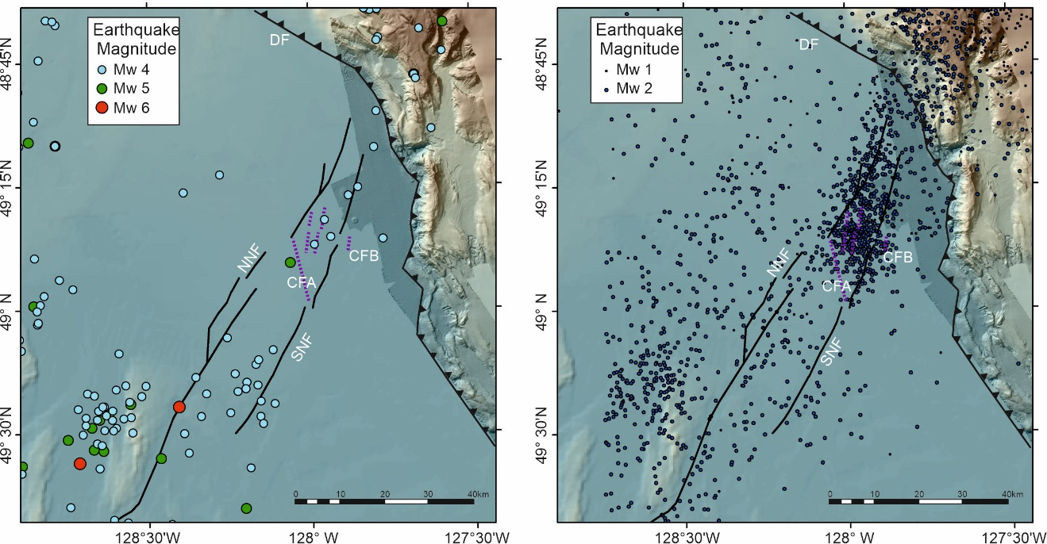

**Figure S6.** Detailed map showing seismicity around the NFZ using regional catalogue data spanning the time period from January 1994 to June 2020 (Earthquakes Canada, 2020). Left are earthquakes with magnitude larger than 3. Right panel shows seismicity of lower magnitude (<3). The north-eastern portion of the NFZ is dominated by micro-seismicity up to the Conjugate Fault A, whereas the south-western portion has more large events. DF=deformation front, NNF: northern Nootka fault trace, SNF: southern Nootka fault trace, CFA: Conjugate Fault A, CFB: Conjugate Fault B.

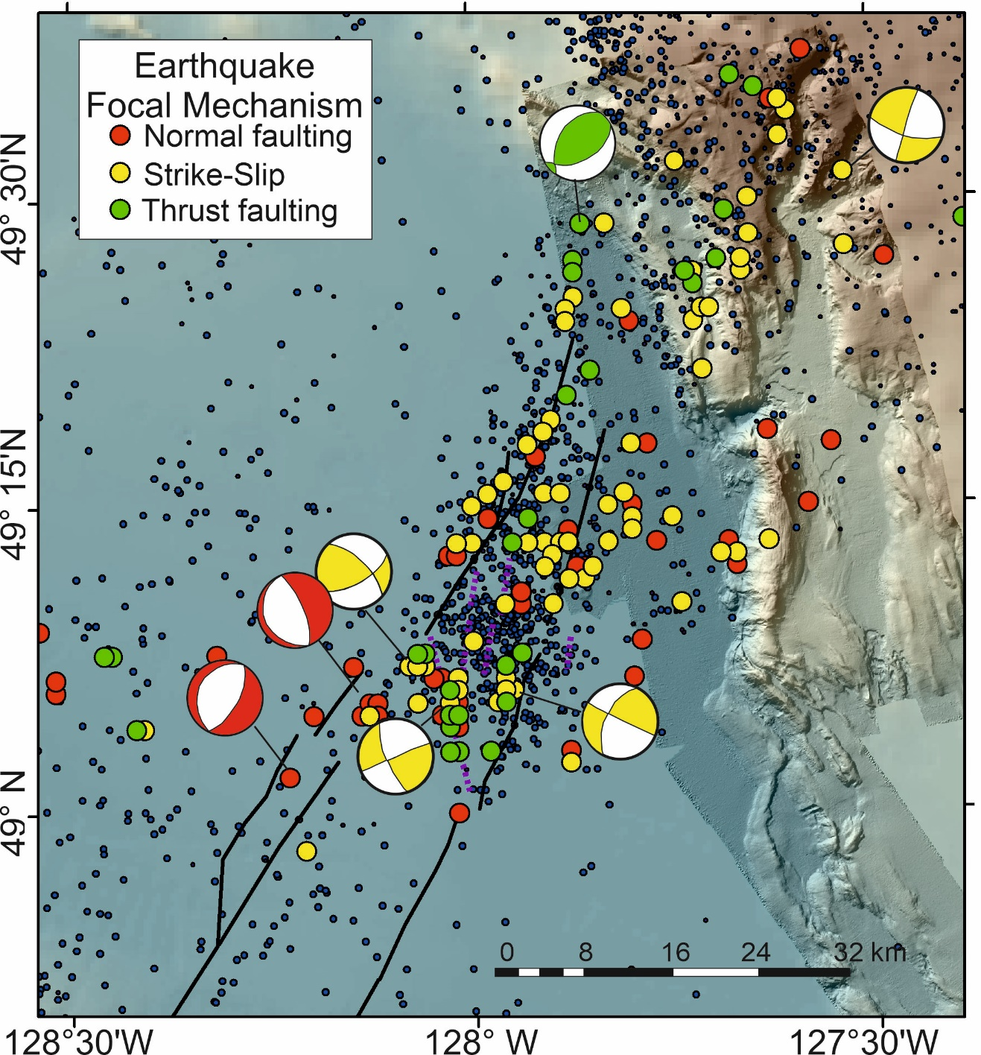

**Figure S7.** Examples of focal mechanisms(colored dots)from earthquakes detected during the SeaJade-1 mission. Shown are differentiated by color-code normal faults (red), strike-slip (yellow) and thrust events (green). Focal mechanisms were determined by Hutchinson et al., (2019) and a few examples are redrawn here. Background micro-seismicity (magnitude < 3) is shown as in Figure S6b.