

Supplementary figure 1: Overview of the CTD - depth profiles of salinity over the course of the experiment. Figure created with MATLAB (version R2013a).

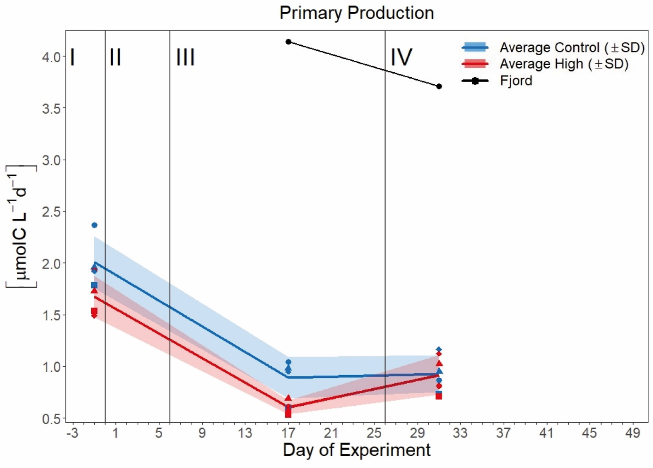

Supplementary figure 2: Temporal development of average primary production (PP, µg C L-1 d-1) over the course of the experiment. Blue, red, and black line indicate the respective average concentration in the control, high pCO2 treatment, and the Fjord. The ribbons represent the standard deviations (SD). Blue symbols represent concentrations in the ambient pCO2 mesocosms (M1, M2, M4, M7), red symbols in the high pCO2 mesocosms (M3, M5, M6, M8), black symbols represent the fjord. For assignment of symbols to the individual mesocosms see **Tab. 1.** Roman numerals indicate the different phases of the experiment separated by vertical lines (for description of phases see **Tab. 2**). Figure created with the ggplot2 package in RStudio (RStudio, 2016;Wickham et al., 2016).

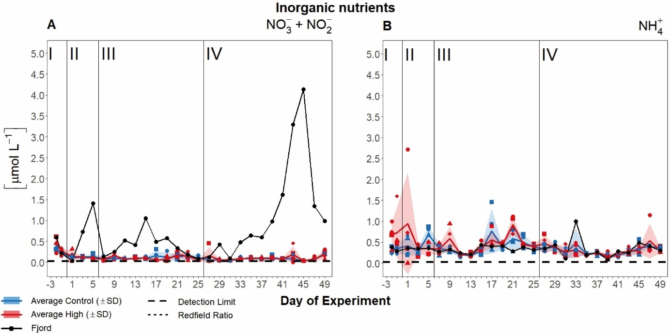

Supplementary figure 3: Nutrient concentrations of **(A)** Nitrate + nitrite ( ${NO}_{3}^{-}+ {NO}_{2}^{-}$ +), and **(B)** ammonium (${NH}_{4}^{+}$) over the course of the experiment. Lines, symbols, and colors are used as described in **Suppl. Fig. 2**. For assignment of symbols to the individual mesocosms see **Tab. 1.** Roman numerals label the different phases of the experiment separated by vertical lines (for description of phases see **Tab. 2**). Figure created with the ggplot2 package in RStudio (RStudio, 2016;Wickham et al., 2016).