**Supplement to “Experimentally decomposing total phytoplankton community change into ecological and evolutionary components”**

**Table of Contents**

Contents

Section 1: General aspects of the Sorting phase 2

Figure S1: 2

Section 2: Technical description of assay community reassembly 3

Table S1: 4

Table S2: 5

Table S3: 5

Figure S7: 5

Section 3: Technical assessment of the artificial assembly 6

Figure S2: 6

Section 4: Additional assessment of intraspecific changes in the sorting phase 7

Figure S3: 7

Figure S4: 8

Figure S5: 8

Figure S6: 9

Supplementary References 10

# Section 1: General aspects of the Sorting phase

The sorting phase allows a phytoplankton community, with a minimum diversity of two stably coexisting species, each comprising at least two genotypes, to restructure in terms of species and genotype frequencies (inter- and intraspecific change, respectively) in response to a changing environment of two treatment levels (ambient and novel; Fig. 1 - Sorting phase). The minimum time that allows for ecological inter- and evolutionary intraspecific diversity changes, can span from days to years and depends on initial community diversity, the species’ generation times, its physiological plasticity, and the selection strength of the chosen environmental driver (Supplement Fig. S1). Instead of adapting communities in a sorting phase in the laboratory future studies could utilize communities, which are naturally exposed to an environmental gradient or strong environmental changes within their habitat by using i) populations from different habitats and ii) dormant stages (Härnström et al. 2011). This, however, requires identifying species, which (i) can be separated from one another and (ii) are major players in the ecosystems of interest.

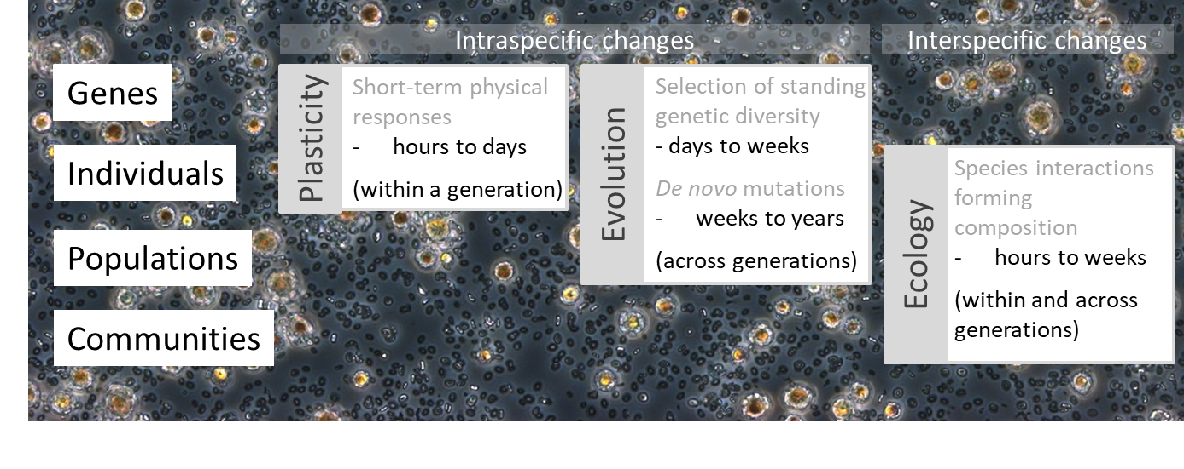

Figure S1:Overview of the hierarchical structure of communities, on which levels ecological and evolutionary processes can act upon, whether they affect inter- and/or intraspecific diversity, and the potential temporal scale at which require to occur.

# Section 2: Technical description of assay community reassembly

The **Controlambient** communitiesreflected the (i) intra- and (ii) interspecific changes of the communities sorted in response to the ambient environment and (iii) continued to grow under the ambient environmental conditions during the assay (Fig. 1 - Eco-Evo assay - step 2 a-c).

The **Effectnovel** communitiesreflected the (i) intra- and (ii) interspecific changes of the communities sorted in response to the novel environment and (iii) continued to grow under the novel environmental conditions in the assay (Fig. 1 - Eco-Evo assay - step 2 a-c).

The **Eco** communities were reassembled using (i) species whose intraspecific changes (i.e., evolutionary and plastic response) were a response to the ambient environment, but (ii) reflected relative species abundances found in communities sorted under the novel environment, and (iii) were exposed to the ambient environment in the assay (Fig. 1 - Eco-Evo assay - step 2 a-c).

The **Evo** communities included intraspecific response to the novel environment by reassembling the communities using (i) species whose intraspecific changes were a response to the novel environment, but (ii) were assembled according to the relative species abundances found in communities sorted in response to the ambient environment, and (iii) were exposed to the ambient environment in the assay (Fig. 1 - Eco-Evo assay - step 2 a-c). The Evo community included intraspecific response to the novel environment and thus mainly reflected the effect of differences in genotype sorting between environments, but could also include plasticity and, with time *de novo* mutations. However, the appearance of fitness improving *de novo* mutations generally takes longer than selection on standing genetic variation, which is consequently mainly reflected in the Evo communities. For example, in coccolithophores such beneficial mutations occurred only after ca. 500 asexual generations (Lohbeck et al. 2012)

The **EcoEvo** communities were reassembled by using (i) species whose intraspecific changes were a response to the novel environment and (ii) started with the relative species abundances found in the communities sorted under the same novel environment, but (iii) were exposed to ambient environment in the assay (Fig. 1 - Eco-Evo assay - step 2 a-c). Hence, this response reflected the combined effects of altered inter- and intraspecific changes. EcoEvo communities combined the manipulations of Eco and Evo communities and thus included both inter- and intraspecific changes in response to the novel environment. Potential divergences in the EcoEvo treatment compared to the additive effect of the single Eco and Evo treatments can result from eco-evolutionary interactions.

Table S1: Details on how the assay communities were combined and inoculated.

*Emiliania huxleyi* inoculated [mL] = (1/ E. huxleyi abundance in sorted community [µm3/mL])×(to transfer Volume of 5.5 million× *E. huxleyi* aim relative abundance [%])

*Chaetoceros affinis* inoculated [mL] = (1/ C. affinis abundance in sorted community [µm3/mL])×(to transfer Volume of 5.5 million × *C. affinis* aim relative abundance [%]).



Table S2:Overview of manipulation of all communities used in the reaction norm approach and the Geber method. Communities that are not part of the Eco-Evo assay are highlighted in grey.

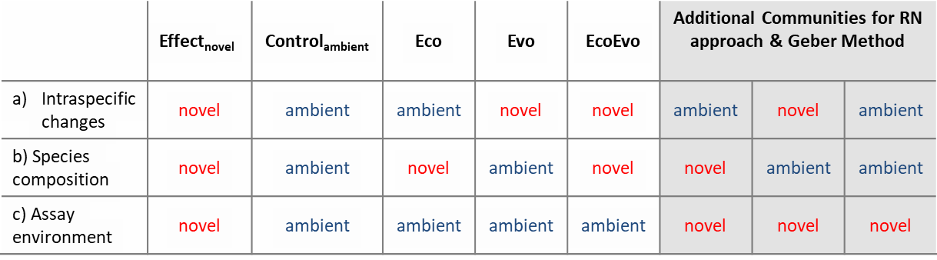

Table S3:Visualization of the potential extension of the Eco-Evo assay including plasticity. Plastic responses can only be separated from genotype compositional changes if genotypes can be monitored *in situ*, separated and artificially assembled. If this is possible, the table indicates how required communities must be assembled.

|  |  |  |  |  |  |  |  |  |  |  |  |  |  |  |
| --- | --- | --- | --- | --- | --- | --- | --- | --- | --- | --- | --- | --- | --- | --- |
|  | **Controlambient** | | **Effectnovel** | | **Plasticity** | | **Eco** | | **Evo** | | **EcoEvo** | | **EcoEvo+ Plasticity** | |
| **Plasticity** | ambient | novel | | novel | | ambient | | ambient | | ambient | | novel | |
| **Genotype composition** | ambient | novel | | ambient | | ambient | | novel | | novel | | novel | |
| **Species composition** | ambient | novel | | ambient | | novel | | ambient | | novel | | novel | |
| **Assay environment** | ambient | novel | | ambient | | ambient | | ambient | | ambient | | ambient | |

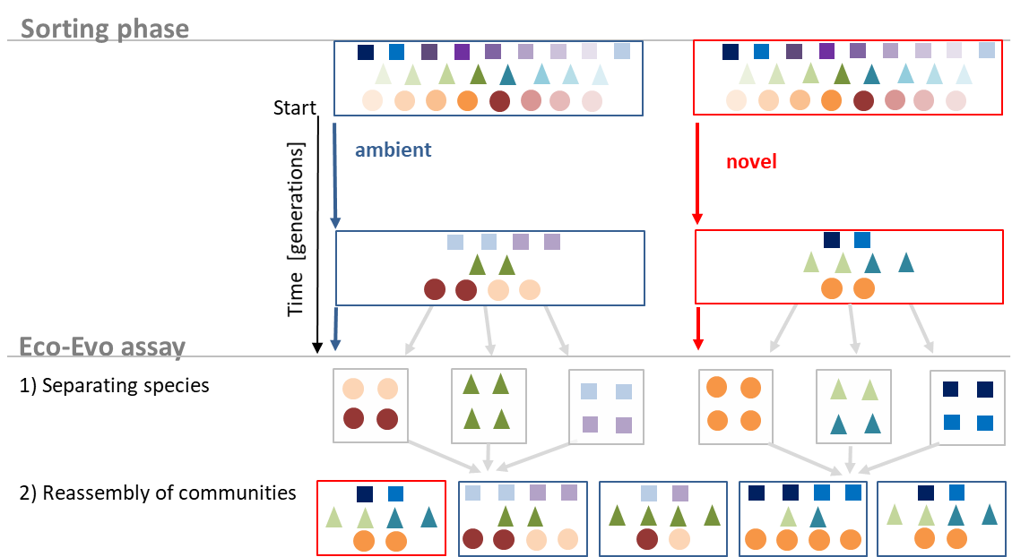

Figure S7: Illustration of the extension of the Eco-Evo assay (Main Fig.1) to partition and quantify the relative importance of ecological and evolutionary contributions to total changes in a community with 3 species. The species are shown as quadrat, triangle and circles, while different colours depict genotypes and blue and red boxes the ambient and novel environment. Species and genotype sorting (dominating inter- and intraspecific changes) is depicted as shifts in absolute number and proportion of these symbols and their colouring, respectively.

# Section 3: Technical assessment of the artificial assembly

We analysed the potential error made by the artificial reassembly of the assay communities. To confirm that the artificially reassembled communities mirror the total community response and species composition in the sorting phase, the responses of the assay communities Controlambient and Effectnovel were compared to the responses of communities in the simultaneously running batch cycle eleven of the continued sorting phase. The statistical comparison was conducted with a two-way ANOVA with the factors CO2 and assay/sorting and using total cell abundance and the ratio between *E. huxleyi* and *C. affinis* as response variables.

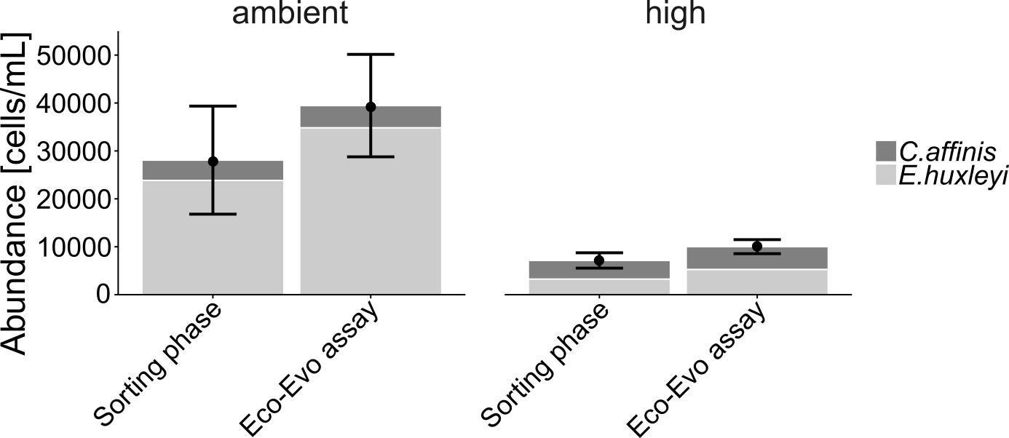

Figure S2: Total cell abundance and underlying relative contribution of *Chaetoceros affinis* and *Emiliania huxleyi* in communities after 88 days in the sorting phase (batch cycle 11) and the simultaneously running Eco-Evo assay communities under ambient and high (novel) CO2. Both, sorting phase and assay communities included the same inter- and intraspecific changes at the start and were exposed to the same environmental conditions. Mean values and standard deviations of n=5 replicates are shown**.**

The comparison of the Controlambient and Effectnovel assay communities with those of the sorting phase shows that the potential bottlenecks of (i) imprecise artificial reassembly and (ii) potential shifts in species frequencies within the assay are not a concern. Regarding (i), the precision of the artificial assemblage was reflected in no detectable differences in total abundance between those assay communities that were artificially assembled, but not compositionally manipulated, and the corresponding communities of the sorting phase (Supplement Fig. S2; *F1, 17 = 2.16, p = 0.16*). Not only was the abundance decline in response to high CO2 of comparable magnitude in both, the Eco-Evo assay and the sorting phase, but also the ratio between *E. huxleyi* and *C. affinis* was preserved in reassembled assay communities (Supplement Fig. S2). Regarding (ii), species compositional shifts in the assay were marginal. The initial species composition left a strong signature towards the end of the batch cycle. Specifically, the Effectnovel, Eco and EcoEvo assay community starting, compared to Controlambient and Evo communities, with lower *E. huxleyi* abundances showed this reduced share also at the end of the assay (Fig. 3A). This is in line with other biodiversity ecosystem functioning experiments using phytoplankton, in which the species composition was manipulated at the onset of plankton growth and equal or significantly stronger effects of initial species composition compared to an environmental driver were shown during bloom (Eggers et al. 2014).

# Section 4: Additional assessment of intraspecific changes in the sorting phase

We assessed genotype-frequency change of *E. huxleyi* throughout the sorting phase. This was not required in order to apply the Eco-Evo assay, however, provides an “internal” quality check for the assay (where manipulation of intraspecific changes should mainly reflect genotype composition shifts). Practically, 20 *E. huxleyi* cells per replicate were re-isolated after 8, 32, 64 and 80 days. The isolated cells were grown for a minimum of two weeks prior to genotype identification with microsatellites (for details see Hattich et al. 2017).

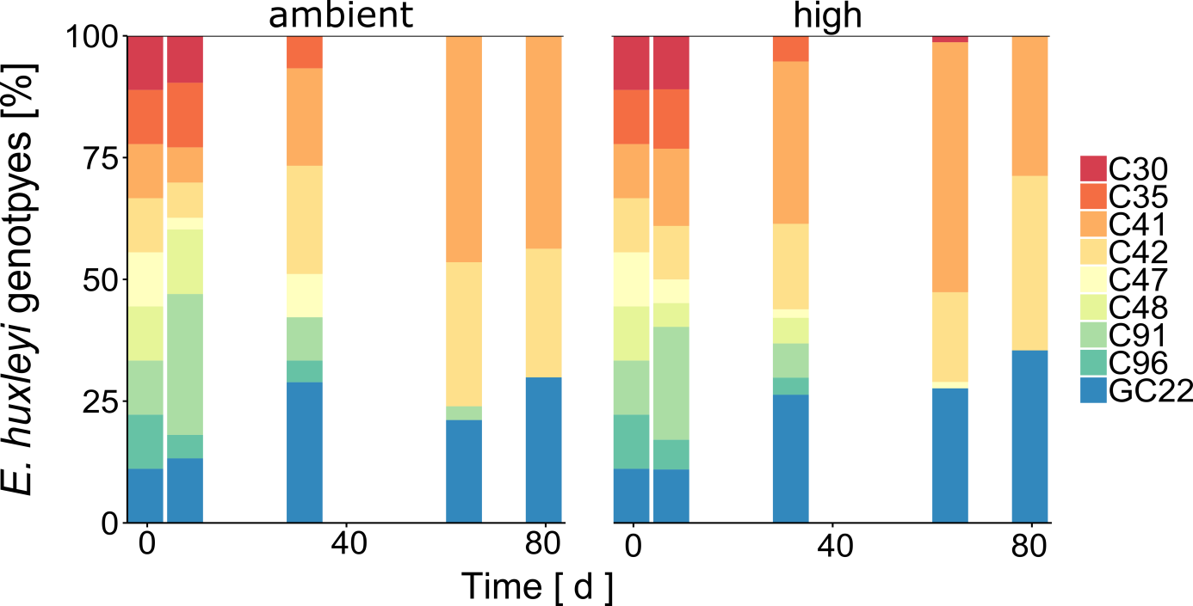

Figure S3: Genotype frequency of *Emiliania huxleyi* under ambient and high (novel) CO2 concentrations are shown for the start and four samplings over the 80 days of the sorting phase. Mean of N=83, 45, 71, 68 and N=82, 57, 76, 38 genotyped cells across all five replicates in ambient and high CO2 concentrations, respectively at day 8, 32, 64, and 80 (correspond to 5, 20, 40, and 50 generations).

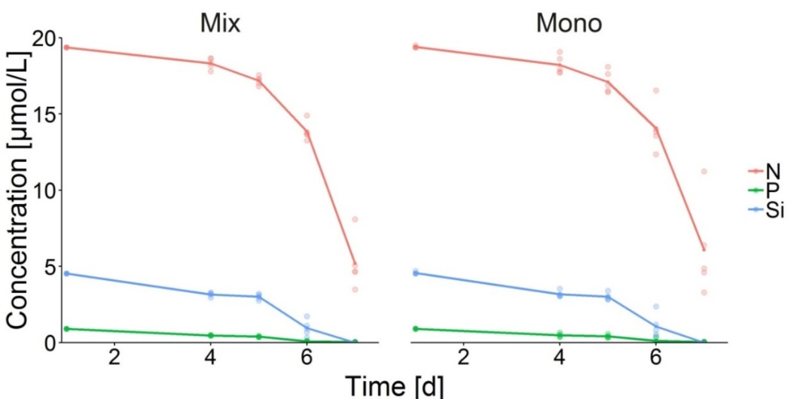

Figure S4: Shows an exemplified nutrient uptake (nitrate N, phosphate P and silicate Si) by a community of *Chaetoceros affinis* and *Emiliania huxleyi* (Mix) and single-species cultures of *C. affinis* including all 9 genotypes (Mono). In batch cycle 11 running simultaneously to the Eco-Evo assay, nutrient samples of each 3 replicates were taken at day 4, 5, 6 and 7, sterile filtered, stored in the freezer until analysis with a SAN++ System from Skalar. At the start of each batch nutrients were added to the final concentrations of 19.59 ± 0.65 μmol L-1 nitrate, 0.97 ± 0.09 μmol/L phosphate and 3.81 ± 0.55 μmol L-1 silicate.

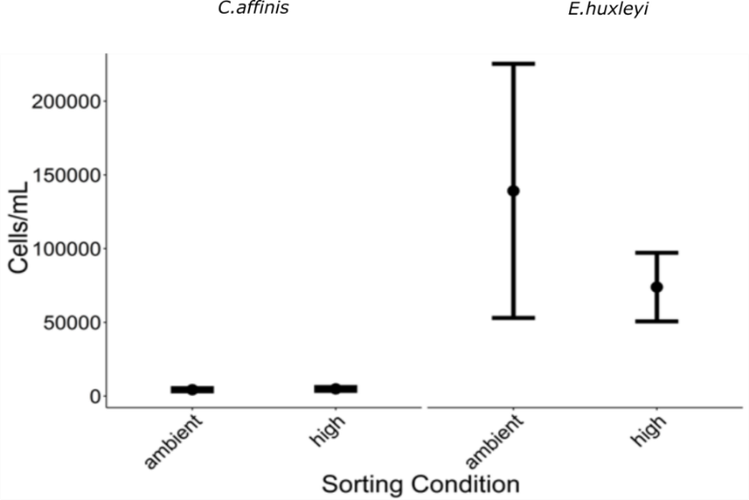

Figure S5: Total cell abundance of *Chaetoceros affinis* and *Emiliania huxleyi* in single-species cultures (with nine genotypes) being exposed to the same laboratory conditions of ambient and high CO2 concentrations as used in the sorting phase. Data from batch cycle 11 running simultaneously to the Eco-Evo assay. Mean values and 95% CI of n=5 replicates are shown.

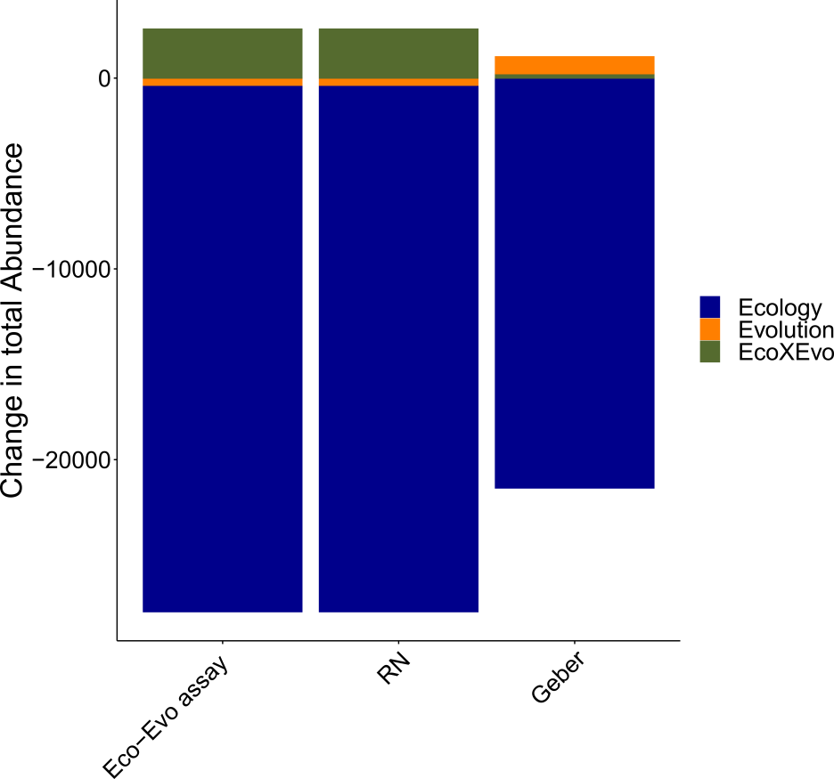

Figure S6:Absolute changes in total abundance by Ecology, Evolution and their interaction (Eco×Evo) as calculated in the Eco-Evo assay as well as reaction norm (RN) approach and the Geber method. These absolute changes are used to calculate the relative importance of ecology and evolution to the total community change.

# Supplementary References

Eggers, S. L., A. M. Lewandowska, J. Barcelos e Ramos, S. Blanco-Ameijeiras, F. Gallo, and B. Matthiessen. 2014. Community composition has greater impact on the functioning of marine phytoplankton communities than ocean acidification. Glob. Chang. Biol. **20**: 713–723. doi:10.1111/gcb.12421

Härnström, K., M. Ellegaard, T. J. Andersen, and A. Godhe. 2011. Hundred years of genetic structure in a sediment revived diatom population. Proc. Natl. Acad. Sci. U. S. A. **108**: 4252–4257. doi:10.1073/pnas.1013528108

Hattich, G. S. I., L. Listmann, J. Raab, D. Ozod-Seradj, T. B. H. Reusch, and B. Matthiessen. 2017. Inter- and intraspecific phenotypic plasticity of three phytoplankton species in response to ocean acidification. Biol. Lett. **13**: 1–4. doi:DOI: 10.1098/rsbl.2016.0774

Lohbeck, K. T., U. Riebesell, and T. B. H. Reusch. 2012. Adaptive evolution of a key phytoplankton species to ocean acidification. Nat. Geosci. **5**: 346–351. doi:10.1038/ngeo1441