Sea-surface slicks and their effect on the concentration of plastics and zooplankton in the coastal waters of Rapa-Nui (Easter Island)

Camila Gallardo^{1,2}, Nicolas Ory^{1,2,3}, María de los Ángeles Gallardo^{1,2}, Marcel Ramos^{1,2,4}, Luis Bravo^{1,2} and Martin Thiel ^{1,2,4*}

¹ Departamento de Biología Marina, Facultad Ciencias del Mar, Universidad Católica del Norte (UCN), Coquimbo, Chile
² Millennium Nucleus for Ecology and Sustainable Management of Oceanic Island (ESMOI), Coquimbo, Chile
³ GEOMAR Helmholtz Centre of Ocean Research Kiel, Marine Ecology Department, Düsternbrooker Weg 20, 24105, Kiel, Germany.
⁴ Centro de Estudios Avanzados en Zonas Áridas (CEAZA), Coquimbo, Chile

Submitted to Frontiers in Marine Science
Draft (18/08/2021)

Running title: Plastics and organisms in slicks

*Corresponding author. Address: Universidad Católica del Norte, Facultad Ciencias del Mar, Larrondo 1281, Coquimbo, Chile; email: thiel@ucn.cl

SUPPLEMENTARY MATERIAL

Supplementary Table 1. Weather conditions (daily mean) of Rapa Nui 5 days before and on the dates of sampling (bold letters) (Source: DGAC). Note: the indicated temperature is the average air temperature of the day.

Date | Wind speed (m s⁻¹) | Maximum Wind speed (m s⁻¹) | Wind direction (degrees) | Wind direction | Rainfall  24 hr (mm) | Air Temp (°C) | Slick
01 Jan 2018 | 3.9 ±1.7 | 11.0 | 81±25 | E | 0.0 | 23.5
02 Jan 2018 | 4.3±2.2 | 11.0 | 98±32 | E | 0.4 | 23.5
03 Jan 2018 | 4.8±2.5 | 10.3 | 98±15 | NE | 0.2 | 23.8
04 Jan 2018 | 4.1±1.4 | 12.0 | 89±59 | NE | 0.6 | 23.8
05 Jan 2018 | 3.0±1.6 | 10.7 | 150±140 | SE | 1.0 | 23.8
06 Jan 2018 | 2.7±1.6 | 7.8 | 182±129 | S | 0.8 | 22.9 | a
07 Jan 2018 | 4.3±1.4 | 9.6 | 275±77 | NE | 1.0 | 22.9
08 Jan 2018 | 6.1±1.5 | 10.5 | 118±15 | SE | 2.2 | 22.8
09 Jan 2018 | 4.0±1.5 | 9.3 | 240±115 | SE | 2.6 | 23.0
10 Jan 2018 | 4.7±1.2 | 9.3 | 319±41 | NE | 0.2 | 23.9
11 Jan 2018 | 2.4±1.5 | 8.3 | 213±115 | SE | 4.8 | 23.4
12 Jan 2018 | 2.0±1.0 | 6.7 | 202±112 | SE | 0.4 | 22.5 | b, c
13 Jan 2018 | 2.4±1.2 | 9.9 | 163±80 | E | 0.6 | 22.5 | d
30 Apr 2019 | 5.4±1.5 | 12.5 | 305±94 | NW | 2.6 | 23.8
01 May 2019 | 4.0±1.1 | 8.2 | 311±69 | NE | 3.4 | 24.0
02 May 2019 | 3.7±2.4 | 10.0 | 138±62 | NE | 1.2 | 21.5
03 May 2019 | 6.8±1.3 | 10.7 | 127±10 | N | 1.4 | 22.1
04 May 2019 | 8.4±2.0 | 14.0 | 116±13 | N | 5.8 | 21.6
05 May 2019 | 4.7±1.8 | 9.4 | 113±34 | NE | 1.8 | 20.7 | e, f, g, h, i
06 May 2019 | 6.0±2.1 | 11.8 | 102±11 | NE | 0.2 | 21.3 | j, k

Supplementary Table 2. Mobility index used to classify the different groups of organisms and particles, in relation to their capacity for movement in the water column. (Categories based on McEdward 1995; Shanks 1995; Al-Yamani et al. 2011).

Mobility index | Criteria | Groups
0 | Organisms without appendages or structures allowing active swimming. In the case of Velella its surface is out of the water, so it is dependent on the wind. The main characteristic of the organisms are passive particles, <1 mm and/or early larval stages. | Eggs, porifera (sponges), foraminiferans, Velella velella, sea-urchin juvenile, cladocerans and cyprid larvae.
1 | Organisms with appendages or structures allowing some active swimming that allow slow and reduced movement (e.g. vertical migration). | Medusae, other cnidarians, polychaete larvae, mollusks snails, stomatopod larvae, phyllosoma larvae, fish with embryonic fin.
2 | Animals with appendages. They make vertical migration; they are advanced stages of development of the organism (most belong to the meroplanktonic group) their capacity of movement is slow and reduced in comparison with the following category. | Polychaetes, galatheoid or porcellanid zoea, anomoran zoea, brachyuran zoea, anomuran megalopa, brachyuran megalopa.
3 | Animals with appendages and/or developed for swimming. They make vertical migration, most of them belong to the holoplanktonic group, their capacity of movement is fast, organisms adapted to the life in the pelagic system. | Chaetognaths, holoplanktonic polychaete, adult copepods, shrimp shape (Euphausiids, Sergestid and Caridean), amphipods, isopods, hemipteran insects (Halobates), pteropods, Early Developmental Stages (EDS) of fish with developed fins and mouth.

McEdward, L. (Ed.). (1995). Ecology of Marine Invertebrate Larvae (1st ed.). CRC Press. https://doi.org/10.1201/9780138758950

Shanks A.L. 1995. Mechanisms of cross-shelf dispersal of larval invertebrates and fish. In Ecology of marine invertebrate larvae, ed. L McEdward, pp. 323-367.

Al-Yamani, F.Y., Skryabin, V., Gubanova, A., Khvorov, S., and Prusova, I. (2011). Marine zooplankton practical guide. (2nd ed.). Kuwait Institute for Scientific Research, Kuwait, 399.

Supplementary Table 3. Temperature obtained inside and outside the slicks with CTD both years and Hobo data logger in 2019. The temperature shown for the CTD is at a depth of 1 meter, while the Hobo is approximately 20 cm deep. The Hobo data logger delta is the difference between outside 1 and outside 2. The delta CTD is the difference between the temperature inside and outside the slick.

 | CTD |  |  | HOBO
Year and ID | Inside | Outside | Delta | Outside 1 | Inside | Outside 2 | Delta | Average outside both ways
2018 a | 24.2 | 24.4 | 0.2 | NA | NA | NA | NA | NA
2018 b | 24.4 | 24.5 | 0.1 | NA | NA | NA | NA | NA
2018 c | 24.8 | 24.7 | 0.1 | NA | NA | NA | NA | NA
2018 d | 24.6 | 24.7 | 0.1 | NA | NA | NA | NA | NA
2019 e | NA | NA | NA | 26.2 | 25.7 | 25.4 | 0.8 | 25.8
2019 f | 24.8 | 24.7 | 0.1 | 22.2 | 22.8 | 23.3 | 1.1 | 22.8
2019 g | 24.5 | 24.7 | 0.2 | 21.8 | 22.4 | 22.8 | 1 | 22.3
2019 h | 24.5 | 24.3 | 0.2 | 21.5 | 21.9 | 22.5 | 1 | 22
2019 i | 24.6 | 24.6 | 0 | 22.2 | 22.3 | 22.6 | 0.4 | 22.4
2019 j | 24.2 | 24.4 | 0.2 | NA | NA | NA | NA | NA
2019 k | 24.6 | 24.6 | 0 | NA | NA | NA | NA | NA

Supplementary Table 4. FTIR analysis summary table
Type | % | Plastics (number)
Polyethylene | 65.2 | 133
Polypropylene | 10.8 | 22
Nylon | 6.4 | 13
Other Plastics | 4.9 | 10
Other Materials | 12.7 | 26
Total | 100 | 204

Supplementary Table 5. Densities (items m⁻³) of zooplankton and particles inside and outside the slicks. The groups are ordered by mobility in the water column. Slick samples n = 11. The association index was calculated as inside/outside, 0.0 to 0.8 indicates that there is a lower concentration of particles inside the slicks, from 0.9 to 1.1 there is no difference in abundance between inside and outside the slicks, ≥ 1.1 there is a higher concentration inside the slicks. The tests used for inside vs outside was Wilcoxon and for comparing years was Mann-Whitney U-tests. Note: if values inside were > 0 and divided by 0, the original value for inside was maintained. Crustaceans M = crustaceans with moderate mobility; Crustaceans H = crustaceans with high mobility; Polychaete L= polychaete larvae. Velella velella * no jellyfish were found in 2019.

Group | Average and standard deviation |  |  | Median |  |  | P-value |  | Times with higher concentration / n° of times present
 | Inside | Outside | Index | Inside | Outside | Index | Inside vs Outside | 2018 vs 2019 | Inside
Plastics | 2.05 ± 4.67 | 1.23 ± 3.32 | 3.26 ± 1.93 | 0.29 | 0.10 | 2.90 | 0.003 | 0.001 | 10/11
Foraminiferans | 14.71 ± 24.34 | 1.79 ± 3.98 | 9.55 ± 15.85 | 0.59 | 0.35 | 1.69 | 0.02 | 0.2 | 7/9
Velella velella * | 0.59 ± 1.11 | 0.1 ± 0.1 | 3.4 ± 7.4 | 0 | 0 | 0 | 0.03 | <0.0001 | 3/3
Eggs | 28.19 ± 62.12 | 4.83 ± 4.89 | 4.24 ± 5.92 | 3.99 | 2.66 | 1.50 | 0.006 | 0.04 | 10/11
Exuvia | 2.71 ± 1.98 | 0.57 ± 0.74 | 7.69 ± 7.17 | 3.40 | 0.31 | 10.97 | 0.7 | 0.6 | 7/11
Vegetal | 1.14 ± 2.75 | 0.09 ± 0.16 | 0.1 ± 0.2 | 0.13 | 0.03 | 4.33 | 0.94 | 0.86 | 2/8
Organic matter | 3.25 ± 3.58 | 1.33 ± 1.10 | 2.70 ± 2.91 | 0.79 | 1.01 | 0.78 | 0.14 | 0.2 | 8/11
Snails juvenile | 3.39 ± 7.80 | 0.97 ± 1.85 | 3.51 ± 6.64 | 0.25 | 0.30 | 0.83 | 0.1 | 0.003 | 3/8
Crustacean M | 4.07 ± 5.06 | 4.53 ± 5.68 | 1.36 ± 109 | 1.33 | 3.14 | 0.42 | 0.07 | 0.001 | 8/11
Polychaete L | 0.77 ± 2.01 | 0.31 ± 0.88 | 0.1 ± 0.2 | 0 | 0 | 0 | 0.6 | 0.4 | 3/6
Crustacean H | 30.54 ± 36.05 | 19.38± 22.76 | 4.48 ± 7.13 | 20.46 | 13.88 | 1.47 | 0.02 | 0.02 | 3/11
Chaetognaths | 0.50 ± 0.51 | 0.43 ± 0.66 | 2.91 ± 3.26 | 0.25 | 0.10 | 2.53 | 0.01 | 0.02 | 8/10
Fish larvae | 1.43 ± 0.33 | 0.19 ± 0.33 | 7.08 ± 15.97 | 0.29 | 0.082 | 3.54 | 0.006 | 0.1 | 6/8

Supplementary Figure 1. Vertical temperature distribution inside (blue) and outside (orange) of the slicks sampled in 2018 and 2019 (upper to lower).

Supplementary Figure 2. Horizontal temperature profile, a) temperature in a sample without slicks (5 May 2019). b) Temperature profiles across the slicks (6 May 2019). Note: The bold parts of profiles represent the width approx. of the slick.
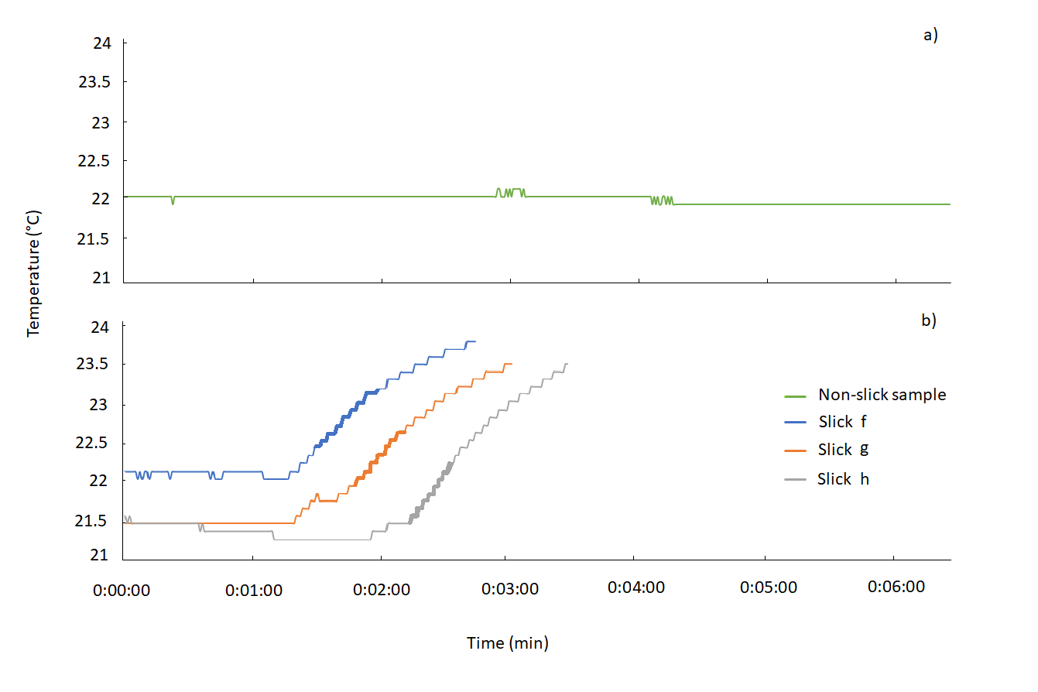

Supplementary Figure 3. The surface current pattern near the motu during (a) autumn (b - May 2015) and (c) summer (d - January 2016) was used as indicator for monthly/seasonal variability in the zone. The green dot indicates the position of the ADCP, the date indicates the average surface current direction at 12 m depth. The ellipse indicates the variability of current directions during the representative months and seasonal for the study period of slicks.”
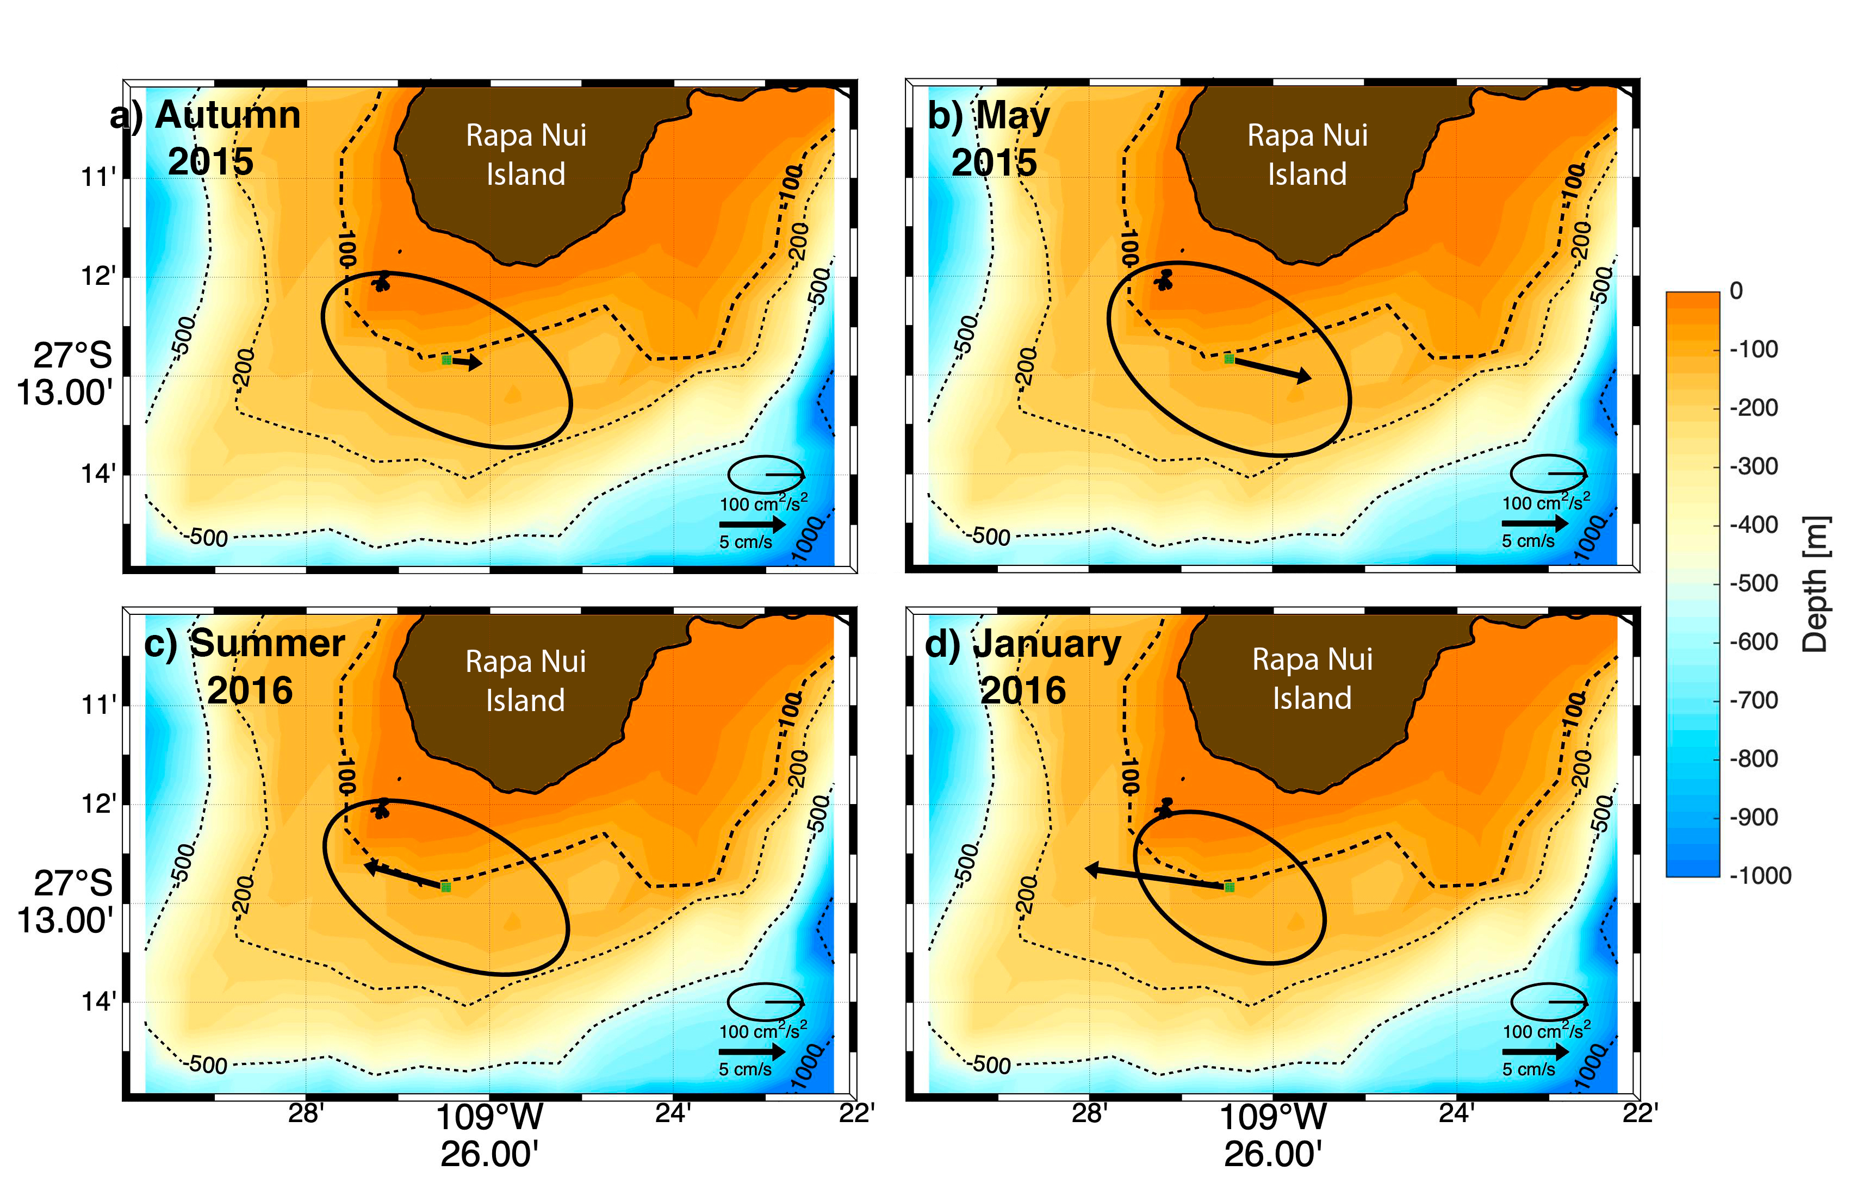

Supplementary Figure 4. Detail of the abundance of crustaceans. Density of organisms found inside and outside the slicks in summer 2018 (left figure) and autumn 2019 (right figure).

Supplementary Figure 5. Detail of the correlation matrix between plastics and groups with no or moderate motility. Symbols correspond to levels of significance: p-values 0.001 (***), 0.01 (**), and 0.05 (*).
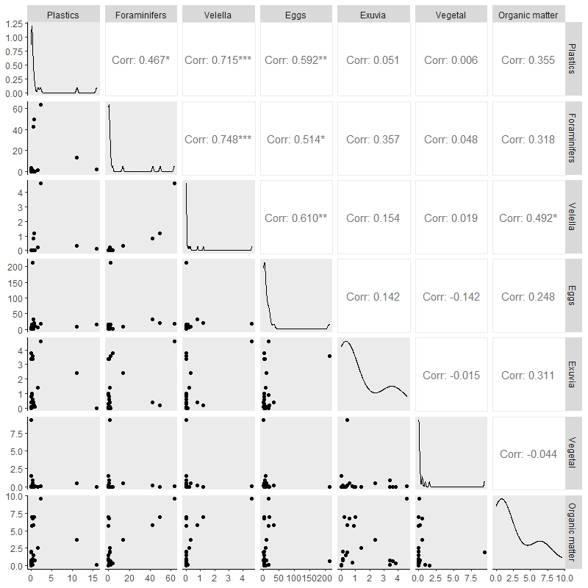

Supplementary Figure 6. Detail of the correlation matrix between plastics and groups with high motility. Symbols correspond to levels of significance: p-values 0.001 (***), 0.01 (**), and 0.05 (*).
