Appendix A. Supplementary Data

Enhanced mercury reduction in the South Atlantic Ocean during carbon remineralization

Igor Živković, Matthew P. Humphreys, Eric P. Achterberg, Cynthia Dumousseaud, E. Malcolm S. Woodward, Natalia Bojanić, Mladen Šolić, Arne Bratkič, Jože Kotnik, Mitja Vahčič, Kristina Obu Vazner, Ermira Begu, Vesna Fajon, Yaroslav Shlyapnikov, and Milena Horvat



**Fig. S1.** Sampling stations during GA10 cruise with indicated position of Stations 17 and 18 (see main text for explanation). Created using Ocean Data View (Schlitzer, 2018). Adapted from Bratkič et al. (2016) with the permission for re-use from John Wiley and Sons (Global Biogeochemical Cycles).







**Fig. S2.** Vertical profiles of total mercury (THg), methylated mercury (MeHg) and dissolved gaseous mercury (DGM) along the GA10 cruise. Created using Ocean Data View (Schlitzer, 2018). Adapted from Bratkič et al. (2016) with the permission for re-use from John Wiley and Sons (Global Biogeochemical Cycles).











**Fig. S3.** Vertical profiles of phosphate, silicic acid, total inorganic nitrogen (TIN), dissolved inorganic carbon and temperature along the GA10 cruise. Created using Ocean Data View (Schlitzer, 2018). Phosphate and temperature panels were adapted from Bratkič et al. (2016) with the permission for re-use from John Wiley and Sons (Global Biogeochemical Cycles).

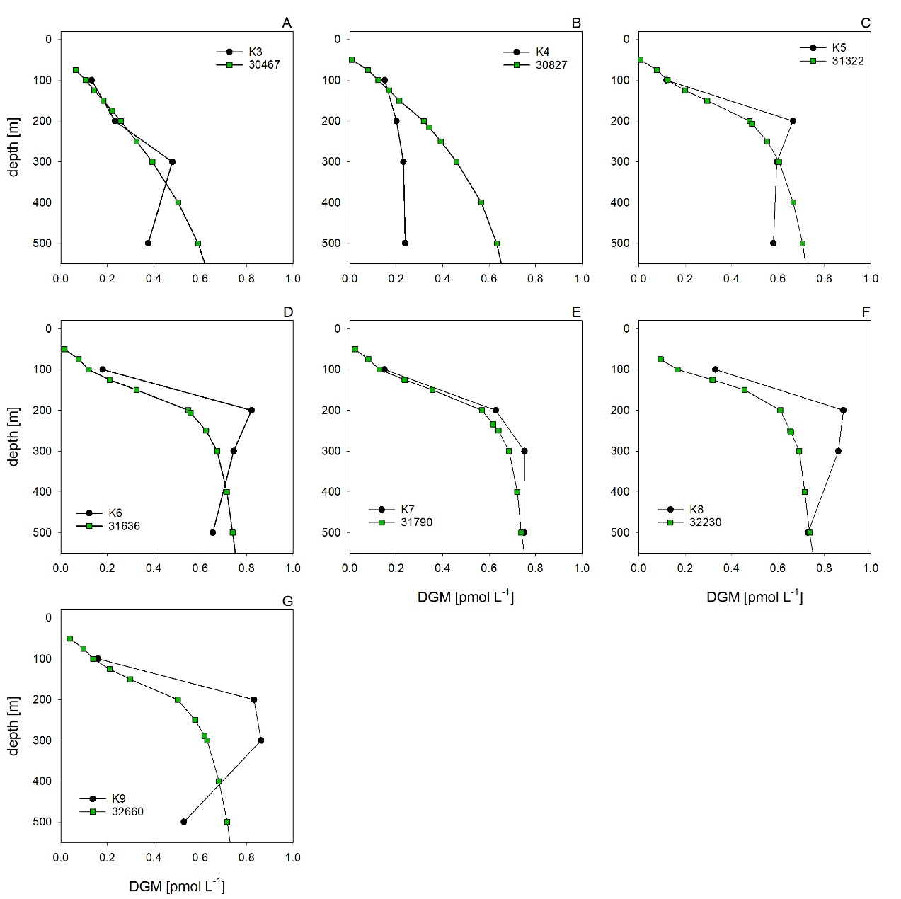

**Fig. S4.** Comparison of vertical profiles (100 – 500 m) of DGM measured in the Northwestern Paciﬁc Ocean (data from Kim et al. (2016); black circles) with calculated DGM values using Equation 2 (data from Goyet et al. (2000); green squares). Sampling point locations are presented in Table S3.

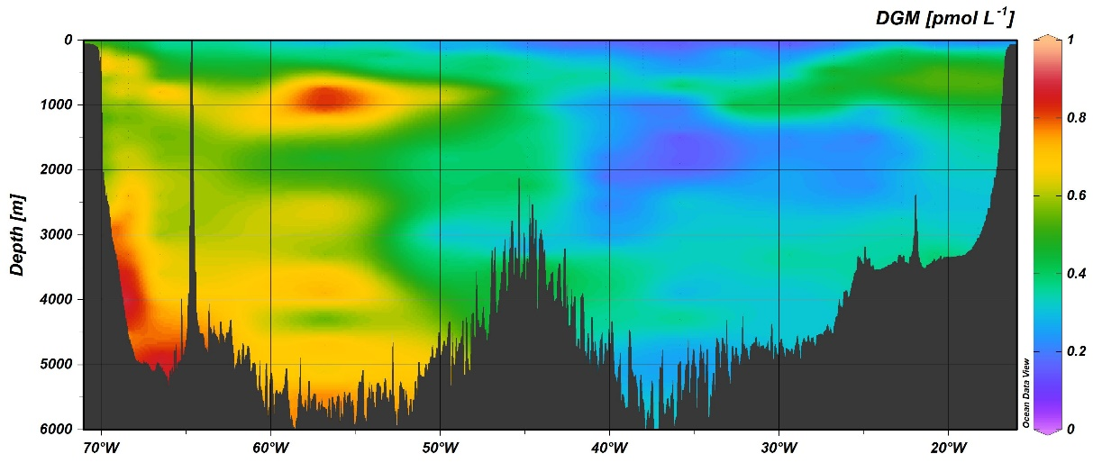

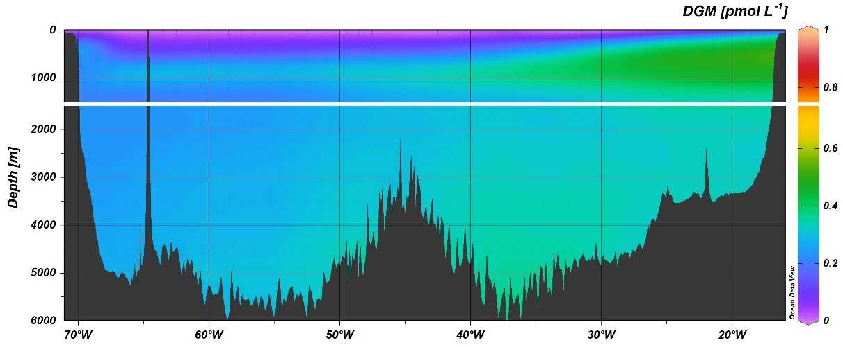

**Fig. S5.** Comparison of measured (upper panel) and calculated (lower panel) DGM concentrations at the zonal section of the North Atlantic Ocean (GEOTRACES GA03 cruise). Measured DGM values were determined as the sum of dHg0 and DMeHg, both previously measured by Bowman et al. (2015) / Lamborg and Hammerschmidt (2017). Calculated DGM values were calculated using DGM–DICbio relation in the upper 1500 m and using DGM–DIC relation below this depth (cutoff, a white stripe, is set to 1500 m as 5 °C waters start approximately at this depth).

**Table S1.** Results of principal component analysis: factor loadings and percentage of variance after Varimax rotation.

|  |  |  |
| --- | --- | --- |
| Factor loadings | D1 | D2 |
| DGM | -0.733 | 0.320 |
| THg | -0.092 | 0.978 |
| MeHg | 0.875 | -0.017 |
| DEP | -0.698 | 0.270 |
| SAL | 0.460 | 0.020 |
| TEMP | 0.683 | -0.224 |
| FLUO | 0.659 | -0.027 |
| PAR | 0.624 | -0.226 |
| O2 | 0.381 | -0.281 |
| TIN | -0.754 | 0.103 |
| SIO4 | -0.698 | 0.319 |
| PO4 | -0.742 | 0.173 |
| DIC | -0.720 | 0.229 |
| TA | -0.056 | 0.340 |
| Variability (%) | 43.759 | 35.295 |
| Cumulative (%) | 43.759 | 79.054 |

(total mercury, THg; dissolved gaseous mercury, DGM; methylated mercury, MeHg; total dissolved inorganic nitrogen, TIN; phosphate, PO4; silicic acid, SiO4; dissolved inorganic carbon, DIC; total alkalinity, TA; dissolved oxygen, O2; sea temperature, TEMP; ocean depth, DEP; salinity, SAL; photosynthetically active radiation, PAR; fluorescence, FLUO)

**Table S2.** Spearman's rank correlation coefficient (*ρ*) between DGM (MeHg) and environmental variables.

|  |  |  |
| --- | --- | --- |
| Variable | DGM | MeHg |
| THg | 0.419 *** (301) | -0.123 ns (102) |
| DGM | × | -0.337 *** (105) |
| MeHg | -0.337 *** (105) | × |
| Depth | 0.870 *** (354) | -0.391 *** (108) |
| Salinity | -0.461 *** (354) | 0.334 *** (108) |
| Temperature | -0.825 *** (354) | 0.396 *** (108) |
| Fluorescence | -0.697 *** (354) | 0.387 *** (108) |
| PAR | -0.597 *** (354) | 0.476 *** (108) |
| Oxygen | -0.511 *** (351) | 0.267 *** (108) |
| TIN | 0.831 *** (354) | -0.482 *** (108) |
| Silicate | 0.867 *** (354) | -0.421 *** (108) |
| Phosphate | 0.841 *** (354) | -0.456 *** (108) |
| DIC | 0.867 *** (349) | -0.390 *** (104) |
| Total alkalinity | 0.306 *** (334) | 0.072 ns (98) |
| Numbers in parentheses indicate sample size. ns – not significant, * *p* < 0.05, ** *p* < 0.01, *** *p* < 0.001. | | |

**Table S3.** Locations of selected stations at which DGM concentrations were calculated or measured.

|  |  |  |  |
| --- | --- | --- | --- |
| Station | Location | Mentioned in: | Reference |
| 62 | 63.9967° S 48.2850° W | Main text | (Wedborg et al., 1998) |
| 516-1 | 63.6950° S 50.8583° W | Main text | (Nerentorp Mastromonaco et al., 2017) |
| 10 | 33.0000° S 40.0000° W | Main text | (Mason and Sullivan, 1999) |
| 17 | 40.0000° S 37.4150° W | Main text | (Bratkič et al., 2016) |
| 18 | 40.0017° S 42.4150° W | Main text | (Bratkič et al., 2016) |
| N-04 | 64.2083° S 139.8417° E | Main text | (Cossa et al., 2011) |
| ST2 | 41.4240° N 7.9770° E | Figure 4, Figure 5 | (Kotnik et al., 2007) |
| 30624 | 41.5000° N 7.5000° E | Figure 4, Figure 5 | (Goyet et al., 2000) |
| ST4 | 37.4800° N 11.5660° E | Figure 4, Figure 5 | (Kotnik et al., 2007) |
| 30055 | 38.5000° N 11.5000° E | Figure 4, Figure 5 | (Goyet et al., 2000) |
| ST5 | 35.7497° N 17.9163° E | Figure 4, Figure 5 | (Kotnik et al., 2007) |
| 29438 | 35.5000° N 18.5000° E | Figure 4, Figure 5 | (Goyet et al., 2000) |
| WP4 | 35.9005° N 17.9171° E | Figure 4, Figure 5 | (Kotnik et al., 2007) |
| 29437 | 35.5000° N 17.5000° E | Figure 4, Figure 5 | (Goyet et al., 2000) |
| WP13 | 37.8669° N 5.3507° E | Figure 4, Figure 5 | (Kotnik et al., 2007) |
| 29848 | 37.5000° N 4.5000° E | Figure 4, Figure 5 | (Goyet et al., 2000) |
| WP14 | 35.8500° N 4.0000° W | Figure 4, Figure 5 | (Kotnik et al., 2007) |
| 29842 | 36.5000° N 1.5000° W | Figure 4, Figure 5 | (Goyet et al., 2000) |
| WP15 | 40.4670° N 6.4757° E | Figure 4, Figure 5 | (Kotnik et al., 2007) |
| 30440 | 40.5000° N 6.5000° E | Figure 4, Figure 5 | (Goyet et al., 2000) |
| M2015/2 | 40.2167° N 10.9333° E | Figure 4, Figure 5 | This work |
| 30253 | 39.5000° N 11.5000° E | Figure 4, Figure 5 | (Goyet et al., 2000) |
| M2015/9 | 39.7000° N 12.8333° E | Figure 4, Figure 5 | This work |
| 30254 | 39.5000° N 12.5000° E | Figure 4, Figure 5 | (Goyet et al., 2000) |

**Table S3.** Continued.

|  |  |  |  |
| --- | --- | --- | --- |
| Station | Location | Mentioned in: | Reference |
| M2015/11 | 38.7500° N 15.1667° E | Figure 4, Figure 5 | This work |
| 30058 | 38.5000° N 14.5000° E | Figure 4, Figure 5 | (Goyet et al., 2000) |
| M2015/13 | 37.1833° N 15.3333° E | Figure 4, Figure 5 | This work |
| 29645 | 36.5000° N 15.5000° E | Figure 4, Figure 5 | (Goyet et al., 2000) |
| M2017/3 | 39.2167° N 14.4333° E | Figure 4, Figure 5 | This work |
| 30255 | 39.5000° N 13.5000° E | Figure 4, Figure 5 | (Goyet et al., 2000) |
| K3 | 40.3231° N 148.5808° E | Figure S4 | (Kim et al., 2016) |
| 30467 | 40.5000° N 148.5000° E | Figure S4 | (Goyet et al., 2000) |
| K4 | 42.7661° N 153.6798° E | Figure S4 | (Kim et al., 2016) |
| 30827 | 42.5000° N 153.5000° E | Figure S4 | (Goyet et al., 2000) |
| K5 | 45.6341° N 157.7134° E | Figure S4 | (Kim et al., 2016) |
| 31322 | 45.5000° N 157.5000° E | Figure S4 | (Goyet et al., 2000) |
| K6 | 47.3951° N 160.5788° E | Figure S4 | (Kim et al., 2016) |
| 31636 | 47.5000° N 160.5000° E | Figure S4 | (Goyet et al., 2000) |
| K7 | 48.4508° N 162.5699° E | Figure S4 | (Kim et al., 2016) |
| 31790 | 48.5000° N 162.5000° E | Figure S4 | (Goyet et al., 2000) |
| K8 | 51.2627° N 168.1097° E | Figure S4 | (Kim et al., 2016) |
| 32230 | 51.5000° N 168.5000° E | Figure S4 | (Goyet et al., 2000) |
| K9 | 54.8782° N 173.5981° E | Figure S4 | (Kim et al., 2016) |
| 32660 | 54.5000° N 173.5000° E | Figure S4 | (Goyet et al., 2000) |

**Table S4.** Comparison of vertical profiles of measured DGM (data from Nerentorp Mastromonaco et al. (2017) and Mason and Sullivan (1999)) with calculated DGM values obtained using Equation 1 (data from Wedborg et al. (1998) and Humphreys et al. (2016)), respectively. Measured DGM concentrations were extracted from graphs. Please refer to the main text for information about sampling points.

|  |  |  |  |  |  |
| --- | --- | --- | --- | --- | --- |
| Depth  (m) | Measured DGM (pmol L−1)  Data from Nerentorp Mastromonaco et al. (2017) | Calculated DGM (pmol L−1)  Data from Wedborg et al. (1998) | Depth  (m) | Measured DGM (pmol L−1)  Data from Mason and Sullivan (1999) | Calculated DGM (pmol L−1)  Data from Humphreys et al. (2016) |
| 0 |  | 0.11 | 25 | 1.01 |  |
| 45 | 0.80 |  | 32 |  | 0.02 |
| 51 |  | 0.35 | 62 |  | 0.11 |
| 103 |  | 0.37 | 69 | 0.74 |  |
| 150 | 0.37 |  | 173 | 1.33 |  |
| 196 |  | 0.42 | 197 |  | 0.17 |
| 302 | 0.39 |  | 242 | 1.79 |  |
| 499 | 0.54 |  | 297 |  | 0.21 |
| 505 |  | 0.43 | 397 |  | 0.23 |
| 748 | 0.55 |  | 450 | 1.29 |  |
| 999 | 0.53 |  | 746 |  | 0.27 |
| 1000 |  | 0.44 | 749 | 0.69 |  |
| 1250 | 0.55 |  | 974 | 0.70 |  |
| 1500 |  | 0.43 | 994 |  | 0.33 |
| 1515 | 0.49 |  | 1475 | 1.19 |  |
| 1935 | 0.32 |  | 1492 |  | 0.41 |
| 1966 | 0.35 |  | 1993 |  | 0.36 |
| 1989 | 0.33 |  | 2173 | 0.81 |  |
| 2000 |  | 0.42 | 2744 | 0.90 |  |
| 2017 | 0.45 |  | 2991 |  | 0.36 |
| 3000 |  | 0.42 | 3487 | 0.79 |  |
| 3607 |  | 0.41 | 3490 |  | 0.41 |
| 3975 |  | 0.40 |  |  |  |
| 4027 |  | 0.40 |  |  |  |

**Table S5.** Comparison of vertical profiles of measured DGM (data from Cossa et al. (2011)) with calculated DGM values obtained using Equation 1 (data from Tilbrook et al. (2013)), respectively. Measured DGM concentrations were extracted from graphs. Please refer to the original publications for information about sampling point locations.

|  |  |  |  |  |  |  |  |  |  |  |  |
| --- | --- | --- | --- | --- | --- | --- | --- | --- | --- | --- | --- |
| Station N−04 | DGM (pmol L−1) | | Station N−07 | DGM (pmol L−1) | | Station N−09 | DGM (pmol L−1) | | Station N−14 | DGM (pmol L−1) | |
| Depth (m) | Measured | Calculated | Depth (m) | Measured | Calculated | Depth (m) | Measured | Calculated | Depth (m) | Measured | Calculated |
| 7 | 0.28 | 0.25 | 50 | 0.12 | 0.21 | 6 | 0.18 | 0.19 | 4 | 0.01 | 0.18 |
| 48 | 0.12 | 0.25 | 75 | 0.19 | 0.22 | 26 | 0.15 | 0.19 | 98 | 0.01 | 0.18 |
| 98 | 0.59 | 4.35 | 99 | 0.20 | 0.27 | 102 | 0.08 | 0.22 | 200 | 0.35 | 0.30 |
| 151 | 0.42 | 0.41 | 200 | 0.33 | 0.39 | 300 | 0.08 | 0.37 | 397 | 0.25 | 0.39 |
| 200 | 0.33 | 0.42 | 499 | 0.23 | 0.41 | 600 | 0.22 | 0.41 | 598 | 0.21 | 0.41 |
|  |  |  | 1000 | 0.15 | 0.40 | 800 | 0.24 | 0.41 | 999 | 0.20 | 0.42 |
|  |  |  |  |  |  | 2201 | 0.21 | 0.42 | 1301 | 0.21 | 0.41 |
|  |  |  |  |  |  |  |  |  | 2001 | 0.20 | 0.43 |
|  |  |  |  |  |  |  |  |  | 2502 | 0.21 | 0.44 |

**Table S5.** Continued.

|  |  |  |  |  |  |  |  |  |
| --- | --- | --- | --- | --- | --- | --- | --- | --- |
| Station N−17 | DGM (pmol L−1) | | Station N−20 | DGM (pmol L−1) | | Station N−23 | DGM (pmol L−1) | |
| Depth (m) | Measured | Calculated | Depth (m) | Measured | Calculated | Depth (m) | Measured | Calculated |
| 50 | 0.01 | 0.15 | 11 | 0.05 | 0.14 | 1001 | 0.23 | 0.30 |
| 99 | 0.07 | 0.15 | 49 | 0.03 | 0.14 | 1502 | 0.29 | 0.40 |
| 152 | 0.10 | 0.17 | 101 | 0.03 | 0.14 | 1999 | 0.28 | 0.42 |
| 301 | 0.09 | 0.20 | 200 | 0.04 | 0.16 | 3200 | 0.28 | 0.44 |
| 500 | 0.23 | 0.26 | 301 | 0.08 | 0.16 | 3382 | 0.30 | 0.44 |
| 1000 | 0.26 | 0.36 | 2499 | 0.26 | 0.42 |  |  |  |
| 2198 | 0.31 | 0.41 | 2901 | 0.25 | 0.43 |  |  |  |
| 3734 | 0.30 | 0.44 | 3798 | 0.26 | 0.44 |  |  |  |
|  |  |  | 4300 | 0.24 | 0.44 |  |  |  |

**References**

Bowman, K.L., Hammerschmidt, C.R., Lamborg, C.H., Swarr, G., 2015. Mercury in the North Atlantic Ocean: The U.S. GEOTRACES zonal and meridional sections. Deep. Res. Part II Top. Stud. Oceanogr. 116, 251–261. https://doi.org/10.1016/j.dsr2.2014.07.004

Bratkič, A., Vahčič, M., Kotnik, J., Obu Vazner, K., Begu, E., Woodward, E.M.S., Horvat, M., 2016. Mercury presence and speciation in the South Atlantic Ocean along the 40°S transect. Global Biogeochem. Cycles 30, 105–119. https://doi.org/10.1002/2015GB005275

Cossa, D., Heimbürger, L.E., Lannuzel, D., Rintoul, S.R., Butler, E.C.V., Bowie, A.R., Averty, B., Watson, R.J., Remenyi, T., 2011. Mercury in the Southern Ocean. Geochim. Cosmochim. Acta 75, 4037–4052. https://doi.org/10.1016/j.gca.2011.05.001

Goyet, C., Healy, R., Ryan, J., Kozyr, A., 2000. Global Distribution of Total Inorganic Carbon and Total Alkalinity below the Deepest Winter Mixed Layer Depths. Oak Ridge National Laboratory, Oak Ridge, US. https://doi.org/10.2172/760546

Humphreys, M.P., Dumousseaud, C., Achterberg, E.P., 2016. Discrete carbonate chemistry measurements from UK GEOTRACES cruises D357 and JC068 on the South Atlantic transect GA10. British Oceanographic Data Centre - Natural Environment Research Council. Accessed January 15th 2019. https://doi.org/10.5285/33d2c2c7-84dc-718b-e053-6c86abc0da4d

Kim, H., Rhee, T.S., Hahm, D., Hwang, C.Y., Yang, J., Han, S., 2016. Contrasting distributions of dissolved gaseous mercury concentration and evasion in the North Pacific Subarctic Gyre and the Subarctic Front. Deep Sea Res. Part I Oceanogr. Res. Pap. 110, 90–98. https://doi.org/10.1016/j.dsr.2016.02.001

Kotnik, J., Horvat, M., Tessier, E., Ogrinc, N., Monperrus, M., Amouroux, D., Fajon, V., Gibičar, D., Žižek, S., Sprovieri, F., Pirrone, N., 2007. Mercury speciation in surface and deep waters of the Mediterranean Sea. Mar. Chem. 107, 13–30. https://doi.org/10.1016/j.marchem.2007.02.012

Lamborg, C.H., Hammerschmidt, C., 2017. Mercury speciation across the US GEOTRACES North Atlantic Zonal Section from R/V Knorr KN199-04, KN204-01 in the subtropical North Atlantic Ocean from 2010-2011 (U.S. GEOTRACES NAT project). Biological and Chemical Oceanography Data Management Office (BCO-DMO). Accessed March 15th 2020. https://www.bco-dmo.org/dataset/3860/data

Mason, R.P., Sullivan, K.A., 1999. The distribution and speciation of mercury in the South and equatorial Atlantic. Deep. Res. Part II Top. Stud. Oceanogr. 46, 937–956. https://doi.org/10.1016/S0967-0645(99)00010-7

Nerentorp Mastromonaco, M.G., Gårdfeldt, K., Assmann, K.M., Langer, S., Delali, T., Shlyapnikov, Y.M., Zivkovic, I., Horvat, M., 2017. Speciation of mercury in the waters of the Weddell, Amundsen and Ross Seas (Southern Ocean). Mar. Chem. 193, 20–33. https://doi.org/10.1016/j.marchem.2017.03.001

Schlitzer, R., 2018. Ocean Data View. Alfred-Wegener-Institute for Polar and Marine Research. https://odv.awi.de/

Tilbrook, B., Rintoul, S.R., Warner, M.J., Hansell, D.A., Rosenberg, M., 2013. Dissolved inorganic carbon (DIC), total alkalinity, temperature, salinity and other variables collected from discrete sample and profile observations during the R/V Aurora Australis cruise AU0806, CLIVAR_SR03_2008 (EXPOCODE 09AR20080322) in the Indian Ocean from 2008-03-22 to 2008-04-17. NOAA National Centers for Environmental Information. Accessed March 15th 2019. https://doi.org/10.3334/cdiac/otg.clivar_sr03_2008

Wedborg, M., Hoppema, M., Skoog, A., 1998. On the relation between organic and inorganic carbon in the Weddell Sea. J. Mar. Syst. 17, 59–76. https://doi.org/10.1016/S0924-7963(98)00029-3