Supplementary Material

Supplementary Figures and Tables

Supplementary Figures

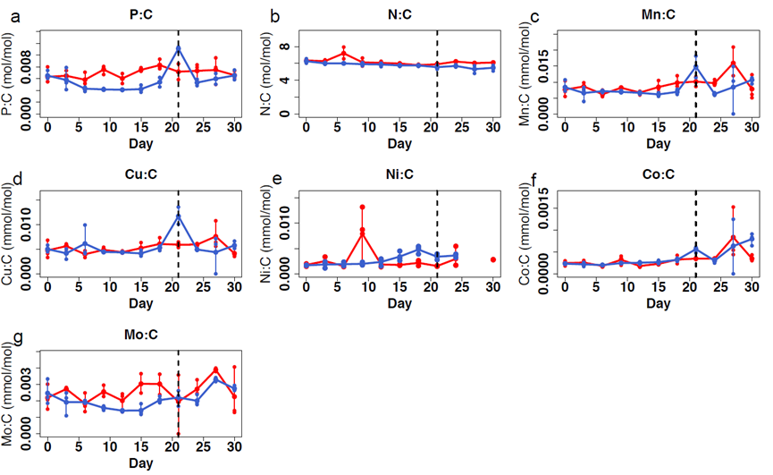
Supplementary Figure 1. Elemental ratios determined throughout the duration of the exponentially fed batch culture at steady state (day≥21) for Trichodesmium ISM101 growing with a constant dilution rate of 0.1 d⁻¹ with 2 different P sources (DIP and MPA). Points show triplicate measurements every three days, lines map the change in the mean value with time, right side of the dashed line is considered to be the steady state.

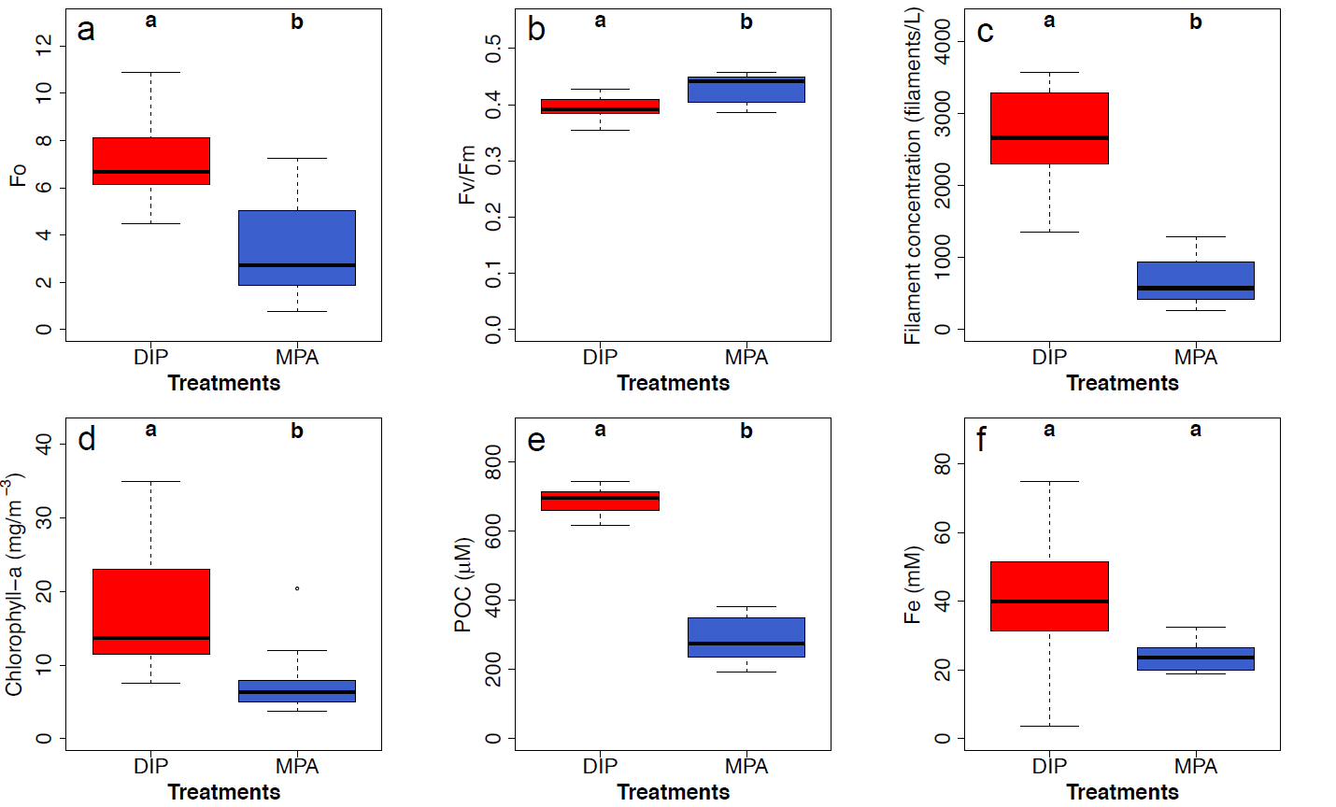Supplementary Figure 2. Parameters determined at steady state (day≥21) for Trichodesmium ISM101 growing with a constant dilution rate of 0.1 d⁻¹ with 2 different P sources (DIP and MPA). a, F₀. b, Fv/Fm. c, Filament concentration. d, Chlorophyll a concentration. e, POC. f. Particulate Fe concentration. Letters indicate statistically significant differences between treatments (pairwise Wilcox test, p<0.05).

Supplementary Figures
Supplementary Table 1. Modified YBCII media recipe used in our experiment
Component | Concentration in media (mol L⁻¹)
Major salt
NaCl | 0.42
KCl | 0.01
NaHCO₃ | 0.0025
H₃BO₃ | 0.00058
KBr | 0.00097
NaF | 0.00007
MgSO₄ | 0.025
MgCl₂ | 0.02
CaCl₂ | 0.01
SrCl₂ | 0.000065
LiCl | 0.03
Macronutrient
Na₂EDTA·2H₂O | 2.0×10⁻⁶
CuSO₄·5H₂O | 8.0×10⁻⁹
ZnSO₄·7H₂O | 2.0×10⁻⁸
CoCl₂·6H₂O | 8.0×10⁻⁹
MnCl₂·4H₂O | 1.8×10⁻⁸
Na₂MO₄·2H₂O | 1.0×10⁻⁷
NiSO₄·6H₂O | 2.0×10⁻⁸
Na₂SeO₃ | 1.0×10⁻⁸
FeEDTA | 4.0×10⁻⁸
Vitamin
Thiamine | 3.0×10⁻⁷
Biotin | 2.0×10⁻⁹
Cyanocobalamin | 3.7×10⁻¹⁰

