*Global biogeochemical Cycles*

Supporting Information for

**Shallow Calcium Carbonate Cycling in the Ocean Driven by Organic Matter Respiration**

Adam V. Subhas1, Sijia Dong2, John D. Naviaux3, Nick E. Rollins4, Patrizia Ziveri5, William Gray6, James W.B. Rae7, Xuewu Liu8, Robert H. Byrne8, Sang Chen9, Christopher Moore8, Loraine Martell-Bonet8, Zvi Steiner10, Gilad Antler11, Huanting Hu9, Abby Lunstrum4, Yi Hou12, Nathaniel Kemnitz4, Johnny Stutsman13, Sven Pallacks5, Mathilde Dugenne14, Paul D. Quay13, William M. Berelson4, and Jess F. Adkins2

1Department of Marine Chemistry and Geochemistry, Woods Hole Oceanographic Institution, Woods Hole, MA, USA. 2Division of Geological and Planetary Sciences, California Institute of Technology, Pasadena, CA, USA. 3Four Twenty Seven Inc., Sunnyvale, CA, USA. 4Department of Earth Sciences, University of Southern California, Los Angeles, CA, USA. 5Institut de Ciencia I Tecnologia Ambientals, Universitat Autonoma de Barcelona, Barcelona, Spain. 6Laboratorie des Sciences du Climat et de l’Environnement, CNRS, France 7School of Earth and Environmental Sciences, University of St Andrews, St Andrews, Scotland 8College of Marine Science, University of South Florida, St. Petersburg, FL, USA 9School of Oceanography, Shanghai Jiao Tong University, Shanghai, China 10Marine Biogeochemi FE Chemische Ozeanographie, GEOMAR, Germany 11Department of Earth and Environmental Sciences, Ben-Gurion University, Israel 12Department of Earth, Environmental, and Planetary Sciences, Rice University, Houston, TX, USA 13School of Oceanography, University of Washington, Seattle, WA, USA 14School of Ocean and Earth Science and Technology, University of Hawaii, HI, USA

Corresponding author: Adam V. Subhas ([asubhas@whoi.edu)](mailto:asubhas@whoi.edu))

**Contents of this file**

Text S1 to S7

Figures S1 to S8

Table S1

**Introduction**

This document contains supporting calculations and figures for the main text. In particular we describe how we calculate the effects of oxic respiration on saturation state and pH. We step through corrections for anthropogenic CO2 on isotope and DIC balances. We provide several other figures pertinent to discussions in the main text.

**S1 Data availability statement**

Some of the data presented here are discussed in detail in companion papers by Dong et al. (2019), Subhas et al. (2019), and Naviaux et al. (2019a). All data will be uploaded to the BCO-DMO repository as text files.

**S2 GLODAP data and Pacific Section Analysis**

GLODAP v2.2019 data were downloaded from the database as MATLAB (.mat) files (Olsen et al., 2016; Olsen et al., 2019). All quality data (flag = 2) were fed into CO2SYS (via matlab) to calculate Ω for the entire Pacific basin. We used GLODAP oxygen data to examine the potential for respiration within particles to drive microenvironments towards undersaturation. This calculation assumes that there is an excess of organic carbon, and oxygen is the limiting reactant. This is a reasonable assumption given that marine snow aggregates contain a large amount of particulate organic carbon. Our calculation assumes that all oxygen within the particle is consumed, and corresponding amounts of CO2 and NO3 are produced:

DICresp = DICm + [O2]*RCO;

Alkresp = Alkm - [O2]*RNO;

PO4resp = PO4m + [O2]*RPO,

where the subscripted “m” quantities are the reported measurements in the GLODAP database. RCO, RNO, and RPO are the Redfield ratios of carbon to oxygen (0.688), nitrate to oxygen (0.0941), and phosphate to oxygen (0.0059), respectively (Anderson and Sarmiento, 1994). These respiratory quantities were then used to recalculate a “potential respiration” Ω for the entire basin. The method of oxygen supply to particle interiors must also be considered, becuase oxygen diffuses roughly twice as fast as bicarbonate (McCorkle and Emerson, 1988). Our above calcaultions assume equal fluxes of oxygen consumption and DIC production, but slower relative CO2 diffusion would lead to a buildup of respired CO2 for the same oxygen gradient. Assuming a purely diffusion-limited particle environment, the Ωresp sectionin Fig. 1B is achieved with only 50% oxygen drawdown. In other words, particles need not become completely anoxic for this mechanism to apply. The ratio of diffusion to advection likely plays an important role in coupling respiration to dissolution, and the dynamics of fluid flushing through porous aggregates deserves further study. We posit that this calculation is a minimum estimate of the potential particle interior saturation state because localized CO2 generation can immediately interact with CaCO3 before diffusing and/or equilibrating with the DIC system. CO2SYS outputs were then gridded on a 1x1° latitude-longitude, and 10-meter depth, 3D grid using the ‘griddata’ MATLAB function. Figure 1 in the main text shows this gridded data as a zonal mean section (i.e. averaged over longitude) as a function of latitude and depth.

**S3 Historical Particle Microenvironment Data**

Microelectrode work on marine snow particles has been researched in the laboratory, and we are aware of only one study that measured oxygen and pH microelectrode profiles simultaneously (Alldredge and Cohen, 1987). These authors pointed out in their original paper that the DIC change inferred from their oxygen data did not agree with the DIC change inferred from their pH data. Here we re-plot these oxygen depletion and delta-pH data from Alldredge and Cohen (1987) Table 1 through the lens that CaCO3 dissolution may be buffering pH and leading to a smaller change in pH than the oxygen drawdown would predict. The fecal pellet data was not used, leaving only marine snow aggregates that experienced at most a 46% depletion in oxygen (i.e. they did not go anoxic). The oxygen depletion was converted to a DIC increase assuming only respiration and the Redfield ratio above (170:116 O:C). The total DIC change from respiration was estimated by multiplying the ambient [O2] (Fig 1A of Alldredge and Cohen, 1987) by the measured oxygen gradient (∆O2, Table 2 of Alldredge and Cohen, 1987) between ambient seawater and the particle interior and by 170:116 O:C:

∆DIC = [O2]amb * ∆O2,% /RO:C

The ambient pH data from their Figure 1A was then combined with a mean alkalinity of 2200 ueq/kg to generate an initial DIC. The DIC increase due to respiration was then added to this initial DIC, and a new pH was calculated using CO2SYS. The change in pH from the ambient value (∆pHresp) was then plotted against their measured ∆pH (Fig 8), with a 1:1 line shown for reference. It should be noted that this delta-pH is likely a lower bound on the total pH change, since alkalinity is consumed upon ammonia oxidation to nitrate and will further depress pH. We do not account for the factor of 2 larger oxygen diffusivity compared to CO2 (McCorkle and Emerson, 1988) because particles may experience advection rather than diffusion of oxygen during settling. However if diffusion ends up being a dominant transport mechanism of O2 into particle interiors, then our calculations represent an upper limit that particle interior saturation states can reach.

**S4 Comparison to historical sediment trap data**

A picture of our sediment trap design is shown in Fig S1. We compare our sediment trap fluxes to hitorical OSP data (Timothy et al., 2012) and to the Hawaii Ocean Timeseries (HOT). HOT data were obtained via the Hawaii Ocean Time-series HOT-DOGS application; University of Hawai'i at Mānoa. National Science Foundation Award # 1756517. Our sediment trap data agree well with historical data (Fig S1). Hawaii Ocean Timeseries (HOT) sediment traps are deployed at 150m, whereas our traps were deployed at 100 and 200 m. We could not collect PIC data for our 200m trap, and instead estimate the PIC flux by scaling the 100m PIC flux by the change in total mass flux between the two depths, i.e. PIC200 = PIC100*M200/M100 = 0.7*63/197 = 0.22 mmol/m2/d, where PICz is the PIC flux, and Mz is the mass flux, at depth z. Traps at Ocean Station Papa (OSP; 50N, 145W) were deployed at 200 m, and we show the comparison between our 200m trap and historical OSP data from Timothy et al. (2013).We also compare our data to the high-resolution shallow sediment trap array data from Wong et al. (1999) in Fig S6B.

**S5 Historical P16 Data and Anthropogenic CO2 corrections**

The invasion of anthropogenic CO2 increases amount of DIC and decreases its isotopic composition (i.e. the Suess Effect). Because emissions are increasing over time, the increasing addition of isotopically light CO2 impacts regressions of DIC versus δ13C. “Newer” DIC appears even lighter than “older” DIC, which torques Keeling intercepts towards less negative values. It also torques slopes of DIC:AOU to larger values, because invasion of CO2 affects DIC without affecting AOU. Because we did not measure transient tracer concentrations (i.e. CFC-12 and SF6) on our CDisK-IV cruise, we turned to historical North Pacific data to estimate the invasion of Anthropogenic CO2 along our transect, and to estimate its influence on the δ13C, DIC, and AOU relationships presented in the main text. Data from three occupations of the P16 line were accessed through the GLODAP v2.2019 database (Olsen et al., 2019). The 1991 occupation (EXPOCODE 31DS19910216) included DIC, δ13C, spectrophotometric pH, and CFC tracer data, but did not include total alkalinity determinations. The 2006 occupation (EXPOCODE [325020060213](https://www.nodc.noaa.gov/ocads/oceans/PACIFICA/maps/325020060213.png)) included DIC, δ13C, spectrophotometric pH, total alkalinity (TA), and CFC tracer data. The 2015 occupation data was provided by co-author P. Quay and included DIC, δ13C, total alkalinity, CFC, and SF6 tracer data. We applied the same screening criteria (26.4<σθ<26.8 and 33.9<Sal<34.1) to identify and isolate NPIW from the rest of the water column data for each cruise, confirmed by visual inspection of T-S plots. Keeling plots and AOU:DIC analysis for these cruises are compared to our CDisK-IV cruise data in Figure S7. Note that the Keeling intercept grows more positive with time, indicative of either increased CaCO3 dissolution, an increased contribution of anthropogenic CO2, or both. We estimated the contribution of anthropogenic CO2 to historical DIC and δ13C data by conducting regressions of preformed DIC and δ13C against CFC and/or SF6 data, in a similar way to Kortzinger et al. (2003) and Olsen and Ninnemann (2010), which we outline here. Preformed DIC (DIC0) was calculated using measured DIC, AOU, T, S, and TA:

$${DIC}^{0}={DIC}^{meas}- R_{co} AOU-0.5\left({TA}^{meas}- {TA}^{0}+ R_{NO}AOU\right);$$

Where RCO is the ratio of remineralized carbon to oxygen consumption (assumed to be 170:106 in the Pacific; Anderson and Sarmiento, 1994), TA0 is the preformed alkalinity as defined for the Pacific by equation 4 in Feely et al. (2002), and RNO is the ratio of remineralized nitrogen to oxygen consumption (16:170; Anderson and Sarmiento, 1994). We note that TA was not measured on the 1991 P16 cruise, but spectrophotometric pH (SWS) was. We therefore estimated TA using CO2SYS and the DIC-pH pair. Preformed δ13C was calculated in a similar manner (Kortzinger et al., 2003):

$δ^{13}C^{0}=\frac{[δ^{13}C^{meas} {DIC}^{meas}- δ^{13}C_{org} R_{CO} AOU]}{\left[{DIC}^{meas}- R_{CO} AOU\right]}$.

Here, we assume that $δ^{13}C_{org}$ is -21‰ and “*R*” ratios are the same as above. Preformed DIC and δ13C data were then regressed against pCFC-12 to estimate the invasion of DIC and the Suess Effect in NPIW, following the method of Eide et al. (2017,a,b):

$δ^{13}C^{ti}=δ^{13}C^{tm}+a(pCFC-12)$;

$$DIC^{ti}=DIC^{tm}+b(pCFC-12)$$

Where pCFC-12 is the partial pressure of CFC-12, calculated using measured concentrations and its solubility in seawater (Warner and Weiss, 1985); *a* and *b* are the slopes of the regression of δ13C0 and DIC0 against pCFC-12, respectively. $δ^{13}C^{ti}$ is the δ13C at the time CFC-12 started accumulating in the atmosphere (1945 for CFC-12); and $δ^{13}C^{tm}$ is the isotopic composition of DIC at the time of measurement. In the case of δ13C, *a* is negative because fossil CO2 is isotopically light. For DIC, *b* is positive because DIC has been accumulating in concert with CFCs. The pre-anthropogenic DIC ( $DIC^{PI})$ and d13C ( $δ^{13}C^{PI})$ are then calculated as (Olsen and Ninemann, 2010; Eide et al., 2017a,b):

$$δ^{13}C^{PI}= δ^{13}C^{tm}-\left(δ^{13}C^{tm}-δ^{13}C^{ti}\right)\frac{δ^{13}C_{atm}^{tm}-δ^{13}C_{atm}^{PI}}{δ^{13}C_{atm}^{tm}-δ^{13}C_{atm}^{ti}};$$

$$DIC^{PI}= DIC^{tm}-(DIC^{tm}-DIC^{ti})\frac{p{CO}_{2,atm}^{tm}-p{CO}_{2, atm}^{PI}}{{pCO}_{2,atm}^{tm}-{pCO}_{2,atm}^{ti}}$$

Where *DICtm* and *δ13Ctm* are defined as above. The difference term in parentheses is equal to *a(pCFC-12)* and *b(pCFC-12)* above. The right-most atmospheric term assumes a steady increase in CO2 such that the change in δ13C and DIC from *ti* to *tm* can be linearly scaled to the total change since preindustrial time ($δ^{13}C_{atm}^{PI}, p{CO}_{2,atm}^{PI}$; Eide et al., 2017a). We define these atmospheric scaling factors as *s13C,inc* and *sCO2,inc* for the scaling of 13C and CO2, respectively. We used 310 ppm for ${pCO}_{2,atm}^{ti}.$ and -6.85‰ for $δ^{13}C_{atm}^{ti}$, and 285 ppm and -6.3‰ for ${pCO}_{2,atm}^{PI}$ and $δ^{13}C_{atm}^{PI}$, respectively. Values were taken from the sealevel.info website (pCO2) and Graven et al. (2017; *δ13Catm*). Substituting the above CFC-12 relationships and *f* values into the above equation, we come to the final anthropogenic correction equations:

$$δ^{13}C^{PI}= δ^{13}C^{tm}-a\left(pCFC-12\right)s_{13C,inc};$$

$$DIC^{PI}= DIC^{tm}-b(pCFC-12)s_{CO2,inc}$$

An example plot of measured and calculated pre-anthropogenic DIC and δ13C is shown in Figure S7, and regression parameters for each cruise are shown in Table S2. The mean change in DIC from 2006 to the preindustrial period is about 44 umol/kg, qualitatively consistent with the recent estimates of Carter et al. (2019). We also tested SF6 as a transient tracer for the 2015 cruise, since CFC-12 has stopped accumulating in the atmosphere since the mid-2000s (Eide et al., 2017a), but the measured CFC-12 concentrations in 2015 produced pCFC-12 values of ~500ppt or lower, and regressing against pSF6 produced indistinguishable results to the pCFC-12 regression.

Calculations of Keeling regressions and AOU:DIC relationships were redone using pre-anthropogenic estimates of DIC and δ13C, the results of which are compared to our CDisK-IV results in Figure S8. Within the uncertainty of the regression, we do not see a significant change in Keeling intercept (*f*org, 13C) over the time series. There may be a change in AOU:DIC (*forg,AOU*) with time. Nevertheless, we interpret these results, and the concordance of Keeling intercept (*forg,13C* = 0.61±0.05) and AOU-based *forg* estimates (*forg,AOU*= 0.59±0.08), as evidence that DIC cannot be coming from respiration and anthropogenic CO2 alone, and that CaCO3 dissolution has a measurable impact on the DIC budget of NPIW.

**S6 Particle sinking and dissolution model**

The flux of particulate CaCO3 was partitioned into aragonite and calcite:

$$F_{arag}=F_{tot}f_{arag};$$

$$F_{calc}=F_{tot}\left(1-f_{arag}\right),$$

where Ftot is the total PIC export flux at 100 meters, and *f*arag is the fraction of total CaCO3 as aragonite measured in the sinking flux (Table 1, Dong et al., 2019). The dissolution flux was then calculated at all depths for which we acquired water column dissolution data (at least 24 vertical points, usually more) in a similar way to Dong et al. (2019):

$F_{zi}=F_{zi-1}\left(1-R_{diss}(f\left(Ω_{zi-1}\right))\frac{z_{i}-z_{i-1}}{w}\right)$,

where *Fzi* is the mineral flux at depth *zi*, *Rdiss* is the dissolution rate of the mineral and is a function of the measured mineral saturation state at depth *zi-1*, and w is the particle sinking rate. The total dissolution rate is split into aragonite and calcite terms *Rdiss* = *Rarag*+*Rcalc*. We use the aragonite dissolution kinetic rate law generated from in situ data on the same cruise (Dong et al., 2019, Table 2). We assume that the calcite rain is exclusively foraminifera and coccoliths (*fcocco+ fforam* = 1), with mixed layer inventory results showing that coccoliths make up >90% of the calcite (i.e. *fcocco* > 0.9 at all stations, Table 1, Ziveri et al., in revision). The dissolution rate of coccoliths, *Rcocco*, uses the parameters derived from the data in Figure 2, described in Table 2. The dissolution rate of foraminifera, *Rforam*, is assumed to follow the same functional form as the dissolution rate of coccoliths, *Rcocco*, but dissolves a factor of 1.6 faster, when normalized by mass (*Rforam = 1.6Rcocco*; Figure 2, Table 2). This assumption yields a total calcite dissolution rate of:

$$R_{calc}= f_{foram}R_{foram}+f_{cocco}R_{cocco};$$

$$=\left(1-f_{cocco}\right)1.6R_{cocco}+f_{cocco}{ R}_{cocco}; \\ =\left(1.6-{0.6f}_{cocco}\right)R_{cocco}.$$

Errors in regression parameters were propagated through the dissolution model (shaded envelopes in Figures 3 and 4) by using the linearized log-log fits as “linear model” variables in MATLAB and the “predict” function. The dissolution rate at each depth z, *RAlk,zi*, in units of μmol kg-1 yr-1, is calculated as:

$R_{Alk,zi}= \frac{F_{zi}*R_{diss}(f\left(Ω_{zi}\right))}{ρw}$,

where ρ is the density of seawater. Fluxes and alkalinity regeneration rates are compared to TA*-CFC values in Figure 4. Figure 4c shows the dissolution rates calculated assuming that all O2 is respired and a “Redfieldian” amount of CO2 is produced. In essence, this calculation illustrates the potential for respiration to drive CaCO3 dissolution, and is not a quantitative estimate of respiration-driven dissolution.

We follow Eqs. 1-3 in the main text for this calculation:

DICresp = DICm + [O2]*RCO;

Alkresp = Alkm - [O2]*RNO;

PO4resp = PO4m + [O2]*RPO,

Where DICm, Alkm, and PO4m are those quantities we measured on our CDisK-IV cruise. DICresp and Alkresp were then fed back into CO2sys to calculate Ωresp for all depths, and the model was re-run using this adjusted Ωresp.

**S7 Alk* calculation within NPIW**

We calculated Alk* using the definition of Carter et al. (2014), such that Alk* = Alkm – 1.26[NO3] – 66.4*S*, where Alkm is the measured total alkalinity, [NO3] is the measured nitrate concentration, and *S* is measured salinity. We conducted this analysis on all GLODAPv2.2019 data that fell within the salinity and density range as defined in the main text, along the section band shown in Fig. S6. The results demonstrate essentially no Alk* gradient across the basin.

**S8 Alk* - TTD age dissolution rate estimates**

We followed the established methods of calculating Alk* from Carter et al. (2014) and TA* from Feely et al. (2002) across the North Pacific basin, defined using the GLODAPv2 database, from 10N to 50N. We combined these excess alkalinity estimates with Time Transit Distribution ages (https://www.ncei.noaa.gov/access/ocean-carbon-data-system/oceans/ndp_108/ndp108.html) for the GLODAPv2.2016 database. We binned all data in this region by potential density, and used an excess alkalinity cutoff of -5 ueq/kg to account for uncertainty in the accuracy of preformed alkalinity (Carter et al., 2021, Sulpis et al., 2021, Carter et al., 2014), and an age cutoff of 50 years similar to Feely et al. (2002). Regressions were discarded if they contained less than 5 points, and if the p-value of the regression was greater than 0.05. Regressing excess alkalinity (either Alk* or TA*) against water mass TTD age yielded alkalinity regeneration rate profiles as a function of potential density, shown in Fig. 6 in the main text. We present these data as an envelope, bounded by the TA* and Alk* estimates – these discrepancies are likely due to differences in how excess alkalinity is calculated, and how preformed alkalinity is defined.

**S9 Water mass transport considerations**

**Along-isopycnal transport:** As a case study we focus this discussion on alkalinity transport within NPIW. The appearance of a CaCO3 signature in DIC and δ13C (Fig. 4) could originate near the margin, such as the Sea of Okhotsk, where NPIW is formed, and could be transported to the basin interior reflecting sedimentary dissolution at the ocean margins rather than *in situ* dissolution along our cruise track. Isopycnal diffusion acts on spatial gradients to drive a flux Fi = Ki*dC/dx, where the diffusive flux F is equal to the isopycnal diffusivity multiplied by the gradient in concentration across NPIW. We calculated Alk* (Carter et al., 2014) across the basin along 30°N and detected no significant gradient (Fig. S10).

Horizontal advection of sedimentary signals would push the boundary Alk* value into the basin interior along the flowpath of NPIW. We calculate an advective flux Fa = *w*C where w is current speed (~1 cm s-1, Friis et al., 2006) and C is the boundary concentration of Alk* (~50 μeq kg-1, Fig. S7). The resulting advective flux of 22 mmol m-2 d-1 is unreasonably large. Further there is little direct evidence for advected dissolution signals in the North Pacific more broadly. Battaglia et al. (2016) calculated that total shallow sedimentary CaCO3 deposition was only 16% of their modeled shallow dissolution flux, meaning that if all sedimentary CaCO3 dissolved it could only account for 16% of the total shallow dissolution signal. Similarly, Berelson et al. (2007) found that sedimentary alkalinity fluxes scaled to the available seafloor area in the N. Pacific were too small to explain shallow TA* budgets. We therefore suggest that advected alkalinity signals are unlikely to be the dominant contributor to our observed tracer relationships (Fig. 4) or to the alkalinity budget of NPIW.

**Diapycnal transport:** Given the large vertical gradients in Alk and DIC in the upper North Pacific, we consider vertical diffusion of these quantities, i.e. Fz = Kz*dC/dz. Averaged across all stations, DIC and Alk increase by 148±65 μmol kg-1 and 86±25 μeq kg-1 from 500-1000m, respectively. We calculate a concentration gradient between 500 and 1000m (dC/d*z*) of 0.29±0.15 mmol m-4 for DIC and 0.17±0.05 meq m-4 for total Alk. Multiplying this gradient by a diffusion coefficient of 10-5 m2 s-1 (Watson and Ledwell, 2000) gives diffusive fluxes of 0.09±0.05 mol m-2 yr-1 for DIC and 0.06±0.02 eq m-2 yr-1 for Alk (divided by 2, equivalent to 0.03±0.01 mol m-2 yr-1 CaCO3). This diffusive flux is too small by a factor of 2-6 compared to the flux attenuation of at least 0.5 mmol CaCO3 m-2 d-1 (0.18 mol CaCO3 m-2 yr-1) that we generate by driving our model with Ωresp (Figs. 6,7), and further cannot explain solid-phase CaCO3 loss in the upper ocean (Table 1, Section 5.5). More recent estimates using global ARGO data estimate diapycnal diffusivities as small as 10-6 m2 s-1 in the North Pacific at 500m (de Lavergne et al., 2020). This low diffusivity is part of the North Pacific “shadow zone”, which sits above a more vigorous deep circulation (Holzer et al., 2021), and would render diapycnal transport of abyssal dissolution products vanishingly significant to the tracer budget of the North Pacific mesopelagic. Diapycnal advection is calculated as in the isopycnal case. Using an upwelling velocity of 0.3 m yr-1 (Haskell et al., 2015) and a deep Pacific Alk* of 100 μeq kg-1 (Feely et al., 2002) gives a diapycnal advective flux of only 0.03 mol m-2 yr-1, a negligible contribution.

In summary, given these calculations, we rule out the contribution of isopycnal diffusion and diapycnal advection entirely. While isopycnal advection and diapycnal diffusion may play some role in broadening or modifying tracer distributions (Fig 6C, Friis et al., 2006), the magnitude of their potential influence on dissolved alkalinity budgets makes them secondary, not primary, drivers of shallow alkalinity distributions in the North Pacific. Instead, driving shallow dissolution via respiration provides a mechanism for the observed decoupling of alkalinity regeneration from ambient water column saturation state (Battaglia et al., 2016, Dong et al., 2019, Carter et al., 2020). Particularly in the shallow ocean, ambient saturation state now sets the backdrop for the ability of oxic respiration to drive dissolution (Figs. 1,2,7).Embedding a particle-based CaCO3 dissolution model driven by a combination of ambient saturation state and oxygen drawdown into a water mass transport framework could help to fully reconcile our proposed mechanism with TA* regeneration and other water column-based approaches.

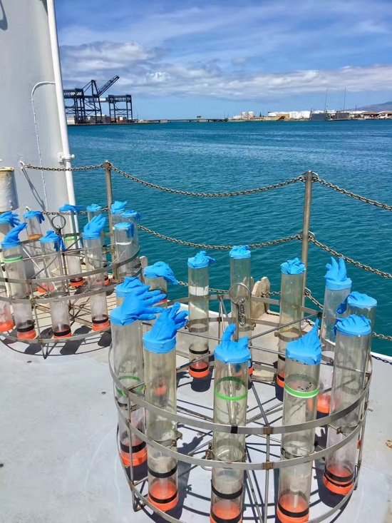

**Figure S1.** Picture of the sediment trap array used in this study, Dong et al., 2019, and Subhas et al., 2019.

**Figure S2**. Comparison between CDisK-IV sediment trap PIC fluxes and historical data at HOT and OSP. The starred point at 200m was calculated assuming linear scaling between mass and PIC fluxes; see text for details.

**Figure S3.** Results of the sinking-dissolution model for all 5 stations, initialized with the 100m PIC flux shown in Table 1. PIC fluxes at 200m, where available, are also plotted (Dong et al., 2019).

**Figure S4.** Results of the sinking-dissolution model compared to Ocean Station Papa data from Timothy et al. (2013) and Wong et al. (1999). **A** shows the model initialized with our 100m PIC flux and a sinking rate of 100 m d-1. Separate lines for calcite (blue), aragonite (red), and the total PIC flux (black) are shown. **B** shows the model initialized with the 100m PIC flux from the surface trap data of Wong et al. (1999) and a sinking rate of 10 m d-1



**Figure S5.** The difference in potential density (left axis, squares) and depth (right axis, circles) between the first instance of calcite and aragonite undersaturation at each station. Note that this difference does not exceed 200m, and is as little as 40m in the Subpolar N. Pacific.

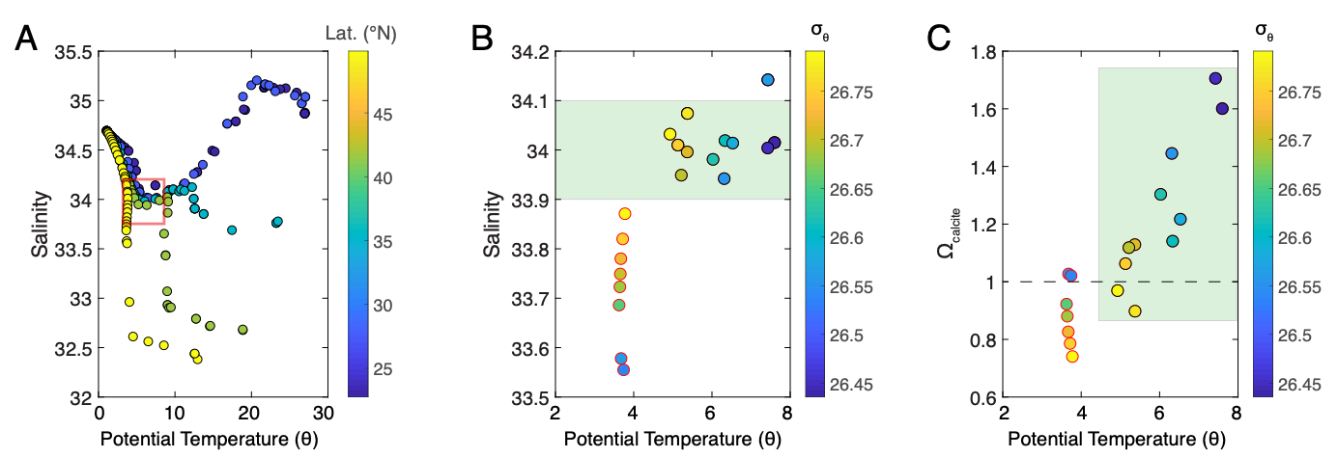**Figure S6**. T-S water mass analysis of shallow water column data. **A**:Full section T-S plot, with the colorbar showing station latitude. Four of the five stations converge around a salinity of 34, identifying a region of thermocline mixing. Station 5 (at 49N, yellow points) follows its own T-S path, and although it intersects at a similar density range, it appears to be a distinct water mass. The green square shows the water mass region of interest for our shallow analysis in the main text. **B**: A blown-up T-S diagram for the water mass of interest. Colorbars for  **B** and **C** show potential density (σθ). We excluded points (outlined in red) from Station 5 in the water mass analysis because they appear to be distinct from the water mass of Stations 1-4 (outlined in black). We interpret the water mass of Stations 1-4 as North Pacific Intermediate Water, with the temperature variability arising from the co-location of NPIW and the thermocline. **C**: Calcite saturation state of these waters as a function of potential temperature. Note that there are only two black-outlined points that sit below the saturation horizon (dashed black line).



**Figure S7.** Raw measured and calculated Preindustrial DIC and δ13C of NPIW from the 2006 P16 cruise. Corrections for anthropogenic CO2 were made as discussed in the SI text, and regression parameters are shown in Table S2.

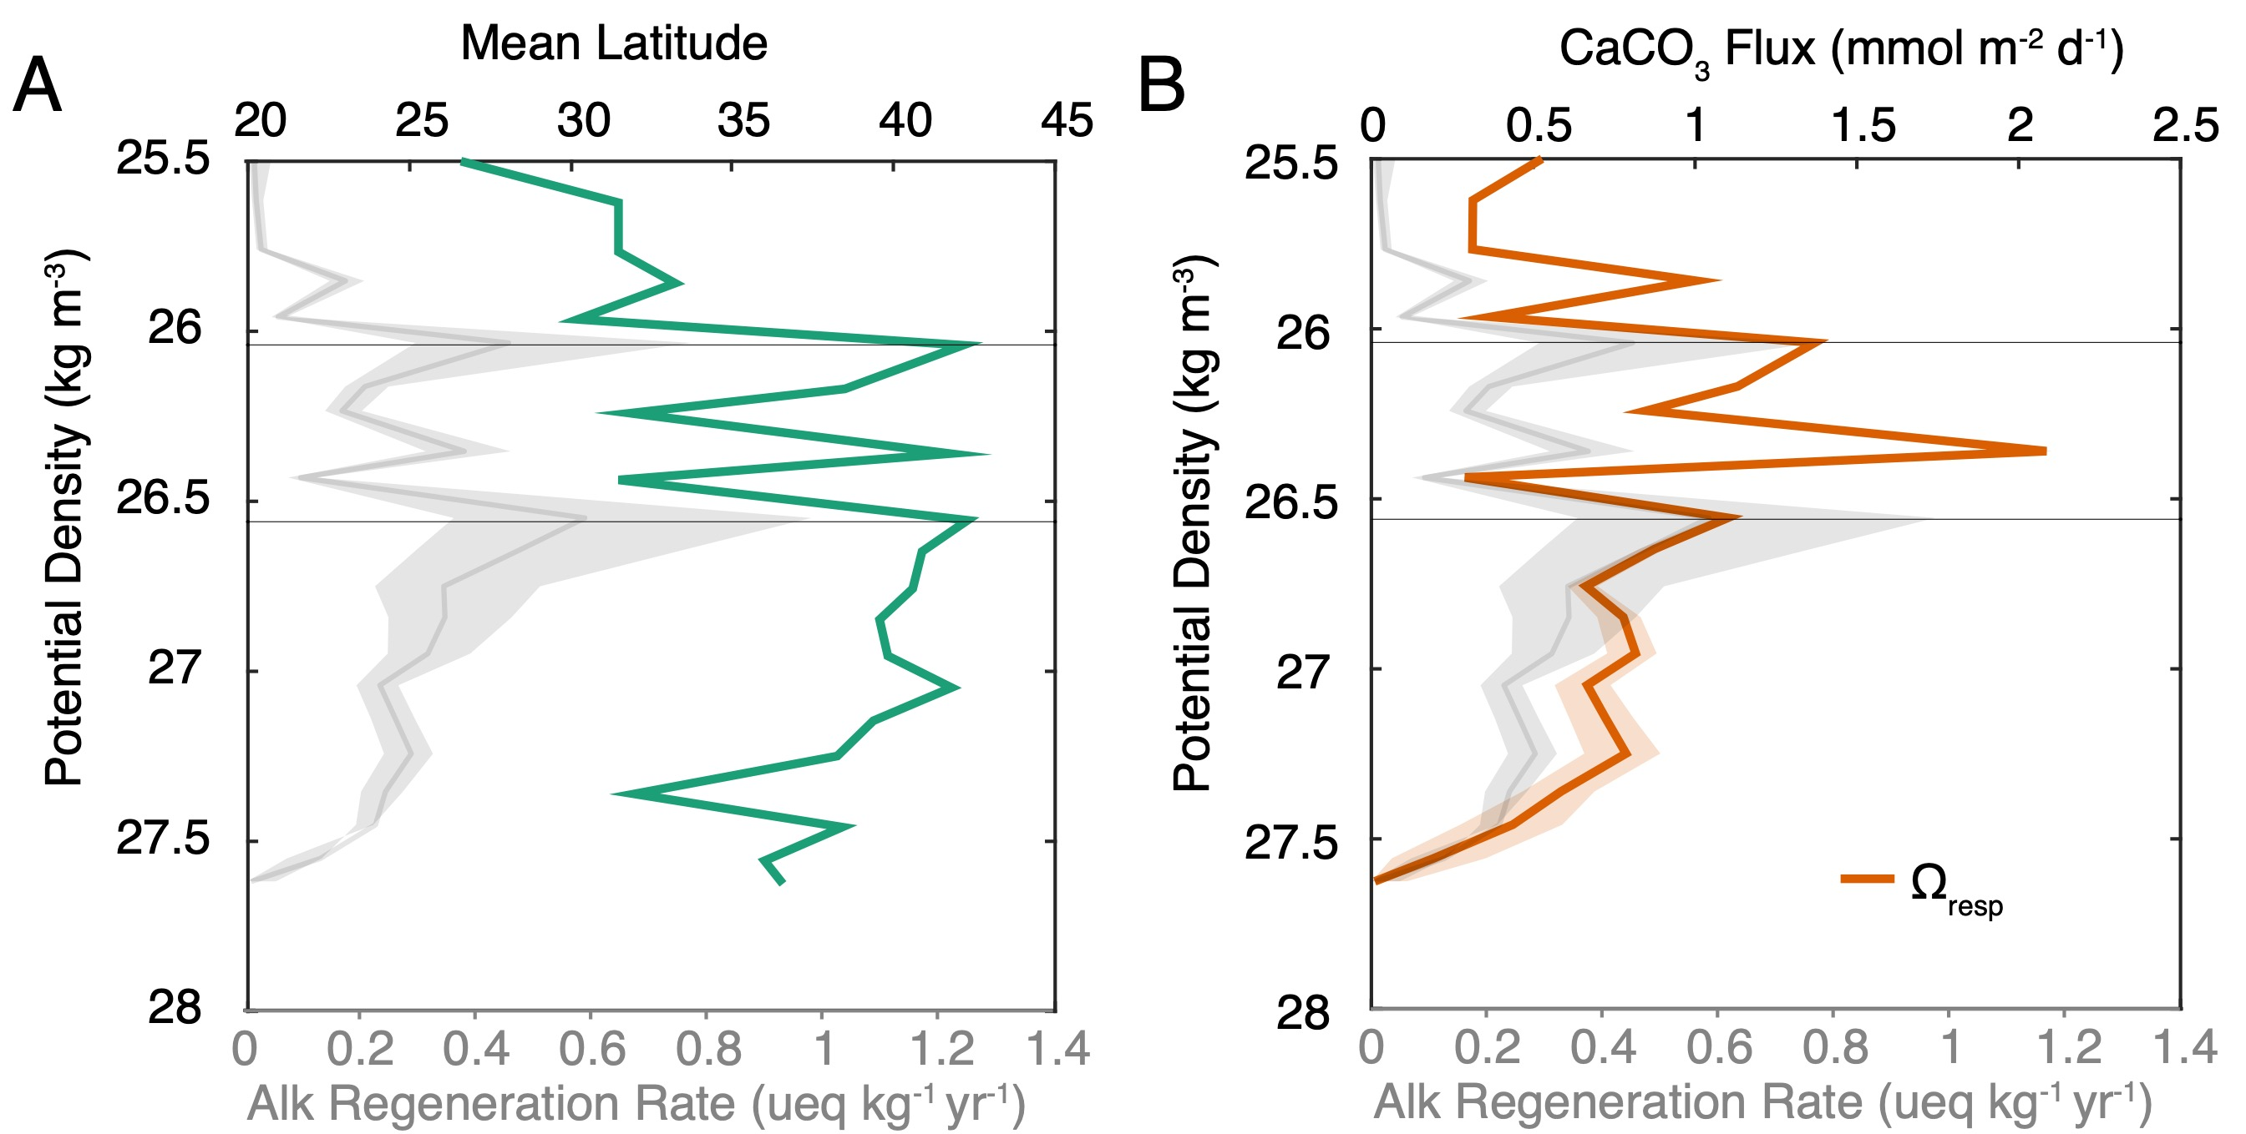

**Figure S8**. Analysis of the dissolution model binned by potential density (Section 5.3 in the main text). **A** shows the average latitude represented in each density class. The upper 0.5 kg m-3 demonstrates the densification of shallow water masses from South to North. **B** shows modeled CaCO3 flux in the basin, driven by surface export, a 10 m d-1 sinking rate, and Ωresp. The increase in CaCO3 flux from the subtropics to the Subpolar gyre is evident and the subsequent dissolution is evident by the flux attenuation in denser waters. The alkalinity regeneration rate profile from Fig. 6C (main text) is show for comparison.



**Figure S9**. The percentage decrease in Particulate Inorganic Carbon (PIC) flux between 100 amd 200m at Stations 2,4, and 5 on the CDisK-IV transect. Percent PIC remineralization, calculated as:1- PIC200/PIC100, where PICz are the PIC fluxes at depths z, was previously shown to correlate with POC flux attenuation (Main text Table 1, Dong et al., 2019), and we show here that this flux attenuation also shows no relationship to ambient seawater saturation state. We plot the aragonite saturation state at 200m, which due to both K’sp and depth, is the most undersaturated metric to use.



**Figure S10.** Analysis of Alk* (as defined by Carter et al., 2014) in NPIW along the cruise track shown, identified in Ocean Data View. There is no resolvable gradient in Alk* across the basin.

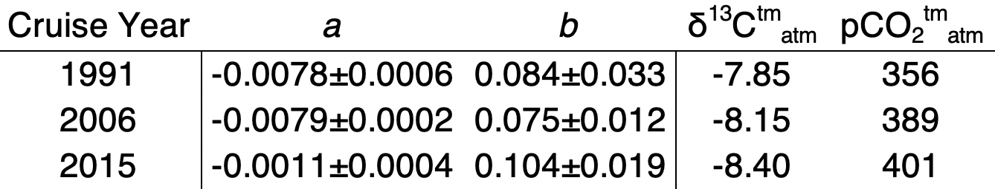

**Table S1.** Parameters used to remove the effects of anthropogenic CO2 from NPIW identified in historical P16 cruise data. *a* and *b* are the calculated regression slopes of NPIW pCFC-12 versus δ13C0 and DIC0, respectively, shown with the calculated error on the slopes. Atmospheric values for δ13C and pCO2 for each cruise year were taken from Graven et al., (2017) and sealevel.info, respectively.