On the consolidation state of sediments from the accretionary prism offshore Vancouver Island, North Cascadia Margin

Journal: Marine Geophysical Research

Michael Riedel1*, Awais Saeed2, Morelia Urlaub1, Achim Kopf2

1 GEOMAR Helmholtz Centre for Ocean Research Kiel, Wischhofstr. 1 – 3,

D-24148 Kiel, Germany

## 2 MARUM Cen­ter for Mar­ine En­vir­on­mental Sci­ences, Leo­bener Str. 8 D-28359 Bre­men, Ger­many

*Corresponding author: mriedel@geomar.de

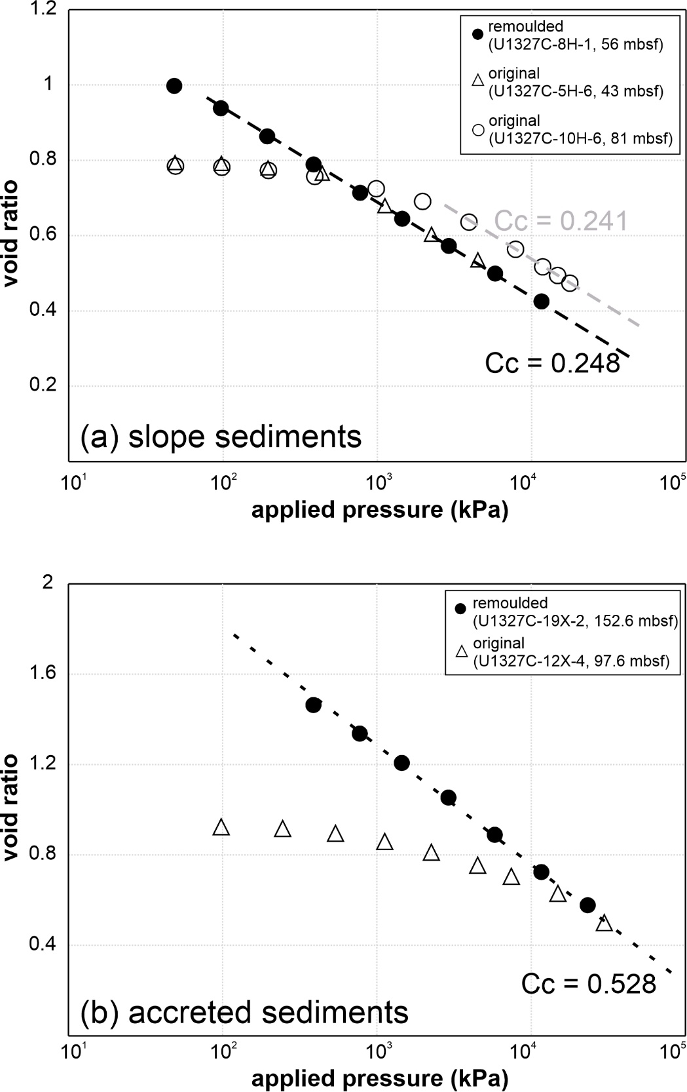

Figure A3 Comparison of oedometer test results of remoulded (solid circles) and original samples (open triangles) for (a) samples typical for slope-sediments and (b) samples typical for accreted sediments.