Effects of changing environmental conditions on plastic ingestion and feeding ecology of a benthopelagic fish (*Gadus morhua*) in the Southwest

Baltic Sea

1. Grace Walls a, b,*, Thorsten Reusch a, Catriona Clemmesen a, Nicolas C. Ory a

a *GEOMAR Helmholtz Centre of Ocean Research Kiel, Düsternbrooker Weg 20, 24105 Kiel, Germany*

b *Department of Ocean Sciences, Ocean Sciences Centre, Memorial University of Newfoundland, St. John's, NL, A1C 5S7, Canada*

*Keywords: Gadus morhua*

*Sprattus sprattus* Microplastic pollution Trophic transfer

Baltic

FTIR spectroscopy

A B S T R A C T

This study documents how the abundance of microplastics (<5 mm) in the Atlantic cod, *Gadus morhua*, relates to the changes of the fish diet during years with contrasting levels of anoxia for example following years of low or high major Baltic inflows (MBI). A MultiNet Maxi trawl and CTD were deployed annually to collect microplastic

samples alongside oxygen, temperature, and salinity conditions. Microplastics were homogenously distributed both within the water column and across years. *Gadus morhua* diet shifted from dominantly benthic invertebrates (61 %) under oxygenated conditions to dominantly *Sprattus sprattus* (81 %) under anoxic conditions. The pro- portion of *G. morhua* with microplastics in their digestive tract increased when they fed on pelagic fish (38 %) versus on benthic invertebrates (15 %). The proportion of *S. sprattus* which ingested microplastics (~18 %) did not vary. As anoxia at depth is expected to increase due to climate change, microplastic ingestion by *G. morhua* will potentially increase.

# Introduction

The presence of marine litter has been reported in all seas and oceans worldwide: the predominant component of such waste is plastic, which constitutes up to 80 % of the total debris found in the marine environ- ments (Derraik, 2002). Although the deleterious effects of large plastic litter on the marine wildlife have been well documented (e.g., suffoca- tion, entanglement, internal injury, starvation), the impacts of millimeter-sized contaminants are still unclear (Bucci et al., 2020). Microplastic fragments (≤5 mm), which mostly come from the gradual fragmentation of larger plastic items, are omnipresent in the marine environment (Akdogan and Guven, 2019). They have been found in the digestive tract of many marine organisms at most trophic levels e.g. (Lusher, 2015; Rezania et al., 2018; Thiel et al., 2018), therefore raising concerns about potential hazard microplastics present to the marine food webs.

Microplastics have been documented primarily at the surface and subsurface of the Baltic Sea with variation in densities dependent on

distance from shore and sampling location. The Bornholm basin was shown to have 0.27 microplastic particles/m3 while 0.5 particles/m3 were found in the Strait of Baltiysk (Beer et al., 2018; Gewert et al.,

2017; Lenaker et al., 2019; Zobkov et al., 2019). Unfortunately, little is known about the distribution of microplastics within the water column. To our knowledge, no information on the microplastic contamination within the water column of the Southwest Baltic Sea or the Bornholm Basin is available. Once at sea, high-density plastics sink relatively close to where they were introduced, whereas buoyant plastics can be trans- ported over long distances via wind and currents (e.g., Eriksen et al. (2014)). The floatability of microplastics, primarily related to their size, shape, and density, is altered during the physical and chemical break- down of the particles, or when they are overgrown by biofouling (Cole et al., 2011; Kowalski et al., 2016). The fate of sinking plastics is still unclear, but theoretical models suggest that a large portion can accu- mulate at intermediate depths (Kooi et al., 2017). Part of the sinking particles may accumulate at depths where the water density changes markedly, such as at the halocline (Zobkov et al., 2019).

Fish are exposed to microplastics depending on their feeding strategy and trophic position (Collard et al., 2019). For example, visually ori- ented predators, such as planktivorous fish, are susceptible to mistak- enly ingest microplastics floating within the water column that resemble their prey (de S´a et al., 2015; Ory et al., 2018; Ory et al., 2017). Piscivorous fish are, on the other hand, unlikely to directly target such

* Corresponding author at: P.O. Box 5000, Antigonish, NS B2G 2W5, Canada.

*E-mail address:* [lgwalls@mun.ca](mailto:lgwalls@mun.ca) (L.G. Walls).

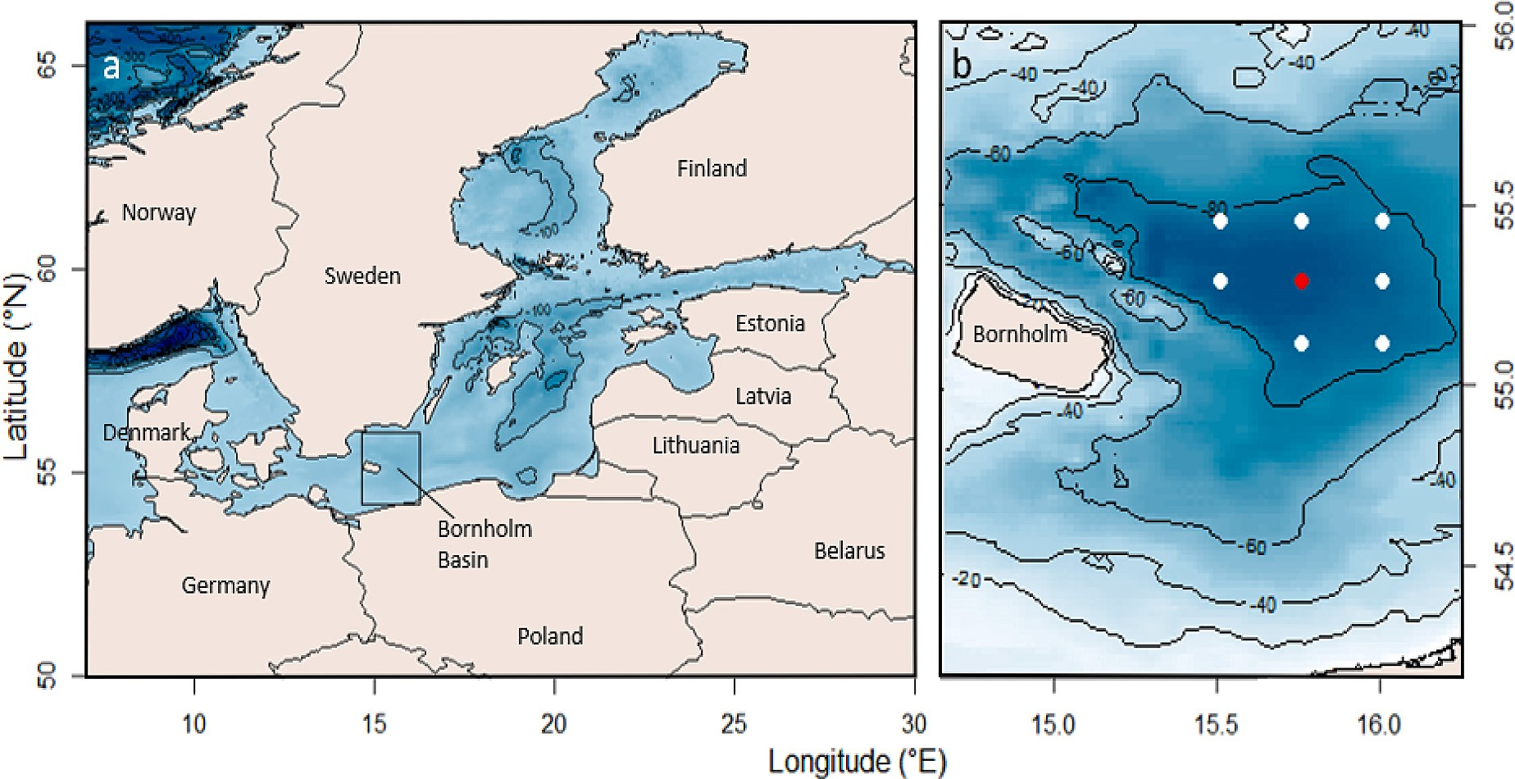

**Fig. 1.** (a) Map of the Baltic Sea and its neighboring countries (GEBCO Compilation Group, 2019) with bathymetry lines denoting depth change of 100 m and (b) location map of sampling stations within the Bornholm Basin where CTD measurements and fish (white and red dots), and water samples (red dot) were collected. Bathymetry lines denote depth change of 20 m. (For interpretation of the references to color in this figure legend, the reader is referred to the web version of this article.)

small particles as microplastics, but may nevertheless be contaminated by particles present in their prey (Chagnon et al., 2018; Welden et al., 2018), or by passive ingestion.

The fish community of the Baltic Sea is dominated by the predator Atlantic cod, *Gadus morhua* (Gadidae), which feeds pelagically, mostly on clupeid fish, and on benthic invertebrates (Andersen et al., 2017; Uzars and Plikshs, 2000), depending on the fish ontogeny and the bot- tom oxygen condition (Neuenfeldt and Beyer, 2003). *G. morhua* shifts from a diet mainly constituted of invertebrates to fish as they age (Andersen et al., 2017). The diets of pelagically and demersally caught

*G. morhua* have been found to differ with fish caught in demersal hauls containing more benthic food than their pelagic counterparts whose gut contents primarily contained pelagic fish (Neuenfeldt and Beyer, 2003). *Sprattus sprattus* is one of the most abundant clupeid species within the Baltic Sea, and a common prey of *G. morhua*. This species is exclusively pelagic (Stepputtis, 2006), schooling in the water column to feed pre- dominantly on zooplankton (such as copepods and cladocerans), as well as fish eggs on diurnal migrations to shallower depths (Lenz et al., 2016; Neuenfeldt and Beyer, 2003).

Gut content analysis has shown that 5–23 % of fish within the Baltic Sea contain plastic (Beer et al., 2018; Lenz et al., 2016; Rummel et al., 2016). However, only a few studies have documented the abundance of (micro)plastics in *G. morhua* and *S. sprattus* with no studies to date having attempted to quantify plastic ingestion in benthic invertebrates of the Baltic (Beer et al., 2018; Foekema et al., 2013; Rummel et al., 2016). The majority of plastic found within digestive tracts of fish consisted of microplastic fibers with a higher ingestion frequency in pelagic feeders. Completed studies have not related the plastic ingestion to the abundance and distribution of plastic within the water column nor to changes in the feeding strategy of cod. Such factors may be important in influencing the ingestion of microplastics by these two ecologically and commercially important fish species in the Baltic Sea (Stepputtis, 2006).

The Baltic Sea is a stratified, semi-enclosed sea characterized by a low-salinity surface layer, a permanent halocline and a deep saline layer of varying volume, salinity, temperature, and oxygen concentration (Tomkiewicz et al., 1998). A strong density stratification prevents ver- tical mixing of the water column leading to temporary anoxia at depth

(Mohrholz, 2018). The only input of oxygenated and saline water at depth occur during Major Baltic inflows (MBI) during winter when sa- line water from the North Sea enters the Baltic Sea (Mohrholz, 2018). The majority of inflow events that occurred between 2013 and 2018 were of low intensity with little effects on deep water salinity and ox- ygen within the Bornholm Basin (Fig. SM 1). The largest inflows (i.e.,

>200 km3 of water input) occurred during the winters of 2014 and

2015, resulting in an increase of oxygen and salinity the following years, which substantially increased the proportion of the water column with viable conditions for *G. morhua*.

Water temperature, salinity and oxygen concentration are the major abiotic factors that influence the distribution of *G. morhua* and *S. sprattus* within the water column (Schaber et al., 2012; Schaber et al., 2009). During spawning *G. morhua* aggregate primarily in deep basins within the Baltic, including Gotland Deep, the Gdansk Deep and the Bornholm Basin where they preferentially occupy water with a salinity of 11–15

psu and an oxygen concentration > 1 ml/l (Schaber et al., 2012, Schaber

et al., 2009). In the western Baltic Sea, *G. morhua* is mostly found beneath the halocline; its lower depth limit depending on the oxygen condition near the bottom (Andersen et al., 2017). In years of anoxic bottom conditions, *G. morhua* can nevertheless venture briefly within the oxygen-depleted waters near the bottom to feed on benthic prey (Neuenfeldt et al., 2009). *S. sprattus* also move into deep water basins as a part of their early winter migration, remaining there until June before migrating to areas closer to the coast. While in the Bornholm Basin

*S. sprattus* avoids waters <5 ◦C and with dissolved oxygen <1 ml/l

(Fakult and Kiel, 2006), meaning that, in the western Baltic Sea, its distribution covers most of the water column, except the near surface areas that can be too cold in winter. The distribution of the two species within the water column, and their interactions, should thus influence their direct and indirect ingestion of microplastics through trophic transfer.

The aim of this study was to examine the ingestion of microplastic by

*G. morhua* and *S. sprattus* in relation to changes in the feeding behavior (benthic vs pelagic) of *G. morhua*, under contrasting abiotic conditions (salinity, temperature, and oxygen concentration) within the water column following high or low MBI. We quantified plastic abundance at varying depths within the water column to determine whether plastic

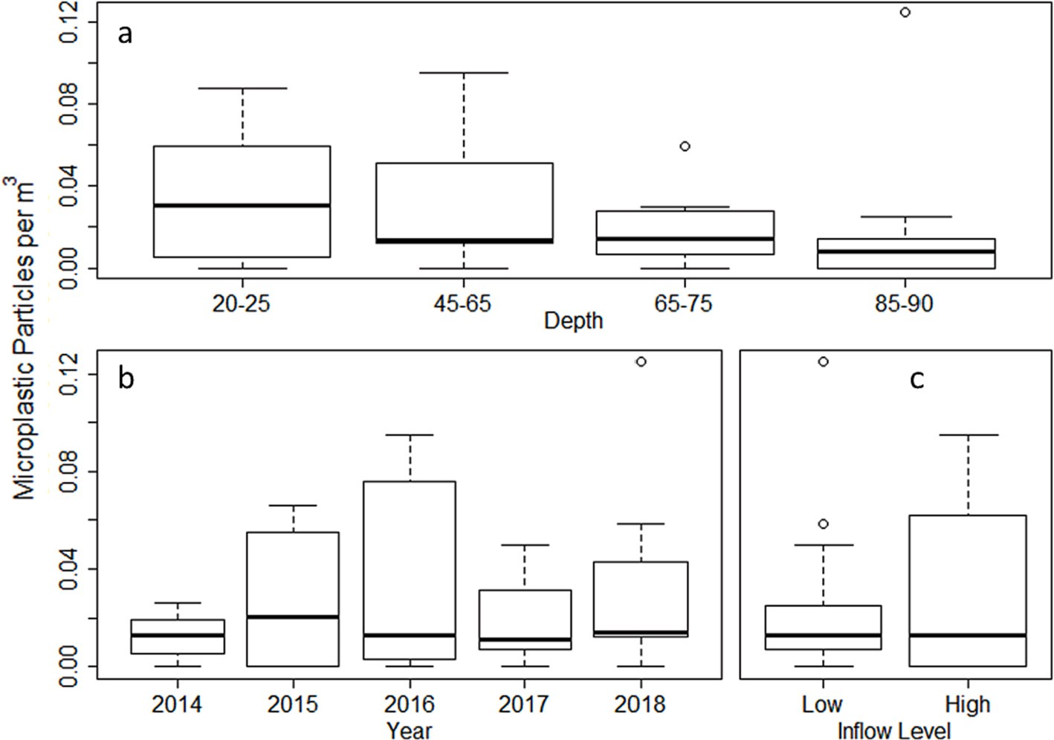

**Fig. 2.** Microplastic abundance (microplastic per m3) within the water column in relation to a) depth (m), b) year and c) MBI level (low, high). No significant difference was found in plastic accumulation at different depths within the water column, among years or between inflow levels.

**Table 1**

Feature (number, size, weight) of the *G. morhua* individuals examined in this study and their feeding behavior (benthic invertebrate, benthic invertebrate + fish, fish) during years with high major Baltic inflow (MBI) or low MBI.

Massive Baltic inflow (MBI) Fish characteristics Feeding behavior (proportion (%) for each MBI category)

|  |  |  |  |  |  |  |  |  |
| --- | --- | --- | --- | --- | --- | --- | --- | --- |
|  | n | Mean weight (g) | Mean size (cm) |  | Benthic (polychaeta) | Benthopelagic (polychaeta + fish) | Pelagic (fish) |  |
| High | 27 | 414.8 | 36.7 |  | 60.9 | 13.0 | 26.1 |  |
| Low | 45 | 279.2 | 31.3 |  | 0.0 | 18.9 | 81.1 |  |

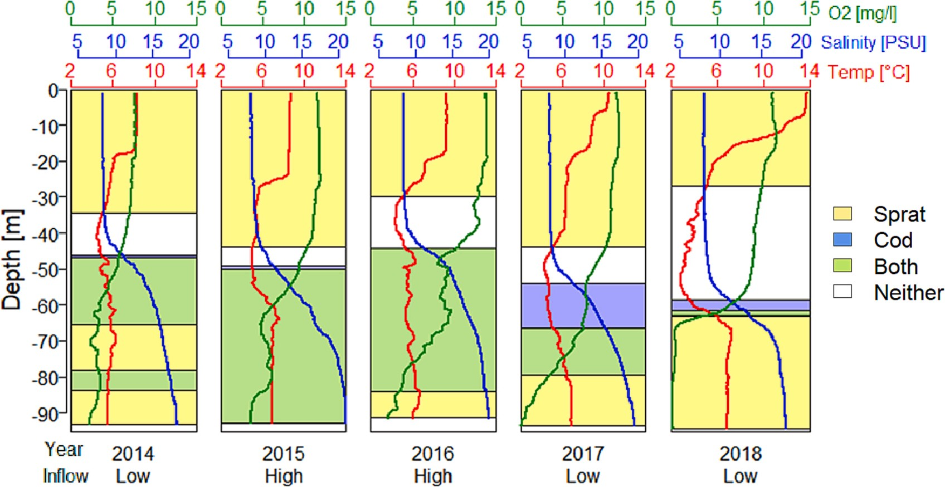

**Fig. 3.** Theoretical model showing the vertical distribution of *Gadus morhua*, *Sprattus sprattus*, both species (distribution overlap) and neither of these species, within the water column for the different sampling years. The distributions were estimated from the natural limitation of each species at the time of the study to oxygen concentration (green line) and salinity (blue line). *G. morhua* are limited to water with oxygen >2.5 ml/L and salinity >11.2 psu*. S. sprattus* distribution is limited to

temperature (red line) <5 ◦C. The number of Major Baltic Inflows (low, high) is indicated below each year. (For interpretation of the references to color in this figure

legend, the reader is referred to the web version of this article.)

**Table 2** Percentage of water column (0–90 m) covered by *G. morhua* and *S. sprattus* distribution, percentage of overlap of the two species distributions and distance (m) from the lower-end distribution of *G. morhua* and the seafloor (95 m) for each sampling year and inflow level (low, high).

Year *Gadus morhua* vertical distribution *Sprattus sprattus* vertical distribution Proportion (%) of the water column with predator prey

|  |  |  |  |  |  |  |
| --- | --- | --- | --- | --- | --- | --- |
|  | Distribution  depth range (m) | Proportion (%) of the water  column covered by the fish distribution | Distance from the lower  end of distribution to seafloor (m) | Distribution  depth range (m) | Proportion (%) of the water  column covered by the fish distribution | overlap |
| 2014 | 43.8–65.4, | 20 | 29.6, | 0–34, 47–90 | 85 | 25.3 |
|  | 78.3–83.9 |  | 11.1 |  |  |  |
| 2015 | 45.2–90 | 47 | 5 | 1–43.9, 50–90 | 92 | 42.1 |
| 2016 | 42.2–90 | 42 | 5 | 1.3–29.9, | 84 | 50.3 |
|  |  |  |  | 41.9–90 |  |  |
| 2017 | 51.9–79.4 | 27 | 15.6 | 0–44, 66.5–90 | 75 | 13.6 |
| 2018 | 60.1–73.3 | 5 | 21.7 | 69.6–90 | 63 | 3.9 |

|  |  |  |  |  |  |  |
| --- | --- | --- | --- | --- | --- | --- |
| Inflow |  | | | | | |
| High | 43.7–90 | 48.7 | 5 | 1.15–36.9, | 88 | 46.3 |
|  |  |  |  | 46.0–90 |  |  |
| Low | 51.9–75.3 | 24.6 | 19.7 | 0–39, 61.0–90 | 75 | 23.7 |

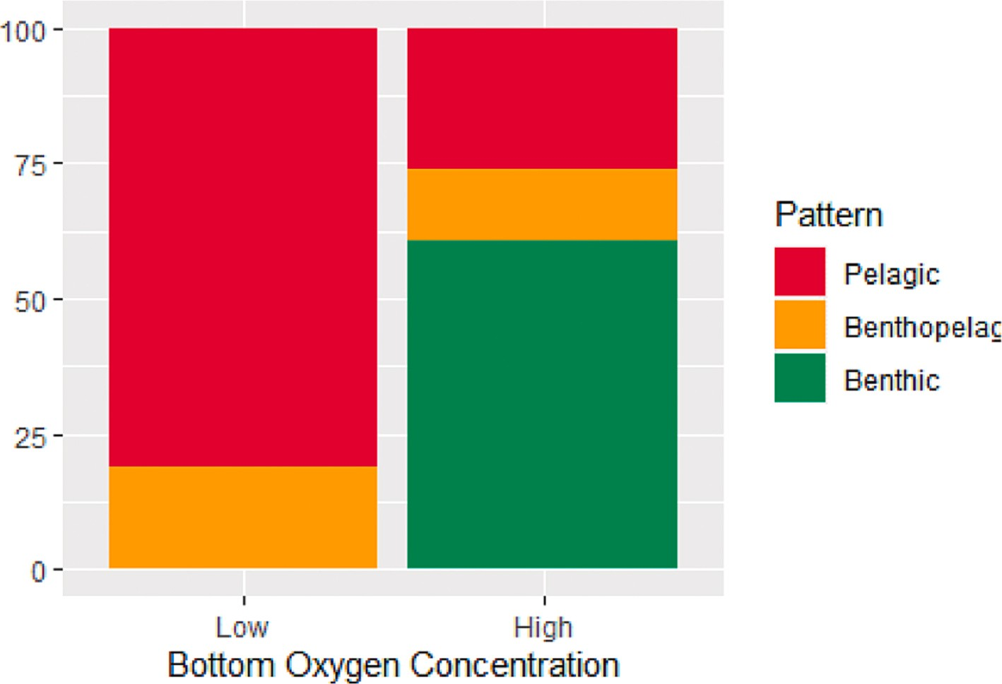

**Fig. 4.** Proportion (percentage of the total individuals) of *Gadus morhua* with a pelagic, benthopelagic or benthic diet in relation to low (following low MBI) and high (following high MBI) bottom water oxygen concentrations.

ingestion would occur within the natural vertical distribution range of these species. We anticipated an accumulation of plastics at the halo- cline where salinity, and thus water density, increases markedly. Under anoxic bottom conditions (no MBI), we expected *G. morhua* to switch from feeding principally on benthopelagic prey to a pelagic diet and, thereby, ingest more microplastics through trophic transfer from their pelagic prey (*S. sprattus*). Inflows were not expected to affect *S. sprattus* vertical distribution or feeding behavior as that species can be found throughout the majority of the water column during all years regardless of MBI levels. To test these hypotheses, we quantified microplastic abundances from MultiNet water samples at different depths, between 20 and 90 m, above, at and below the halocline, and approximately 2–4 m above the bottom during years of high and low MBI. We also compared the gut content of *G. morhua* and *S. sprattus* between those years to document the diet of the fish and the presence of microplastics.

# Materials and methods

* + 1. *Water sample collection*

Water samples were collected annually in May from 2014 to 2018 at station BB23 within the central Bornholm Basin (Fig. 1) using a MultiNet Maxi trawl (mesh size 300 μm, mouth opening 0.5 m2) closed at one

extremity by a soft net bag. At noon, the MultiNet was lowered to 90 m depth which corresponds to approximated 5 m above the seafloor and trawled at 3 kn while being continuously raised at a speed of 0.5 m/s

through the water column. Once approximately 100 m3 of seawater had

been filtered, the net mouth of the first net was closed, opening the mouth of the next net to sample the next 5 m of the water column. This process was repeated every 5 m until the entire water column had been sampled. Once retrieved, the body of each net was thoroughly cleaned from the outside to push any particles stuck in the mesh into the net bag while avoiding potential particles from the hose getting inside the net. The content of each net bag was sieved through a 100-μm mesh sieve and stored in a 500 ml plastic Kautex flask filled with formalin. Sampling

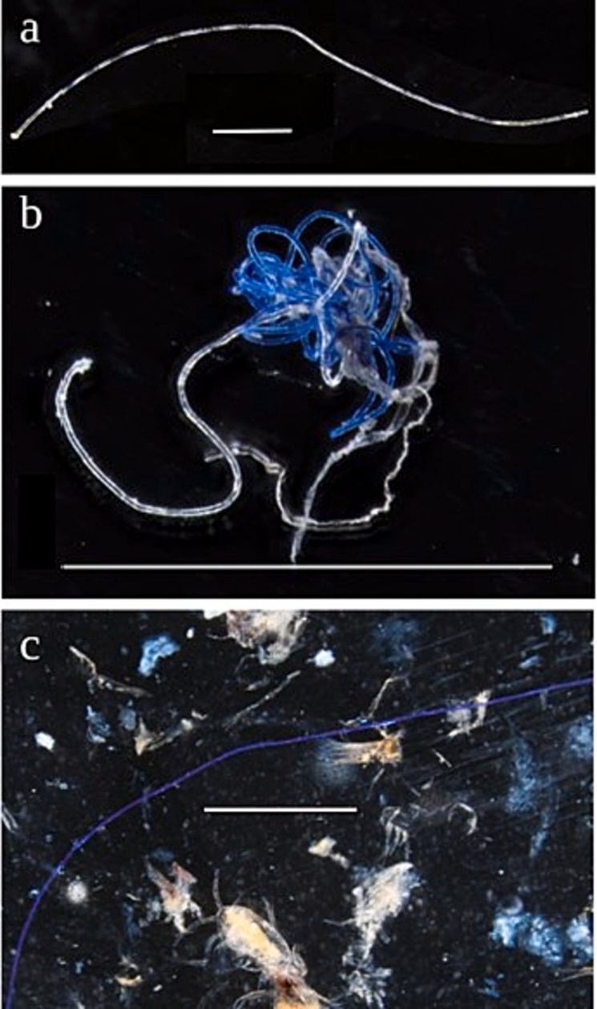**Table 3**

Number and proportion of total *Gadus morhua* and *Sprattus sprattus* that had ingested plastic (particle or fiber) during low and high Major Baltic Inflows.

Plastic occurrence *Gadus morhua Sprattus sprattus*

Low inflow

High inflow

Total Low inflow

High inflow

Total

No plastic 28 (62) 23 (85) 51

(71)

Any plastic 17 (38) 4 (15) 21

(29)

>1 plastic 6 (13) 2 (7) 8

(11)

24 (80) 18 (90) 42

(84)

6 (20) 3 (15) 9

(18)

4 (13) 0 (0) 4 (8)

Microplastic particle

>1 Microplastic

particle

2 (4) 0 (0) 2 (3) 0 (0) 0 (0) 0 (0)

0 (0) 0 (0) 0 (0) 0 (0) 0 (0) 0 (0)

Microplastic fiber 15 (33) 4 (15) 19

(26)

6 (20) 3 (15) 9

(18)

>1 Microplastic fiber

Median number of plastic (per fish with plastic)

Median absolute deviation

6 (13) 2 (7) 8

(11)

|  |  |  |  |  |  |
| --- | --- | --- | --- | --- | --- |
| 1 | 1.5 | 1 | 2 | 1 | 1 |
| 0 | 0.74 | 0 | 0 | 0 | 0 |

4 (13) 0 (0) 4 (8)

procedure was replicated at midnight. Station BB23 MultiNet Maxi trawl samples were selected for analysis as the station is within the deepest portion of the Bornholm Basin, central within the 45-station sampling grid and has been repeated annually as a part of the Baltic Sea inte- grative long-term data series 1987–present).

Alongside the MultiNet sample, a CTD probe was deployed to mea- sure the oxygen, the salinity and the temperature every 0.5 s while being lowered to the bottom at approximately 90 m depth (Fig. SM 2). The depth of the upper end of the halocline was determined when the

salinity varied of >1 PSU over 5 m depth. The lower end of the halocline was determined when the change of salinity was <1 PSU over 5 m (Liblik and Lips, 2019). The water samples from shallow (20–25 m)

halocline (different for each year, see below), intermediate (65–70 m) and maximum (85–90 m) depths were fixed in 10 % formaldehyde to be further analyzed to determine the abundance of plankton and micro- plastics. Using the oxygen concentration data collected by the CTD probe at Bornholm Basin station 22, the average oxygen concentration across all years of the study at each depth were calculated, as well as the averages across all depths within each year and across depths below the halocline within each year (Table SM 1). The years following high MBI events (2015 and 2016) had above average oxygen concentration both across all depths and beneath the halocline. Similarly for years following low MBI events (2014, 2017 and 2018) the average oxygen concentra- tion both across all depths and beneath the halocline was below average. Additionally, the distribution of both *G. morhua* and *S. sprattus* within the water column was estimated by applying the known biological limits of these species to CTD data collected.

* + 1. *Plankton and microplastic analysis*

In the laboratory, water samples were rinsed out of the formalin with ultrapure water, filtered through a 100-μm mesh sieve and transferred into a clean glass petri dish divided into three equal compartments. The samples were visually inspected under a stereo microscope (Nikon SMZ18; 0.75–13.5 X zoom) for the presence of microplastics. All the particles identified as potential plastic were placed into a drop of ul- trapure water within a 24-well cell culture polystyrene plastic plate and incubated at 60 ◦C for 24 h. Particles that had lost their three- dimensional structure after incubation were considered organic and discarded from the analysis. Unaltered particles were considered plastic and were photographed using a Nikon Ds Fi3 camera mounted to a Nikon SMZ18 stereo microscope.

**Fig. 5.** Examples of microplastic collected during fish gut content analysis from

*G. morhua* (1–2) and *S. sprattus* (3). All scale bars are 1000 μm.

The plastics parameters including particle type (hard fragment, soft fragment, filament, or fiber), color and shape were recorded following the protocol by Ory et al. (2017). The size of the particles was measured

at the nearest 0.1 mm from the photographs using Image J software ([imagej.nih.gov/ij](http://imagej.nih.gov/ij)/). Size was categorized as small (<1500 μm), me- dium (1500–4500 μm) or large (>4500 μm). Plastics were then sent for Fourier Transform Infrared Spectroscopy (FTIR) analysis. Fibers were

excluded from the analyses of plankton samples (not of the fish, see below) because of the high risk of contamination of the samples with airborne fibers during on-board sampling.

* + 1. *Fish collection*

*Gadus morhua* and *Sprattus sprattus* were collected each May, from 2014 to 2018, within the central Bornholm Basin (Fig. 1b) aboard the F/ V ALKOR as a part of a long-term multidisciplinary program on ecosystem composition and function of the Baltic Sea. A pelagic trawl with an 11 mm mesh size was towed from the rear of the boat for approximately 30 min to capture fish at a depth between 62 and 87 m. After each haul, all *S. sprattus* captured were identified. The total length of each sprat was measured and recorded. A subset of each length (~20 individuals) was removed for other projects and the remainder were

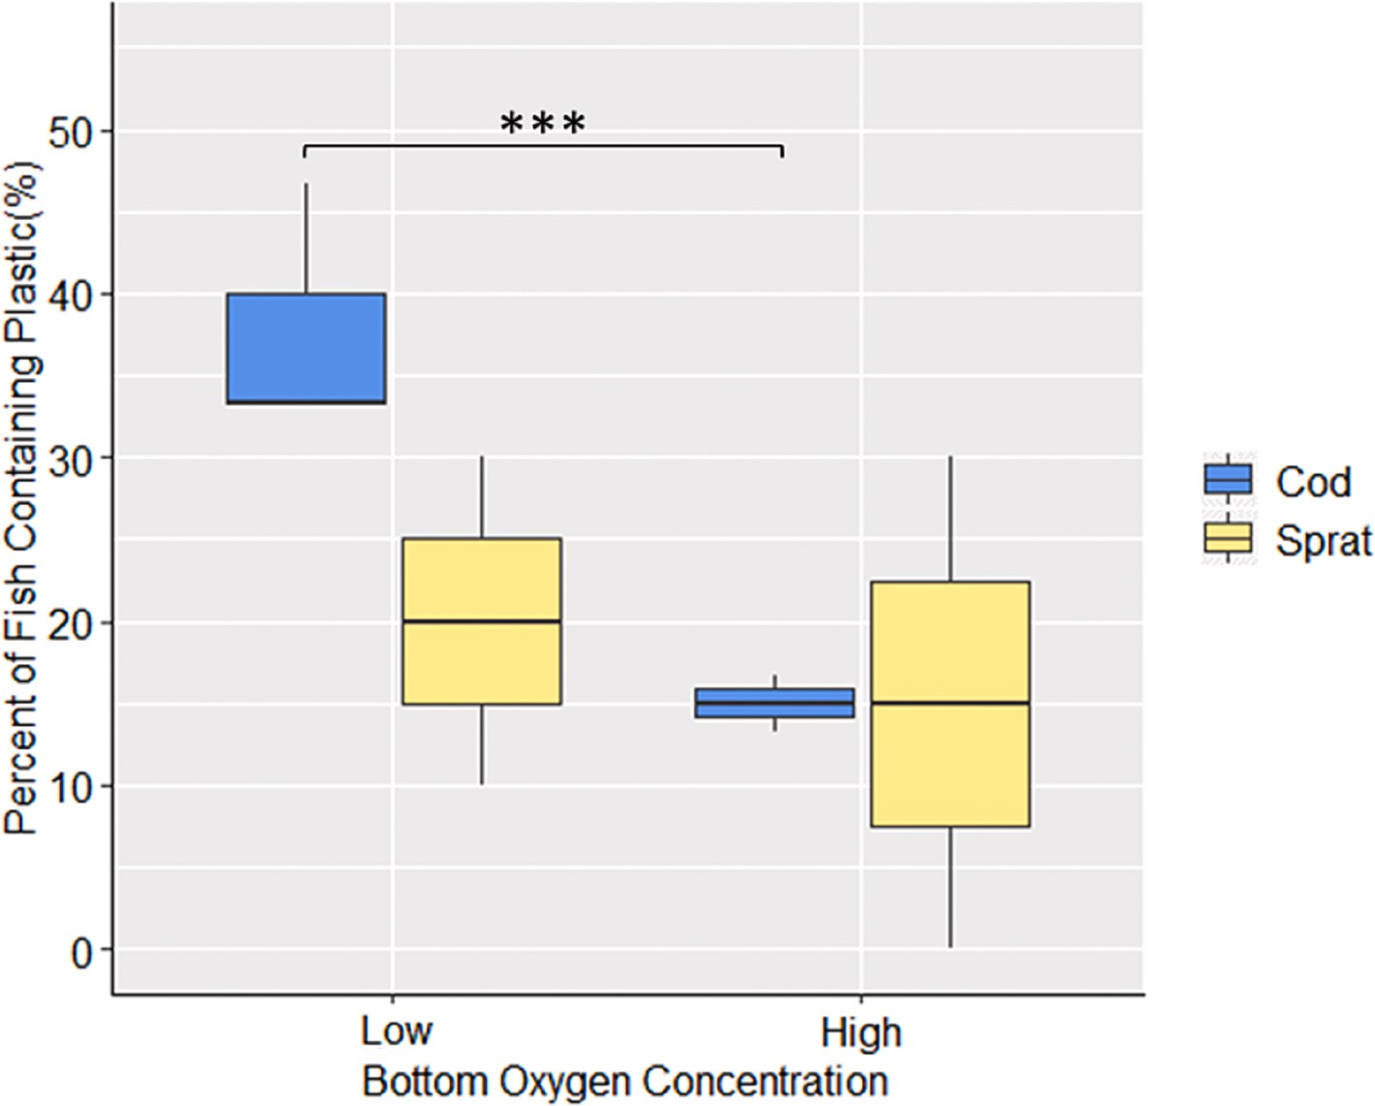

**Fig. 6.** Proportion (percentage of total individuals) of *Gadus morhua* and *Sprattus sprattus* that had ingested microplastics under low (no MBI) and high (MBI) bottom oxygen concentration conditions. *** indicates significant differences at the level of error α = 0.05.

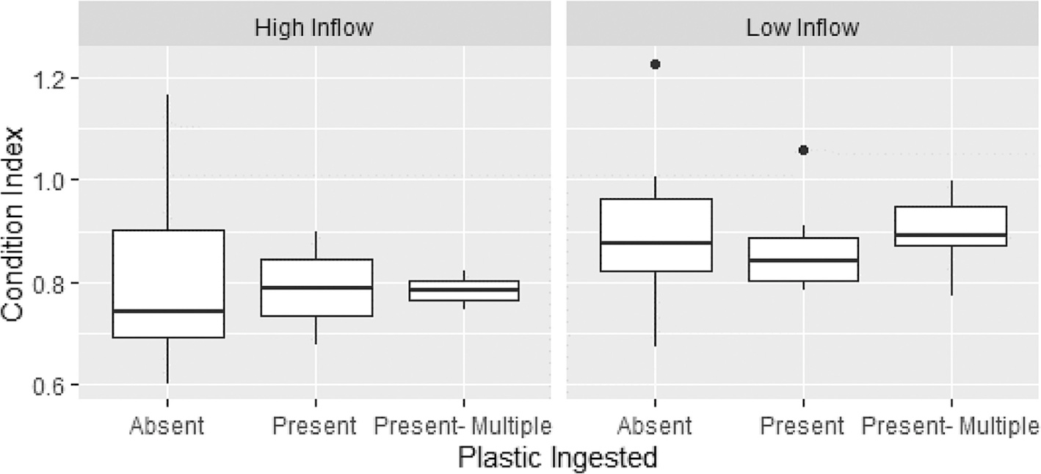

**Fig. 7.** The general condition of *G. morhua* was gauged using Fulton's condition index with regards to levels of MBI (high and low) and microplastic ingested (absent, present, and present-multiple). While there was a marginally significant effect of inflow on condition with low inflow scoring higher on the condition index, there was no significant effect of plastic ingestion on the general condition of *G. morhua.*

stored whole at -20 ◦C for further analysis. All *G. morhua* were measured (total length) to the nearest cm using a length strip, weighed full and gutted (from end of the esophagus to the anus) to the nearest 0.1

g. The fish gut was stored on board in individual Ziplock plastic bags at

-20 ◦C. In 2015, no *G. morhua* stomach samples were available from the May cruise but were collected from an additional cruise in August 2015. Fulton's condition index was used as an indicator to gauge the effect of plastic ingestion and inflow levels on of the general condition of

*G. morhua*. This was calculated as F = (W/TL3) * 100, where W = total

weight (g) and TL = total length (cm).

* + 1. *Fish gut content analysis*

In the laboratory, the gut of 15 *G. morhua* and 10 *S. sprattus* were randomly chosen among the total of the fish captured for each studied

year (2014–2018). A summary of the total length and weight ranges by species, years and inflow levels can be found in the supplementary materials (Table SM 2). Guts were defrosted for at least 1 h before dissection. Each gut was cut at the pylorus to separate the stomach from the intestine, and each was weighed to the nearest 0.1 g before being analyzed separately. The intestine of *S. sprattus* were too small to be handled and were moved directly into a 15 ml falcon tube filled with 10

% KOH and incubated at 60 ◦C for 24 h. Experiments in the laboratory

confirmed that KOH dissolves organic tissue but leave most of the par- ticles (at the exception of cellulose acetate, biodegradable plastics, and polyethylene sheet) intact, independently of the shape and the condition they remained in the environment (Karami et al., 2017; Kühn et al., 2017).

The stomach and intestine of *G. morhua* as well as *S. sprattus* stomach were opened longitudinally with a dissecting scissor. Fullness of the

**Table 4**

Proportion (% of each category total) of different shapes, colors, types, and sizes of the microplastics collected within the water column.

Microplastic features Percentage of the total

Shape Angular 52.5

Filamentous 24.8

Other 11.9

Round 10.9

Color White 31.7

Blue 25.7

Black 13.9

Transparent 8.9

Red 6.9

Yellow 4.0

Green 4.0

Orange 3.0

Multicolor 2.0

Type Hard fragment 75.2

Filament 24.8

Size Medium (1500–4500 μm) 45.5

Large (>4500 μm) 29.7

Small (<1500 μm) 24.8

stomach and intestine was assessed on a scale from 0 to 4 (Ory et al., 2017): no visible prey or empty (0), 1–25 % full (1), 26–50 % full (2), 51–75 % full (3) or >75 % full (4). Stomach and intestine contents were

then each placed into a separate petri dish half-filled with ultrapure

water and closed with a lid until analyzed.

The content of the stomach and the intestine of *G. morhua,* as well as the stomach of *S. sprattus* were analyzed visually under a stereo micro- scope (Nikon SMZ18; 0.75–13.5× zoom) to determine the abundance and composition of organisms as well as potential plastic particles. Or- ganisms were assessed to the lowest possible taxonomic group. The feeding strategy of each *G. morhua* was defined from the content of their digestive tract as pelagic (only fish prey), benthopelagic (fish and benthic invertebrate prey) or benthic (only benthic invertebrate prey). Empty stomachs/intestines or those containing only unidentifiable re- mains were excluded from the analysis of the fish's diet. Every prey and plastic item found within *G. morhua* or *S. sprattus* gut was photographed. Once visual analysis was complete the stomach and the intestine of

*G. morhua*, as well as the stomach of *S. sprattus* were placed into indi- vidual falcon tubes filled with 10 % KOH and incubated at 60 ◦C for 24 h to digest organic matter. The content of the tube was then filtered through a 100 μm mesh sieve with ultrapure water and visually analyzed under the dissecting microscope to check for the presence of micro- plastics that may have been overlooked during the first inspection.

Fish prey found within the stomach of the *G. morhua* were collected and, when possible, the content of their gut analyzed for the presence of prey and plastic items. Each prey's gut was then digested into a 15 ml falcon tube filled with 10 % KOH incubated at 60 ◦C for 24 h. Prey which was too digested to be dissected itself was placed whole into a 15 ml falcon tube filled with 10 % KOH incubated at 60 ◦C for 24 h. The content of the tubes was then filtered through a 100 μm mesh sieve, flushed with ultrapure water and visually inspected to check for the presence of potential plastic particles and fibers. All particles were dried at 60 ◦C for 24 h; particles of which color or three-dimensional structure was altered after incubation were considered to not be plastic and were discarded. The remaining particles were considered microplastics. Multiple plastic particles with similar characteristics (e.g., color, shape, hardness) found within the same organ were considered to come from the fragmentation of the same particle and were thus counted as a single item for the analysis. At no point were whole benthic invertebrates found within any *G. morhua* samples, nor were benthic invertebrates collected outside of the fish collection making the trophic transfer of microplastic from invertebrates to *G. morhua* impossible to quantify within this study.

* + 1. *Cross-contamination*

In the laboratory, precautionary steps adapted from (Rummel et al., 2016) were used to prevent contamination of samples by airborne microfibers during the analysis of the water and the fish gut samples. The steps included wearing a lab coat (100 % cotton) and nitrile gloves, cleaning all the instruments and dishes with 99 % ethanol, working under a fume hood whenever not at the microscope, and verifying the absence of microplastics at the surface of the instruments under the microscope prior to analysis. Microscopes were placed on top of a 50 × 50 × 8 cm (length × width × height) grid connected to a pump system that gently sucked out the air around the base of the microscope. The amount and type of fibers found in each sample was compared with that of a petri dish filled with ultrapure water (control) that was placed be- sides the sample during the analysis. Any fiber found in the sample that had similar color and size as that found in the control were excluded from the analysis.

* + 1. *Chemical analysis of the particles*

A total of 101 potential plastic fragments were visually identified from the water samples. Due to time and budget constraint, the chemical signature of only a subset of 46 of these fragments was analyzed using an Agilent Cary 630 Fourier-transform infrared (FTIR) spectrometer. By using IR light, the chemical bonds between the atoms within a molecule are excited causing a reduced transmission of light specific to the needed energy for this process. As every chemical contains different bonds and has a different chemical constitution, these spectra represent a finger- print of the substance and can be used to confirm the identity of a ma- terial. Each particle was analyzed three times and the results were averaged. Between each measurement, the diamond tip and sampling plate of the spectrometer were cleaned with a cellulose cloth. The resulting spectrum was compared using siMPle version 1.0.1 (Primpke et al., 2020) with the siMPle ATR single spectra IR library version 1.0.2 (Primpke et al., 2018) to produce a hit quality of the spectral distance between all known spectra within the database and that from the par- ticle analyzed. Analysis of fibers found within fish specimens could not be analyzed at this time.

* + 1. *Statistical analysis*

The concentration of microplastic particles within the water column was compared among depths (shallow, halocline, intermediate and bottom), years (2014–2018) and between inflow levels (high, low) using three non-parametric Kruskal-Wallis tests at the conservative level of error α = 0.01 %. The homogeneity of variances of the data was verified using three Fligner-Killen tests. The proportion of *G. morhua* and

*S. sprattus* that had ingested plastic or not was compared for each species between anoxic (low MBI) and oxygenated (high MBI) years using a 2 × 3 contingency table with a Fisher's exact test robust to the presence of structural zeros (West and Hankin, 2008). The differences in *G. morhua* feeding behavior under different environmental conditions were also tested with a 2 × 3 contingency table with Fisher's exact test. The sizes of

*G. morhua* were compared among different years with a Kruskal-Wallis test. To investigate the differences Fulton's condition index between inflow levels and plastic ingestion a 2 × 3 factorial ANOVA was used. Normality of this data was tested with the Shapiro-Wilk test and Levene's test was used to confirm homogeneity of variances. All the analyses were conducted in R version 3.6.1 with the packages ‘gmodels’ v.2.18.1, ‘pastecs’ v.1.3.21, and ‘car’ v.3.0–6.

# Results

* + 1. *Plastic within the water column*

Out of the 101 potential plastic fragments found within water

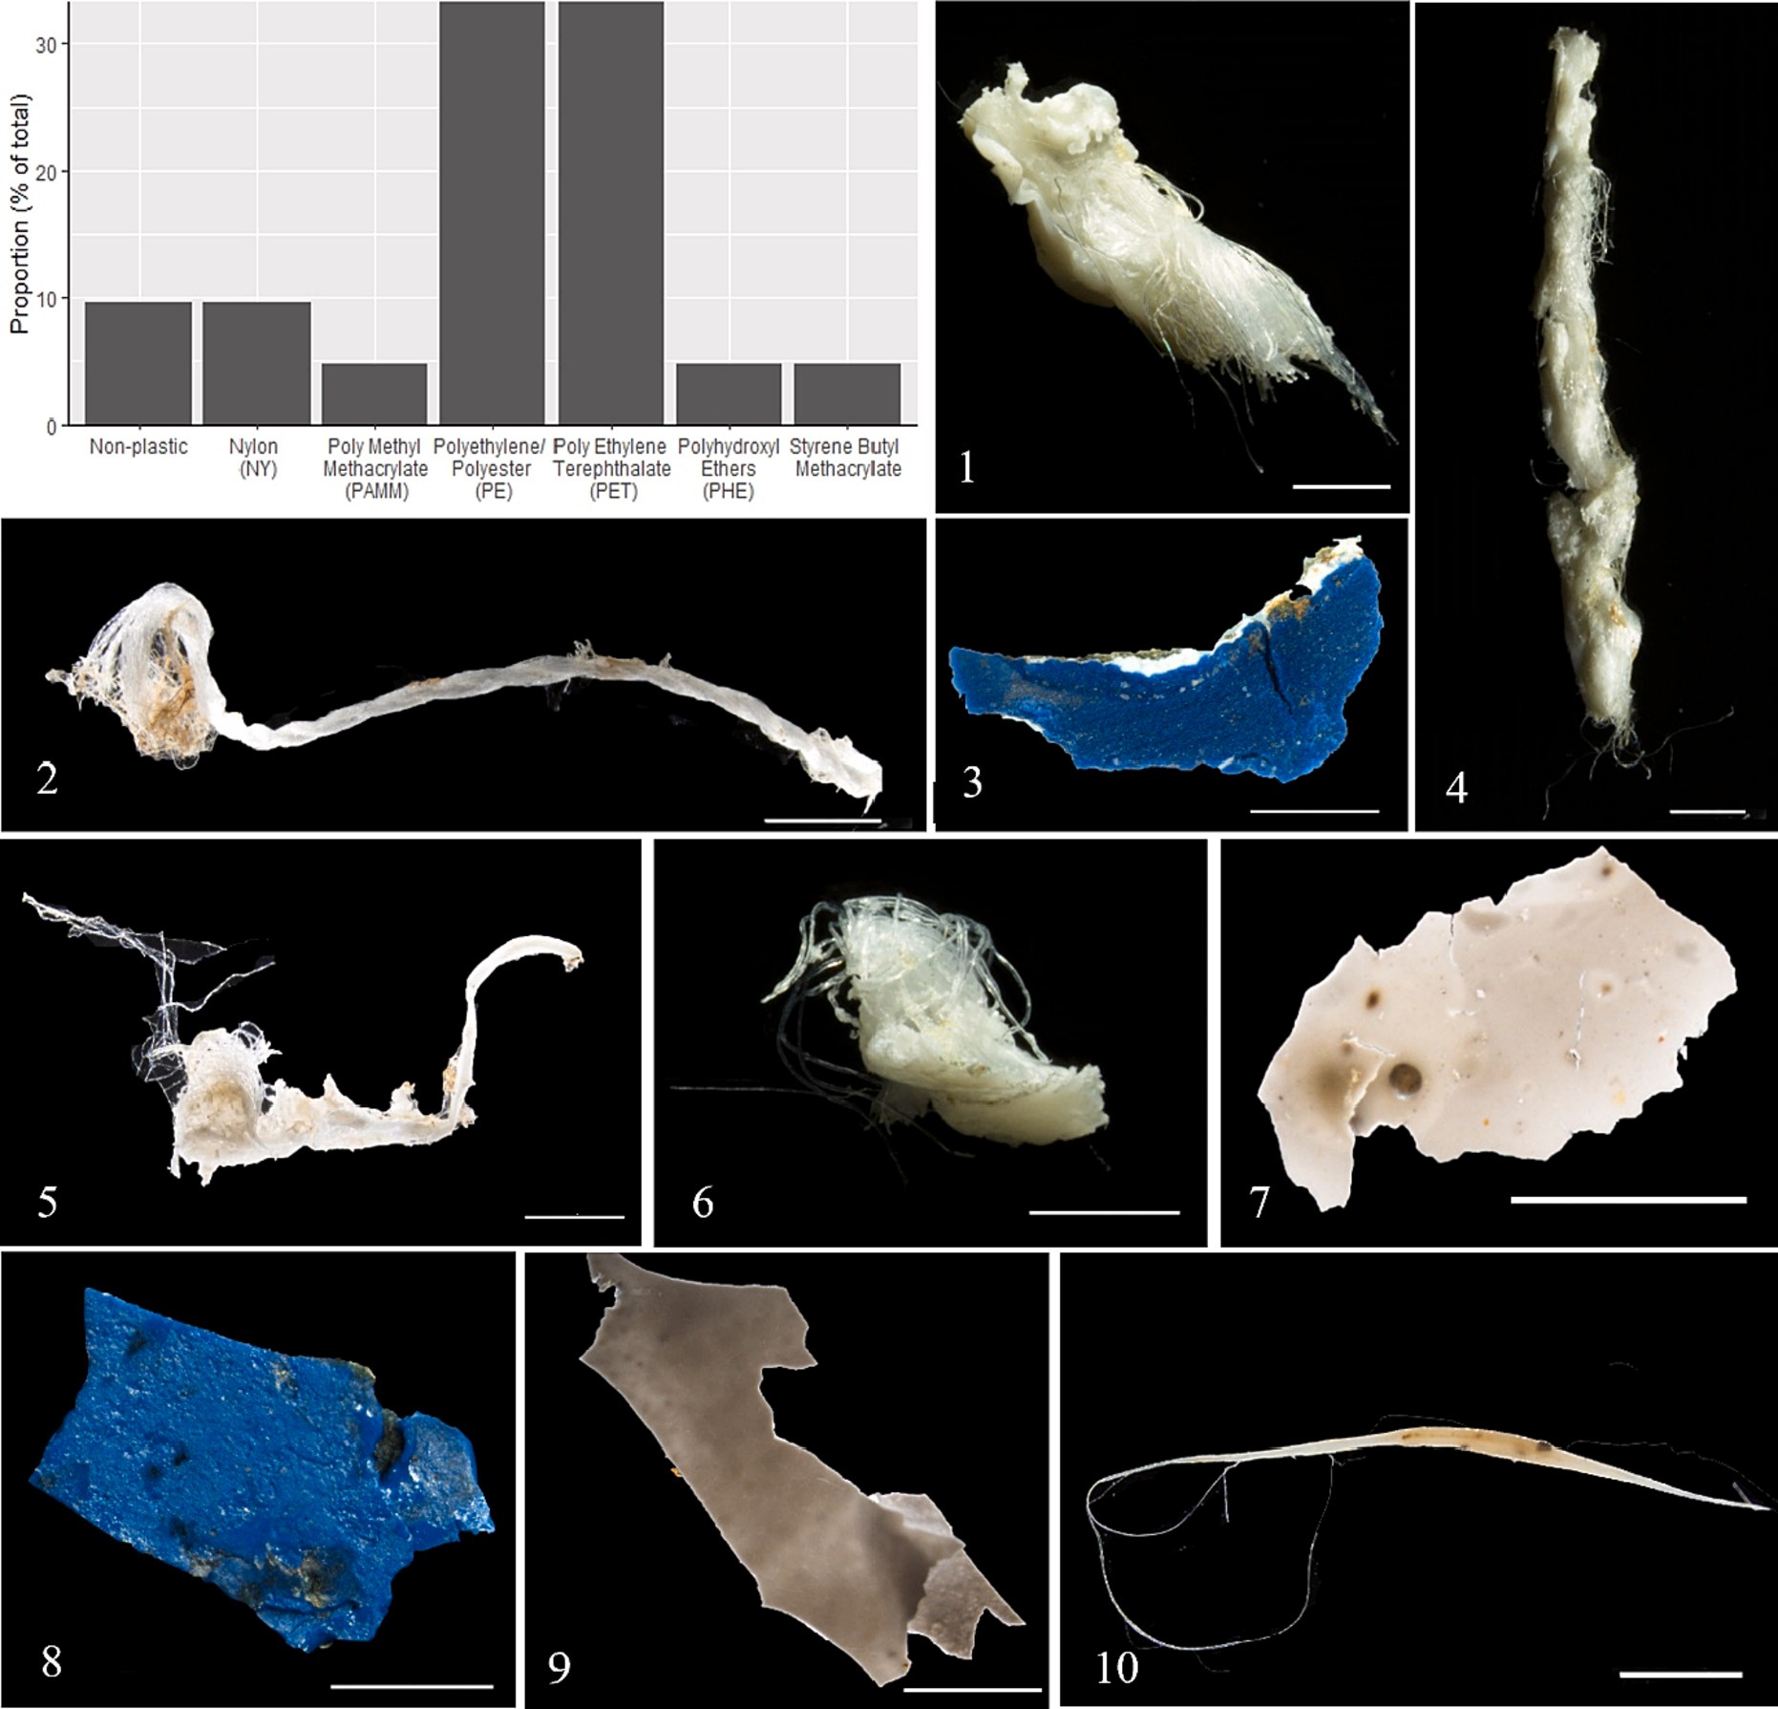

**Fig. 8.** Proportion (% of the total number) of the most common types of polymers determined by Spectrometer analysis of the microplastics collected within the water column. (1-10) examples of microplastics; 1–4 Polyester (PE); 5–7 Polyethylene terephthalate (PET); 8 Polymethyl methacrylate (PAMM); 9 Phenoxy resins (PHE); 10 Nylon (NY). Scale bars represent 500 μm with the exception of picture 2 (1000 μm), and picture 10 (2000 μm).

column samples 46 particles were analyzed, with 21 particles found to have a spectrum with a correspondence ≥70 % (Lusher, 2015) and were considered to reliably describe the polymer type of the particle. Nine- teen of those particles were confirmed as plastic, meaning that 90 % of the fragments were correctly previously described as plastics. The remaining 10 % were anthropogenic materials identified as jute or linen fibers. This error ratio was used to estimate the total amount of plastic fragments in the water samples, meaning a total of 91 plastic particles was found in all the water samples. The overall abundance ranged from

0.004 to 0.049 microplastics per m3, with an overall median of 0.01 ±

IQR 0.02 microplastics per m3. The abundance of microplastics did not significantly vary among the years (H = 2.47, df = 4, *p* = 0.65), between low or high inflow (H = 0.86, df = 1, *p* = 0.35; Fig. 2) or in relation with the water depth (H = 4.28, df = 3, *p* = 0.23; Fig. 2).

* + 1. *G. morhua diet under contrasting abiotic conditions*

The total length and weight of *G. morhua* varied among years (H = 26.53, df = 4, *p* ≤ 0.001 and H = 20.08, df = 4, p ≤ 0.001, respectively): the fish were larger and heavier in 2015 and 2016 compared to the other

years (Table 1). The years with the most pronounced MBI where those during which the fish were the largest and with the diet dominated by benthic invertebrates (Fig. SM 3).

The distribution of both *G. morhua* and *S. sprattus* were estimated by applying the known biological limits of these species to CTD data. This allowed for the visualization of species dispersal throughout the water column during each year of the study, including the overlap of predator and prey (Fig. 3). There were major variations in the expected distri- butions of *G. morhua* between years with emphasis given to the pro- portion of the water column within the species biological limits (salinity

of 11–15 psu and an oxygen concentration > 1 ml/l (Schaber et al.,

2012, Schaber et al., 2009)). Additional variation occurred within the distance from the lower end of *G. morhua* distribution to the seafloor. As the CTD was deployed to a maximum depth of 90 m the remaining 5 m to benthos was assumed to be not within biological limits (Table 2).

*S. sprattus* were estimated to be found throughout the majority of the water column in all years as they were only limited within this range of the Baltic by water temperature < 5 ◦C and with dissolved oxygen <1

ml/l (Fakult and Kiel, 2006).

The majority of *G. morhua* (*n* = 60) had identifiable food items in

their stomach that could be assigned to a feeding category. Under anoxic bottom water conditions, 81 % of *G. morhua* fed exclusively on pelagic fish whereas, under oxygenated bottom conditions, the majority had ingested benthic invertebrates. Of the 74 % of *G. morhua* that ingested benthic invertebrates 61 % feed exclusively benthically and the remained 13 % fed benthopelagically with both benthic invertebrates and fish found within the gut content (Fig. 4). This difference in feeding strategies was found to be significant (Fisher's exact test, chi-squared = 29.96, df = 2, *p* ≤ 0.001).

* + 1. *Fish plastic ingestion*

Overall, microplastics were found in 29 % of all the *G. morhua* analyzed (*n* = 72). In total, 21 individuals had 47 microplastics in their digestive tract, with a median of 1 ± IQR 1 particles per individuals, ranging from 1 to 7 particles in a single fish (Table 3). The vast majority of these particles were microplastic fibers (96 %), with few filaments (2

%) and filament knots (2 %) (Fig. 5ab). A higher proportion of *G. morhua* had microplastics in their digestive tract during anoxic years (38 %) than during years with oxygenated conditions (15 %) (*t* = -4.8, df = 2.50, *p*

= 0.026; Fig. 6 and Table 3). Among the *G. morhua* individuals con- taining plastic particles (*n* = 21), the location of the plastic items within the fish gut (stomach or intestine) did not differ: 13 *G. morhua* (62 %) had plastic within their stomach only, 12 *G. morhua* (57 %) had plastic only in their intestines and four *G. morhua* (19 %) had plastic in both the stomach and the intestine (Table SM 3). Among all the *G. morhua* in- dividuals that had ingested plastic items, eight individuals (38 %) had

>1 microplastic particle. A maximum of seven fibers were found in a

single individual in 2017 and 2018.

Nine out of 50 *S. sprattus* (18 %) had a total of 13 microplastics in their digestive tract (Fig. 5c), with a maximum of 2 particles in a single individual. These particles consisted entirely of microplastic fibers of varying colors and lengths. The proportion of *S. sprattus* with micro- plastic did not differ between anoxic (15 %) and oxygenated years (20

%) (*t* = -0.31, df = 1.30, *p* = 0.8; Fig. 6 and Table 3). Of all the *S. sprattus* that had ingested plastic (*n* = 9), four individuals (44 %) had a maximum of two fibers. Of the *S. sprattus* which were located within

*G. morhua* stomach samples and analyzed as prey (*n* = 13), no plastic particles or fibers were found.

* + 1. *Impact of inflows and microplastic ingestion on fish condition*

Overall, Fulton's condition index revealed that plastic little connec- tion between the condition of *G. morhua* and either inflow levels or plastic ingestion. The main effect for inflow level yielded an F ratio of F (1, 66) = 3.85, *p* = 0.054, indicating a marginally significant effect with low inflow (M = 0.88, SD = 0.099) higher than high inflow (M = 0.80, SD = 0.14). The main effect of plastic ingestion F (2, 66) = 0.13, *p* = 0.87, indicating that the effect of plastic ingestion was not significant whether absent (M = 0.85, SD = 0.13), present (M = 0.85), SD = 0.089), or multiple plastic pieces present (M = 0.869, SD = 0.087). The inter- action effect of inflow and plastic ingestion was also insignificant, F (2, 66) = 0.072, *p* = 0.93 (Fig. 7).

* + 1. *Microplastic types*

The microplastics collected from the water column samples varied in color, type, size, and shape. Particles were predominantly of angular shape, hard fragments (as opposed to soft or filamentous) and were colored either white or blue (Table 4). The majority of plastic were polyester (PE, *n* = 7) or polyethylene terephthalate (PET, n = 7), which represented each a third of the plastic found (Fig. 8). Other plastic types included polymethyl methacrylate (PAMM, *n* = 1), phenoxy resins (PHE, n = 1), nylon (NY, *n* = 2) and styrene butyl methacrylate (n = 1).

# Discussion

* + 1. *Plastic within the water column*

We found an average of 0.02 microplastics/m3 within the water column of the Central Bornholm Basin. Previous studies have reported

higher levels of plastic pollution within other areas of the Baltic when including microplastic fibers (0.5 particles/m3 (Zobkov et al., 2019),

0.27 particles/m3 (Beer et al., 2018). The microplastic abundance found in our study is low in comparison, and we acknowledge that the exclu- sion of microfibers from our water sample counts (which dominate other forms of microplastics in previous studies) may have led to an under- estimation of their number. When contamination can be prevented, the inclusion of microplastic fibers is important as they constituted the majority of microplastic particles ingested by *G. morhua* and *S. sprattus* in this study. Moving forward, microplastic fiber contamination must be taken into account during water sample collection and cannot be sampled onboard for additional studies as it introduces the sample to unregulated exposure to laboratory air conditions at sea.

Our original assumption that microplastics accumulate in the upper layer of the halocline due to an increase in water density with higher salinity at that depth was not confirmed. Microplastics were similarly abundant throughout the water column. Additionally, microplastic abundance varied between replicates of the same depth/year, indicating high spatial variability of plastic distribution within the water column.

* + 1. *Plastic ingestion in Atlantic G. morhua varies with environmental conditions*

Overall, 29 % of Atlantic *G. morhua* analyzed had microplastics in their digestive tracts. Plastic ingestion was influenced by oxygen con- centration because plastic items were present in 38 % of *G. morhua* in years of anoxia, whereas only 15 % of the fish contained plastic in years with oxygenated bottom water. The majority (95.7 %) of these micro- plastics were microplastic fibers. As microplastic abundance did not vary throughout the water column, the increase in plastic ingestion by

*G. morhua* during anoxic years is not likely due to the fish moving to a more contaminated area within the water column but may instead be the result of trophic transfer from their prey. Indeed, microplastics were often found in the gut of *S. sprattus*, independently of the oxygen con- ditions. Previous studies have shown a wide range of plastic ingestion in Atlantic *G. morhua*, from 1 to 47 % (Brate et al., 2016), spread across sampling stations and seasons. The cods analyzed in this study were captured at the same location and time of the year for several consec- utive years, which allows for a better understanding of environmental changes caused by Major Baltic Inflows (MBI).

There was no difference in the proportion of stomach and intestines containing plastic, which implies that microplastics within the size range examined here (200–8000 μm) do not accumulate within the fish's digestive tract and are egested by the fish. However, three *G. morhua* individuals were found containing plastic within relatively empty or- gans, meaning that microplastics may remain within the fish's guts longer than organic material before being egested. Due to both the low number of microplastic particles found and the size of particles consis- tent with normal egestion (Chagnon et al., 2018), we expect that microplastics within the size range observed here (200–8000 μm), do not represent an imminent threat to *G. morhua*. Additionally, through using Fulton's condition index we have shown that there is no significant effect of plastic ingestion, even of multiple microplastics on the general condition of *G. morhua*, only a marginally significant effect of the inflow level. The predicted increase of anoxic events and the current over- exploitation of the species within the Baltic Sea are certainly more serious threats to *G. morhua* and other commercially and ecologically important species, such as *S. sprattus*.

* + 1. *G. morhua feeding strategies are impacted by environmental conditions*

As expected, *G. morhua* used different feeding strategies during years with contrasting water inflows. During years with anoxic bottom con- ditions following low MBI (2014, 2017 and 2018), *G. morhua* fed exclusively on fish prey (mostly *S. sprattus*), which confirms our pre- diction that *G. morhua* feed mostly pelagically during bottom-anoxic conditions. Predation of *S. sprattus* by *G. morhua* was expected to occur primarily at dusk and dawn during ascent and descent of

*S. sprattus* associated with school dissolution and formation, respectively (Andersen et al., 2017). *S. sprattus* schools were located at the same depth as *G. morhua* in the daylight hours, whereas at night dispersed

*S. sprattus* were located higher in the water column (Andersen et al., 2017; Stepputtis, 2006). During low inflow years, *G. morhua* likely avoided the deepest anoxic waters to remain in shallower, more oxygenated waters. The remains of some invertebrates (*Cancer* sp., Polychaeta, Bivalvia) were found in the digestive tract of *G. morhua* during anoxic years, confirming that the fish can nevertheless venture into anoxic waters to feed on invertebrate prey, as also documented in another study in the area (Neuenfeldt et al., 2009). Strictly benthic feeding only occurred during years with the highest bottom oxygen concentrations following large MBI (2015 and 2016), which allow

*G. morhua* to feed normally at the bottom. *S. sprattus* were not expected to be affected by the environmental conditions changed during high or low inflow years (Fig. 7). As such, the fact that there was no change in plastic ingestion or diet during these years was expected.

Years following high inflows had increased oxygen concentration at depth that, in turn, resulted in a larger vertical range within the water column of *G. morhua*. In years following low inflow levels, the spatial overlap of *G. morhua* and *S. sprattus* was limited to a narrow range, meaning that the majority of the water column was outside of the preferential limits of *G. morhua*. These environmental conditions would increase the distance needed to travel through anoxic water to reach benthic prey and resulted in an increase in piscivorous feeding despite having a small overlap with *S. sprattus* within the water column.

# Conclusion

In future decades, the Baltic Sea is expected to have an increase of areas with anoxia at depth (Reusch et al., 2018), making anoxic bottom conditions the norm within the Bornholm Basin. Our results thus advocate for an increasing likelihood of plastic ingestion by *G. morhua* through their pelagic prey. *S. sprattus* should be less impacted by such a shift in anoxic conditions as we found that they should be present throughout the majority of the water column regardless of inflow level and oxygen concentration. As *S. sprattus* showed, as expected, no shift within the water column, they also showed no change in plastic inges- tion. With 18 % of *S. sprattus* containing microplastics, a shift in

*G. morhua* feeding strategy that increases predation on *S. sprattus* within the oxygenated water column could bring *G. morhua* into contact with microplastics through their prey with increased frequency.

# CRediT authorship contribution statement

**L. Grace Walls:** Conceptualization, Formal analysis, Investigation, Writing – original draft. **Thorsten Reusch:** Resources, Supervision. **Catriona Clemmesen:** Conceptualization, Writing – review & editing. **Nicolas C. Ory:** Conceptualization, Methodology, Resources, Writing – review & editing, Supervision.

# Declaration of competing interest

The authors declare that they have no known competing financial interests or personal relationships that could have appeared to influence the work reported in this paper.

# Data availability

Data will be made available on request.

# Acknowledgements

We thank Jan Dierking for allowing us access to both ALKOR cruise time and samples. Jens Peter Herrmann for access and allowing Uni- versity of Hamburg samples to be included. Finally, Tim Kiessling for access and assistance involving the FTIR spectrometer.

# References

Akdogan, Z., Guven, B., 2019. Microplastics in the environment: a critical review of current understanding and identification of future research needs. Environ. Pollut. 254, 113011 <https://doi.org/10.1016/j.envpol.2019.113011>.

Andersen, N.G., Lundgren, B., Neuenfeldt, S., Beyer, J.E., 2017. Diel vertical interactions between Atlantic cod Gadus morhua and sprat Sprattus in a stratified water column. Mar. Ecol. Prog. Ser. 583, 195–209. <https://doi.org/10.3354/meps12319>.

Beer, S., Garm, A., Huwer, B., Dierking, J., Nielsen, T.G., 2018. No increase in marine microplastic concentration over the last three decades – a case study from the Baltic Sea. Sci. Total Environ. 621, 1272–1279. [https://doi.org/10.1016/j.](https://doi.org/10.1016/j.scitotenv.2017.10.101) [scitotenv.2017.10.101](https://doi.org/10.1016/j.scitotenv.2017.10.101).

Brate, I.L.N., Eidsvoll, D.P., Steindal, C.C., Thomas, K.V., 2016. Plastic ingestion by Atlantic cod (Gadus morhua) from the Norwegian coast. Mar. Pollut. Bull. 112, 105–110. <https://doi.org/10.1016/j.marpolbul.2016.08.034>.

Bucci, K., Tulio, M., Rochman, C.M., 2020. What is known and unknown about the effects of plastic pollution: a meta-analysis and systematic review. Ecol. Appl. 30, 1–16. <https://doi.org/10.1002/eap.2044>.

Chagnon, C., Thiel, M., Antunes, J., Ferreira, J.L., Sobral, P., Ory, N.C., 2018. Plastic ingestion and trophic transfer between Easter Island flying fish (Cheilopogon rapanouiensis) and yellowfin tuna (Thunnus albacares) from Rapa Nui (Easter Island). Environ. Pollut. 243, 127–133. [https://doi.org/10.1016/j.](https://doi.org/10.1016/j.envpol.2018.08.042) [envpol.2018.08.042](https://doi.org/10.1016/j.envpol.2018.08.042).

Cole, M., Lindeque, P., Halsband, C., Galloway, T.S., 2011. Microplastics as contaminants in the marine environment: a review. Mar. Pollut. Bull. 62, 2588–2597. [https://doi.](https://doi.org/10.1016/j.marpolbul.2011.09.025) [org/10.1016/j.marpolbul.2011.09.025](https://doi.org/10.1016/j.marpolbul.2011.09.025).

Collard, F., Gasperi, J., Gabrielsen, G.W., Tassin, B., 2019. Plastic particle ingestion by wild freshwater fish: a critical review. Environ. Sci. Technol. [https://doi.org/](https://doi.org/10.1021/acs.est.9b03083) [10.1021/acs.est.9b03083](https://doi.org/10.1021/acs.est.9b03083).

[Derraik, J.G.B., 2002. The pollution of the marine environment by plastic debris: a](http://refhub.elsevier.com/S0025-326X(22)00683-X/rf202207291127535981) [review. Mar. Pollut. Bull. 44, 842–852](http://refhub.elsevier.com/S0025-326X(22)00683-X/rf202207291127535981).

Eriksen, M., Lebreton, L.C.M., Carson, H.S., Thiel, M., Moore, C.J., Borerro, J.C., Galgani, F., Ryan, P.G., Reisser, J., 2014. Plastic pollution in the world's oceans: more than 5 trillion plastic pieces weighing over 250,000 tons afloat at sea. PLoS ONE 9, 1–15. <https://doi.org/10.1371/journal.pone.0111913>.

[Fakult, M., Kiel, D.S., 2006. Distribution patterns of Baltic sprat (Sprattus](http://refhub.elsevier.com/S0025-326X(22)00683-X/rf202207291118338665).

Foekema, E.M., Gruijter, C.De, Mergia, M.T., Franeker, J.A.Van, Murk, A.J., Koelmans, A. A., 2013. Foekema EM. Plastic in North Sea Fish. ES&T 2013. Environ.Sci.Technol. 47, 8818–8824. <https://doi.org/10.1021/es400931b>.

GEBCO Bathymetric Compilation Group 2019, 2019. The GEBCO_2019 Grid - a continuous terrain model of the global oceans and land. British Oceanographic Data Centre, National Oceanography Centre, NERC, UK. British Oceanographic Data Centre. <https://doi.org/10.5285/836f016a-33be-6ddc-e053-6c86abc0788e>. In press.

Gewert, B., Ogonowski, M., Barth, A., MacLeod, M., 2017. Abundance and composition of near surface microplastics and plastic debris in the Stockholm Archipelago, Baltic Sea. Mar. Pollut. Bull. 120, 292–302. [https://doi.org/10.1016/j.](https://doi.org/10.1016/j.marpolbul.2017.04.062) [marpolbul.2017.04.062](https://doi.org/10.1016/j.marpolbul.2017.04.062).

Karami, A., Golieskardi, A., Choo, C.K., Romano, N., Ho, Y.Bin, Salamatinia, B., 2017.

A high-performance protocol for extraction of microplastics in fish. Sci. Total Environ. 578, 485–494. <https://doi.org/10.1016/j.scitotenv.2016.10.213>.

Kooi, M., Van Nes, E.H., Scheffer, M., Koelmans, A.A., 2017. Ups and downs in the ocean: effects of biofouling on vertical transport of microplastics. Environ. Sci. Technol. 51, 7963–7971. <https://doi.org/10.1021/acs.est.6b04702>.

Kowalski, N., Reichardt, A.M., Waniek, J.J., 2016. Sinking rates of microplastics and potential implications of their alteration by physical, biological, and chemical factors. Mar. Pollut. Bull. 109, 310–319. [https://doi.org/10.1016/j.](https://doi.org/10.1016/j.marpolbul.2016.05.064) [marpolbul.2016.05.064](https://doi.org/10.1016/j.marpolbul.2016.05.064).

Kühn, S., van Werven, B., van Oyen, A., Meijboom, A., Bravo Rebolledo, E.L., van Franeker, J.A., 2017. The use of potassium hydroxide (KOH) solution as a suitable approach to isolate plastics ingested by marine organisms. Mar. Pollut. Bull. 115, 86–90. <https://doi.org/10.1016/j.marpolbul.2016.11.034>.

Lenaker, P.L., Baldwin, A.K., Corsi, S.R., Mason, S.A., Reneau, P.C., Scott, J.W., 2019. Vertical distribution of microplastics in the water column and surficial sediment

from the Milwaukee River Basin to Lake Michigan. Environ. Sci. Technol. 53, 12227–12237. <https://doi.org/10.1021/acs.est.9b03850>.

Lenz, R., Enders, K., Beer, S., Sørensen, T.K., Stedmon, C.A., Reeh, L., 2016. In: Analysis of Microplastic in the Stomachs of Herring And Cod From the North Sea And Baltic Sea. National Institute of Aquatic Resources, pp. 1–30. [https://doi.org/10.13140/](https://doi.org/10.13140/RG.2.1.1625.1769) [RG.2.1.1625.1769](https://doi.org/10.13140/RG.2.1.1625.1769).

Liblik, T., Lips, U., 2019. Stratification has strengthened in the Baltic sea – an analysis of 35 years of observational data. Front. Earth Sci. 7, 1–15. [https://doi.org/10.3389/](https://doi.org/10.3389/feart.2019.00174) [feart.2019.00174](https://doi.org/10.3389/feart.2019.00174).

Lusher, A., 2015. Microplastics in the marine environment: distribution, interactions and effects. In: Bergmann, M., Gutow, L., Klages, M. (Eds.), Marine Anthropogenic Litter. Springer International Publishing, Cham, pp. 245–307. [https://doi.org/10.1007/](https://doi.org/10.1007/978-3-319-16510-3_10) [978-3-319-16510-3_10](https://doi.org/10.1007/978-3-319-16510-3_10).

Mohrholz, V., 2018. Major Baltic inflow statistics – revised. Front. Mar. Sci. 5, 1–16. <https://doi.org/10.3389/fmars.2018.00384>.

Neuenfeldt, S., Beyer, J.E., 2003. Oxygen and salinity characteristics of predator-prey distributional overlaps shown by predatory Baltic cod during spawning. J. Fish Biol. 62, 168–183. <https://doi.org/10.1046/j.1095-8649.2003.00013.x>.

Neuenfeldt, S., Andersen, K.H., Hinrichsen, H.H., 2009. Some Atlantic cod Gadus morhua in the Baltic Sea visit hypoxic water briefly but often. J. Fish Biol. 75, 290–294. <https://doi.org/10.1111/j.1095-8649.2009.02281.x>.

Ory, N.C., Sobral, P., Ferreira, J.L., Thiel, M., 2017. Amberstripe scad Decapterus muroadsi (Carangidae) fish ingest blue microplastics resembling their copepod prey along the coast of Rapa Nui (Easter Island) in the South Pacific subtropical gyre. Sci. Total Environ. 586, 430–437. <https://doi.org/10.1016/j.scitotenv.2017.01.175>.

Ory, N.C., Gallardo, C., Lenz, M., Thiel, M., 2018. Capture, swallowing, and egestion of microplastics by a planktivorous juvenile fish. Environ. Pollut. 240, 566–573. <https://doi.org/10.1016/j.envpol.2018.04.093>.

Primpke, S., Wirth, M., Lorenz, C., Gerdts, G., 2018. Reference database design for the automated analysis of microplastic samples based on Fourier transform infrared (FTIR) spectroscopy. Anal. Bioanal. Chem. 410, 5131–5141. [https://doi.org/](https://doi.org/10.1007/s00216-018-1156-x) [10.1007/s00216-018-1156-x](https://doi.org/10.1007/s00216-018-1156-x).

[Primpke, S., Christiansen, S.H., Cowger, W., Frond, H.De, Deshpande, A., Fischer, M.,](http://refhub.elsevier.com/S0025-326X(22)00683-X/rf202207291115274454) [Holland, E.B., Meyns, M., O’Donnell, B.A., Ossmann, B.E., Pittroff, M., Sarau, G.,](http://refhub.elsevier.com/S0025-326X(22)00683-X/rf202207291115274454) [Scholz-Bo¨ttcher, B.M., Wiggin, K.J., 2020. Critical assessment of analytical methods](http://refhub.elsevier.com/S0025-326X(22)00683-X/rf202207291115274454) [for the harmonized and cost-efficient analysis of microplastics. Appl. Spectrosc. 74,](http://refhub.elsevier.com/S0025-326X(22)00683-X/rf202207291115274454) [1012–1047](http://refhub.elsevier.com/S0025-326X(22)00683-X/rf202207291115274454).

Reusch, T.B.H., Dierking, J., Andersson, H.C., Bonsdorff, E., Carstensen, J., Casini, M., Czajkowski, M., Hasler, B., Hinsby, K., Hyyti¨ainen, K., Johannesson, K., Jomaa, S., Jormalainen, V., Kuosa, H., Kurland, S., Laikre, L., MacKenzie, B.R., Margonski, P., Melzner, F., Oesterwind, D., Ojaveer, H., Refsgaard, J.C., Sandstro¨m, A., Schwarz, G., Tonderski, K., Winder, M., Zandersen, M., 2018. The Baltic Sea as a time machine for the future coastal ocean. Sci. Adv. 4 <https://doi.org/10.1126/sciadv.aar8195>.

Rezania, S., Park, J., Md Din, M.F., Mat Taib, S., Talaiekhozani, A., Kumar Yadav, K., Kamyab, H., 2018. Microplastics pollution in different aquatic environments and biota: a review of recent studies. Mar. Pollut. Bull. 133, 191–208. [https://doi.org/](https://doi.org/10.1016/j.marpolbul.2018.05.022) [10.1016/j.marpolbul.2018.05.022](https://doi.org/10.1016/j.marpolbul.2018.05.022).

Rummel, C.D., Lo¨der, M.G.J., Fricke, N.F., Lang, T., Griebeler, E.M., Janke, M.,

Gerdts, G., 2016. Plastic ingestion by pelagic and demersal fish from the North Sea and Baltic Sea. Mar. Pollut. Bull. 102, 134–141. [https://doi.org/10.1016/j.](https://doi.org/10.1016/j.marpolbul.2015.11.043) [marpolbul.2015.11.043](https://doi.org/10.1016/j.marpolbul.2015.11.043).

de Sa´, L.C., Luís, L.G., Guilhermino, L., 2015. Effects of microplastics on juveniles of the common goby (Pomatoschistus microps): confusion with prey, reduction of the predatory performance and efficiency, and possible influence of developmental conditions. Environ. Pollut. 196, 359–362. [https://doi.org/10.1016/j.](https://doi.org/10.1016/j.envpol.2014.10.026) [envpol.2014.10.026](https://doi.org/10.1016/j.envpol.2014.10.026).

Schaber, M., Hinrichsen, H.H., Neuenfeldt, S., Voss, R., 2009. Hydroacoustic resolution of small-scale vertical distribution in Baltic cod Gadus morhua - habitat choice and limits during spawning. Mar. Ecol. Prog. Ser. 377, 239–253. [https://doi.org/](https://doi.org/10.3354/meps07822) [10.3354/meps07822](https://doi.org/10.3354/meps07822).

Schaber, M., Hinrichsen, H.H., Gro¨ger, J., 2012. Seasonal changes in vertical distribution patterns of cod (Gadus morhua) in the Bornholm Basin, central Baltic Sea. Fish.

Oceanogr. 21, 33–43. <https://doi.org/10.1111/j.1365-2419.2011.00607.x>.

[Stepputtis, D., 2006. Distribution Patterns of Baltic Sprat (Sprattus L.)–Causes And](http://refhub.elsevier.com/S0025-326X(22)00683-X/rf202207291116162784) [Consequences. PhD Thesis. University of Kiel, Kiel, Germany](http://refhub.elsevier.com/S0025-326X(22)00683-X/rf202207291116162784).

Thiel, M., Luna-Jorquera, G., A´ lvarez-Varas, R., Gallardo, C., Hinojosa, I.A., Luna, N.,

Miranda-Urbina, D., Morales, N., Ory, N., Pacheco, A.S., Portflitt-Toro, M., Zavalaga, C., 2018. Impacts of marine plastic pollution from continental coasts to subtropical gyres-fish, seabirds, and other vertebrates in the SE Pacific. Front. Mar. Sci. 5, 1–16. <https://doi.org/10.3389/fmars.2018.00238>.

Tomkiewicz, J., Lehmann, K.M., St. John, M.A., 1998. Oceanographic influences on the distribution of Baltic cod, Gadus morhua, during spawning in the Bornholm Basin of the Baltic Sea. Fish.Oceanogr. 7, 48–62. [https://doi.org/10.1046/j.1365-](https://doi.org/10.1046/j.1365-2419.1998.00051.x) [2419.1998.00051.x](https://doi.org/10.1046/j.1365-2419.1998.00051.x).

Uzars, D., Plikshs, M., 2000. Cod (Gadus morhua L.) cannibalism in the Central Baltic: interannual variability and influence of recruit abundance and distribution. ICES J. Mar. Sci. 57, 324–329. <https://doi.org/10.1006/jmsc.1999.0527>.

Welden, N.A., Abylkhani, B., Howarth, L.M., 2018. The effects of trophic transfer and environmental factors on microplastic uptake by plaice, Pleuronectes plastessa, and spider crab, Maja squinado. Environ. Pollut. 239, 351–358. [https://doi.org/](https://doi.org/10.1016/j.envpol.2018.03.110) [10.1016/j.envpol.2018.03.110](https://doi.org/10.1016/j.envpol.2018.03.110).

West, L.J., Hankin, R.K.S., 2008. Exact tests for two-way contingency tables with structural zeros. J. Stat. Softw. 28, 1–19. <https://doi.org/10.18637/jss.v028.i11>.

Zobkov, M.B., Esiukova, E.E., Zyubin, A.Y., Samusev, I.G., 2019. Microplastic content variation in water column: the observations employing a novel sampling tool in stratified Baltic Sea. Mar. Pollut. Bull. 138, 193–205. [https://doi.org/10.1016/j.](https://doi.org/10.1016/j.marpolbul.2018.11.047) [marpolbul.2018.11.047](https://doi.org/10.1016/j.marpolbul.2018.11.047).