**Supplementary Informations to Freudenthal et al. (2022) Heat flux estimation from borehole temperatures acquired during logging while tripping: a case study with the the sea floor drill rig MARUM-MeBo. Marine Geophysical Resarch. doi: 10.1007/s11001-022-09500-1**

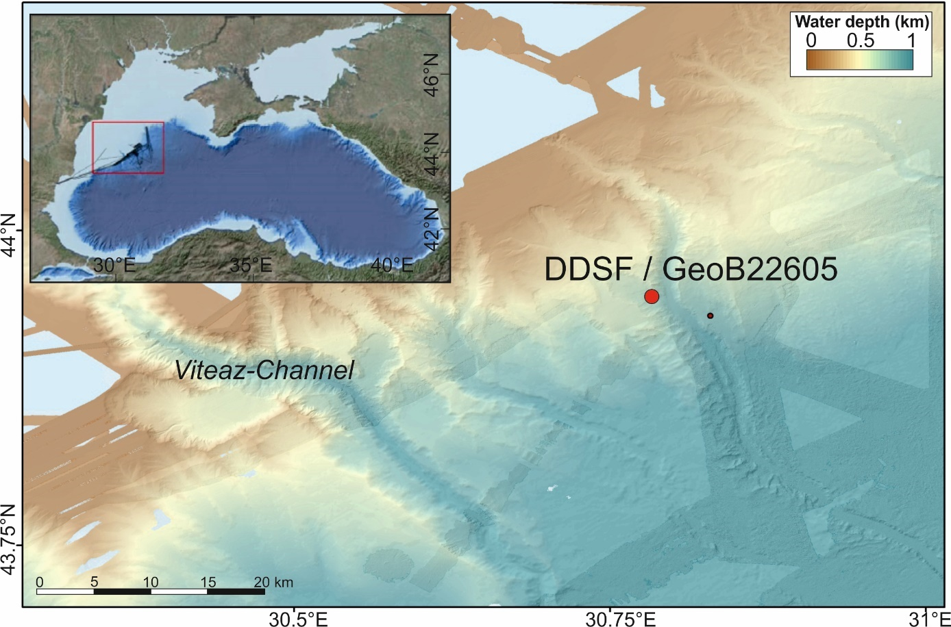

Fig. S1: Bathymetric map of the Black Sea investigation area with location of the Danube Deep Sea Fan DDSF drilling site GeoB22605-1 (modified from Riedel et al., 2020a, 2021a, 2021b)

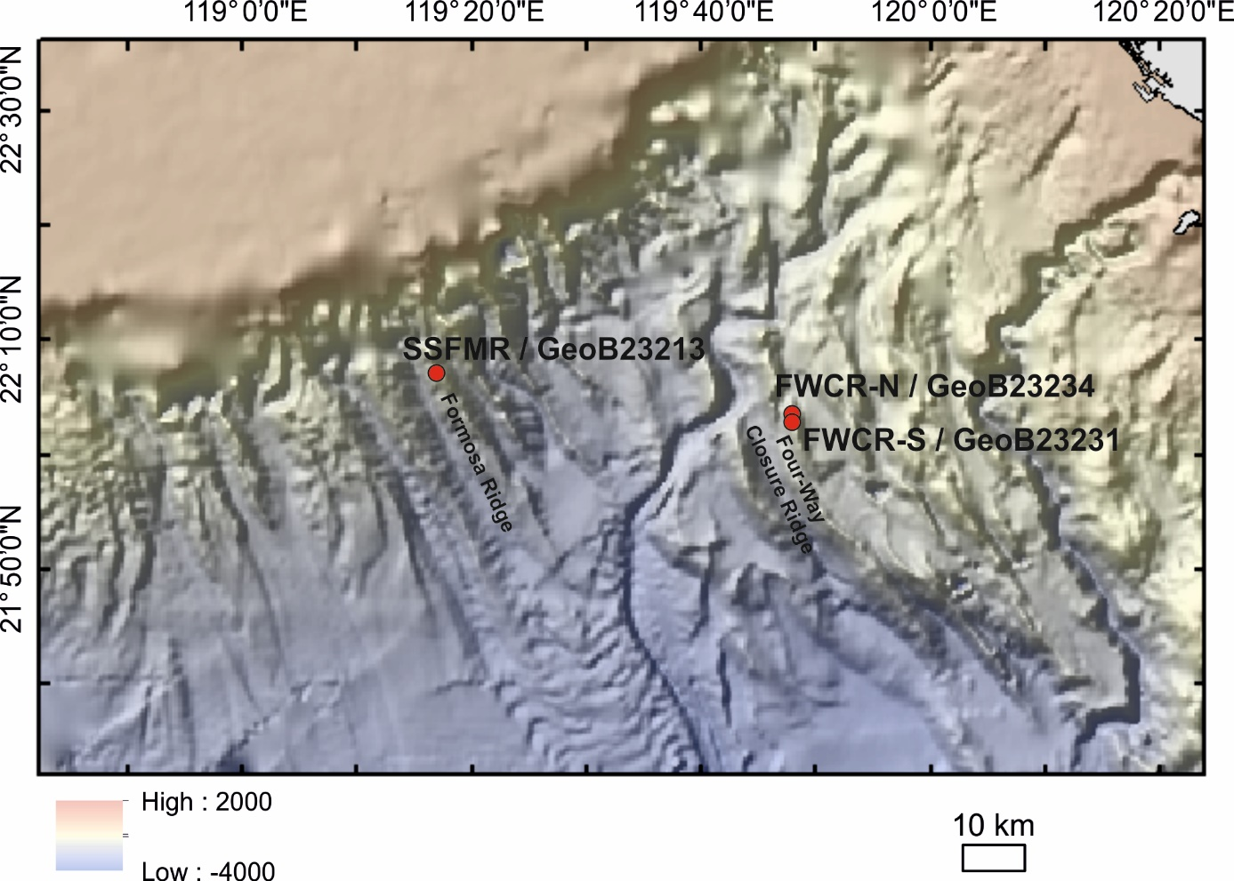

Fig. S2: Bathymetric map (GMRTv4_20220401topo (1).grd) of the South China Sea investigation area SW of Taiwan with locations of the drill sites at the southern summit of Formosa Ridge (SSFMR / GeoB23213-1) and at Four-Way Closure Ridge (FWCR-S / GeoB23231-1 and FWCR-N / GeoB23234-1).

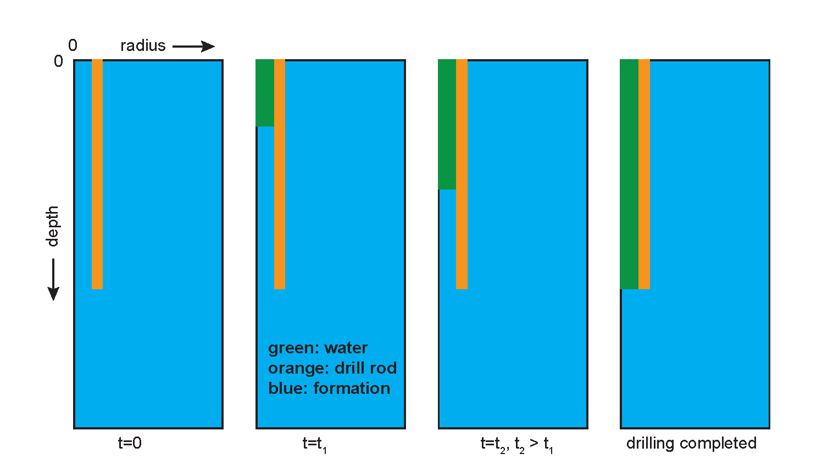

Fig. S3: Simulation of the drilling process. Dimensions are not to scale. For details, see text in the article.

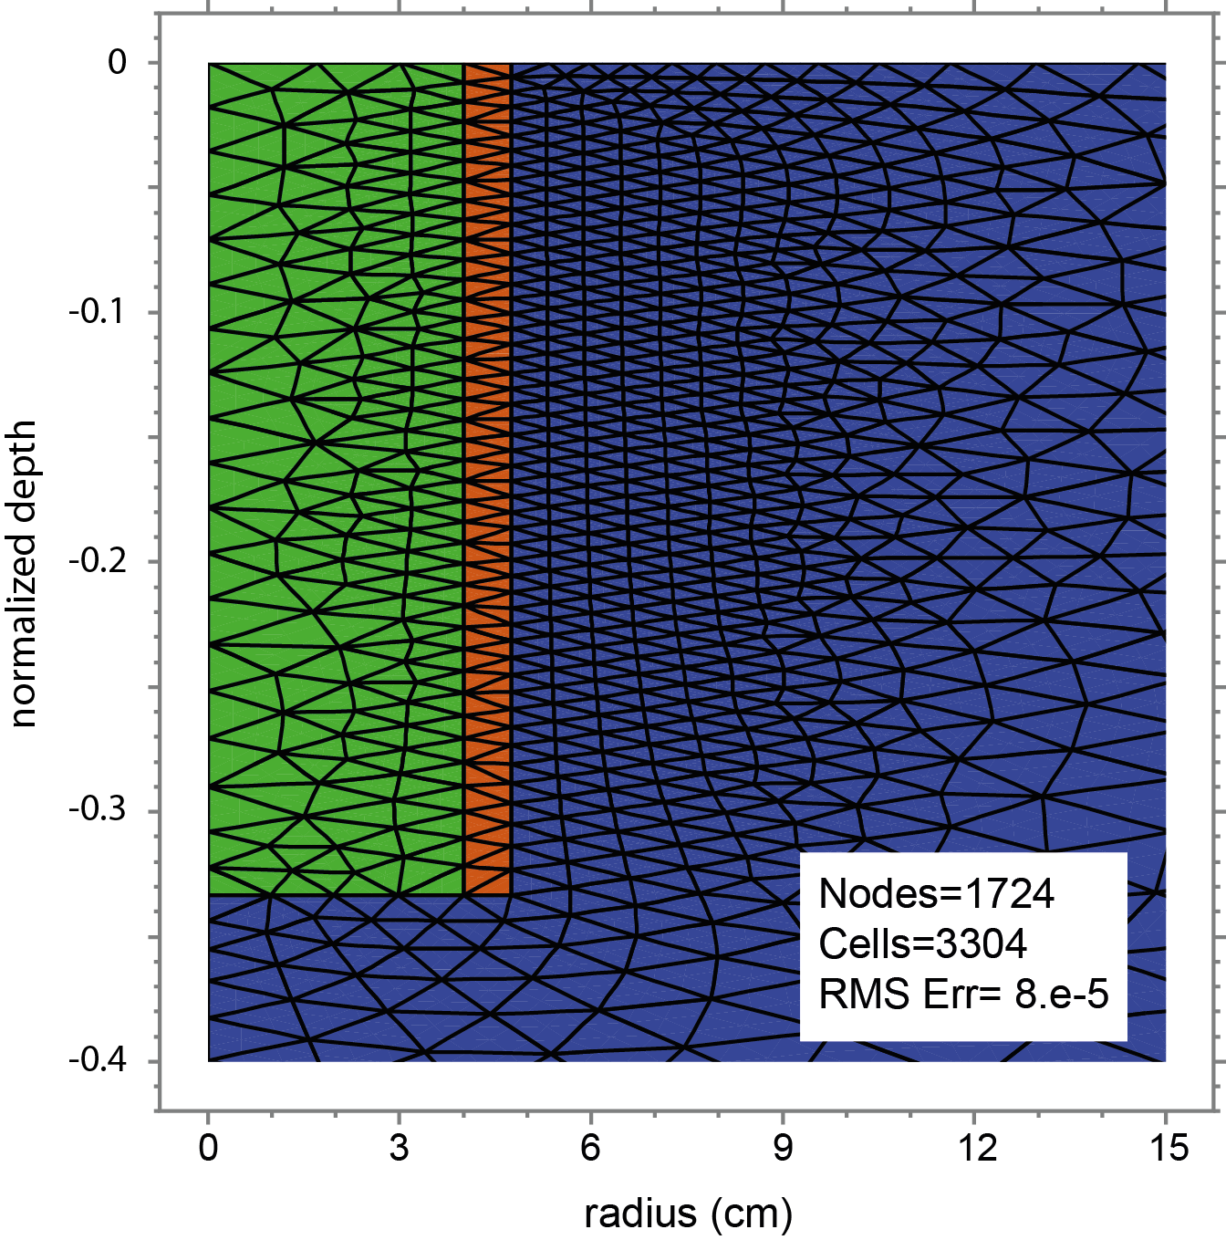

Fig. S4: Closeup of the grid of borehole DDSF after the borehole has been drilled to its final depth. Depth is normalized to 3 x borehole depth which means that the borehole itself extends to 0.33 in normalized depth coordinates. Maximal radial dimension of the model is 10 x borehole diameter i.e. 0.95 m. Green: water-filled borehole, brown: drill pipe, blue: formation.

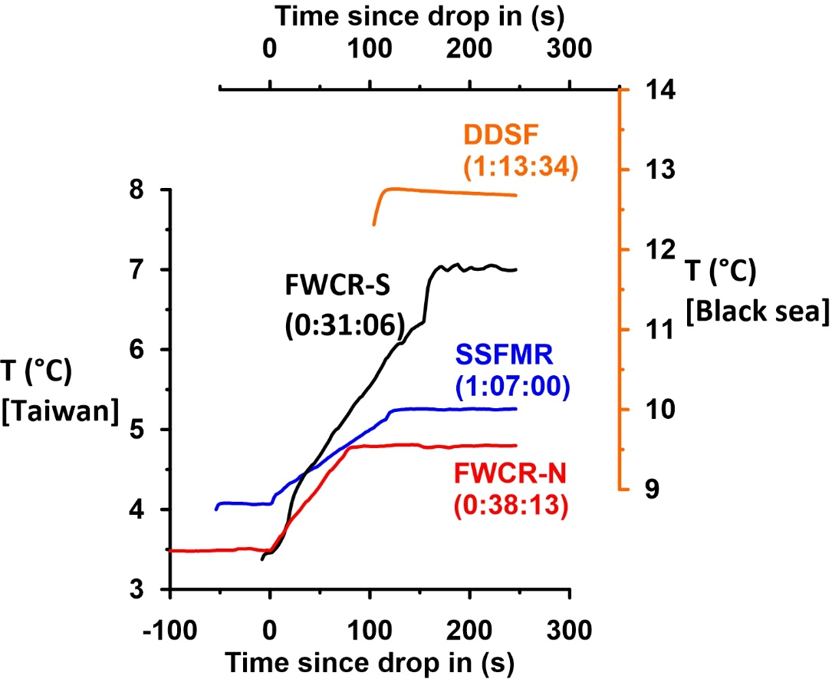

Fig. S5: Borehole temperature measurements during drop in of the Memory Acoustic Tool (MAT) at the South China Sea sites (SSFMR, FWCR-S, FWCR-N) and at the Black Sea Site (DDSF). Temperatures are plotted against time passed since start of drop in. Note that no depth control exists for the temperature measurements until the MAT has landed on the drill bit. Times in brackets (hr:mm:ss) indicate the time that has passed between stop of flushing and start of the drop in.

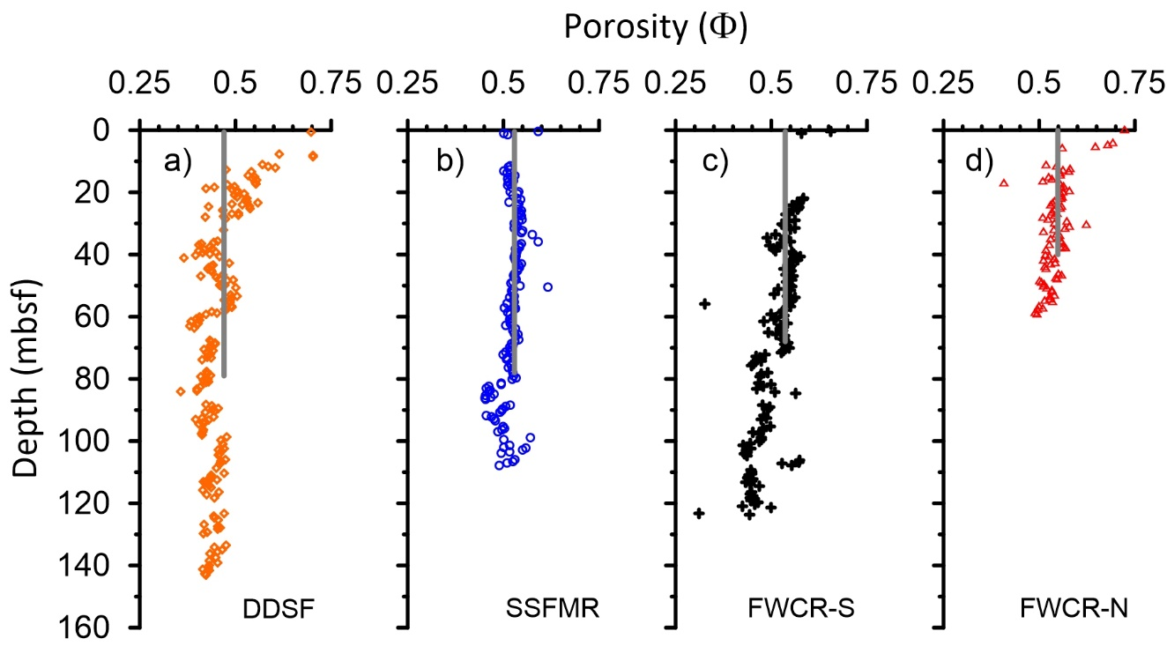

Fig. S6: Porosity values at (a) the Black Sea site DDSF (Riedel et al., 2020) and the South China Sea sites SSFMR, FWCR-S, and FWCR-N(b-d). Porosity values at the South China Sea site were determined according the method described by Pape et al. (2020). Porosity values at site FWCR-S were determined on core samples of MeBo deployment GeoB23216-1 which was drilled in close proximity (less than 70 m distance) to drill hole GeoB23231-1, where borehole temperature data were collected for this study. Grey lines mark the average porosity values that were used for estimating thermal conductivities.

Tab. S1: List of abbreviations

|  |  |
| --- | --- |
| BTW | Bottom water temperature |
| DDSF | Drill site at the Danube Deep Sea Fan, Black Sea |
| FlexPDE® | Finite Element Software package for modeling thermal processes |
| FWCR-N | Drill site at the Four-Way Closure Ridge (north), South China Sea |
| FWCR-S | Drill site at the Four-Way Closure Ridge (south), South China Sea |
| GHSZ | Gas hydrate stability zone |
| MARUM | Center for Marine Environmental Sciences at the University of Bremen |
| MAT | Memory Acoustic Tool with an integrated temperature sensor for borehole temperature measurements |
| mbsf | Meters below sea floor |
| MeBo | Meeresboden-Bohrgerät, German expression for sea floor drill rig |
| MTL | Miniature temperature logger; used within a push-in probe for measurement of formation temperature |
| SSFMR | Drill site at the Southern Summit of Formosa Ridge, South China Sea |

Tab. S2: List of variables

|  |  |
| --- | --- |
| k | Thermal conductivity |
| Q | Basal heat flux |
| T | Temperature (borehole or formation) |
| Tav | Averaged borehole temperature during stationary phases of the trip out |
| Tmax | Maximum flush water warming when the final drilling depth is reached |
| dT/dt | Temperature adaption rate, measured during stationary phases of the trip out within the borehole |
| δT | Difference between modeled and measured borehole temperature |
| δT0 | Difference between modeled and measured borehole temperature at the base of the borehole just before start of the trip out |
| avT | Difference between modeled and measured borehole temperatures averaged for the upper section of the borehole with uniform lithology |
| φ | Porosity |

Tab. S3: Comparison of bottom water temperatures. Bottom water temperatures BWTmeas and BWTmodel were determined by a linear fit of the uppermost three temperature values (measured and simulated) and extrapolating the fit to the sediment-water interface. BWTCTD is based on CTD casts (Bohrmann et al. 2018; Mau and Bohrmann, 2020)

|  |  |  |  |
| --- | --- | --- | --- |
|  | **BWTmeas  (°C)** | **BWTmodel  (°C)** | **BWTCTD  (°C)** |
| DDSF | 9.631 | 9.631 | 9.36 |
| SSFMR | 4.042 | 4.043 | 4.07 |
| FWCR-S | 3.523 | 3.523 | 3.47 |
| FWCR-N | 3.481 | 3.483 | 3.48 |

**References:**

Bohrmann G, and cruise participants (2018) R/V METEOR cruise report M142, Drilling Gas Hydrates in the Danube Deep-Sea Fan, Black Sea, Varna – Varna – Varna, 04 November – 22 November – 09 December 2017, Berichte, MARUM – Zentrum für Marine Umweltwissenschaften, Fachbereich Geowissenschaften, Universität Bremen, 320. 1-121 <http://nbn-resolving.de/urn:nbn:de:gbv:46-00106617-14>

Mau S, Bohrmann, G (2020) Physical Oceanography at CTD stations of Sonne cruise SO266. PANGAEA. doi: 10.1594/PANGAEA.915954

Pape T, Bünz S, Hong W-L, Torres ME, Riedel M et al (2020) Origin and transformation of light hydrocarbons ascending at an active pockmark on Vestnesa Ridge, Arctic Ocean, J Geophys Res: Sol Earth 125(1). doi:10.1029/2018JB016679

Riedel M, Freudenthal T, Bergenthal M, Haeckel M, Wallmann K, Spangenberg E, Bialas J, Bohrmann G (2020) [Physical properties and core-log seismic integration from drilling at the Danube deep-sea fan, Black Sea.](https://publications.marum.de/4112/) Marine and Petroleum Geology 114: 104192. [doi: 10.1016/j.marpetgeo.2019.104192](http://dx.doi.org/10.1016/j.marpetgeo.2019.104192)

Riedel M, Freudenthal T, Bialas J, Papenberg C, Haeckel M, Bergenthal M, Pape T, Bohrmann G (2021a) In-situ borehole temperature measurements confirm dynamics of the gas hydrate stability zone at the upper Danube deep sea fan, Black Sea. Earth and Plan Sci Let 563. [doi: 10.1016/j.epsl.2021.116869](https://doi.org/10.1016/j.epsl.2021.116869)

Riedel M, Hähnel L, Bialas J, Bachmann AK, Gaide S, Wintersteller P, Klaucke I, Bohrmann G (2021b) Controls on gas emission distribution on the continental slope of the western Black Sea, Front Earth Sci. doi: 10.3389/feart.2020.601254