Supplemental
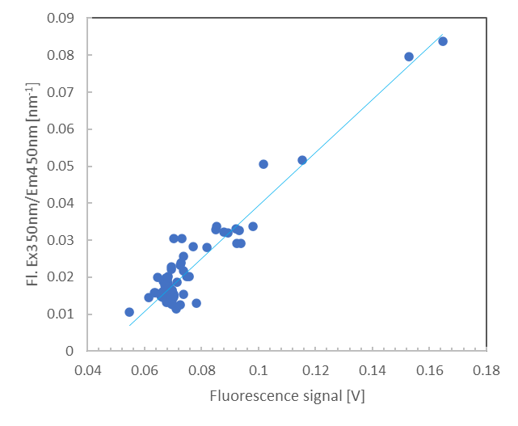
Figure S1. Calibration of the CTD mounted Haardt fluorometer on GN01 to water samples taken and measured onboard (following Stedmon et al., 2021). Fl. = V * 0.7143 – 0.0321; R² = 0.91.
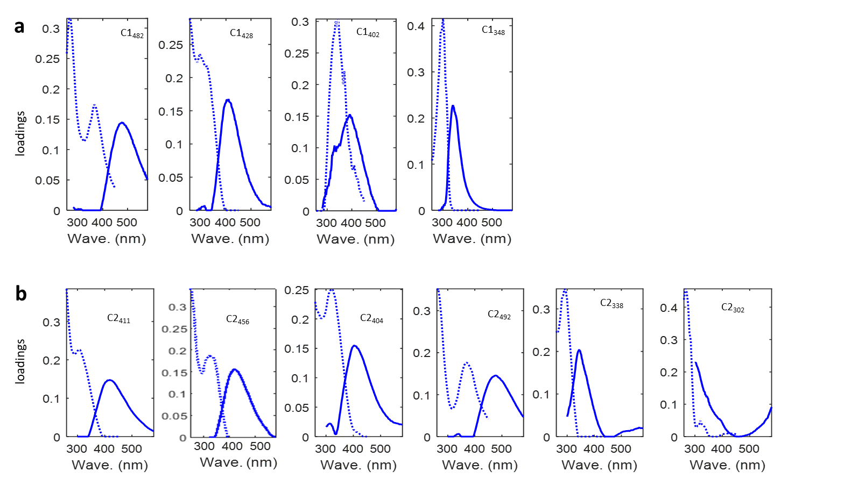
Figure S2. The fluorescence properties of fluorescent components identified by PARAFAC modeling in the Canada Basin (a) and the Nansen, Makarov, and Amundsen Basins (b). Dotted line- excitation, solid line- emission.

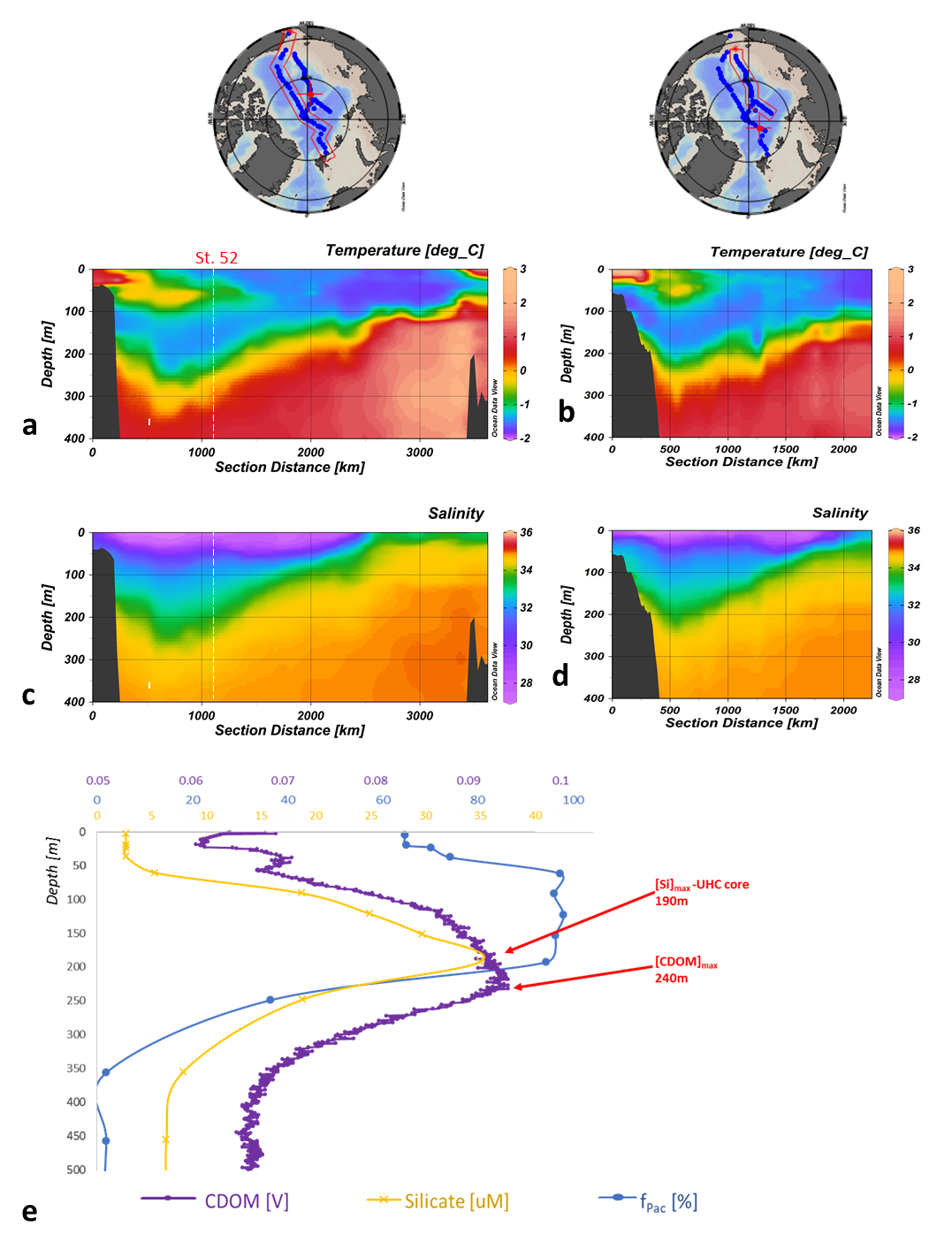

Figure S3. Sectional plots of temperature and salinity in the upper 400 m for sections A (a, c) and B (b, d); vertical distribution of in situ CDOM fluorescence (CDOM), silicate concentration ([Si]max corresponds to the upper halocline core (Anderson et al., 2013)), the Pacific water fraction (fPac) estimated from the δ18O/salinity method (e) at GN01 station 52 (central Canada Basin).

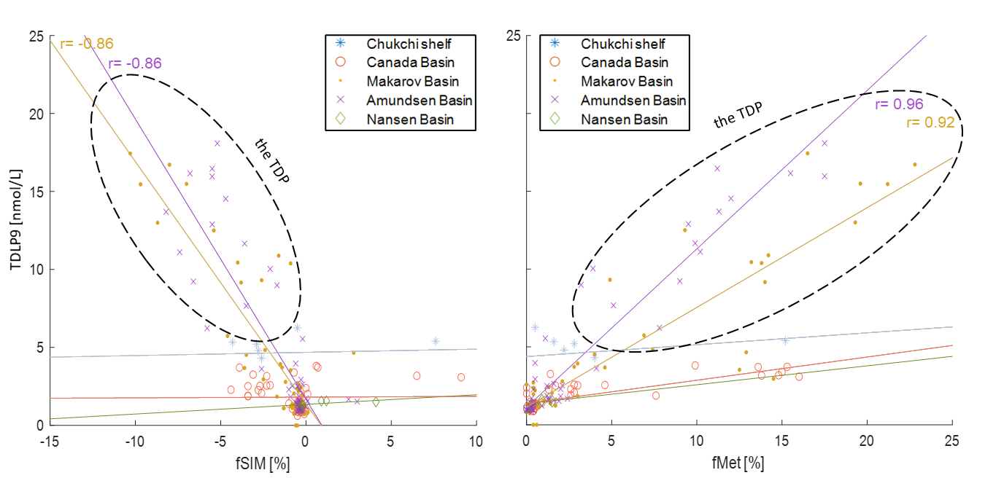
Figure S4. Relationship (Pearson correlation) of lignin phenol (TDLP9) concentrations, f_{SIM} and f_{Met} in the Chukchi Sea, Canada, Makarov, Amundsen and Nansen Basins. Only significant (p < 0.001) correlations are shown.

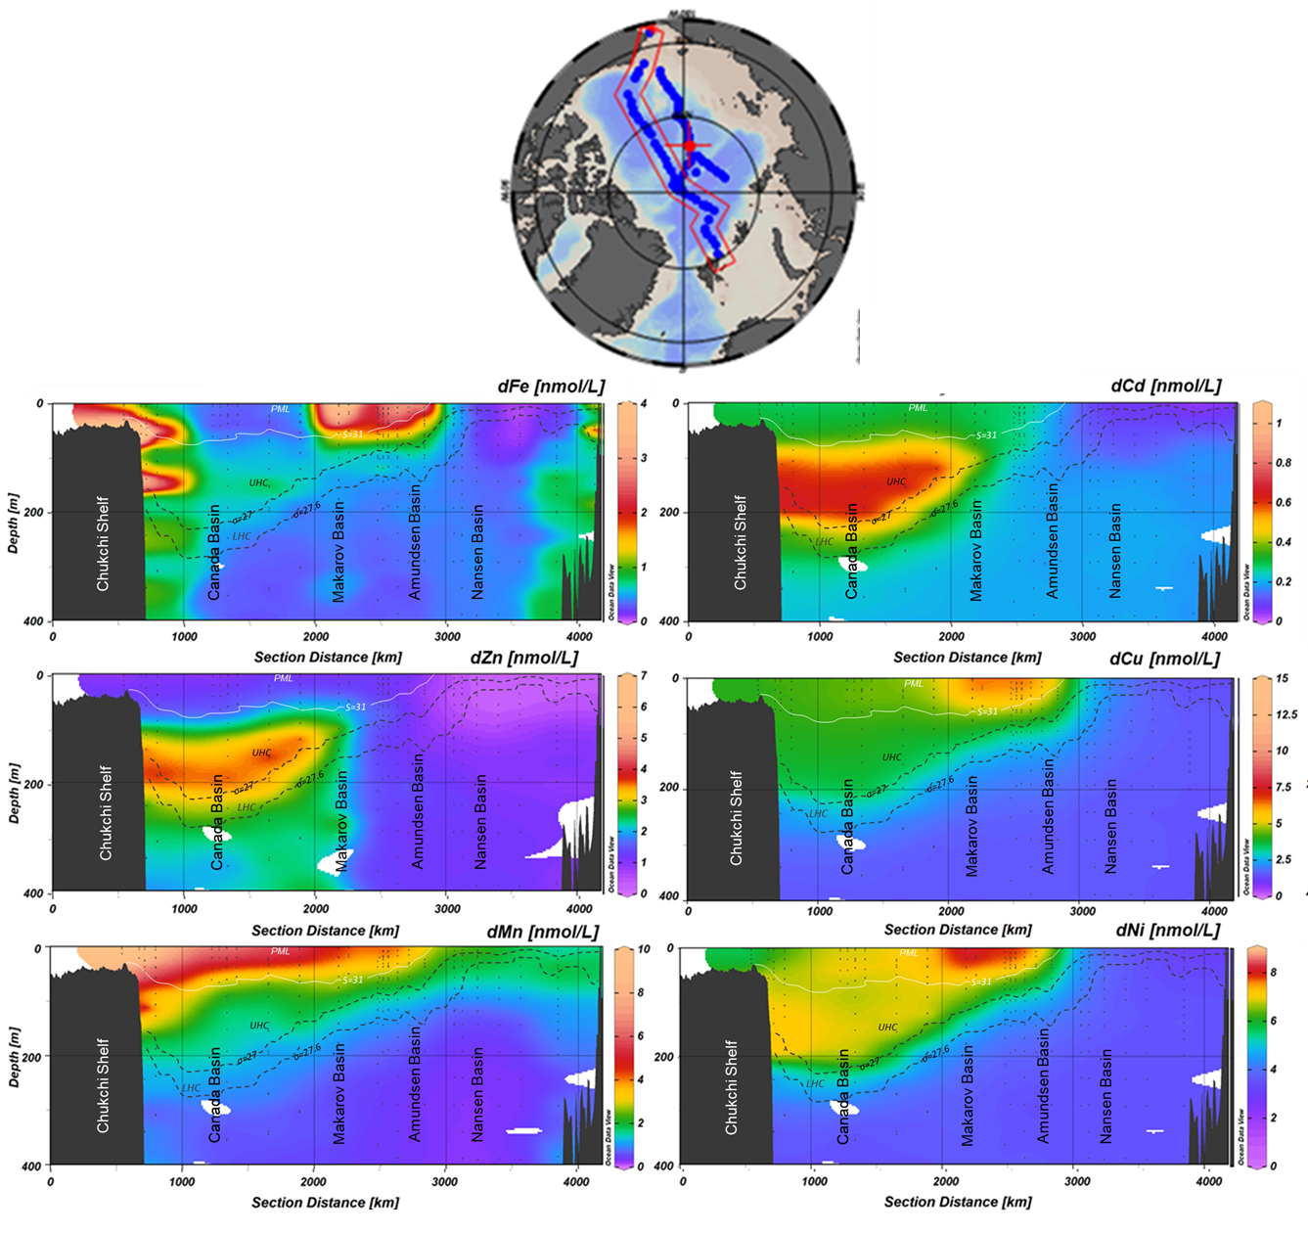
Figure S5. Sectional plots of dFe, dMn, dNi, dCu, dZn, dCd in the upper 400 m (section A). The white line represents the isohaline of S=31, which is the border of the PML in the Canada Basin. Black dashed isohaline of σ = 27 kg/m³ represents the LHC/UHC border. The LHC is bordered at the bottom by the isopycnal of σ = 27.6 kg/m³.
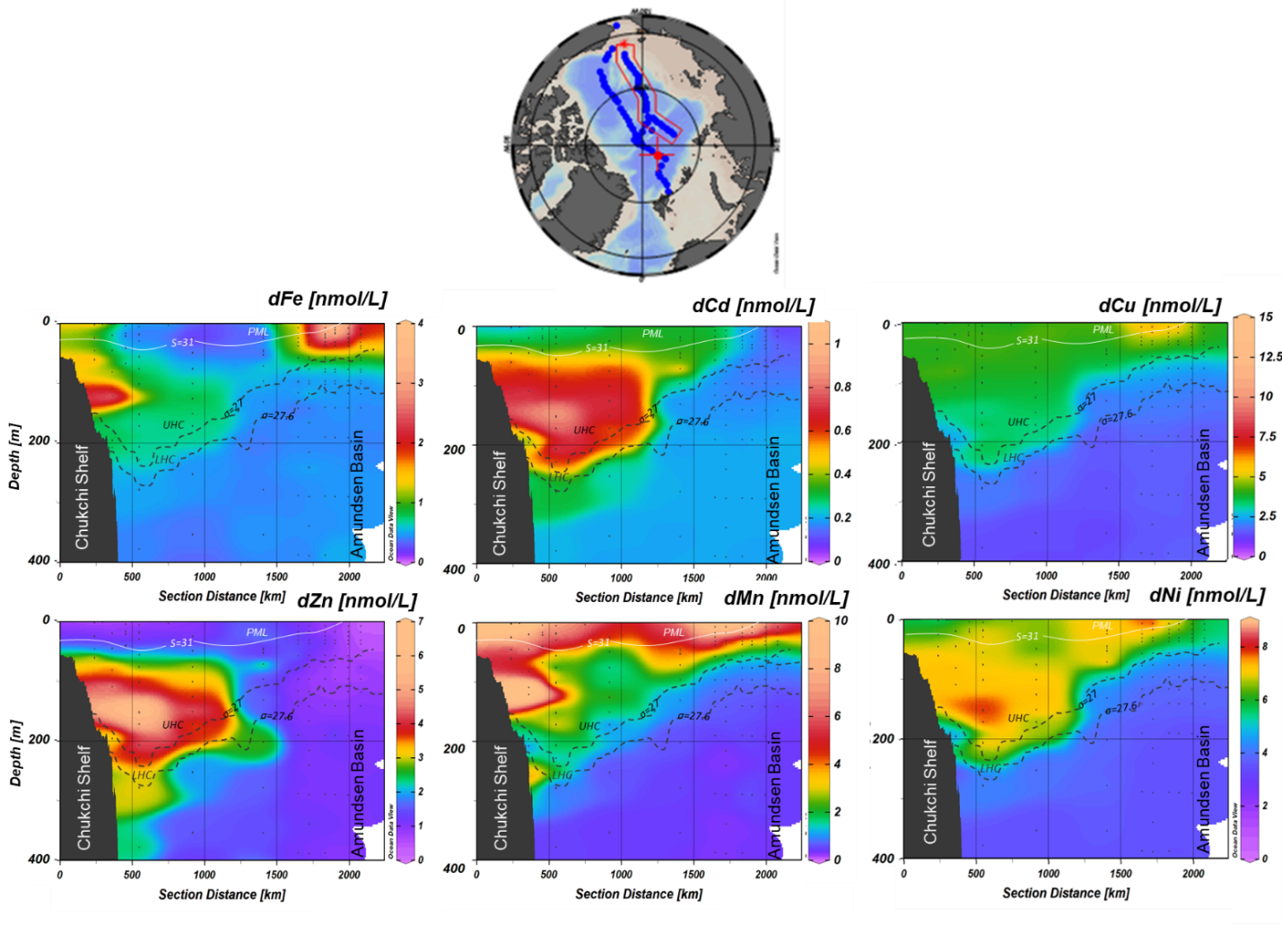
Figure S6. Sectional plots of dFe, dMn, dNi, dCu, dZn, dCd in the upper 400 m (section B). The white line represents the isohaline of S=31, which is the border of the PML in the Canada Basin. Black dashed isohaline of σ = 27 kg/m³ represents the LHC/UHC border. The LHC is bordered at the bottom by the isopycnal of σ = 27.6 kg/m³.
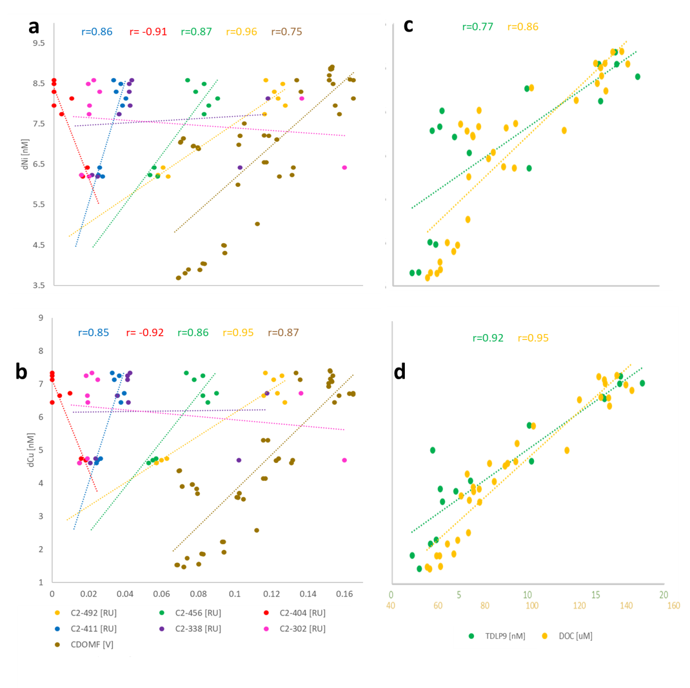
Figure S7. Scatterplots between the dNi (top panels), dCu (bottom panels) and C1 PARAFAC components and in situ CDOM fluorescence (CDOMF; a, b), lignin phenols (TDLP9) and dissolved organic carbon (DOC; b, d), in the top 300 meters of the Arctic Ocean. Only significant correlations (p<0.001 are shown).
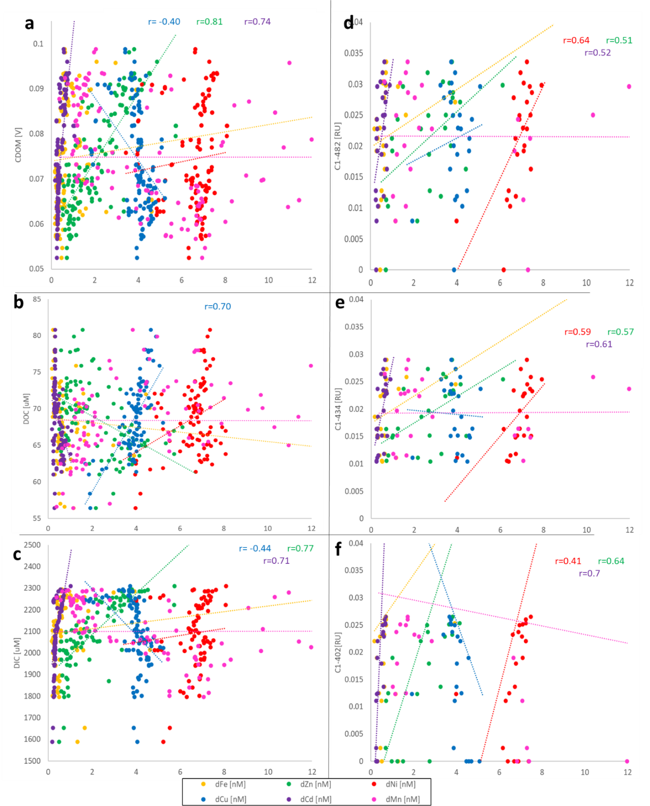
Figure S8. Scatterplots between the trace metals and in situ CDOM fluorescence (a), DIC (b), DOC (c), terrigenous humic-like C1₄₈₂ (d), marine humic-like C1₄₃₄ (e), marine humic-like with sediment signature C1₄₀₂ (f), in the top 300 meters of the Canada Basin. Only significant correlations (p<0.001 are shown).

Table S1. Spectral characteristics of the six fluorescence components identified by PARAFAC in the Eurasian Basin and the TPD region and comparisons to previously identified components.
PS94 | Description | Excitation max/ | Similar components | References
 |  | Emission max, nm
C2₄₁₁ | Humic-like | 260,300/411 | Florida Keys C1 | Yamashita et al., 2013
C2₄₅₆ | Humic-like  terrigenous | 260,340/456 | Florida Keys C2,  Lena 2013 C2 | Yamashita et al., 2013,  Gonçalves-Araujo et al., 2015
C2₄₀₄ | Humic-like | <260,309/404 | Omdrev C2,  Arctic Seawater C2 | Kothawala et al., 2014,  Chen et al., 2018
 |  |  | C3 | Williford et al., 2021
C2₄₉₂ | Humic-like  terrigenous | 285/492 | Omdrev C3 | Kothawala et al., 2014
C2₃₃₈ | Protein-like (Tryptophan) | 280/338 | Antarctic Ice C3 | Stedmon et al., 2011
C2₃₀₂ | Protein-like (Tyrosine) | 273/302 | Arctic Seawater C3 | Chen et al., 2018
 |  |  | C5 | Williford et al., 2021

Table S2. Spectral characteristics of the four components identified by PARAFAC in the Canada Basin and the Chukchi Sea and their comparison to previously identified components.
GN01 | Description | Excitation max/ | Similar components | References
 |  | Emission max, nm
C1₄₈₂ | Humic-like, terrigenous | 285,380/482 | Omdrev C3,  Beringia C3 | Kothawala et al., 2014,  Walker et al., 2009
 |  |  | C1 | Williford et al., 2021
C1₄₃₄ | Humic-like | 260,340/434 | Omdrev C4, | Kothawala et al., 2014,
C1₄₀₂ | Humic-like | 295,395/402 | Arctic Seawater C2,  Beringia C6 | Chen et al., 2018,  Walker et al., 2009
C1₃₄₈ | Protein-like | 275/348 | ArcticFjords_PPL C4 | Wünsch et al., 2018

