# Temporal variation in ecological and evolutionary contributions to phytoplankton functional shifts

Giannina S. I. Hattich, Luisa Listmann, Jonathan Havenhand, Thorsten B. H. Reusch, Birte Matthiessen

Table S1: The number of *E. huxleyi and C.affinis* Individuals (N) that have been genotyped at the different point in the selection phase for from communities sorted under ambient and high CO2 condition, respectively.

|  |  |  |  |  |
| --- | --- | --- | --- | --- |
| Time [d] | *N E. huxleyi* | | N *C.affinis* | |
| Ambient CO2 | High CO2 | Ambient CO2 | High CO2 |
| 8 | 83 | 82 |  |  |
| 32 | 45 | 57 |  |  |
| 64 | 71 | 76 | 82 | 88 |
| 80 | 68 | 38 |  |  |
| 168 | 33 | 36 |  |  |
| 288 | 57 | 59 | 54 | 62 |

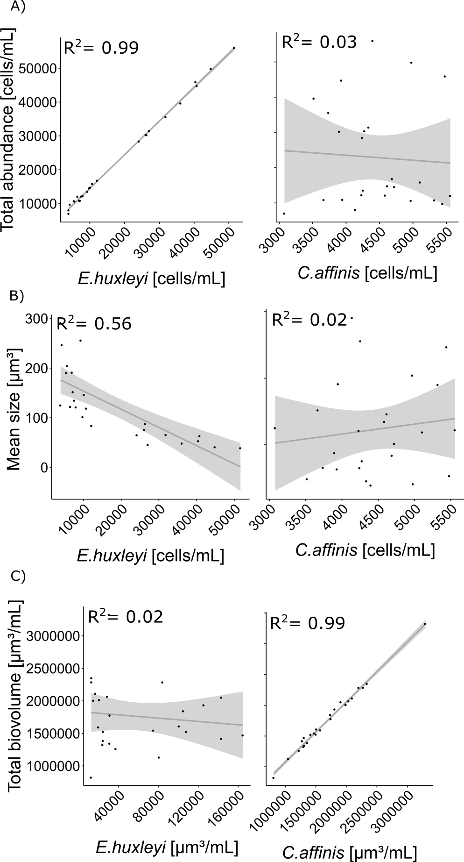

Figure S1: A) Correlation of total cell numbers (Cells/ml) to the abundance of *Emiliania huxleyi* and *Chaetoceros affinis* (cells/mL; top-left and top-right, respectively). B) Correlation of mean size (µmol³/mL) to the abundance of *E. huxleyi* and *C. affinis* (cells/mL; middle-left and middle-right, respectively). Values of all assay communities at 80 days are used for correlations.

Figure S2: Abundance of *C. affinis* and *E. huxleyi* in the communities held under ambient and high CO2 over 288 days corresponding to approximately 180 generations (mean and 95 % CI). To be able to see fluctuations in both species, with quite diverging abundance, the log to the basis of 10 is shown.

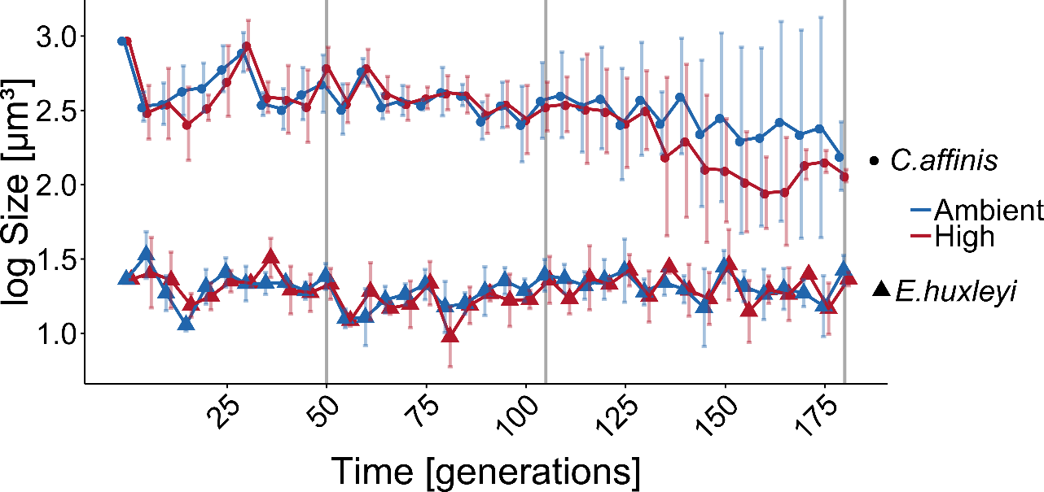

Figure S3: The size of *C. affinis* and *E. huxleyi* in the communities held under ambient and high CO2 over time (mean and 95 % CI). To be able to see fluctuations in both species, with quite diverging size, the log to the basis of 10 is shown.

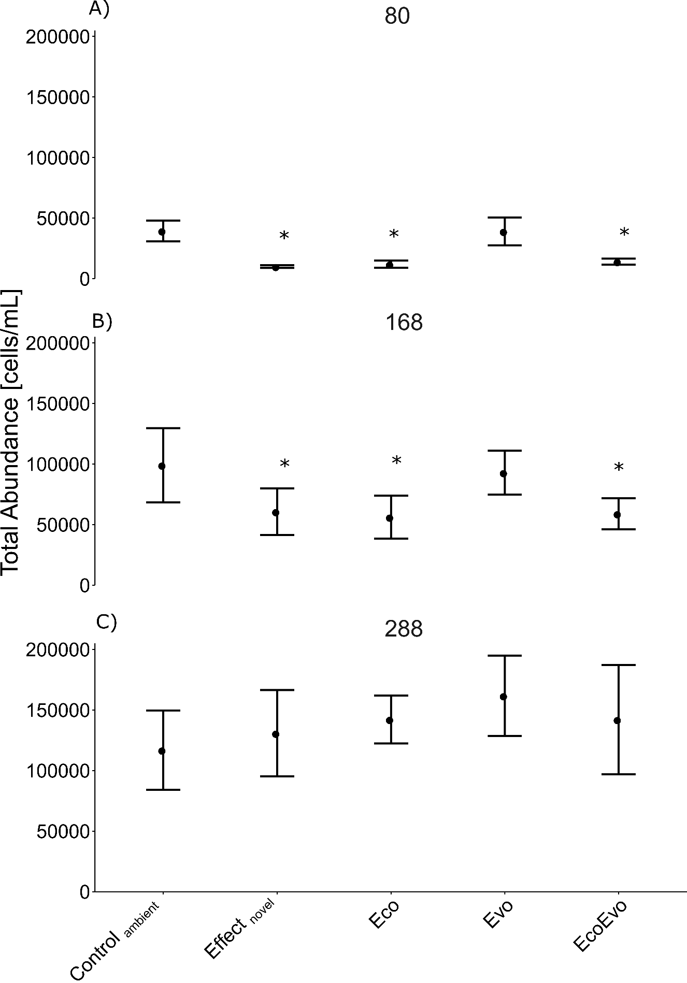

Figure S4: The total abundance of the Eco-Evo Assay communities assessed using communities sorted for 80 (A), 168 (B) and 288 (C) generations (mean und standard deviation). Asterisks indicate significant change between Effectnovel and the Eco, Evo and EcoEvo communities to the Controlambient (Anova with Controlambient as intercept). n=5 until 168 days then n=4.

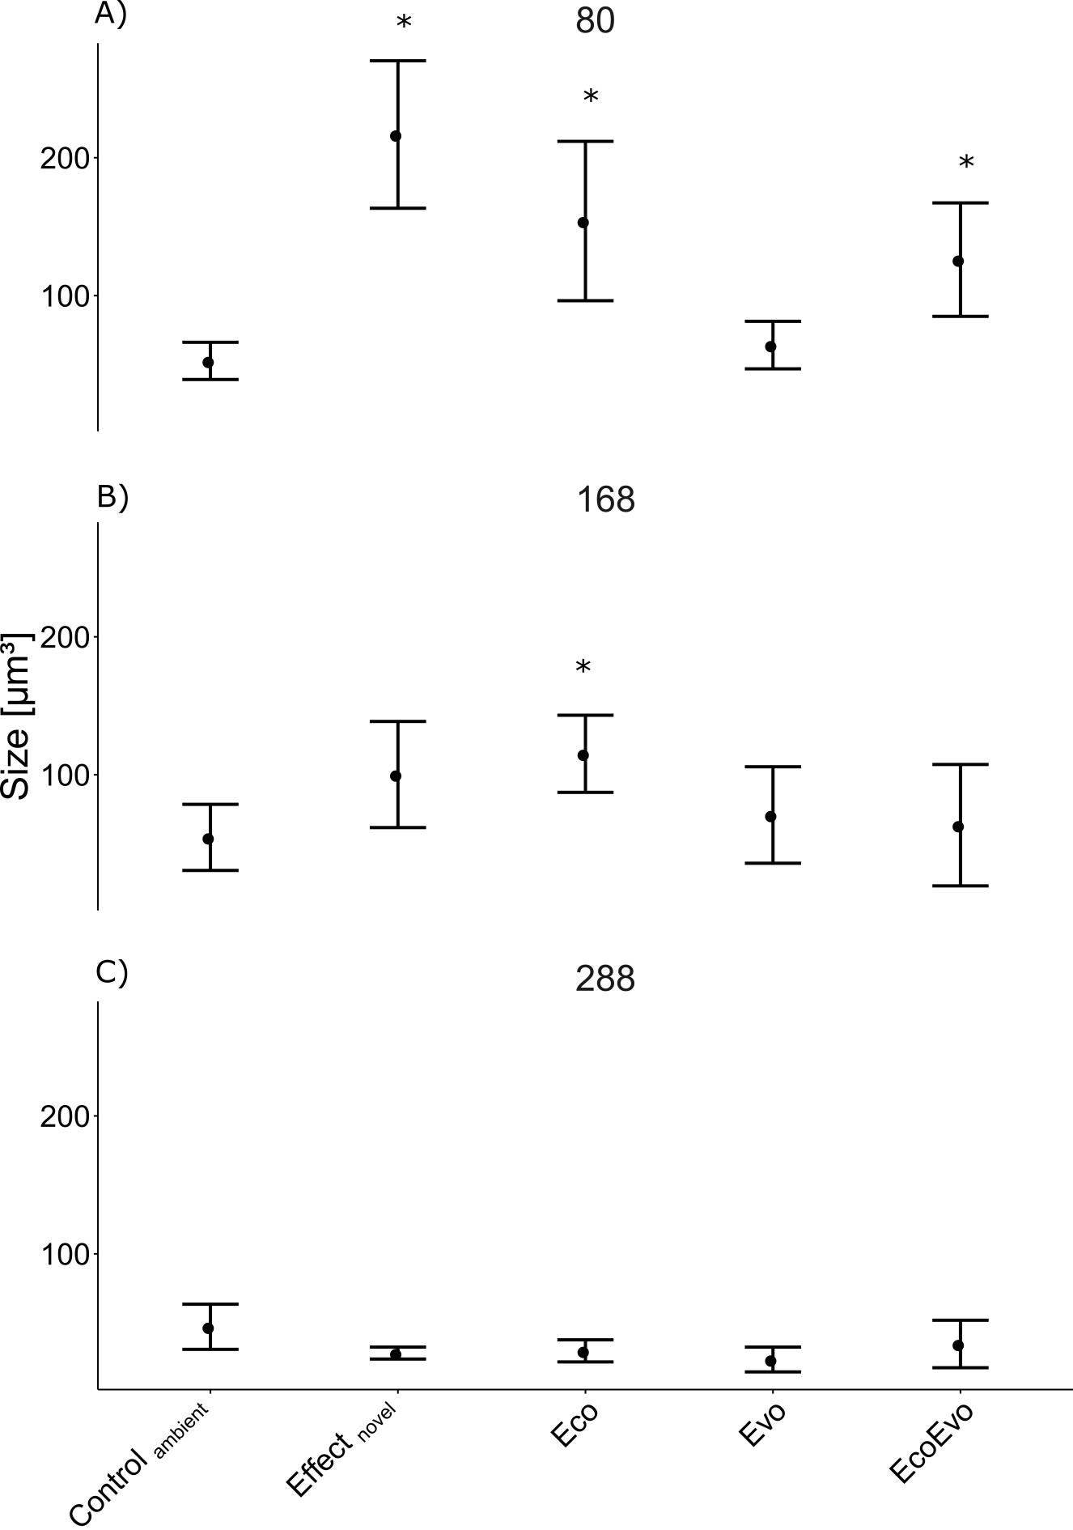

Figure S5: The mean cell size of the Eco-Evo Assay communities assessed using communities sorted for 80 (A), 168 (B) and 288 (C) days (mean und standard deviation). Asterisk shows significant change between Effectnovel and the Eco, Evo and EcoEvo communities to the Controlambient (Anova with Controlambient as intercept). n=5 until 168 days then n=4.

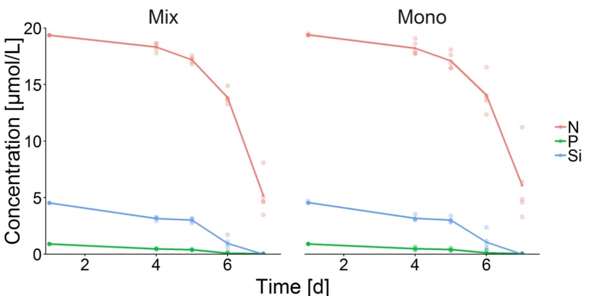

## Figure S6: Examplified nutrient uptake (nitrate N, phosphate P and silicate Si) by a community of Chaetoceros affinis and Emiliania huxleyi (Mix) and single-species cultures of C. affinis including all 9 genotypes (Mono). In batch cycle 11 running simultaneously to the Eco-Evo assay, nutrient samples of each 3 replicates were taken at day 4, 5, 6 and 7, sterile filtered, stored in the freezer until analysis with a SAN++ System from Skalar. At the start of each batch nutrients were added to the final concentrations of 19.59 ± 0.65 μmol/L nitrate, 0.97 ± 0.09 μmol/L phosphate and 3.81 ± 0.55 μmol/L silicate.