**Supplementary Information (SI)**

**(a)**

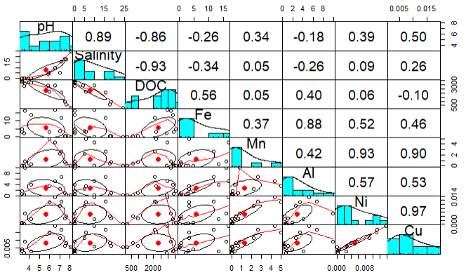

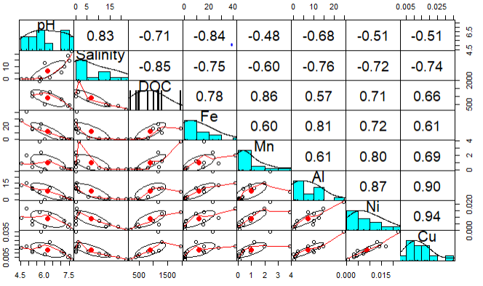

**(b)**

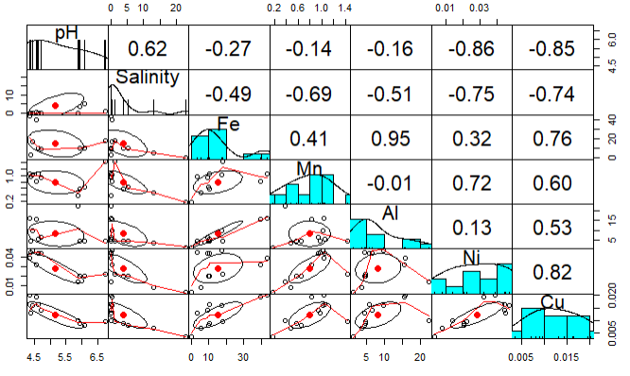

**(c)**

**Fig. SI 1**. Scatter plots and correlation coefficient for pH, Salinity, DOC, Fe, Mn, Al, Ni and Cu in the following rivers (a) Maludam River (b) Sebuyau River (c) Belait River. The dataset for each parameter is a combination of the wet and dry seasons.

Table SI 1: Particulate (P) and dissolved (D) trace metals from selected stations during the sampling campaign in 2019.

|  |  |  |  |  |  |  |  |  |  |  |  |  |
| --- | --- | --- | --- | --- | --- | --- | --- | --- | --- | --- | --- | --- |
| Sample ID | **pH** | **Salinity** | **Fe (µmol kg−1)** | | **Al (µmol kg−1)** | | **Mn (µmol kg−1)** | | **Cu (µmol kg−1)** | | **Ni (µmol kg−1)** | |
|  |  |  | **P** | **D** | **P** | **D** | **P** | **D** | **P** | **D** | **P** | **D** |
| 20719|MAL|ST7 | 8.06 | 24.46 | 79.9 | 0.2 | 644 | 0.4 | 0.823 | 0.045 | 0.034 | 0.005 | 0.079 | 8.0E-05 |
| 171219|MAL|ST2 | 4.23 | 0 | 0.5 | 13.3 | 4 | 4.1 | 0.004 | 0.265 | 0.000 | 0.003 | 0.001 | 0.0027 |
| 171219|MAL|ST3 | 5.86 | 4.35 | 45.6 |  | 275 | - | 0.476 | - | 0.020 | - | 0.043 | - |
| 171219|MAL|ST4 | 6.54 | 9.79 | 139.5 | 16.7 | 935 | 5.2 | 1.609 | 4.345 | 0.052 | 0.019 | 0.119 | 0.0136 |
| 171219|MAL|ST5 | 7.16 | 15.56 | 53.4 | 11.7 | 256 | 6.7 | 0.586 | 2.604 | 0.023 | 0.017 | 0.051 | 0.0113 |
| 171219|MAL|ST6 | 7.62 | 17.57 | 37.7 | 0.7 | 200 | 0.4 | 0.374 | 0.420 | 0.018 | 0.008 | 0.039 | 0.0040 |
| 171219|SEB|ST5 | 6 | 13.02 | 20.8 | 0.1 | 98 | 0.1 | 0.229 | 0.071 | 0.010 | 0.009 | 0.022 | 0.0031 |
| 101219| BEL |ST2 | 4.35 | 0 | 16.5 | 43.2 | 103 | 15.8 | 0.038 | 1.037 | 0.009 | 0.020 | 0.015 | 0.0389 |
| 101219| BEL |ST3 | 4.55 | 0.22 | 7.3 | 39.8 | 47 | 15.6 | 0.016 | 0.822 | 0.007 | 0.019 | 0.006 | 0.0319 |
| 101219| BEL |ST4 | NA | 13 | 15.9 | 5.7 | 86 | 3.6 | 0.058 | 0.475 | 0.040 | 0.007 | 0.014 | 0.0079 |

Key: 20719|MAL|ST7 = 20(Date), 7(Month), 19(Year), Mal (Maludam), SEB(Sebuyau), BEL(Belait) and ST7 (Station 7)

Table SI 2: Summary of trace element and DOC fluxes in Maludam, Sebuyau and Belait rivers in July and December 2019.

|  |  |  |  |  |
| --- | --- | --- | --- | --- |
|  | Maludam River | Sebuyau River | Belait River | Reference |
| Catchment Area km2 | 91.4 | 453 | 2700 | (Muller et al., 2015; Wu et al., 2019) |
| Catchment Area m2 | 91,400,000 | 453,000,000 | 2,700,000,000 | (Muller et al., 2015; Wu et al., 2019) |
| Aver. Precipitation (July) (mm) | 194 | 194 | 202 | DWD |
| Aver. Precipitation (December) (mm) | 580 | 580 | 651 | DWD |
| Aver. Monthly Evaporation (mm) | 141 | 141 | 141 | (Hirano et al., 2015; Kumagai et al., 2005; Moore et al., 2013) |
| Seconds in a Month | 2678400 | 2678400 | 2678400 |  |
| Aver. Discharge (Q) m3 s−1 in July | 1.8 | 8.9 | 61.3 |  |
| Aver. Discharge (Q) m3 s−1 in December | 15.0 | 74.2 | 513.9 |  |
| Aver. Discharge (Q) dm3 s−1 in July | 1801 | 8926 | 61268 |  |
| Aver. Discharge (Q) dm3 s−1 in December | 14973 | 74211 | 513889 |  |
| Average salinity in Jul | 0.05 | 0.03 | 0.01 |  |
| Average salinity in Dec | 0 | 0 | 0 |  |
| Average DOC (µmol L−1) in Jul | 3226 | 1118 | NA |  |
| Average DOC (µmol L−1) in Dec | 3315 | NA | NA |  |
| Average Fe (µmol L−1) in July | 6.5 | 18.1 | 7.8 |  |
| Average Fe (µmol L−1) in Dec | 13.3 | 27.8 | 43.2 |  |
| Average Al (µmol L−1) in July | 3.3 | 14.9 | 5.6 |  |
| Average Al (µmol L−1) in Dec | 4.1 | 12.7 | 19 |  |
| Average Si (µmol L−1) in July | 8.6 | 85.3 | 34.4 |  |
| Average Si (µmol L−1) in Dec | 52.6 | 19.6 | 48.7 |  |
| Average Mn (µmol L−1) in July | 0.23 | 1.24 | 1.0 |  |
| Average Mn (µmol L−1) in Dec | 0.27 | 0.84 | 0.7 |  |
| Average Ni (µmol L−1) in July | 0.002 | 0.01 | 0.04 |  |
| Average Ni (µmol L−1) in Dec | 0.003 | 0.01 | 0.03 |  |
| Average Cu (µmol L−1) in July | 0.004 | 0.02 | 0.01 |  |
| Average Cu (µmol L−1) in Dec | 0.003 | 0.02 | 0.02 |  |