Extended Data Table 1 | b-values for OBS catalogue for different magnitude cut-off values, as derived by maximum likelihood estimation (MLE⁵⁰) and the repeated median approach (RM⁵¹), with their standard errors.
 | Mc=2.0 | Mc=2.1 | Mc=2.2 | Mc=2.3 | Mc=2.4 | Mc=2.5 | Mc=2.6 | Mc=2.7
MLE | 0.65±0.03 | 0.70±0.03 | 0.72±0.04 | 0.76±0.04 | 0.78±0.04 | 0.80±0.05 | 0.83±0.05 | 0.86±0.06
RM | 0.83±0.08 | 0.82±0.09 | 0.82±0.09 | 0.83±0.09 | 0.84±0.10 | 0.83±0.10 | 0.83±0.11 | 0.82±0.11

Extended Data Animation 1 | Along-strike variation of b-value in Chain. Different moving windows are considered, ranging from N=50 to N=100 events, advancing by 1 event, superimposed over a bathymetry map of Chain. Each calculation is shown as a coloured circle, centred at the longitude of the central event in each window. The events shown as white circles and used for b-value calculations correspond to the complete dataset (M_{L}≥2.3) along the transform valley.

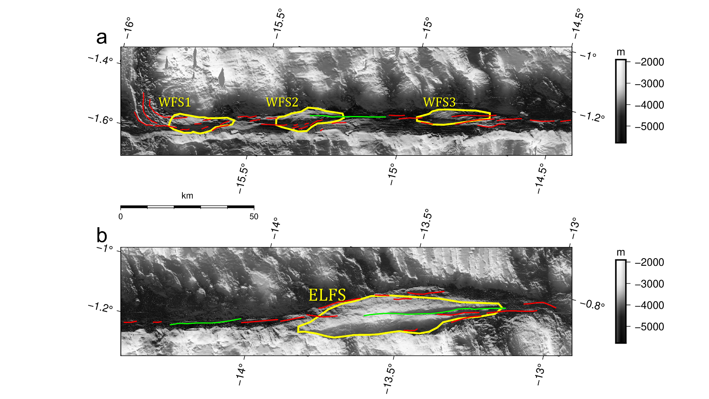
Extended Data Fig. 1 | Flower Structures and Fault Scarps. a) Western half of Chain TF and b) eastern half of Chain TF. The red and green curves show the fault scarps, with latter highlighting the longest of them (L>30km). The yellow curves denote the positive flower structures. The bathymetry in shown in grey scale.

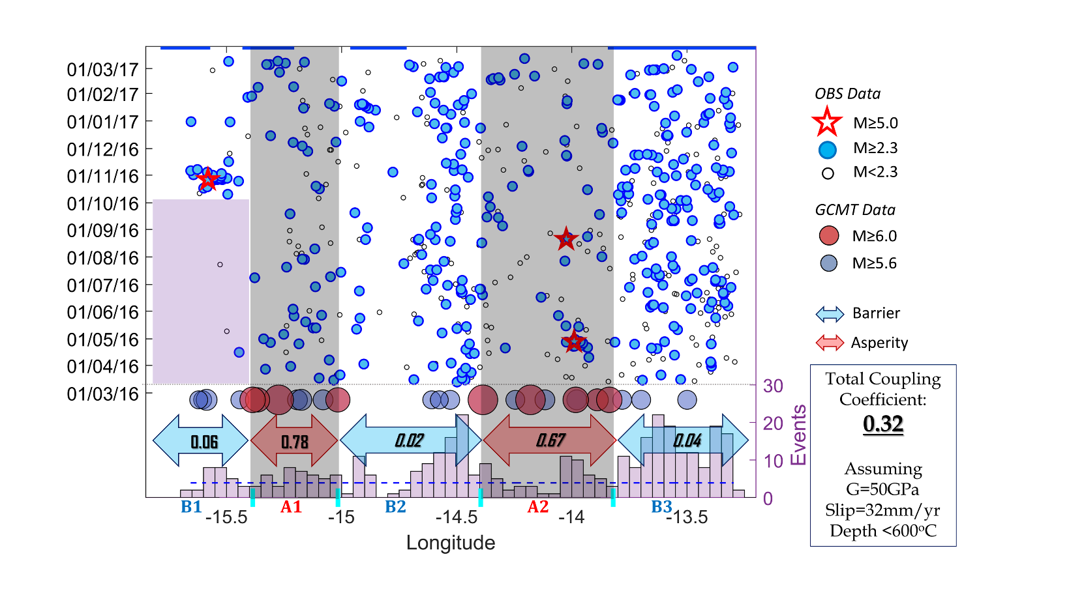
Extended Data Fig. 2 | Temporal and along strike microseismicity distribution. The blue circles indicate the OBS events above M_{C}=2.3, whereas the white circles denote all located events. The largest OBS events with 5.0≤M_{L}≤5.4 are depicted by red stars. The histogram shows the number of OBS events per 0.05° longitudinal bins. The purple box indicates a spatio-temporal microseismicity gap occurred at least 7 months before the M5.4 event sequence in barrier zone, B1. The large blue and red circles show the historical events with M_{W}≥5.6 and M_{W}≥6.0, respectively²⁶. The grey shaded areas correspond to asperities (A1 and A2) which separate the barriers (B1, B2, B3). The number in the arrows show the seismically released moment fraction for these segments. The blue lines at upper horizontal margin indicate the location of the positive flower structures.

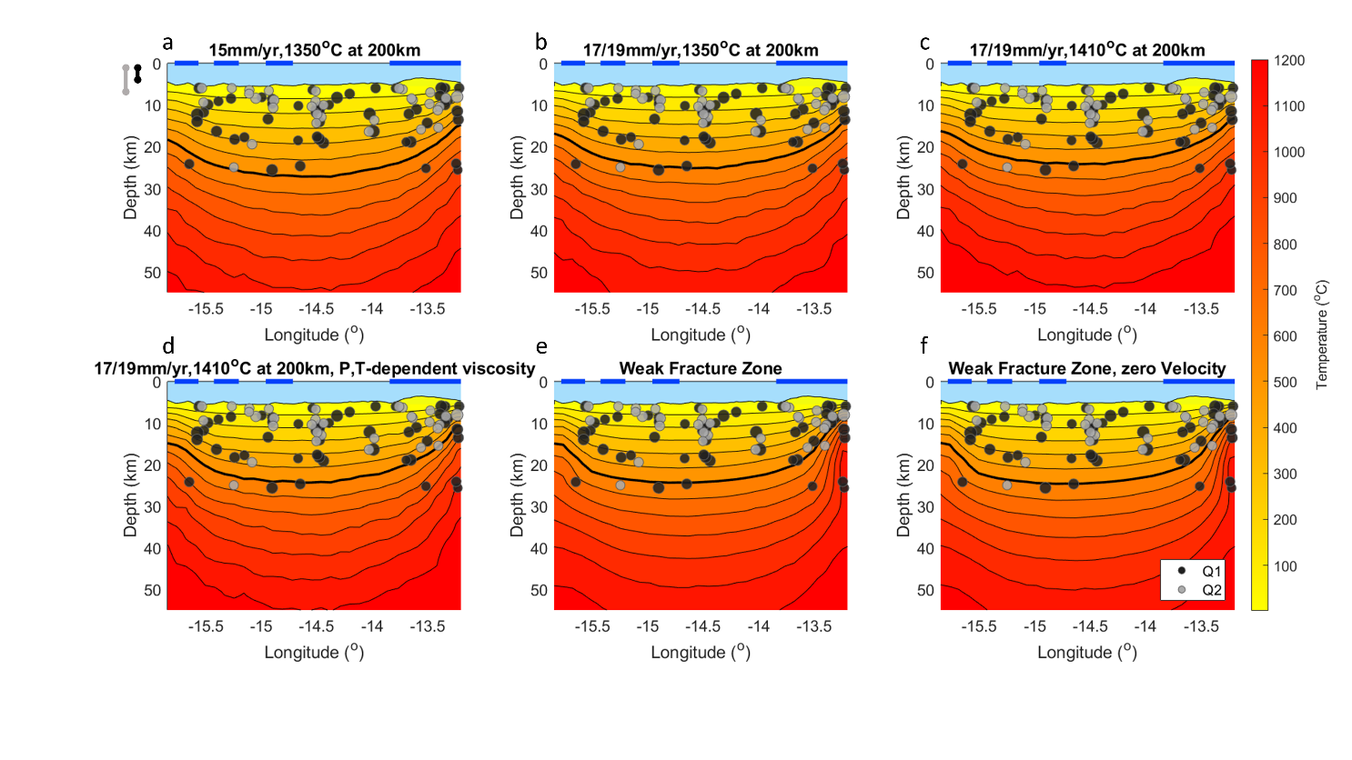
Extended Data Fig. 3 | Alternative thermal models. a) Spreading rate 15 mm/yr and 1350°C at 200km depth, b) unequal spreading rate 17 mm/yr (west-east) and 19mm/yr (east-west) and 1350°C at 200km depth, c) unequal spreading rate 17 mm/yr (west-east) and 19mm/yr (east-west) and 1410°C at 200km depth, d) unequal spreading rate 17 mm/yr (west-east) and 19mm/yr (east-west), 1410°C at 200km depth and pressure-temperature dependent viscosity, e) Weak fracture zone model, f) Weak fracture zone model, zero velocity. The depth determination quality (Q1 and Q2) is indicated as dark and light circles, respectively. Mean vertical uncertainties are 3 km for Q1 events and 6 km for Q2 events (black and grey vertical error bar, respectively, shown at the upper left corner). The horizontal blue lines denote the location of the transpressional flower structures. The isolines have 100°C difference with the bold one representing the 600°C isotherm.

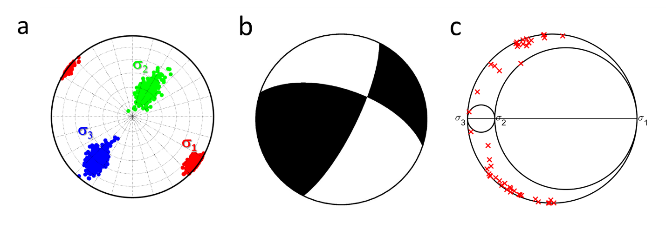
Extended Data Fig. 4 | Stress inversion results. (a) Confidence intervals of the principal stresses orientation, for the 47 best quality mechanisms. (b) Principal focal mechanism, shown as lower hemisphere projection, with compression denoted by black. (c) Mohr’s circle plot showing the relative magnitudes of the principal stresses, with the positions of the faults indicated by red crosses.

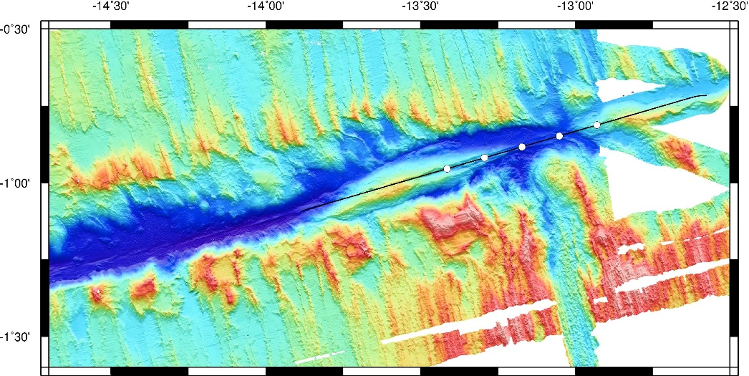
Extended Data Fig. 5 | Active source seismic profile. Location map of the active source seismic profile conducted at the eastern Ridge-Transform intersection of the Chain Transform Fault aboard the French N/O Pourquoi-Pas?.

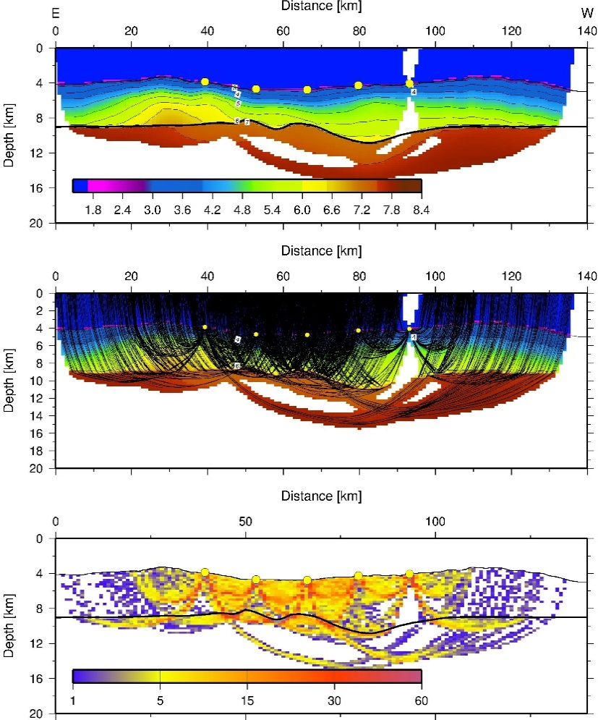
Extended Data Fig. 6 | Tomographic inversion. Results from the tomographic travel time inversion (top) seismic velocity model masked with available ray coverage; (middle) ray coverage; (bottom) cell hit counts (derivative weight sum) of the tomographic inversion.

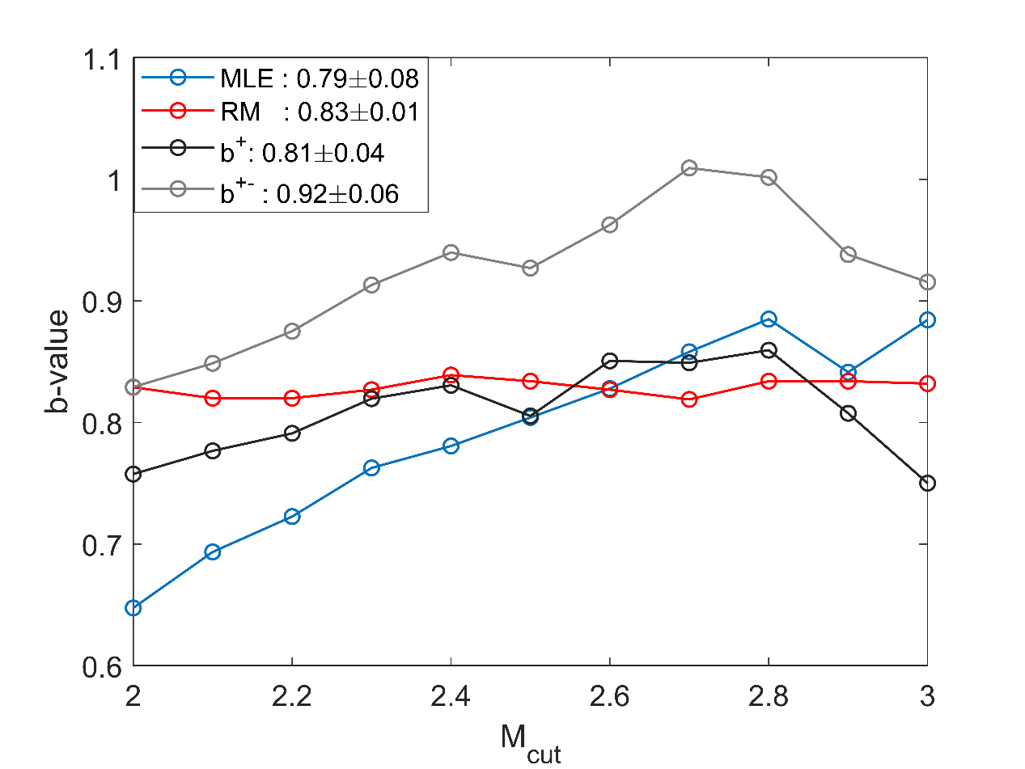
Extended Data Fig. 7 | b-values estimation. b-value of the OBS catalogue estimated by different techniques, including: MLE, maximum likelihood estimate⁵⁰; RM, repeated medians technique⁵¹; b⁺, b-positive estimate⁵²; b⁺⁻, b-positive/b-negative estimate⁵². The legend shows the mean values within the given range and their standard deviation.

