
Journal of Geophysical Research: Solid Earth
Supporting Information for
Seismotectonics of the Blanco Transform Fault System, Northeast Pacific: Evidence for an immature plate boundary
Yu Ren, Dietrich Lange, and Ingo Grevemeyer
GEOMAR Helmholtz Centre for Ocean Research Kiel, Wischhofstr. 1-3, 24148 Kiel, Germany

Contents of this file

Figure S1. Gravity map of Blanco transform fault system (BTFS) in the Northeast Pacific.
Figure S2. Distribution of the OBS stations used in this study.
Figure S3. Seismicity catalog constructed in this study for precise relocation.
Figure S4. Station corrections for P- and S- phase onsets.
Figure S5. Comparison of the local and moment magnitudes for the events that are included in both NEIC and our local catalogs.
Figure S6. Comparison of the focal mechanisms for the 7 events that are included in both GCMT and our local catalogs.
Figure S7. Focal mechanisms of 84 local events recorded by the OBS array.
Figure S8. P- and S-phase residuals of the location procedures.
Figure S9. Wadati diagram of P-phase onsets versus S-phase onsets.
Figure S10. Temporal evolution of the recorded local seismicity of the BTFS.
Figure S11. Waveform recordings of the Earthquake swarm at EBD.
Figure S12. Focal mechanisms from the ISC-EHB, GCMT, RMT and our local catalog.
Figure S13. Examples of focal mechanisms of the local earthquakes with at least 10 first-motion polarities of P-phase onsets.
Figure S14. Ternary plot for the Focal mechanisms along the BTFS.

Additional Supporting Information (Files uploaded separately)

Caption for Tables S1

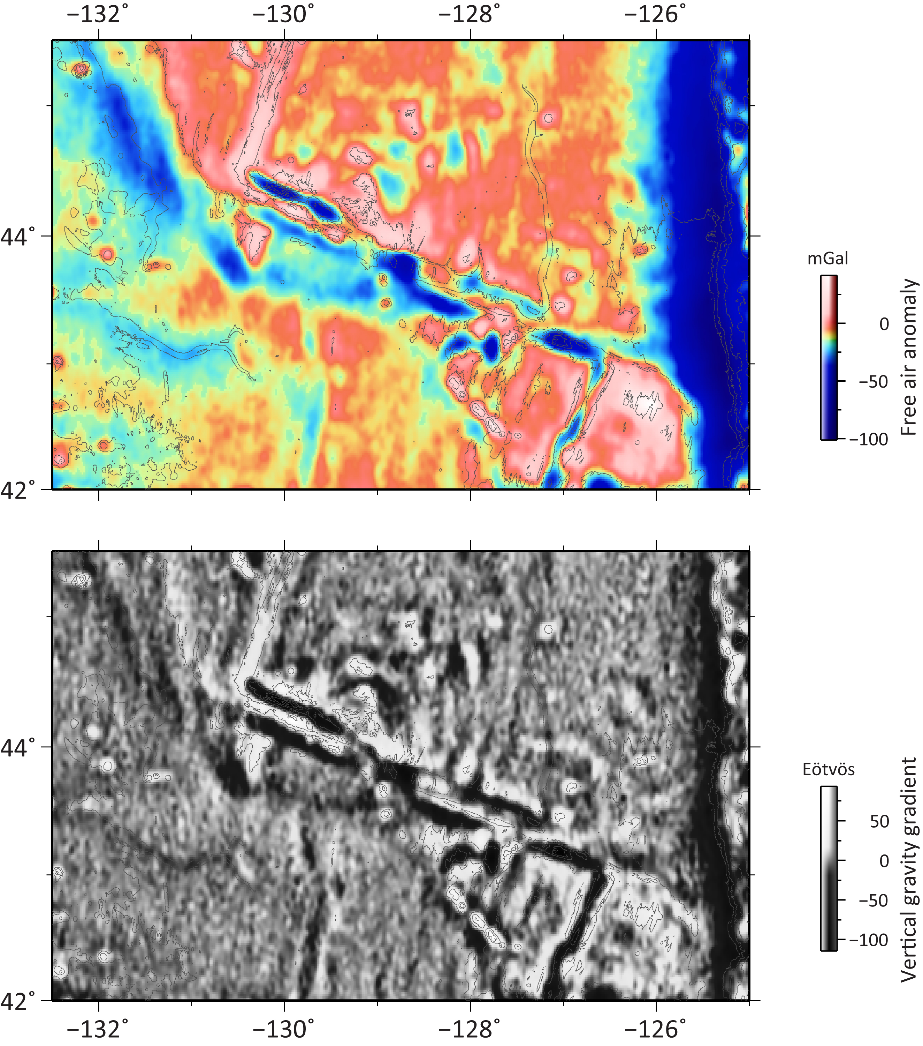

Figure S1. Gravity map (Sandwell et al., 2014) of the 350-km-long Blanco transform fault system (BTFS) in the Northeast Pacific, indicating no fracture zone in the west and a short fracture zone trace developed recently in the east (around 126° W).

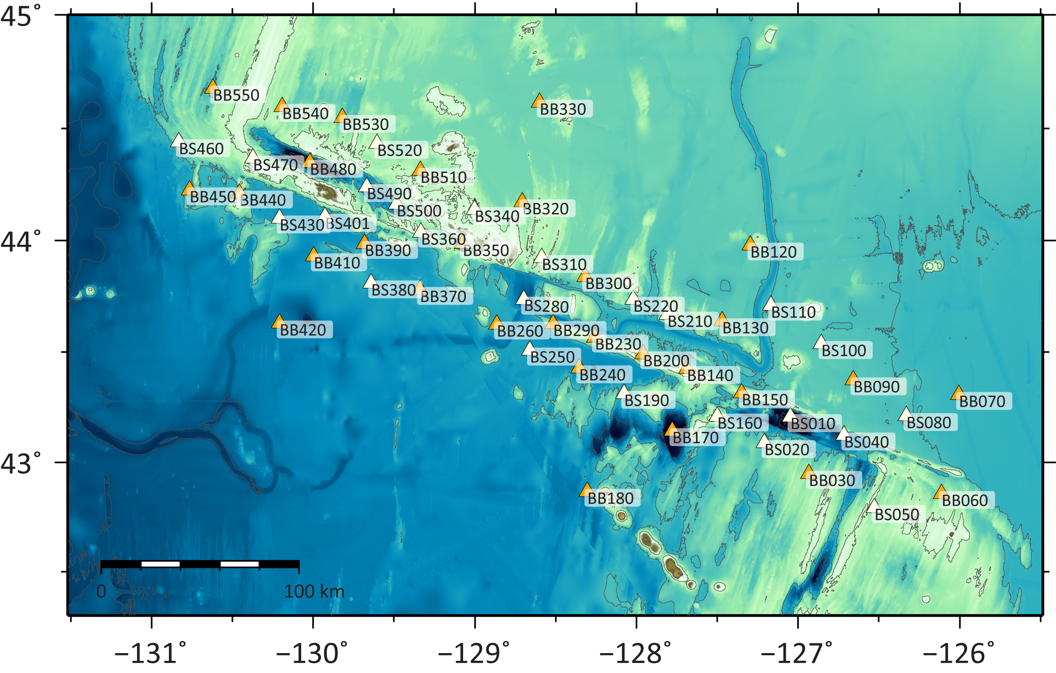

Figure S2. Distribution of the OBS stations (labeled with station names) used in this study.

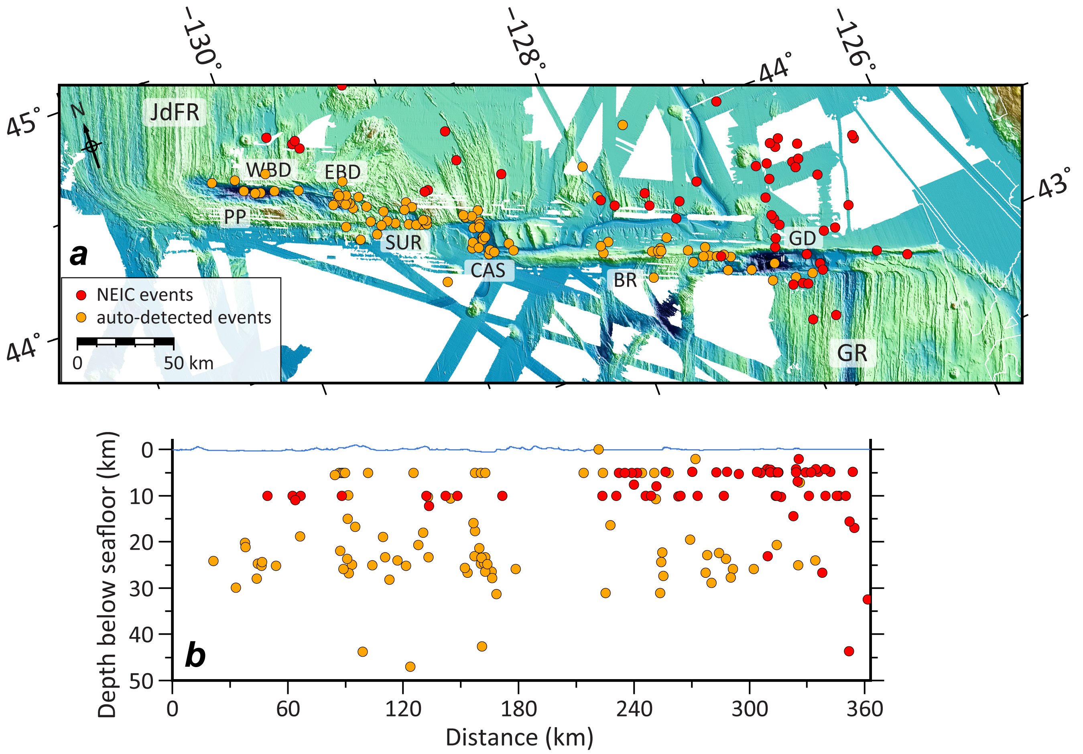

Figure S3. Seismicity catalog constructed in this study for precise relocation. (a) Distribution of local events from the NEIC and the auto-detected catalogs along the entire BTFS. (b) Along-strike vertical profile showing the focal depth distribution. Red and yellow dots show the location of NEIC and auto-detected events, respectively.

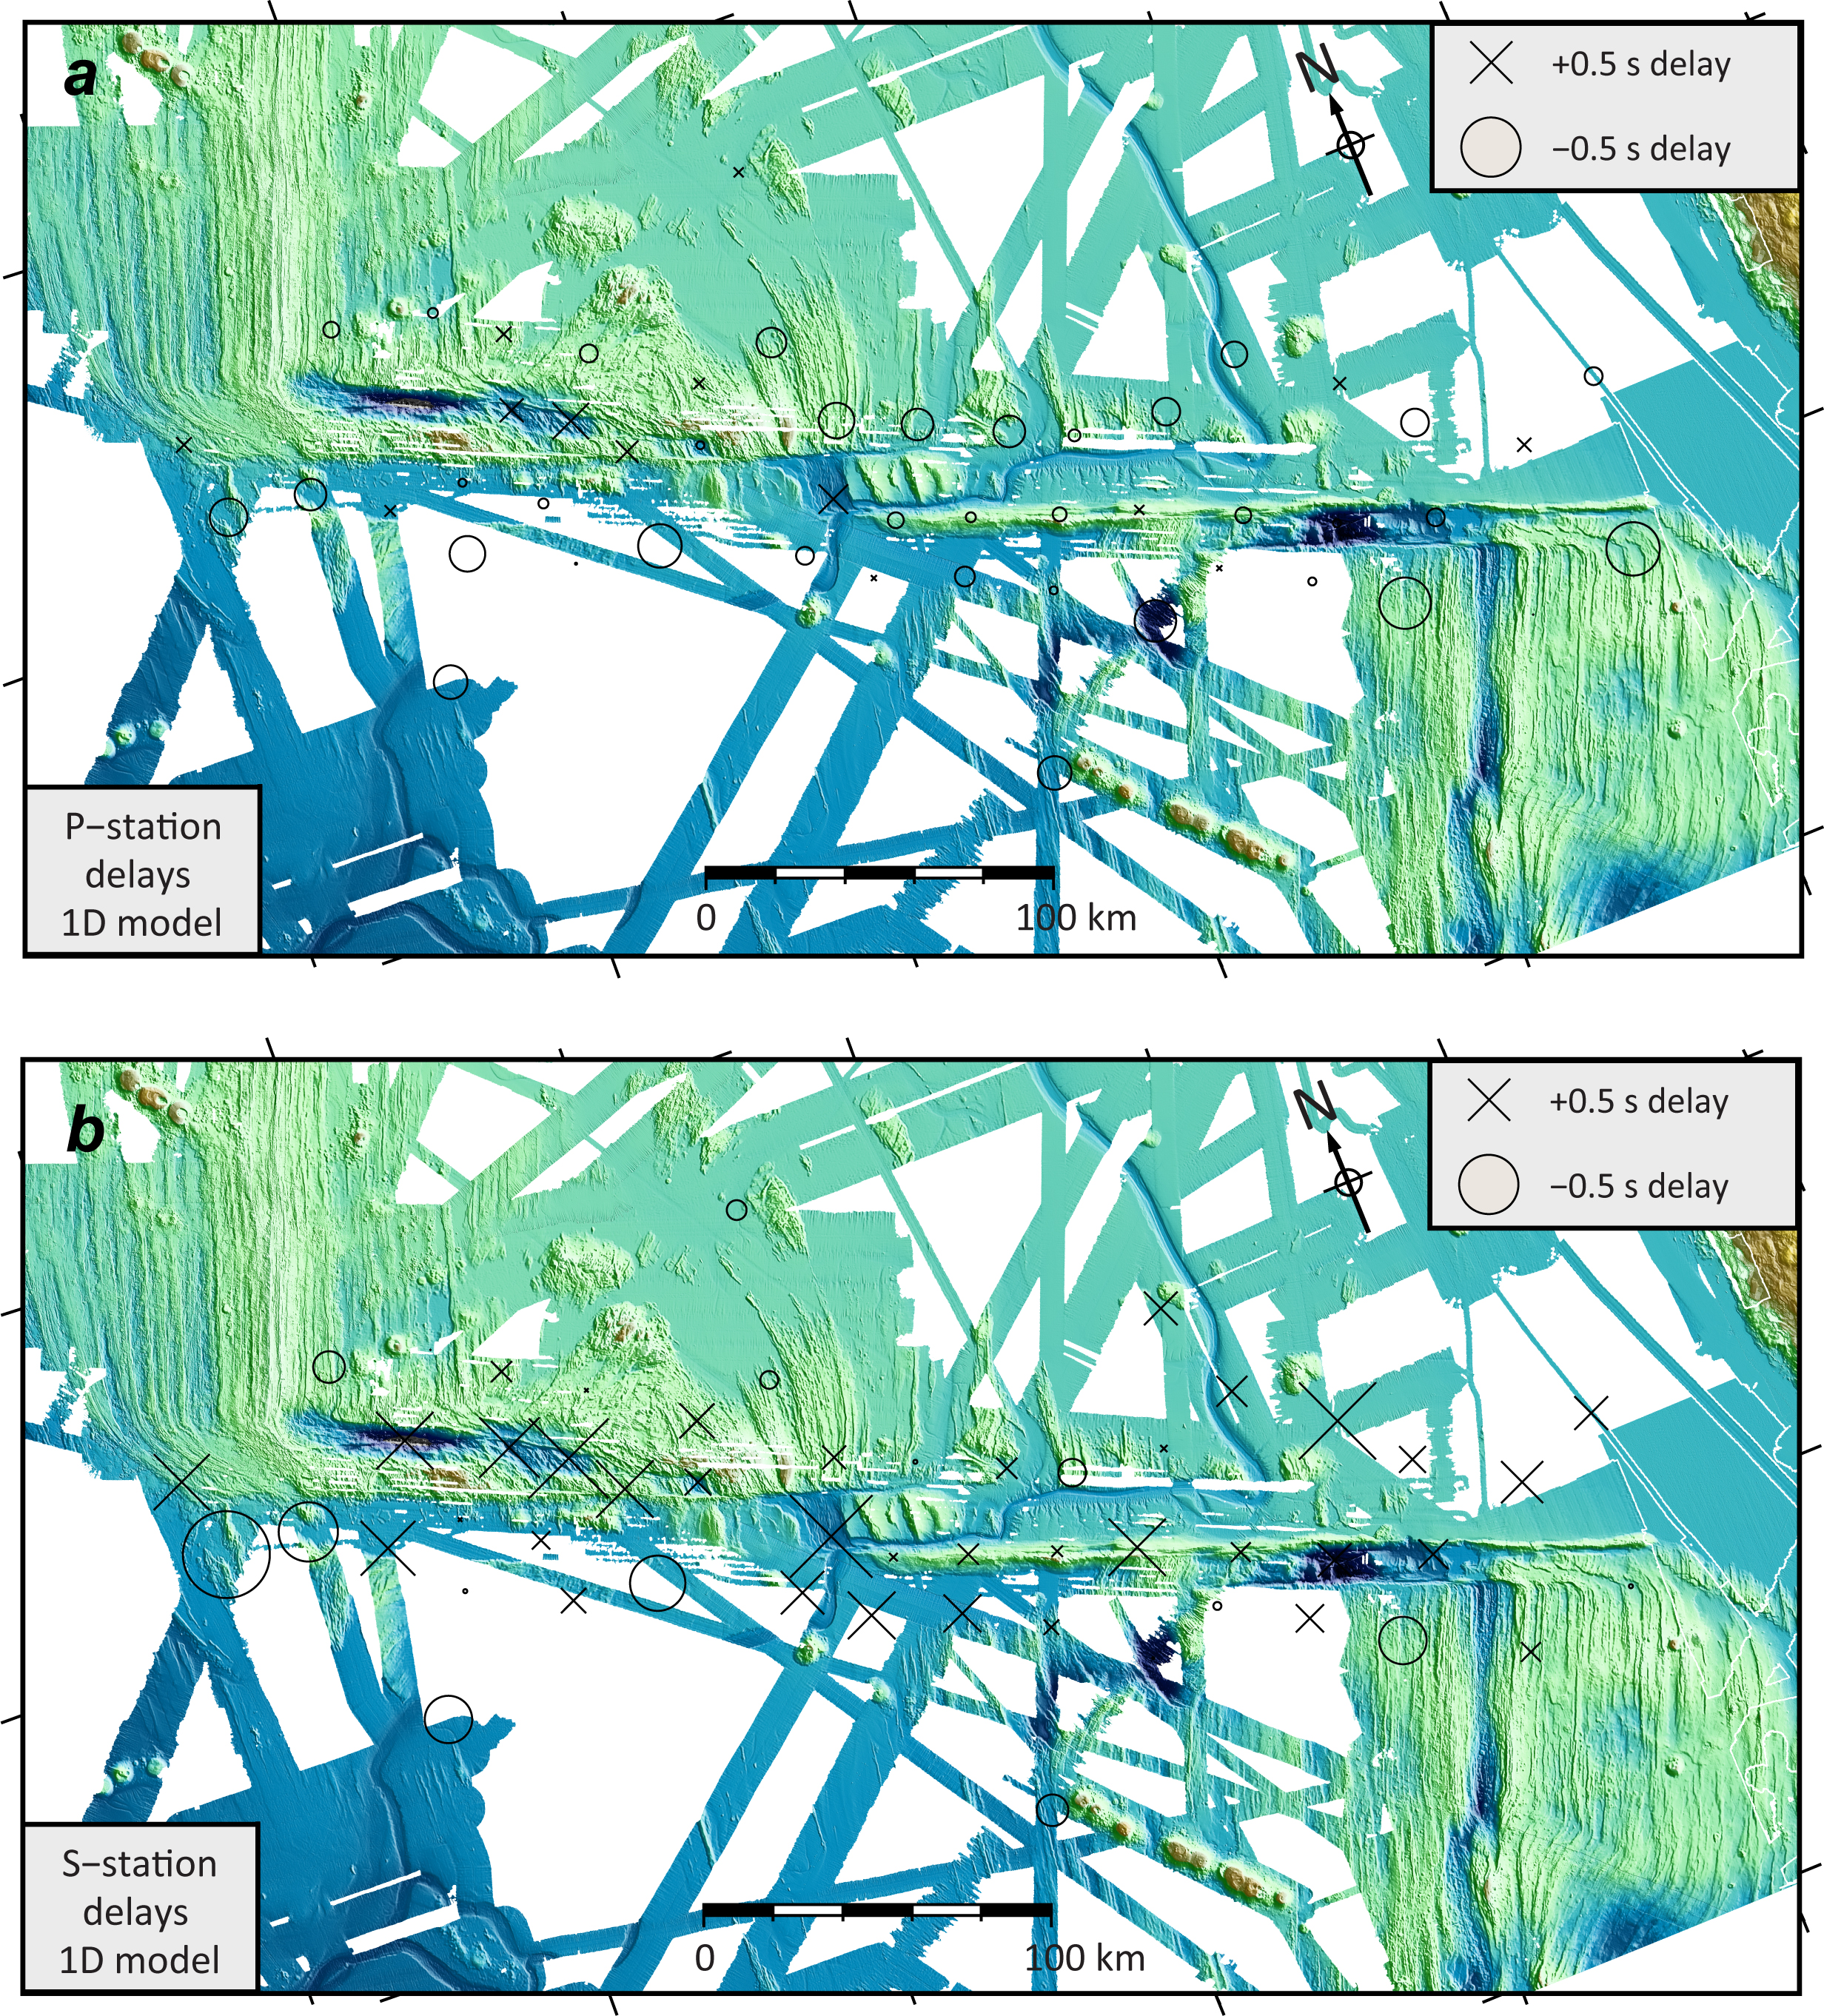

Figure S4. Station corrections for P- (panel a) and S- (panel b) phase onsets. The size of the symbol scales with the delay of each station.

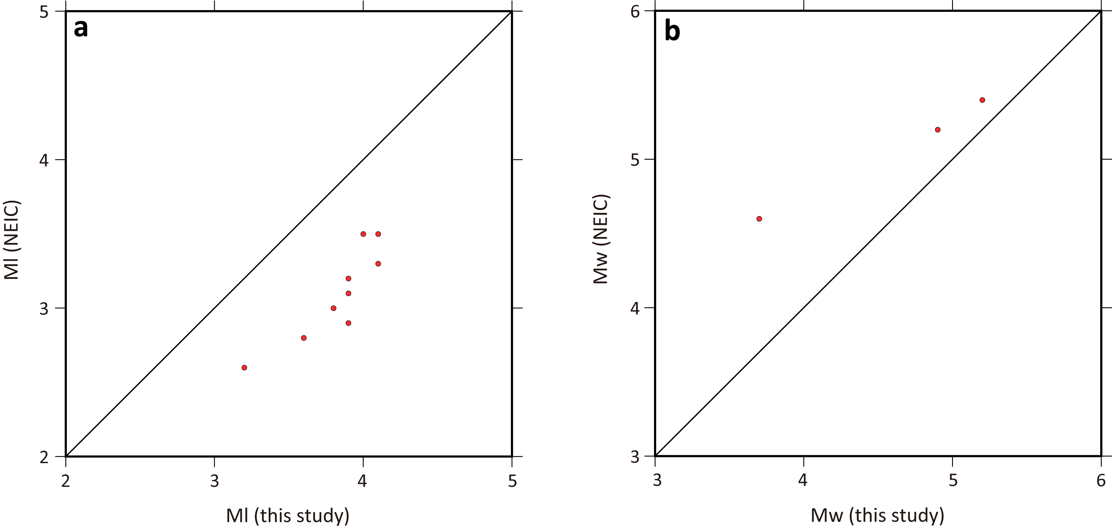

Figure S5. Comparison of the local (panel a) and moment magnitudes (panel b) for the events that are included in both NEIC and our local catalogs.

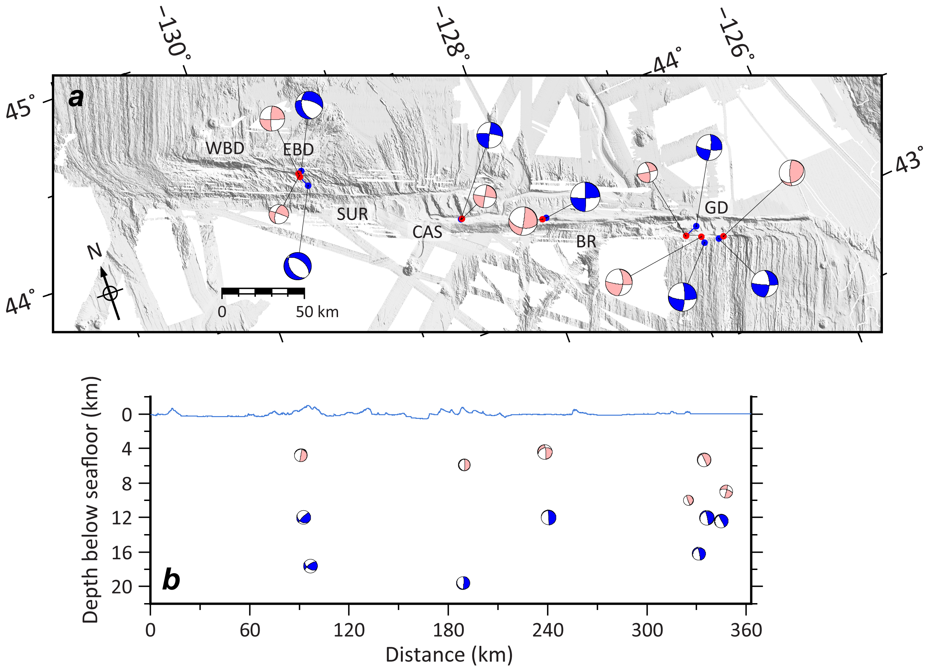

Figure S6. Comparison of the focal mechanisms for the 7 events that are included in both GCMT and our local catalogs. (a) Location bias of the GCMT catalog. The locations of GCMT events are in blue, while our local event locations are shown in red. (b) Depth bias of the GCMT catalog.

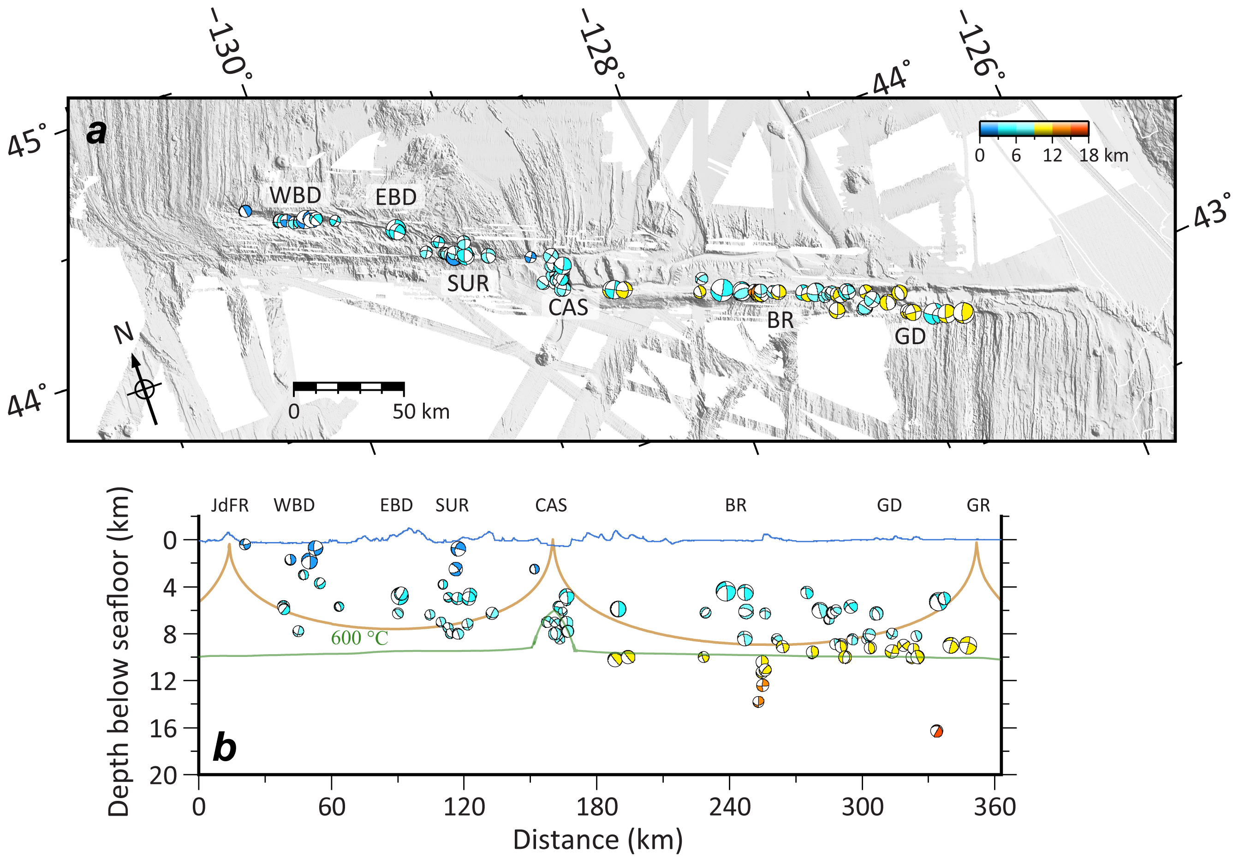

Figure S7. Focal mechanisms of 84 local events recorded by the OBS array. (a) Distribution of the focal mechanisms along the BTFS. (b) Along-strike vertical profile showing depth distribution of the focal mechanisms. Brown and green lines indicate the 600°C isotherms calculated from a half-space cooling model and a numerical model incorporating hydrothermal cooling (Roland et al., 2010), respectively.

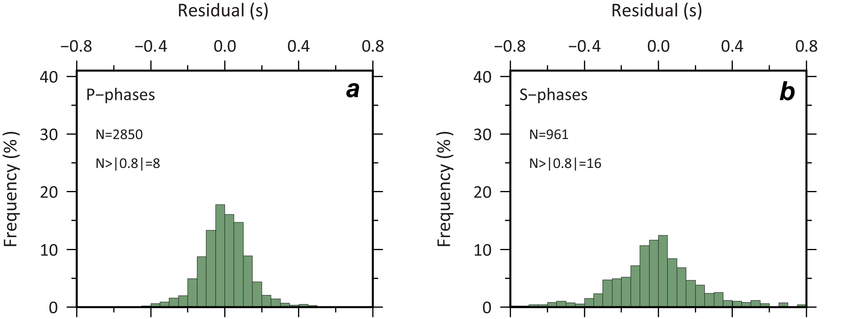

Figure S8. P- (panel a) and S-phase (panel b) residuals of the location procedures. N: number of phases.

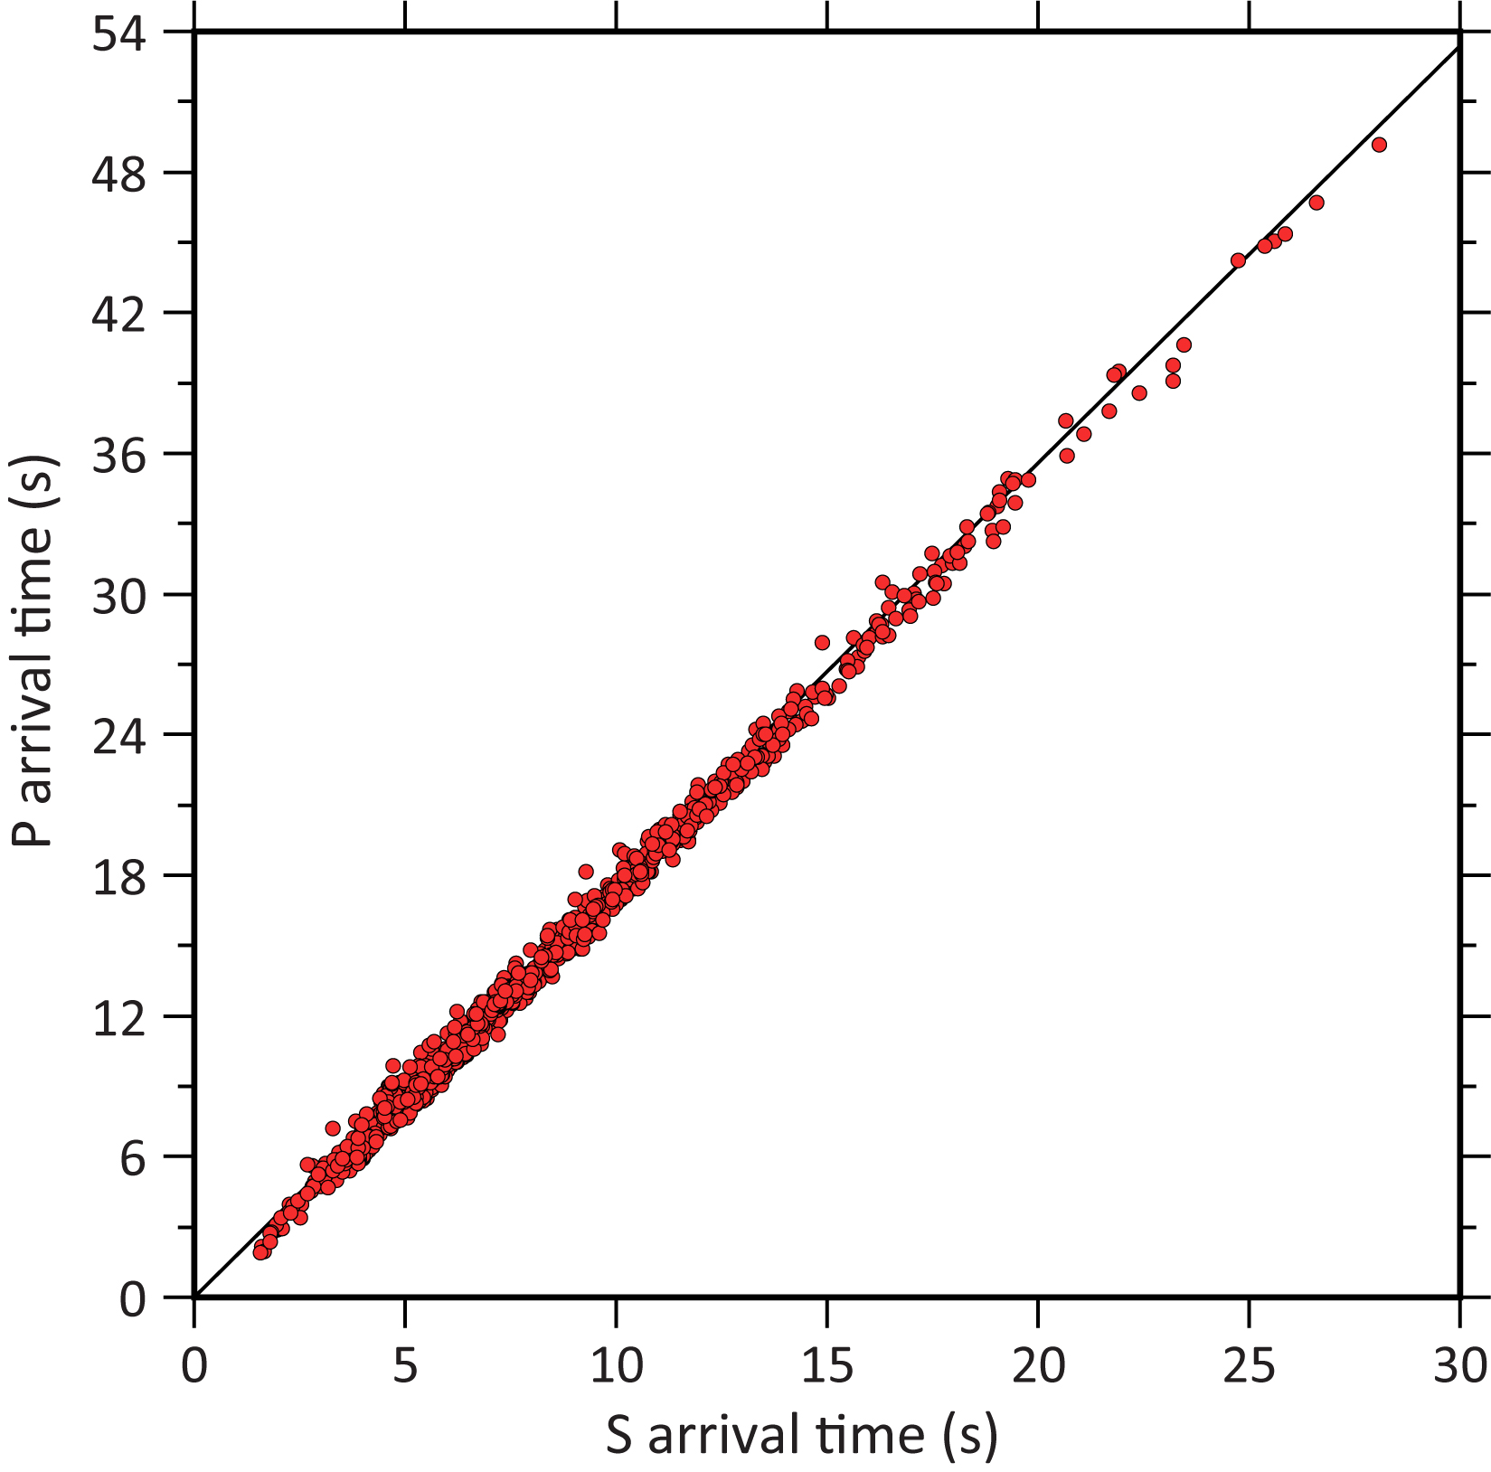

Figure S9. Wadati diagram of P-phase onsets versus S-phase onsets, yielding Vp/Vs ratio for the BTFS.

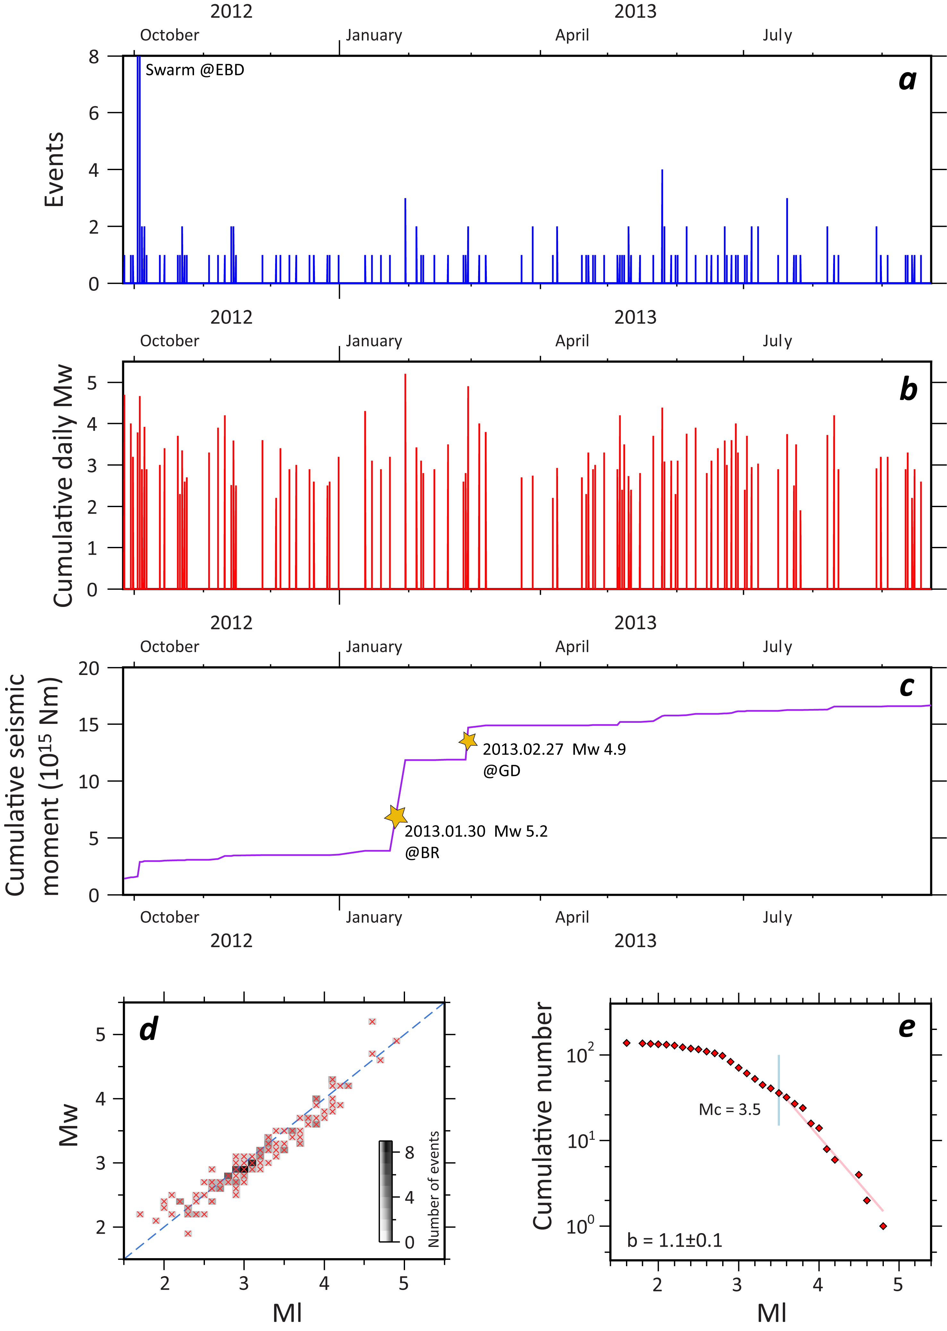

Figure S10. Temporal evolution of the recorded local seismicity of the BTFS. (a) The number of events per day. (b) Temporal distribution of moment magnitudes. (c) Cumulative seismic moment release. (d) Relationship between moment magnitude (Mw) and local magnitudes (Ml). (e) The frequency-local magnitude distribution of local events along the BTFS in this study.

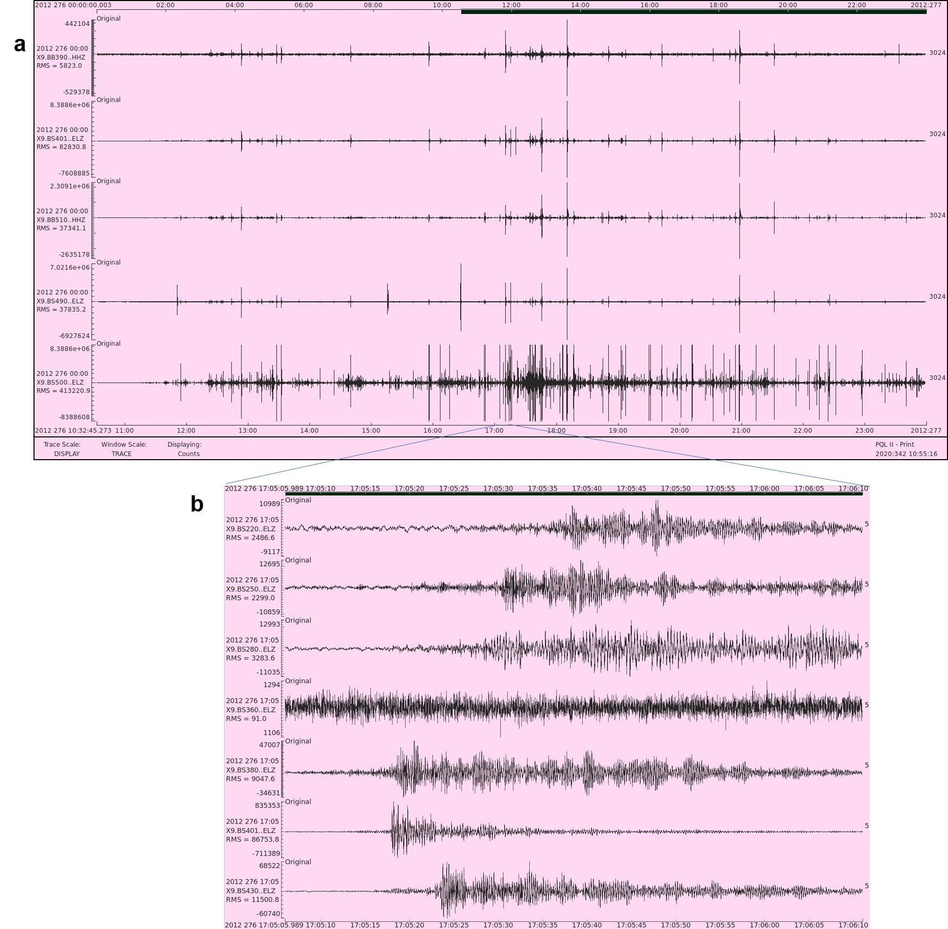

Figure S11. (a) Waveform recordings of the Earthquake swarm at EBD recorded by the OBS network. Figure shows 12 hours of Z-components from 5 different OBS stations. (b) Elevated noise level of one weak event of the EBD swarm. The locations of the OBS are as in Figure S2.

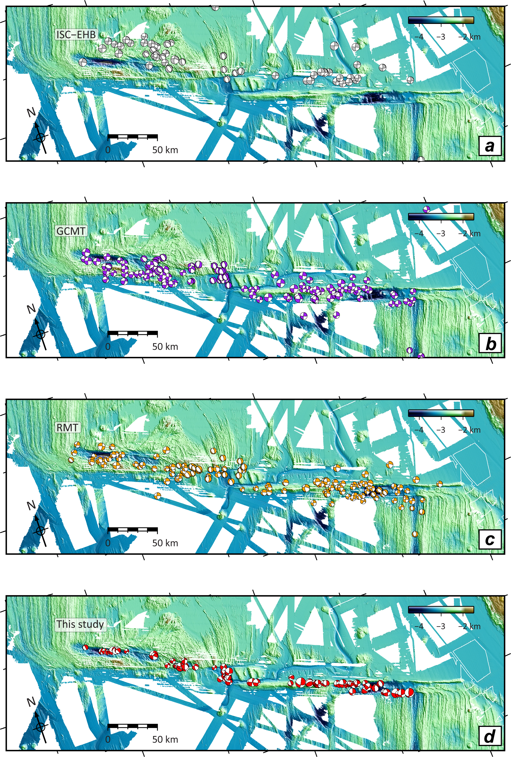

Figure S12. Focal mechanisms from (a) ISC-EHB (in grey; Engdahl, 2006) (b) GCMT (in purple; Ekström et al., 2012) (c) RMT (in yellow; Braunmiller & Nábělek, 2008) and (d) our local catalog in this study (in red).

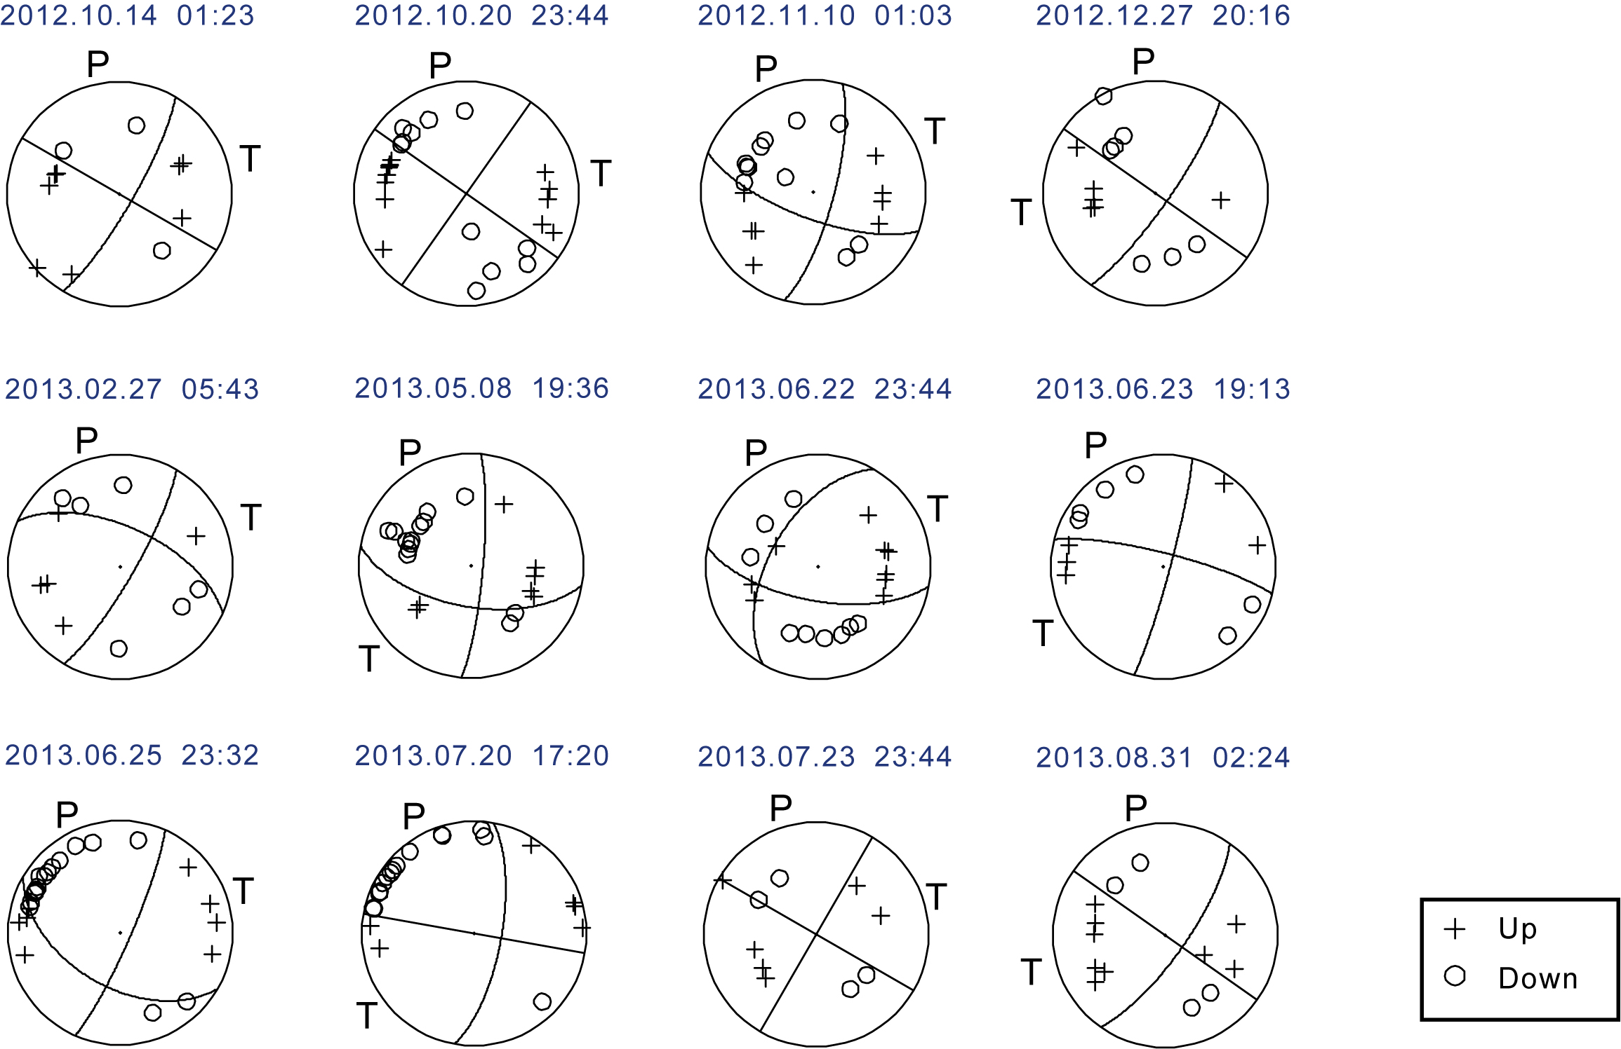

Figure S13. Examples of focal mechanisms of the local earthquakes with at least 10 first-motion polarities of P-phase onsets.

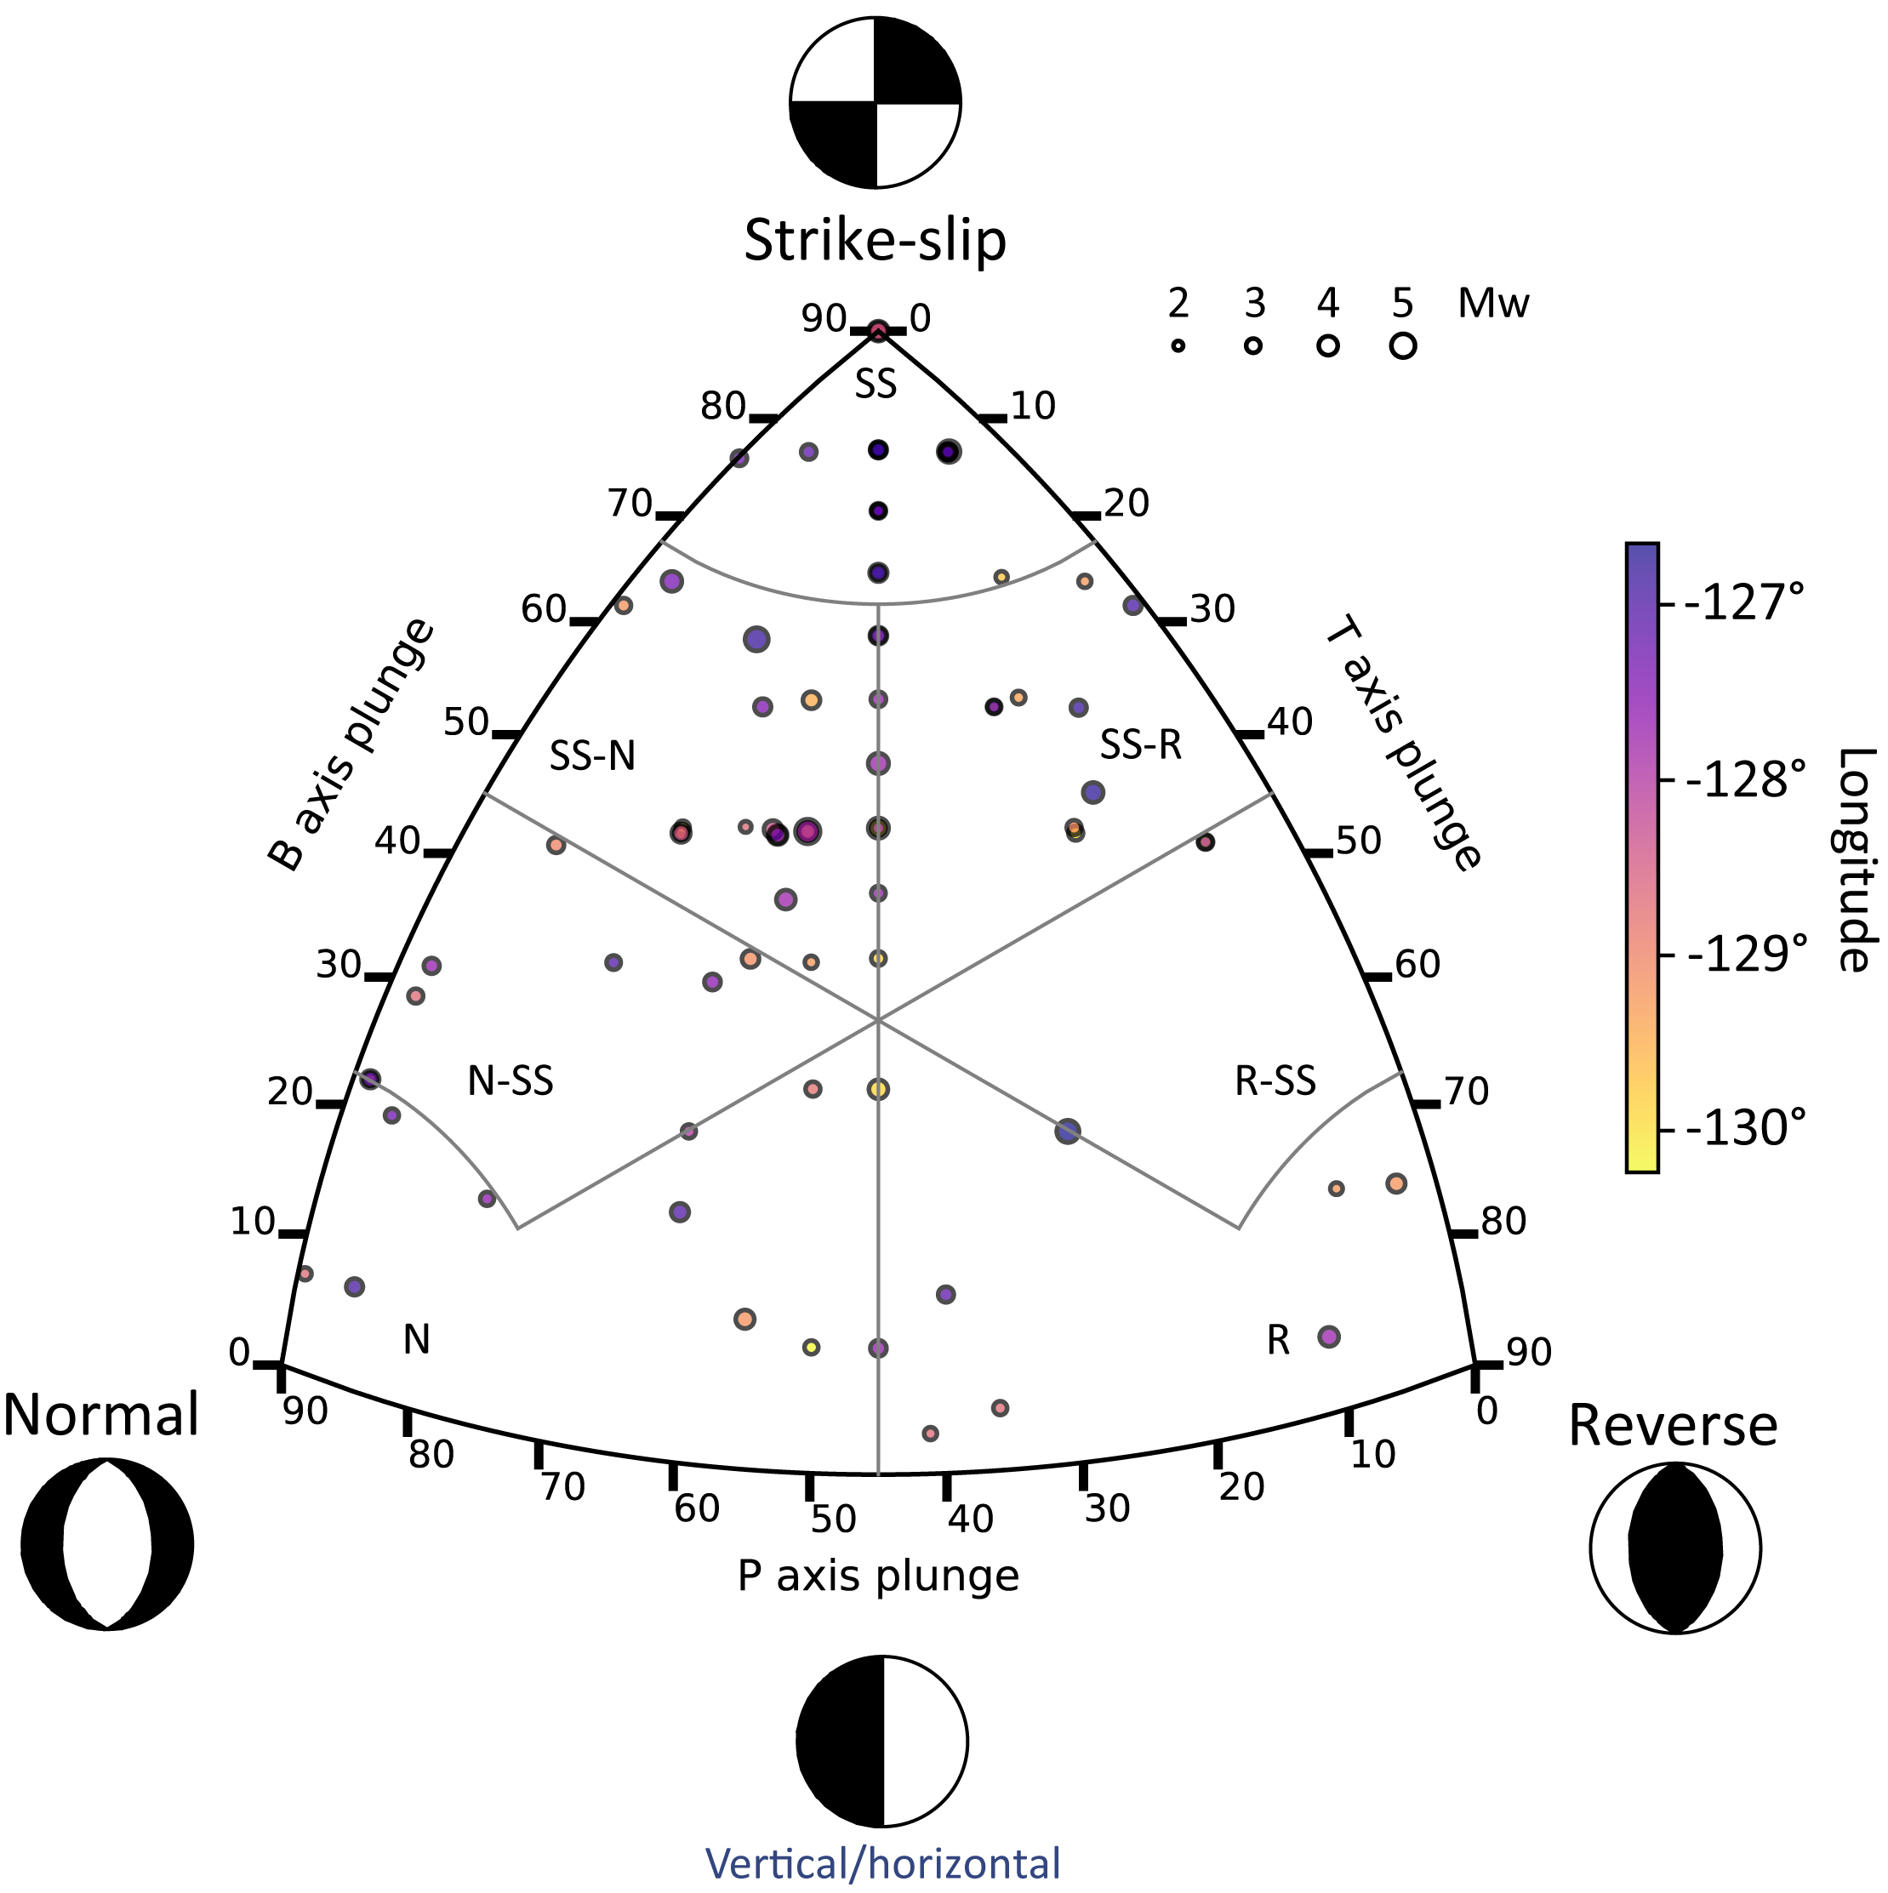

Figure S14. Ternary plot for the Focal mechanisms (Álvarez-Gómez, 2019) along the BTFS, constrained by the OBS network. This diagram indicates faulting styles of the BTFS. The major faulting style of the BTFS is strike-slip to transtensional (SS-N) rather than pure strike-slip. SS: Strike-slip; SS-N: Strike-slip-Normal; SS-R: Strike-slip-Reverse; N-SS: Normal-Strike-slip; R-SS: Reverse-Strike-slip; N: Normal; R: Reverse.

Table S1. Local seismicity catalog of the Blanco transform fault system (BTFS) derived in this study (provided as a separate ASCII file). Errx: Uncertainties in latitude (km); Erry: Uncertainties in longitude (km); Errz: Depth uncertainties (km).

