

*Geochemistry, Geophysics, Geosystems*

Supporting Information for

**Revealing the extent of submarine permafrost and gas hydrates in the Canadian Arctic Beaufort Sea using seismic reflection indicators**

*H. Grob1, *; M. Riedel2; M. J. Duchesne3; S. Krastel1; J. Bustamante4; G. Fabien-Ouellet4;* Y. K. Jin5; J. K. Hong5

*1 Kiel University, Germany   
2 GEOMAR Helmholtz Centre for Ocean Research Kiel, Germany   
3 Geological Survey of Canada, Canada  
4 Polytechnique Montreal, Canada   
5 Korea Polar Research Institute, Rep. of Korea  
  
* Corresponding author.  
Email address:* [*henrik.grob@ifg.uni-kiel.de*](mailto:henrik.grob@ifg.uni-kiel.de)

**Contents of this file**

Figures S1 to S24

**Introduction**

The supplementary material comprises five figures. The first figure (Fig. S1) gives additional information about the properties required for the viscoelastic modelling. Fig. S2 shows the attempt to rebuild the original input model of the viscoelastic modelling only based on the interpretation of Fig. 5b. Fig. S3 is reprinted from Riedel et al. (2017). Figs. S4 and S5 are seismic images that complement explanations made in the discussion. Fig. S4 shows the tuning bed effect and Fig. S5 gives velocity information from a borehole in the eastern part of the study area. In Figs. S6-S24, all interpreted top of ice-bearing permafrost reflections (Figs. S6-S22) and base of ice-bearing permafrost reflections (Figs. S23,24), respectively, are shown, which were used in this study.

Text S1.

Fig. S1 shows the physical properties used for the synthetic model of submarine permafrost and associated gas hydrates. It is an addition to Fig. 4 and Tab. 2 in the manuscript. It shall complement information necessary for synthetic modelling.

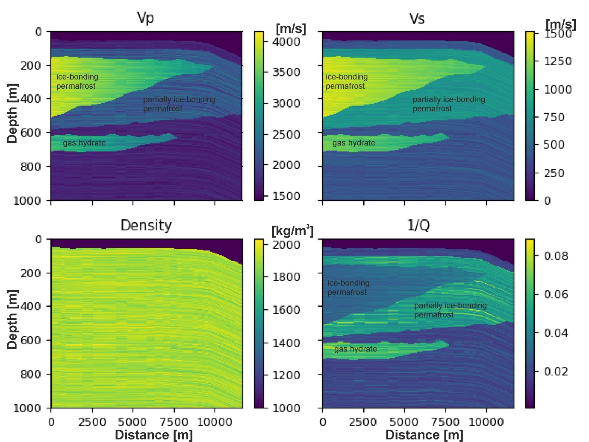

**Figure S1**. Physical properties of the synthetic model of submarine permafrost and permafrost-associated gas hydrates in the Canadian Beaufort Sea. Vp and Vs are the p-wave velocities and s-wave velocities, respectively, and 1/Q is the seismic wave attenuation.

**Text S2.**

To verify the interpretation of the synthetic seismic data, we build an interpretation-derived velocity model of the synthetic seismic section (Fig. S2a). We placed velocity units based on the interpretation in Fig. 5b whereas the required velocity values are based on the input model in Fig. 4 and were not newly derived by an independent velocity analysis. Fig. S2a was converted to the depth domain by scaling each time sample with half of the assigned velocity (Fig. S2b). As we did not find reflections indicating the top and the base of the partially ice-bonding permafrost, we placed an additional unit with velocities for partially ice-bonding in Fig. S2a to be able to compare input (Fig. 4) and recreated model (Fig. S2b).

The rebuilt model is similar to the input model which supports our interpretation in Fig. 5b. The gas hydrate body, which dips to larger CMPs in the time domain (Fig. S2a), becomes horizontal in the depth domain (Fig. S2b). The ice-bonding permafrost wedge keeps its shape. Although the thickness of the gas hydrate body may differ, particularly where the gas hydrate thins out, the interpretation seems suitable. Furthermore, the acquisition parameters and the applied processing do not significantly harm possible permafrost and gas hydrate-related reflections in our synthetic modelling effort. Consequently, we are encouraged that the processing when applied to our field data is appropriate and allows the interpretation of reflections associated with permafrost and gas hydrates.

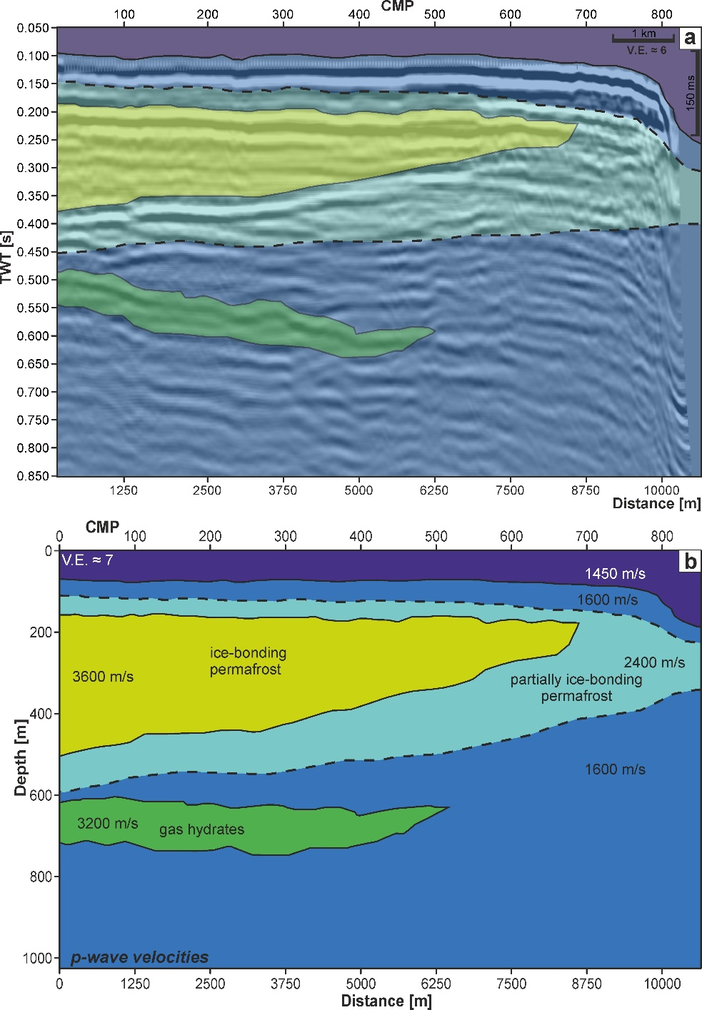

**Figure S2**. In a) inferred velocity units based on interpretation in Fig. 5b. In b) resulting velocity model in the depth domain. The partially ice-bonding permafrost zone (dashed lines) was inserted and adjusted according to the input model to obtain a comparable image to Fig. 4 although a related reflection could not be identified.

Text S3.

Fig. S3 shows a seismic cross line from Riedel et al. (2017). It is a line from the Ajurak 3D volume at the Canadian Beaufort Shelf. We find a reflection in this figure, which we interpret here to be the base of ice-bearing permafrost (pink dashed line). Note that this was here added to the figure as the authors worked on the deeper BGHSZ reflection only.

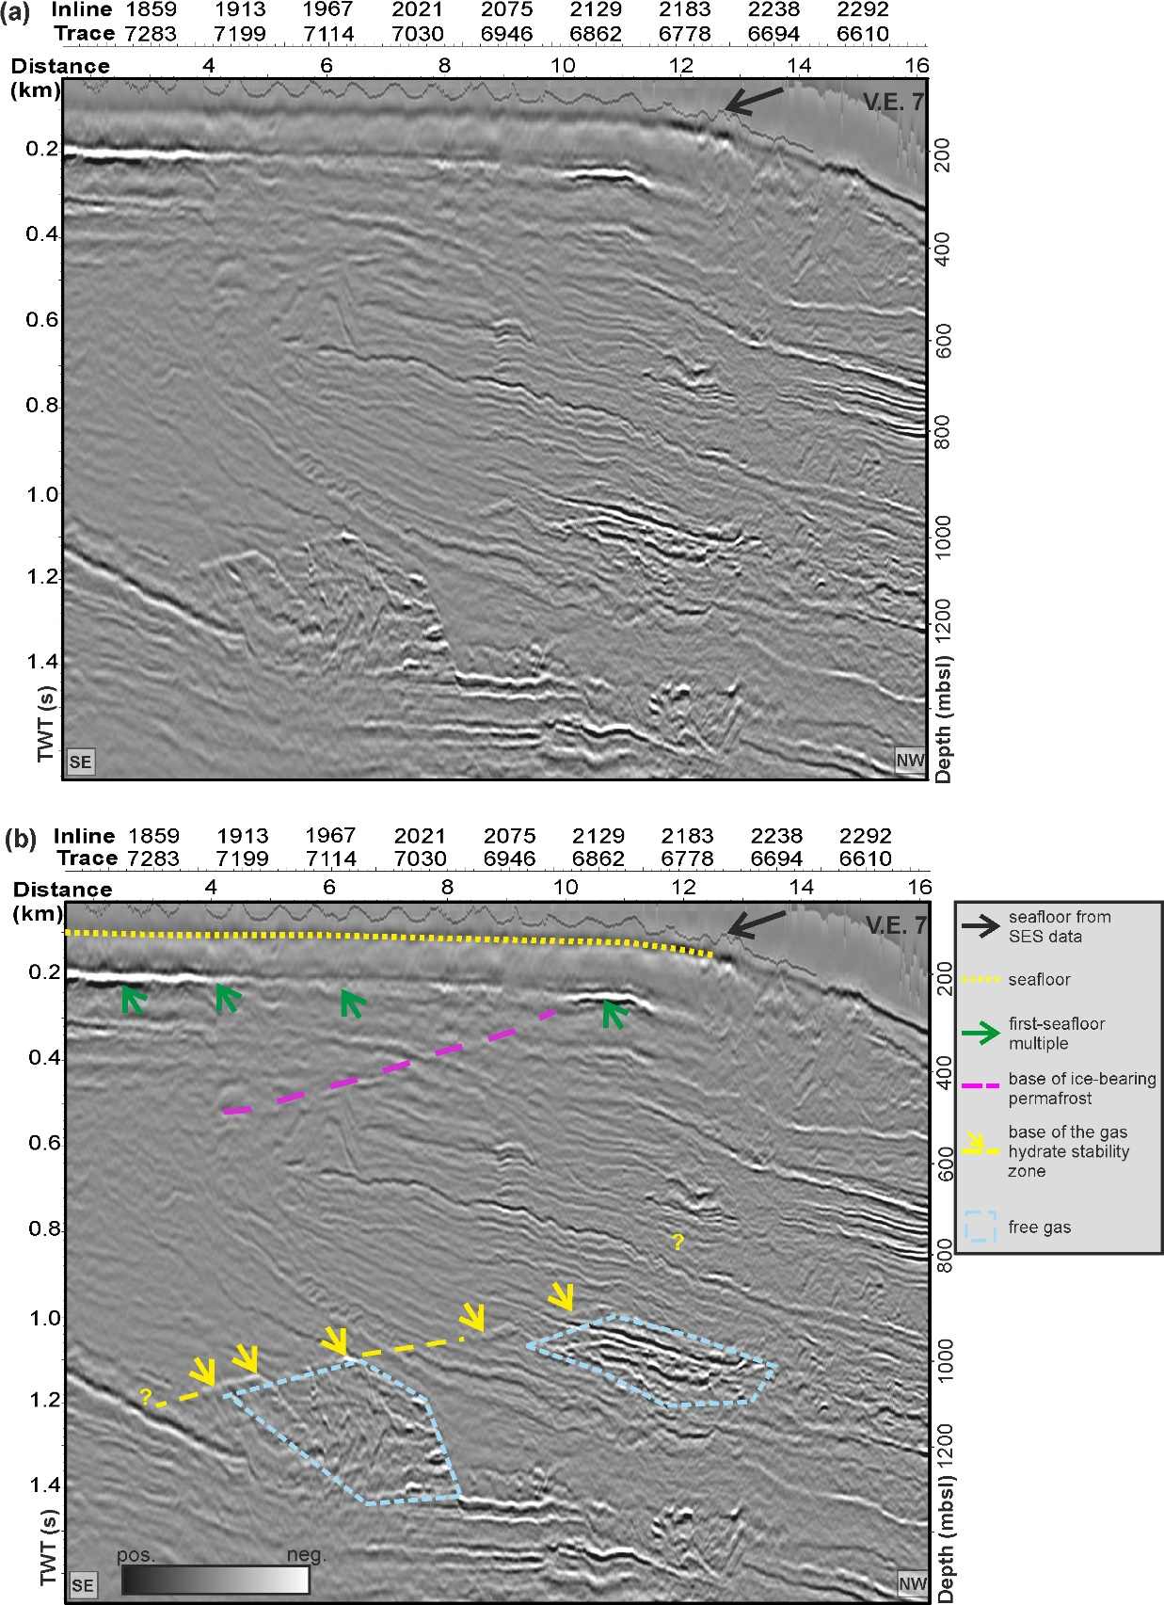

**Figure S3.** Modified figure from Riedel et al. (2017). It shows a seismic cross line in the Canadian Beaufort Shelf from the Ajurak 3D Volume with (a) time-migrated data and (b) interpreted section. The yellow dotted line depicts the seafloor. Seafloor picks from echo sounder data are shown by the black solid line and black arrow. Green arrows point at the first-seafloor multiple. The yellow arrows and yellow dashed line indicate the interpreted base of the gas hydrate stability zone (BGHSZ). The light-blue dashed polygons outline areas interpreted to contain free gas. Here, we added the dashed pink line which we interpret as the base of ice-bearing permafrost. In addition, we added the legend to b). Reprinted from “Evidence for gas hydrate occurrences in the Canadian Arctic Beaufort Sea within permafrost-associated shelf and deep-water marine environments. Marine and Petroleum Geology, 81, p. 66–78, Riedel, M., Brent, T. A., Taylor, G., Taylor, A. E., Hong, J.-K., Jin, Y.-K., & Dallimore, S. R. (2017)”, with permission from Elsevier.

Text S4.

Fig. S4 shows how the polarity of the top of ice-bearing permafrost reflection is different when the frequency band is altered. This effect is called tuning bed effect because reflecting waves from the top and base of a bed thinner than a quarter of the wavelength (beyond vertical resolution) interfere constructively.

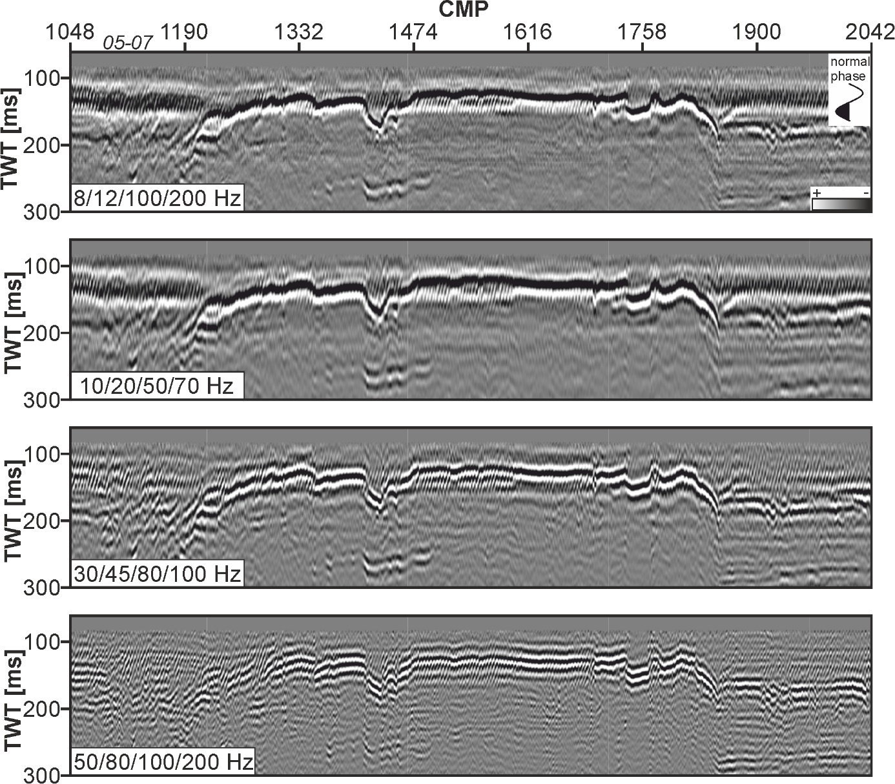

**Figure S4.** Tuning effect of top of ice-bearing permafrost in Line 05-07 (see Fig. 10). The polarity of the high-amplitude top of ice-bearing permafrost alters with frequency band. A tuning effect can occur when the reflection target is thinner than a quarter of the wavelength leading to constructive interferences of reflections from the top and base of the target (see Sheriff & Geldart, 1995)

Text S5.

Fig. S5 shows a prolongation of Fig. 10 in the manuscript. This line crosses the Irkaluk B-35 well and gives information about the seismic velocity.

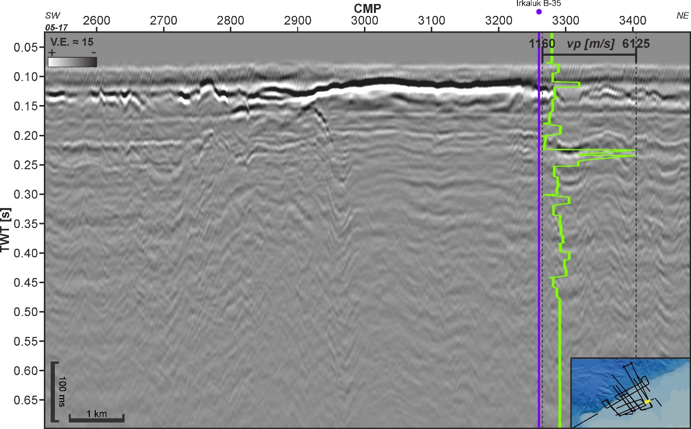

**Figure S5.** Line 05-17 crossing the well Irkaluk B-35 shows a high-velocity zone (~0.12 s TWT) overlying a lower velocity zone in the corresponding depth of the polarity-reversed top of ice-bearing permafrost reflection

Text S6-S22.

Figs. S6-S22 show all interpreted top of ice-bearing permafrost (IBPF) reflections (17 profiles). As written in the main text, we interpreted shallow high-amplitude reflections as the top of IBPF along all other MCS lines

**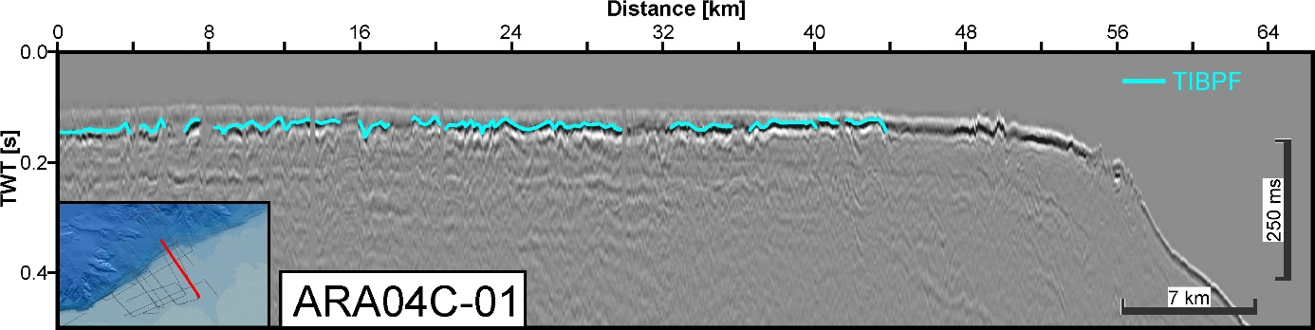  
Figure S6.** Top of ice-bearing permafrost (TIBPF) reflections alongLine 04-01

**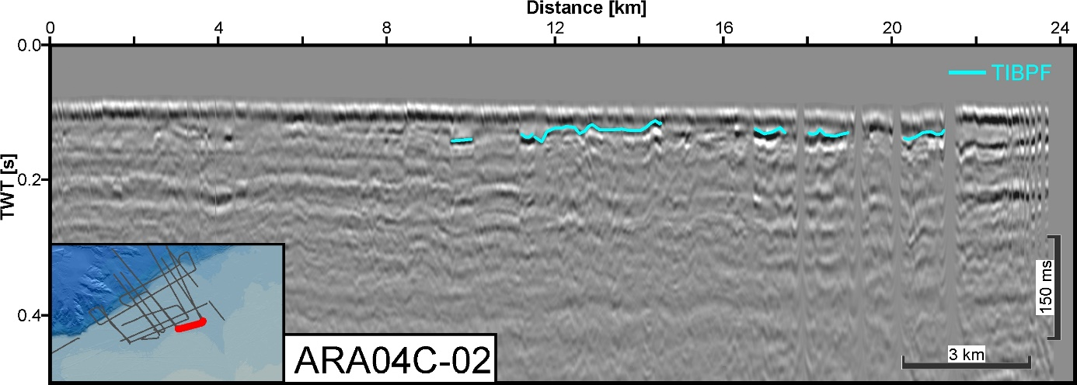  
Figure S7.** Top of ice-bearing permafrost (TIBPF) reflections alongLine 04-02

**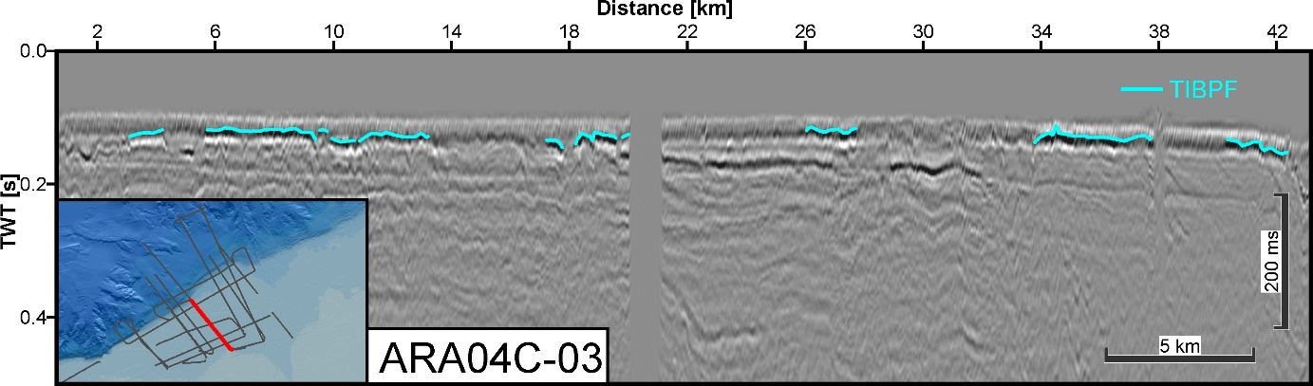  
Figure S8.** Top of ice-bearing permafrost (TIBPF) reflections alongLine 04-03

**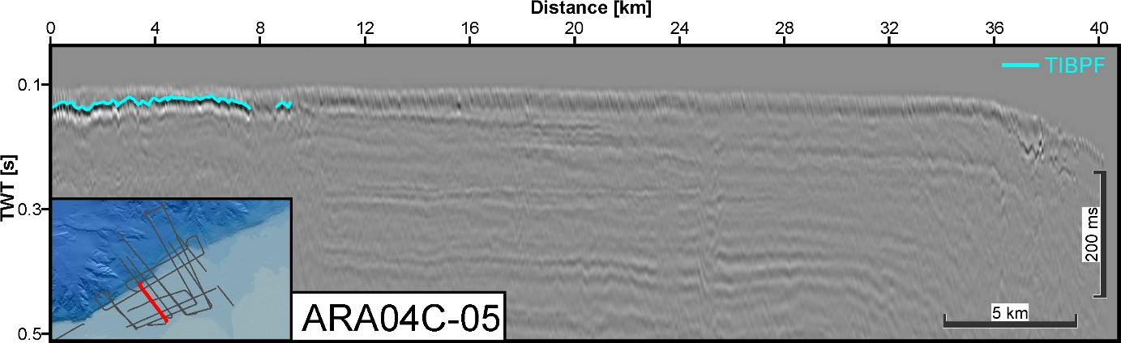  
Figure S9.** Top of ice-bearing permafrost (TIBPF) reflections alongLine 04-05

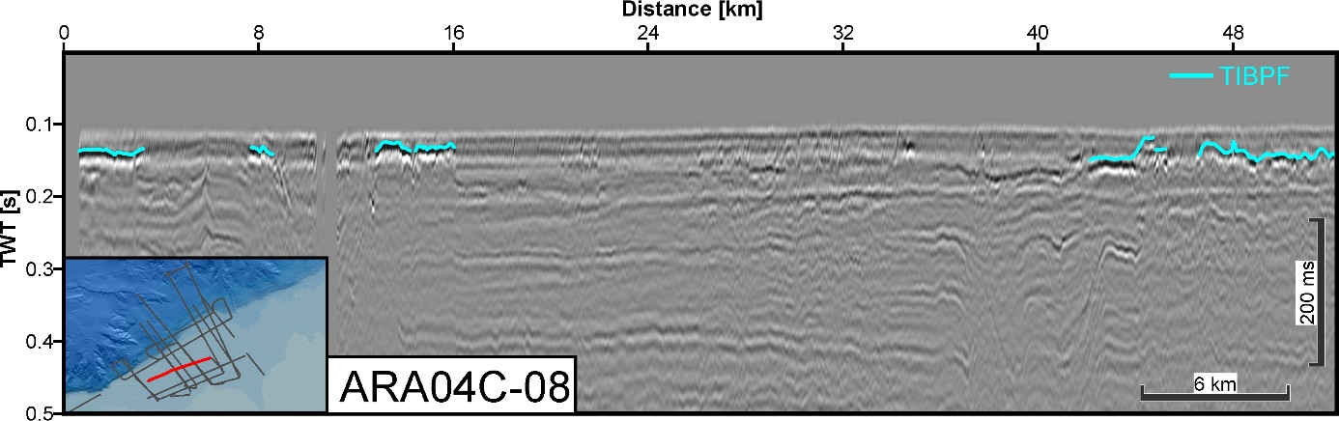  
**Figure S10.** Top of ice-bearing permafrost (TIBPF) reflections alongLine 04-08

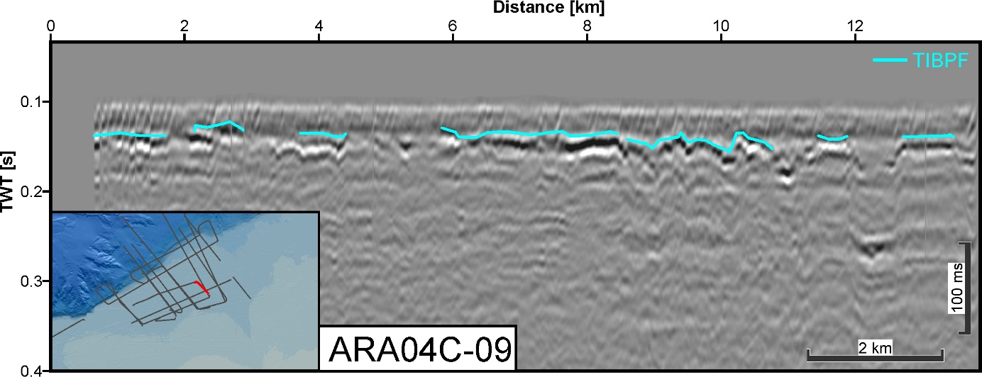  
**Figure S11.** Top of ice-bearing permafrost (TIBPF) reflections alongLine 04-09

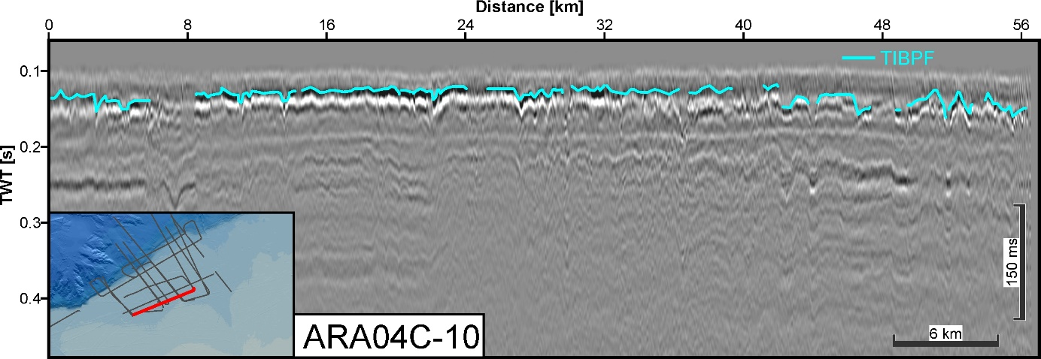  
**Figure S12.** Top of ice-bearing permafrost (TIBPF) reflections alongLine 04-10

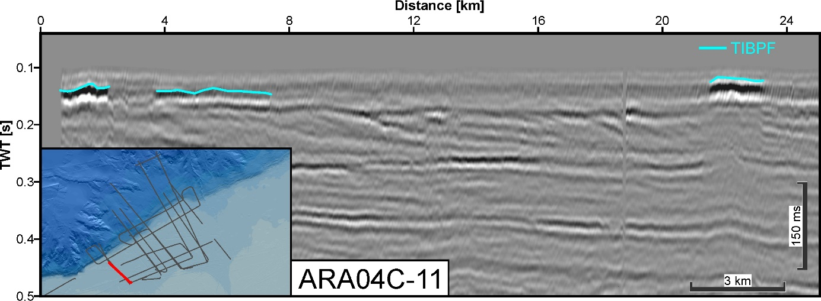  
**Figure S13.** Top of ice-bearing permafrost (TIBPF) reflections alongLine 04-11

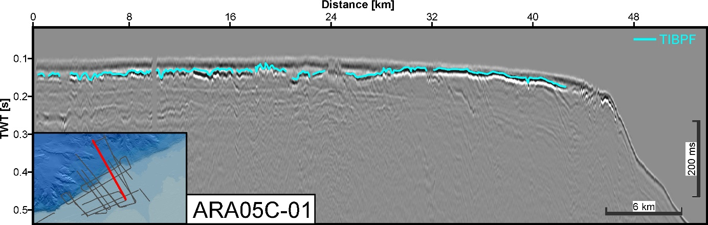  
**Figure S14.** Top of ice-bearing permafrost (TIBPF) reflections alongLine 05-01

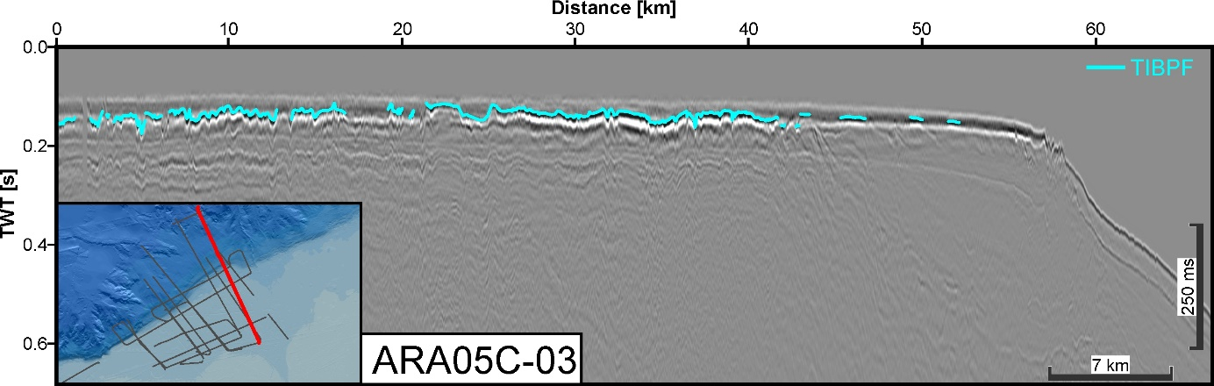  
**Figure S15.** Top of ice-bearing permafrost (TIBPF) reflections alongLine 05-03

**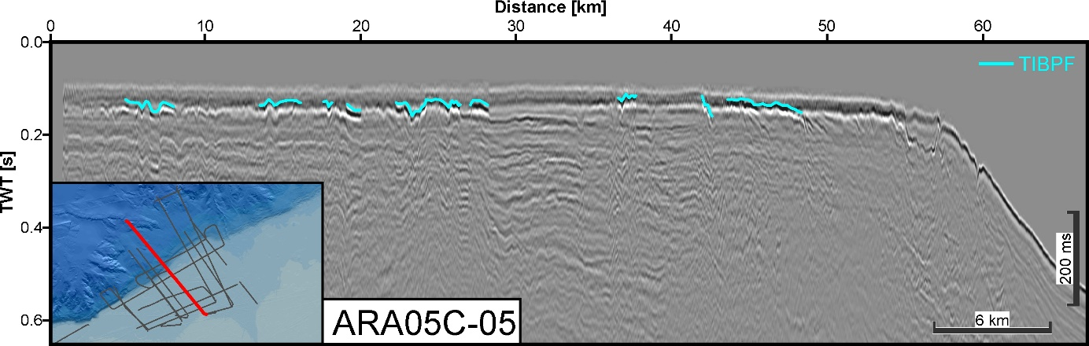  
Figure S16.** Top of ice-bearing permafrost (TIBPF) reflections alongLine 05-05

**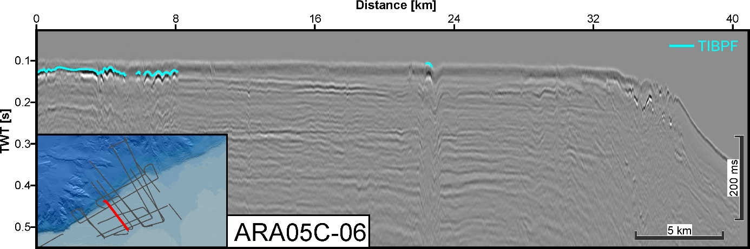  
Figure S17.** Top of ice-bearing permafrost (TIBPF) reflections alongLine 05-06

**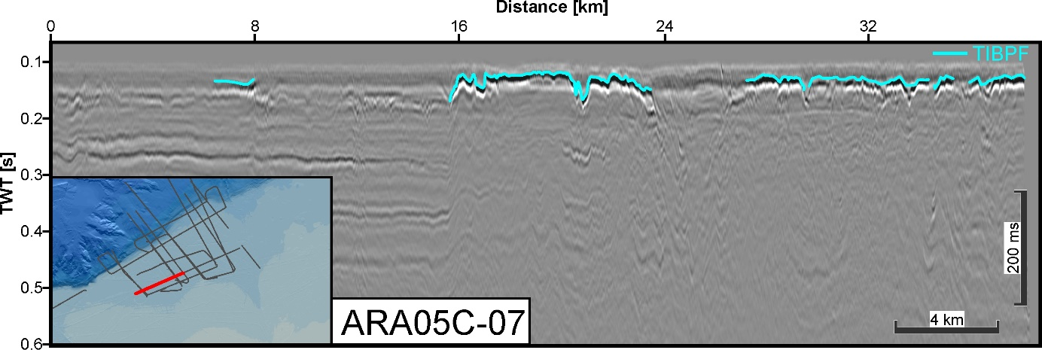  
Figure S18.** Top of ice-bearing permafrost (TIBPF) reflections alongLine 05-07

**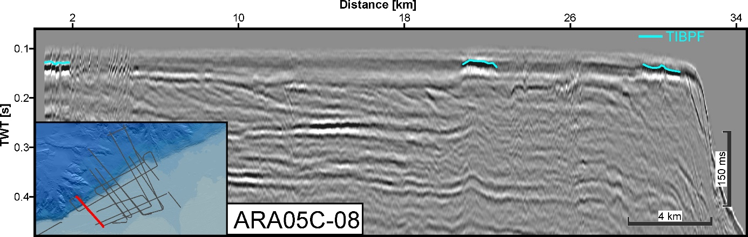  
Figure S19.** Top of ice-bearing permafrost (TIBPF) reflections alongLine 05-08

**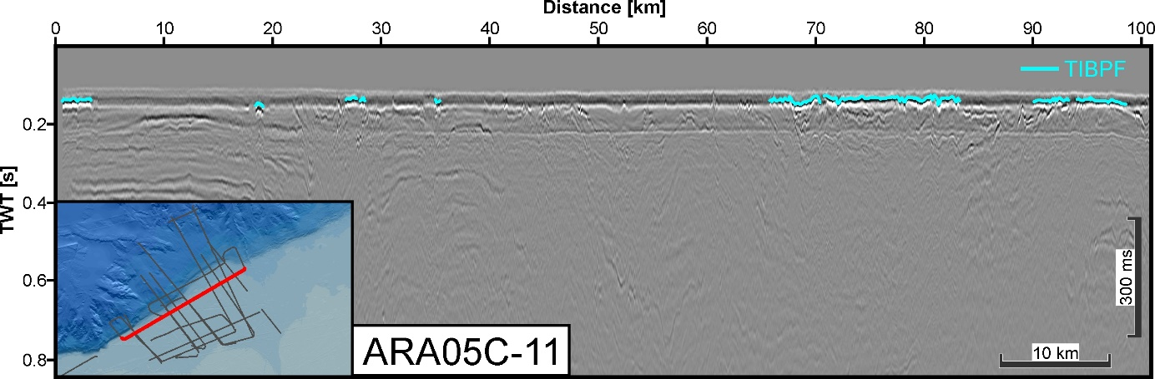  
Figure S20.** Top of ice-bearing permafrost (TIBPF) reflections alongLine 05-11

**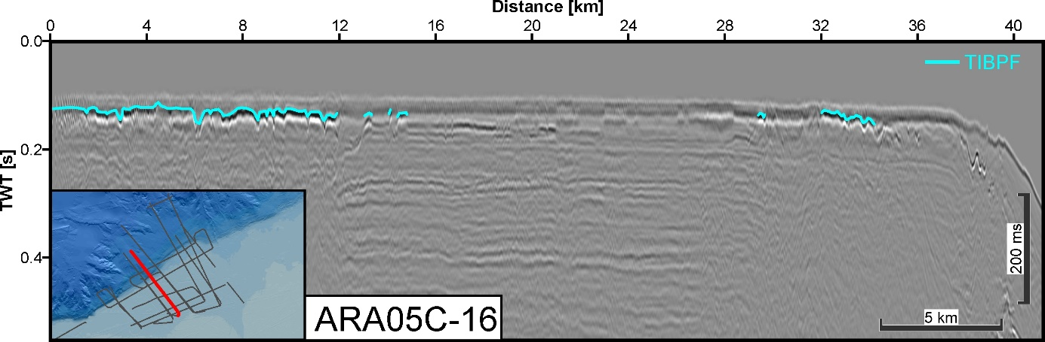  
Figure S21.** Top of ice-bearing permafrost (TIBPF) reflections alongLine 05-16

**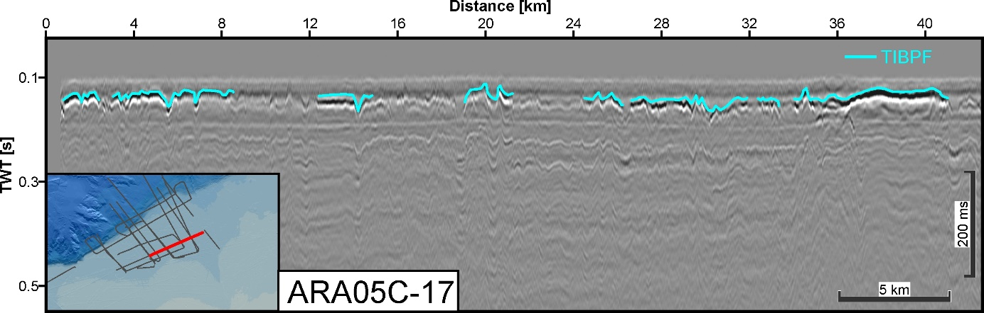  
Figure S22.** Top of ice-bearing permafrost (TIBPF) reflections alongLine 05-17

Text S23+S24.

Figs. S23+S24 show all interpreted base of ice-bearing permafrost (IBPF) reflections (2 profiles).

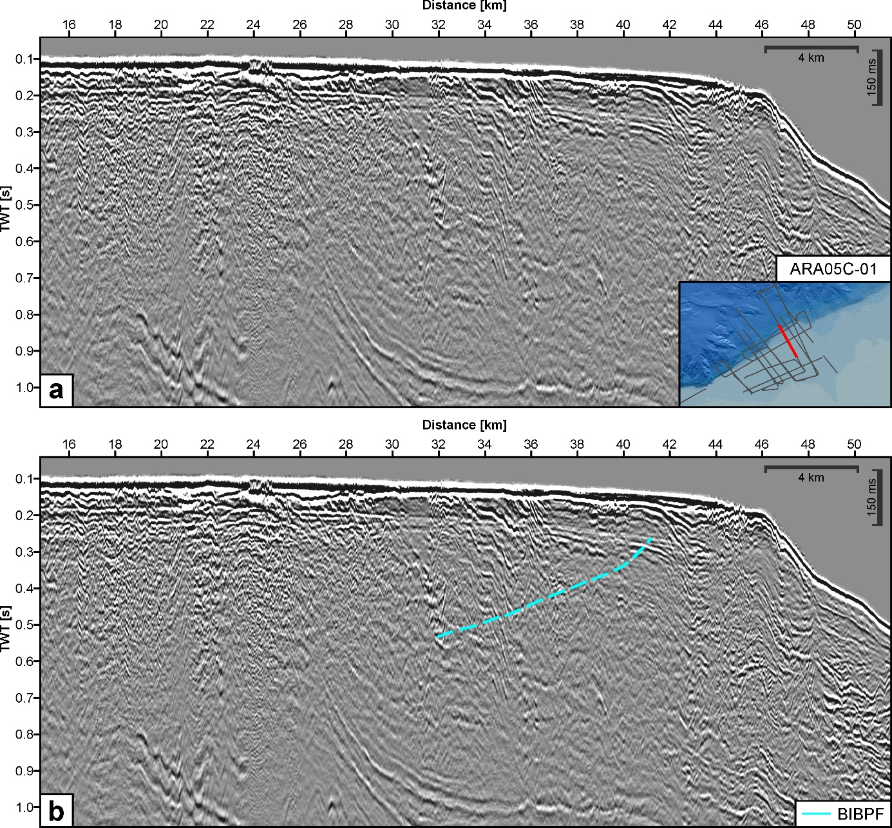

**Figure S23.** Base of ice-bearing permafrost (BIBPF) reflections alongLine 05-01: a) uninterpreted, b) interpreted

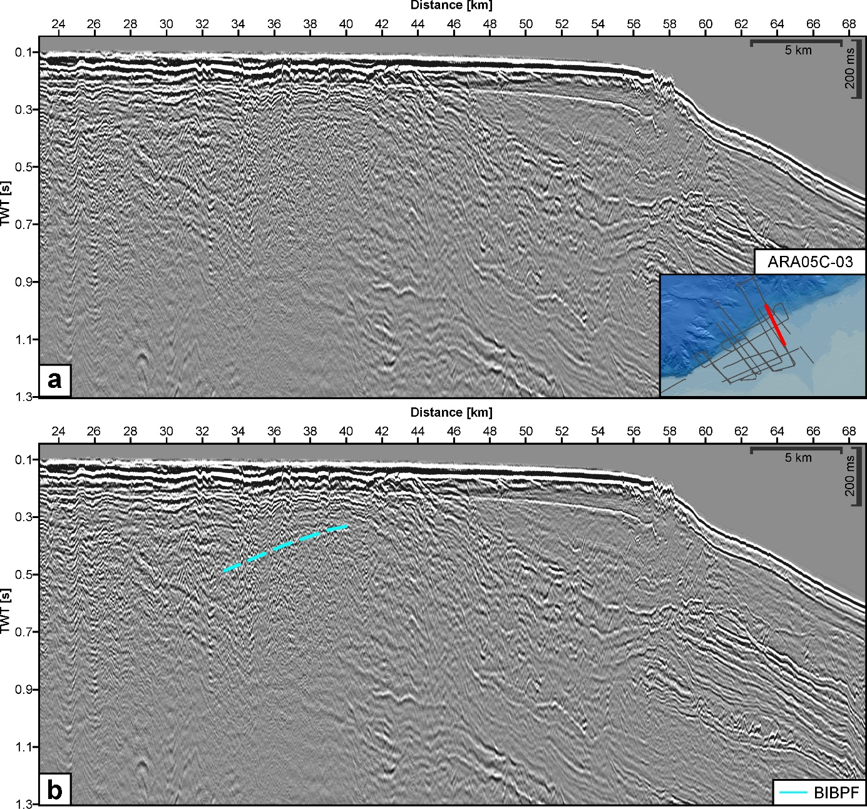  
**Figure S24.** Base of ice-bearing permafrost (BIBPF) reflections alongLine 05-03: a) uninterpreted, b) interpreted