### Supporting information

**Large-scale nutrient and carbon dynamics along the river-estuary-ocean continuum**

Norbert Kamjunkea*, Holger Brixb, Götz Flöserb, Ingeborg Bussmannc, Claudia Schützed, Eric P. Achterberge, Uta Ködeld, Philipp Fischerc, Louise Rewrieb, Tina Sandersb, Dietrich Borchardtf, Markus Weiterea

aHelmholtz Centre for Environmental Research - UFZ, Department of River Ecology, Brückstraße 3a, D-39114 Magdeburg, Germany

bHelmholtz-Zentrum hereon GmbH, Institute of Carbon Cycles, Max-Planck-Straße 1, 21502 Geesthacht, Germany

cAlfred-Wegener-Institut, Helmholtz Centre for Polar and Marine Research, Departments of Marine Geochemistry & Shelf Sea System Ecology, Am Handelshafen 12, 27570 Bremerhaven, Germany

dHelmholtz Centre for Environmental Research - UFZ, Department of Monitoring and Exploration Technologies, Permoserstr. 15, 04318 Leipzig, Germany

eGEOMAR, Helmholtz Centre for Ocean Research, Wischhofstr 1-3, 24148 Kiel, Germany

fHelmholtz Centre for Environmental Research - UFZ, Department of Aquatic Ecosystem Analysis, Brückstraße 3a, D-39114 Magdeburg, Germany

*corresponding author: E-mail address: [norbert.kamjunke@ufz.de](mailto:norbert.kamjunke@ufz.de) (N. Kamjunke)

*Key words*: river-ocean continuum, phytoplankton, nutrients, oxygen, pH, autotrophic, heterotrophic

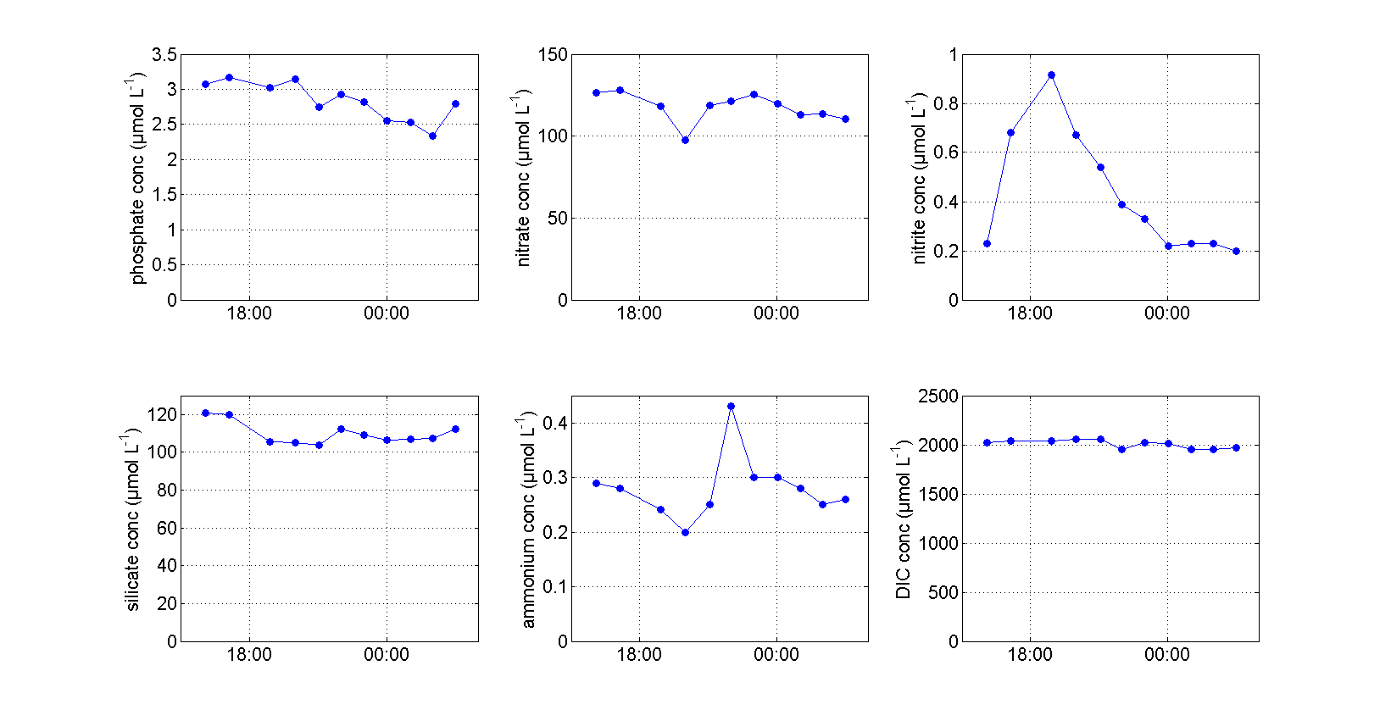Fig. S1: Concentrations of solutes during the tidal cycle in the tidal zone: ammonium, dissolved inorganic carbon (DIC), nitrite, nitrate, phosphate, silicon.

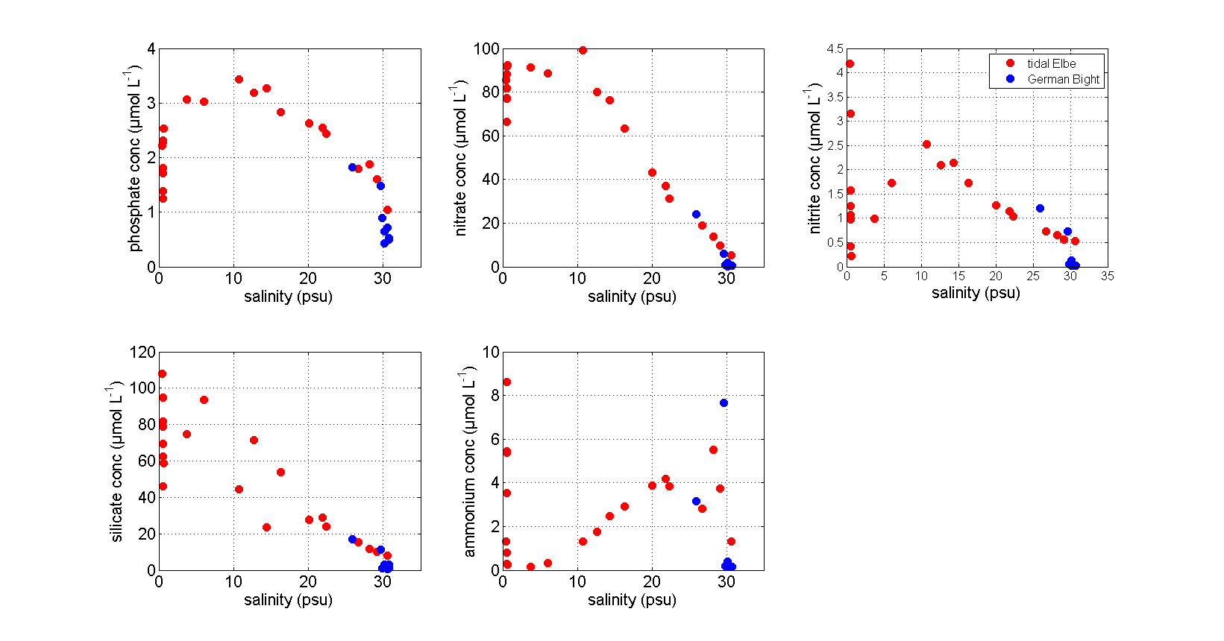

Fig. S2: Concentrations of dissolved nutrients as a function of salinity in the tidal Elbe and German Bight.

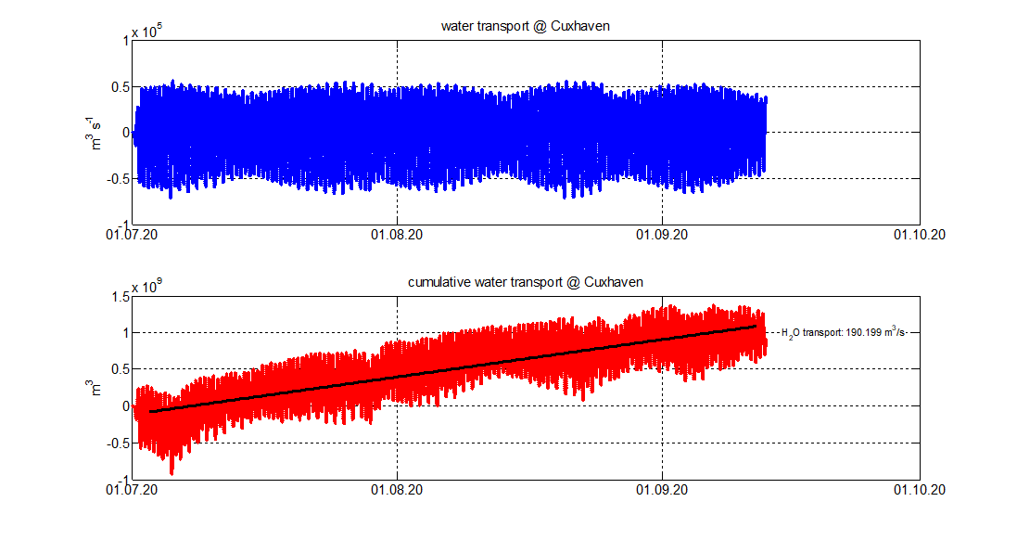

Fig. S3: Time series of water fluxes from estuary to ocean (Cuxhaven).

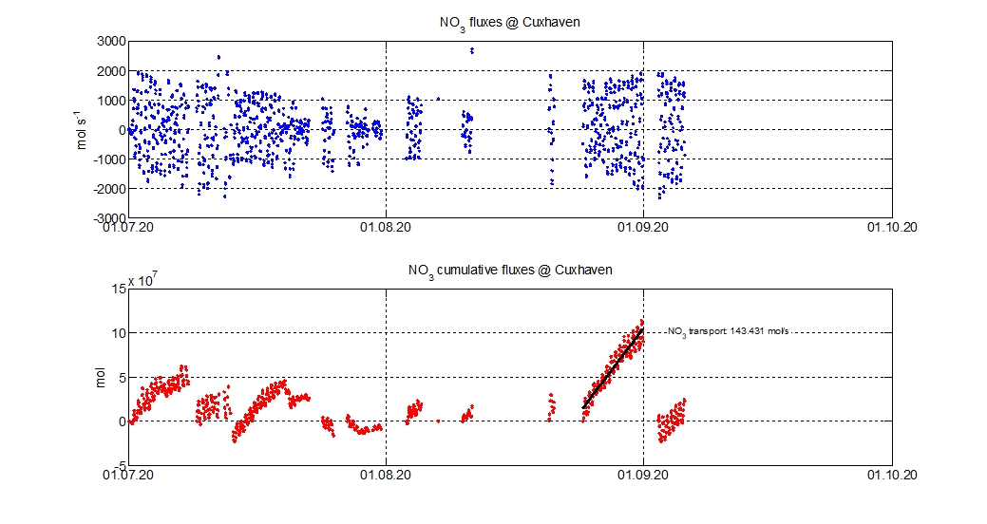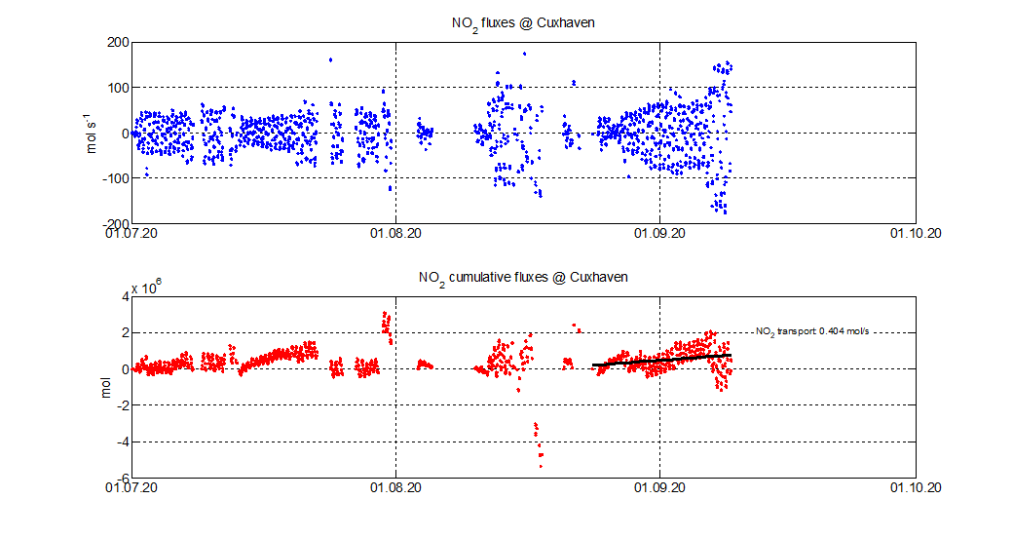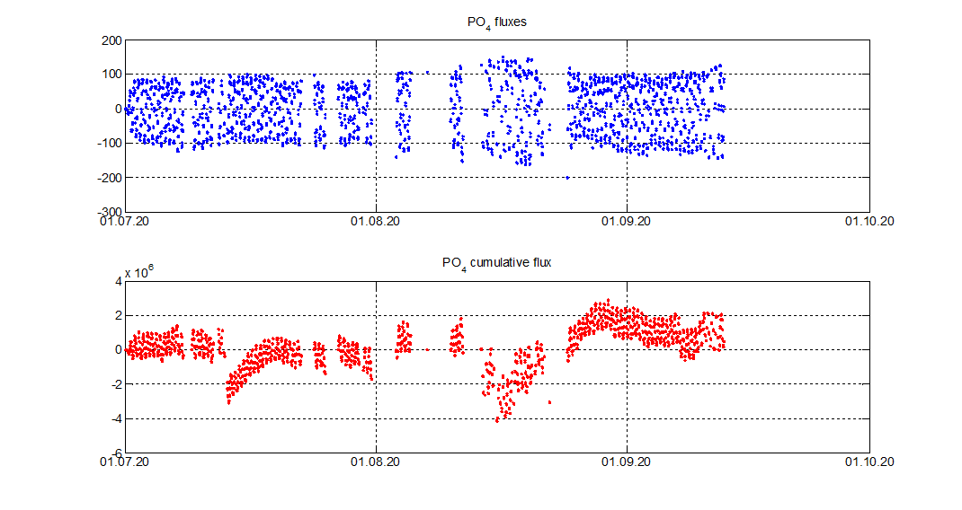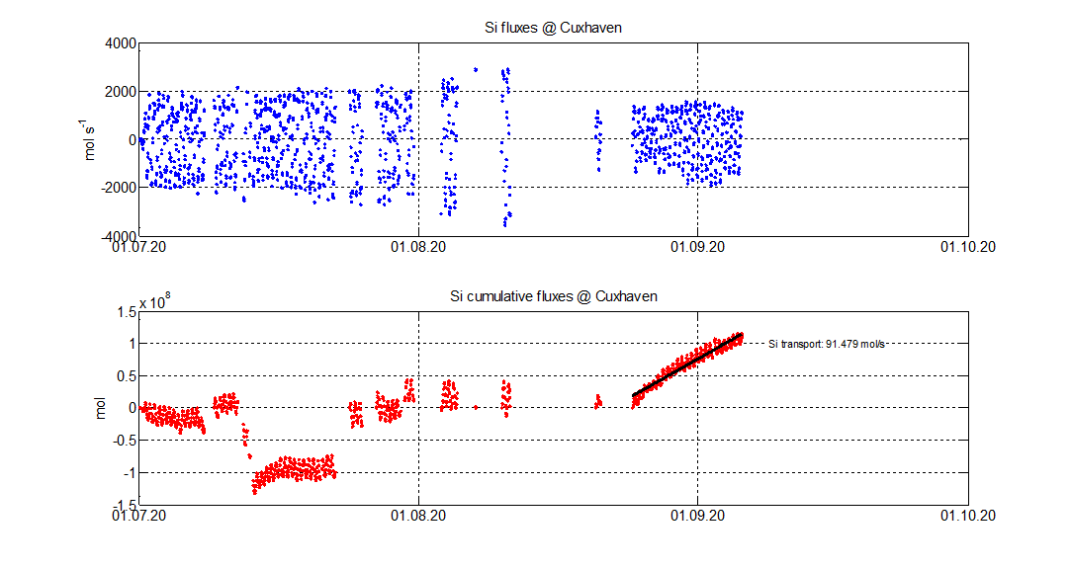

Fig. S4: Time series of nutrient fluxes from estuary to ocean (Cuxhaven).

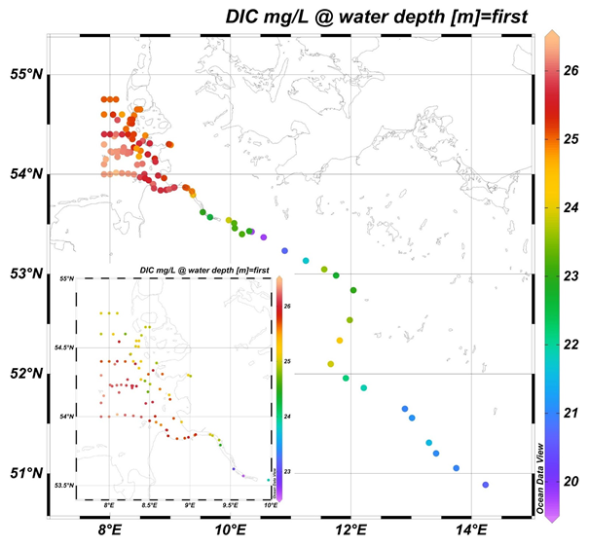

Fig.S5: Spatial distribution of concentrations of dissolved inorganic and organic carbon (DIC)in freshwater River Elbe, Elbe estuary, and German Bight.

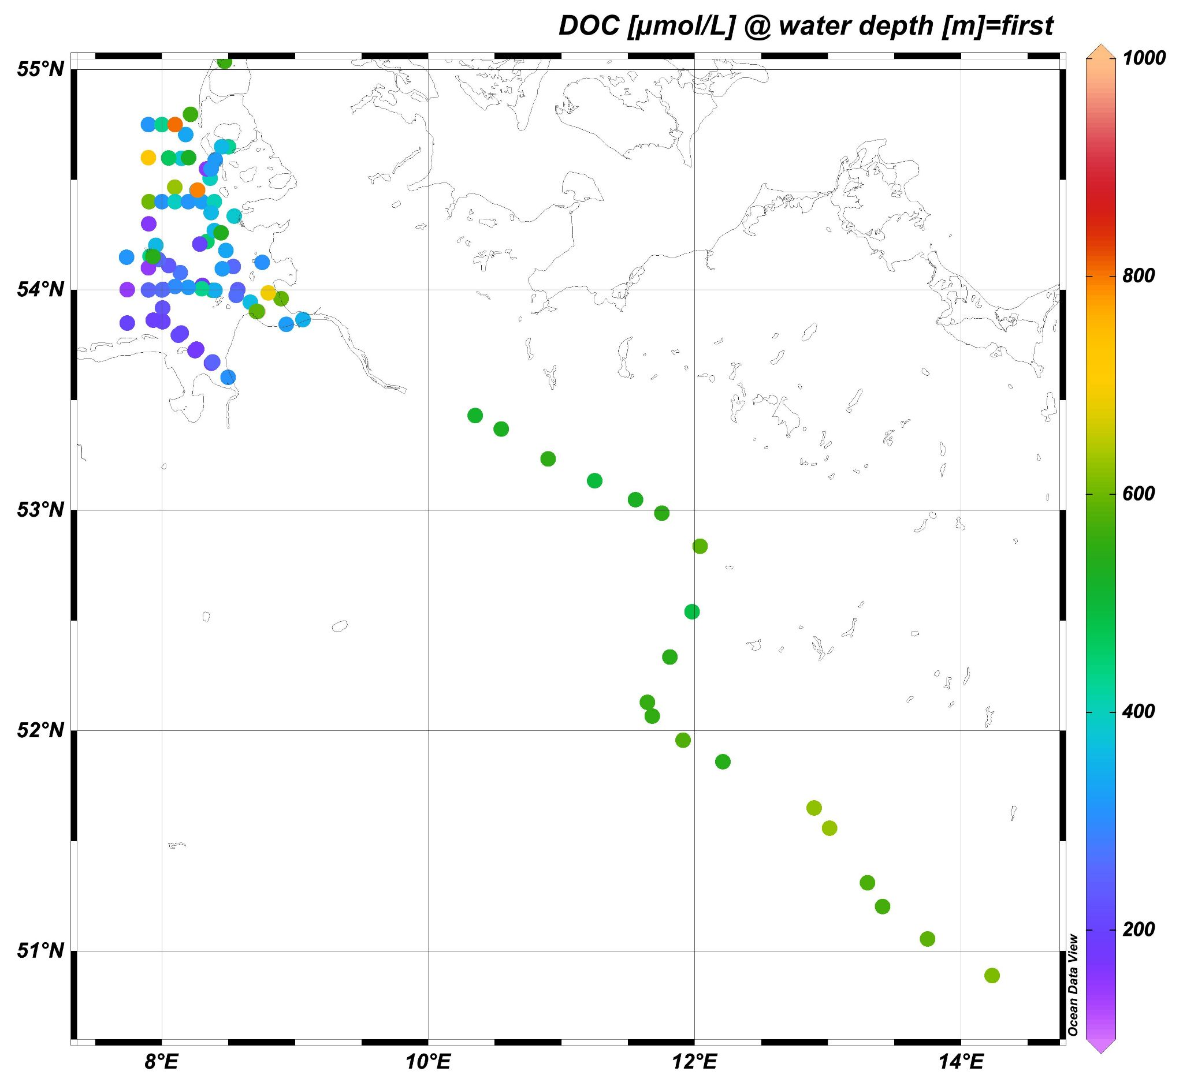

Fig. S6: Spatial distribution of concentrations of dissolved organic carbon (DOC) in freshwater River Elbe and German Bight. DOC was not analysed in the estuary.

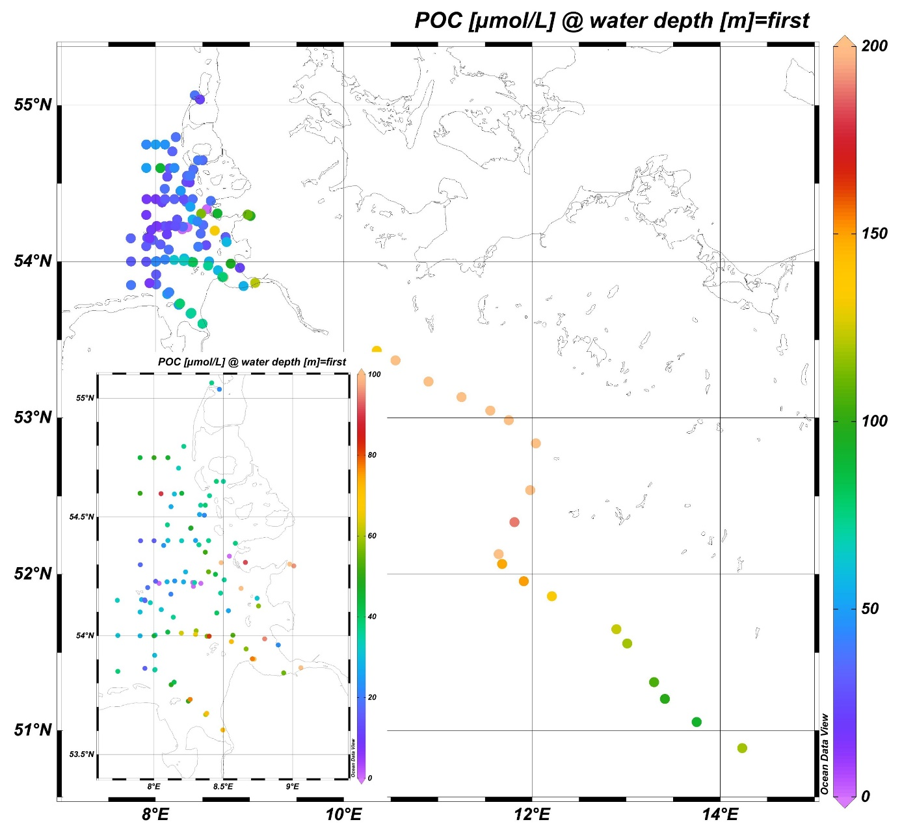

Fig.S7: Spatial distribution of concentrations of particulate organic carbon (POC) in freshwater River Elbe and German Bight. POC was not analysed in the estuary.