

*Reviews of Geophysics*

Supporting Information for

**Upper Ocean Biogeochemistry of the Oligotrophic North Pacific Subtropical Gyre: from Nutrient Sources to Carbon Export**

Minhan Dai1,2*, Ya-Wei Luo1,2*, Eric P. Achterberg3, Thomas J. Browning3, Yihua Cai1,2, Zhimian Cao1,2, Fei Chai1,2, Bingzhang Chen4, Matthew J. Church6, Dongjian Ci1,2, Chuanjun Du7, Kunshan Gao1,2, Xianghui Guo1,2, Zhendong Hu1,2, Shuh-Ji Kao1,2, Edward A. Laws8, Zhongping Lee1,2, Hongyang Lin1,2, Qian Liu9, Xin Liu1,10, Weicheng Luo1,2, Feifei Meng1,2, Shaoling Shang1,2, Dalin Shi1,2, Hiroaki Saito11, Luping Song1,2, Xianhui Sean Wan1,12, Yuntao Wang13, Wei-Lei Wang1,2, Zuozhu Wen1, Peng Xiu14,15, Jing Zhang9,16, Ruifeng Zhang17, Kuanbo Zhou1,2

1State Key Laboratory of Marine Environmental Science, Xiamen University, Xiamen, China

2College of Ocean and Earth Sciences, Xiamen University, Xiamen, China

3GEOMAR Helmholtz Centre for Ocean Research Kiel, Wischhofstrasse 1-3, Kiel, Germany

4Department of Mathematics and Statistics, University of Strathclyde, Glasgow, United Kingdom

5Southern Marine Science and Engineering Guangdong Laboratory (Guangzhou), Guangzhou, China

6Flathead Lake Biological Station, University of Montana, Polson, MT, USA

7State Key Laboratory of Marine Resource Utilization in South China Sea, Hainan University, Haikou, China

8Department of Environmental Sciences, College of the Coast and Environment, Louisiana State University, Baton Rouge, LA, USA

9Frontiers Science Center for Deep Ocean Multispheres and Earth System, and Key Laboratory of Marine Chemistry Theory and Technology, Ministry of Education, Ocean University of China, Qingdao, China

10College of Environment and Ecology, Xiamen University, Xiamen, China

11Atmosphere and Ocean Research Institute, the University of Tokyo, Chiba, Japan

12Department of Geosciences, Princeton University, NJ, USA

13State Key Laboratory of Satellite Ocean Environment Dynamics, Second Institute of Oceanography, Ministry of Natural Resources, Hangzhou, China

14State Key Laboratory of Tropical Oceanography, South China Sea Institute of Oceanology, Chinese Academy of Sciences, Guangzhou, China

15Guangdong Key Laboratory of Ocean Remote Sensing, South China Sea Institute of Oceanology, Chinese Academy of Sciences, Guangzhou, China

16Faculty of Science, Academic Assembly, University of Toyama, Toyama, Japan

17School of Oceanography, Shanghai Jiao Tong University, Shanghai, China

**Contents of this file**

Text S1

Figures S1 to S4

**Introduction**

Text S1 in this supporting information provides extended description of long-term variabilities in physical properties in the North Pacific Subtropical Gyre. Figures in this supporting information are additional results of long-term variabilities in biogeochemical properties and observed concentrations of particulate organic carbon (POC) in the North Pacific Subtropical Gyre.

Text S1. Long-term variabilities in physical properties in the North Pacific Subtropical Gyre (NPSG)

Sea Surface Temperature

The average SST in the global ocean (excluding perennial sea ice regions) has a warming trend of 0.011°C yr-1 between 1981 and 2018 (Bulgin *et al.*, 2020), which has been shown to be accelerating (Bâki Iz, 2018; Cheng *et al.*, 2019; Cox *et al.*, 2000; Koven *et al.*, 2011). The warming is also spatially inhomogeneous with a faster rate at higher latitudes (Deser *et al.*, 2010). SST in the NPSG was reported to increase at 0.012℃ yr-1 between 1998 and 2013 (Signorini *et al.*, 2015), which is higher (0.021℃ yr-1) when we extend the analysis period to 1998 – 2021 (**Fig. 19a**). The rate is even higher (0.027℃ yr-1) if we focus on the later period (2004 – 2021) using Argo float measurements (**Fig. 19a**). We note that the rate estimates are likely affected by the *global warming hiatus* in 1998 – 2012 (Medhaug *et al.*, 2017) and the warming anomalies in the northeastern Pacific in 2014–2016 and later on (**Fig. 19c**) (Bulgin *et al.*, 2020; Gentemann *et al.*, 2017).

Sea Surface Salinity

Salinity changes have more complex spatial variability than temperature changes. Based on the Simple Ocean Data Assimilation reanalysis dataset(Carton and Giese, 2008), the averaged SSS increases by 0.12 psu in the global subtropical gyres over 1950 – 2010 (Melzer and Subrahmanyam, 2015). In the North Pacific, SSS increased in the central NPSG (evaporation-dominated region), whereas decreased in the western Pacific Warm Pool and the North Pacific subpolar region (precipitation-dominated regions) (Durack *et al.*, 2012; Skliris *et al.*, 2014). At Station ALOHA in the eastern NPSG, SSS exhibited a relatively strong increasing trend (0.008±0.001 psu yr-1) from 1989 to 2016 (Kavanaugh *et al.*, 2018). For the whole NPSG region, SSS has a negative trend based on either remote sensing data over 1998 – 2021 or Argo float data over 2004 – 2021 (**Fig. 19d**).

Stratification and Mixed Layer Depth

With changing ocean temperature and salinity, long-term changes in stratification and mixed layer depth (MLD) are expected. Recent observational studies have shown that vertical stratification has been enhanced globally (Li *et al.*, 2020; Sallée *et al.*, 2021). Increased vertical stratification in the upper ocean was shown to be clearer in the central and eastern NPSG (Dave and Lozier, 2013; Sallée *et al.*, 2021). In the northwestern NPSG, however, Kim *et al.* (2022) suggested that the observed warming trend at 300 – 500 m would result in decreased stratification and enhanced vertical mixing in the upper ocean. Enhanced ocean stratification can lead to shoaling of the mixed layer, which can result in greater warming during the warm summer months relative to the winter (Jo *et al.*, 2022). Using the Argo float records, we find a shoaling trend of MLD (−0.265 m yr-1) accompanied by a trend of enhanced thermocline stratification (8.4×10-3 s-2 yr-1) in the NPSG (**Fig. 19g, j**). Our correlation analyses indicate that the shoaling MLD and increased thermocline stratification trends are likely determined by trends in both SST and SSS (**Table 6**). However, several recent studies suggest that these trends are seasonally specific. For example, Sallée *et al.* (2021) described that summertime MLD increased globally, while (S. Sugimoto, 2022) indicated a decreasing wintertime MLD in the northwestern NPSG, as MLD could be further modulated by wind-driven processes in addition to warming.

The time-series of the parameters are subtracted by the climatological monthly mean values before being analyzed (see text). Values of significant trends are marked by * (p < 0.05) or ** (p < 0.01). SST: sea surface temperature; SSS: sea surface salinity; MLD: mixed layer depth; N2: squared buoyancy frequency.

Water Masses

In the western NPSG, observations along 165°E showed that the North Pacific Tropical Water (NPTW) demonstrated an interannual or longer-timescale variation with significant warming and salinification (~0.005 psu yr-1) (Kawakami *et al.*, 2020). The North Pacific Subtropical Mode Water (STMW), which forms in the Kuroshio Extension recirculation gyre region, has warmed at twice the rate of surface warming averaged over the global ocean (Shusaku Sugimoto *et al.*, 2017) and has freshened, particularly over the last 20 years (Oka *et al.*, 2017). The STMW formation rate appears to have decreased in recent decades, due to the contracted ventilation area and the decreased MLD (B Wu *et al.*, 2021). Such long‐term trends in the STMW may lead to warming and freshening in the main thermocline/halocline below the NPTW (Nakano *et al.*, 2007; Oka *et al.*, 2017) through its subduction and advection to the NPSG.

Circulation

Increased vertical stratification due to surface warming has been shown to accelerate circulation in the upper ocean of subtropical gyres (Peng *et al.*, 2022). Additionally, poleward shift of subtropical WBCs due to changes of atmospheric circulation in a warming climate (L Wu *et al.*, 2012; Yang *et al.*, 2016) appear to be linked with the poleward expansion of subtropical gyres (Meng *et al.*, 2021; Yang *et al.*, 2020). In the North Pacific, both the subtropical front and the Kuroshio Extension front have shifted poleward (L Wu *et al.*, 2012; Xu *et al.*, 2022), likely affecting the properties and distributions of STMW in the central gyre. Numerical models also predict significant changes in WBCs and subtropical gyres due to warming. For example, the Coupled Model Intercomparison Project Phase 3 models show warming-related poleward expansion of subtropical gyres in both the North and South Pacific (Zhang *et al.*, 2014). The poleward shift of the Kuroshio extension front is projected to be up to 2° in latitude within the late twenty-first century in the extreme climate warming case, the representative concentration pathway (RCP) 8.5 (Nishikawa *et al.*, 2020). Under the moderate warming case RCP 4.5, Wang *et al.* (2015) showed an intensified gyre circulation in the upper layer of the NPSG and suggested that the strengthened stratification due to surface warming was the dominant driver. Sea surface warming was further shown to cause an intensified upper-layer Kuroshio current in RCP 4.5 (Chen *et al.*, 2019). In a low warming scenario (RCP 2.6), Ju *et al.* (2020) also reported a strengthened NPSG circulation from the surface layer down to the main thermocline driven by changes in both surface wind and stratification.



Figure. S1. The anomalies of average concentrations of nitrate (a), phosphate (b) and silicate (c) in North Pacific Subtropical Gyre to their monthly climatology.

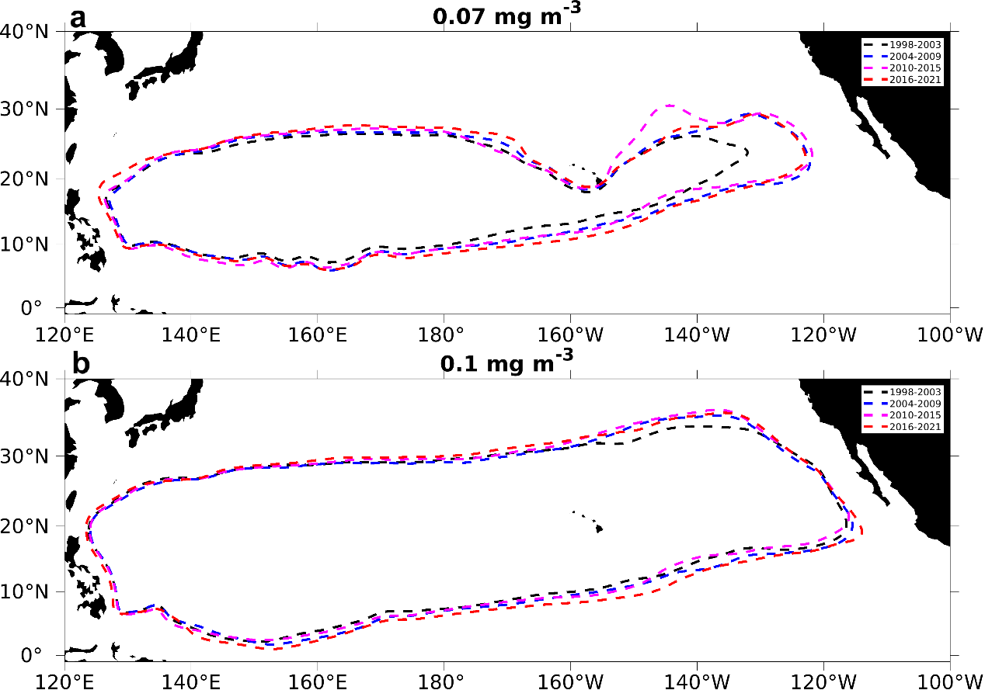

Figure S2. The ranges of North Pacific Subtropical Gyre based on 6-year mean chlorophyll remote sensing. Ranges defined by the Chl-a contour at (a) 0.07 mg m-3 and (b) 0.1 mg m-3. Black, blue, magenta, and red contours indicate ranges over 1998–2003, 2004–2009, 2010–2015, and 2016–2021, respectively.

**a**

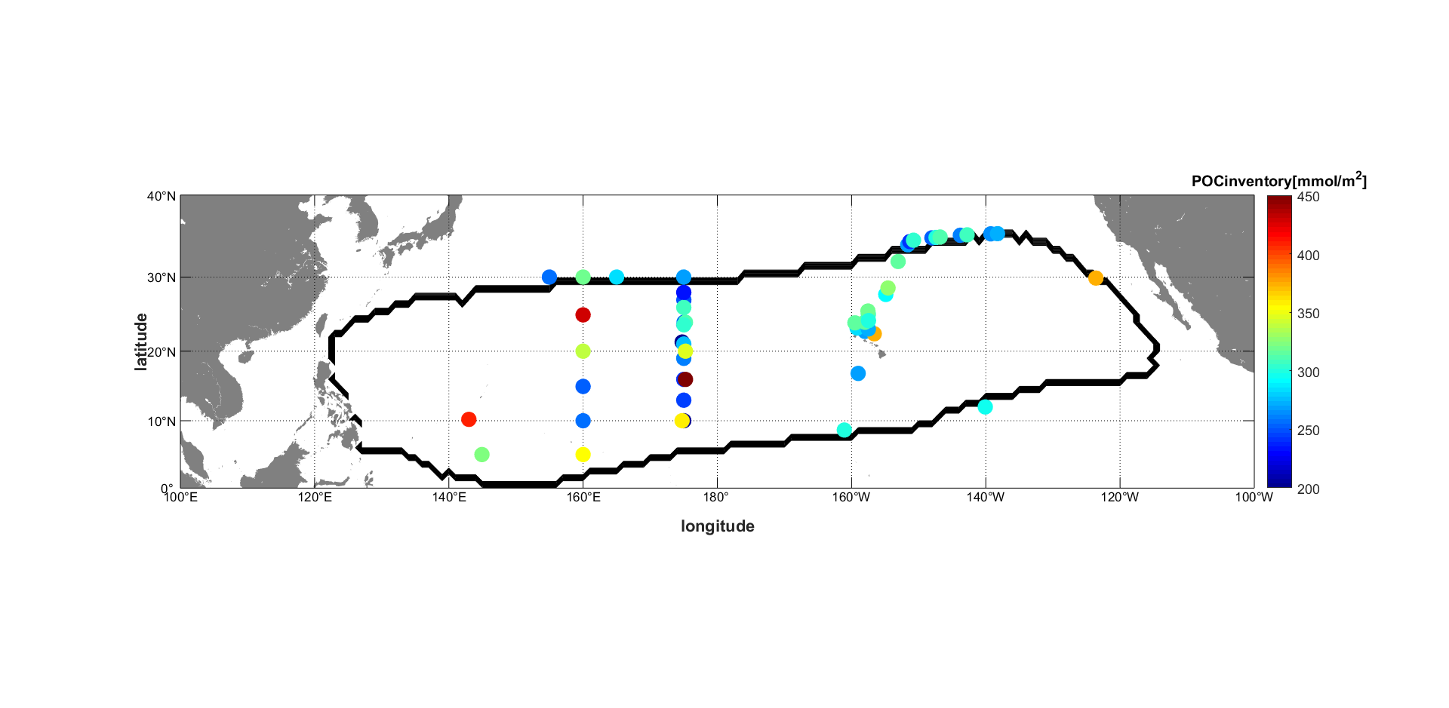

**b**

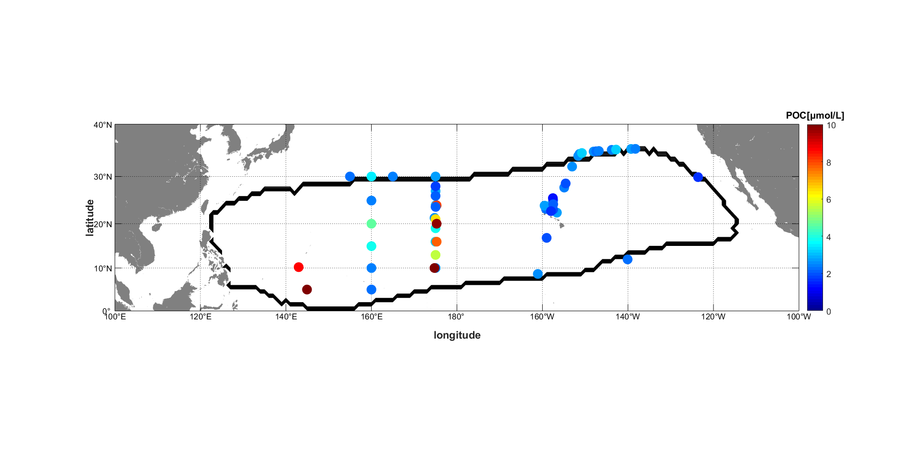

**Figure S3.** Observed particulate organic carbon (POC) concentrations (**a**) integrated in upper 150 m and (**b**) in surface waters.



Figure S4. Long-term trend (p<0.01) of depth at potential density (σθ) of 24.5 kg m-3 at Station ALOHA.