Supplementary Material

A novel in-vivo phagocytosis assay to gain cellular insights on sponge-microbe interactions
Angela M. Marulanda-Gomez, Kristina Bayer , Lucia Pita*, Ute Hentschel*
* Correspondence:
Lucia Pita
luciapita@cmima.csic.es
Ute Hentschel
uhentschel@geomar.de

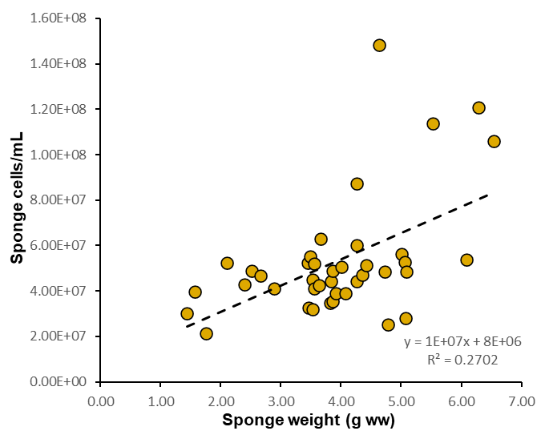
Supplementary Figure 1. Relation of sponge cells recovered per g (wet weight) sponge after the cell dissociation of the individuals used for the phagocytosis assay.
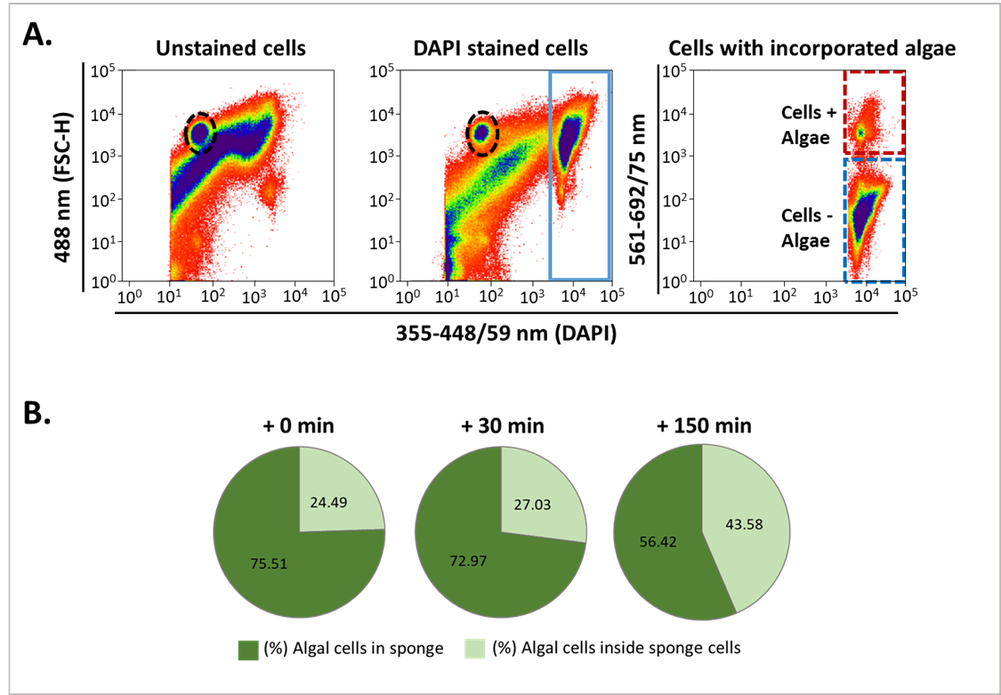
Supplementary Figure 2. Estimates of Nannochloropsis sp. cells found inside the sponge tissue or incorporated in H. panicea cells (A) Representative FACS cytograms showing the population of intact, free algae (dashed oval). (B) Percentage of free algal cells after the pulse-chase experiment. All sponges were incubated for 30 min (pulse-period) with Nannochloropsis sp.(initial concentration of approx. x10⁶ algae mL⁻¹) and sampled after 0 min, 30 min, and 150 min chase period.

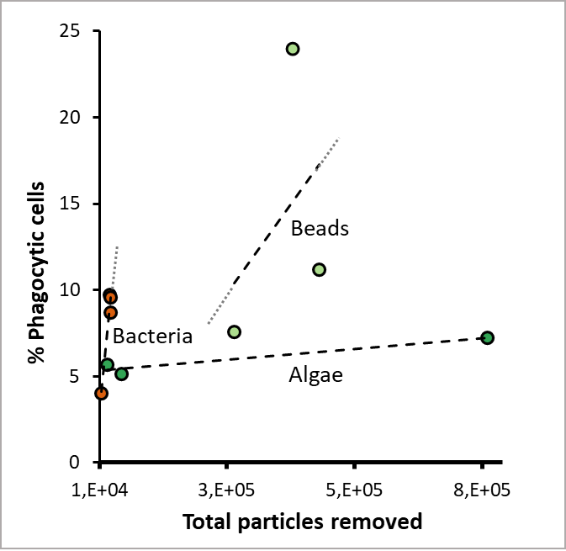
Supplementary Figure 3. Relation between phagocytosis and particle uptake. The percentage of H. panicea cells phagocytizing algae (Nannochloropsis sp.), bacteria (Vibrio sp.), and fluorescent latex beads tends to increase linearly (n = 3. More data points are needed to validate a linear regression fit) with a higher number of particles removed by the sponge during the 30 min incubations. Dotted gray line: extension of the slope calculated with the linear regression equation.

Supplementary Table 1. Fluorescent microscopy observations of phagocytic cells of H. panicea from the assays with algae (Nannochloropsis sp.), TAMRA-stained bacteria (Vibrio sp.), and fluorescent latex beads (1 µm). The total number of cells observed and percentages are reported. A two-tailed z-test was performed to compare the proportion of different cell types between treatments. *Significant values.
Assay | Visible flagellum (5 µm) | No visible flagellum (5 µm) | Medium (6 to 10 µm) | Big (10 to 12 µm) | Total
Algae (+ 0 min) | 11 (39.3 %) | 4 (14.3 %) | 5 (17.9 %) | 8 (28.6 %) | 28
Algae (+ 30 min) | 2 (11.8 %) | 3 (17.6 %) | 7 (41.2 %) | 5 (29.4 %) | 17
Algae (+ 150 min) | 1 (4.0 %) | 4 (16.0%) | 14 (56.0 %) | 6 (24.0 %) | 25
Bacteria | 11 (45.8 %) | 9 (37.5%) | 3 (12.5 %) | 1 (4.2 %) | 24
Beads | 15 (51.7 %) | 10 (34.5 %) | 3 (10.3 %) | 1 (3.4 %) | 29
 | Visible flagellum (5 µm) |  | Med-Big (6 to 12 µm)
Pairwise comparison | z-value | p-value | z-value | p-value
Algae + 0 min vs. + 30 min | 1.97 | 0.049* | -1.58 | 0.114
Algae + 0 min vs. + 150 min | 3.13 | 0.002* | -2.30 | 0.021*
Algae + 30 min vs. + 150 min | 1.00 | 0.317 | -0.47 | 0.638
Algae + 0 min vs. Bacteria | 0.476 | 0.631 | -2.28 | 0.023*
Algae + 0 min vs. Beads | 0.400 | 0.689 | -2.69 | 0.007*

