
Journal of Geophysical Research: Solid Earth
Supporting Information B for
Seismic Structure of the Izu Arc-backarc System
Yuhan Li¹, Ingo Grevemeyer¹, Shuichi Kodaira², and Gou Fujie²
¹GEOMAR Helmholtz Centre for Ocean Research Kiel, Kiel, Germany
²Japan Agency for Marine-Earth Science and Technology (JAMSTEC), Yokohama, Japan
Contents of this file
Figure S1 to S4.

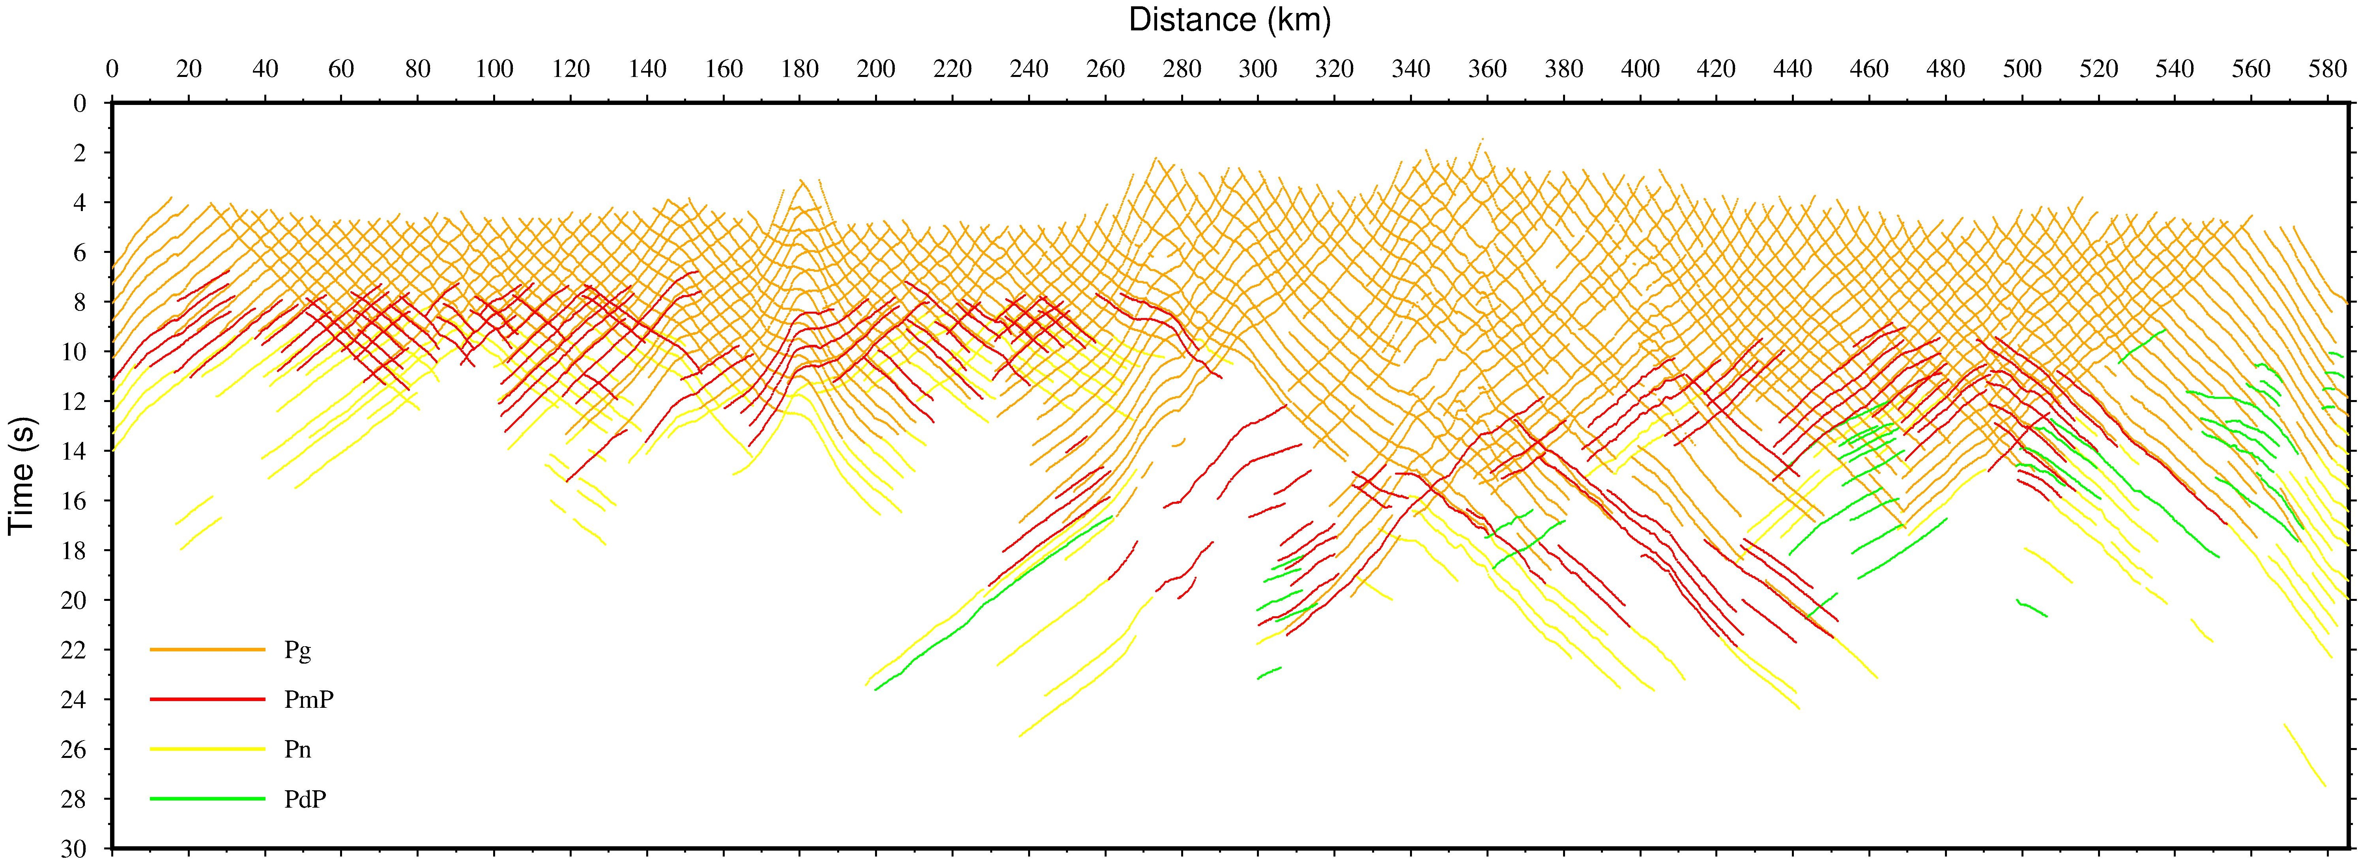

Figure S1. Summarization of all the picking arrivals in all the instruments along profile IBr5.

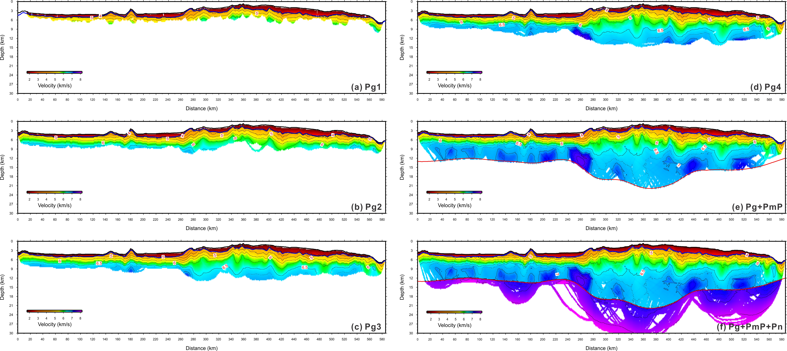

Figure S2. Seismic velocity structures after each step of inversion from Pg1 to Pg+PmP+Pn based on the layer-stripping strategy. See Figure 3 for other captions. See Table 1 for the RMS and χ² values of each step inversion.
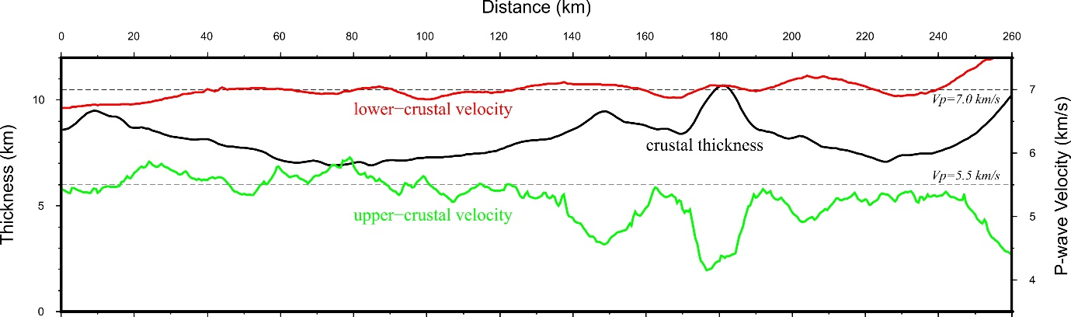

Figure S3. The variation of crustal thickness, upper- and lower-crustal velocity in the Shikoku Basin.

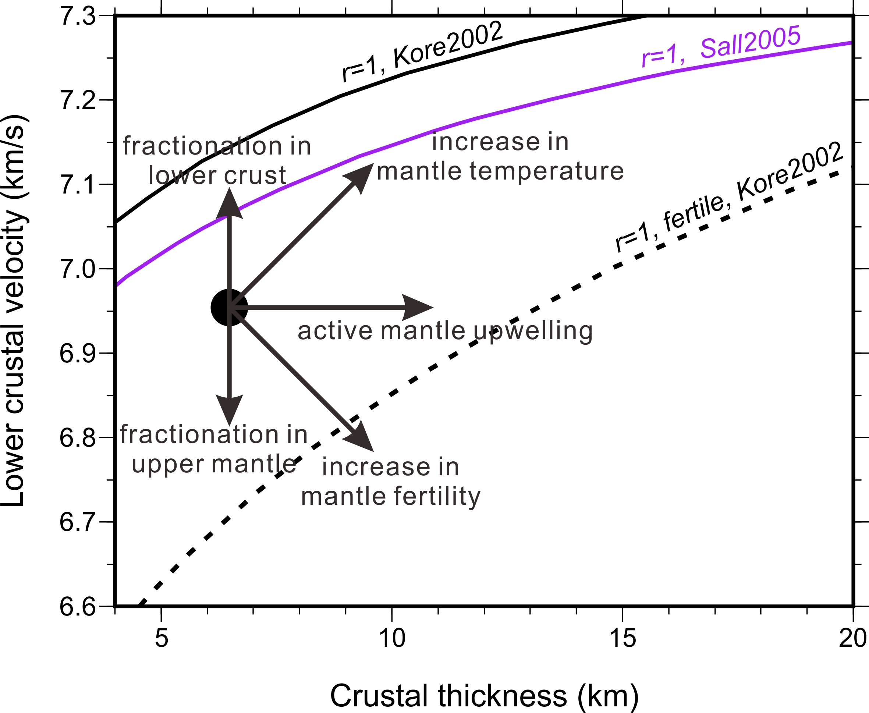

Figure S4. The effect of active mantle upwelling, temperature, fertility, and the position of fractionation on the theoretical mantle melting model of igneous crustal thickness versus P-wave velocity. The arrows show schematically the directions in which the lower crustal velocity and total igneous thickness would change. Other captions can be seen in Figure 8.

