*[Earth and Planetary Science Letters]*

Supporting Information for

**Introduction of isotopically light barium from the Rainbow hydrothermal system into the deep Atlantic Ocean**

Zhouling Zhang1*, Linbin Zhou1,2, Xue-Gang Chen1,3, Eric P. Achterberg1, Yang Yu1, Ed Hathorne1, Zvi Steiner1, Christopher Siebert1, Martin Frank1

1GEOMAR Helmholtz Centre for Ocean Research Kiel, Wischhofstr. 1-3, 24148 Kiel, Germany

2CAS Key Laboratory of Tropical Marine Bio-resources and Ecology, Guangdong Provincial Key Laboratory of Applied Marine Biology, South China Sea Institute of Oceanology, Chinese Academy of Sciences, 510301 Guangzhou, China

3Ocean College, Zhejiang University, 316021 Zhoushan, China

Corresponding author: Zhouling Zhang (zzhang@geomar.de)

**Contents of this file**

Text S1 to S7

Figures S1 to S6

**Additional Supporting Information (File uploaded separately)**

Caption for Dataset S1

**Text S1.** **Details in sampling**

Samples for dBa and its isotopes were filtered (AcroPak™500 cartridges 0.8/0.2 μm) into 1 L acid-cleaned polyethylene bottles (Nalgene) and acidified to pH ~2 with distilled HCl. The bottles were sealed with parafilm and transported to the laboratory at GEOMAR for further analysis of dBa concentration and isotopes. Sampling blanks derived by filtration of MQ water on board under the same conditions as the samples are all in the pmol/kg range and negligible compared to sample concentrations.

Particulate samples (> 0.2 μm) were collected under nitrogen-pressurized filtration (approx. 0.5 bar, 99.999% Alphagaz™ 1). Approximately 3-9 L of seawater were filtered through acid-washed 0.2 μm polyethersulfone (PES) filters (25 mm, Pall), which were placed in Swinnex filter holders and directly attached to the outlet tap of the Niskin bottles. The filters were stored at −20°C for analysis of trace metals in the particulate fraction at GEOMAR.

Seawater samples for helium (He) isotope analyses were collected using a copper tube connected to the Niskin bottles, with water allowed to flow through until air bubbles in the tube were completely removed. The pipe was then closed tightly using an electrical drill and a ratchet to prevent any air from entering. Helium isotopes were analyzed at the University of Bremen. Additionally, 1.5 L samples for tritium analyses were collected at 3 full-depth CTD casts. These samples were analyzed at the University of Bremen, and the tritium data were used to correct the He isotope measurements for any tritium present in the deep-water samples.

**Text S2. Analyses of particulate samples**

Particulate samples were leached and digested following a previously developed protocol (Al-Hashem et al., 2022). Briefly, to extract labile components, particulate samples were leached with a mild reducing agent (0.02 M hydroxylamine hydrochloride, 99.999% TM basis, Aldrich) mixed with a weak acid (25% Acetic Acid, Optima) for a total of 2 hours. Refractory particles were digested using a mixture of 50% nitric acid (Optima, Fisher Scientific) and 10% hydrofluoric acid (UpA grade, Fisher Scientific) (v/v %), with the sample filter adhered to the inner-wall of the digestion vessel and refluxed at 150°C for 15 hours. All labile and refractory samples were dried and re-dissolved in 4.5 mL of 1 M nitric acid (Optima, Fisher Scientific) for storage. The particulate Ba (pBa) and trace metal concentrations (labile particulate trace metal: pTML; refractory particulate trace metal: pTMR) in sub-samples were measured by High-Resolution ICP-MS (Thermo Fisher Element XRTM) at GEOMAR. Calibration of particulate analyses was achieved by 1) collecting procedural blanks with blank polyethersulfone filters during the onboard sampling, 2) using two certified reference materials (BCR-414 plankton (33.93 ± 1.37 µg/g) and PACS-3 marine sediments (824.29 ± 43.32)) and procedure blanks during the lab leaching and digestion work, 3) spiking with an internal rhenium standard for refractory particle digestion, and 4) adding an internal indium standard into the sub-samples ready for ICP-MS test for signal calibration.

**Text S3. Analyses of δ138Ba in dissolved and particulate samples**

For dissolved δ138Ba, a calibrated 130Ba-135Ba double spike was added to 5–8 mL seawater samples. After an equilibration period of 48 hours, Ba was precipitated from seawater as a carbonate by a stepwise addition of 1.1 M Na2CO3 solution. The supernatant was removed and the residual precipitate was dissolved in 1 M HCl for cation exchange chromatography. For particulate δ138Ba determination, the same 130Ba-135Ba double spike was added to labile leachates and refractory digests. After an equilibration period of 48 hours, the sample solutions were dried down overnight at 80°C and re-dissolved in 1 M HCl. For most of the labile leachates, Ba concentrations were not high enough to conduct Ba isotope measurements. Therefore, labile leachates from 2–3 adjacent depths (only those with similar dBa and labile particulate Ba concentrations) were combined for Ba isotope measurements. Sample solutions from both dissolved and particulate phases were further purified twice using ion exchange chromatography (cation exchange resin: BIORAD® AG50W-X8 resin) before measurement. Finally, the purified sample solutions were introduced as a dry aerosol into the plasma using an Aridus II desolvator. The MC-ICP-MS was tuned to a matrix tolerance state defined by a high Normalised Argon Index value (NAI, an index of plasma temperature; Yu et al., 2020).

Long-term repeated measurements of in-house seawater reference materials yielded δ138Ba values of 0.55 ± 0.05‰ (2 standard error (SD), N=26) and 0.47 ± 0.04‰ (2SD, N=18) for BATS 15m and 2000m, respectively, over a course of three years. International seawater reference samples SAFe surface and SAFe 1000m yielded values of 0.62 ± 0.03‰ (2SD, N = 6) and 0.29 ± 0.03‰ (2SD, N = 19), respectively, within error identical to those published in (Cao et al., 2021; Geyman et al., 2019; Hsieh and Henderson, 2017). Carbonate reference material JCp-1 yielded a value of 0.29 ± 0.03‰ (2SD, N=27), which is also identical within error to those reported (see references above).

**Text S4. Calculation of excess Ba**

Excess particulate Ba (pBaXS), which is considered non-lithogenic Ba, consists of authigenic barite, biogenic Ba (e.g. incorporated into SrSO4 *acantharia* skeletons or associated with organic matter) and Ba adsorbed onto metal oxyhydroxides. The pBaXS can be empirically derived by subtracting lithogenic Ba from total particulate Ba (pBaT). Here we use the recommended Ba:Al ratio of 0.0015 mol:mol in the upper continental crust (Rudnick and Gao, 2014) and pAlT to determine lithogenic Ba:

$p{Ba}_{XS}=p{Ba}_{T}-{\left(\frac{Ba}{Al}\right)}_{UCC}× p{Al}_{T}$ (1)

**Text S5. Two-endmember conservative mixing model calculation**

In case the concentrations of 3Hexs and Ba in the hydrothermal plume are only controlled by two-endmember conservative mixing, they can be calculated as follows:

$f_{1}+f_{2}=1$ (2)

${}_{}^{3}{{He}_{xs}}={}_{}^{3}{{He}_{xs_1}}×f_{1}+{}_{}^{3}{{He}_{xs_2}}×f_{2}$ (3)

$Ba={Ba}_{1}×f_{1}+{Ba}_{2}×f_{2}$ (4)

$δ{}_{}^{138}{Ba}=\frac{(δ{}_{}^{138}{{Ba}_{1}}×{Ba}_{1}×f_{1}+δ{}_{}^{138}{{Ba}_{2}}×{Ba}_{2}×f_{2})}{Ba}$ (5)

where 3Hexs, Ba and δ138Ba represent the excess 3He, Ba concentration and δ138Ba of samples in the plume. *f1* and *f2* represent the fraction of the two endmember water masses. 3Hexs_1 (or 3Hexs_2), Ba1 (or Ba2), and δ138Ba1 (or δ138Ba2) represent the endmember excess 3Hexs, Ba concentration and δ138Ba of water mass 1 (or 2), respectively.

Based on these equations, both 3Hexs and Ba follow a linear regression with f1 (or f2):

(6)

(7)

while δ138Ba follows a rational function regression of f1 (or f2).

(8)

as f1 can be represented by 3Hexs

(9)

Hence in principle, two endmember conservative mixing should lead to a linear regression between Ba and 3Hexs, and to a rational function regression between δ138Ba and 3Hexs.

**Text S6: Ba stabilization at lower temperatures (0-160°C)**

1) BaSO4(0) ion pairs (the orange curve in Fig.S5)

The CHNOSZ calculation (Fig.S5) is based on a strong electrolyte model. However, ion pairs can form in weak electrolytes where the complete dissociation hypothesis is no longer valid (see more details in Monnin, 1999). Therefore, ion pair formation can significantly reduce the number of free ions and consequently the saturation index of a sulfate mineral.

Here, we use the empirical equation proposed by Monnin (1999) to calculate the solubility concentration of BaSO40 (aq) ion pair:

$$\ln{K_{ip}}=-6.5032+\frac{383.677}{T}$$

$$m_{{{BaSO}_{4}}^{0}}=\frac{K_{sp}}{K_{ip}}∙\frac{1}{γ_{{{BaSO}_{4}}^{0}}}$$

where *Ksp* is the solubility product; *Kip* stands for the equilibrium constant for the equilibrium reaction between the BaSO40 (aq) ion pair and aqueous Ba2+ (aq) and SO42- (aq); *m* and *γ* are the molarity and activity coefficient of BaSO40 (aq) ion pair, respectively.

Here, we define the ion pair index (I.P.I.; the red line in fig. S5) to quantify the extent to which Ba can be stabilized through ion pair formation. This index is calculated as follows:

$$I.P.I. =\log{ (\frac{{Ba}_{mix}}{{{BaSO}_{4}}^{0}})}$$

Where Bamix is the theoretical Ba concentration in the Rainbow plume resulting from the mixing between the Rainbow vent fluid endmember and North Atlantic Deep Water. When the I.P.I. ≤ 0, it indicates that all the total Ba can be stabilized by BaSO40 (aq) ion pair.

As shown in Fig.S5 (orange curve), all Ba ions at temperature below ~ 160 °C can be stabilized by BaSO40 (aq) ion pair. At temperatures above ~160 °C, the presence of BaSO4(0) ion pairs also decreases the concentration of free Ba ions in the system, consequently reducing the S.I.

2) barite impurity, potential influence of Sr (the solid black curve)

The influence of Sr on the *Ksp* of barite (only valid up to 50°C) was discussed in Rushdi et al. (2000). The authors determined the stoichiometric solubility products of Sr-bearing barite as a function of salinity and temperature, which we employ here to calculate the *Ksp* of barite at temperatures below 50°C:

$$\ln{K_{sp}}=247.88-38.333 ×Ln T-\frac{15421}{T}+1.27×S^{0.3}$$

As shown in Figure S5, the presence of Sr increases the log *Ksp* of Sr-bearing barite, consequently leading to a decrease in the S.I. of barite.

**Text S7. Error propagation of the global endmember Ba to 3He ratio**

For the function f = A/B, the error of f is calculated as:

$$σ_{f}≈\left|f\right|\sqrt{{(\frac{σ_{A}}{A})}^{2}+{(\frac{σ_{B}}{B})}^{2}+2\frac{σ_{AB}}{AB}}$$

$$σ_{AB}=ρ_{AB}σ_{A}σ_{B}$$

A and B are the function variables, represent the mean concentrations of Ba and 3He in the endmembers, respectively. σA and σB are the standard deviations of A and B, respectively. σAB is the covariance. ρAB is the correlation.

Coexisting datasets of vent fluid Ba and 3He concentrations have shown a significant correlation between these two variables. Hence, ρAB is calculated to be 0.94 (Pearson correlation coefficient).

**Figure S1:** A visualization of the decay in turbidity, and therefore plume particle density, with distance from the vent field down-plume (Achterberg and Steiner, 2021). A) a turbidity versus distance down-plume from the Rainbow vent field plot, with an exponential fit. B) The depths of the peak turbidity signal from each vertical CTD cast are shown colored based on its turbidity value, with the top and bottom of the plume (when observed) represented by crosses.



**Figure S2:** Distribution of (a) 3Hexs, (b) dBa, (c) pBaL and (d) pBaT along the whole transect following the dissipating hydrothermal plume. The figure is generated using ODV (Schlitzer, 2023) with the DIVA (Data-Interpolating Variational Analysis) gridding interpolation method. Notably, the x-axis is significantly stretched on the left side.

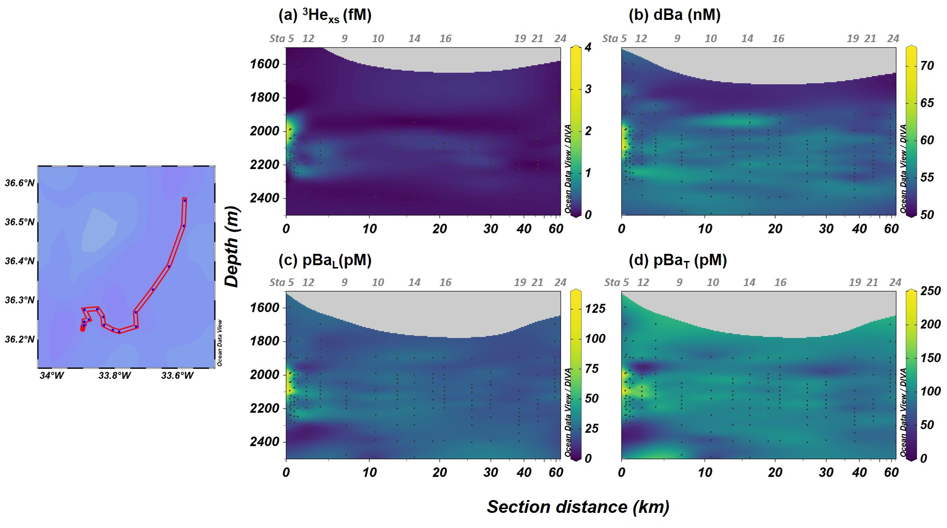

**Figure S3:** An illustration of the particulate Ba composition. The complete circle represents the total particulate Ba (pBaT), which consists of the labile particulate Ba (pBaL) and the refractory particulate Ba (pBaR). The overlying transparent area represents the excess particulate Ba (pBaxs). Subtracting the pBaxs from the pBaT yields the lithogenic Ba fraction.

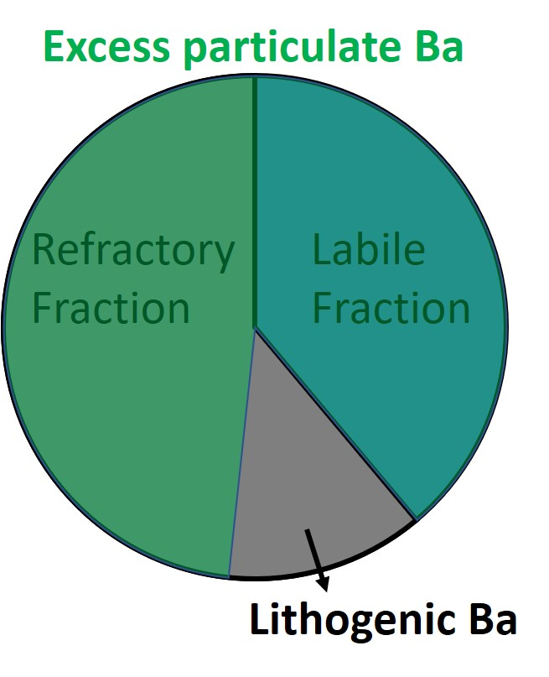

**Figure S4.** Cross plots of pBaxs (a,b) and refractory pBaxs (c,d) versus 3Hexs (a,c) and pFeL (b,d).

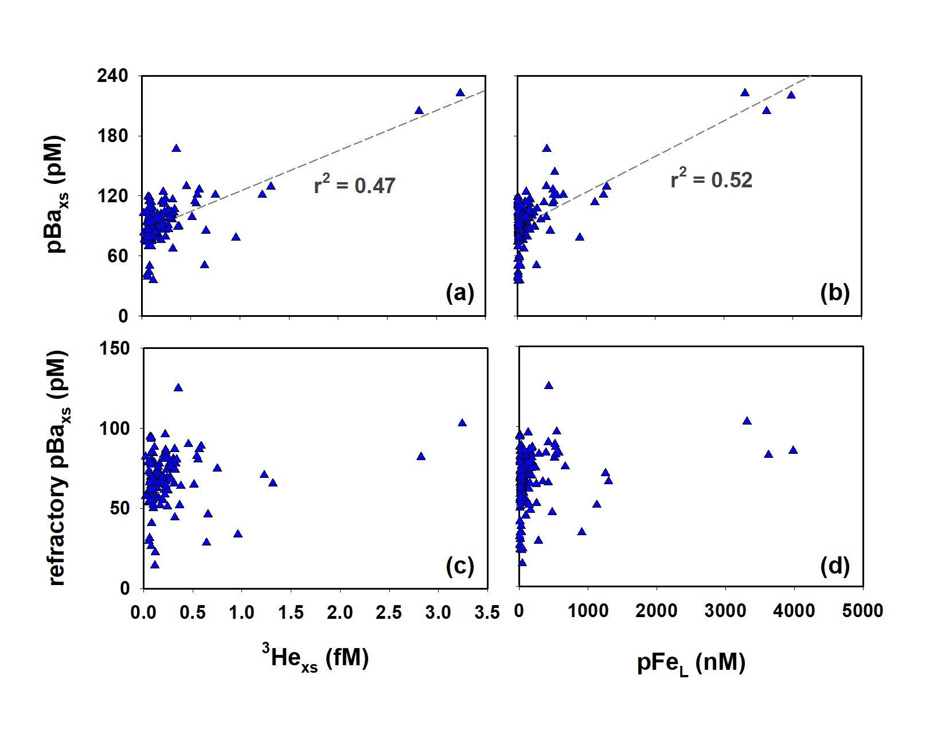

**Figure S5.** Geochemical model of the saturation index (log Q/K) for anhydrite (black dashed curve) and barite (blue curve) assuming conservative mixing with respect to temperature between Rainbow vent fluids (Ba = 117 μM, Ca = 73.2 mM (Konn et al., 2022), SO4 =0, T =364°C) and NADW (Ba = 0.05 μM, Ca = 10.5 mM, SO4 = 28 mM, T = 2°C). Both curves were constructed with the help of *R* package CHNOSZ (Dick, 2019). Q is the activity product and K is the equilibrium constant. Saturation index of zero means mineral-fluid equilibrium, positive values imply supersaturation and potential precipitation, and negative values indicate undersaturation favoring dissolution. In addition, the black solid curve represents the S.I. based on the empirical equation for the solubility products of strontian barite (Rushdi et al., 2000). The orange curve represents the ion pair index (I.P.I, right y-axis) for the BaSO4(0) (aq) ion pair formation based on the empirical equation in Monnin (1999). Details of calculations can be found in Text S7.

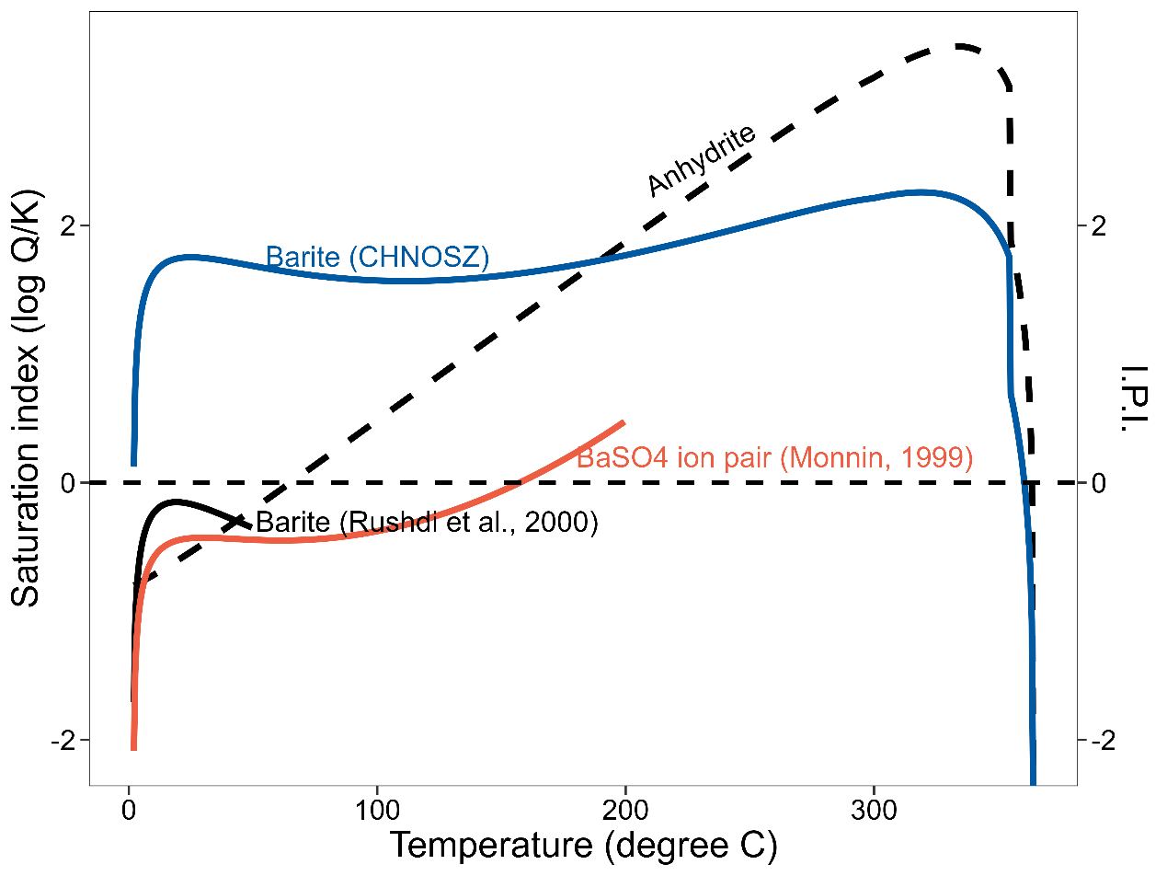

**Figure S6.** Cross plot of vent fluid concentrations of Ba versus Mg compiled in MARHYS 3.0, an updated version of the MARHYS database (Diehl and Bach, 2020)

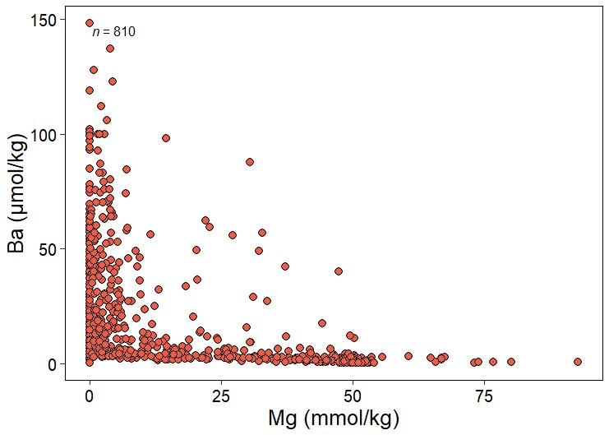

**Dataset S1.**

The dissolved (<0.2 μm), labile particulate (>0.2 μm), and refractory particulate (>0.2 μm) barium concentrations and stable isotopes, labile particulate iron concentrations (>0.2 μm), as well as helium isotopes from cruise M176/2 onboard the German R/V Meteor from September to October 2021. This dataset is available on PANGAEA for the He isotopes data (https://doi.org/10.1594/PANGAEA.961104) and Ba concentration and isotope data (https://doi.org/10.1594/PANGAEA.961129)

**References**

Achterberg, E., Steiner, Z., 2021. Rainbow non-boyant hydrothermal plume GEOTRACES study, Cruise No. M176/2, 01.09.2021-06.10.2021, Emden (Germany) - Emden (Germany). https://doi.org/https://doi.org/10.48433/cr_m176_2

Al-Hashem, A.A., Beck, A.J., Krisch, S., Menzel Barraqueta, J.L., Steffens, T., Achterberg, E.P., 2022. Particulate Trace Metal Sources, Cycling, and Distributions on the Southwest African Shelf. Global Biogeochem. Cycles 36. https://doi.org/10.1029/2022GB007453

Cao, Z., Rao, X., Yu, Y., Siebert, C., Hathorne, E.C., Liu, B., Wang, G., Lian, E., Wang, Z., Zhang, R., Gao, L., Wei, G., Yang, S., Dai, M., Frank, M., 2021. Stable Barium Isotope Dynamics During Estuarine Mixing. Geophys. Res. Lett. 48, 1–11. https://doi.org/10.1029/2021GL095680

Geyman, B.M., Ptacek, J.L., LaVigne, M., Horner, T.J., 2019. Barium in deep-sea bamboo corals: Phase associations, barium stable isotopes, & prospects for paleoceanography. Earth Planet. Sci. Lett. 525, 115751. https://doi.org/10.1016/j.epsl.2019.115751

Hsieh, Y., Henderson, G.M., 2017. Barium stable isotopes in the global ocean: Tracer of Ba inputs and utilization. Earth Planet. Sci. Lett. 473, 269–278. https://doi.org/10.1016/j.epsl.2017.06.024

Jamieson, J.W., Hannington, M.D., Tivey, M.K., Hansteen, T., Williamson, N.M.B., Stewart, M., Fietzke, J., Butterfield, D., Frische, M., Allen, L., Cousens, B., Langer, J., 2016. Precipitation and growth of barite within hydrothermal vent deposits from the Endeavour Segment, Juan de Fuca Ridge. Geochim. Cosmochim. Acta 173, 64–85. https://doi.org/10.1016/j.gca.2015.10.021

Konn, C., Donval, J.P., Guyader, V., Germain, Y., Alix, A., Roussel, E., Rouxel, O., 2022. Deep-Sea Research Part I Extending the dataset of fluid geochemistry of the Menez Gwen , Lucky Strike , Rainbow , TAG and Snake Pit hydrothermal vent fields : Investigation of temporal stability and organic contribution. Deep. Res. Part I 179, 103630. https://doi.org/10.1016/j.dsr.2021.103630

Rudnick, R.L., Gao, S., 2014. Composition of the Continental Crust, in: Treatise on Geochemistry. Elsevier, pp. 1–51. https://doi.org/10.1016/B978-0-08-095975-7.00301-6

Yu, Y., Siebert, C., Fietzke, J., Goepfert, T., Hathorne, E., Cao, Z., Frank, M., 2020. The impact of MC-ICP-MS plasma conditions on the accuracy and precision of stable isotope measurements evaluated for barium isotopes. Chem. Geol. 549, 119697. https://doi.org/10.1016/j.chemgeo.2020.119697