Journal of Geophysical Research: Biogeosciences

Supporting Information for

**Allochthonous groundwater microorganisms affect coastal seawater microbial abundance, activity and diversity**

Keren Yanuka-Golub1,4,5, Natalia Belkin2, Nurit Weber1, Meor Mayyani1, Yehuda Levy1,3, Itay J. Reznik3, Maxim Rubin-Blum2, Eyal Rahav2†, Yael Kiro1

1 Department of Earth and Planetary Sciences, Weizmann Institute of Science, Rehovot 7610001, Israel.

2 Israel Oceanographic and Limnological Research, National Institute on Oceanography, Haifa, 310220, Israel.

3 Geological Survey of Israel, Jerusalem 96921, Israel.

4 The Institute of Applied Research, The Galilee Society, ShefaAmr 2020000, Israel.

5 The Institute of Evolution (IoE), Haifa University, Haifa, Israel]

**Contents of this file**

Figures S1 to S9

Table S1 to S2

**Introduction**

This Supporting Information contains nine additional figures and two additional tables on microbial abundance and activity, nutrient concentration changes during experiment 2 and 3; mixing lines of porewater and surface seawater measurements vs. water density collected from Achziv beach; significantly differentially abundant taxa and microbiota composition. Table S1 summarizes activity, abundance and community composition of all samples collected during the study (three incubation experiments and three field campaigns). Table S2 compares result of pairwise PERMANOVA analysis based on the Non-metric multidimensional scaling (NMDS) analyses of the entire community.

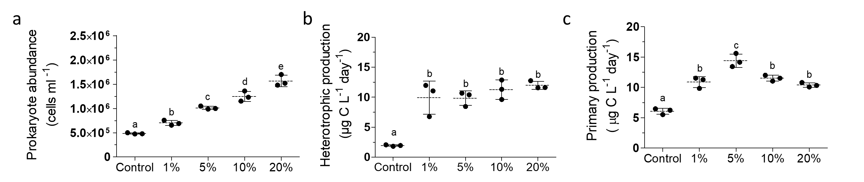

**Figure S1.** Scatter dot plots of surface seawater (control) prokaryote abundance (a), heterotrophic production rate (b) and primary production rate (c) following dilution with discharged brackish groundwater (1-20% v:v) or un-amended seawater (control). Results are shown for the 2nd time point of the experiment (42Hr.) as described in the text. Lowercase letters indicate significant differences between treatments (using ANOVA followed by Tukey Post hoc tests, p ≤ 0.05). The temporal variability of all time points is shown in Supplementary Information (S2). **Here, the dilution factor was not calculated** (See Figure 2 in main text for normalized results).

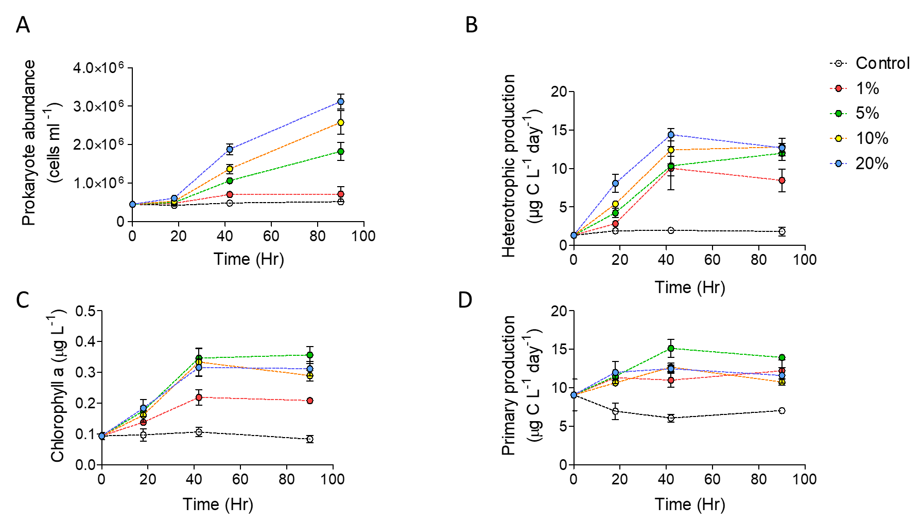

Figure S2. Temporal variability of surface seawater (control) prokaryote abundance (A), heterotrophic production rate (B) primary production rate (C) and Chlorophyll a concentrations (D) following dilution with discharged brackish groundwater (1-20% v:v) or un-amended seawater (control) during Experiment 1. The dilution factor was calculated for each treatment to account for the volume of groundwater added to ambient seawater.

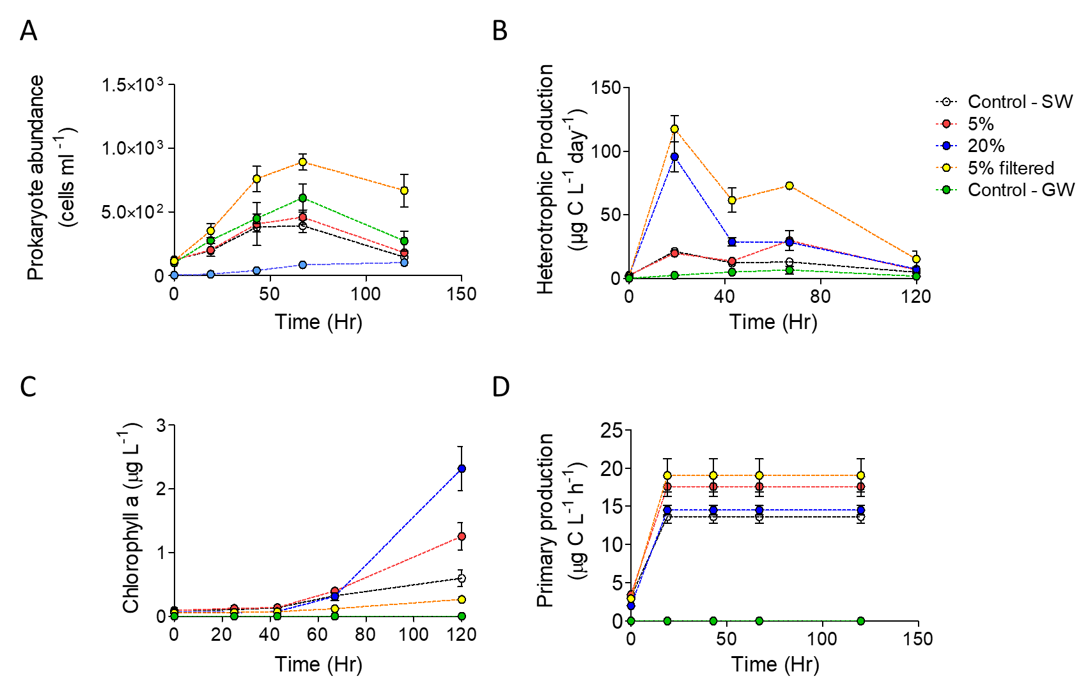

Figure S3. Temporal variability of surface seawater (control) prokaryote abundance (A), heterotrophic production rate (B) primary production rate (C) and Chlorophyll a concentrations (D) following dilution with fresh groundwater (5%, 20% and 5% filtered 0.1 μm v:v), un-amended seawater (control SW) or fresh groundwater (Control GW) during Experiment 2. The dilution factor was calculated for each treatment to account for the volume of groundwater added to ambient seawater.

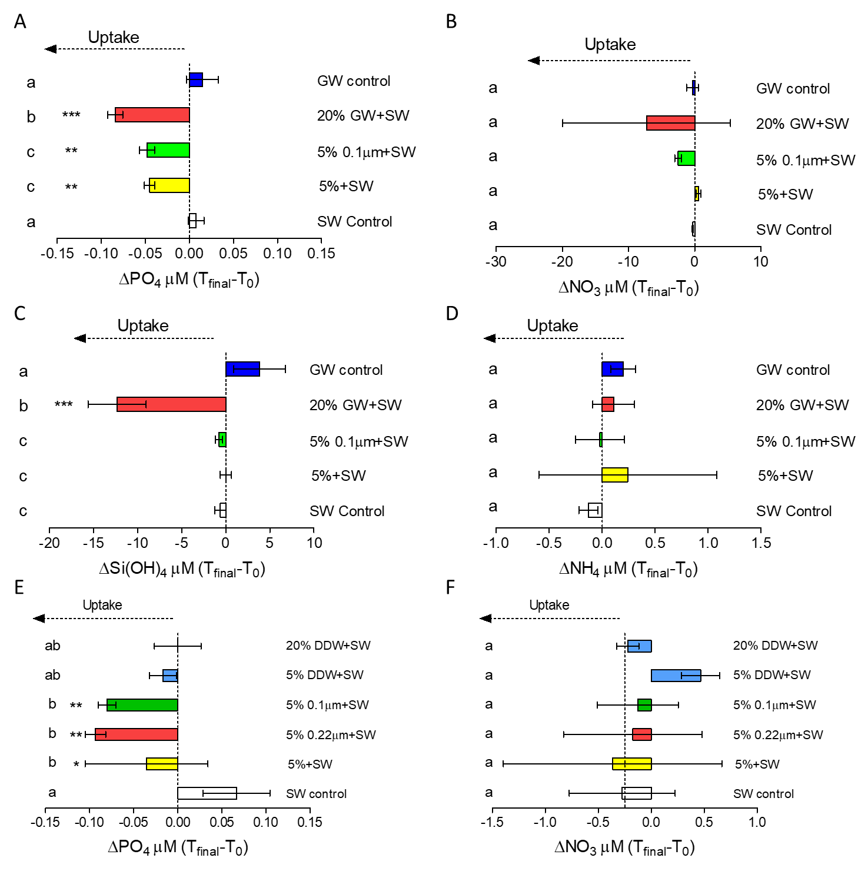

Figure S4. Change in phosphate (A), nitrate (B), silicate (C), ammonium (D) concentrations in the water of each treatment over the 5-day interval of experiment 2. Change in phosphate (E) and nitrate (F) concentrations in the water of each treatment over the 5-day interval of experiment 3. Negative values indicate microbial uptake. Units are in μM. Lowercase letters indicate significant differences between treatments (using ANOVA followed by Tukey posthoc tests, p ≤ 0.05).

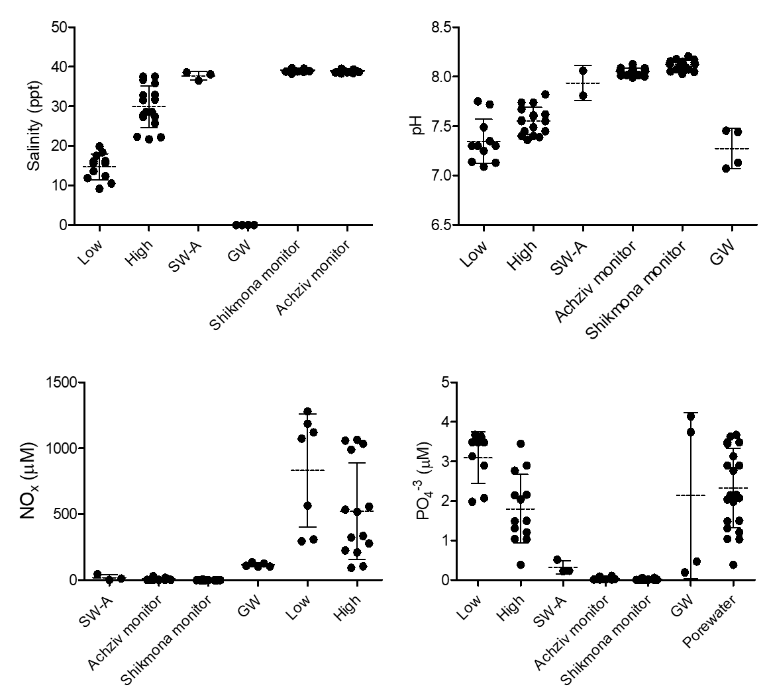Figure S5. Scatter dot plots of salinity, pH, Nox and phosphate concentrations measured for Achziv surface seawater (SW-A), fresh groundwater (GW), low- and high-salinity porewater (Low and High, respectively) and two-year monitoring measurements of Achziv and Shikmona (reference site). Statistical analysis is described in Table 2 (main text).

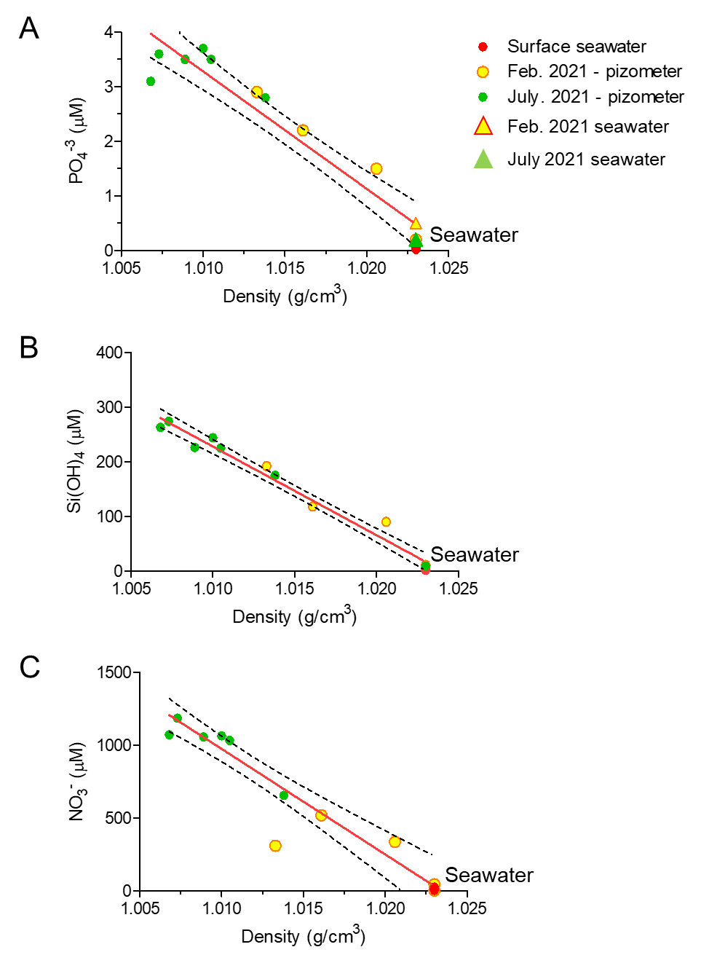

Figure S6. (A) PO4-3 (B) Si(OH)4 (C) NO3- vs. water density in porewater using piezometers (Figure 1, main text) and open seawater from Achziv beach.

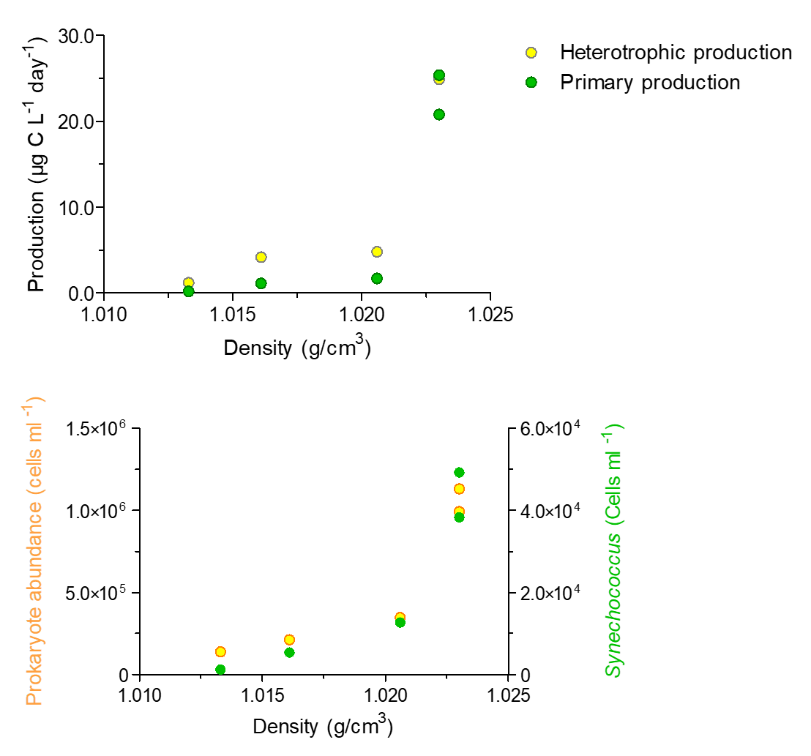

Figure S7: Microbial production (top) and abundance (bottom) vs. water density in porewater using piezometers (Figure 1, main text) and open seawater from Achziv beach.

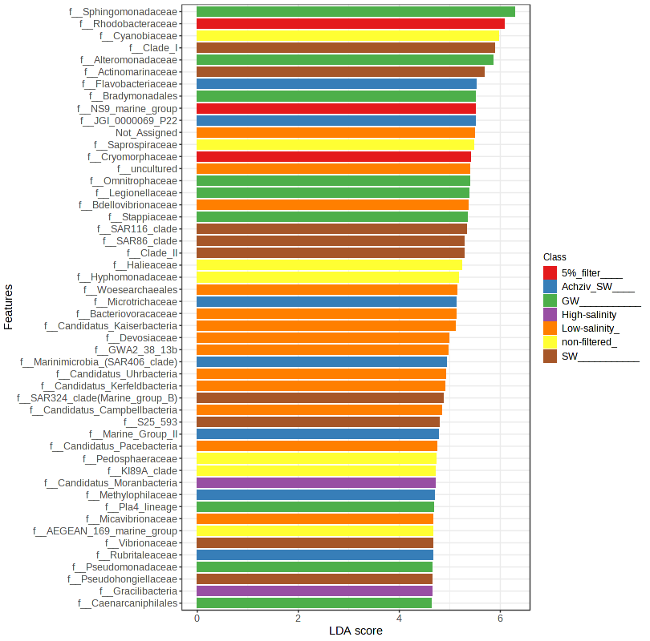

Figure S8: Linear discriminant effect size analysis (LEfSe) of top 50 significantly differentially abundant taxa (>3-fold change of relative ASV) of different experimental and field groups.

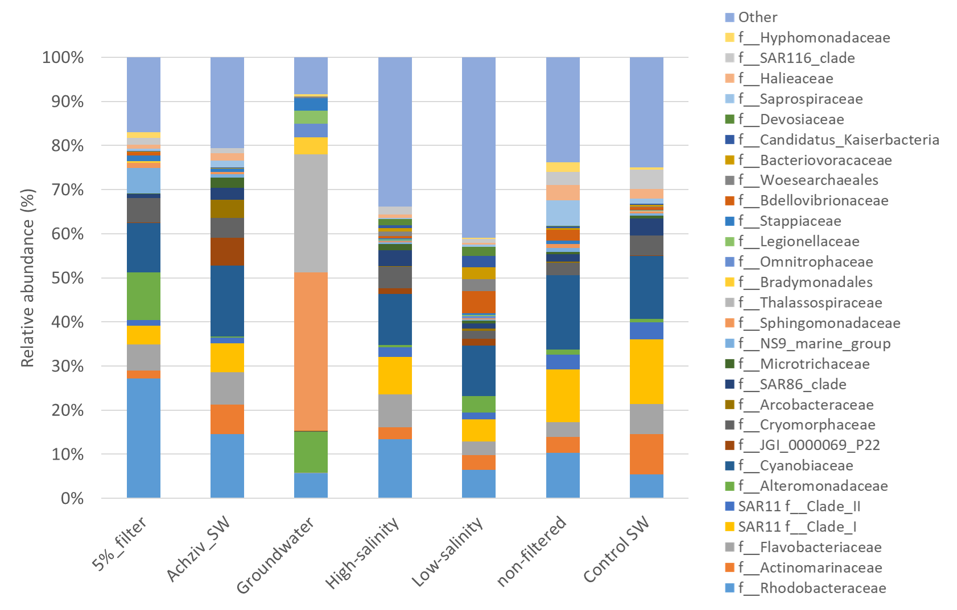

**Figure S9**: Stacked bar-plot representation of microbiota compositions with taxonomic features at the level of families. Families with abundance higher than 2.0% are grouped as others.

Table S1: Summary of community composition, activity and microbial abundance averaged by sample groups

|  |  |  |  |  |  |  |  |  |  |  |
| --- | --- | --- | --- | --- | --- | --- | --- | --- | --- | --- |
| Sample source | Group | Relative abundance (%) of four  marine dominant families | | | | | Abundance and activity a, b | | | |
| *Synechococcus*  Cyanobacteriia | *Rhodobacteraceae*  Alphaproteobacteria | *Actinomarinaceae*  Acidimicrobiia | SAR11 Clade  Alphaproteobacteria | *Alteromonadaceae*  Gammaproteobacteria | Prokaryote abundance (Cells/ml) | Heterotrophic production  (µg C L-1 day-1) | *Synechococcus* abundance  (Cells/ml) | Primary production  (µg C L-1 day-1) |
| Environmental  Achziv study site | Low-salinity  porewater | 11.4% | 6.4% | 3.4% | 5.1% | 3.7% | 1.3x  105 | 1.2±0.2 | 1.2x103 | 0.2± 0.09 |
| High-salinity  porewater | 12.2% | 14.1% | 2.9% | 8.9% | 0.5% | 2.8x  105 | 4.5±2.2 | 9.0x103 | 1.4±0.3 |
| Achziv surface seawater | 17.63% | 15.86% | 7.35% | 7.12% | 0.31% | 1.0x  106 | 29.3±  6.3 | 3.7x104 | 27.0±  7.1 |
| Incubation experiments | Control seawater | 15.2% | 5.8% | 9.7% | 15.7% | 0.8% | 4.9x  105 | 6.8±5.6 | 3.7 x104 | 9.7±3.7 |
| Non-filtered: | 18.2% | 11.1% | 3.9% | 12.9% | 1.3% | 9.9x  105 | 17.6±  9.0 | **1-5%:**  2.5 x104  **20%:**  2.0 x104 | 14.6±  2.8 |
| 5%-filtered | 12.53% | 30.35% | 1.88% | 4.61% | 12.01% | 1.02 x  106 | 42.8±  33.1 | 7.3 x104 | 16.6±  4.1 |
| Fresh groundwater | 0.0% | 5.8% | 0.0% | 0.0% | 9.3% | 4.5 x  105 | 8.5±2.9 | 1.8 x102 | 0.2±0.3 |

a Results for abundance and activity of field samples were measured for one campaign (February 2021).

b Bottle incubation results include all values measured for experiments 1-3 after 40-72 hr. incubation time.

**Table S2:** Result of pairwise PERMANOVA analysis based on the Non-metric multidimensional scaling (NMDS) analyses of the entire community (Figure 5). The multi-testing adjustment is based on Benjamini-Hochberg procedure procedure (FDR).

|  |  |  |  |  |
| --- | --- | --- | --- | --- |
| **Pair** | **F-value** | **R-squared** | **P-value** | **FDR** |
| GW vs Low-salinity | 1.502 | 12.302 | 0.486 | 0.004 |
| GW vs Achziv SW | 1.730 | 29.709 | 0.730 | 0.007 |
| GW vs High-salinity | 1.632 | 23.598 | 0.682 | 0.006 |
| GW vs control SW | 1.327 | 39.435 | 0.887 | 0.034 |
| GW vs non-filtered | 1.611 | 28.635 | 0.705 | 0.004 |
| **GW vs 5% filter** | **0.913** | **27.443** | **0.873** | **0.100** |
| Low-salinity vs Achziv SW | 1.290 | 12.445 | 0.384 | 0.001 |
| Low-salinity vs High-salinity | 0.488 | 4.451 | 0.182 | 0.004 |
| Low-salinity vs control SW | 0.753 | 6.581 | 0.320 | 0.002 |
| Low-salinity vs non-filtered | 1.178 | 11.741 | 0.359 | 0.001 |
| Low-salinity vs 5% filter | 0.704 | 5.843 | 0.310 | 0.002 |
| Achziv_SW vs High-salinity | 0.436 | 6.291 | 0.259 | 0.001 |
| Achziv_SW vs control SW | 0.310 | 5.689 | 0.322 | 0.009 |
| Achziv_SW vs non-filtered | 0.579 | 9.471 | 0.333 | 0.001 |
| Achziv_SW vs 5% filter | 0.349 | 6.196 | 0.360 | 0.005 |
| High-salinity vs control SW | 0.347 | 5.370 | 0.309 | 0.002 |
| High-salinity vs non-filtered | 0.693 | 10.283 | 0.351 | 0.001 |
| High-salinity vs 5% filter | 0.426 | 6.334 | 0.365 | 0.005 |
| control SW vs non-filtered | 0.189 | 3.571 | 0.216 | 0.021 |
| control SW vs 5% filter | 0.426 | 14.452 | 0.743 | 0.033 |