**Supplementary information for**

**Promoting effects of aluminum addition on chlorophyll biosynthesis and growth of two cultured iron-limited marine diatoms**

Linbin Zhou1, 2, 3*, Fengjie Liu2, 4, Eric P. Achterberg2, Anja Engel2, Peter G.C. Campbell5, Claude Fortin5, Liangmin Huang1, 3, Yehui Tan1, 3*

1 CAS Key Laboratory of Tropical Marine Bio-resources and Ecology, Guangdong Provincial Key Laboratory of Applied Marine Biology, South China Sea Institute of Oceanology, Chinese Academy of Sciences, Guangzhou, China

2 Marine Biogeochemistry Division, GEOMAR Helmholtz Centre for Ocean Research, 24148 Kiel, Germany

3 University of Chinese Academy of Sciences, Beijing, China

4 Grantham Institute - Climate Change and the Environment and Department of Life Sciences, Imperial College London, London, SW7 2AZ, United Kingdom

5 Institut national de la recherche scientifique, Centre Eau Terre Environnement, Québec, Canada

Corresponding authors: L. Zhou (zhoulb@scsio.ac.cn), Y. Tan (tanyh@scsio.ac.cn)

Running head: Effects of Al on Fe-limited diatoms

**Table S1** Recipes for the experimental media

|  |  |  |  |  |  |  |
| --- | --- | --- | --- | --- | --- | --- |
|  | Fe-limited experimental media | | | Fe-sufficient experimental media | | |
| Treatments | Control | 20 nM Al | 100 nM Al | Control | 20 nM Al | 100 nM Al |
| AlCl3 (nM) | 0 | 20 | 100 | 0 | 20 | 100 |
| Nitrate (μM） | 100 | 100 | 100 | 100 | 100 | 100 |
| Phosphate (μM） | 10 | 10 | 10 | 10 | 10 | 10 |
| Silicate (μM） | 100 | 100 | 100 | 100 | 100 | 100 |
| EDTA (μM） | 100 | 100 | 100 | 100 | 100 | 100 |
| FeCl3 (nM) | 40 | 40 | 40 | 500 | 500 | 500 |
| ZnSO4 (nM) | 79.7 | 79.7 | 79.7 | 79.7 | 79.7 | 79.7 |
| MnCl2 (nM) | 121 | 121 | 121 | 121 | 121 | 121 |
| CoCl2 (nM) | 50.5 | 50.5 | 50.5 | 50.5 | 50.5 | 50.5 |
| CuSO4 (nM) | 19.6 | 19.6 | 19.6 | 19.6 | 19.6 | 19.6 |
| Na2SeO3 (nM) | 10 | 10 | 10 | 10 | 10 | 10 |
| Vitamin B12 (µg/L) | 0.55 | 0.55 | 0.55 | 0.55 | 0.55 | 0.55 |
| Biotin (µg/L) | 0.50 | 0.50 | 0.50 | 0.50 | 0.50 | 0.50 |
| Thiamine (µg/L) | 0.10 | 0.10 | 0.10 | 0.10 | 0.10 | 0.10 |

**Table S2**. Chemical composition of artificial seawater according to Sunda et al. (2005)

|  |  |
| --- | --- |
| Component | Concentration (M) |
| Cl- | 0.5597176 |
| Na+ | 0.4800514 |
| SO42- | 2.88E-02 |
| K+ | 1.023E-02 |
| CO32- | 2.38E-03 |
| Br- | 8.40E-04 |
| H3BO3 | 4.85E-04 |
| F- | 7.14E-05 |
| Mg2+ | 5.46E-02 |
| Ca2+ | 1.05E-02 |
| Sr2+ | 6.38E-05 |
| H4SiO4 | 1.00E-04 |
| NO3- | 1.00E-04 |
| PO43- | 1.00E-05 |

**Table S3**. Fe uptake parameters indicated by the linear regression of cellular Fe with exposure time for *T. weissflogii* cells in treatments enriched with different concentrations of aluminum (Al). The data are expressed as mean ± standard error (n = 9). The symbols *, and ** indicate significant (*p* < 0.05), and highly significant (*p* < 0.01) differences compared to the control, respectively.

|  |  |  |  |  |  |
| --- | --- | --- | --- | --- | --- |
| Treatments | Intercept (initial binding sites) | | Slope (uptake rate) | | R2 |
| fmol/cell | amol/μm2 | fmol/cell/h | amol/μm2/h |
| Control | 0.006 ± 0.017 | 0.013 ± 0.042 | 0.218 ± 0.005 | 0.529 ± 0.011 | 0.997 |
| + 20 nM Al | 0.056 ± 0.022* | 0.135 ± 0.055* | 0.171 ± 0.006** | 0.414 ± 0.014** | 0.992 |
| + 100 nM Al | 0.084 ± 0.022** | 0.205 ± 0.053** | 0.193 ± 0.006** | 0.468 ± 0.014** | 0.994 |

**Table S4** The calculated speciation of dissolved iron (40 nM) in seawater media buffered with 100 µM EDTA enriched with different concentrations (0, 20, and 100 nM) of dissolved aluminum. The speciation and concentrations of dissolved iron were calculated with Visual MINTEQ model version 3.1. The pH was set at 8.1, and the temperature was 20oC. The component of seawater is listed in Table S2. The results show that the addition of Al does not influence the speciation of dissolved iron in seawater media.

|  |  |  |  |
| --- | --- | --- | --- |
| Iron speciation | Control | + 20 nM Al | + 100 nM Al |
| Fe(OH)2+ | 6.63E-13 | 6.63E-13 | 6.63E-13 |
| Fe(OH)3 (aq) | 2.30E-14 | 2.30E-14 | 2.30E-14 |
| Fe(OH)4- | 5.06E-14 | 5.06E-14 | 5.06E-14 |
| Fe(SO4)2- | 9.93E-23 | 9.93E-23 | 9.93E-23 |
| Fe3+ | 3.54E-22 | 3.54E-22 | 3.54E-22 |
| Fe2(OH)2(EDTA)24- | 9.94E-13 | 9.94E-13 | 9.94E-13 |
| Fe2(OH)24+ | 9.06E-31 | 9.06E-31 | 9.06E-31 |
| Fe3(OH)45+ | 1.86E-39 | 1.86E-39 | 1.86E-39 |
| FeBr2+ | 1.63E-25 | 1.63E-25 | 1.63E-25 |
| FeCl2+ | 7.28E-22 | 7.28E-22 | 7.28E-22 |
| FeEDTA- | 7.69E-09 | 7.69E-09 | 7.69E-09 |
| FeF2+ | 2.24E-21 | 2.24E-21 | 2.24E-21 |
| FeF2+ | 1.00E-21 | 1.00E-21 | 1.00E-21 |
| FeF3 (aq) | 1.82E-23 | 1.82E-23 | 1.82E-23 |
| FeH2BO32+ | 5.69E-20 | 5.69E-20 | 5.69E-20 |
| FeH2PO42+ | 1.16E-24 | 1.16E-24 | 1.16E-24 |
| FeHEDTA (aq) | 1.28E-15 | 1.28E-15 | 1.28E-15 |
| FeHPO4+ | 1.98E-18 | 1.98E-18 | 1.98E-18 |
| FeOH2+ | 7.77E-17 | 7.77E-17 | 7.77E-17 |
| FeOHEDTA2- | 3.23E-08 | 3.23E-08 | 3.23E-08 |
| FeSO4+ | 1.83E-21 | 1.83E-21 | 1.83E-21 |

Gustafsson, J. P. (2019). Visual MINTEQ. Stockholm, Sweden, KTH Royal Institute of Technology, Department of Land and Water Resources Engineering. <https://vminteq.lwr.kth.se/>

**Table S5** The calculated speciation of dissolved aluminum (20 nM) in seawater with 100 µM EDTA by using the Visual MINTEQ model version 3.1. The pH was set at 8.1, and the temperature was 20°C. The component of seawater is listed in Table S2.

|  |  |  |
| --- | --- | --- |
| Aluminum speciation | Concentration (M) | Percentage (%) |
| Al(OH)2+ | 9.4885E-12 | 4.74 E-02 |
| Al(OH)2EDTA3- | 1.1577E-11 | 5.79 E-02 |
| Al(OH)3 (aq) | 2.0998E-10 | 1.05 |
| Al(OH)4- | 1.8761E-08 | 93.81 |
| Al(SO4)2- | 1.3131E-16 | 6.57E-07 |
| Al3+ | 3.1824E-16 | 1.59E-06 |
| Al2(OH)24+ | 1.0216E-23 | 5.11E-14 |
| Al2(OH)2CO32+ | 3.2505E-18 | 1.63E-08 |
| Al2PO43+ | 2.1133E-23 | 1.06E-13 |
| Al3(OH)45+ | 2.0175E-29 | 1.01E-19 |
| AlCl2+ | 1.0331E-17 | 5.17E-08 |
| AlEDTA- | 8.8906E-12 | 4.44E-02 |
| AlF2+ | 1.9445E-14 | 9.72E-05 |
| AlF2+ | 8.9048E-14 | 4.45E-04 |
| AlF3 (aq) | 1.8826E-14 | 9.41E-05 |
| AlF4- | 4.0593E-16 | 2.03E-06 |
| AlH3SiO42+ | 2.6006E-14 | 1.3 E-04 |
| AlHEDTA (aq) | 3.3734E-17 | 1.69E-07 |
| AlHPO4+ | 7.6426E-15 | 3.82E-05 |
| AlOH2+ | 6.2964E-14 | 3.15E-04 |
| AlOHEDTA2- | 9.9881E-10 | 4.99 |
| AlSO4+ | 7.1129E-16 | 3.56E-06 |

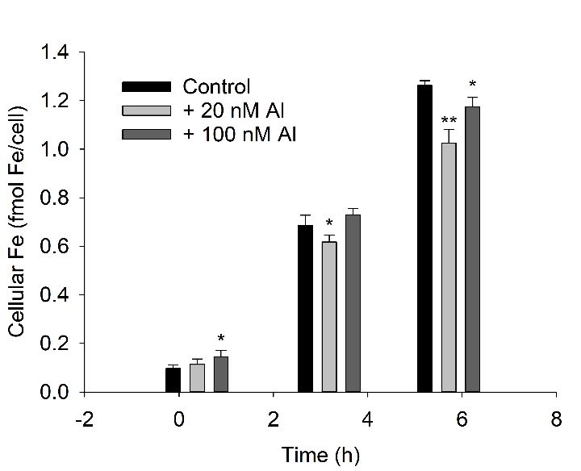

**Figure S1**. Changes in cellular 55Fe of *T. weissflogii* as a function of exposure time in the seawater with 47 nM 55Fe buffered by 100 µM EDTA and with different concentrations of aluminum (Al). The error bars represent standard deviations (n = 3). The symbols *, and ** indicate significant (*p* < 0.05), and highly significant (*p* < 0.01) differences compared to the control, respectively.

C:\Users\zhoul\Desktop\Increase compared to Fe-limited control.TIF

**Figure S2.** Comparisons of the treatments enriched with aluminum (Al) or iron (Fe) to the Fe‑limited control. The data are illustrated on common logarithmic axes. The results showed that Al addition, as well as Fe addition, increased all the parameters including cellular chlorophyll content, Fv/Fm, chlorophyll biosynthesis rate, and growth rates. Supply of sufficient Fe, compared to the enrichment of Al (20 and 100 nM) led to higher increases in cellular chlorophyll content, Fv/Fm, and chlorophyll biosynthesis rate.