**Alkor Expedition AL616, Kiel – Kiel, 18. Juli – 9. August 2024**

3. Weekly Report, 4. August 2024

Stefan Sommer and the AL616 Team

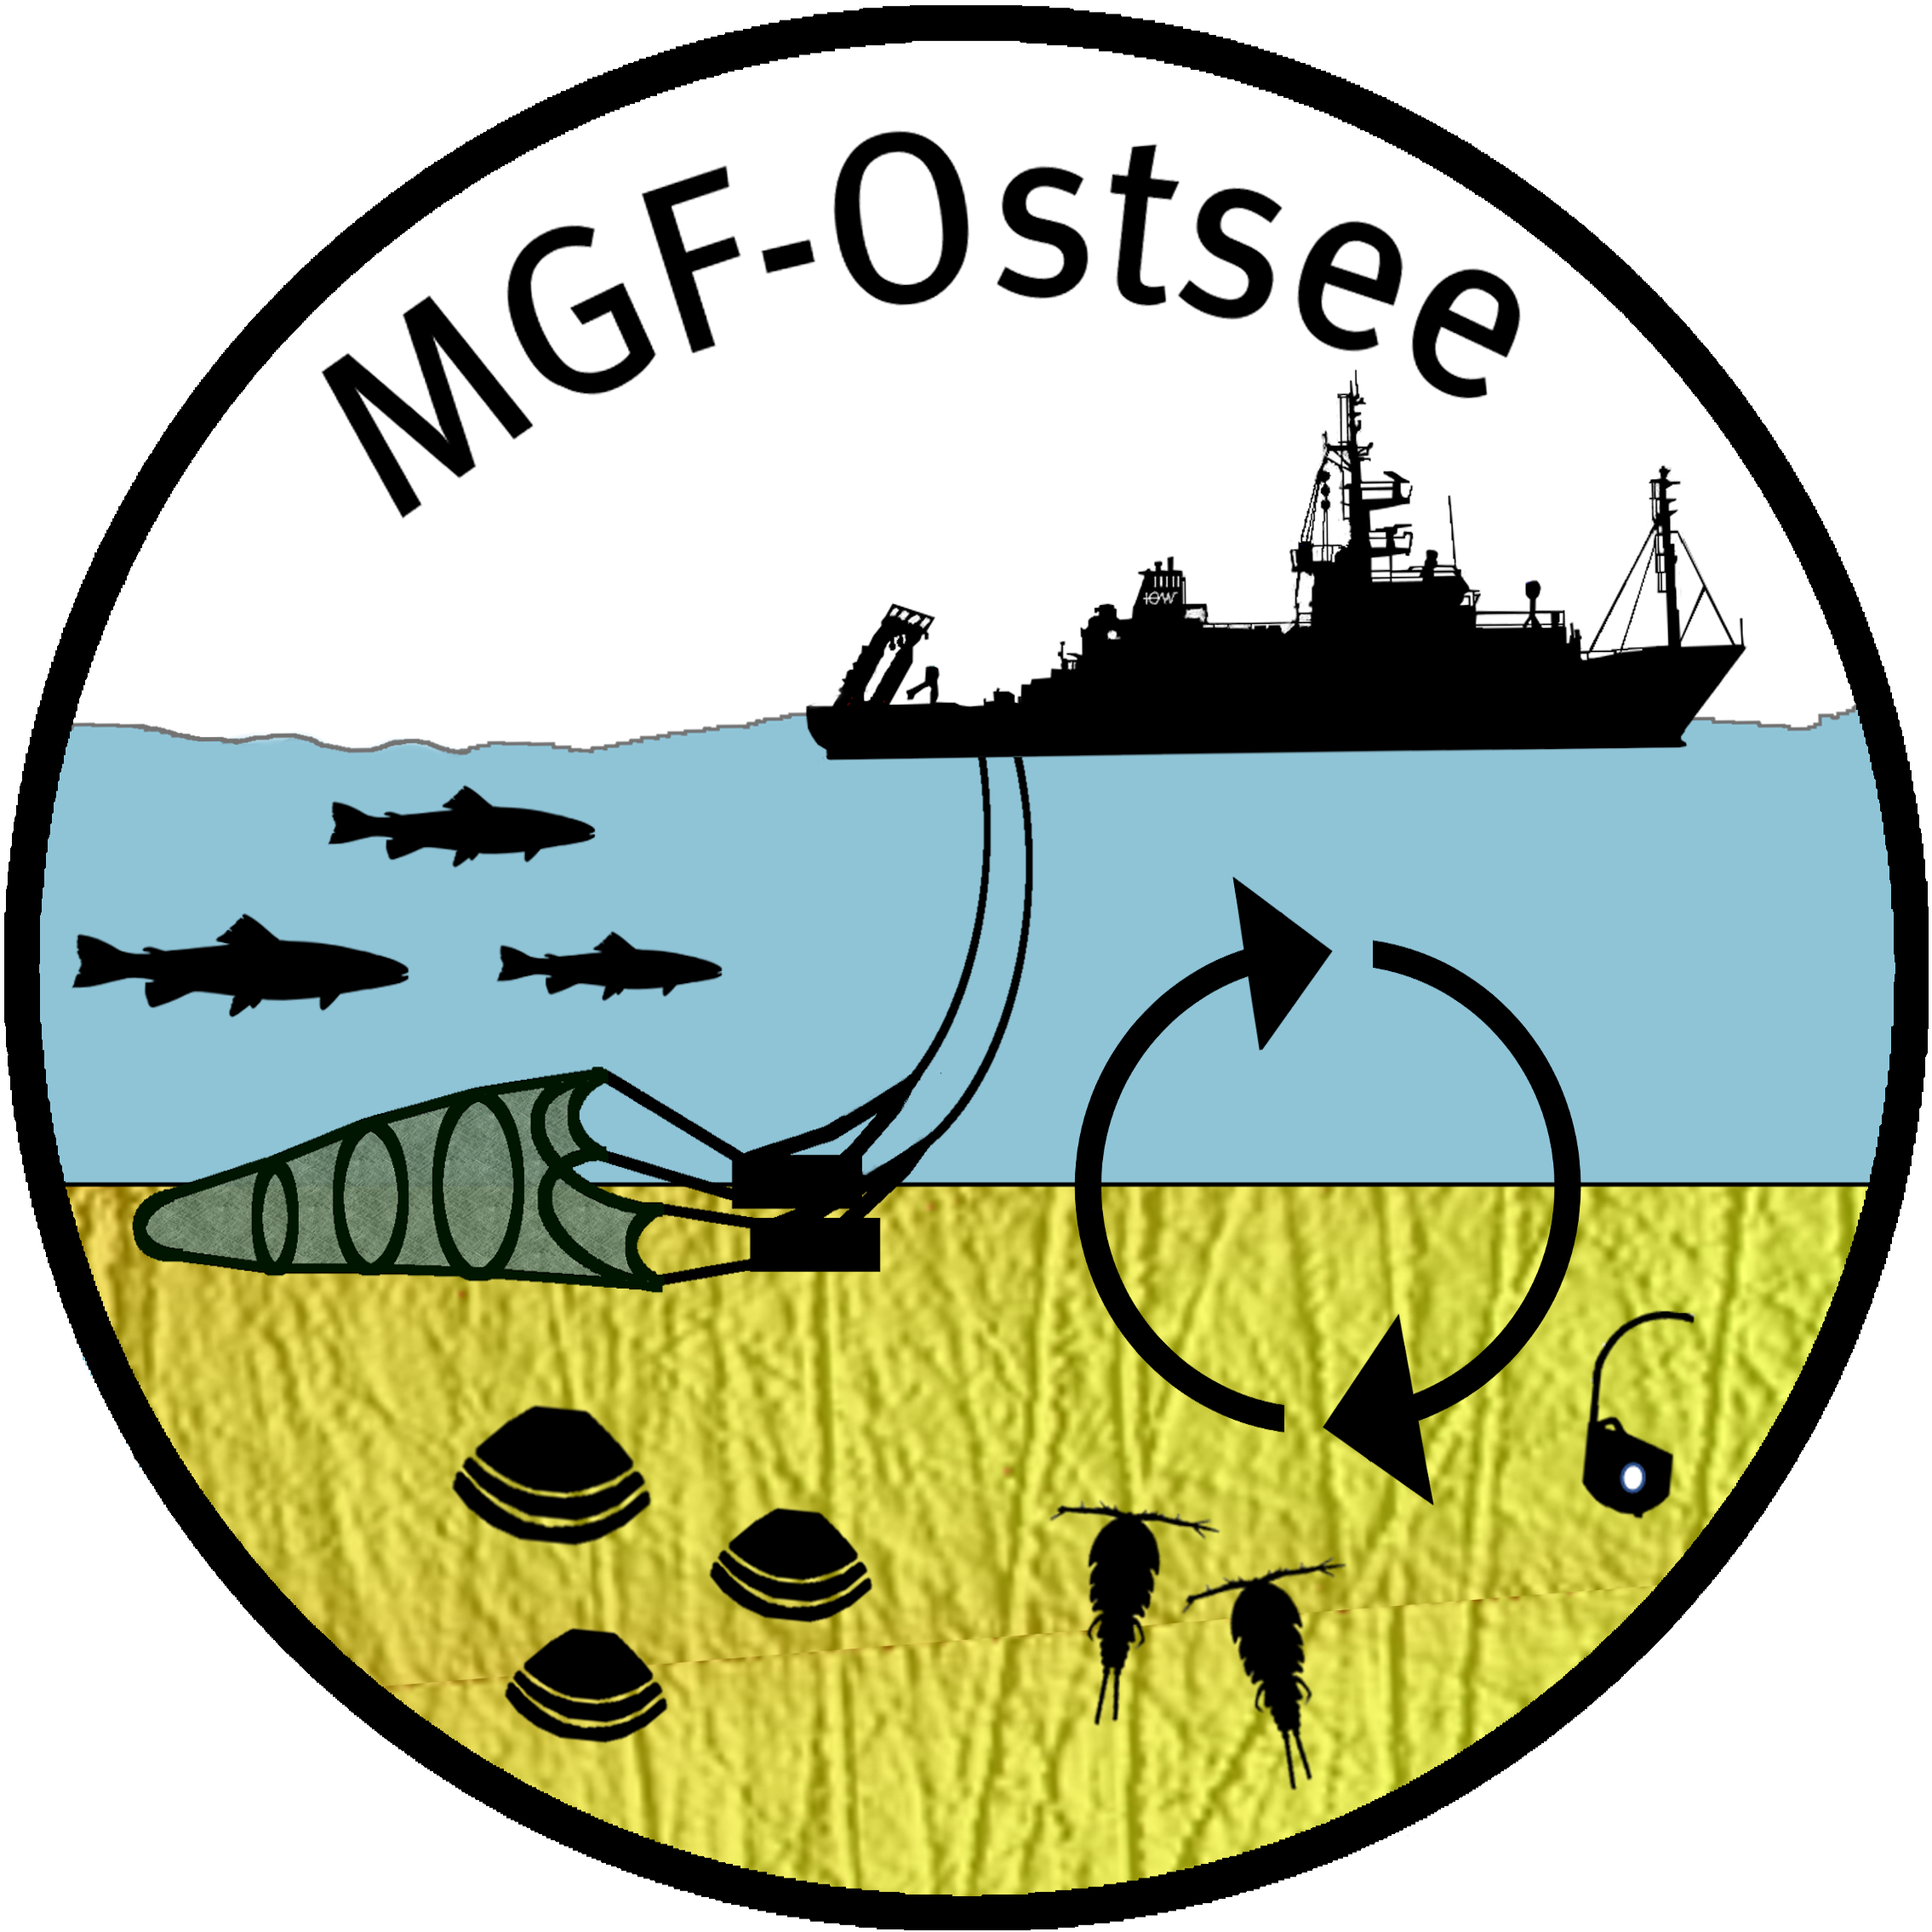

The station work for our trawl experiment in Mecklenburg Bay off Kühlungsborn made good progress in predominantly good weather. The second SCUBA dive on Tuesday 30 July to sample the otter trawl track was successful. In the afternoon, the dive support boat ‘Klashahn’ handed over several sediment cores for biogeochemical analysis.

In addition to the geochemical investigations of the sediments, we are also making good progress with our in situ measurement programme to record the exchange of dissolved substances along the sediment-water interface using the reliable GEOMAR landers BIGO-I and BIGO-II (Biogeochemical Observatory) as well as our novel underwater vehicle Deep-Sea Rover Panta Rhei (DSR). Despite initial concerns that the traction of the rover might not be sufficient for its forward movement on the muddy sediment, we have been able to successfully deploy the rover three times so far.

On Friday 2 August, after picking up a BIGO lander and the rover, we entered Warnemünde for a crew exchange. On this day, our colleagues from the RV Elisabeth Mann Borgese completed their station work and left the working area in the direction of Marienehe, Rostock.

An important parameter for recording the activity of the benthic ecosystem is its oxygen uptake. Oxygen is mainly required for respiration by aerobic organisms of all size classes living in and on the sea floor (microbenthos, protozoa, meiobenthos, macrofauna and epifauna) to maintain their energy metabolism. Furthermore, oxygen is required in the organic-rich sediments for the aerobic oxidation of ammonium (nitrification) and hydrogen sulphide. It is still unclear how the oxygen uptake rate of the benthic ecosystem changes as a result of the mechanical impact of the otter boards and the foot rope on the sediment. Using our lander and the rover, we have carried out a large number of measurements of the total oxygen uptake rate both in the fished high impact area and in the neighbouring control area. In particular, the rover, which was specially designed for the repeated recording of the oxygen uptake rate, has helped to increase the number of measurements and enables a statistical comparison between the control and high impact areas.

Figure 1 shows all preliminary oxygen uptake rates measured to date. However, a significant difference between the oxygen uptake rate of the control and high impact area could not be determined. Within the high impact area, most of the measurements were taken within the area affected by the trawl's roller gear. However, the lowest oxygen uptake rates < 5.5 mmol m-2 d-1 were recorded during measurements in close proximity to an otter trawl track.



**Fig. 1**: Total oxygen uptake rate of the sediments in the high impact area (n = 18, red circles) compared to the control area (n = 14, blue circles).

When we resumed our station work when the sea was calm, we observed extensive blooms of cyanobacteria on the sea surface. In addition, the calm weather conditions have greatly reduced the oxygen content of the bottom water. In some parts of the high impact area, we were able to identify extensive sediment areas colonised by dense mats of sulphide-oxidising bacteria, Figure 2. During previous deployments of the towed camera and sensor system XOFOS (X Ocean Floor Observation System), such mat systems of this size were not observed. Whether the effect of trawling may have favoured the formation of these bacterial mats or whether this is due to the low oxygen concentration in the bottom water cannot be clearly determined at present.

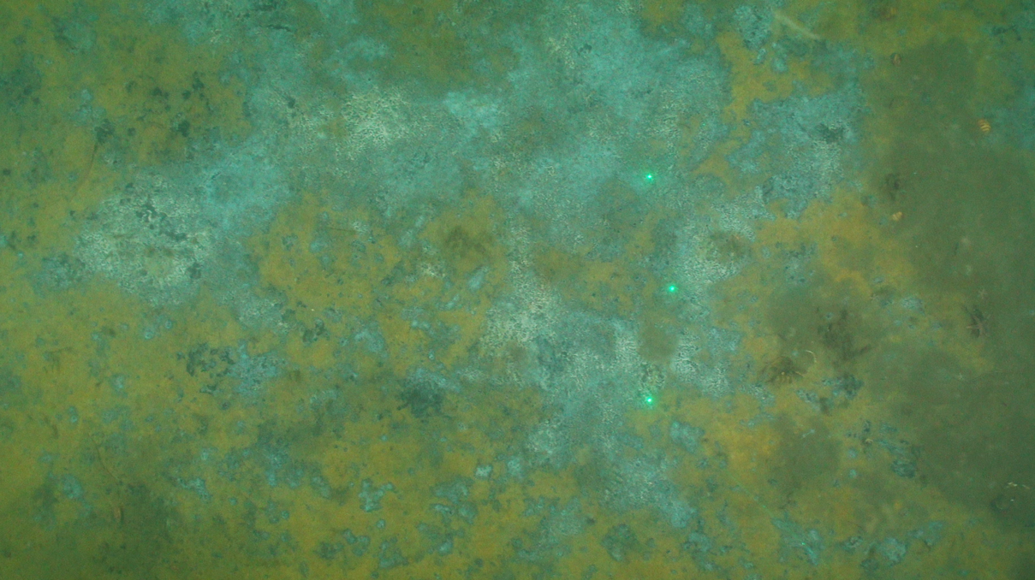

**Fig. 2**: Bacterial mats in the high impact area (XOFOS application #12). The three green laser points are used to measure distance and height. The outer points are 45 cm apart.

Our seafloor observations using XOFOS clearly show that the trawl track and sediment cast are almost lost after 11 days, Figure 3. The trawl tracks shown in Figure 3 are not identical, but during our extended XOFOS observations after the trawl experiment, no trawl track with a distinctive geometry of the track and cast as shown in Figure 3 (left image) could be observed again.



**Fig. 3**: Comparison of a otter trawl track shortly after trawling and after approx. 11 days.

Over the next few days, we will continue to intensively analyse the survey areas.

Everyone on board is doing well, best regards

Stefan Sommer and the AL616-Team