**Supplementary Materials to: Calcium isotope composition in serum and urine for the assessment of bone mineral balance (BMB) – the Osteolabs post-market follow-up study**

1. **Longterm Reproducibilty of the CIM values – Data comparability**

In Table S1, following the suggestion of Coplen et al. 2011 we present the long-term average values for our various standards from 2018 to 2024 [1]. SRM 915a, SRM 1486, and IAPSO are internationally available Ca isotope standards commonly used in Geosciences. In general, all standard materials are calibrated to SRM915a as the primary standard. Our long-term reproducibility for Ca isotope measurements is notably higher than the commonly reported value of ±0.08 to 0.10 ‰ (2 standard deviations) for δ44/42Ca measurements relative to standards like NIST SRM 915a. Additionally, the accuracy of our data aligns with the published values for these reference materials (Table 1). AK-1 and Sera-1 are secondary in-house urine and serum standards, respectively. Their long-term reproducibility is less than 0.07‰, enabling precise comparisons of single Ca isotope measurements even years apart.

|  |  |
| --- | --- |
| **Table S1:** Calcium isotope standard material used in this study | |
|  | |
| *primary reference material | |
|  |

**2. Calculation of the renal Ca reabsorption rate**

The sequestration of Ca between blood and kidneys can be described as a Raleigh distillation process [2]. In a healthy person, about 95 to 99 % of Ca is reabsorbed by the kidneys (Figure S1) to the blood, and between 1 to 5 % are excreted via the urine. Ca isotope fractionation occurs during Ca sequestration in the kidneys into a largely reabsorbed fraction which shows slightly lower Ca isotope ratios than the blood, whereas the second and smaller fraction, the urine, is enriched in the heavy isotope showing considerably up to 1 ‰ higher values than the blood. The distribution of Ca isotope ratios between serum and urine as a function of the Ca reabsorption rate is described by following a modified Raleigh type like function:

(S01) $e^{\frac{∆_{urine-serum}}{1000}} { f}^{\left(α-1\right)}$;

RN (%) = (1-f) $∙$ 100; 0 < f < 1; 0 < RN < 100

In this equation the term Δurine-serum is the isotope difference of the CIM-serum and CIM-urine values (Δurine-serum = (CIM-urine)-(CIM-serum) = δ44/42Caurine - δ44/42Caserum). The term “f” is the relative amount of Ca excreted via the urine, and RN reported in percent (%) refers to the relative amount of Ca reabsorbed back to the blood. The term “α” is the known isotope fractionation factor to be 0.3 ‰ [3] between urine and serum. Equation (01) is a non-linear function which must be numerically solved f.e. by the application for example the solver function in Excel. For convenience of application we numerically calculated RN values as a function of Δurine-serum and fitted these values by a 6th-order polynomial in equation SO2:

(S02) RN (%) = -21.575 $∙$ (Δurine-serum)6 + 132.34(Δurine-serum)5 - 353.75(Δurine-serum)4 + 547.68(Δurine-serum)3 - 540.29(Δurine-serum)2 + 332Δurine-serum + 0.0241

1. **Adjusting measured CIM values for Ca supplement uptake**

The Ca isotope value of the average diet (δ44/42Cadiet) has been determined to be about -0.46 ‰ [4,5], mainly affected by dairy products being the main source for Ca in the average Western-European diet except for vegetarians, vegans [5], and people taking up Ca supplements [5,6]. The Ca dietary composition is crucial because it determines the individual equilibrium threshold (ET) value being the baseline for the characterization of bone Ca loss or gain. ET variations depend on the individual amount and isotope composition of the Ca consumed. In general, ET variations are rather small because the Ca dietary isotope values only vary by less than about ±10 % for individuals consuming dairy products to 9% for elderly individuals up to about 30 % for children, including vegetarians [7]. Hence, individual ET values can generally be approximated for these groups by the average ET values as determined in the OsteoGeo study to be -0.85 ‰ for serum (δ44/42CaET-serum) and 0.23 ‰ for urine (δ44/42CaET-urine).

However, this is not the case for individuals taking up Ca supplements which are usually produced from Ca carbonate rock, coral Ca material, or any other industrial processed inorganic Ca being about 1 ‰ higher than natural diet (δ44/42Casupplement + 0.54 ± 0.06 ‰, Table S1). As a consequence, the uptake of Ca supplements will gradually change the individual ET value away from a natural δ44/42Cadiet value towards a significantly higher δ44/42Camixed value being a mixture of natural and supplement Ca (Equation 3, Figure S3).

(S03) $δ^{44/42}{Ca}_{mixed}^{}=\left(\frac{a}{c}\right) ∙δ^{\frac{44}{42}}{Ca}_{diet}^{}+\left(\frac{b}{c}\right) ∙δ^{\frac{44}{42}}{Ca}_{supplement}^{}$

Note: δ44/42Camixed is the new Ca isotope composition of the diet; **a**: the amount of Ca originating from the normal diet [g]; **b**: the amount of Ca originating from Ca supplements [g]; **c**: is the sum of a and b [g].

The difference in individual ET due to the difference between normal and mixed supplement diet must be taken into account when comparing CIM values between different individuals. In general, all CIM values based on mixed values tend to be higher than those based on natural diet, indicating an apparent better bone health status as it would be on a natural diet (Figure S3). Furthermore, any comparison of CIM values before and after a supplement-based therapy would be problematic because the individual ET values before and after the start of the therapy would be different and indicates an apparent better BMB after the consumption of Ca supplement. This obscures the monitoring of any real therapy progress. Hence, correction and normalization of the mixed CIM values to the normal δ44/42Cadiet values is crucial.

The change of δ44/42Caserum towards the new mixed serum value, δ44/42Caserum-mIxed, is not an instantaneous process that involves only diet, serum, or urine, but the process is rather mediated via the bones and the equilibrium exchange of bone Ca with serum Ca. Hence, the process is time dependent controlled by the bone Ca turnover time (tTurnover). Estimates of the Ca turnover times range from 200 days [8,9] to about 10 years [10]. However, calculations on the knowledge that there is about 1000 g Ca in the skeleton and an exchange rate in equilibrium of Ca input and output (FBoneLoss=FBoneGain) of 0.5 g Ca per day [11] results in tTurnover of about 2000 days corresponding to about 5.48 years. The actual time dependent ET-correction factor Δδ44/42Cacorrection-factor(t) can then be estimated as follows:

(S04) $δ^{\frac{44}{42}}{Ca}_{correction-factor}^{}\left(t\right)= δ^{\frac{44}{42}}{Ca}_{mixed}^{}+\left(δ^{\frac{44}{42}}{Ca}_{diet}^{}{-δ}^{\frac{44}{42}}{Ca}_{supplement}^{}\right)∙e^{\frac{t}{t_{Turnover}}}$

Note: Δδ44/42Cacorrection-factor(t) is the time dependent correction factor to calibrate mixed Ca diet to a normal diet making direct comparison possible; δ44/42Camixed is the Ca isotope composition of the mixed diet of normal diet and Ca supplements; δ44/42Cadiet refers to the normal average Ca isotope composition of the diet (-0.46 ‰); δ44/42Casupplement refers to the Ca isotope composition of the Ca supplement throughout time; t refers to time since Ca supplements have been taken up; tTurnover refers to the bone Ca turnover time to be 2000 days.

For final correction, the correction factor Δδ44/42CaCorrection-factor(t) is then subtracted from the measured CIM values:

(S05) $δ^{\frac{44}{42}}{Ca}_{serum-corrected}^{}= δ^{\frac{44}{42}}{Ca}_{serum-measured}^{}+δ^{\frac{44}{42}}{Ca}_{adaptation-factor}^{}\left(t\right)$

(S06) $δ^{\frac{44}{42}}{Ca}_{urine-corrected}^{} = δ^{\frac{44}{42}}{Ca}_{urine-measured}^{}+δ^{\frac{44}{42}}{Ca}_{adaption-factor}^{}\left(t\right)$

The general consequence of this Ca supplement adaptation is that the high mixed CIM values indicating an apparent positive BMB will be shifted towards lower CIM values. For example (see also Figure S3), CIM values of a person who takes 800 mg of normal diet (δ44/42Cadiet = -0.46 ‰) and 500 mg of Ca supplement (δ44/42Casupplement = +0.54 ‰) for 1500 days shows measured δ44/42Caserum-mIxed and δ44/42Caurine-mIxed of -0.7‰ and 0.3‰, respectively, apparently above the TE value and indicating an apparent positive BMB. From equation (05) and (06), the Δδ44/42Cacorrection-factor(t) can be calculated to be -0.2‰ which then corrects this individually measured value to the “true” values of δ44/42Caserum-corrected = -0.9 ‰ and δ44/42Caurine-corrected = +0.1‰. Both corrected values are below TE which correctly indicate negative BMB. Note that this adjustment is tailored individually for each participant based on their specific information regarding the duration and amount of calcium supplements taken.

**Supplementary tables and figures:**

|  |
| --- |
| **Table S2**: Calcium isotope composition of different brands of Ca supplements |
|  |
| **Note:** These are the Ca isotope values of commercially available Ca supplements that are sold in Germany. Their Ca isotope values are quite similar with an average Ca isotope value of +0.54‰ ± 0.06‰ (1SD). |

|  |
| --- |
| **Table S3.** The CIM-urine and CIM-serum values in the participants with medical condition |
|  |
| **Note:** Breast and blood cancer samples came from different participants. The δ44/42Ca values were compared to the corresponding thresholds (CIM-serum: -0.85±0.06 ‰ and δ44/42Caurine: 0.23±0.06 ‰) using two-tailed one-sample t-test (for data with normal distribution, *a*) or two-tailed Wilcoxon rank test (for data with non-normal distribution, *b*). *significantly different. |
| |  | | --- | | **Table S4.** The CIM values of the participants with different supplementation, diet, and lifestyle | |  | | *Mann-Whitney test with a significance level of *p*<0.05, unless otherwise specified.  **t-test was used with a significance level of *p*<0.05.  ϮLow dose was the participants who consumed < 10000 IU of vitamin D, while high dose was the participants who consumed > 10000 IU of vitamin D.  ϮϮComparison of CIM values in participants consuming low dose of vitamin D compared to those consuming high dose of vitamin D.  Participants with osteoporosis, cancer, kidney disease, or those consuming osteoprotective drugs were excluded from the analysis for this table, although they were included in the overall study. | |

**Supplementary figures:**

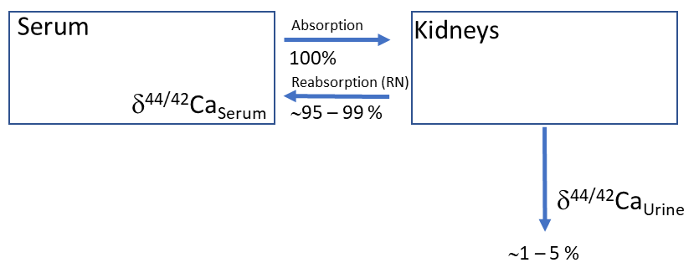

**Figure S1.** A sketch of the Ca cycling between blood and kidneys. Of the Ca absorbed by the kidneys in a healthy person, about 95 to 99 % are reabsorbed (recycled) back to the blood and only about 1 to 5 % of the Ca is excreted via the urine (after Heuser & Eisenhauer, 2010). The relative amount of reabsorbed Ca (RN) can be calculated from the isotope difference of serum and urine (Δurine-serum = CIM-serum - CIM-serum) either from equation S1 or S2.

**Figure S2.** This figure shows the non-linear relationship of the calculated RN-value as a function of the isotope difference between CIM-urine and CIM- serum values.

**Figure S3:** To illustrate the impact of calcium supplement intake on the measured CIM values, the following diagrams showcase model outputs. These examples highlight how the adjustment is applied based on the duration and amount of calcium supplements consumed by the participants. In the example provided, we consider the ingrowth of the CIM values for serum and urine as a function of the uptake of an additional 500 mg of Ca supplement on top of a natural intake of 800 mg of Ca. Over time, the CIM values increased and approached measured values of a CIM-serum value of -0.7 ‰ and CIM-urine of 0.3 ‰ after 1500 days (indicated by an arrow). Both of these values being above their TE value suggesting a positive BCaB and a seemingly healthy situation.

Applying the correction, the "true" CIM values are revealed to be -0.9 ‰ in serum and 0.1 ‰ in urine. Both corrected values fall below the TE value, indicating a negative BCaB and ongoing bone calcium loss.

.

**Figure S4**:

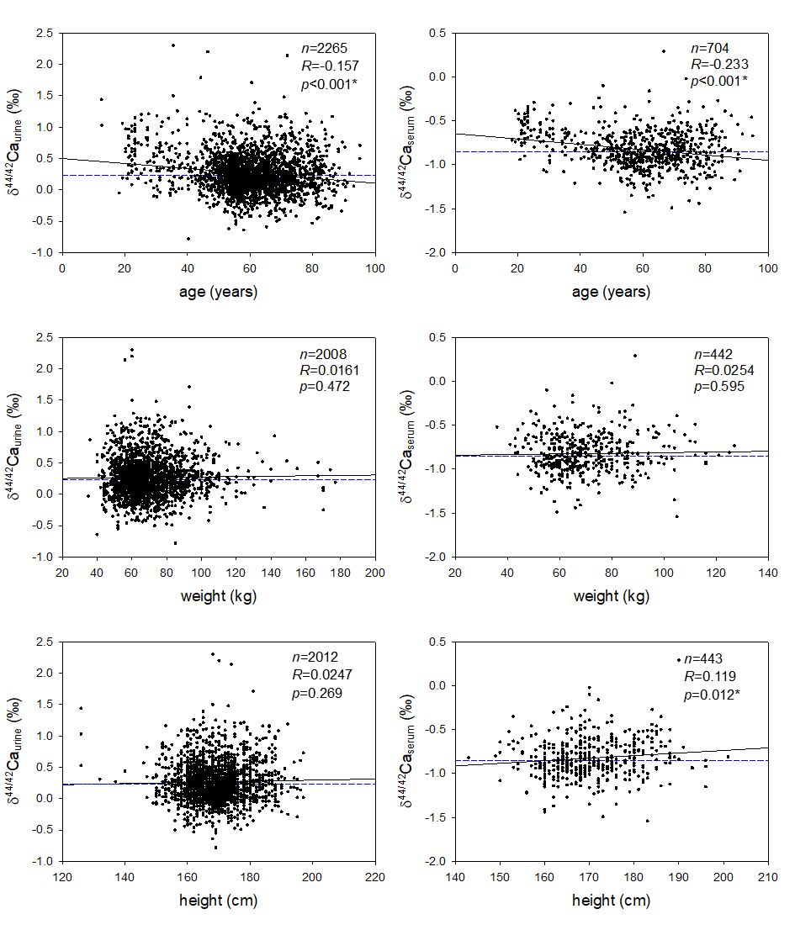

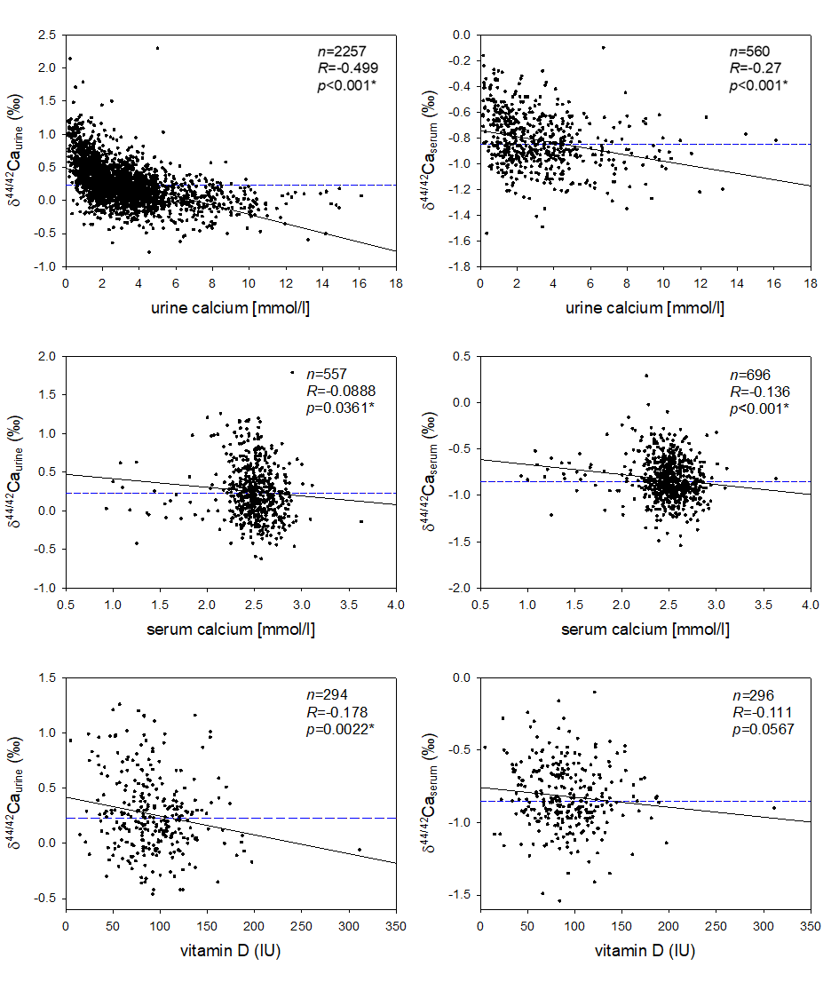



Figure S4: The correlation between Ca isotopic compositions and clinical parameters: age, weight, height, urine calcium concentration, serum calcium concentration, vitamin D, eGFR, creatinine, and calcium reabsorption RN-value. Left panels show correlations with CIM-urine; right panels show correlations with CIM-serum. Pearson correlation test was used to calculate the correlation between Ca isotopes and clinical parameters, except for RN-value, where Spearman correlation was used. RN-value is plotted using a logarithmic scale. The horizontal dashed lines represent the threshold CIM-urine and CIM-serum values in the respective figures, where the fraction of bone loss equals the fraction of bone gain (FBoneLoss=FBoneGain) [4]. The vertical dashed lines of RN-value represent normal kidney function. *Significant correlation on *p*<0.05.

**Figure S5**. The correlation between eGFR value (ml/min) and calcium reabsorption RN-value (%) plotted in a log-log graph. Pearson correlation test showed that there was no significant correlation between log eGFR and log RN-value (*R*=0.0868, *p*=0.137, N=294). The horizontal and vertical dashed lines represent normal kidney function.

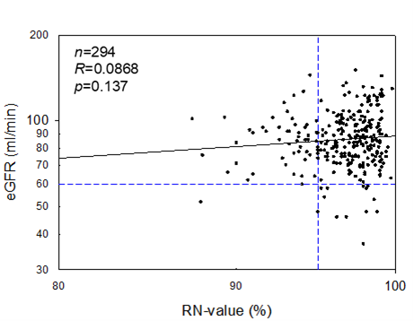

**References**

[1] T.B. Coplen, Guidelines and recommended terms for expression of stable‐isotope‐ratio and gas‐ratio measurement results, Rapid Commun. Mass Spectrom. 25 (2011) 2538–2560. https://doi.org/10.1002/rcm.5129.

[2] R.E. Zeebe, D. Wolf-Gladrow, CO2 in seawater: Equilibrium, kinetics, isotopes, Elsevier Science, 2001.

[3] J. Skulan, D.J. DePaolo, Calcium isotope fractionation between soft and mineralized tissues as a monitor of calcium use in vertebrates, Proc. Natl. Acad. Sci. U. S. A. 96 (1999) 13709–13713. https://doi.org/10.1073/pnas.96.24.13709.

[4] A. Eisenhauer, M. Müller, A. Heuser, A. Kolevica, C.C. Glüer, M. Both, C. Laue, U. V. Hehn, S. Kloth, R. Shroff, J. Schrezenmeir, Calcium isotope ratios in blood and urine: A new biomarker for the diagnosis of osteoporosis, Bone Reports. 10 (2019) 100200. https://doi.org/10.1016/j.bonr.2019.100200.

[5] R. Shroff, M. Fewtrell, A. Heuser, A. Kolevica, A. Lalayiannis, L. McAlister, S. Silva, N. Goodman, C.P. Schmitt, L. Biassoni, A. Rahn, D.C. Fischer, A. Eisenhauer, Naturally Occurring Stable Calcium Isotope Ratios in Body Compartments Provide a Novel Biomarker of Bone Mineral Balance in Children and Young Adults, J. Bone Miner. Res. 36 (2021) 133–142. https://doi.org/10.1002/jbmr.4158.

[6] R. Shroff, A.D. Lalayiannis, M. Fewtrell, C.P. Schmitt, A. Bayazit, V. Askiti, A. Jankauskiene, J. Bacchetta, S. Silva, N. Goodman, L. McAlister, L. Biassoni, N. Crabtree, A. Rahn, D.C. Fischer, A. Heuser, A. Kolevica, A. Eisenhauer, Naturally occurring stable calcium isotope ratios are a novel biomarker of bone calcium balance in chronic kidney disease, Kidney Int. 102 (2022) 613–623. https://doi.org/10.1016/j.kint.2022.04.024.

[7] A. Heuser, A. Eisenhauer, A pilot study on the use of natural calcium isotope (44Ca/40Ca) fractionation in urine as a proxy for the human body calcium balance, Bone. 46 (2010) 889–896. https://doi.org/10.1016/j.bone.2009.11.037.

[8] K.D. Mörike, E. Betz, W. Mergenthaler, Biologie des Menschen, ‎ Quelle & Meyer, Wiesbaden, 2007.

[9] P. Vaupel, H.-G. Schaible, E. Mutschler, Anatomie, Physiologie, Pathophysiologie des Menschen, Wissenschaftliche Verlagsgesellschaft, Stuttgart, 2015.

[10] P. Reuter, Der Große Reuter: Springer Universalwörterbuch Medizin, Pharmakologie und Zahnmedizin, Springer-Verlag, Berlin/Heidelberg, 2005. https://doi.org/10.1007/3-540-28721-3.

[11] G. Schaafsma, Calcium in Extracellular Fluid: Homeostasis, in: B. Nordin (Ed.), Calcium Hum. Biol. Homeost., Springer, London, 1988: pp. 241–259. https://doi.org/10.1007/978-1-4471-1437-6_10.