**Table S1.** Modified YBCII media recipe used in the experiment

|  |  |
| --- | --- |
| Components | Concentration in media (mol L-1) |
| Major salts |  |
| NaCl | 0.42 |
| KCl | 0.01 |
| NaHCO3 | 0.0025 |
| H3BO3 | 0.00058 |
| KBr | 0.00097 |
| NaF | 0.00007 |
| MgSO4 | 0.025 |
| MgCl2 | 0.02 |
| CaCl2 | 0.01 |
| SrCl2 | 0.000065 |
| LiCl | 0.03 |
| Macronutrients |  |
| Na2EDTA·2H2O | 2.0×10-6 |
| CuSO4·5H2O | 8.0×10-9 |
| ZnSO4·7H2O | 2.0×10-8 |
| CoCl2·6H2O | 8.0×10-9 |
| MnCl2·4H2O | 1.8×10-8 |
| Na2MO4·2H2O | 1.0×10-7 |
| NiSO4·6H2O | 2.0×10-8 |
| Na2SeO3 | 1.0×10-8 |
| FeEDTA  NaH2PO4 | 4.0×10-8 |
| Vitamins |  |
| Thiamine | 3.0×10-7 |
| Biotin | 2.0×10-9 |
| Cyanocobalamin | 3.7×10-10 |

**Table S2.** Targeted metabolites, class and function.

|  |  |  |
| --- | --- | --- |
| Name | Class | Function |
| Adenosine diphosphate | Nucleotide | A precursor to ATP. |
| Adenosine monophosphate | Nucleotide | A precursor to AMP. |
| Arginine | Amino acid | A precursor to cyanophycin, a dynamic nitrogen reservoir in many cyanobacteria (Zhang and Yang 2019). |
| Adenosine | Nucleoside | A precursor to RNA and ATP. |
| Choline | Nutrient | A component of the majority of phospholipids in membranes. |
| Flavin mononucleotide | Vitamin | An essential cofactor for numerous enzymes |
| Glutamate | Amino acid | Involved or produced during? in ammonium assimilation |
| Guanine | Nucleotide | Essential component of DNA and RNA. |
| Guanosine | Nucleoside | A precursor of nucleic acids and proteins. |
| Histidine | Amino acid | An essential amino acid precursor to peptides and proteins. |
| Isoleucine | Amino acid | A branched chain amino acid precursor to peptides and proteins. |
| Kynurenine | Amino acid | Critical in generating cellular energy in the form of nicotinamide adenine dinucleotide (NAD+). |
| Leucine | Amino acid | An essential amino acid that is a precursor to peptides and proteins. |
| 5'-Deoxy-5'-methylthioadenosine | Nucleo | S-methyl derivative of the adenosine. |
| NAD+ | Vitamin | Participates in core metabolic redox reactions. |
| Phenylalanine | Amino acid | An essential amino acid precursor to peptides and proteins. |
| Proline | Amino acid | A multifunctional amino acid. |
| Riboflavin | Vitamin | A precursor of the flavin coenzymes flavin mononucleotide and flavin adenine dinucleotide; a coenzyme. |
| Thiamine | Vitamin | The precursor of TPP, which is an important coenzyme in central carbon metabolism. |
| Tryptophan | Amino acid | A precursor to peptides and proteins. |

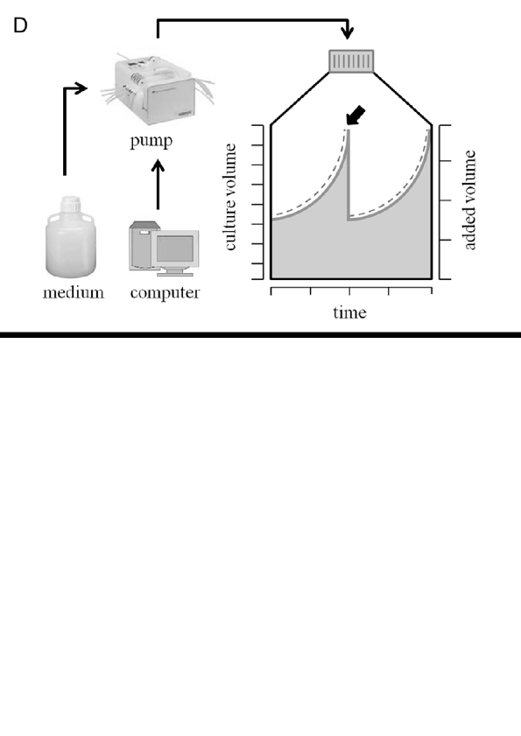

**Fig S1.** The exponentially fed batch culture. In order to maintain a constant dilution rate (0.1/day), a continuous supply of fresh medium occurs at a rate proportionate to the current culture volume at 3 days. The culture volume (depicted by the solid grey line) and the in-flow rate (represented by the dashed line) exhibit exponential increases over time until the sampling point (indicated by the bold arrow). Subsequent to sampling, the culture volume is reset to its initial volume. The figure is from Fischer et al. (2014).



**Fig S2.** Responses in POC of *Trichodesmium* IMS 101 with statistical significance numbers under DIP and DOP phosphorus sources to variations in Fe supply. (i), (ii) and (iii) indicate POC changes of DIP treatment, DOP treatment and the control treatment, respectively; Points show triplicate measurements from the biologically independent replicates every three days, lines map the change in the mean value with time. The left part without shading indicates period where Fe depleted (4 nM) media was supplied. The shaded region indicates where the high Fe (40 nM) media was supplied. The time period to the right side of the dashed line for each condition is considered here to be at steady state (Quade post hoc test; p<0.05). The letters in the context refer to statistical differences in POC over time. The data analysis was performed using the R statistical software, and the analyses were conducted with reference to the guidelines outlined on the following website (<https://www.rdocumentation.org/packages/PMCMR/versions/4.1/topics/posthoc.quade.test>).



**Fig S3.** Elemental responses of *Trichodesmium* IMS 101 under DIP and DOP phosphorus sources to variations in Fe supply. (**a**) Relative change of POC in percentage over time for the three treatments. (**b**) Calculated growth rate over time for the three treatments. (**c**) POP normalized APA over time for the three treatments. Points show triplicate measurements every three days, lines map the change in the mean value with time. The left part without shading indicates period where Fe depleted (4 nM) media was supplied. The shaded region indicates where the high Fe (40 nM) media was supplied. The time period to the right side of the dashed line for each condition is considered here to be at steady state (Quade post hoc test; p<0.05).



**Fig S4.** Elemental responses of *Trichodesmium* IMS 101 under DIP and DOP phosphorus sources to variations in Fe supply. (**a**) PON concentration over time for the three treatments. (**b**) POP concentration over time for the three treatments. (**c**) Particulate Fe concentration over time for the three treatments. (**d**) Particulate Zn concentration over time for the three treatments. (**e**) Particulate Mn concentration over time for the three treatments. (**f**) Particulate Cu concentration over time for the three treatments. (**g**) Particulate Ni concentration over time for the three treatments. (**h**) Particulate Mo concentration over time for the three treatments. (**i**) Particulate Co concentration over time for the three treatments. Points show triplicate measurements every three days, lines map the change in the mean value with time. The left part without shading indicates period where Fe depleted (4 nM) media was supplied. The shaded region indicates where the high Fe (40 nM) media was supplied. The time period to the right side of the dashed line for each condition is considered here to be at steady state (Quade post hoc test; p<0.05).

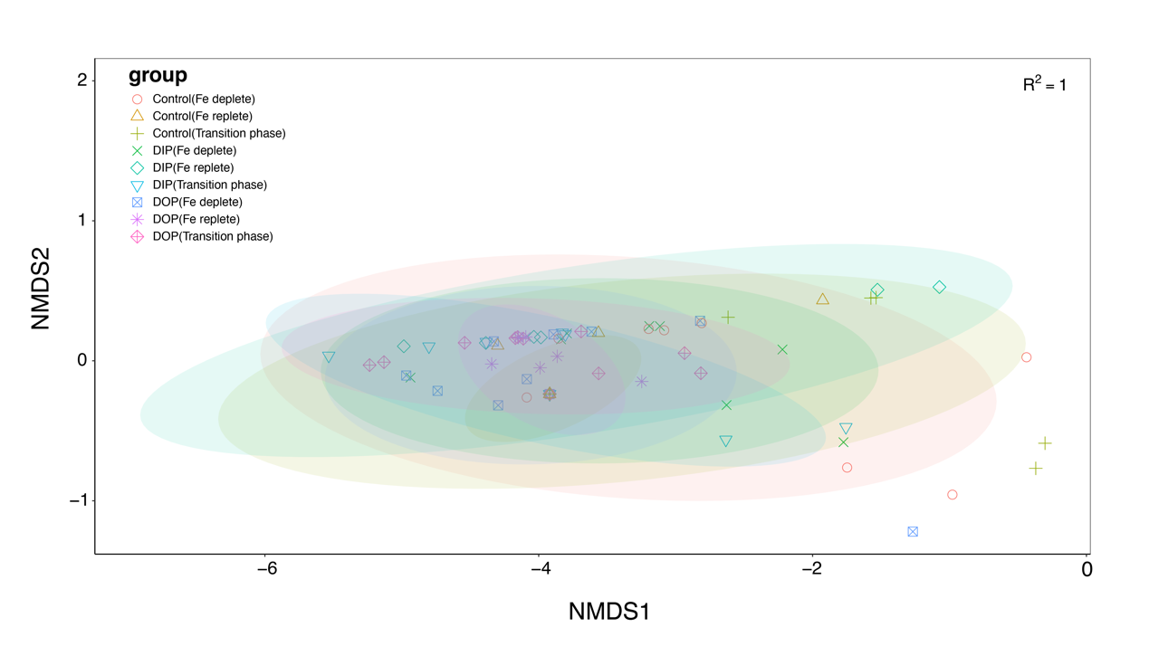

**Fig S5.** Non-metric multidimensional scaling (NMDS) of metabolites comparing treatment effects across sampling days (Fe deplete = day 24-33, Transition phase = day 36-45, Fe replete = day 48-54).