manuscript submitted to Gobal Biogeochemical Cycles
Supporting Information for

A close look at dissolved silica dynamics in Disko Bay, west Greenland
Mark J. Hopwood¹, Dustin Carroll², Yuanyuan Gu¹, Xin Huang¹, Jana Krause³, Stefano Cozzi⁴, Carolina Cantoni⁴, Maria Fernanda Gastelu Barcena⁵, Shandy Carroll⁶ and Arne Körtzinger³
¹ Department of Ocean Science and Engineering, Southern University of Science and Technology, Shenzhen, China
² Moss Landing Marine Laboratories, San José State University, Moss Landing, California, USA
³ GEOMAR Helmholtz Centre for Ocean Research Kiel, Kiel, Germany
⁴ CNR-ISMAR Consiglio Nazionale delle Ricerche, Istituto di Scienze Marine, Trieste, Italy
⁵ University of Florida, USA
⁶ County of Monterey, Monterey, California, USA
Corresponding author: Mark J. Hopwood (mark@sustech.edu.cn)

Supplementary Figure 1. Underway turbidity along the cruise track from a sensor deployed in the flow-through box. Near surface turbidity was assessed at 1-2 m depth at 2-minute intervals. Additional spot measurements from the pre-cruise campaign in Ilulissat and Saqqarleq Fjord are also shown. Please note that fine glacier flour particles were inefficiently flushed through the sensor box and so measured turbidity is unrealistically high in some areas due to a lag in particles being fushed out of the sensor box. This is apparent contrasting the in-going and out-going turbidity measurements in parts of the cruise routes that entered visible particle plumes for long periods (e.g. Disko Fjord around 54°W 69.50°N and Kangersuneq around 51°W 68.75°N).

Supplementary Figure 2. Sampling locations in fjords as per Figure 2.
Supplementary Figure 3. A comparison of the highest resolution satellite derived data products (bottom) to cruise observations (top): (left) salinity, (centre) temperature and (right) chlorophyll.
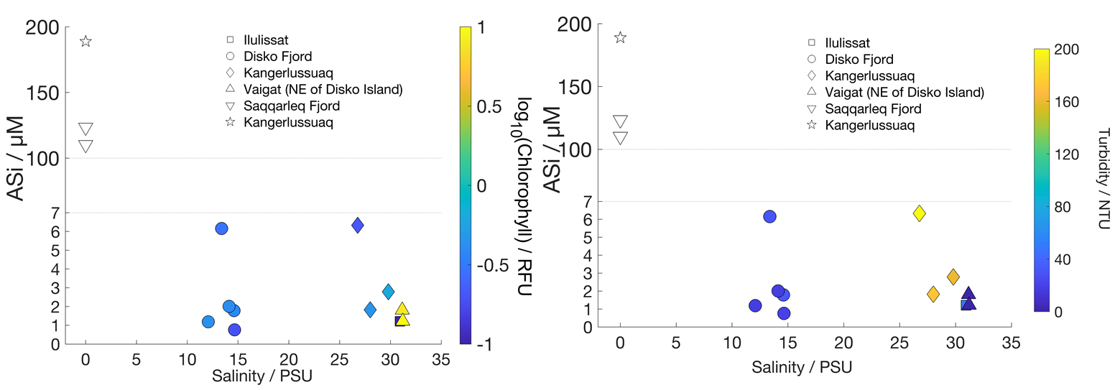
Supplementary Figure 4. Runoff and seawater aSi concentrations. Note the broken y-axis. Left, chlorophyll a (underway data) is shown on the colour bar. Right, same data with turbidity (underway data) shown on the colour bar.
Supplementary Figure 5. Profiles of dSi and NO_{x}⁻ in Disko Bay and in a subregion in the fjord mouth close to the edge of the ice mélange where Ilulissat Icefjord enters Disko Bay. Macronutrient profiles near the ice edge were universally distinct from the typical remineralization profile shown in Disko Bay with higher dSi (top) and NO_{x}⁻ (bottom) concentrations evident. The nutrient anomaly was largest in the upper 50 m.
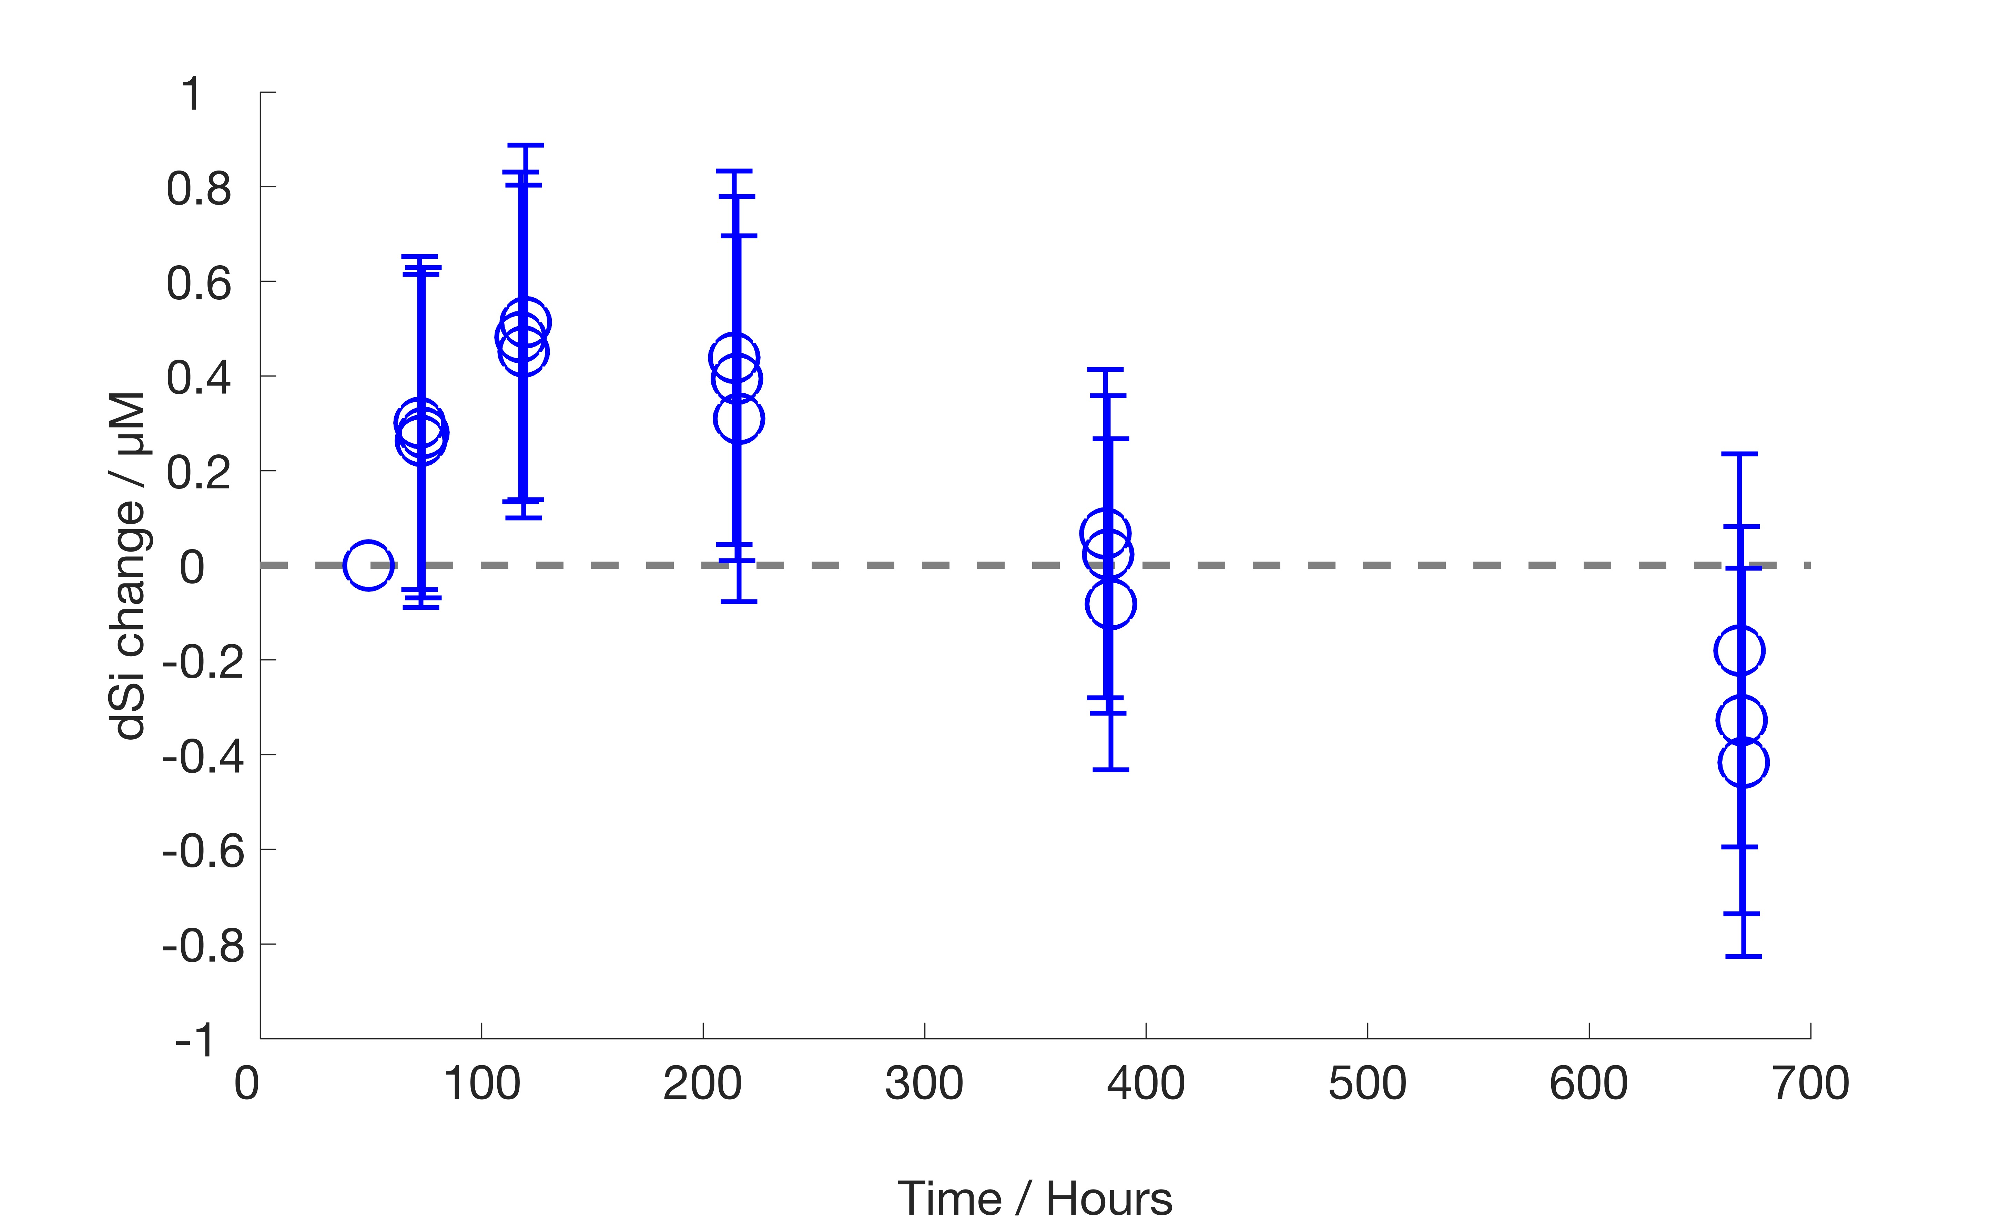
Supplementary Figure 6. Release of dSi from coarse glacier rock flour from Kangerlussuaq during incubation experiments with continuous shaking in the dark (loadings of 10, 50 and 100 mg L⁻¹; temperature 15°C; 40 rpm). The initial dSi concentration was 1.01 µM.
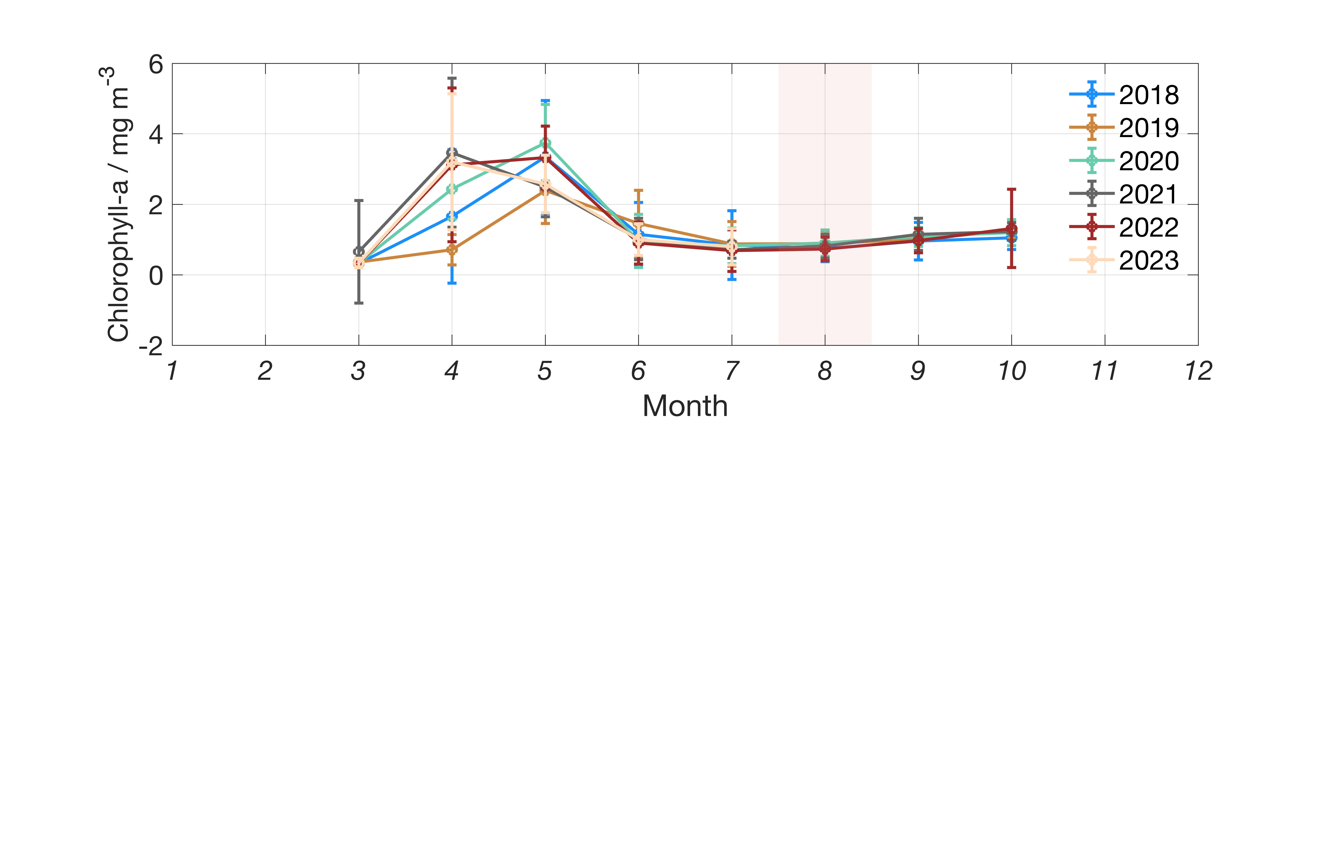
Supplementary Figure 7. Satellite derived chlorophyll a at monthly resolution integrated over the Disko Bay area. Moderately high inter-annual variability is observed during the spring-bloom period in April-May, whereas August experiences less variability with conditions in 2022 typical of the situation from 2018-2023. The cruise time period (in 2022) is shaded in red.
Sample origin | Sample type | aSi (µM) | aSi (mg g⁻¹)
Kangerlussuaq | Fine suspended particles | 188.8 | 11.81
Saqqarleq Fjord west | Fine suspended particles | 110.2 | 4.53
Saqqarleq Fjord east | Fine suspended particles | 123.4 | 20.0
Kangerlussuaq | Bulk glacier rock flour | n/a | 0.027
Saqqarleq Fjord west | Bulk glacier rock flour | n/a | 0.137
Saqqarleq Fjord east | Bulk glacier rock flour | n/a | 0.360
Iceberg surface sediment in Ilulissat Icefjord | Bulk glacier rock flour | n/a | 0.254
Supplementary Table 1. Measured aSi concentrations for rock flour samples from west Greenland.
Supplementary Methods 1: Calculating the nutrient anomaly associated with Ilulissat Icefjord outflow
To calculate the nutrient anomaly associated with fjord outflow, we bin data at the fjord mouth from August 2022 (as per Supp. Fig. 5) into depth bins of 0-2, 5, 10, 15, 20, 40, 60 and 100 m. Using the trapezium rule we then integrate the NO_{x}⁻, PO₄³⁻ and dSi concentrations. The same depth bins were then compiled for Disko Bay data excluding profiles within the outflowing plume of the Icefjord (as per Supp. Fig. 5). The difference in concentrations determined over the sill and in Disko Bay is defined as the nutrient anomaly attributable to Icefjord outflow. For all macronutrients (NO_{x}⁻, dSi and PO₄³⁻), the anomaly is positive in surface waters and transitions to zero in between 60 and 100 m deep. This is in accordance with modelled and observed patterns of fjord outflow (Gladish et al., 2015). The integrated anomalies are 501 ± 96 mmol m⁻² dSi, 512 ± 108 mmol m⁻² NO_{x}⁻ and 34 ± 6 mmol m⁻² PO₄³⁻. The salinity anomaly is 645 ± 154 L m⁻² (or 1.17% freshwater by volume if we assume a reference salinity of 33.0 psu).
Whilst we cannot deduce fluxes for August 2022 without modelled or measured fjord outflow rates, we can present the nutrient anomalies in outfowing water scaled to the associated freshwater anomaly. Dividing the integrated nutrient anomalies by the salinity anomaly gives nutrient enrichment of 777 ± 238 µmol L⁻¹ dSi, 794 µmol L⁻¹ ± 253 NO_{x}⁻ and 53 ± 16 µmol L⁻¹ PO₄³⁻. The high magnitude of these values and their ratio (dSi: NO_{x}⁻: 0.979 ± 0.433) cannot be explained by direct freshwater additions, the concentrations of nutrient in runoff from prior work around Greenland are too low and the dSi:NO_{x}⁻ ratio of runoff is too high (3-200, Meire et al., 2016).
Freshwater added within the Icefjord is a mixture of runoff, subglacial discharge and ice melt. Without extensive measurements of these, or unique tracers, we cannot deduce their exact effects on the observed concentrations of nutrients in the outflowing plume from the Icefjord or propagate the associated uncertainty. However, pan-Greenland values suggest ice melt is likely close to negligible as a nutrient source so can be used to define a lower bound for nutrient inputs from freshwater (Krause et al., 2024). Accordingly, we use measured runoff and ice melt nutrient concentrations to derive two scenarios. We use runoff from the adjacent Saqqarleq fjord branch as a ‘high’ dSi freshwater endmember (24.9 µmol L⁻¹ dSi, 0.60 µmol L⁻¹ NO_{x}⁻) and iceberg meltwater as a ‘low’ dSi freshwater endmember (0.17 µmol L⁻¹ dSi, 0.83 µmol L⁻¹ NO_{x}⁻). A comparison of values herein to prior work shows that freshwater NO_{x}⁻ concentrations around Greenland are universally low and the main variation in freshwater macronutrient concentrations concerns dSi (e.g. Meire et al., 2016). The concentrations of the ‘high’ and ‘low’ endmembers (µmol L⁻¹) are deducted from the observed anomaly at the fjord mouth (Supp. Table 2).
 | dSi | NO_{x}⁻ | Ratio
Observed outflow anomaly | 777 ± 238 µmol L⁻¹ | 794 µmol ± 253 | 0.980 ± 0.433
Observed outflow anomaly deducting runoff* | 752 µmol L⁻¹ | 793 µmol L⁻¹ | 0.949
Observed outflow anomaly deducting ice melt* | 777 µmol L⁻¹ | 793 µmol L⁻¹ | 0.980
Supplementary Table 2. Nutrient anomalies (per litre of freshwater) associated with outflow from the Icefjord are too high to be explained by dissolved freshwater endmembers (either ice melt or runoff). *Due to the mixing of multiple freshwater sources, and the absence of measurements for subglacial discharge we instead define scenarios with runoff and ice melt, and continue to use the uncertainty from the observed outflow anomaly in subsequent calculations.
The similar distributions of all macronutrients in Icefjord outflow and the very high concentrations when normalized to the salinity anomaly (Supp. Table 2) are consistent with entrainment of nutrients in a buoyant glacier discharge plume. The rapid dilution of freshwater in these plumes, typically to 2% or less (Beaird et al., 2018; Carroll et al., 2015), and the associated entrainment of nutrient-rich water from below the nutricline creates large nutrient anomalies (Oliver et al., 2023). The upwelling flux from these plumes has been estimated in prior work (Slater et al., 2022).
If the upwelling flux is derived using in-fjord profiles close to the glacier terminus it corresponds to Flux Gate A (Fig. 1). The deduced flux is thus inclusive of any nutrient sources which affect nutrient concentrations in the inflowing, deep saline layer during its ~1 month residence in the fjord. The effects of net benthic dSi efflux, aSi dissolution in the deep saline layer and any other pelagic biogeochemical processes are integrated in the dSi concentration in the deep layer used to force upwelling/entrainment calculations. The dSi budget for Nuup Kangerlua by Meire et al., (2016), for example, uses this approach. Herein, with respect to the Icefjord, we are instead defining the outflowing flux at Flux Gate B (Fig. 1). The outflowing flux anomaly at gate B reflects the combination of all processes in the fjord in the deep and surface layers. To deduce the net change of in-fjord processes, we need to compare the properties of the outflowing plume to inflowing water mass properties.
Cruisework herein only surveyed the fjord entrance for two days, which is very short compared to the estimated 32-day timescale over which saline waters reside in the Icefjord (Gladish et al., 2015). Only 6 measured nutrient concentrations were made in the depth range 170-250 m which brackets the potential inflow to the Icefjord between the outflowing freshwater layer and the sill depth. Unfortunately there are no sustained observatories close to the Icefjord outflow, however several cruises have visited the area with open access data. Gladish et al., (2015) note that the inflowing density of saline waters entering the Icefjord was rather constant for the 3 decades prior to 2014 ranging from σ_{θ} 27.2 to 27.3 kg m⁻³. Searching for marconutrient data at depth >100 m within a box bounded by the Greenland coastline, 68.60-69.50° North and 53.75° West reveals 22 timepoints with measured dSi and NO₃ or NO_{x}⁻ in the same density window for the months July-September (Boyer et al., 2018; Elferink et al., 2019; Graeve et al., 2018; “The Greenland Ecosystem Monitoring (GEM) Database,”). Using these values we define the background dSi:NO_{x}⁻ ratio in Icefjord inflow as 0.9102 ± 0.2706.
Using the ratios of observed outflow (0.9796 ± 0.4329) and inflow (0.9102 ± 0.2706), it can now be deduced that the net change in the dSi:NO_{x}⁻ ratio during the residence time of saline water in the Icefjord is relatively small and within uncertainties. The difference between inflow and outflow for dSi:NO_{x}⁻ is 0.07 ± 0.51. The effects of freshwater dSi inputs on this ratio are minor (Supp. Table 2). Because of the large uncertainty in this calculation, it is possible other sources (or sinks), including aSi dissolution and benthic dSi effluxes contribute to the observed dSi anomaly in the outflow. Yet recirculation of inflowing macronutrients has to remain the main nutrient source in order to maintain the observed ratio of dSi:NO_{x}⁻. Dedicated measurements in the Icefjord mouth over seasonal timescales would markedly reduce the uncertainties on this calculation and provide some more clarity about the extent to which other processes might affect observed concentrations in the outflowing plume seasonally.
There are numerous caveats in the above calculation which, as noted, could only be improved with a time-series of measurements in the Icefjord mouth. In addition to dSi sources, any process causing loss of NO_{x}⁻ relative to dSi would also shift the dSi:NO_{x}⁻ ratio. These processes could include primary production by non-siliceous microalgae groups within the Icefjord, a prolonged residence time of saline waters in the northern or southern side-branches of the fjord network, or denitrification. Conversely, remineralization of inflowing organic material might plausibly add NO_{x}⁻ relative to dSi. Most of these processes we cannot comment on in depth, however some insights can be provided by considering prior work. Whilst the Icefjord experiences extensive ice cover for most of the year, the northern and southern branches of the same fjord network are open in summer (see, for example, https://ocean.dmi.dk/arctic/satimg.uk.php, last accessed September 2024). These branches are separated from the main Icefjord by sills and their inflow/outflow dynamics are not clear. But they are productive, with the southern branch of the fjord hosting an active fishing community. As the main source of NO_{x}⁻ and PO₄³⁻ to these systems is saline inflow, supplemented by ‘new’ dSi from glacier-associated sources, it is possible that these branches function as zones in which NO_{x}⁻ and PO₄³⁻ are lost from the water column whilst dSi accumulates. Our nutrient measurements within the southern fjord branch (Saqqarleq) were confined to the upper 40 m and suggested similar nutrient distributions to the Icefjord entrance. Low NO_{x}⁻ concentrations <2 µM were limited to the upper 5 m of the water column with a slight excess of dSi (up to 2.5 µM Si*). Higher concentrations of up to 12 µM NO_{x}⁻ and 11 µM dSi were found at 20-40 m depth. These are not suggestive of critical differences in inflow/outflow dynamics to the main Icefjord, but we lack a detailed understanding of the connectivity between the fjord branches to explicitly confirm this. Productivity under the ice mélange in the Icefjord is another key unknown. The outflow of nutrients in near-surface waters at the mouth of the icefjord (also observed by Cape et al., 2018) is in sharp contrast with the status of other studied Greenlandic fjords where outflow is normally nutrient deficient relative to inflow (Hopwood et al., 2020). Nutrient outflow within the photic zone indicates limited nutrient drawdown within the Icefjord. Whilst the Icefjord retains a high percentage of ice mélange cover through the year, small patches of thin ice and open water within the Icefjord are likely to accommodate some degree of nutrient drawdown. In other ice-covered Arctic environments, diatoms are the main blooming species (Ardyna et al., 2020) and thus productivity in the Icefjord might be the same resulting in no significant changes to the NO_{x}⁻:dSi ratio during the outflow of glacially modified waters. However, we have no measurements to explicitly confirm this. Growth of non-siliceous microalgae under the ice would instead deplete NO_{x}⁻ relative to dSi in the outflowing surface layer.
Contributions to the outflowing dSi anomaly
Freshwater | 0.02% (assuming an ice melt endmember) 3.2% (assuming a runoff endmember)
Recirculation of saline inflow | 93 ± 51%
Supplementary Table 3. The origin of the dSi anomaly at the Icefjord mouth deduced from changing dSi: NO_{x}⁻ ratios. Freshwater in the Icefjord is assumed to arise from either glacier ice melt, or from runoff. Note, these calculations assume that changes to the dSi:NO_{x}⁻ ratio only arise from dSi sources within the fjord.
Supplementary Methods 2: dSi budgets for Nuup Kangerlua (southwest Greenland)
Nuup Kangerlua is a well studied glacier fjord system in southwest Greenland and is one of the few Greenlandic fjords subject to year-round monitoring (Juul-Pedersen et al., 2015). A station in the fjord mouth is visited monthly by the Greenland Ecosystem Monitoring (GEM) program and so the fjord is an ideal site to construct a fjord-scale dSi budget (Meire et al., 2016). To construct a budget for dSi inputs during summer Meire et al., (2016) defined three input terms: runoff, icebergs and subglacial discharge. Each of these is represented by an endmember dSi concentration and volume flux. The runoff flux was derived from measured dSi concentrations and estimated runoff discharge volume. The subglacial discharge flux includes two components: first the direct input of dSi from freshwater and, second, the entrained dSi vertically displaced in the water column by a buoyant discharge plume released at the glacier grounding line depth (Carroll et al., 2015). The entrained flux is the larger of these two terms due to the high volume ratio (14:1) of deep saline waters entrained within the buoyant plume. Dissolved Si entrained within the buoyant plume does not distinguish between dSi originally entering the fjord in saline water inflow from the shelf, or aSi which has dissolved at depth, or net benthic effluxes of dSi. Finally, as very limited measurements of dSi in icebergs were available at the time, the mean dSi concentration of icebergs was deduced from a two end-member mixing model for low salinity data. This assumed that ice melt and runoff both contributed to the observed dSi concentrations at low salinities and produced an estimated iceberg dSi endmember of 13 ± 15 µM.

More extensive measurements of several hundred ice samples since 2016 around Greenland (including Nuup Kangerlua) suggest a lower dSi iceberg endmember with less variability; 0.41 ± 1.11 µM for Greenland (n= 387) and 0.33 ± 0.47 µM specifically for Nuup Kangerlua (n = 83, Krause et al., 2024). Using the same calved ice volumes per the Meire et al., (2016) estimate for comparison (600 ± 120 km³ yr⁻¹ for Greenland, Bamber et al., 2012, and 7.0 ± 1.4 km³ yr⁻¹ for Nuup Kangerlua, Van As et al., 2014) produces revised iceberg dSi flux estimates of 246 ± 668 Mmol yr⁻¹ dSi for Greenland and 2.3 ± 3.3 Mmol dSi yr⁻¹ for Nuup Kangerlua. To produce a budget for glacier-derived dSi into Nuup Kangerlua, Meire et al., (2016) combined estimates of dSi from runoff (825 ± 172 Mmol yr⁻¹), entrainment in subglacial discharge plumes (130 ± 106 Mmol yr⁻¹) and icebergs (93 ± 105 Mmol yr⁻¹). Substituting the revised iceberg flux produces a revised annual flux, but strictly we also have to account for the cause of the discrepancy in the two endmember mixing model used to deduce the- apparently too high- iceberg endmember.

There are two main reasons why the prior estimate of the iceberg dSi endmember may have been over-stated. The first is that the dSi present at low salinities could also include a fraction of dSi which was released from aSi over the short time periods during which mixing between fresh and saline waters occurs. This would make the extrapolated iceberg endmember dSi concentration from a mixing model higher than the measured dSi concentrations in ice melt. Mixing experiments herein however suggest that this not the major explanation as the rates of aSi dissolution to produce dSi occur more slowly. It should also be noted that the slow collection of ice melt samples means that their dSi concentrations, as measured, are inclusive of any aSi dissolution occurring over short (~1 day) time periods at room temperature. A second reason is that the concentrations of dSi measured in runoff in Nuup Kangerlua may be lower than the dSi concentrations in freshwater released as subglacial discharge. Measured dSi concentrations around Greenland are skewed towards proglacial runoff and land-terminating glacier systems. There are, to our knowledge, no direct measurements of dSi in subglacial discharge from large marine-terminating glacier systems due to the inherent logistical challenges in trying to make such measurements. In any catchment, including both Nuup Kangerlua and the Ilulissat Icefjord, use of measured runoff dSi concentrations to deduce freshwater endmembers for subglacial discharge could be incorrect. Never-the-less, we can substitute the measured iceberg dSi endmember into the original two endmember mixing model of Meire et al., (2016) to deduce the meltwater endmember. Using the Nuup Kangerlua ice endmember of 0.33 ± 0.47 µM (Krause et al., 2024) and substituting this into the same two endmember model (Meire et al., 2016) has the effect of increasing the runoff dSi concentration to 36.7 ± 4.0 µM.

$${[dSi}_{FW}]=\left(\left[{dSi}_{MW}\right]×F_{MW}\right)+{[dSi}_{Ice}]×\left(1-F_{MW}\right)$$

Where [dSi_{FW]} is the average zero salinity concentration of dSi, [dSi_{MW}] is the freshwater concentration in glacier meltwater, F_{MW} is the fraction of freshwater from glacier meltwater, and [dSi_{Ice}] is the dSi concentration in meltwater from icebergs. The runoff flux for dSi into Nuup Kangerlua therefore becomes 918 ± 209 Mmol yr⁻¹. Combined with icebergs (2.3 ± 3.3 Mmol yr⁻¹) and entrainment (130 ± 106 Mmol yr⁻¹) this produces an estimated dSi input of 1050 ± 235 Mmol yr⁻¹.

Using more recent work, it is also possible to compare the dSi budget for Nuup Kangerlua with measurements of primary production from the same fjord system. Primary production varies along Nuup Kangerlua, with the highest mid-fjord productivity up to ~700 mg C m⁻² day⁻¹ (Meire et al., 2017, 2023). As we cannot combine a dSi budget with measured primary production data for the same year, we instead use a range of 200-700 mg C m⁻² day⁻¹ (Meire et al., 2017, 2023) with a bloom duration of 3 months composed of 95% diatoms (Krawczyk et al., 2015, 2018), a fjord area of 2013 km² and Redfield stoichiometry of 106 C:16 Si (Brzezinski, 1985). This would create a demand for 0.43-1.5 Gmol dSi year⁻¹. Demand for dSi during summer therefore constitutes 41-144% of calculated supply. These calculations differ from the Icefjord because they are determined at different flux gates. For rough comparative purposes, dSi supply to the surface layer in Nuup Kangerlua is supplied mainly by runoff (87%) and to a lesser extent by entrainment in a glacier discharge plume (12%) and ice melt (0.2%). Whilst not directly comparable, this implies the role of entrainment is considerably more important in the Icefjord where it accounts for 93 ± 51% of dSi in the outflowing surface layer (Supp. Table 3).

Sediment origin | Si* µM | Salinity | Phosphate µM | Nitrite µM | Silicate µM | Nitrate µM
Kangerlussuaq | 31.18 | 0.00 | 0.082 | 0.005 | 31.658 | 0.478
Kangerlussuaq | 25.04 | 5.25 | 0.134 | 0.001 | 28.711 | 3.674
Kangerlussuaq | 8.91 | 23.15 | 0.581 | 0.005 | 17.700 | 8.789
Kangerlussuaq | 1.68 | 31.48 | 0.862 | 0.008 | 13.070 | 11.387
Kangerlussuaq | 6.84 | 26.24 | 0.693 | 0.006 | 16.611 | 9.773
Kangerlussuaq | 4.89 | 28.62 | 0.785 | 0.008 | 15.507 | 10.619
Kangerlussuaq | 4.05 | 31.17 | 0.872 | 0.008 | 15.328 | 11.282
Saqqarliup Sermia (E) | 13.47 | 0.00 | 0.121 | 0.004 | 13.677 | 0.201
Saqqarliup Sermia (E) | 14.96 | 5.25 | 0.205 | 0.001 | 17.232 | 2.271
Saqqarliup Sermia (E) | 12.02 | 9.00 | 0.336 | 0.001 | 15.732 | 3.715
Saqqarliup Sermia (E) | 9.76 | 15.74 | 0.473 | 0.004 | 15.930 | 6.168
Saqqarliup Sermia (E) | 3.49 | 26.24 | 0.765 | 0.008 | 13.358 | 9.867
Saqqarliup Sermia (E) | 2.16 | 28.62 | 0.809 | 0.007 | 12.796 | 10.638
Saqqarliup Sermia (W) | 3.37 | 31.17 | 0.895 | 0.008 | 14.851 | 11.482
Saqqarliup Sermia (W) | 5.33 | 31.48 | 0.877 | 0.007 | 16.302 | 10.968
Saqqarliup Sermia (W) | 22.92 | 0.00 | 0.179 | 0.004 | 23.327 | 0.406
Saqqarliup Sermia (W) | 29.44 | 5.25 | 0.314 | 0.002 | 31.873 | 2.432
Saqqarliup Sermia (W) | 19.43 | 9.00 | 0.367 | 0.004 | 23.394 | 3.963
Saqqarliup Sermia (W) | 12.32 | 15.74 | 0.494 | 0.004 | 18.863 | 6.545
Saqqarliup Sermia (W) | 6.40 | 26.24 | 0.763 | 0.006 | 16.168 | 9.770
Saqqarliup Sermia (W) | 5.89 | 28.62 | 0.812 | 0.008 | 16.235 | 10.350
Saqqarliup Sermia (W) | 0.57 | 30.27 | 0.854 | 0.009 | 11.722 | 11.152
Saqqarliup Sermia (W) | -0.03 | 31.17 | 0.883 | 0.008 | 11.478 | 11.505
Saqqarliup Sermia (W) | -0.32 | 31.48 | 0.917 | 0.008 | 11.378 | 11.702
Unmodified seawater | -0.24 | 31.48 | 0.893 | 0.004 | 11.280 | 11.520
Supplementary Table 4. Changing nutrient concentrations over the 2-day mixing experiment in Disko Bay (data for Fig. 5).

Supplementary References

Ardyna, M., Mundy, C. J., Mayot, N., Matthes, L. C., Oziel, L., Horvat, C., et al. (2020). Under-Ice Phytoplankton Blooms: Shedding Light on the “Invisible” Part of Arctic Primary Production. Frontiers in Marine Science, 7.
Van As, D., Andersen, M. L., Petersen, D., Fettweis, X., Van Angelen, J. H., Lenaerts, J. T. M., et al. (2014). Increasing meltwater discharge from the Nuuk region of the Greenland ice sheet and implications for mass balance (1960–2012). Journal of Glaciology, 60(220), 314–322. https://doi.org/10.3189/2014JoG13J065
Bamber, J., van den Broeke, M., Ettema, J., Lenaerts, J., & Rignot, E. (2012). Recent large increases in freshwater fluxes from Greenland into the North Atlantic. Geophysical Research Letters, 39. https://doi.org/10.1029/2012gl052552
Beaird, N. L., Straneo, F., & Jenkins, W. (2018). Export of strongly diluted Greenland meltwater from a major glacial fjord. Geophysical Research Letters, 43. https://doi.org/10.1029/2018GL077000.
Boyer, T. P., Garcia, H. E., Locarnini, R. A., Zweng, M. M., Mishonov, A. V., Reagan, J. R., et al. (2018). World Ocean Atlas 2018. NOAA National Centers for Environmental Information.
Brzezinski, M. A. (1985). The Si:C:N ratio of marine diatoms: interspecific variability and the effect of some environmental variables. Journal of Phycology, 21(3), 347–357. https://doi.org/10.1111/j.0022-3646.1985.00347.x
Cape, M. R., Straneo, F., Beaird, N., Bundy, R. M., & Charette, M. A. (2018). Nutrient release to oceans from buoyancy-driven upwelling at Greenland tidewater glaciers. Nature Geoscience. https://doi.org/10.1038/s41561-018-0268-4
Carroll, D., Sutherland, D. A., Shroyer, E. L., Nash, J. D., Catania, G. A., & Stearns, L. A. (2015). Modeling Turbulent Subglacial Meltwater Plumes: Implications for Fjord-Scale Buoyancy-Driven Circulation. Journal of Physical Oceanography, 45(8), 2169–2185. https://doi.org/10.1175/JPO-D-15-0033.1
Elferink, S., Wohlrab, S., Neuhaus, S., & John, U. (2019). Inorganic nutrient measured during Maria S. Merian cruise MSM21/3 (ARCHEMHAB). [Dataset], PANGAEA. https://doi.org/10.1594/PANGAEA.897293
Gladish, C. V, Holland, D. M., Rosing-Asvid, A., Behrens, J. W., & Boje, J. (2015). Oceanic Boundary Conditions for Jakobshavn Glacier. Part I: Variability and Renewal of Ilulissat Icefjord Waters, 2001–14. Journal of Physical Oceanography, 45(1), 3–32. https://doi.org/10.1175/JPO-D-14-0044.1
Graeve, M., Ludwichowski, K.-U., & Leefmann, T. (2018). Inorganic nutrients measured on water bottle samples from CTD/Water sampler-system during MARIA S.MERIAN cruise MSM65 (GREENHAB II). [Dataset], PANGAEA. https://doi.org/10.1594/PANGAEA.887413
Hopwood, M. J., Carroll, D., Dunse, T., Hodson, A., Holding, J. M., Iriarte, J. L., et al. (2020). Review article: How does glacier discharge affect marine biogeochemistry and primary production in the Arctic? The Cryosphere. https://doi.org/10.5194/tc-14-1347-2020
Juul-Pedersen, T., Arendt, K. E., Mortensen, J., Blicher, M. E., Søgaard, D., & Rysgaard, S. (2015). Seasonal and interannual phytoplankton production in a sub-Arctic tidewater outlet glacier fjord, SW Greenland. Marine Ecology Progress Series, 524, 27–38. https://doi.org/10.3354/meps11174
Krause, J., Carroll, D., Höfer, J., Donaire, J., Achterberg, E. P., Alarcón, E., et al. (2024). The macronutrient and micronutrient (iron and manganese) content of icebergs. The Cryosphere. 18(12), 5735-5752. https://doi.org/10.5194/tc-18-5735-2024
Krawczyk, D. W, Meire, L., Lopes, C., Juul-Pedersen, T., Mortensen, J., Li, C. L., & Krogh, T. (2018). Seasonal succession, distribution, and diversity of planktonic protists in relation to hydrography of the Godthåbsfjord system (SW Greenland). Polar Biology, 41(10), 2033–2052. https://doi.org/10.1007/s00300-018-2343-0
Krawczyk, D. W, Witkowski, A., Juul-Pedersen, T., Arendt, K. E., Mortensen, J., & Rysgaard, S. (2015). Microplankton succession in a SW Greenland tidewater glacial fjord influenced by coastal inflows and run-off from the Greenland Ice Sheet. Polar Biology, 38(9), 1515–1533. https://doi.org/10.1007/s00300-015-1715-y
Meire, L., Meire, P., Struyf, E., Krawczyk, D. W., Arendt, K. E., Yde, J. C., et al. (2016). High export of dissolved silica from the Greenland Ice Sheet. Geophysical Research Letters, 43(17). https://doi.org/10.1002/2016GL070191
Meire, L., Mortensen, J., Meire, P., Juul-Pedersen, T., Sejr, M. K., Rysgaard, S., et al. (2017). Marine-terminating glaciers sustain high productivity in Greenland fjords. Global Change Biology, 23(12), 5344–5357. https://doi.org/10.1111/gcb.13801
Meire, L., Paulsen, M. L., Meire, P., Rysgaard, S., Hopwood, M. J., Sejr, M. K., et al. (2023). Glacier retreat alters downstream fjord ecosystem structure and function in Greenland. Nature Geoscience, 16(8), 671–674. https://doi.org/10.1038/s41561-023-01218-y
Oliver, H., Slater, D., Carroll, D., Wood, M., Morlighem, M., & Hopwood, M. J. (2023). Greenland Subglacial Discharge as a Driver of Hotspots of Increasing Coastal Chlorophyll Since the Early 2000s. Geophysical Research Letters, 50(10), e2022GL102689. https://doi.org/10.1029/2022GL102689
Slater, D. A., Carroll, D., Oliver, H., Hopwood, M. J., Straneo, F., Wood, M., et al. (2022). Characteristic Depths, Fluxes, and Timescales for Greenland’s Tidewater Glacier Fjords From Subglacial Discharge-Driven Upwelling During Summer. Geophysical Research Letters, 49(10), e2021GL097081. https://doi.org/10.1029/2021GL097081
The Greenland Ecosystem Monitoring (GEM) Database. [Dataset], Retrieved from https://g-e-m.dk

