Froese R, Proelss A. Evaluation and legal assessment of certified seafood. Mar. Policy (2012) http://dx.doi.org/10.1016/j.marpol.2012.03.017
Evaluation and Legal Assessment of Certified Seafood
Rainer Froese, GEOMAR, Kiel, Germany, rfroese@geomar.de
Alexander Proelss, University of Trier, Trier, Germany, proelss@uni-trier.de
ABSTRACT
This study presents a legal review of international treaties to derive sound definitions of overfishing. It examines seafood stocks that were certified by the Marine Stewardship Council (MSC) or Friend of the Sea (FOS). Stock size and fishing pressure were compared with the internationally agreed reference points which both organizations have accepted. No suitable status information was found for 11% (MSC) to 53% (FOS) of the certified stocks. For the stocks with available status information, 19% (FOS) to 31% (MSC) had overfished stock sizes and were subject to ongoing overfishing. An analysis of legal implications of certification of overfished stocks suggests that a certifying body cannot be held liable for a violation of internationally agreed standards unless the domestic law of its home country so regulates. States may ban the import of fish products from overfished stocks, but only in very specific cases. Possible causes for the certification of overfished stocks are discussed and recommendations are given on how the certifiers could improve their performance. The study concludes that it is still reasonable to buy certified seafood, because the percentage of moderately exploited, healthy stocks is 3-4 times higher in certified than in non-certified seafood.

1. Introduction
According to the latest assessment of world fisheries by the Food and Agriculture Organization of the United Nations (FAO) [1], the number of seafood stocks that have been depleted by overexploitation continues to rise globally, documenting the ongoing failure of most fisheries management bodies to implement sustainable fishing practices for the majority of their stocks [2,3,4,5]. Capture-based seafood stems from thousands of species and stocks and retailers and consumers who want to support non-overexploited, sustainable fisheries need professional guidance in making the right choices. Seafood labels claim to address this need, but their performance has been criticized [6]. How reliable are they?
The Marine Stewardship Council (MSC) is the best-known certifying organization, with currently over 100 fisheries and many more seafood products certified. The Friends of the Sea (FOS) organization has similarly certified more than 80 stocks in over 30 fisheries. Both organizations claim that products carrying their label stem from non-overexploited fish stocks. This study puts that claim to a test.

1.1 International Reference Points
The reference points for sustainable, non-overexploited fish stocks are given by the United Nations Convention on the Law of the Sea (UNCLOS) [7] and the United Nations Fish Stock Agreement (UNFSA) [8], albeit only in comparatively general terms. According to these international agreements, fish stocks have to be maintained at or rebuilt to a size that can support the Maximum Sustainable Yield (MSY), “taking into account fishing patterns, the interdependence of stocks and any generally recommended international minimum standards, whether subregional, regional or global” [9]. With regard to the international minimum standards mentioned in these provisions, the FAO Code of Conduct for Responsible Fisheries [10] is particularly relevant. Although the Code is of political nature and does not establish specific legal obligations as a treaty would, indirect (even though comparatively weak) binding effects results from the UNCLOS, which obliges the States parties to the Convention to “take into account” standards such as contained in the Code. This obligation only applies in the Exclusive Economic Zone (EEZ) and on the High Seas, though.
Both UNCLOS and UNFSA imply that coastal States enjoy a certain scope of discretion in fulfilling the obligation to maintain or restore populations of harvested species at MSY-producing levels, which can lawfully lead to weighing economic and social objectives higher than stock status. But this scope of discretion of the coastal State is not unlimited, since low biomass and low catches have negative impacts with regard to environmental, economic, social and political goals in the long term. Therefore, a permanent outweighing of these goals for short term gains over the obligation to maintain or rebuild MSY-producing stocks cannot be held to be in accordance with the international law of the sea as incorporated in the aforementioned agreements.
Another legal consideration that ought to be taken into account is the precautionary principle/approach, which is present in practically all legal systems globally. It basically says that in light of scientific uncertainty, and depending on the individual stock concerned, safety margins ought to be taken into account when taking fisheries measures such as fixing total allowable catches (TACs). For example, Art. 6.5 of the FAO Code of Conduct for Responsible Fisheries [10] calls for the wide application of the precautionary approach in the conservation, management and utilization of marine living species and underlines that the “absence of adequate scientific information should not be used as a reason for postponing or failing to take measures to conserve target species, associated or dependent species and non-target species and their environment.” Similarly, Art. 6 (1) of the UNFSA establishes a direct legal obligation for all parties to apply the precautionary approach to the conservation, management and exploitation of fish stocks in order to protect and preserve the marine environment and its living resources. Art. 6 (3)(b) UNFSA then sets out that parties must use the best scientific knowledge available to establish stock-specific precautionary reference points and to take action if these are exceeded.
The abundance or size of fish stocks is typically measured as the total weight of wild fish, referred to as the biomass B. The stock size B_{msy} that can produce MSY is about 35-50% of the unexploited biomass, depending on the models used for estimating unexploited biomass. The fishing pressure that stabilizes the stock around B_{msy} is typically referred to as the fishing mortality F_{msy}. A lawful application of the precautionary principle/approach thus entails that the target value for stock biomass, based on long-term considerations, generally has to be larger than B_{msy}, and the target value for fishing pressure has to be smaller than F_{msy}. Such management system, which reflects the requirements contained in Annex II UNFSA establishing guidelines for the application of precautionary reference points, has been implemented in the USA, following the 2006 amendment of the Magnuson-Stevens Act [11], and previously in Australia [12] and New Zealand [13]. In Europe, a similar implementation has been proposed by the European Commission [14].

1.2 Definition of overfished and overfishing
But what exactly defines an overfished stock? One of the central problems in international fisheries management is the absence of sufficiently clear definitions of the relevant parameters, or their uniform application. In particular, no generally accepted legal definitions exist of what “overfished” and MSY constitute quantitatively. Most regional fisheries management organizations as well as the FAO use 0.5 B_{msy} as a limit reference point but this does not necessarily mean that only stocks with a biomass below that point can be considered as being overfished. It is submitted that para. 7 Annex II of the UNFSA (“biomass which would produce maximum sustainable yield can serve as a rebuilding target for overfished stocks”) establishes a link between B_{msy} and the status of stocks as being overfished, because stocks below B_{msy} need rebuilding. Similarly, it seems difficult to treat stocks which are managed at 0.5 B_{msy} as sustainably managed and not overfished, given the fact that such a stock will not be able to produce MSY, which is, again, a general but nonetheless binding legal obligation under UNCLOS and UNFSA. In this respect, para. 2 of Annex II of the UNFSA clarifies that “limit reference points set boundaries which are intended to constrain harvesting within safe biological limits within which the stocks can produce maximum sustainable yield” and thus establishes a direct connection between the overarching requirement of maintaining harvested stocks within safe biological limits and the more specific requirement of achieving MSY-producing stock sizes within these limits.
In light of these legal considerations, the following definitions are proposed:
Overfishing: A fishery is overfishing and a stock is subject to overfishing and overfishing is ongoing, if removals (landings plus discards plus other human-induced mortality) from the stock are higher than those that would allow the stock to grow to and maintain a size that can produce the maximum sustainable yield. Technically, overfishing means that fishing mortality F is larger than F_{msy}.
Overfished: A stock is overfished if fishing has reduced the stock to a size below the level that can produce the maximum sustainable yield. Technically, overfished means that the stock biomass B is below B_{msy}.
Recruitment-overfished: An overfished stock is recruitment-overfished if fishing has resulted in a stock size where the number of reproducing adults is reduced to a level where below-average production of offspring becomes more frequent. Technically this means that the stock is smaller than 40-50% of B_{msy}, the biomass that can produce MSY. For example, since its MSC-certification in 2008, North Sea Saithe (Pollachius virens) is subject to ongoing overfishing (F = 0.37 – 0.41 while F_{msy} = 0.3, ICES 2011). Its spawning stock biomass, which was already below B_{msy} [4] and thus overfished in 2008, has subsequently declined further and approached the status of recruitment-overfished in 2011 [15].
Note again that in light of the lacking uniform practice in international fisheries law, the above-mentioned definitions are not uncontroversial. For example, the FAO’s Guidelines for the Ecolabelling of Fish and Fishery Products [16] state that “[t]he stock under consideration is not overfished if it is above the associated limit reference point (or its proxy)”, where that limit reference point or proxy is the 40-50% B_{msy} referred to above. This means that FAO’s definition of overfished is what has here been defined as recruitment-overfished. This also means that FAO’s widely used classification of fully exploited stocks [1] includes stocks that, according to above definitions, are overfished, because in these stocks a reduction in fishing pressure would rebuild stocks to the size that can produce the maximum sustainable yield, i.e., higher future catches can be obtained if fishing effort is reduced.

1.3 What are the reference points for stock status used by MSC and FOS?
Under the MSC, fisheries are assessed against 31 criteria under three principles [17,18]. Only one of these criteria refers to the status of the stock, with a weight of 25% under Principle I and an overall weight of only 8.3%. To be acceptable for certification, a stock has to be non-recruitment-overfished, i.e., as a default, MSC requires that spawning stock biomass is larger than 50% of B_{msy} or 20% of the biomass the stock would have if no fishing took place. Exceptions for lower values are possible. These fisheries then need to present a rebuilding plan before certification. High scores are obtained if the stock fluctuates at or above B_{msy}. There is no explicit requirement in the criteria that fishing pressure may not exceed F_{msy}. If it does, a condition to reduce F to F_{msy} in the future is included in the certification [18].
Under the FOS assessment [19], there are over 40 essential criteria which a fishery has to pass for certification. A fishery fails certification if it fails one of these criteria. Three criteria refer to the status of the stock and require that the stock under consideration is “NOT Data Deficient, [NOT] Overexploited (F > F_{msy}), [and NOT] Overfished (B < B_{msy}).” However, there is an exception to these very clear and adequate rules, which allows fisheries of overexploited stocks to be certified if they “respect all other criteria [and] are not responsible for the overexploitation of the stock and represent no more than 10% of the total catch of the stock under consideration.”
In summary, with exceptions, both MSC and FOS ultimately aim for stock status at or above B_{msy} and fishing pressure at or below F_{msy}, and therefore it seems fair to assess how close the stocks targeted by the certified fisheries mirror this goal.

2. Material and Methods
For MSC and for FOS certified stocks, information about the certification was gathered from their respective web portals [20,21] in April 2011. The indicated fishing area was used to determine which stocks were included in a certification. The date of certification was recorded. If several fisheries were certified for the same stock, that stock was evaluated only once and the date of the earliest certification was recorded. The latest assessment reports were examined to see what information was used for evaluation of the status of the stock by the assessors. In addition, independent assessments of these stocks, such as performed by national or international fisheries management bodies or published by fisheries scientists were retrieved where possible and the best available estimates of B_{msy}, current B, F_{msy}, and current F, or proxies for these parameters, were recorded. Current B and F estimates were classified as being below, around or above the respective reference point. If numeric estimates were available, ratios of 0.9 – 1.1 were used for assignment as around the reference point. Cases where no direct or indirect information about reference points was found, neither in the certification report nor elsewhere, were assigned a “no info” category. If the newest data used in assessments were from before 2005, the “no info” category was assigned, meaning that no recent information was available. For MSC stocks biomass at the time of certification and current biomass were recorded, as well as target fishing pressure in management plans. See Table 1 for status of stocks used to assign the categories in Figures 1 and 2.
For comparison of the status of certified stocks with that of all stocks, the classification of the Food and Agriculture Organization of the United Nations [1] was used. Assuming that the FAO category of underexploited or moderately exploited stocks referred to B above B_{msy} and F below F_{msy}, the current global estimate of 15% [1] was compared with the respective percentages in MSC and FOS stocks with available data.
Results were shared with MSC and FOS in order to give them an opportunity to point out any errors, omissions or misunderstandings. Such comments were received from FOS and MSC and the respective stocks were then re-evaluated and some assignments were changed if justified by new evidence. This procedure does not imply that FOS or MSC agreed with the methods or results of this study. A spreadsheet with the data used in this analysis is available from http://www.fishbase.de/rfroese/MSC_FOS.xls.

3. Results and Discussion
3.1 Status of Certified Stocks
In 11% (MSC) to 53% (FOS) of the certified stocks, the available information was insufficient to make a judgment about stock status or exploitation level (Figure 1). Worse, 19% (FOS) to 31% (MSC) of the stocks with available data were overfished and were currently subject to overfishing (Figure 2). In 21% of the MSC-certified stocks for which official management plans were available, target fishing pressure was above 1.1 F_{msy}, i.e., management planned to continue overfishing despite certification.

3.2 Does certification replenish the oceans?
The vision of MSC “is of the world’s oceans teeming with life, and seafood supplies safeguarded for this and future generations” [18]. One would thus expect stocks that were at or above B_{msy} at the time of certification to maintain their biomass, while stocks below B_{msy} should increase. Suitable data were available for 20 MSC-certified stocks. Of these, eight were at or above B_{msy} levels at certification. Two of these stocks increased in biomass after certification, two remained within 10% of the certified biomass, three reduced in size but remained above B_{msy}, and one certified stock fell below B_{msy}. In other words, half of the stocks that were above B_{msy} at certification did not maintain their biomass. Of the twelve stocks that were below B_{msy} at certification, six increased in biomass, two remained within 10% of the certified biomass, and four decreased more than 10%. Thus, half of the stocks that were overfished at certification did not increase in biomass after certification. Figure 3 shows the changes in biomass as a function of time after certification. If a regression line was fitted to the data for stocks below B_{msy} at certification, the slope would not be significantly different from zero. In summary, these data do not support the claim that MSC certification will replenish the oceans.

3.3 Are there legal implications concerning compliance for MSC or FOS?
From a purely legal perspective, neither UNCLOS nor UNFSA are directly binding for NGOs such as MSC and FOS. But both MSC and FOS are subjected to the procedural and substantive (even though legally non-binding) requirements contained in the above-mentioned Guidelines for the Ecolabelling of Fish and Fishery Products from Marine Capture Fisheries [16]. According to these guidelines, “[t]he owner of an ecolabelling scheme should engage a separate independent specialist accreditation body to take on the task of accreditation of certification bodies on its behalf. The accreditation body could be private, public or an autonomous body governed by public service rules”. Concerning the pertinent standards for accreditation, the guidelines refer to the general requirements for assessment and accreditation of certification/registration bodies contained in Guide 61 adopted by the members of the International Standard Organization (ISO). However, it should be noted in this respect that the ISO is not an international organization in terms of international law that was awarded the competence to adopt legally binding standards. Consequently, a certifying body can only be held liable for a violation of internationally agreed standards if the domestic law of its home country so regulates. Thus, no legal duty exists under public international law according to which certifying and accrediting bodies are obliged to follow the guidelines adopted by the FAO, or the ISO standards to which the guidelines refer, respectively.
With regard to the issue of standard compliance and dispute resolution, the FAO guidelines [16] call for the establishment of policies and procedures for dealing with any complaints in relation to any aspect of the accreditation or de-accreditation of certifying bodies, and certification or de-certification respectively. The guidelines thus promote a system of internal self-control. While this “does not exclude recourse to other forms of legal and administrative processes as provided for in national legislation or international law”, the procedural requirements to be fulfilled in order to provide for the admissibility of challenging the accreditation and certification standards are, in light of the absence of international legal specifications, subjected to the discretion of the individual State concerned.
This conclusion is particularly relevant in case the entire accreditation process is outsourced. For example, in Germany accreditation of MSC is governed by a private limited liability company established under German law (ASI-Accreditation Services International GmbH). Germany has not created any kind of government supervision regime and was, as demonstrated above, not obliged to do so under international law. In such a situation, the schemes relevant here significantly differ from more traditional ecolabeling approaches, with regard to which accreditation of certifiers is processed by State-owned accreditation agencies. This may be welcomed or not – the result is that in such instances none of the potential failures of the certification process can be directly subjected to judicial review before State courts.
Note that European Union (EU) law does not add significant content to the situation under international law. In particular, a requirement to provide information on the sustainability of fisheries did not make it into the existing Regulation which governs the information of consumers about fishery and agriculture products [22]. The EU Commission in 2005 stated that the establishment of minimum requirements for voluntary demanded eco-labeling would be the most appropriate option of a future regulation of eco-labeling and indicated that it “may come forward with appropriate legislative proposals” [23]. This has resulted in a regulation [24] that merely asks the EU Commission to “undertake a study, by 31 December 2011 at the latest, exploring the feasibility of establishing reliable criteria covering environmental performance during the whole life cycle of such products, including the products of fishing and aquaculture.”
If the certifying organizations are thus not bound to the pertinent international and European standards, and if certification and accreditation schemes are established beyond the traditional mechanisms of State control, the question remains what sanctions exist under the law to indirectly enforce conformity with the relevant management criteria such as the precautionary approach and the MSY. Apart from potential claims for damages on the private level (e.g. of sellers and distributors which have suffered damages in light of reports on having sold and distributed wrongly certified fish), States might consider to implement import bans on fish products subject to overfishing if such overfishing (F > F_{msy}) would be illegal for domestic stocks. This is apparently the case for sardines (Sardina pilchardus) from Portugal, which the International Council for the Exploration of the Seas rates as overexploited (F too high, B too low) [25] and which are traded in the USA by several seafood shops and restaurants as MSC certified Portuguese Sardines [26]. Similar cases are hake from South Africa (Merluccius paradoxus) and Albacore tuna (Thunnus alalunga) from the North Pacific.
However, such measures could only be lawfully applied if they would correspond with the prerequisites of world trade law. Art. XI of the General Agreement on Tariffs and Trade [27] is particularly relevant in this respect, as it prohibits the imposition “of prohibitions or restrictions other than duties, taxes or other charges, whether made effective through quotas, import or export measures […] instituted or maintained by any contracting party on the importation of any product of the territory of any other contracting party […]”. On the other hand, Art. XX lit. g GATT accepts that “[s]ubject to the requirement that such measures are not applied in a manner which would constitute a means of arbitrary or unjustifiable discrimination between countries where the same conditions prevail, or a disguised restriction on international trade, nothing in this Agreement shall be construed to prevent the adoption or enforcement by any contracting party of measures: […] relating to the conservation of exhaustible natural resources if such measures are made effective in conjunction with restrictions on domestic production or consumption.”
The individual elements of this exception clause have been dealt with by the Appellate Body of the dispute settlement body of the World Trade Organization (WTO). In its report on United States Import Prohibition of Certain Shrimp and Shrimp Products, it clarified that the term “exhaustible natural resources” includes both living and non-living resources and is thus applicable to fish stocks [28]. It further accepted that measures taken in accordance with Art. XX lit. g GATT may include the conservation of extraterritorial environmental goods, if and to the extent to which these goods also occur within the areas under the jurisdiction of the State which relies on the exception clause [28]. In contrast, whether implementation of an import ban on fish products is equally lawful in case the respective fish stock does not occur in the EEZ of that State is not fully clear [29,30]. As regards the third element, i.e. that the relevant measures are made effective in conjunction with restrictions on domestic production or consumption, that there is a good case to argue that import bans concerning fish products caught in an unsustainable manner would constitute a complementary measure to the implementation and enforcement of a sustainable fisheries management regime established by a coastal State. For example, if national TACs for a straddling stock, i.e. a stock that occurs both within the EEZ and in an area beyond and adjacent to it (high seas), were set at sustainable levels such that F < F_{msy}, but a foreign fleet catches these fish outside the EEZ with F > F_{msy}, a State may invoke the legality of an import-ban on these foreign catches because allowing these imports would make it difficult or even impossible to enforce its sustainable approach to fisheries management within its EEZ. The ban would have to apply to all flag States of vessels engaged in such fisheries, and not just to some of them. Additionally, such a measure would only be in accordance with world trade law if the demanded standards are equally met by domestic products, and if the import ban is established in a clear and precise, i.e. predictable, manner [31]. In conclusion, we submit that import restrictions could, depending on the circumstances of the individual case at hand, constitute a lawful measure for safeguarding observance of sustainable fishing. Interestingly, a similar path has been followed by the EU in order to enforce compliance with high seas fisheries measures adopted by the International Convention for the Conservation of Atlantic Tunas (ICCAT) vis-à-vis third States [32]. Note, however, that a different conclusion might have to be drawn if the coastal State and the third State fishing on the high seas were both members of a regional fisheries management organization (RFMO) responsible for the management of the stock concerned on the high seas, and the third State would comply with the management measures set by that organization.

3.4 Why have overfished stocks been certified?
As demonstrated, the FAO Guidelines require that the body which does the assessing and certification of fisheries is independent from the body which sets the rules for a given label. In the case of MSC, the assessors are for-profit companies which are chosen and paid by the fisheries to be assessed. After reading through over 100 assessments and related documents, we could not help the feeling that these assessors were biased towards bending the rules in favor of their clients. Conflicting interests could be a reason for this. Clearly, a company with a high rate of failed assessment will find it difficult to gain new customers [6]. Also, it seemed to us that MSC itself, who may participate in the assessment process as one of the stakeholders, did not make efficient use of this opportunity to point out cases where their criteria were not applied correctly by the assessors. MSC is financed about half from contributions by donors and half from license fees, i.e., a share of the price paid by the consumers for certified products. Thus, not certifying a fishery or withdrawing an existing certification means less income for the MSC.

3.5 Common Sense Advice
Reflecting on the status of the certified stocks, the following recommendations to MSC and FOS seem appropriate:
- In the certification criteria, give more weight to the status of the stock and close any loopholes. Especially MSC would be well advised to drastically simplify their assessment procedure and prescribe much shorter, highly standardized assessment reports where status of the stocks and fishing pressure can be easily found and verified.
- Withhold or withdraw certification from overfishing fisheries (F > F_{msy}).
- Ensure that assessors impartially apply intent and wording of the certification criteria, e.g. through input during the assessment process and through independent review afterwards.
- Be honest with retailers and consumers, e.g. by showing a different label for products from stocks that still need to rebuild biomass.

3.6 Reactions by FOS and MSC
The results of this study were shared with MSC and FOS, with a request for short comments. Here is what FOS said: “FOS welcomes this external review. Although we do not agree with every single assessment, we decided to critically review all stocks not marked as green and remove FOS certifications if necessary.” FOS has meanwhile de-certified three stocks that were marked red in this study. This would bring their share of ‘green’ stocks to 88% in Figure 2. MSC did not provide a comment, but certification was suspended for four stocks in April 2012, as this study went to press.
In December 2011, MSC published a report about “the environmental impacts of the MSC certification program” [33]. This report used a confusing mix of scores attributed by the assessors to changes in stock size and changes in the availability of suitable reference points. It found that significant increases in scores in 9 - 12% of the stocks were about the same as significant decreases in 9 – 9% of the stocks. These numbers imply that there were no significant changes in stock status scores for the majority of stocks, which confirms our results.
4. Conclusions
- Sound definitions of the overfished status of a stock and the act of overfishing by a fishery can be derived, if implicitly, from legally binding international agreements.
- When compared against internationally agreed reference points, a substantial fraction of seafood stocks certified by the Marine Stewardship Council (MSC) or Friend of the Sea (FOS) had no recent information about stock status, or were overfished, or were subject to ongoing overfishing.
- Certifying bodies cannot be held liable for a violation of internationally agreed standards in their certifications, unless the domestic law of their home country so regulates.
- States may ban the import of seafood products from overfished stocks, but only in very specific cases.
- Common sense measures for MSC and FOS to improve their performance are straightforward and easy to implement.

4.1 Is it worthwhile buying certified seafood?
So, shall consumers shopping for seafood still buy certified products? Yes! While both MSC and FOS need to improve their operations to live up to the promise of their labels, this study shows that the percentage of stocks whose biomass was above B_{msy} with fishing pressure below F_{msy} was three to four times higher (47 - 69%) in certified seafood than the estimate of 15% for all stocks [1]. By buying seafood from these healthy stocks, consumers support sustainable fisheries, meaning that they can eat their fish and have it, too.

Acknowledgements
Susann Diercks helped with the assembly of information. This study was supported in part by the Future Ocean Excellence Cluster 80, funded by the German Research Foundation on behalf of the German Federal State and State Governments.

References
[1] FAO. The state of World fisheries and aquaculture 2010. Rome, Food and Agriculture Organization of the United Nations; 2010.
[2] Pitcher T, Kalikoski D, Pramod G, Short K. Not honoring the code. Nature 2009;457:658-659.
[3] Cullis-Suzuki S, Pauly D. Failing the high seas: a global evaluation of regional fisheries management organizations. Marine Policy 2010;34(5):1036-1042.
[4] Froese R, Proelss A. Rebuilding fish stocks no later than 2015: will Europe meet the deadline? Fish and Fisheries 2010;11:194-202.
[5] Pauly D, Froese R. Comments on FAO’s state of fisheries and aquaculture, or ‘SOFIA 2010’. Marine Policy 2012;36:746-752.
[6] Jacquet J, Pauly D, Ainley D, Holt S, Dayton P, Jackson J. Seafood stewardship in crisis. Nature 2010;467:29-29.
[7] UNCLOS. United Nations Convention on the Law of the Sea. 1833 UNTS 3. 1982. Retrieved from http://www.un.org/Depts/los/convention_agreements/texts/unclos/unclos_e.pdf in April 2011.
[8] UNFSA. Agreement for the implementation of the provisions of the United Nations Convention on the Law of the Sea of 10 December 1982, relating to the conservation and management of straddling fish stocks and highly migratory fish stocks. 2167 UNTS 88. 1995. Retrieved from http://www.un.org/Depts/los/convention_agreements/texts/fish_stocks_agreement/CONF164_37.htm in April 2011.
[9] See Art. 61 (3) and Art. 119 (1)(a) of UNCLOS and Art. 5 (b) of UNFSA.
[10] FAO. Code of Conduct for Responsible Fisheries. 1995. Retrieved on 14.12.2011 from http://www.fao.org/docrep/005/v9878e/v9878e00.HTM.
[11] MSA. Magnuson-Stevens Fishery Conservation and Management Reauthorization Act, Public Law 109-479. 2006. Retrieved from http://www.nero.noaa.gov/sfd/MSA_amended_20070112_FINAL.pdf in April 2011.
[12] DAFF. Commonwealth fisheries harvest strategy: policy and guidelines. Australian Government, Department of Agriculture, Fisheries and Forestry, 2007.
[13] MFNZ. Harvest strategy standard for New Zealand fisheries. Ministry of Fisheries, Wellington, New Zealand; 2008. retrieved from http://www.fish.govt.nz in April 2011.
[14] EC. Proposal for a regulation of the European Parliament and of the Council on the Common Fisheries Policy. COM(2011) 425 final; 2011. Retrieved on 14.12.2011 from http://eur-lex.europa.eu/LexUriServ/LexUriServ.do?uri=COM:2011:0425:FIN:EN:PDF
[15] ICES. Saithe in Subarea IV (North Sea), Division IIIa (Skaggerak), and Subarea VI (West of Scotland and Rockall); 2011. Retrieved from http://www.ices.dk/committe/acom/comwork/report/2011/2011/sai-3a46.pdf on 14 December 2011.
[16] FAO. Guidelines for the Ecolabelling of Fish and Fishery Products from Marine Capture Fisheries. Revision 1. Rome, Food and Agriculture Organization of the United Nations; 2009. Downloaded on 14.12.2011 from http://www.fao.org/docrep/012/i1119t/i1119t.pdf
[17] FAM. Marine Stewardship Council fisheries assessment methodology; 2010. Retrieved from http://www.msc.org/documents/scheme-documents/methodologies/Fisheries_Assessment_Methodology.pdf/view on 12.04.2011.
[18] MSC. MSC Certification Requirements; 2011. World Wide Web electronic publication accessed at http://www.msc.org/documents/scheme-documents/msc-scheme-requirements/msc-certification-requirement-v1.1/view on 14 December 2011.
[19] FOS. Friend of the Sea certification criteria checklist for wild catch fisheries; 2010. Retrieved from http://www.friendofthesea.org/public/page/Checklist%20FoS%20Wild%20Catch%20Fisheries.pdf on 12.04.2011.
[20] MSC. Certified fisheries; 2011. World Wide Web electronic publication accessed on 07 April 2011 at http://www.msc.org/track-a-fishery/certified.
[21] FOS. Friend of the Sea approved fisheries and fleets; 2011. World Wide Web electronic publication accessed on 19 April 2011. http://friendofthesea.org/fisheries.asp?ID=7
[22] EU. Commission Regulation (EC) No. 2065/2001 of 22 October 2001 laying down detailed rules for the application of Council Regulation (EC) No. 104/2000 as regards informing consumers about fishery and aquaculture products. Official Journal; 2001, L278/6.
[23] EU. Communication from the Commission to the Council, the European Parliament and the European Economic and Social Committee: Launching a debate on a Community approach towards eco-labeling schemes for fishery products. COM(2005) 275 of 29 June 2005.
[24] EU. Regulation (EC) No. 66/2010 of the European Parliament and of the Council of 25 November 2009 on the EU Ecolabel. Official Journal; 2010, L27/1.
[25] ICES. Sardine in Divisions VIIIc and IXa, Bay of Biscay and Western Iberian Sea, Supporting Information July; 2010, retrieved from http://www.ices.dk/committe/acom/comwork/report/2010/2010/sar-soth.pdf on 12 April 2011.
[26] MSC. Where to buy, United States; 2011. World Wide Web electronic publication accessed at http://www.msc.org/where-to-buy/msc-labelled-seafood-in-shops-and-restaurants/united-states on 12 April 2011.
[27] GATT. General Agreement on Tariffs and Trade. 1867 United Nations Treaty Series (UNTS) 187; 1994, retrieved from: http://www.wto.org/english/docs_e/legal_e/06-gatt.pdf.
[28] WTO. Appellate Body Report on United States Import Prohibitions of Certain Shrimp and Shrimp Products (India, Malaysia, Pakistan and Thailand v. USA). 12 October 1998. International Legal Materials 1998;38:121-175.
[29] WTO. Panel Report on United States Restrictions on Imports of Tuna (European Community v. USA). 20 May 1994. International Legal Materials 1994;33:839-903.
[30] Epiney A. Welthandel und Umwelt. Deutsches Verwaltungsblatt 2000; 115:77-86.
[31] Mavroidis P. Trade and environment after the Shrimp-Turtles Litigation. Journal of World Trade 2000;34:73-88.
[32] Proelss A. Meeresschutz im Völker- und Europarecht. Berlin, Duncker & Humblot 2004.
[33] MSC. Researching the environmental impacts of the MSC certification programme. MSC, London, 2011.

Captions
Table 1. Criteria used for assigning traffic-light colors to overall stock status, biomass and fishing pressure.
Figure 1. Status of MSC and FOS certified stocks, indicating in the upper pie-charts cases where biomass B was above (green), around (yellow) or below (red) the internationally agreed reference point B_{msy}, and in the lower pie-charts cases where F was below (green), around (yellow) or above (red) the respective reference point F_{msy}. The pink areas denote stocks where no information was available to make such judgment.
Figure 2. Percentages of stocks with available data, which were not overfished with no ongoing overfishing (green), overfished or subject to overfishing (yellow), overfished with ongoing overfishing (red), as certified by MSC and FOS, respectively.
Figure 3. Change of stock biomass relative to biomass at certification, over years after certification. Green circles are stocks which were above B_{msy} at certification, open triangles are stocks which were below. The broken horizontal line indicates no change.

Table 2.
Assessment | Status | Biomass | Fishing pressure
Green | not overfished AND not overfishing | B >= 0.9 B_{msy} AND F =< 1.1 F_{msy}
Yellow | overfished OR overfishing | B < 0.9 B_{msy} OR F > 1.1 F_{msy}
Red | overfished AND overfishing | B < 0.9 B_{msy} AND F > 1.1 F_{msy}

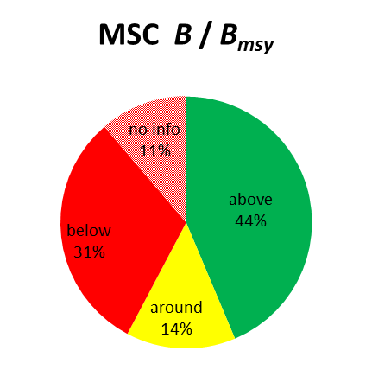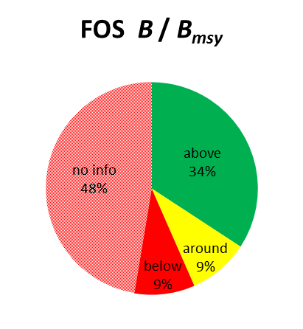

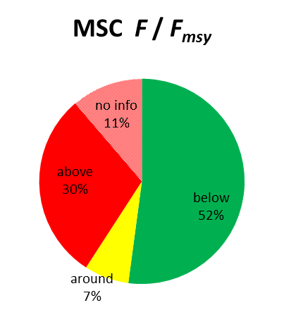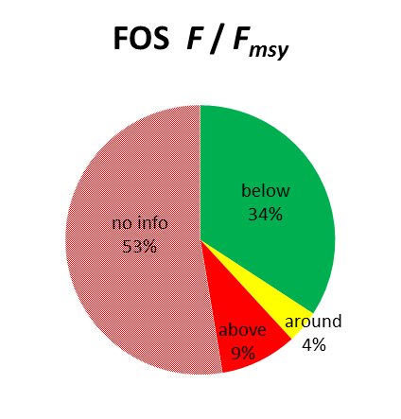

Figure 1.

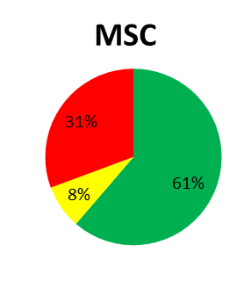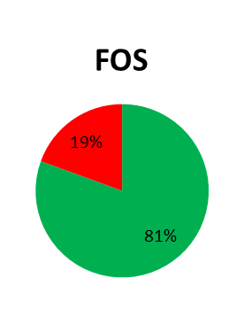
Figure 2.

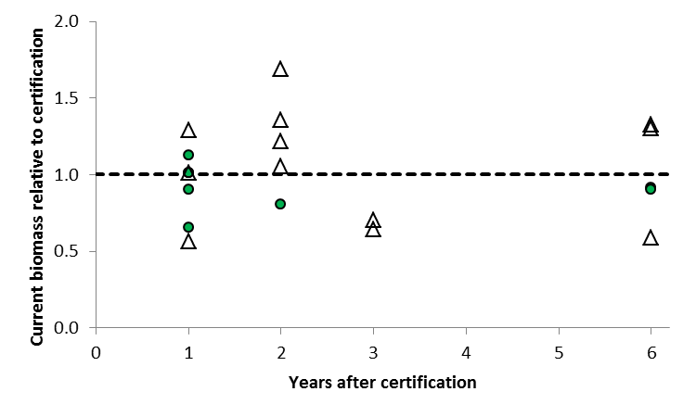
Figure 3.

