Mismanagement of the North Sea Cod by the Council of the European Union
Ocean and Coastal Management, in press, doi: 10.1016/j.ocecoaman.2012.04.005
Rainer Froese¹ and Martin Quaas²
¹GEOMAR, Düsternbrooker Weg 20, 24105 Kiel, Germany, rfroese@geomar.de, Tel. +49 431 600 4579, Fax + 40 431 600 1699, corresponding author
²Institut für Volkswirtschaftslehre, Wirtschafts- und Sozialwissenschaftliche Fakultät, Christian-Albrechts-Universität zu Kiel, Wilhelm-Seelig-Platz 1, 24118 Kiel, Germany, quaas@economics.uni-kiel.de
Abstract
The North Sea cod stock is outside of safe biological limits, yet it continues to suffer from overfishing at three times the level that could produce the maximum sustainable yield (MSY). As a result, the subpopulation of cod in the southern North Sea may have gone extinct. Continued overfishing was decided and thus legalized by the Council of European agriculture ministers despite repeated scientific advice, since 2003, to close the fishery. Here we show that with observed recruitment, a three-year closure of the cod-fishery from 2003 to 2005 would have rebuilt the stock sufficiently for fishing activities to resume. MSY-level fishing pressure would then have allowed further recovery of the stock and would have led to high profits that could have easily paid for the costs of the closure. We stress that this recovery scenario is not unrealistic because it is built on actual recruitment, fish growth, and landing prices. Given the gross management failure, we question the functionality of the current management system.

1. Introduction
In fisheries, the ultimate mismanagement may be defined as a stock collapsing as a result of decisions which were clearly wrong given the information available to the managers at the time. This definition fits the management of North Sea cod by the Council of European agriculture and (few) fisheries ministers. Under the Common Fisheries Policy of 1983, the Council determines the total allowable catches that may be taken in the subsequent year from the over 100 fished stocks in the exclusive economic zone of Europe.
The North Sea is one of the most productive shelf areas of the World and Atlantic cod (Gadus morhua) used to be its dominant predator, shaping the ecosystem and supporting substantial fisheries since historic times. Estimates of the fishing pressure (F_{msy}) that would result in the maximum sustainable yield (MSY) range from 0.19 to 0.24 (Cook et al. 1997; Horwood et al. 2006; Froese & Proelss 2010; ICES 2011a), meaning that 17-21% of the fishable cod stock could be harvested every year, in a sustainable manner. However, fisheries management as enacted by the Council of European agriculture ministers has allowed total removals (landings plus discards) of about 60% per year over the past three decades (Cook et al. 1997; Horwood et al. 2006; ICES 2011a). As a result, spawning stock biomass declined to the lowest historical level in 2006 with catches consisting mostly of immature fish. This development was predicted in a prominently published paper by Cook et al. (1997), who warned that “without a substantial reduction in the rate of fishing, the North Sea cod stock may well collapse.” In addition, Hutchinson et al. (2003) demonstrated “marked genetic changes in the declining North Sea cod.” To avoid further stock deterioration and collapse, the International Council for the Exploration of the Sea (ICES) that advises the European Commission on the state of fish stocks, called for a closure of the North Sea cod fishery in 2003 and in several subsequent years. However, the Council ignored this advice and the supporting information and instead adopted a management plan (Council Regulation No 423, 2004) which allowed removals of up to 48%, far beyond MSY-levels, even while the stock was outside of safe biological limits. This insufficient plan (Horwood et al. 2006) was subsequently not implemented. Instead, another long-term management plan was agreed between the EU and Norway in 2008, which aimed for removals of 33% after a transition phase (ICES 2011b). This management plan was also not implemented (ICES 2011b) and removals continued at 59% in 2003 and 50% in 2010. Several opportunities to rebuild the stock from better-than-recent-average recruitments (e.g. in 2000 and 2006) were wasted and these one year old recruits were mostly caught and discarded dead at sea (ICES 2011c), because the legal nets caught cod that were smaller than the legal landing size of 35 cm (ICES 2003, 2004). As a result of this continued mismanagement, the North Sea cod stock remained outside of safe biological limits at least since 1998. Its subpopulation in the southern North Sea (Wright et al. 2006; Hutchinson 2008) was depleted and may be permanently lost as evolutionarily significant unit adapted to the southern North Sea (ICES 2011c,d).
Here we explore whether the collapse of the North Sea cod could have been avoided if the Council had followed the scientific advice and closed the cod-fishery in 2003.

2. Material and Methods
We simulated the development of the North Sea cod stock assuming a closure of the fishery in 2003. For the simulation we used data on stock biomass and abundance, rate of maturity, weight in catch and stock, number and weight of discards, natural mortality and relative fishing mortality for ages 1 to 10, as provided by ICES (2011c). We also used the observed recruitment (age 1) data from 2003 to 2011 as provided by ICES (2011c). We assumed that during the closure of the targeted fishery, by-catch of cod in other fisheries would continue at the level indicated as discard numbers by age by ICES (2011c). We assumed that fishing would resume with a fishing mortality of F_{msy} = 0.19 once spawning stock biomass surpassed the level of reduced recruitment, estimated by ICES (2011a) at 150,000 tonnes.
Fishing mortality F and removals expressed as percentage of the stock size at the beginning of the fishing season were calculated as Percentage = 100 (1 – e^{-F}).
Fishing costs and profits were calculated using the most recent data for 2003-2008 from STECF (Anderson and Guillen 2010). We used data on variable profits, value of landings, fishing and non-fishing income for the United Kingdom demersal trawl and demersal seiner fleet (vessels of more than 12 m length), and calculated profit and cost shares for cod according to the cod share in the value of landings. We estimated actual profit of the North Sea cod fishery by multiplying the profits per ton with total landings from ICES (2011c). To calculate profits for the rebuilding scenario, we used the available price data for 2003-2008. For the years 2009-2011, for which actual prices were not yet available, we assumed the mean price of 2003-2008. We multiplied this with the landing share of total removals, assuming that the share of discards would remain equal to the average from the past years according to ICES (2011c) data. We used the Spence (1974) fishing cost function, which assumes that the instantaneous catch per unit of effort is proportional to stock biomass, as deemed appropriate for cod fisheries (e.g. World Bank 2008). We focused on true variable costs (i.e. without subsidies) to capture only those costs that would matter for the decision on harvest quantities in the absence of distorting policy interventions. For the simulations, we used the observed cost parameters for 2003-2008 and the average of 2003-2008 for 2009-2011.
We used the term ‘actual’ to refer to the real, observed management decisions, recruitment, removal, biomass and price data. We used the term ‘overfishing’ to refer to fishing pressure beyond the level that would result in the maximum sustainable yield (F > F_{msy}).
An annotated spreadsheet with the simulation methods and data is available as electronic supplementary material.
3. Results
A comparison between actual stock development and the simulated closure and recovery are shown in Figures 1 and 2. Under actual management of 2003-2011, spawning stock biomass remained far outside of safe biological limits, with discards and unreported catches dominating the total removals, see flat bold line near the X-axis in Fig. 1. In contrast, a closure of three years and subsequent fishing at F_{msy} would have rebuilt the stock by 2011 to sizes above the highest values in the historic time series, see broken line in Figure 1.
Actual management allowed total removals to substantially exceed the remaining spawning stock biomass in every year (bold line in Figure 2). Under the recovery scenario, the fishery would have been closed for three years from 2003 to 2005 and reopened with catches above the actual ones in 2006, increasing steadily thereafter. Despite the three year closure, total removals from 2003 to 2011 would have been higher under the recovery scenario (591,337 tonnes) than actual removals (539,301 tonnes) (Fig. 3).
Under actual management, the North Sea cod fishery was hardly profitably in 2003-2008, with profits below EUR 6 million per year during the whole period. This is due to high fishing costs because of the high fishing mortality rate requiring high effort. Under the recovery scenario, revenue and profits in the cod fishery would have been zero during closure (2003-2005), but vastly higher than actual values thereafter: profits would have grown from about EUR 50 million in 2006 to almost EUR 90 million in 2011.
4. Discussion
4.1 Actual recruitment and growth were used
The crucial point in any simulation of stock development are the assumptions about recruitment. Recruitment success is a function of, among other, parental stock size, environmental conditions, and predator-prey interactions. Here we used the observed recruitments from 2003 to 2010 as reported by ICES (2011c). Thus, our recovery scenario would have been feasible because it is built on the observed replenishment of the stock and only differs from reality by allowing a larger proportion of recruits to survive fishing and grow. Our scenario is also conservative with respect to speed and magnitude of stock recovery, because it is reasonable to assume that recruitment would have been better than observed given the much larger spawning stock size resulting from surviving and maturing recruits (Cook et al. 1997).
For the purpose of this exercise we accepted the ICES (2011a) estimate of full reproductive capacity at a spawning stock biomasses above 150,000 tonnes, a fishing pressure at F_{msy}, and a continued fishing of juvenile cod, although these choices are not compatible with more precautionary and more profitable (Grafton et al. 2007, Davis and Rangeley, 2010) harvest control rules such as implemented in New Zealand, Australia and the United States and proposed for Europe (Froese et al. 2011). We did this to stay within the accepted management options that were available to the Council at the time. For example, studies by its Scientific, Technical and Economic Committee on Fisheries (STECF) showed that a reduction of fishing pressure below F = 0.3 (removals of less than 26%) was needed to ensure a recovery of spawning stock biomass to 150,000 tonnes within a decade (STECF 2002). Also, ICES (2004) advised that “Candidates for reference points which are consistent with taking high long-term yields and achieving a low risk of depleting the productive potential of the stock may be identified in the range of F_{0.1} – F_{max}.” This range was given as 0.13 – 0.20 and thus included the F_{msy} = 0.19 (≈17%) used in our recovery scenario.
4.2 We allowed for bycatch and discards to continue during closure
It might have been unrealistic to assume zero removals during the closure of the cod fishery, given that cod is taken as bycatch in other demersal fisheries. We therefore allowed discards, i.e. the catching and disposal at sea of undersized or unwanted cod, as estimated by ICES, to continue. Even if bycatch of cod during the three year closure period would have been higher than represented by these discards, and therefore the build-up of biomass slower than simulated, the reopening of the fishery in 2006 would probably not have been affected, because the simulated spawning stock biomass at the beginning of 2006 was well beyond the threshold of 150,000 tonnes (Fig. 1). More specifically, the sum of discards reported by ICES for 2003 – 2005 amounted to 18,283 tonnes, while the simulated spawning stock biomass at the beginning of 2006 exceeded the threshold by 72,775 tonnes. Thus, the reopening of the fishery in 2006 should not have been endangered even if discards had been 2-3 times higher than reported.
4.3 The abandoned recovery plan
In 2003, the Council developed a recovery plan for the North Sea Cod and some other stocks. This recovery plan was formally adopted and published in the Official Journal of the European Union (Council Regulation No 423/2004). It is worth a closer look, as it gives insight into the mindset, procedures and goals of the managers. First, the Council Regulation makes clear that “Each year, the Council shall decide by qualified majority, on the basis of a proposal by the Commission, on a TAC [total allowable catch] for the following year for each of the depleted cod stocks.” In other words, also in the case of this cod recovery plan, which contained a clear procedure for TAC-setting, the ministers insisted on their annual ritual of negotiating and deciding next year’s catch, rather than deciding reasonable harvest-control rules and long-term management plans and delegating implementation of these to the administration (Froese et al. 2011, Wakeford et al. 2009).
According to the recovery plan (Council Regulation No 423/2004), the proposal of the Commission and the decisions of the ministers were to take into account the “scientific evaluation, carried out by the STECF in the light of the most recent reports by ICES.” The Scientific, Technical and Economic Committee on Fisheries consists of 30-35 experts who are appointed by the Commission “on the basis of their expertise” (Commission Decision 2005) whereas the International Council for the Exploration of the Seas (ICES) brings together several hundred fisheries scientist around the North Atlantic. The recovery plan aimed to increase spawning stock biomass (SSB) to levels considered biologically safe, within an expected but not mandatory period of 5-10 years. More specifically, TACs should be set such that SSB would increase annually by 30%. For the North Sea cod SSB of 34,718 tonnes in 2004, this plan would have led to a presumably safe SSB of 167,577 tonnes in 2010, compared to 222,775 tonnes in 2006 with no targeted fishing in our simulation. However, after closed-door discussions, the Council abandoned its own rescue plan and the actual SSB at the beginning of 2010 was still depleted at 52,733 tonnes, with subsequent total removals estimated at 69,286 tonnes. The removals exceeded the spawning stock biomass because they consisted mainly of immature fish (ICES 2011c). Clearly, over a period of at least seven years, despite numerous warnings and adequate advice and recovery plans, the Council failed to act responsibly on the depleted state of the North Sea cod stock. This continued failure calls into questions the current organization of fisheries management in Europe.

4.4 The southern subpopulation of cod may have gone extinct
The North Sea cod stock consists of several subpopulations with different degrees of intermixing and with different population characteristics (Blanchard et al. 2005a; Wright et al. 2006; ICES 2011d), a fact that was communicated to the managers by their advisory body (STEFC 2005). If such a complex of sub-units is managed as one, the weakest stock components are prone to extinction, a problem that is well known among resource managers and which had been explicitly pointed out for the case of North Sea cod (Hutchinson 2008). The demise of the southern subpopulation of North Sea cod was known to managers from the results of the annual international bottom trawl surveys (IBTS) (Blanchard et al. 2005b) and from the distribution of catch data (ICES 2011c). Recent analyses suggest that this disappearance was not the result of a northward movement of southern North Sea cod to avoid warming waters (Wright et al. 2006; Neat and Righton 2007; ICES 2011d) but more likely the result of lower recruitment in the southern area due to the depletion of that spawning stock component (Horwood et al. 2006; ICES 2011d). The area is unlikely to be resettled by the surviving northern subpopulation, which is adapted to deep-water conditions (ICES 2011d). It is unclear whether our proposed recovery management would have come too late in 2003 to save the southern subpopulation, because it was already severely diminished. But first quarter IBTS surveys, which overlap with the spawning season of North Sea cod, show slightly more mature cod (3 years and above) remaining in the southern North Sea in 2003 than in 2011 (ICES 2011c).
4.5 Our study confirms previous ones
Horwood et al. (2006) conducted similar simulations of potential recovery of the North Sea cod. They concluded that a recovery beyond the 150,000 tonnes level was possible even at (assumed) low level of recruitment, if fishing pressure was drastically reduced, e.g. to F_{msy} which they estimated as 0.2. Our results confirm their study in hindsight, with recruitment levels that were actually observed instead of assumed. Davies and Rangeley (2010) predict that, after a recovery period of 5-10 years, the North Sea cod stock could support profits that are two to six fold the pre-recovery level. Our study shows a nearly two-fold increase in profits 8 years after the closure, thus confirming their projections.
4.6 Discussion of profits
The large difference in profits under actual management and the recovery scenario after 2005 is caused by two effects: First, fishing revenues are higher because of larger landings. Second, and more importantly, fishing costs are lower because of the much smaller fishing mortality and associated fishing effort. Note that from the economic point of view, only the true cost of fishing (i.e., without subsidies) matter for efficiency considerations (Stöven and Quaas, 2012). Thus, the results on fishing profits rely on the view that fishing effort must be considered as an economic cost. Accordingly, fishing effort must be kept below the levels applied during the phase of overfishing even after stocks have been rebuilt. Attempts to keep fishing effort at extremely high levels are incompatible with both, stock sizes within biologically safe limits and fisheries that are economically profitable on a sustainable basis. After the collapse of the Newfoundland cod stock in the early 1990s, trade-flows, consumer preferences, demand and supply factors, and prices had changed significantly, making it unlikely that pre-collapse conditions could be restored (Khan 2010). In contrast, we have assumed that the market price for cod would not be affected by the increased supply after stock recovery. This is reasonable, as North Sea cod is already competing on international markets with cod from much larger stocks such as the North East Arctic cod, with annual catches that are five to ten times higher. It is also in line with previous studies that have assumed little influence of supply on prices of North Sea cod (Arnason et al. 2004). A change in the supply of fish products from other stocks (other cod stocks; pollock and hoki) or fish farms might influence prices for North Sea cod as well. These effects are important for optimal management decisions (Quaas and Requate, forthcoming). However, all these effects are likely to reduce the price for North Sea cod. From an economic perspective, the case for reducing harvest and increasing stock sizes would even be stronger: With lower output prices, a reduction of cost of fishing would become even more important to make fishing profitable again.
5. Conclusions
In summary, our analysis shows that the call for closure of the fishery in 2003 already came late, but was well-justified, and that such closure would have rebuild the stock and possibly saved the southern subpopulation. Profits of fishers from the rebuilt stock would have been several-times higher than what they are today. These higher profits could have easily paid for the cost incurred during the closure of the fishery. Management as enacted by the Council ignored scientific advice, economic considerations, and international agreements, and resulted in the ultimate mismanagement, the commercial and possibly biological extinction of the southern part of the stock, with yet unforeseen consequences for the North Sea ecosystem. Recent population increases of plaice (Pleuronectes platessa) and brown shrimp (Crangon crangon) in the area may well result from the disappearance of cod as a major competitor and predator, respectively. Given the continuing inability of the Council of European Agriculture Ministers to responsibly manage an important natural resource, calls for giving the management of European fisheries to the Ministers of the Environment (Froese 2011) seem justified.
6. Acknowledgement
This study was supported in part by the Future Ocean Excellence Cluster 80, funded by the German Research Foundation on behalf of the German Federal and State Governments.
7. References
Anderson J., Guillen, J., 2010. The 2010 Annual Economic Report on the European Fishing Fleet, Scientific, Technical and Economic Committee for Fisheries (STECF), Joint Research Centre, Ispra, Italy. 688 pp.
Arnason, R., Sandal, L. K., Steinshamn, S. I., Vestergaard, N., 2004. Optimal Feedback Controls: Comparative Evaluation of the Cod Fisheries in Denmark, Iceland, and Norway. American Journal of Agricultural Economics, 86(2), 531–542.
Blanchard, J. L., Heffernan, O. A., Fox, C. J. 2005. North Sea (ICES Divisions IVaec and VIId), in: Spawning and Life History Information for North Atlantic Cod Stocks. ICES Cooperative Research Report, 274. ICES, Copenhagen,154 pp.
Blanchard, J. L., Mills, C., Jennings, S., Fox, C. J., Rackham, B. D., Eastwood, P., and O’Brien, C. M. 2005. Distribution – abundance relationships for North Sea cod: observation versus theory. Canadian Journal of Fisheries and Aquatic Sciences, 62, 2001-2009.
Cook, R.M., Sinclair, A., Stefansson, G., 1997. Potential collapse of North Sea cod stocks. Nature 385, 521-522.
Council Regulation (EC) No 423/2004 of 26 February 2004, establishing measures for the recovery of cod stocks. Official Journal of the European Union, L 70, 8-11.
Davies, R.W.D., Rangeley, R., 2010. Banking on cod: exploring economic incentives for recovering Grand Banks and North Sea cod fisheries. Marine Policy 34, 92-98.
Froese, R., 2011. Fishery reform slips through the net. Nature 475, 7.
Froese, R., Proelss, A., 2010. Rebuilding fish stocks no later than 2015: will Europe meet the deadline? Fish and Fisheries 11, 194-202.
Froese, R., Branch, T.A., Proelss, A., Quaas, M., Sainsbury, K., Zimmermann, C., 2011. Generic harvest control rules for European fisheries. Fish and Fisheries 12, 340-351.
Grafton, R.Q., Kompas, T., Hilborn, R.W., 2007. Economics of overexploitation revisited. Science 318, 1601.
Horwood, J., O’Brien, C., Darby, C., 2006. North Sea cod recovery? ICES Journal of Marine Science 63, 961-968.
Hutchinson, W.F., 2008. The dangers of ignoring stock complexity in fishery management: the case of North Sea cod. Biology Letters 4, 693-695.
Hutchinson, W.F., Oosterhut, C. v., Rogers, S.I., Carvalho, G.R., 2003. Temporal analysis of archived samples indicates marked genetic changes in declining North Sea cod (Gadus morhua). Proceedings of the Royal Society, B, 22, 2125-2132.
ICES, 2003. Report of the Working Group on the Assessment of Demersal Stocks in the North Sea and Skagerrak (Part 1 of 3). ICES, Copenhagen.
ICES, 2004. Cod in Subarea IV (North Sea), Division VIId (Eastern Channel), and Division IIIa (Skagerrak). p. 200-215, downloaded on 1. July 2011 from http://www.ices.dk/committe/acom/comwork/report/2004/oct/cod-347d.pdf
ICES 2011a. ICES Advice June 2011 on Cod in Subarea IV (North Sea) and Divisions VIId (Eastern Channel) and IIIa West (Skagerrak), p. 10-27, downloaded on 1. July 2011 from http://www.ices.dk/committe/acom/comwork/report/2011/2011/cod-347.pdf
ICES 2011b. Joint EU-Norway request on the evaluation of the long-term management plan for cod. ICES Advice 2001, Book 6:6-16, downloaded on 1. July 2011 from http://www.ices.dk/committe/acom/comwork/report/2011/Special%20requests/EUNorway%20evaluation%20of%20MP%20for%20NS%20cod.pdf
ICES 2011c. WGNSSK Report, Cod, pages 770-843, downloaded on 1. July 2011 from http://www.ices.dk/reports/ACOM/2011/WGNSSK/Sec%2014%20Cod.pdf
ICES 2011d. Report of the Workshop on the Analysis of the Benchmark of Cod in Subarea IV (North Sea), Division VIId (Eastern Channel) and Division IIIa (Skagerrak) (WKCOD 2011), 7-9 February 2011, Copenhagen, Denmark. ICES CM 2011/ACOM:51. 94 pp.
Khan, A.S. 2010. A market chain analysis of Northern Gulf cod fisheries pre-and post-collapse: Implications for resource sustainability and economic viability. Proceedings of the International Institute for Fisheries Economic and Trade. Montepellier, France
Neat, F., Righton, D., 2007. Warm water occupancy by North Sea cod. Proceedings of the Royal Society, B, 274, 789-798.
Quaas, M. F., and Requate, T., in press. Sushi or Fish Fingers? Seafood Diversity, Collapsing Fish Stocks and Multi-species Fishery Management. Scandinavian Journal of Economics.
Spence, A.M., 1974. Blue whales and applied control theory, in: H. W. Gottinger (Ed.), System Approaches and Environmental Problems (pp. 97–124). Göttingen: Vandenhoeck and Ruprecht.
Stoeven, M.T., and Quaas, M.F., 2012. Privatizing renewable resources: Who gains, who loses?, Economics working paper / Christian-Albrechts-Universität Kiel, Department of Economics, No. 2012-02, http://hdl.handle.net/10419/55521
STECF 2002. Sub-group on review of stocks (SGRST). Evaluation of recovery plans, Brussels, 20 - 22 March 2002, Annex III. Evaluation of harvest control rules for North Sea cod. Report of a two-day meeting of scientists from Norway and the Community. Brussels, 18 and 19 March 2002. EC SEC (2002) 764. 152 pp.
STECF 2005. STECF Sub-group SGRST Evaluation of the Cod Recovery Plan, Joint Research Centre, Ispra, Italy, 13-17 June 2005. 34 pp.
Wakeford, R.C., Agnew, D.J., Mees, C.C., 2009. Review of institutional arrangements and evaluation of factors associated with successful stock recovery plans. Reviews in Fisheries Science 17, 190-222
World Bank, 2008. The Sunken Billions. The Economic Justification for Fisheries Reform. Washington DC: Agriculture and Rural Development Department, The World Bank.
Wright, P.J., Neat, F.C., Gibb, F.M., Gibb, I.M.,Thordarson, H., 2006. Evidence for metapopulation structuring in cod from the west of Scotland and North Sea. Journal of Fish Biology 69, 181-199.

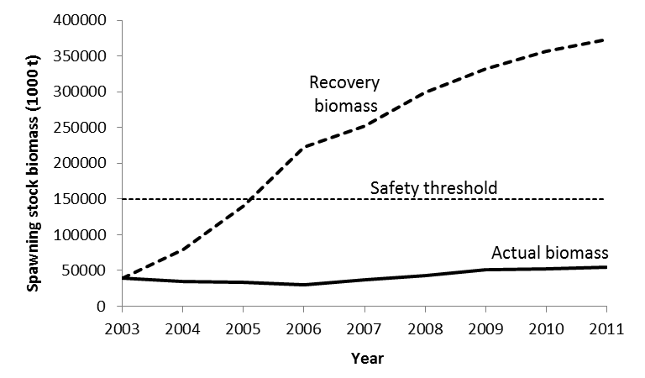
Figure 1. Comparison of two management scenarios for the North Sea cod with respect to spawning stock biomass: the bold line is actual management; the broken line is a simulated recovery with three year closure and then fishing at F_{msy}. The area below the horizontal dotted line is considered to be outside of safe biological limits.

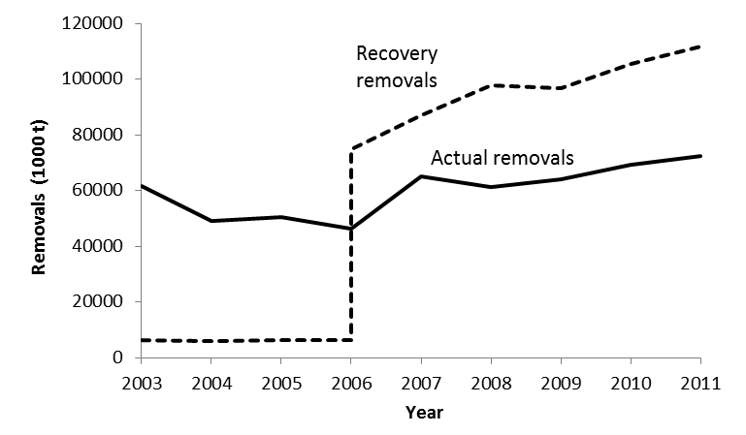
Figure 2. Comparison of two management scenarios with respect to total removals, which consist of landings, discards, and unreported catches: the bold line is the actual management, the broken line represents a simulated recovery, with only discard mortality in 2003-2005, and fishing at F_{msy} from 2006 onward.

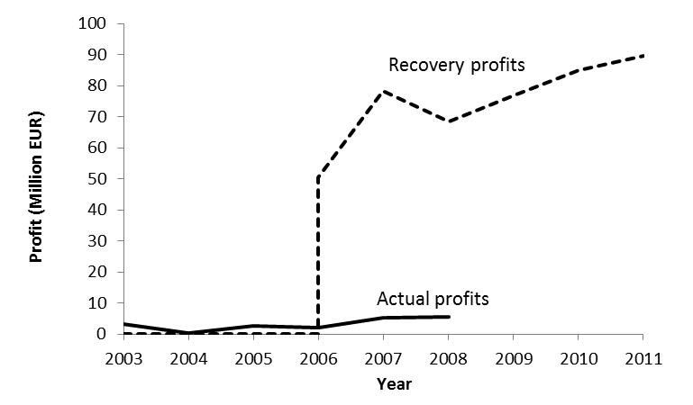
Figure 3. Comparison of two management scenarios with respect to profits, which consist of the difference between revenues (market price of cod times landings) and fishing costs: the bold line are profits according to STECF data, the broken line represents profits from simulated recovery, with only discard mortality (zero profits) in 2003-2005, and fishing at F_{msy} from 2006 onward.

