Supplement material

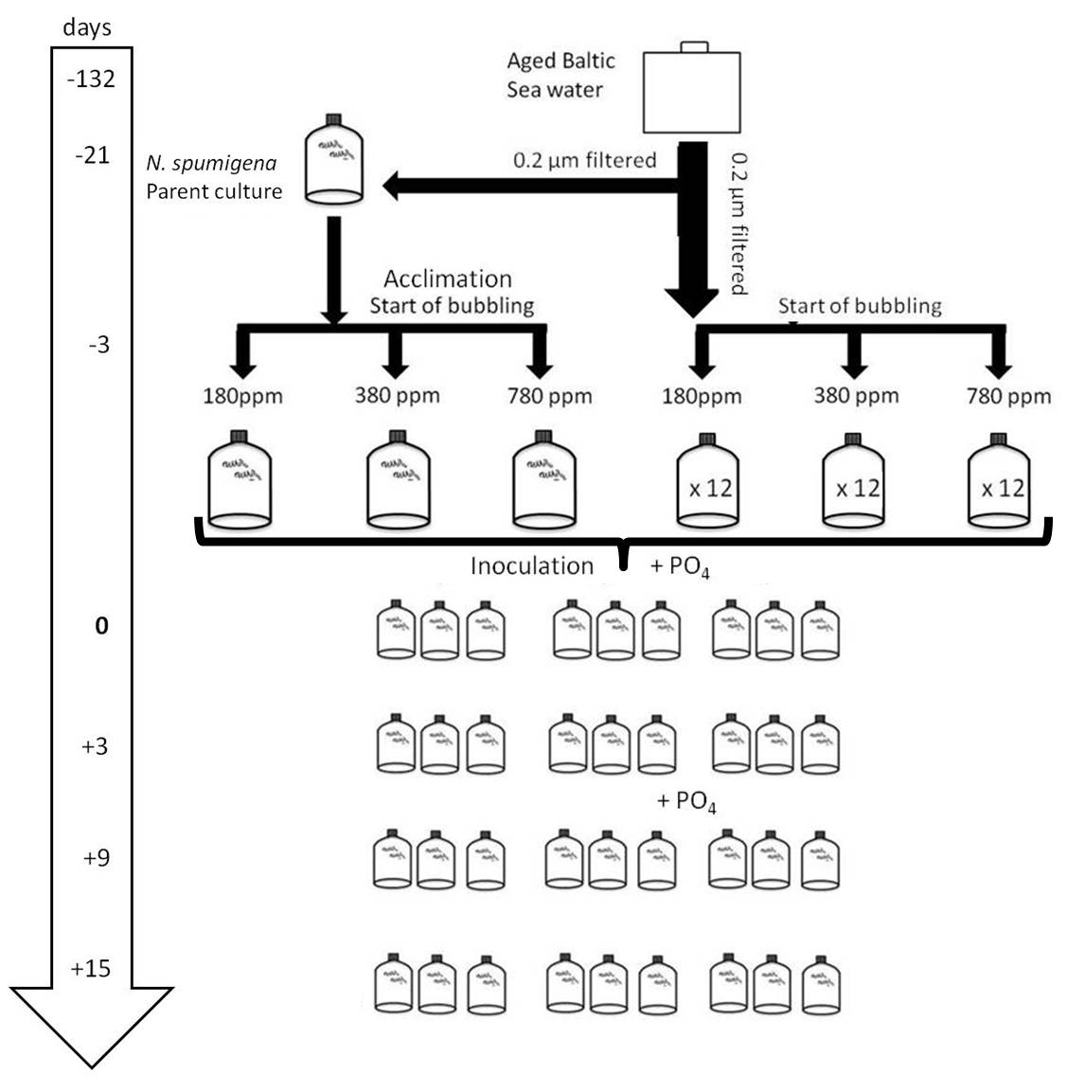
Supplement A. Schematic overview of the experimental set up and time flow of the single steps taken from preparation (-132 days) to the end of the experiment (+15 days). See Wannicke et al. (2012) for detailed information.

Supplement B. Carbonate system variables for the four sampling time points. pH and total carbon (C_{T}) were measured, total alkalinity (A_{T}) and pCO₂ in seawater were calculated from pH and C_{T} using CO2SYS (Lewis and Allison, 1998).Values are means and standard deviations of three replicates (except one replicate bottle of the 180 ppm treatment at day 9) (from Wannicke et al. 2012)
Date | CO₂ target  [µatm] | Incubation time  [d] | pH  total scale | C_{T}  [µmol kg ⁻¹] | A_{T}  [µmol kg ⁻¹] | pCO₂  [µatm]
29.3.2010 | 180 | 0 | 8.02 ± 0.02 | 1651.9 ± 8.9 | 1724.2 ± 6.4 | 464.1 ± 29.9
 | 380 | 0 | 7.95 ± 0.01 | 1656.8 ± 3.6 | 1713.4 ± 2.8 | 561.0 ± 8.7
 | 780 | 0 | 7.93 ± 0.03 | 1676.7 ± 2.7 | 1730.3 ± 2.6 | 590.7 ± 35.3
1.4.2010 | 180 | 3 | 8.16 ± 0.03 | 1607.4 ± 10.2 | 1709.7 ± 3.2 | 330.1 ± 26.3
 | 380 | 3 | 8.09 ± 0.03 | 1617.5 ± 11.4 | 1703.5 ± 3.5 | 388.8 ± 36.0
 | 780 | 3 | 7.94 ± 0.02 | 1667.9 ± 1.9 | 1720.5 ± 5.1 | 576.8 ± 23.3
7.4.2010 | 180 | 9 | 8.22 ± 0.04 | 1570.4 ± 14.6 | 1690.8 ± 5.0 | 276.7 ± 27.1
 | 380 | 9 | 8.18 ± 0.03 | 1581.1 ± 2.8 | 1690.9 ± 5.9 | 305.3 ± 20.3
 | 780 | 9 | 8.07 ± 0.02 | 1620.7 ± 5.3 | 1702.3 ± 3.8 | 412.2 ± 16.9
13.4.2010 | 180 | 15 | 8.20 ± 0.04 | 1568.0 ± 11.4 | 1683.3 ± 22.6 | 291.8 ± 29.3
 | 380 | 15 | 8.14 ± 0.01 | 1595.9 ± 4.9 | 1696.7 ± 2.0 | 339.6 ± 12.5
 | 780 | 15 | 8.03 ± 0.06 | 1626.9 ± 21.1 | 1702.2 ± 6.7 | 452.9 ± 82.2

