NRA_Daily_Cycle1.tif

Figure 1. Daily cycle of mean (± SE, n=3) nitrate reductase activity in *C. officinalis* in the light in April 2011. The hourly light intensity is shown by the dotted lines.

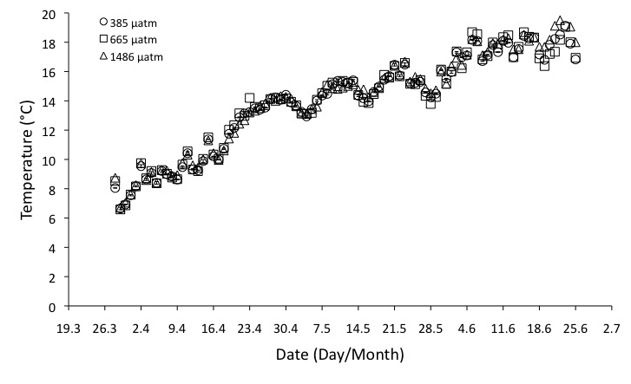

Figure 2. Mean (± SE, n = 4) seawater temperature in the mesocosm tanks during the experimental period. Circles: 385, squares = 665, triangles = 1486 µatm CO2.

*Nutrients.tif*

Figure 3. Inorganic nutrient concentrations of the ambient seawater throughout the duration of the experiment, from March 30th to June 17th, 2011.

A) B)

Boxplot_Nitrate_Ammonum_Uptake1.tifBoxplot_Phosphate_Uptake1.tif

Figure 4. Boxplots showing the median, minimum, maximum, and first and third quartiles of *C. officinalis* uptake rates for A) nitrate and ammonium and B) phosphate as a function of CO2 concentration.

A) B)

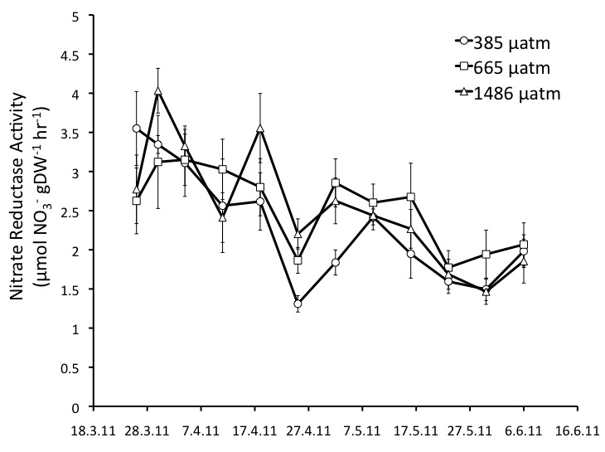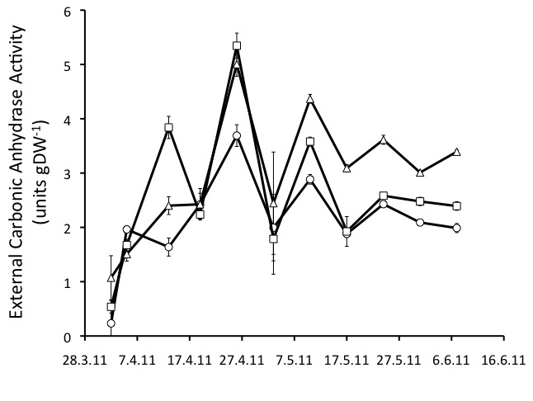

C) D)

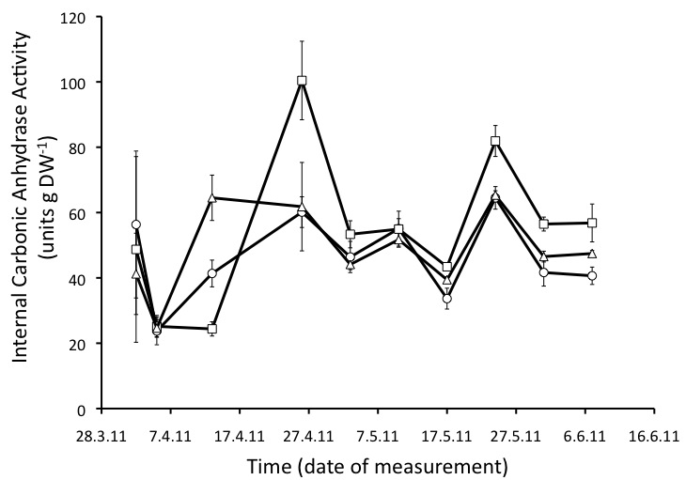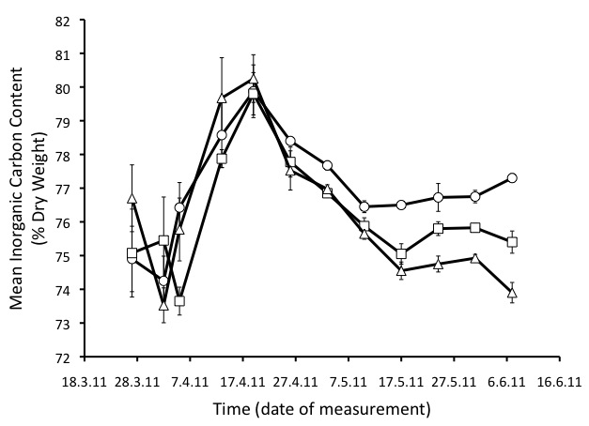

Figure 5. Time series of mean (± SE, n = 4) A) nitrate reductase activity B) external carbonic anhydrase activity C) internal carbonic anhydrase activity and D) percent inorganic carbon of *C. officinalis* exposed to three carbon dioxide concentrations. Circles: 385, squares = 665, triangles = 1486 µatm CO2.

Figure 6. Mean nitrate reductase activity (± SE, n = 4) as a function of mean nitrate uptake rates in *C. officinalis* exposed to the three CO2 levels. Circles: 385, squares = 665, triangles = 1486 µatm CO2.

A) B)

Inorg_vs_eCAA_D36.tifInorganic_vs_CAA_Sylt2011.tif

Figure 7. Inorganic content of *C. officinalis* as a function of external carbonic anhydrase activity after A) 36 and B) 71 days of exposure to three CO2 concentrations