Supplementary information

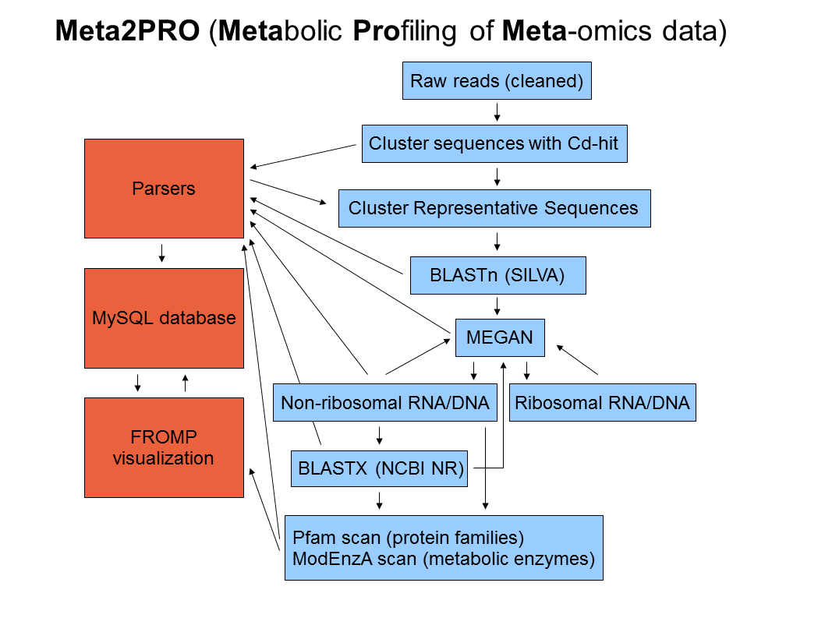

**Figure S1**: Schematic diagram of the Meta2Pro annotation workflow. Meta2Pro includes sequence clustering, BLAST-searches, scans with profile hidden Markov models of the ModEnzA EC and Pfam groups, the profiling of EC number counts with FROMP and the storage of the data and the metadata in a web browser-based MySQL database (to be accessed with phpMyAdmin).

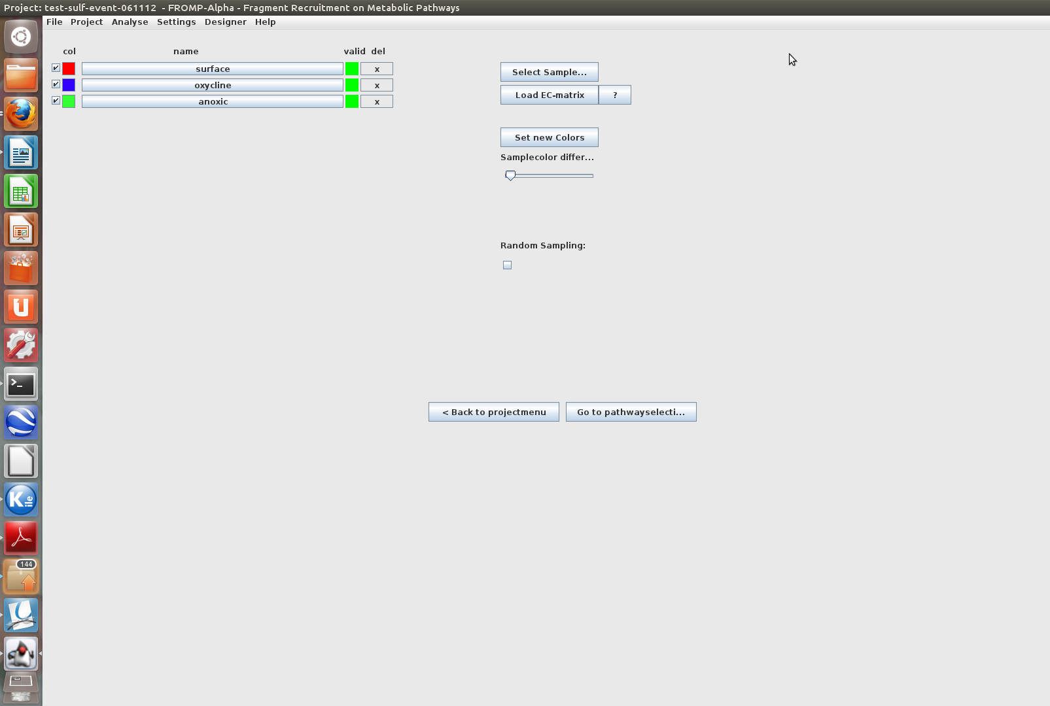

**Figure S2**: Screen shot demonstrating the addition of the metatranscriptomic samples, collected at different depths (oxic surface,oxycline and anoxic) from a single station in the oxygen minimum zone (OMZ) off Peru, to a new project in FROMP.

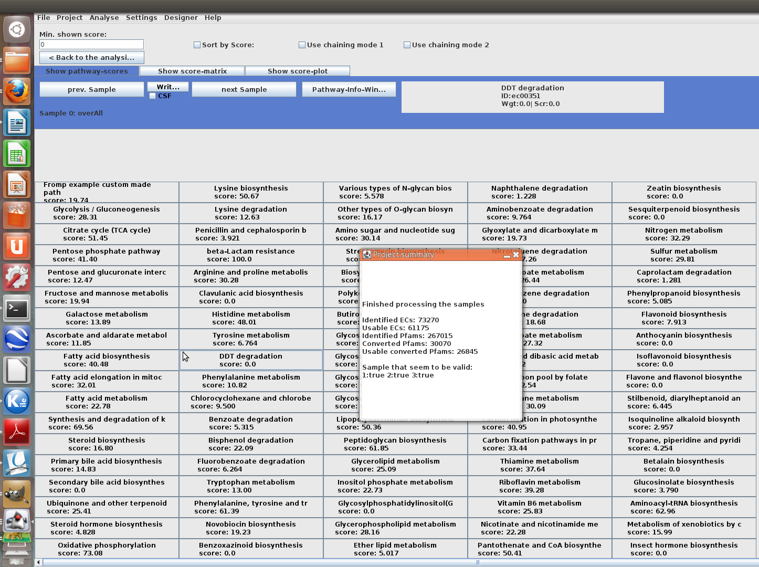

**Figure S3**: A summary of the Pathway Completeness scores of various pathways for the metatranscriptomes

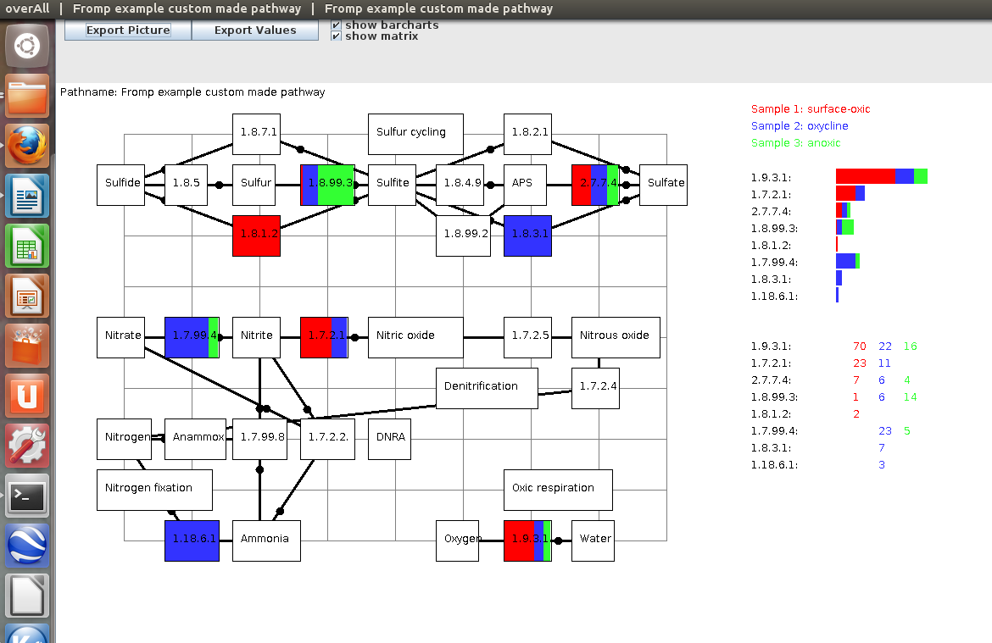

**Figure S4**: Screen shot demonstrating the mapping of EC numbers from the three metatranscriptomic samples onto the custom-made pathway depicting reactions presumably occurring in Oxygen depleted environments. Shown are bar chart visualization and a matrix of the EC number counts.

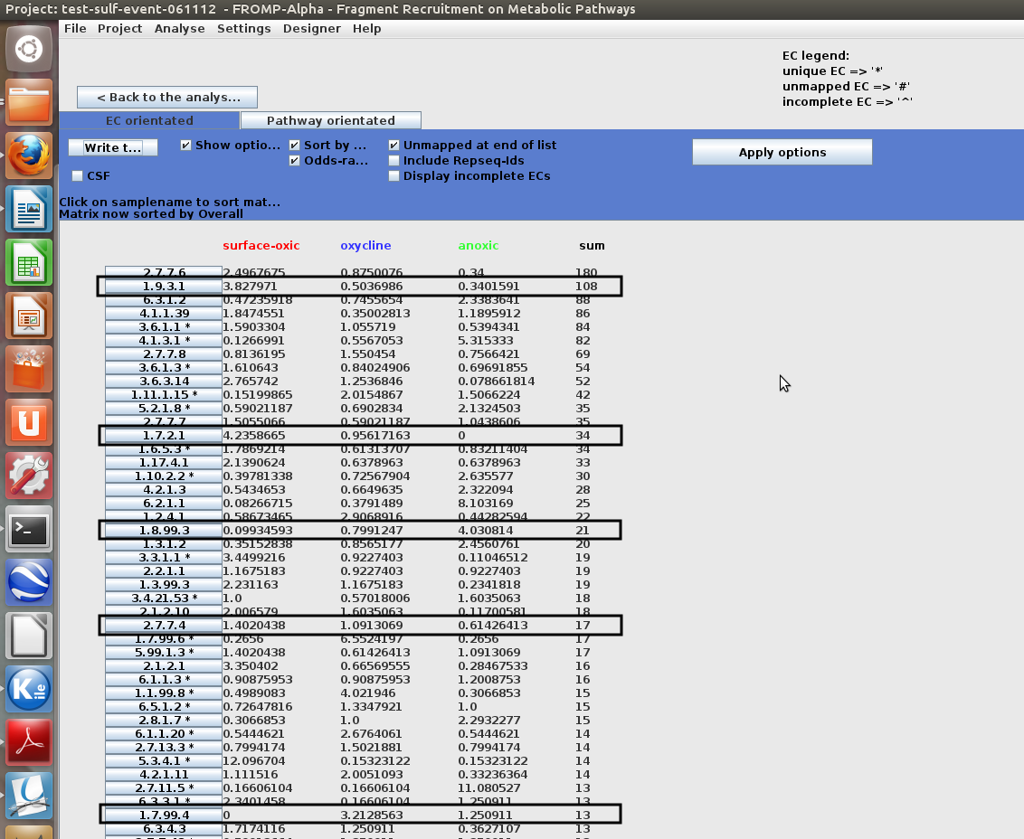

**Figure S5**: Screen shot of FROMP demonstrating the comparative analysis of the EC counts of the three metatranscriptomic samples. The sample sizes were first equalized to remove the bias from different sequencing efforts and then an odds-ratio of EC enrichment in the samples was carried out. The EC numbers of the custom-made pathway (Figure S4) showing a marked enrichment in some of the samples are highlighted.