Supplementary Information

New bhimamycins from Streptomyces sp. AK 671

Philipp Jetter^{1,2,5}, Claudia Steinert^{3,5}, Michael Knauer³, GuoLiang Zhang³, Torsten Bruhn³, Jutta Wiese⁴, Johannes F. Imhoff⁴, Hans-Peter Fiedler¹ and Gerhard Bringmann³

¹Mikrobiologisches Institut, Universität Tübingen, Tübingen, Germany; ²present address: Institut für Organische Chemie, Universität Tübingen; ³Institut für Organische Chemie, Universität Würzburg, Würzburg, Germany; ⁴Kieler Wirkstoff-Zentrum am GEOMAR Helmholtz-Zentrum für Ozeanforschung, Kiel, Germany
⁵ These authors contributed equally to this report.

Correspondence:
Professor G Bringmann, Institut für Organische Chemie, Universität Würzburg, Am Hubland, 97074 Würzburg, Germany.
E-mail: bringman@chemie.uni-wuerzburg.de
or Professor H-P Fiedler, Mikrobiologisches Institut, Universität Tübingen, Auf der Morgenstelle 28, 72076 Tübingen, Germany.
E-mail: hans-peter.fiedler@uni-tuebingen.de

Table of contents

Supplementary Table S1 1D and 2D NMR data of EM18 (11a) (600/150MHz, [D₆] acetone, 20°C)
Supplementary Table S2 1D and 2D NMR data of EM18 (11b) (600/150MHz, [D₆] acetone, 20°C)
Supplementary Table S3 1D and 2D NMR data of bhimamycin F (15) (600/150MHz, [D₆] acetone, 20°C)
Supplementary Table S4 1D and 2D NMR data of bhimamycin H (16) (600/150MHz, [D₅] pyridine, 25°C)
Supplementary Table S5 1D and 2D NMR data of bhimamycin I (17) (600/150MHz, [D₆] acetone, 20°C)
Supplementary Figure S1 HPLC-UV chromatogram of EM18 (11a) on a chiral stationary phase
Supplementary Figure S2 Online-CD spectra (stopped-flow mode) of peaks A and B of EM18 (11a)
Supplementary Figure S3 HPLC-UV chromatogram of EM18 (11b) on a chiral stationary phase
Supplementary Figure S4 Online-CD spectra (stopped-flow mode) of peaks A and B of EM18 (11b)
Considerations on the native origin of bhimamycin I (17)

Supplementary Table S1 1D and 2D NMR data of EM18 (11a) (600/150MHz, [D₆] acetone, 20°C)
Pos. | δ_{C} | δ_{H} (J Hz) | COSY | HMBC | NOESY
1 | 163.7 | - | - | 2-H | -
2 | 90.6 | 5.29 s | - | 4-H | 4-H
3 | 170.6 | - | - | 2-H, 4-H | -
4 | 103.1 | 6.21 s | - | 2-H, 6-H | 2-H, 6-H, 8-H
5 | 165.3 | - | - | 4-H, 6-H | -
6 | 56.5 | 4.17 s | - | 4-H, 8-H, 14-H,  15-CH₃ | 4-H, 8-H, 15-CH₃
7 | 142.7 | - | - | 6-H, 9-H | -
8 | 121.4 | 6.87 dd (1.0, 8.4) | 9-H, 10-H | 6-H, 10-H | -
9 | 137.5 | 7.49 dd (8.4, 8.4) | 8-H, 10-H | - | -
10 | 117.4 | 6.85 dd (1.0, 8.4) | 8-H, 9-H | 8-H, 11-OH | -
11 | 163.4 | 12.5 s | - | 9-H, 10-H, 11-OH | -
12 | 117.4 | - | - | 6-H, 8-H, 10-H,  14-H, 11-OH | -
13 | 205.0 | - | - | 14-H, 15-CH₃ | -
14 | 49.6 | 3.27 d eq (17.5)  2.75 d ax (17.5) | - | 6-H, 15-CH₃ | 15-CH₃
15 | 72.5 | - | - | 6-H, 14-H, 15-CH₃ | -
15-CH₃ | 28.2 | 1.41 s | - | 6-H, 14-H | 14-H_{ax}, 14-H_{eq}

Supplementary Table S2 1D and 2D NMR data of EM18 (11b) (600/150MHz, [D₆] acetone, 20°C)
Pos. | δ_{C} | δ_{H} (J Hz) | COSY | HMBC | NOESY
1 | 163.4 | - | - | 2-H | -
2 | 90.4 | 5.31 s | - | 4-H | 4-H
3 | 170.6 | - | - | 2-H, 4-H | -
4 | 104.0 | 6.21 s | - | 2-H, 6-H | 2-H, 6-H, 8-H
5 | 165.2 | - | - | 4-H, 6-H | -
6 | 56.2 | 4.23 s | - | 4-H, 8-H, 14-H,  15-CH₃ | 4-H, 8-H, 15-CH₃
7 | 142.8 | - | - | 6-H, 9-H | -
8 | 120.8 | 6.87 dd (1.0, 7.8) | 6-H, 9-H | 6-H, 10-H | -
9 | 137.5 | 7.50 dd (7.8, 7.8) | 8-H, 10-H | - | -
10 | 117.4 | 6.83 dd (1.0, 7.8) | 9-H | 8-H, 11-OH | -
11 | 163.4 | 12.45 s | - | 9-H, 10-H, 11-OH | -
12 | 117.4 | - | - | 6-H, 8-H, 10-H,  14-H, 11-OH | -
13 | 204.8 | - | - | 14-H, 15-CH₃ | -
14 | 49.7 | 2.87 d eq (17.5)  3.22 d ax (17.5) | - | 6-H, 15-CH₃ | 15-CH₃
15 | 72.2 | - | - | 6-H, 14-H, 15-CH₃ | -
16-CH₃ | 28.8 | 1.41 s | - | 6-H, 14-H | 14-H_{ax}, 14-H_{eq}
Supplementary Table S3 1D and 2D NMR data of bhimamycin F (15) (600/150MHz, [D₆] acetone, 20°C)
Pos. | δ_{C} | δ_{H} (J Hz) | COSY | HMBC | NOESY
1 | 148.1 | - | - | 10-H, 10-CH₃ | -
2 | N | - | - | - | -
3 | 139.2 | - | - | 3-CH₃ | -
3-CH₃ | 12.3 | 2.43 s | - | - | 2'-H
3a | 117.9 | - |  | 3-CH₃ | -
4 | 188.0 | - | - | 5-OH, 6-H, 8-H, 3-CH₃ | -
4a | 118.4 | - | - | 5-OH, 6-H, 8-H | -
5 | 163.6  163.9 | 13.2 s | 7-H | 5-OH, 6-H, 7-H, 8-H | 6-H
6 | 124.6  124.7 | 7.27-7.29 m | 7-H, 8-H | 5-H, 8-H | 5-OH, 7-H
7 | 136.6  136.7 | 7.74 dd (7.5, 8.4) | 6-H, 8-H | - | 6-H, 8-H
8 | 119.8 | 7.78 dd (1.2, 8.4)  7.79 dd (1.2, 8.4) | 6-H, 7-H | 6-H | -
8a | 136.6  136.7 | - | - | 7-H | -
9 | 182.0 | - | - | 7-H, 8-H | -
9a | 117.6 | - | - | 10-H | -
10 | 63.8 | 4.51 q (6.6) | 10-CH₃ | 10-CH₃ | 10-CH₃, 2'-H
10-CH₃ | 23.8 | 1.40 d (6.6) | 10-H | 10-H | 10-H, 2'-H
1' | 140.0 | - | - | 2'-H, 3'-H
2', 4' | 129.2  129.5 | 7.70-7.72 m | 3'-H, 5'-H | 3'-H, 5'-H | 3-CH₃, 10-H,  10-CH₃,3'-H, 5'-H
3', 5' | 132.1  132.2 | 8.31-8.33 m | 2'-H, 4'-H | 3'-H, 5'-H | 2'-H, 4'-H
6' | 133.5 | - |  | 4'-H
7' | 166.7 | - |  | 5'-H

Supplementary Table S4 1D and 2D NMR data of bhimamycin H (16) (600/150MHz, [D₅] pyridine, 25°C)
Pos. | δ_{C} | δ_{H} (J Hz) | COSY | HMBC | NOESY
1 | 134.9 | - | - | 10-CH₃ | -
2 | N | - | - | - | -
3 | 141.3 | - | - | 3-CH₃ | -
3-CH₃ | 12.4 | 2.48 s | - | - | 2'-H
3a | 117.9 | - | - | 3-CH₃ | -
4 | 187.7 | - | - | 6-H, 8-H, 3-CH₃ | -
4a | 118.0 | - | - | 6-H, 8-H | -
5 | 163.4 | - | - | 6-H, 7-H | -
6 | 124.4 | 7.40 dd (1.2, 8.4) | 7-H, 8-H | 8-H | 7-H
7 | 136.5 | 7.64 dd (7.5, 8.4) | 6-H, 8-H | - | 6-H, 8-H
8 | 119.7 | 7.95 dd (1.2, 7.5) | 7-H | 6-H | 7-H
8a | 136.5 | - | - | 7-H | -
9 | 180.1 | - | - | 8-H | -
9a | 122.2 | - | - | - | -
10 | 194.0 | - | - | 10-CH₃ | -
10-CH₃ | 31.3 | 2.92 s | - | - | -
1' | 140.6 | - | - | 2'-H, 3'-H, 5'-H, 6'-H | -
2', 6' | 128.2 | 7.66 d (8.6) | 3'-H, 5'-H | 3'-H, 5'-H | 3-CH₃, 3'-H, 5'-H
3', 5' | 131.7 | 8.55 d (8.6) | 2'-H, 6'-H | 2'-H, 6'-H | 2'-H, 6'-H
4' | 134.0 | - | - | 2'-H, 6'-H | -
7' | 168.4 | - | - | 3'-H, 5'-H | -

Supplementary Table S5 1D and 2D NMR data of bhimamycin I (17) (600/150MHz, [D₆] acetone, 20°C)
Pos. | δ_{C} | δ_{H} (J Hz) | COSY | HMBC | NOESY
1 | 138.6 | - | - | 10-H, 10-CH₃, 1'-H | -
2 | N | - | - | - | -
3 | 137.7 | - | - | 3-CH₃, 1'-H | -
3-CH₃ | 10.7 | 2.65 s | - | - | 1'-H
3a | 117.3 | - | - | 3-CH₃ | -
4 | 188.2 | - | - | 6-H, 8-H, 3-CH₃ | -
4a | 118.5 | - | - | 6-H, 7-H, 8-H | -
5 | 163.3 | - | - | 6-H, 7-H, 8H | -
6 | 123.4 | 7.16-7.18 m | 7-H, 8-H | 7H, 8-H | 7-H
7 | 136.2 | 7.63-7.65 m | 6-H, 8-H | - | 6-H, 8-H
8 | 118.9 | 7.63-7.65 m | 6-H, 7-H | 6-H | 7-H
8a | 137.2 | - | - | 6-H, 7-H, 8-H | -
9 | 179.0 | - | - | 7-H, 8-H, 10-H | -
9a | 115.9 | - | - | - | -
10 | 70.4 | 5.25 q (6.5) | 10-CH₃ | 10-CH₃, 2'-H_{a}, 2'-H_{b} | 10-CH₃, 1'-H, 2'-H_{b}
10-CH₃ | 18.9 | 1.66 d (6.5) | 10-H | 10-H | 10-H, 2'-H_{a}
1' | 43.3 | 4.04-4.06 m | 2'-H | 2'-H_{a}, 2'-H_{b} | 2'-H_{a}, 2'-H_{b}
2' | 60.3 | 3.99-4.02 m a  4.24-4.27 m b | 1'-H_{a}, 1'-H_{b} | 10-H, 1'-H | 10-CH₃, 1'-H  10-H, 1'-H

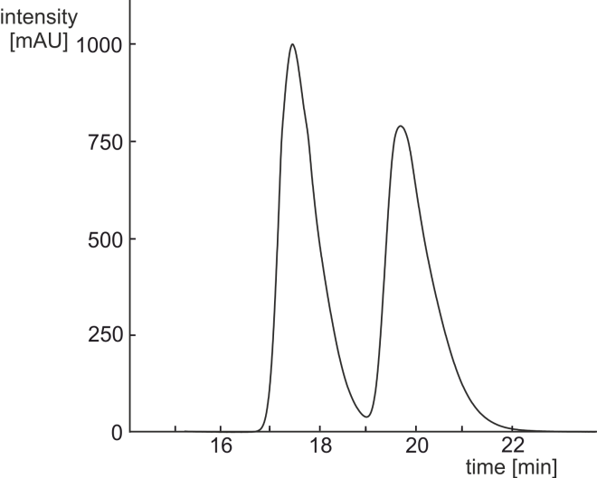
Peak A (11a)
(6R,15S)-EM18
Peak B (11a)
(6S,15R)-EM18

Supplementary Figure S1 HPLC-UV chromatogram of EM18 (11a) on a chiral stationary phase (lux cellulose-1 column, 0.5 µm; 250 mm × 4.6 mm; Phenomenex, Torrance, CA, USA; flow rate 0.8 ml min⁻¹ and isocratic solvent system: solvent (A) H₂O (+ 0.05% trifluoroacetic acid), and solvent (B) CH₃CN (+ 0.05% trifluoroacetic acid), 18% of solvent A).

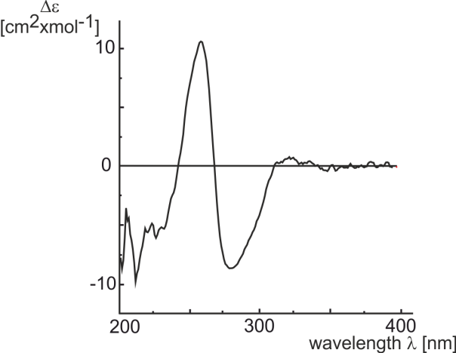
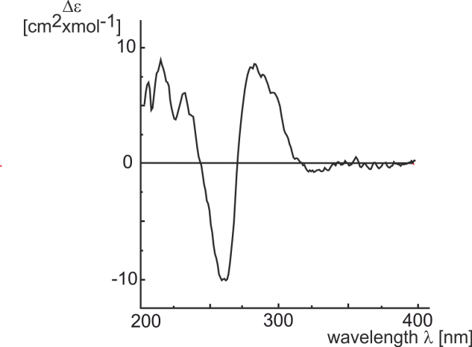
Peak A (11a)
(6R,15S)-EM18
Peak B (11a)
(6S,15R)-EM18

Supplementary Figure S2 Online-CD spectra (stopped-flow mode) of peaks A and B of EM18 (11a).

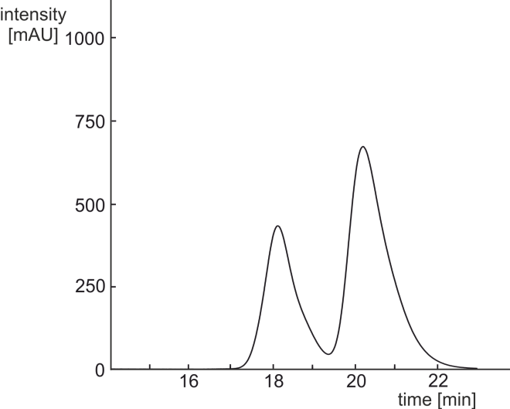
Peak B (11b)
(6R,15R)-EM18

Peak A (11b)
(6S,15S)-EM18

Supplementary Figure S3 HPLC-UV chromatogram of EM18 (11b) on a chiral stationary phase (lux cellulose-1 column, 0.5 µm; 250 mm × 4.6 mm; Phenomenex, Torrance, CA, USA; flow rate 0.8 ml min⁻¹ and isocratic solvent system: solvent (A) H₂O (+ 0.05% trifluoroacetic acid), and solvent (B) CH₃CN (+ 0.05% trifluoroacetic acid), 18% of solvent A).

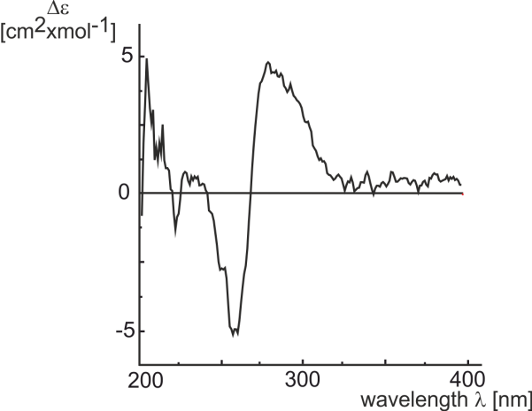
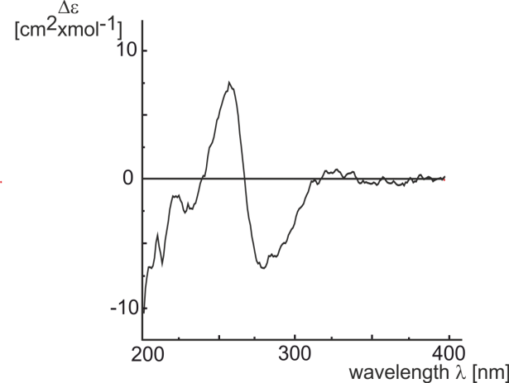
Peak A (11b)
(6S,15S)-EM18
Peak B (11b)
(6R,15R)-EM18

Supplementary Figure S4 Online-CD spectra (stopped-flow mode) of peaks A and B of EM18 (11b).

Considerations on the native origin of bhimamycin I (17)
If bhimamycin C (18, Figure 8)⁸ is present in the Streptomyces strain, the conditions during the workup will favor the condensation, which will easily occur as an S_{N}1 reaction, for several reasons. Firstly, the formation of the rigid ring structure is entropically favored. Secondly, the participating aromatic system is quite electron-rich and will stabilize the intermediate benzylic cation. The high concentration of both reaction partners will enhance the substitution but not the competing elimination. Finally the size of the six-membered ring will lead to a relaxed molecule. Slightly acidic conditions, which may already be reached in an aqueous environment, may trigger the condensation. Once the reaction has taken place the cyclic ether can be opened only under quite harsh conditions, which will not be reached in the fermentor. Since the fermentation was done in aqueous environment and the culture filtrate came in contact with acid and acidic silica gel during workup, it is explainable why only bhimamycin I (17) and no bhimamycin C was isolated.
The fact that bhimamycin I was isolated as a racemic mixture further corroborates the assumption of a spontaneous reaction from bhimamycin C to bhimamycin I, since the formation of the stabilized benzylic cation means the loss of stereo information at C-10. The following condensation occurs.

