GEOMAR
Helmholtz-Zentrum für Date: 05.06.2014
Ozeanforschung Kiel

Cruise Report

Compiled by: Dr. Jan Dierking

R.V. ALKOR Cruise No.: AL 435

Dates of Cruise: 14.04. – 29.04.2014

Areas of Research: Physical, chemical, biological and fishery oceanography

Port Calls: Visby, Sweden, 23.4. – 24.04.2014

Institute: GEOMAR, FB3 (Marine Ecology, Evolutionary Ecology of Marine Fishes)

Chief Scientist: Dr. Jan Dierking

Number of Scientists: 12

Projects: BONUS BIO-C3, BIOACID-II, VECTORS, POPDYN, FISHERIES INDUCED EVOLUTION

Cruise Report

This cruise report consists of 14 pages including the cover page:

1. Scientific crew…………………………………………………………………. 2
2. Research program…………………………………………………………........ 3
3. Narrative of cruise with technical details……………………………………… 4
4. Scientific report and first results……………………………………………….. 7
5. Scientific equipment …………………………..…………………………..…. 12
6. Acknowledgements…………………………………………………………… 13
7. Appendix E1: Station list…………………………………………………….... 14

1. Scientific crew

Name | Function | Institute | Leg
Jan Dierking | Chief scientist | GEOMAR Kiel | Entire cruise
Svend Mees | Scientist | GEOMAR Kiel | Entire cruise
Burkhard von Dewitz | Scientist | GEOMAR Kiel | Entire cruise
Christoph Petereit | Scientist | GEOMAR Kiel | Till Visby
Anders Nissling | Scientist | Uppsala University, Sweden | Entire cruise
Olivia Roth | Scientist | GEOMAR Kiel | Entire cruise
Nazli Demirel | Scientist | GEOMAR Kiel | Entire cruise
Ramona Beckmann | Master student | GEOMAR Kiel | Entire cruise
Jens Paulsen | Bachelor student | Duisburg University | Entire cruise
Martin Grimm | Bachelor student | GEOMAR Kiel | Entire cruise
Clarissa Mohm | Bachelor student | GEOMAR Kiel | Entire cruise
Christian Pawlitzki | Bachelor student | GEOMAR Kiel | Entire cruise
Total | 12

Chief scientist:

Dr. Jan Dierking, GEOMAR Helmholtz Centre for Ocean Research
Düsternbrooker Weg 20, 24105 Kiel
Phone: 0431 600 4580
Fax: 0431 600 4553
E-Mail: jdierking@geomar.de
2. Research program

This multidisciplinary cruise extended a long-term data series on (eco-)system composition and functioning of the Baltic Sea, with a focus on the deeper basins, collected since 1986 by the GEOMAR Helmholtz Centre for Ocean Research and its predecessors IFM-GEOMAR Kiel and IFM Kiel. The key characteristic of this series is the integration of oceanographic and biological information to enhance understanding of environmental and (fish) population fluctuations, and evolutionary processes in this system, in the context of climate change and anthropogenic stressors. The resulting datasets and samples are essential for a number of ongoing projects, including the large-scale international project BONUS BIO-C3 coordinated by GEOMAR. The spatial focus lies on the Bornholm Basin (the most important spawning area of Baltic cod), but also includes the Western Baltic Sea, Arkona and Gotland Basin and Gdansk Deep (Figure 1), thus covering ICES subdivisions 22, 24, 25, 26 and 28 (Figure 2).
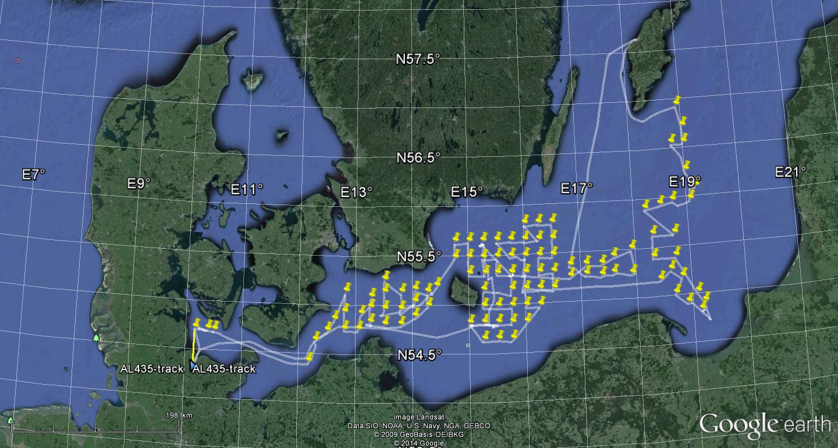

Figure 1 Cruise track of AL 435. Yellow tags denote CTD casts. Image: Google Earth.
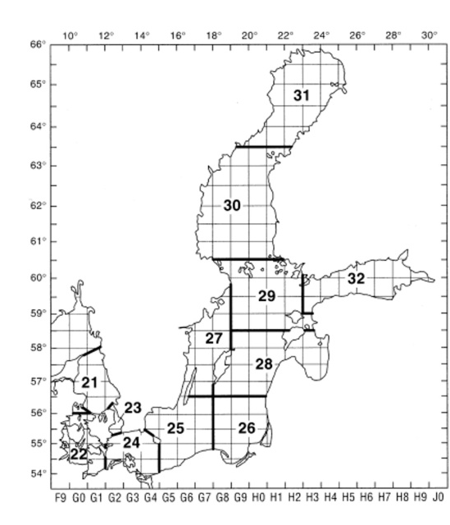

Figure 2 ICES subdivisions in the Baltic Sea area. Source: ICES
Specific investigations included a detailed hydrographic survey (oxygen, salinity, temperature) (see CTD stations in Figure 1), plankton surveys (zoo- and ichthyplankton, with the goal to determine the composition, abundance, vertical and horizontal distribution, and nutritional status of species, and to address questions regarding plankton phenology) (Figure 3), and pelagic fishery hauls (Figure 4, Table 1). The latter served to determine size distributions, maturity status, and length – weight relationships of the three dominant fish species in the pelagic system of the Baltic, cod (Gadus morhua), herring (Clupea harengus) and sprat (Sprattus sprattus), as well as the benthic flatfish flounder (Plathichthys flesus). Secondly, various different samples were obtained for more detailed analyses, including gonad samples of cod, stomachs of cod, herring and sprat for dietary analyses, otoliths of cod for aging, and tissue samples of cod and flounder for genetic analyses. In addition, along the cruise track, hydroacoustic (echosounder) data were collected continuously for later analysis of fish abundance and distribution.
While these analyses and samples mainly stood in the context of the continuation of the long-term data series, cod and plankton samples were also taken for new research lines, e.g., by DTU Aqua in Silkeborg, Denmark, and the IOW in Warnemünde, Germany, in the context of the project BIO-C3. In addition, cruise AL 435 included several new work lines on board, namely: (i) Sampling and measurements to improve understanding of flounder stock structure and dynamics. (ii) Egg buoyancy experiments with flatfishes and cod, including the fertilization of eggs on board and sampling of developing eggs from the water column and measurement of their buoyancy in density columns. (iii) Measurements of sexual immune dimorphisms in cod and herring using Fluorescence Activated Cell Sorting (FACS). (iv) Sampling of muscle tissue of Baltic fish species for stable isotope analysis, foodweb analysis, and analysis of benthic – pelagic coupling in local fish assemblages.

3. Narrative of cruise with technical details

Despite an initial delay of one day due to the malfunctioning of the cool chamber on board, cruise AL 435 successfully accomplished the ambitious work program that had been planned, benefiting from good weather conditions and an ideal working environment and high motivation of permanent crew and scientists on board. Equipment generally functioned smoothly, with the exception of the fishery net probe, which required half a day of repairs at sea but was fully functional afterwards.
RV ALKOR departed from GEOMAR pier with a one day delay on April 15 2014 07:00 (all times board time) heading to the first research area in the Kiel Bight. Over the duration of the cruise, hydroacoustic data obtained with four different echosounder frequencies (38, 70, 120 and 200 kHz) were continuously recorded. In addition, work for special projects took place in parallel to the standard program throughout the duration of the cruise whenever suitable samples were available.
Station work consisting of CTD, Bongo net (or IKS-80 net East of Stolpe trench), and pelagic fishery hauls, as well as Helgoländer larvae net and Multinet MIDI casts at select stations was conducted in the Kiel Bight – SD22 (April 15), Arkona Basin – SD24 (April 16 – 17), Bornholm Basin – SD25 (April 18-20 and April 26-28), Gdansk Deep – SD26 (April 21), Gotland Basin – SD26, 28 (April 22) and Stolpe Trench – SD25 (April 25) (Figures 1, 2, 3).
In addition, the central deep station BB23 in Bornholm Basin was intensively sampled early (April 18) and late (April 26-27) during the cruise, including CTD casts, zoo- and phytoplankton sampling with Bongo, Apstein and WP-2 nets, oxygen measurements of water samples obtained with the rosette water sampler using the Winkler method, and phytoplankton samples taken from the same water samples. The second timepoint entailed the intensive spatially and temporally resolved sampling of plankton communities by four towed
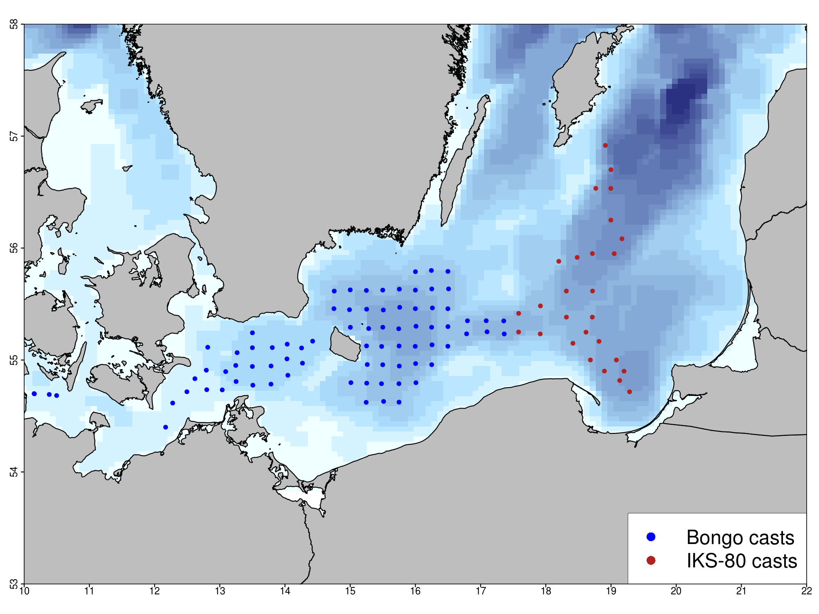
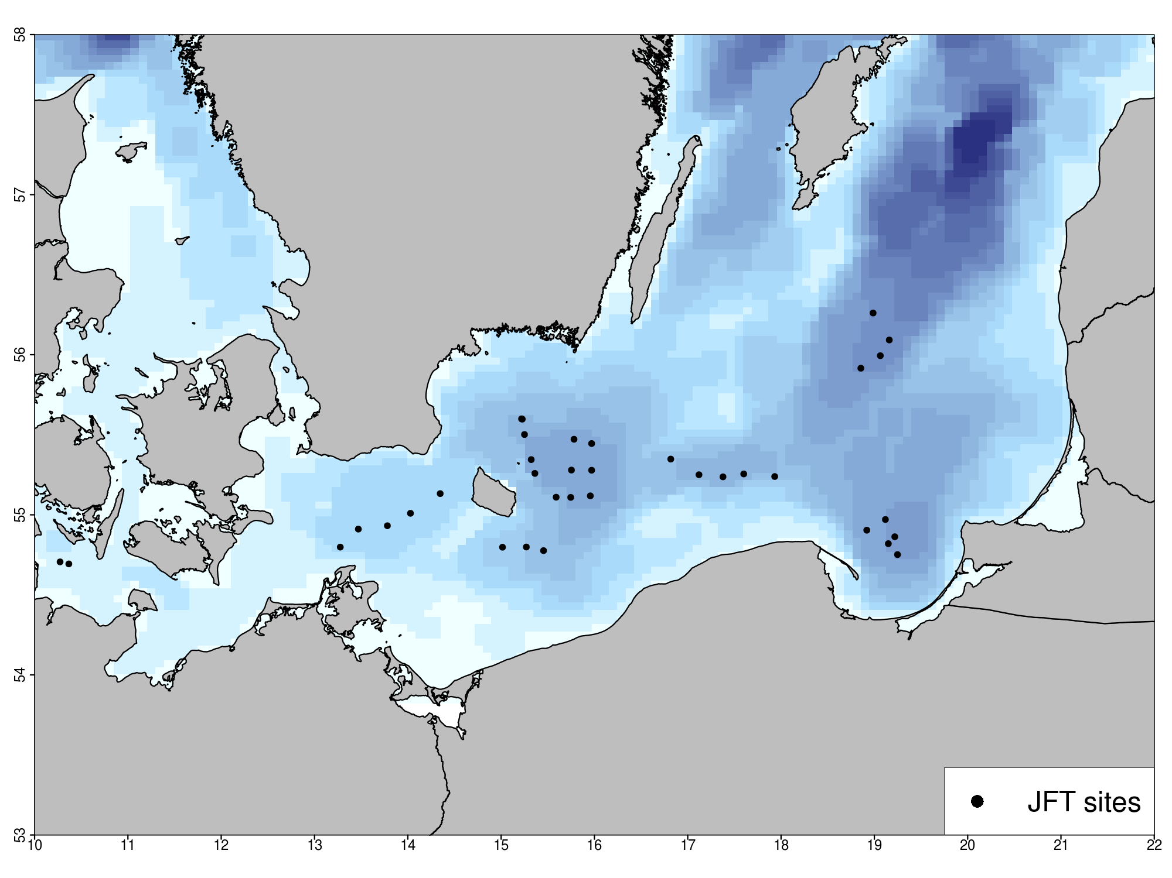
Figure 3 Stations covered during cruise AL 435. a.) Plankton sampling with Bongo (blue circles) and IKS-80 (red circles) net casts. A CTD profile was also obtained at each of these locations (see cruise track in Figure 1). b.) Fishery stations covered during AL 435 with pelagic trawls (“Jungfischtrawls”, JFT). Numbers on the y- and x-axis represent degrees N and E, respectively.
Multinet MAXI and four vertical Multinet MIDI hauls over a 24 hour period, covering the water depth in 5 m and 10 m depth layers, respectively.
A scheduled visit in Visby (Gotland, Sweden) (April 23-24) to debark one scientist rounded out the cruise. Following the completion of the research program on April 28 at 12:47, RV ALKOR steamed for Kiel harbor and reached port on April 29 at 07:45. After unloading, the cruise ended at 11:00. Compared to the initial program, the only changes lay in the delayed departure and some reorganization of the cruise leg order to avoid bad weather.
Additional detail on the cruise timeline and track (Figure 1), the station list (Appendix E1) and an overview of gear deployments (Table 1) are provided below.

Detailed cruise timeline (all times board time):

Monday 14/04/2014 Loading equipment, repair of cooling chamber

Tuesday 15/04/2014 0700 Leaving GEOMAR Westshore pier, steaming to Kiel Bight.
0926 start of station work in Kiel Bight. CTD, Bongo, Helgoländer larvae net, MIDI multinet towed, pelagic fishery.

Wednesday 16/04/2014 – Thursday 17/04/2014 Station work in the Arkona Basin. CTD, Bongo, Helgoländer larvae net, pelagic fishery.

Thursday 17/04/2014 Start of station work in the Bornholm Basin. CTD, Helgoländer larvae net, pelagic fishery. Upon arrival at station BB23 on Friday 18/04/2014 08:28, first detailed plankton sampling with additional Apstein, WP-2, and rosette water sampler hauls. Upon completion, continuation of station work in Bornholm Basin until Sunday 20/04/2014.

Monday 21/04/2014 Station work IKS-80, CTD, pelagic fisheries in the area Gdansk Deep, in addition one Helgoländer larvae net haul on station GD59.

Tuesday 22/04/2014 Station work IKS-80, CTD, pelagic fisheries in the area Gotland Basin, in addition one Helgoländer Larvae net haul on station GB84. After completion of last station at 22:39, steaming for Visby, Sweden.

Thursday 24/04/2014 1830 Debarking of one scientist, departure from Visby, heading to Stolpe Trench.

Friday 25/04/2014 Station work Bongo/IKS-80, CTD, pelagic fishery in area Stolpe Trench, after completion of last station at 23:59, steaming to station BB23.

Saturday 26/04/2014 0328 Upon arrival on central deep station BB23, intensive 24 hour sampling: CTD, water sampler, towed multinet MAXI, vertical multinet MIDI, Apstein, WP-2. After end or sampling, steaming to northwestern Bornholm Basin.

Sunday 27/04/2014 Pelagic fishery hauls in the northwestern Bornholm Basin.

Monday 28/04/2014 Pelagic fishery hauls in the southwestern Bornholm Basin, after completion of last haul at 12:47, steaming for Kiel harbor.

Tuesday 29/04/2014 07:45 Arrival Kiel East shore pier, unloading; 09:00 relocation to GEOMAR west shore berth. 1100 unloading completed; end of cruise.
Table 1 Overview of gear deployment. Mesh sizes are given in brackets.

Gear | Deployments (n)
ADM-CTD | 110
Hydroacoustic transect  (continuous along cruise track) | 1
Watersampler + CTD | 3
Bongo, Babybongo (150μ, 335μ, 500μ) | 80
IKS-80 (500μ) | 27
WP-2 (100μ) | 8
Apstein (55μ) | 8
Helgoländer larvae net (500μ) | 12
Multinet MAXI horizontal (335μ) | 10
Multinet MIDI horizontal (335μ) | 9
Multinet MIDI vertical (50μ) | 8
pelagic trawl (Jungfischtrawl) | 36

4. Scientific report and first results

Ichthyo– and zooplankton sampling

Bongo- and Babybongo hauls covered Kiel Bight (3 hauls), Arkona Basin (25 hauls), and Bornholm Basin including the western part of the Stolpe Trench (52 hauls) (Figure 3 a). Larvae of cod (Gadus morhua) (n = 8 in total), sprat (Sprattus sprattus) (n = 122), and flounder (Plathichthys flesus) (n = 101) were picked from the 500 μm bongo-samples and conserved at -80 °C for subsequent RNA/DNA analysis. All Bongo samples were also checked for the presence of gelatinous zooplankton. The jellyfish species Aurelia aurita and Cyanea capillata were present regularly, whereas no adults and only a small number of larvae (n = 21 in total) of the invasive combjelly Mnemiopsis leidyi were found. Following these initial on board steps, all Bongo samples were conserved in formol, and will be used for the determination of species composition and abundance of (ichthyo-)plankton.
Stations in the eastern part of Stolpe trench and the Gdansk Deep and Southern Gotland Basin were covered with IKS-80 instead of Bongo hauls (Figure 3 a) to ensure compatibility of data with a long-term IKS-80 sampling series maintained by the Latvian Fish Resources Agency (LATFRA; Andrei Makarcuks).
Helgoländer larvae net (500 μm) hauls (12 in total) coupled with CTD deployments were done to obtain live eggs for buoyancy experiments on select stations over the cruise duration.
Repeated Multinet MAXI (335μ, towed, sampling of the water column in 5 m layers) and MIDI (50μ, vertical, sampling of the water column in 10 m layers) (HYDROBIOS, Kiel) casts were done over a 24 hour period on April 26-27 on the central deep Bornholm Basin station BB23 to reveal the vertical distribution of ichthy- and zooplankton. In addition, WP-2 (100 μm) and Apstein (55 μm) nets and the rosette water sampler were deployed to obtain additional samples, including phytoplankton samples in the context of plankton phenology work within the BONUS BIO-C3 project (Dr. Jörg Dutz, IOW).

Fishery

Pelagic fishery was conducted in the Kiel Bight (2 hauls), Arkona Basin (5 hauls), Bornholm Basin (15 hauls), Stolpe Trench (5 hauls), Gotland Basin (4 hauls) and Gdansk Deep (5 hauls) (Figure 3 b). In parallel to the fishery hauls, hydroacoustic measurements of fish distribution patterns were recorded continuously. Catches in the Bornholm Basin were dominated by sprat (Sprattus sprattus) followed by herring (Clupea hargenus), cod (Gadus morhua) (n = 1132), whiting (Merlangius merlangus) (n = 183) and flatfishes. The latter were comprised mainly of flounder (Platichthys flesus) (n = 167), but also, common dab (Limanda limanda) (n = 32) and plaice (Pleuronectes platessa) (9). Eight coal fish (Pollachius virens), 2 fourbeard rocklings (Enchelyopus cimbrius) and one witch flounder (Glyptocephalus cynoglossus) completed the catches. Regarding cod, it was noticeable that higher catches were usually accomplished when the net was trawled on to the bottom, indicating a near benthic distribution and oxygen levels sufficiently high for cod in the bottom layers.
For each haul and the entire catch, catch weight and length frequencies of all species (illustrated in Figure 4 for cod) were taken. Stomach samples were taken from sprat (10 per 1 cm length class) and herring (10 per 2 cm length class). For cod, single fish data (length, weight, sex and maturity stage) and samples (otoliths, fin clips for genetic analysis, stomachs and gonads) were obtained for 765 individuals (see Figure 5 for illustration), whereas only length and weight were measured for the remaining individuals.
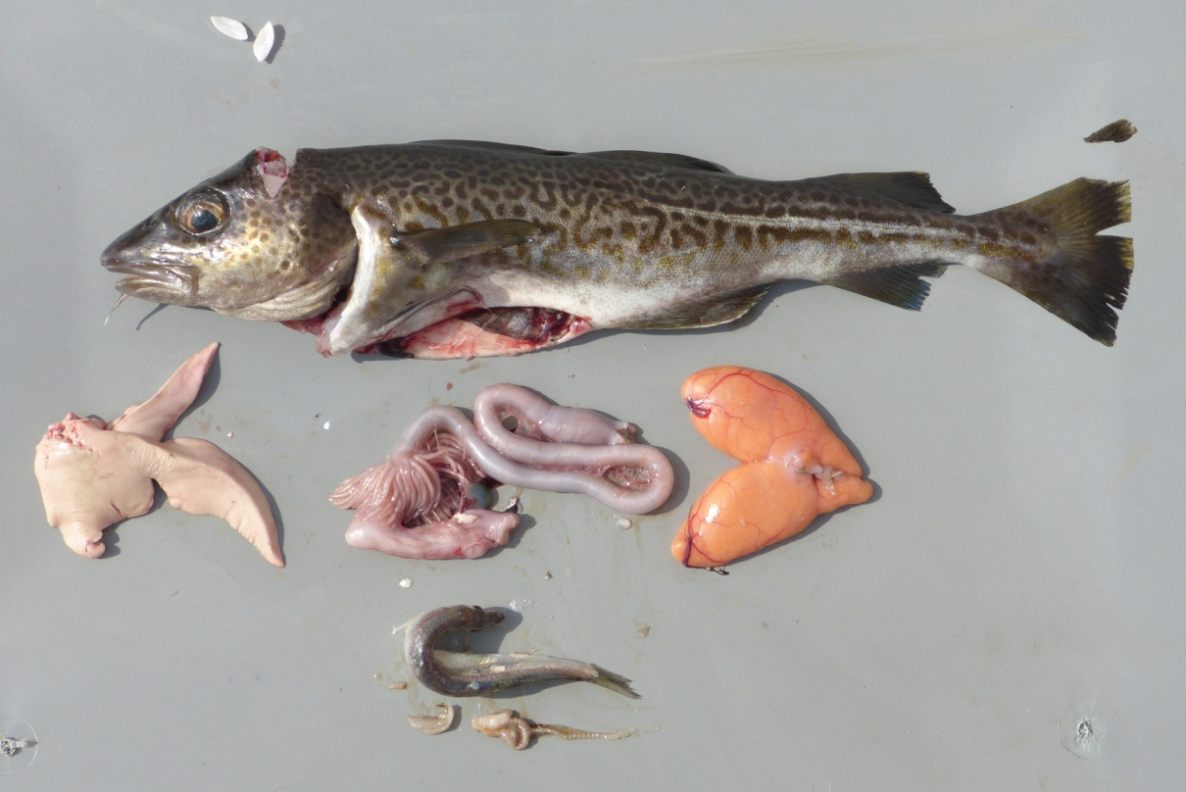

Figure 4 Relative length frequency distribution of cod catches during AL 435
(n = 1132).
Figure 5 Samples (otoliths, fin clips, stomach contents, gonads) and measures (total length, weight, gutted weight, liver and gonad weight) taken from 765 out of 1132 cod individual during the cruise (illustrated here for a 38 cm female, maturity stage IV, with full stomach, from Bornholm Basin). Photo: Nickel

Hydrography

CTD profiles from 113 stations were obtained with the ADM-CTD and the HYDROBIOS water sampler with attached CTD (Figure 1). Conditions varied depending on the basin and location of the Baltic sampled, and will be analyzed in depth in context of the long-term data series on hydrographic conditions. In general, Bornholm Basin stations were characterized by a permanent halocline in ca. 60 m depth, with sharply increasing salinity and decreasing oxygen levels below. However, oxygen near the bottom in most locations still exceeded 2.5 to 3 ml/l and frequently reached up to 4 ml/l, which pointed to a potential inflow over the winter/early spring 2013/2014. The relatively good oxygen situation also explained the distribution of cod adults near the bottom, indicated by increased catches with increasing proximity of the trawl to the bottom during AL 435.
Special projects

All four additional lines of work carried out in parallel to the above cruise program as “special projects” successfully completed the planned sampling and/or measurements. Short summaries of these projects and the work realized on board are given below.

(i) Flounder stock structure and dynamics (Anders Nissling, Uppsala University, Sweden, in collaboration with Christoph Petereit, GEOMAR Kiel)

(Note: This study contributes to the EU-BONUS project “INSPIRE”).

Stock dynamics of flounder in the Baltic Sea are largely unknown. Two ecologically different types exist, one with pelagic eggs spawning at higher salinities in the deep basins, and one with demersal eggs spawning at low salinities in coastal areas and on offshore banks. Fishery exists on a mixed stock. To achieve sustainable management there is a need for increased knowledge of population structure, spatial distribution and migration patterns.
The overall aim of the study is to evaluate the use of biochemical proxies in the otoliths in combination with genetic markers to identify spatial pattern and connectivity. The main objective during the ALKOR-cruise (and during a series of gill-net surveys) was to characterize spawning flounder according to ecotype at an individual level by assessment of egg specific gravity (buoyant or non-buoyant eggs at salinities prevailing in the Baltic Sea deep basins) and spermatozoa mobility at different salinities (swimming or non-swimming at 6-8 psu, corresponding to the salinity in the Baltic Sea surface layer) and thus establish a reference material. In total, 93 individuals were sampled covering the ICES SD 22, 24, 25, 26 and 28. All but one individual showed characteristics of deep basin spawning flounder. For all classified individuals, genetic samples and otoliths were collected to be forwarded to Ann-Britt Florin, SLU Aqua, Sweden (genetic analyses) and Karin Limburg, State University of New York college of Environmental Science, USA (otolith chemistry). In addition, all measurements of egg specific gravity will be forwarded to Andreas Lehmann and Hans-Harald Hinrichsen, GEOMAR, Kiel for modelling of egg dispersal and survival probabilities.

Table 2 Numbers of flounders from different ICES subdivision sampled during AL 435.

ICES SD | Males (n) | Females (n)
22 | 7 | -
24 | 17 | 1
25 | 19 | 3
26 | 6 | 2
28 | 21 | 17
Total | 70 | 23

(ii) Egg Buoyancy measurements (Christoph Petereit, GEOMAR Kiel, in collaboration with Anders Nissling, Uppsala University, Sweden)

(Note: This study contributes to the EU-BONUS project “BIO-C3”.)

During the cruise, >1150 individual buoyancies of cod (Gadus morhua), flounder (Platichthys flesus), dab (Limanda limanda), sprat (Sprattus sprattus) and four-bearded rockling (Enchelyopus cimbrius) eggs were determined using a combination of plankton net hauls (with Helgoländer Larvae net [HLN] or Multinet MIDI [MN]) and artificial strip spawning of individuals caught by fisheries.
The employed technique allows at least two important features for ecologically related research. 1) POPULATION STRUCTURE - Differences in the egg buoyancies may under certain conditions reflect the diversity and characteristic of fish population structure. 2) HABITAT CHARACTERISTICS- In combination with oceanographic information derived e.g., by CTD, the determination of specific depth strata and the characteristic abiotic environment (temperature, salinity, oxygen and pH) in these strata for individual fish eggs is possible (Figure 6).

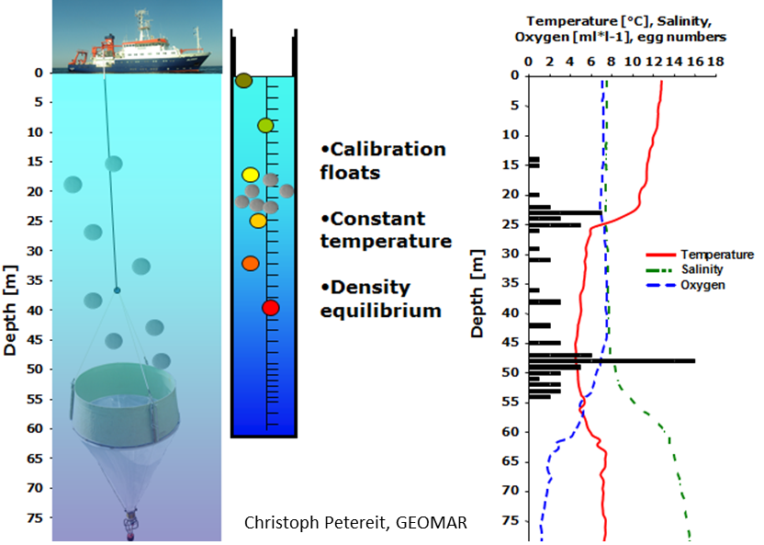

Figure 6 Principle of the characterization of individual egg microhabitats (depth and its abiotic parameters occupied by an egg with a specific buoyancy) connecting HLN hauls, egg gradient column measurements and CTD information. (Exemplary data for sprat eggs from a previous ALKOR cruise used for illustration.)

In total, three stations in the Kiel Bight were analyzed by sorting, counting and measuring fish eggs from stratified MN hauls (300 µm mesh size additionally sieved over 780 µm mesh size). Moreover, HLN (500 µm) hauls were conducted at stations in the Arkona Basin (3 stations), Bornholm Basin (5 stations), Gdansk Deep (1 station) and southern Gotland Basin (1 station). This allowed the determination of individual densities of roughly 480 fish eggs (297 sprat; 61 cod; 82 flounder; ~40 rockling).
Secondly, 27 batches of fish eggs from artificial strip spawning (~25 eggs / batch = 676 eggs) were measured. The majority of successful developing batches stemmed from flounders (n = 20) from the Bornholm Basin (n = 4), Gdansk Deep (n = 2) and Gotland Basin (n = 14). This was accomplished by the continuous determination (every 12 hours) of flounder egg development in a gradient column. Five cod egg batches from the Arkona Basin (n = 2), Bornholm Basin (n = 2) and Gdansk Deep (n = 1), and 2 egg batches of dab from the Kiel Bight, were also measured. The latter was accomplished from fertilization to first hatch, which to our knowledge represents the first such dataset for this species.
(iii) Sexual immune dimorphism in cod and herring (Olivia Roth in collaboration with Martin Grimm, GEOMAR Kiel)

Reproductive success of females depends on longevity, of males on the number of matings. An efficient immune system is important for successful clearance of parasites and pathogens and thus correlates with longevity. This is why females usually have a stronger immune response than males across the animal kingdom. Our recent data, however, suggest that the sole production of eggs and sperm may not be of such outstanding importance but that sexual immune dimorphism rather exclusively bases on the difference in life-history strategy and hence, on investment into the offspring and parental care. Whereas during the last year we mainly focused on animals with extreme parental care, during cruise AL 435 we investigated differences between males and females are also present in species without parental care that reproduce over the simple deposition of the reproductive elements into the water during a mass spawning event, and hence, exclusively rely on the production of reproductive elements without further investment into offspring.
We successfully measured male and female immunocompetence of 230 herring and cod individuals. Specifically, upon capture, the sex of each fish was determined, size was measured and reproductive stage estimated. Animals were grouped into juvenile, pre-spawning and spawning. Blood was collected from the caudal vein, and head kidney and spleen were dissected and collected in medium. The samples from blood, spleen and head kidney were then further processed for immunocompetence measurements using flow cytometry (Fluorescence Activated Cell Sorting, FACS). The number of cells from the innate and adaptive immune system was measured according to size and complexity of cells. The activity of the immune system was assessed using cell cycle measurements. Gills were stored in RNA later to measure immune gene expression in the laboratory.

(iv) Foodweb analysis of Baltic cod and local fish assemblages (Clarissa Mohm in collaboration with Jan Dierking, GEOMAR Kiel)

(Note: This study contributes to the EU-BONUS project “BIO-C3”.)

The study goal is to improve understanding of the feeding ecology of Baltic cod, including the presence and strength of ontogenetic shifts, and the relative importance of benthic versus pelagic prey in cod diet. The method of choice to answer similar questions in ecological studies is commonly stable isotope analysis, but surprisingly, this method has been rarely applied in commercially fished species including cod in the Baltic Sea.
The objective during cruise AL 435 was to obtain muscle tissue samples of Baltic Sea fish species as foundation for planned stable isotope analyses. The pelagic fishery hauls of the cruise allowed us to sample the three dominant fish species cod (Gadus morhua), herring (Clupea harengus) and sprat (Sprattus sprattus) of the pelagic system of the Baltic, as well as less abundant species including whiting (Merlangius merlangus), flounder (Platichthys flesus), plaice (Pleuronectes platessa), dab (Limanda limanda), coalfish (Pollachius virens), fourbeard rockling (Enchelyopus cimbrius) and the mussle ocean quahog (Arctica islandica). Sample sizes realized during the cruise are summarized in Table 3.
To include spatial factors in planned analyses, the sampling design was based on sub-sampling of cod, herring, sprat and whiting in almost equal proportion of both sexes from ICES subdivisions 22, 24, 25 and 26. For all other species, which occurred less commonly in catches, all available individuals were sampled.
Specifically, dorsal white muscle tissue of all fishes, and posterior adductor muscle tissue of the mussle ocean quahog, was sampled and immediately frozen at -20˚C until further analysis. Samples were labeled with a code linking them to the single fish measures taken in the course of the standard program on board, including fish length, weight, gutted weight, organ weight, maturity stage, and samples taken for genetic and aging analyses. Following the successful sampling on board, the next steps will be to conduct stable isotope analysis.

Table 3 Sample sizes per species and ICES subdivision (see Figure 2) obtained during AL 435.

SD | cod | herring | sprat | whiting | flounder | plaice | dab | coalfish | fourbeard | ocean | total
 |  |  |  |  |  |  |  |  | rockling | Quahog | total
22 | 2 | 17 |  | 10 | 9 | 7 | 10 |  |  |  | 55
24 | 42 | 31 | 30 | 10 | 19 | 1 |  |  | 1 | 1 | 135
25 | 114 | 51 | 40 | 12 | 24 | 2 |  | 8 | 1 | 1 | 253
26S | 52 | 4 | 20 |  | 11 |  |  |  |  |  | 87
26N | 18 |  | 20 |  | 34 |  |  |  |  |  | 72
 | 228 | 103 | 110 | 32 | 97 | 10 | 10 | 8 | 2 | 2 | 602

5. Scientific equipment: instruments and gear

Hydrography:
- ADM-CTD with additional pH and O2 sensor
- Hydrobios Water Sampler with CTD, pH and O2 sensor

Zooplankton:
- Baby Bongo-Net (150 μm)
- Bongo-Net (335 μm)
- Bongo Net (500 μm)
- WP2 (100 μm)
- Apstein net (55 μm).

Ichthyoplankton:
- Bongo-Net (335 μm and 500 μm)
- Hydrobios Multinet MAXI (335 μm horizontal tows)
- Hydrobios Multinet MIDI (300 μm horizontal tows and 50 μm vertical hauls)
- IKS-80 (500 μm)
- Helgoländer larvae net (500 μm)

Fish:
- Jungfisch Trawl (pelagic trawls) (0.5 cm)

Hydroacoustic:
- 38, 70, 120 and 200 kHz-echosounder EK60

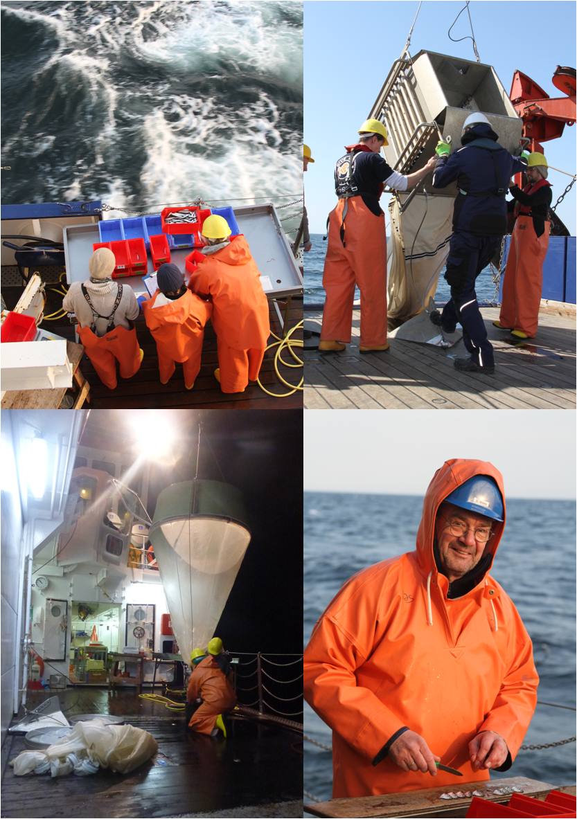

Figure 7 Impressions from cruise AL 435. Top left: Sprat length-weight measurements. Top right: Deployment of Multinet MAXI. Bottom left: Deployment of the Helgoländer larvae net. Bottom right: Taking stomach content samples. Photos: Dierking

6. Acknowledgements

Thanks to Captain Lass and the entire crew of RV ALKOR for their outstanding support during the cruise, and to Rudi Lüthje and Svend Mees for their support in preparing the cruise!
7. Appendix E1: Station list of AL 435

Supplied with the report in electronic form as Excel table, “Appendix E1 – AL435_station_list.

